# Impact of Global Warming on ENSO-driven Precipitation in the Tropical Pacific

## Christine Chung1, Scott Power1 and François Delage1

*1Science to Services, Bureau of Meteorology, Melbourne*

*christine.chung@bom.gov.au*

**Introduction**

The El Niño–Southern Oscillation (ENSO) drives substantial variability in rainfall, severe weather, agriculture, and ecosystems in many parts of the world. Although this issue has been investigated many times over the past 20 years, there is very little consensus on future changes in ENSO, apart from an expectation that ENSO will continue to be a dominant source of year-to-year variability. Here we show that there are in fact robust projected changes in the spatial patterns of year-to-year ENSO-driven variability in both surface temperature and precipitation. We present results from the Coupled Model Intercomparison Project versions 3 and 5 (CMIP3 and CMIP5) coupled model ensembles, as well as from experiments conducted using the ACCESS atmospheric general circulation model (AGCM), showing a nonlinear precipitation response to warmer sea surface temperatures (SSTs).

**Methods and Summary of Results**

To investigate projected changes in precipitation, we analysed four different twenty-first-century emission scenarios are presented (RCP8.5, RCP4.5 and 1% CO2 from CMIP5, and SRES A2 from CMIP5). Fig 1a,c,e,g shows that even though there is a large disagreement amongst models on how ENSO-driven SST variability will change in the 21st century, the models exhibit a greater degree of agreement on how ENSO-driven precipitation will change (Fig 1b,d,f,h).

We also conducted a suite of AGCM experiments using ACCESS 1.0 investigating how ENSO-driven precipitation changes in response to a warmer mean state only, without any changes in ENSO-driven SST variability. We applied El Niño and La Niña SST anomalies of varying strengths (1-4 times the observed composite anomalies). Under 20th century conditions, we found a strong nonlinear precipitation response to El Niño SST anomalies, with precipitation increasing across the central and eastern equatorial Pacific. This nonlinear response is enhanced under 21st century conditions (warmer SSTs and increased CO2; Fig 2a). For La Niña, there is a weaker, though still nonlinear response to imposed SST anomalies, in which precipitation decreases along the central equatorial Pacific. Contrary to the El Niño case, the response to La Niña SST anomalies is weaker under 21st century conditions (Fig 2b). Additional experiments were run using observed time-varying SSTs, with and without an added SST warming pattern (Fig 2c), with the precipitation response to global warming showing good agreement with coupled model projections of precipitation change.

To understand the causes of the precipitation responses from the AGCM, a moisture budget analysis was performed. The precipitation response to El Niño and La Niña was found to be dominated by changes in the atmospheric mean circulation dynamics. The response to global warming was found to be a balance between dynamic and thermodynamic changes during El Niño years, and dominated by thermodynamic changes during La Niña years.

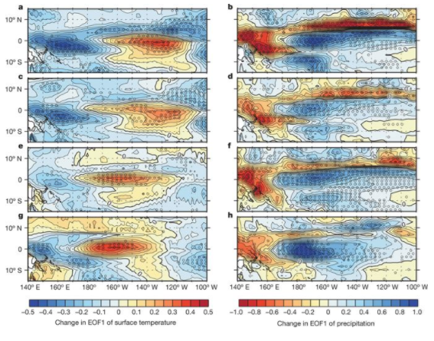

Figure 1: Multi-model average (MMA) of the projected change in the structure of the standardized first EOF of interannual (high-pass-filtered, ‘year-to-year’) variability for the four twenty-first-century scenarios. a, c, e, g, Surface temperature (ST); b, d, f, h, precipitation. The pattern for each model was standardized by the spatial standard deviation of EOF1 over the domain 0–360° E, 30° S to 30° N. The CMIP5 models were forced using RCP8.5 (a, b), RCP4.5 (c, d) and 1% CO2 (e, f). The CMIP3 models were forced using SRES A2 (g, h). Stippling indicates that more than 70% of models agree on the sign of change. Red shades indicate an increase in EOF1 (ST) and a decrease in EOF1 (precipitation).

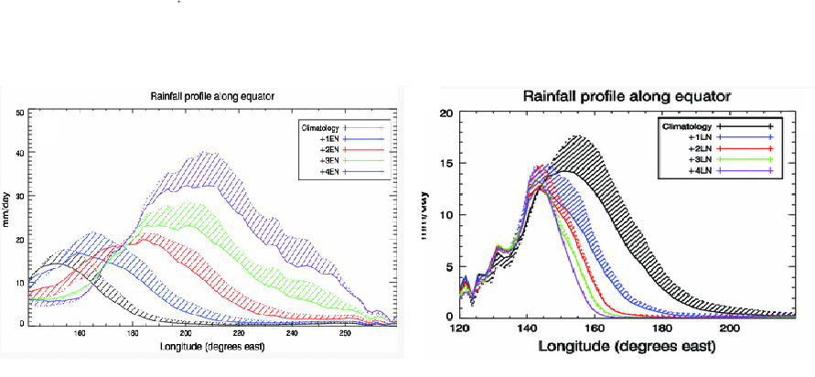

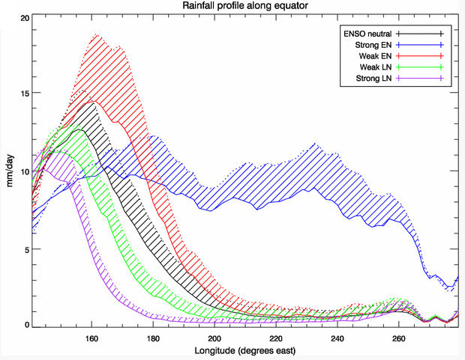

Fig 2: Rainfall profiles along the equator for (a) imposed El Niño SST anomalies (1-4 times observed composite), (b) imposed La Niña SST anomalies (1-4 times observed composite), and (c) imposed time-varying SSTs (1951-2010). Thick solid linesrepresent the 20C runs, and dotted lines represent the 21C runs. The areas between the 21C and 20C runs are stippled to highlight the precipitation changes.

# References

S Power, F Delage, C Chung, G Kociuba, K Keay. 2013: Robust twenty-first-century projections of El Niño and related precipitation variability, Nature, 502 (7472), 541

CTY Chung, SB Power, JM Arblaster, HA Rashid, GL Roff. 2014: Nonlinear precipitation response to El Niño and global warming in the Indo-Pacific, Climate Dynamics, 42, 1837-1856.

CTY Chung, SB Power. 2014: Precipitation response to La Niña and global warming in the Indo-Pacific, Climate Dynamics, 43, 3293-3307

CTY Chung, SB Power. 2015: Modelled rainfall response to strong El Niño sea surface temperature anomalies in the tropical Pacific, Journal of Climate, 28(8), 3133-3151

CTY Chung, SB Power. 2016: Modelled impact of global warming on ENSO-driven precipitation changes in the tropical Pacific, Climate Dynamics, 47 (3-4), 1303-1323