# Impact of global warming on ENSO teleconnections

## Scott Power, François Delage and Christine Chung

*Bureau of Meteorology, Melbourne*

*scott.power@bom.gov.au*

In an earlier presentation we described evidence from CMIP5 climate models that El Nino-Southern Oscillation (ENSO)-driven precipitation variability in the equatorial Pacific is projected to increase during the 21st century in response to business-as-usual increases in greenhouse gas concentrations. In this presentation we will examine some of the implications of this increase as reported by Power et al. (2017) and Power and Delage (2018).  We will describe the most comprehensive study to date on the influence of global warming on the impact of ENSO on rainfall around the world. The study, which took several years to complete, is based on projected changes in climatic conditions during El Niño years and in ENSO-driven precipitation variability in 36 CMIP5 climate models from around the world. The models are forced according to the RCP8.5 scenario in which there are large, unmitigated increases in greenhouse gas concentrations during the twenty-first century (RCP8.5).

Under this scenario ENSO precipitation variability is projected to increase in many locations, about long-term average conditions that will generally be very different from those experienced in the past, if global greenhouse gas emissions continue to rise. ENSO-driven precipitation variability is projected to increase by around 15%–20% of the level of variability experienced during the 20th century in many locations.

The situation in Australasia is a little different: while long-term average drying is projected during winter in southern Australasia, ENSO-driven variability about this drier average is projected to remain roughly the same as it was last century. This means that winter rainfall during El Nino years, for example, will tend to be lower that it was last century, because of long-term average drying, not because the impact of El Niño on southern Australasia increases.

In the second study (Power et al. 2017) we will show that the disruption to Pacific rainfall patterns that ENSO in CMIP5 climate models causes will become more frequent even if large and sustained cuts to global greenhouse gas emissions are implemented. In the models the risk of major disruption was already inflated by the end of the 20th century. This suggests, for example, that the major El Nino events of 1982/83 and 1997/98, may have been rendered more disruptive by greenhouse gas emissions since the industrial revolution began than they would have been without the preceding those emissions. These points are illustrated in Figure 2.

Climate models are not able to perfectly simulate the properties of ENSO. It will therefore be interesting to see how ENSO in the next generation of climate models - as they emerge over the next few years - respond to global warming.

**References:**

Power, S.B. and F.P. Delage, 2018: El Niño–Southern Oscillation and Associated Climatic Conditions around the World during the Latter Half of the Twenty-First Century. *J. Climate*, **31**, 6189–6207, <https://doi.org/10.1175/JCLI-D-18-0138.1>

Power, S.B., F.P.D. Delage, C.T.Y. Chung, H. Ye, and B.F. Murphy, 2017: Humans have already increased the risk of major disruptions to Pacific rainfall. *Nature Communications*, [doi: 10.1038/ncomms14368](http://www.nature.com/articles/ncomms14368).

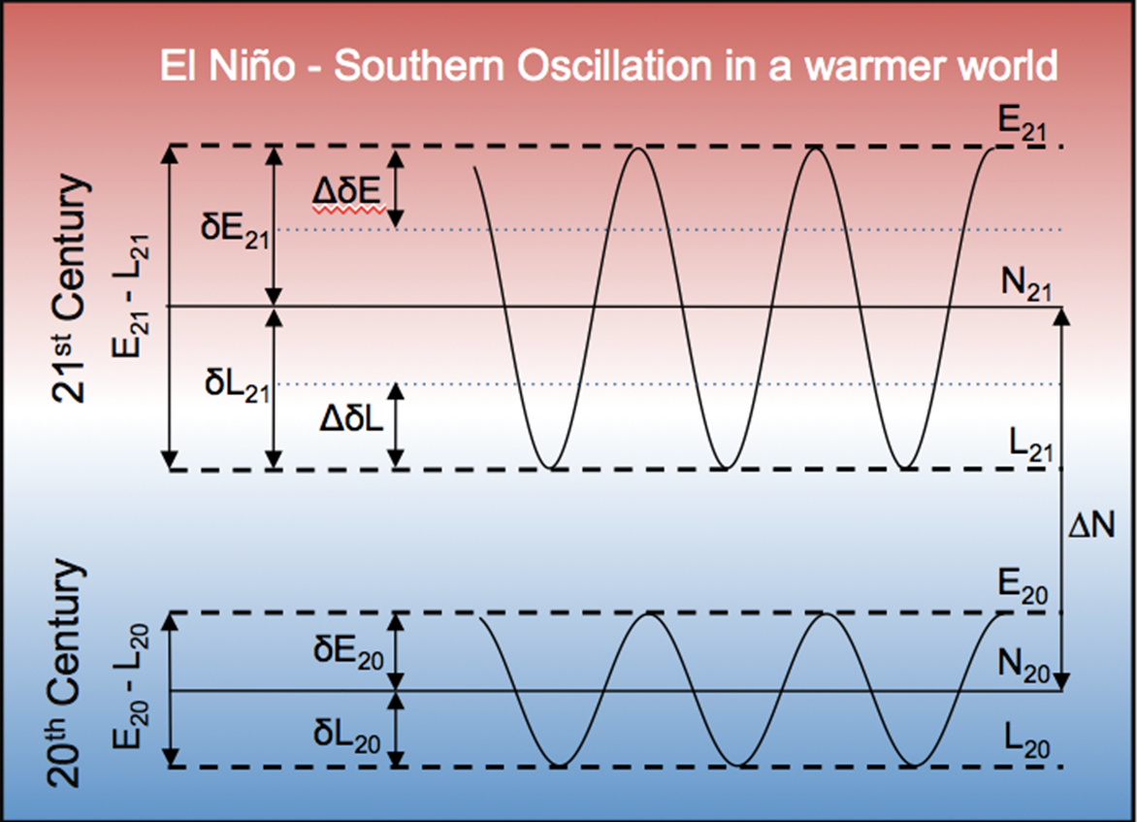

**Figure 1**: Schematic showing that precipitation during future El Nino (E) and La Nina (L) years can depend on changes to ENSO-driven variability, as well as changes in precipitation during neutral years (N).

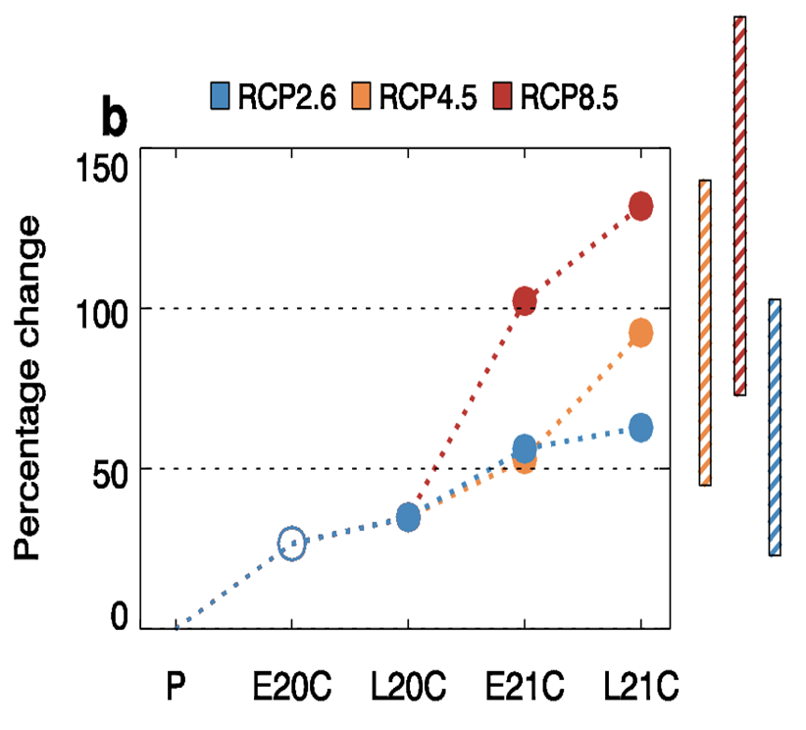

**Figure 2**: Percentage change in the frequency of major disruptions to Pacific rainfall in the 20th and 21st Centuries. Early 20th Century (E20C), late 20th century (L20C), early 21st century (E21C) and late 21st century (L21C) frequency changes relative to the pre-industrial period, for three different scenarios: RCP2.6 (blue), RCP4.5 (orange) and RCP8.5 (red). The results are based on changes obtained from 20 CMIP5 climate models that were forced with all three scenarios. Filled circles indicates statistical significance at 90% level. Bars indicate the 90% confidence interval of the multi-model mean (MMM) change for L21C.