Severe Tropical Cyclone Bakung (05U)
10 – 18 December 2025
Tropical Cyclone Environmental Prediction Services
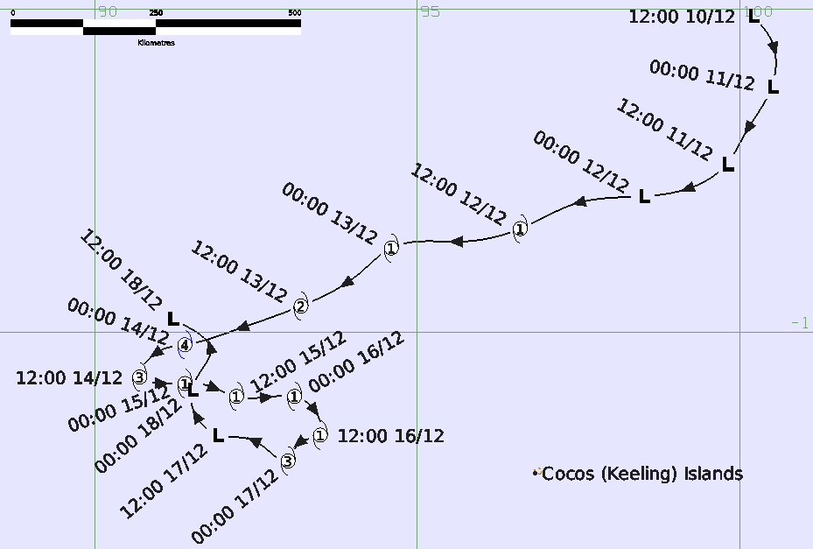

Revision history
Date | Version | Author | Description
23/02/2026 | 1.0 | EPS Tropical Cyclones | Final draft

Review status
Date | Version | Reviewer | Description
24/02/2026 | 1.0 | EPS Tropical Cyclones | Completed

Release history
Date | Version | Status | Approval
25/02/2026 | 1.0 | Approved for release | Manager, EPS Tropical Cyclones
Contact details:
Tropical Cyclone Team Lead
Severe Weather Environmental Prediction Services
Bureau of Meteorology
PO Box 1370, West Perth WA 6872
Email: tcwc@bom.gov.au

This work is copyright. Apart from any use as permitted under the Copyright Act 1968, no part may be reproduced without prior written permission from the Bureau of Meteorology. Refer to www.bom.gov.au/other/copyright.shtml for further information. Unless otherwise noted, all images in this document are licensed under the Creative Commons Attribution Australia Licence.
© Commonwealth of Australia 2026
Published by the Bureau of Meteorology
Cover image: Track of Severe Tropical Cyclone Bakung, 10-18 December 2025. Times in UTC.
Table of Contents

1. Summary 4

2. Meteorological description 7

2.1. Intensity analysis 7

2.2. Structure 8

2.3. Motion 8

3. Impact 18

4. Observations 18

5. Forecast Performance 18

Appendix: List of abbreviations 21

List of Figures
Figure 1. Best track of Severe Tropical Cyclone Bakung, 10-18 December 2025 6
Figure 2. Detailed Best track of Bakung with wind radii shown, 12-18 December 2025. 7
Figure 3. Hovmoller diagram of tropical waves over the latitude range of 5-15S. 11
Figure 4. Sea surface temperatures for eastern Indian Ocean on 9 December. 12
Figure 5. Graph of vertical wind shear and intensity for Severe Tropical Cyclone Bakung.. 13
Figure 6. AMSR2 microwave image at 0718 UTC 12 December at 37 GHz and 89 GHz. 13
Figure 7. Series of three scatterometry wind analyses from 13-15 December 14
Figure 8. AMSR2 89 GHz microwave image at 1849 UTC 13 December. 15
Figure 9. Enhanced IR image from Himawari-9 at 2200 UTC 13 December. 16
Figure 10. Satellite wind speeds from SAR RCM-1 at 1209 UTC 14 December 17
Figure 11. Series of microwave images on 16-17 December 2025. 18
Figure 12. Satellite wind speeds from SAR at 2331 UTC 16 December 19
Figure 13. Scatterometry winds from ASCAT-B at 0257 and 1531 UTC 17 December 2025 19
Figure 14. 7-Day forecasat verification for Bakung from 12 to 17 December. 21
Figure 15. Position accuracy figures for Severe Tropical Cyclone Bakung. 22
Figure 16. Intensity accuracy figures for Severe Tropical Cyclone Bakung 22
Figure 17. Intensity plot of objective and subjective guidance. 25

List of Tables
Table 1. Best track summary for Severe Tropical Cyclone Bakung, 10-18 December 2025.. 6
Table 2: Verification statistics for Severe Tropical Cyclone Bakung.. 17

- Summary
Severe Tropical Cyclone Bakung was a small Indian Ocean cyclone named by Indonesia that had no impact to island communities. It was notable for having two short lived peaks at severe tropical cyclone intensity.
A tropical low developed west of Sumatra on 10 December. Gales were detected by scatterometry on 12 December and tropical cyclone intensity was estimated at 0600 UTC. Jakarta Tropical Cyclone Warning Centre (BMKG, Indonesia) named the cyclone 'Bakung'. Bakung initially moved to the south southwest then adopted a west southwest track on 12 December passing well to the north of Cocos (Keeling) Islands overnight 12-13 December.
Under favourable environmental conditions of low wind shear, Bakung developed rapidly on 13 December as it continued moving to the southwest passing south of 10°S into the Australian area of responsibility overnight from 13-14 December. Bakung peaked at category 4 intensity with maximum winds of 90 kn (165 km/h) on 14 December.
Bakung then weakened under increased wind shear, and slowed, taking an abrupt turn to the east southeast overnight 14-15 December then southeast on 15 December whilst weakening under wind shear. Bakung remained at category 1 intensity on 15-16 December. During 16 December Bakung was steered to the southwest. Overnight on 16-17 December Bakung rapidly intensified to briefly reach category 3 intensity early on 17 December.
Bakung rapidly weakened on 17 December as it turned to the northwest. The circulation dissipated on 18 December as it moved north of 10°S out of the Australian region.
There were no impacts to the Cocos (Keeling) Islands.
Figure 1 shows the best track of Bakung, Figure 2 is a more detailed track showing the extent of strong winds, while Table 1 is a summary of the best track data.
Figure 1. Best track of Severe Tropical Cyclone Bakung, 10-18 December 2025. Times are in UTC (AWST-8h).
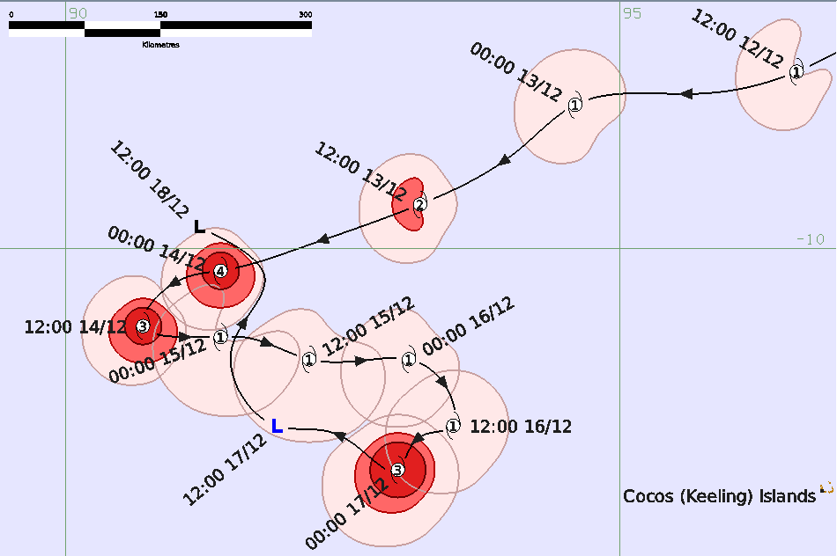
Figure 2. Detailed Best track of Severe Tropical Cyclone Bakung with wind radii shown, 12-18 December 2025. Times are in UTC (AWST-8 h).
Year | Month | Day | Hour | Pos. | Pos. | Pos. | Max Wind | Max | Cent. | Rad. of gales | Rad. of storm | RMW
 |  |  | UTC | Lat. | Long. | Acc. | 10min | gust | Press. | (NE/SE/ | (NE/SE/ | nm
 |  |  |  | S | E | nm | kn | kn | hPa | SW/NW) | SW/NW)
2025 | 12 | 10 | 1200 | 5.1 | 100.2 | 30 | 25 | 45 | 1005 | 0/0/0/0 | 0/0/0/0 | -
2025 | 12 | 10 | 1800 | 5.5 | 100.5 | 30 | 25 | 45 | 1005 | 0/0/0/0 | 0/0/0/0 | -
2025 | 12 | 11 | 0000 | 6.2 | 100.5 | 30 | 30 | 45 | 1003 | 0/0/0/0 | 0/0/0/0 | -
2025 | 12 | 11 | 0600 | 6.9 | 100.1 | 30 | 30 | 45 | 1003 | 0/0/0/0 | 0/0/0/0 | -
2025 | 12 | 11 | 1200 | 7.4 | 99.8 | 30 | 30 | 45 | 1003 | 0/0/0/0 | 0/0/0/0 | -
2025 | 12 | 11 | 1800 | 7.7 | 99.4 | 20 | 30 | 45 | 1003 | 0/0/0/0 | 0/0/0/0 | -
2025 | 12 | 12 | 0000 | 7.9 | 98.5 | 20 | 35* | 50 | 1001 | 0/0/35/0 | 0/0/0/0 | -
2025 | 12 | 12 | 0600 | 8.0 | 97.5 | 20 | 40* | 55 | 998 | 0/20/35/30 | 0/0/0/0 | 13
2025 | 12 | 12 | 1200 | 8.4 | 96.6 | 25 | 40 | 55 | 998 | 0/20/35/30 | 0/0/0/0 | 12
2025 | 12 | 12 | 1800 | 8.6 | 95.7 | 30 | 40 | 55 | 998 | 30/20/35/30 | 0/0/0/0 | 12
2025 | 12 | 13 | 0000 | 8.7 | 94.6 | 20 | 45 | 65 | 996 | 30/20/35/30 | 0/0/0/0 | 12
2025 | 12 | 13 | 0600 | 9.1 | 94.1 | 15 | 50 | 70 | 991 | 30/20/35/30 | 0/0/0/0 | 12
2025 | 12 | 13 | 1200 | 9.6 | 93.2 | 20 | 55 | 75 | 987 | 20/20/35/30 | 0/0/15/15 | 10
2025 | 12 | 13 | 1800 | 10.0 | 92.1 | 10 | 75 | 105 | 974 | 20/25/35/25 | 15/20/20/15 | 8
2025 | 12 | 14 | 0000 | 10.2 | 91.4 | 10 | 90 | 125 | 957 | 20/25/35/25 | 15/20/20/15 | 6
2025 | 12 | 14 | 0600 | 10.3 | 91.0 | 20 | 80 | 110 | 965 | 20/25/35/25 | 15/20/20/15 | 6
2025 | 12 | 14 | 1200 | 10.7 | 90.7 | 20 | 80 | 110 | 966 | 20/25/35/30 | 15/20/20/15 | 5
2025 | 12 | 14 | 1800 | 10.8 | 91.2 | 20 | 60 | 85 | 982 | 20/30/40/30 | 10/20/20/15 | 10
2025 | 12 | 15 | 0000 | 10.8 | 91.4 | 20 | 45 | 65 | 992 | 0/45/40/30 | 0/0/0/0 | 10
2025 | 12 | 15 | 0600 | 10.8 | 91.6 | 30 | 40 | 55 | 995 | 0/45/45/30 | 0/0/0/0 | 10
2025 | 12 | 15 | 1200 | 11.0 | 92.2 | 20 | 40 | 55 | 993 | 20/45/45/30 | 0/0/0/0 | 10
2025 | 12 | 15 | 1800 | 11.0 | 92.8 | 20 | 40 | 55 | 997 | 20/35/45/30 | 0/0/0/0 | 10
2025 | 12 | 16 | 0000 | 11.0 | 93.1 | 20 | 40 | 55 | 995 | 20/30/40/30 | 0/0/0/0 | 10
2025 | 12 | 16 | 0600 | 11.4 | 93.5 | 25 | 35 | 50 | 998 | 20/30/40/30 | 0/0/0/0 | 10
2025 | 12 | 16 | 1200 | 11.6 | 93.5 | 25 | 40 | 55 | 994 | 30/30/40/30 | 0/0/0/0 | 10
2025 | 12 | 16 | 1800 | 11.7 | 93.2 | 20 | 50 | 70 | 990 | 30/30/40/30 | 0/20/20/20 | 9
2025 | 12 | 17 | 0000 | 12.0 | 93.0 | 15 | 75 | 105 | 969 | 30/35/45/30 | 20/20/25/20 | 7
2025 | 12 | 17 | 0600 | 11.7 | 92.5 | 20 | 50 | 70 | 991 | 30/35/45/30 | 0/15/15/0 | 10
2025 | 12 | 17 | 1200 | 11.6 | 91.9 | 30 | 30 | 45 | 1003 | 0/0/0/0 | 0/0/0/0 | -
2025 | 12 | 17 | 1800 | 11.1 | 91.5 | 25 | 30 | 45 | 1003 | 0/0/0/0 | 0/0/0/0 | -
2025 | 12 | 18 | 0000 | 10.9 | 91.5 | 30 | 30 | 45 | 1002 | 0/0/0/0 | 0/0/0/0 | -
2025 | 12 | 18 | 0600 | 10.3 | 91.8 | 20 | 30 | 45 | 1003 | 0/0/0/0 | 0/0/0/0 | -
2025 | 12 | 18 | 1200 | 9.8 | 91.2 | 20 | 25 | 45 | 1004 | 0/0/0/0 | 0/0/0/0 | -
Table 1. Best track summary for Severe Tropical Cyclone Bakung, 10-18 December 2025. UTC=AWST+8h.
* Not a tropical cyclone as gales less than halfway around centre.

- Meteorological description
  - Intensity analysis
A comparison of the subjective and objective intensity estimates is shown in Figure 17.
A tropical low developed west of Sumatra and well to the northeast of Cocos (Keeling) Islands on 10 December, despite not having a tropical wave present as shown in the tropical wave analysis in Figure 3. Sea surface temperatures along the track of Bakung started at 30.5-31°C and only reduced to about 29°C at its furthest point south (Figure 4).
Scatterometry on 11 December (e.g. ASCAT-C 0221 UTC) showed near gales to the north of the centre. Easterly wind shear resulted in deep convection consolidating west of the centre on 11 December but the wind shear reduced on 12 December allowing deep convection to develop around the centre, as shown in Figure 5. Tropical cyclone intensity was estimated at 0600 UTC 12 December on the basis of Dvorak estimates reaching 3.0 supported by microwave imagery (AMSR2 at 0718 UTC 12 December in Figure 6) that showed a compact circulation with deep convection around the centre. During operations the system was named Bakung by Jakarta Tropical Cyclone Warning Centre (BMKG, Indonesia) at 1200 UTC.
Bakung's small size (shown in ASCAT images from 13-15 December in Figure 7) allowed it to quickly change intensity. Rapid intensification occurred on 13 December and an eye developed on microwave imagery (89 GHz AMSR2 image at 1849 UTC in Figure 8). An eye then became apparent on infra-red imagery (e.g. 2200 UTC 14 December in Figure 9) which caused Dvorak intensity estimates to peak at CI=5.5 consistent with maximum wind speed of 90 kn (165 km/h) at 0000 UTC 14 December. The small eye size and the large viewing angle of Himawari-9 (141°E) to Bakung's longitude (90-100°E) likely resulted in the eye being under sampled. For example the ADT objective algorithm did not resolve an eye at any stage during Bakung's lifetime. Overall the objective intensity techniques (Figure 17) underestimated the intensity during the two peak intensity phases.
An increase in northeasterly wind shear (Figure 5) during 14 December weakened deep convection east of the centre, although the intensity at 1200 UTC was estimated at 80 kn, consistent with subjective Dvorak and slightly lower than winds from SAR RCM-1 at 1209 UTC in Figure 10. Deep convection then contracted southwest of the centre and Bakung weakened to a category 1 system on 15 December, consistent with Dvorak estimates and scatterometry (ASCAT-B 1452 UTC in Figure 7). This pattern continued on 16 December.
Overnight from 16 to 17 December deep convection increased near the centre and once more an eye appeared on microwave imagery AMSR2 1920 UTC, SSMIS 2327 UTC shown in Figure 11. The rapid intensification was confirmed by an RCM-3 SAR pass at 2331 UTC in Figure 12. Bakung was estimated to have intensified to 75 kn at 0000 UTC 17 December.
This period of rapid intensification occurred despite the analysed wind shear remaining above 20 kn as shown in Figure 5. It is likely that overnight bursts in deep convection near the centre initiated around 1100 UTC and then 1700 UTC, assisted by strong upper-level outflow associated with an upper trough to the southwest, were sufficient to overcome the negating influences of the wind shear. Being a small system allowed the circulation to rapidly respond to the deep convection and to form an eye.
Remarkably just as quickly as Bakung intensified, it then dramatically weakened in the following 6-12 hours as the effects of wind shear became apparent. ASCAT-B at 0257 UTC showed much weaker winds than the SAR three hours earlier, and then winds were below gale-force by 1531 UTC as shown in Figure 13. Visible and microwave imagery showed the erosion of deep convection and contraction southeast of the centre. The circulation dissipated late on 18 December.
  - Structure
Bakung was a compact system as shown in the extent of defined wind radii in Table 1 and Figure 2. The extent of gales was only 20-45 nm (35-85 km) as indicated in the series of ASCAT and SAR wind analyses in Figures 7, 10, 12 and 13. The radius of maximum winds was less than 10 nm (20 km/h) when it peaked on 14 December and then again as it re-intensified on 17 December as shown on the SAR analyses in Figures 10 and 12.

  - Motion
Bakung's track in Figure 1 shows that initially Bakung moved to the south southwest then adopted a west southwest track on 12 December passing well to the north of Cocos (Keeling) Islands overnight 12-13 December. Bakung crossed 10°S and entered the Australian area of responsibility just as it reached peak intensity early on 14 December. The motion then became more complex from 14 December, as an upper trough to the south turned Bakung to the east southeast. On 16 December Bakung turned southwards and then, following reaching its second peak intensity early on 17 December, tracked to the northwest during its final weakening phase under the influence of a steering ridge in the low to mid-levels to the south.

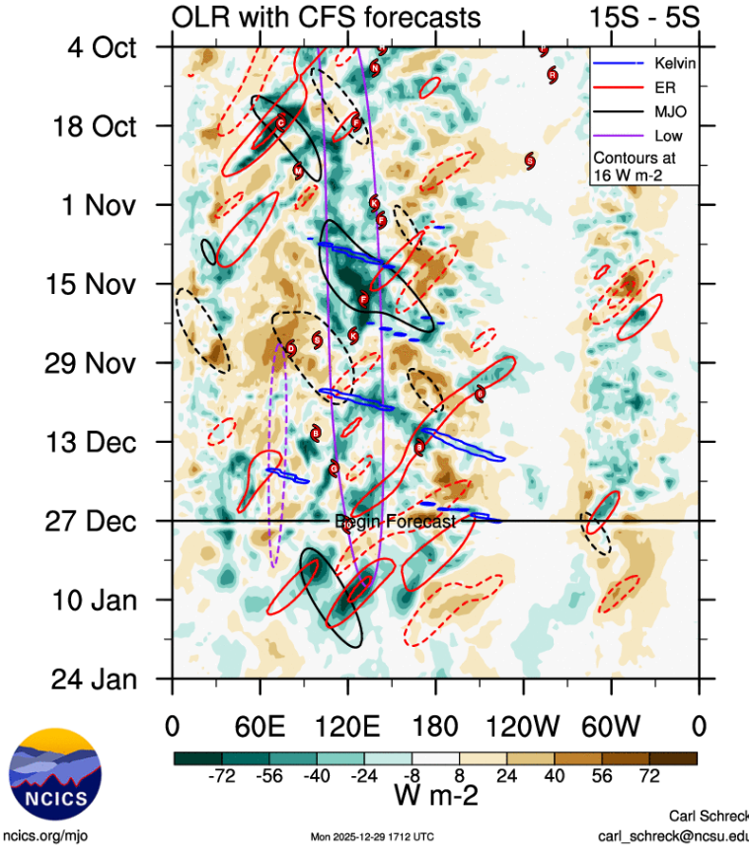
Figure 3. Hovmoller diagram of tropical waves over the latitude range of 5-15S. The formation of Bakung (the system annotated B on 13 December near 90E) did not coincide with an analysed tropical wave. The image is courtesy of the North Carolina Institute for Climate Studies: https://ncics.org/pub/mjo/archive/2025/2025-11-25/v2/
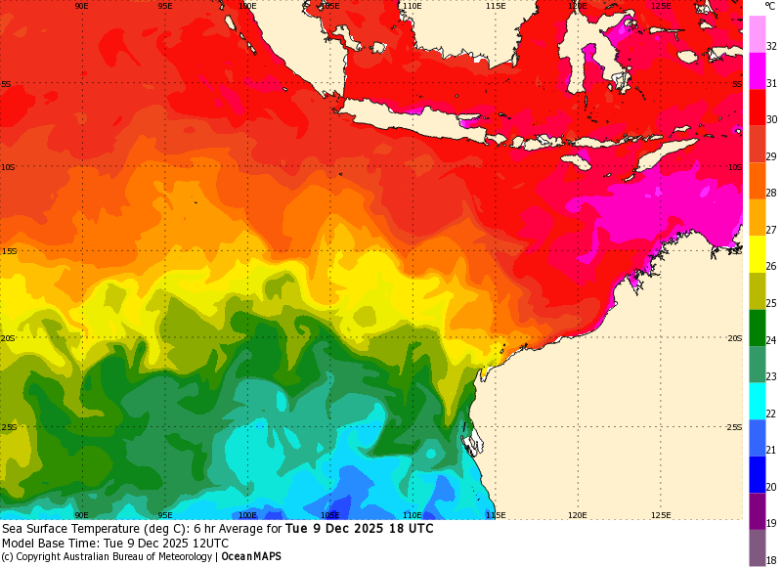
Figure 4. Sea surface temperatures for eastern Indian Ocean on 9 December. Temperatures along Bakung's track started at about 30.5-31°C (5°S 100°E) then decreased to 28-29°C at its furthest point south (12°S 93°E).
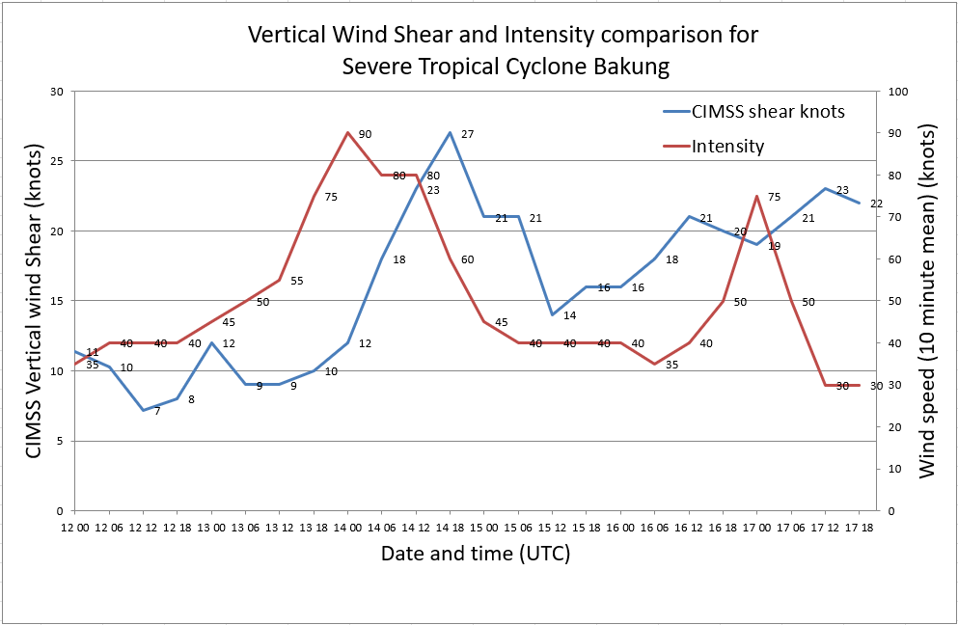
Figure 5. Graph of vertical wind shear and intensity for Severe Tropical Cyclone Bakung. Wind shear values courtesy of CIMSS.
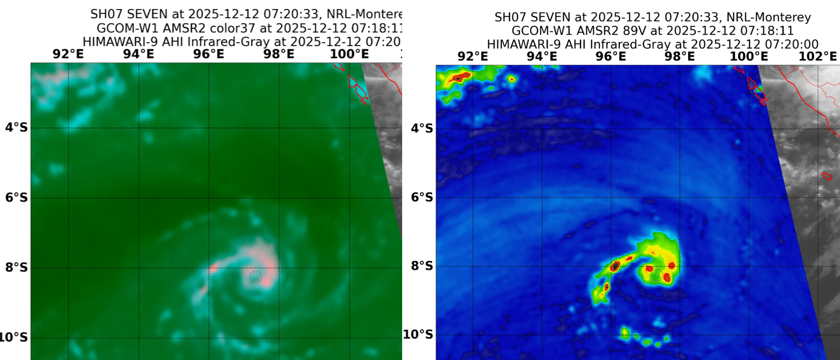
Figure 6. AMSR2 microwave image at 0718 UTC 12 December: left 37 GHz; and right 89 GHz. Image courtesy NRL: https://science.nrlmry.navy.mil/geoips/tcweb/
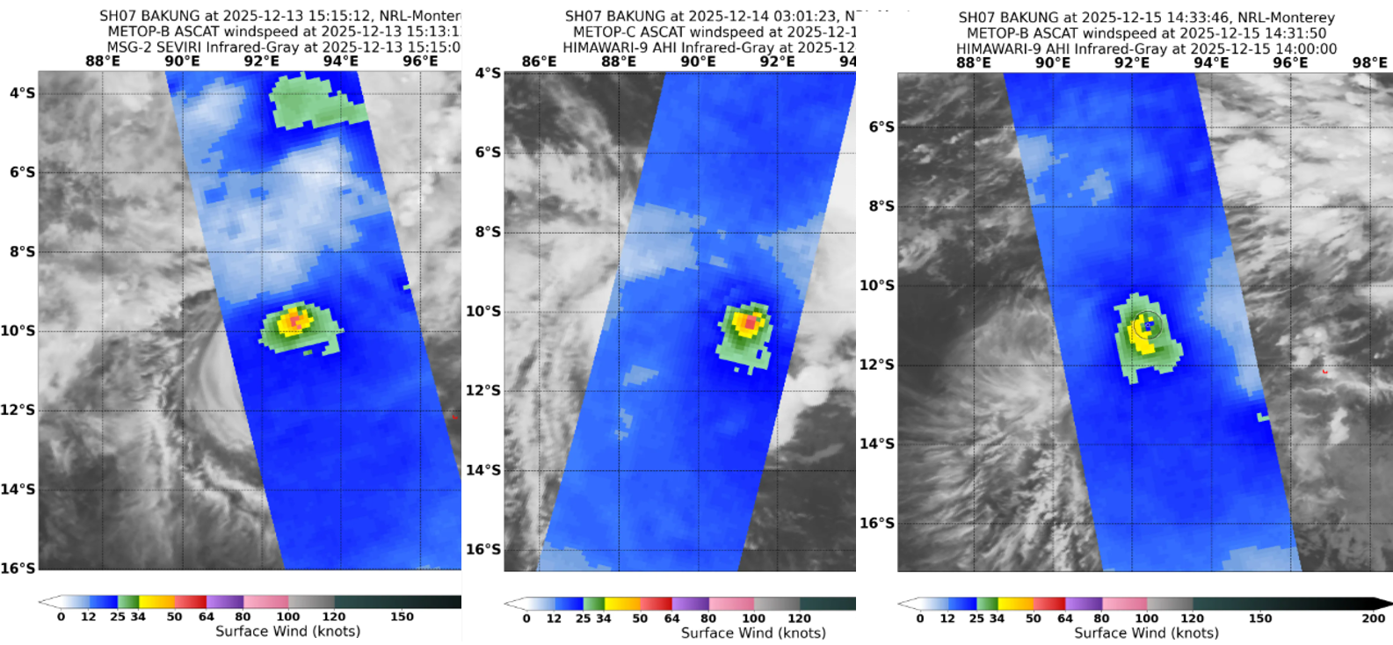
Figure 7. Series of three scatterometry wind analyses from 13-15 December: left ASCAT-B 1513 UTC 13 December; centre ASCAT-C 0259 UTC 14 December; and right ASCAT-B 1431 UTC 15 December. In all three cases the extent of gales shown in yellow is very small. Images courtesy NRL: https://science.nrlmry.navy.mil/geoips/tcweb/

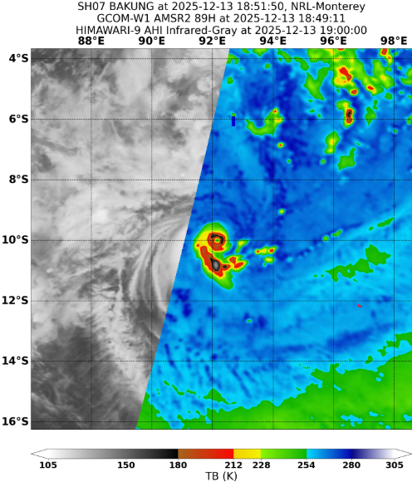
Figure 8. AMSR2 89 GHz microwave image at 1849 UTC 13 December. The image shows a well-defined eye surrounded by a compact eye wall. Image courtesy NRL: https://science.nrlmry.navy.mil/geoips/tcweb/

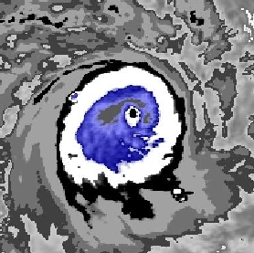
Figure 9. Enhanced IR image from Himawari-9 at 2200 UTC 13 December. The Dvorak analysis of an eye pattern indicated a CI=5.5 matching the peak intensity of 90 kn (category 4).

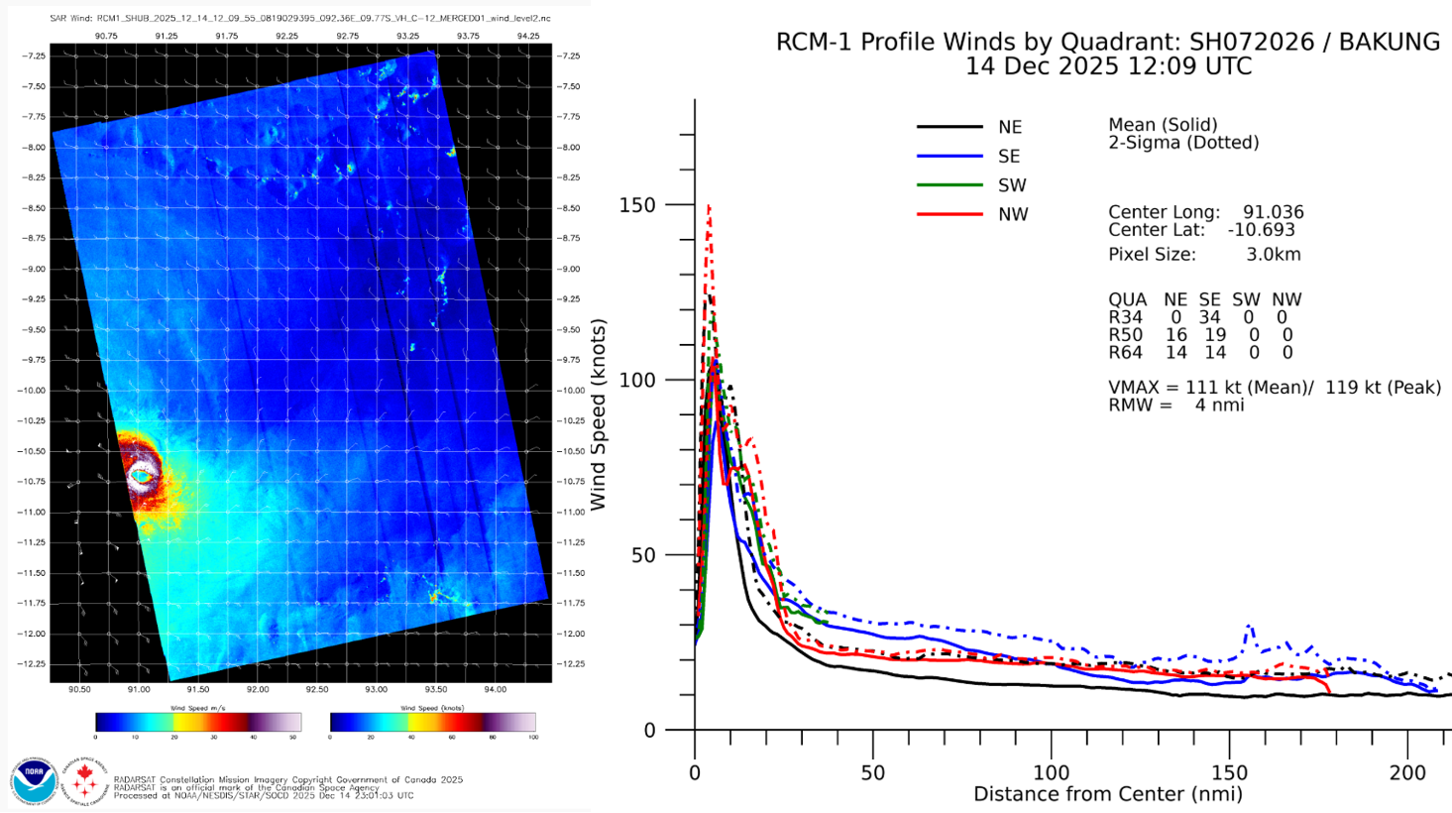
Figure 10. Satellite wind speeds from SAR RCM-1 at 1209 UTC 14 December after peak intensity. Left: wind distribution and right: wind profile by quadrant. Hurricane force winds wrap around the system centre, with near instantaneous maximum shown analysed as 111 kn. The estimated 10-minute mean at the time was 80 kn. The system is very compact, with a radius of maximum winds of 4 nm (8 km). Image courtesy of NOAA https://www.star.nesdis.noaa.gov/socd/mecb/sar/sarwinds_tropical.php

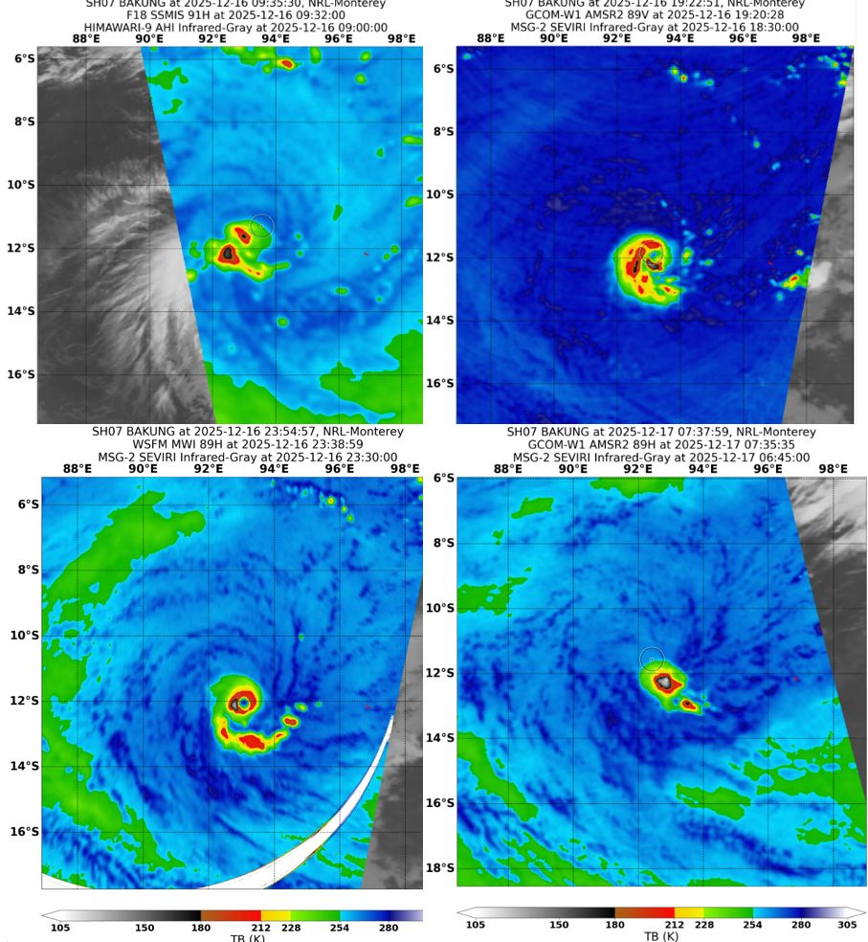
Figure 11. Series of microwave images showing the rapid intensification then weakening of Bakung on 16-17 December 2025. Top left SSMIS 91 GHz at 0932 UTC 16 December; top right: AMSR2 89 GHz 1920 UTC 16 December; lower left: WSFM 89 GHz at 2339 GHz 16 December; and lower right: AMSR2 89 GHz 0735 UTC 17 December. Images courtesy NRL: https://science.nrlmry.navy.mil/geoips/tcweb/
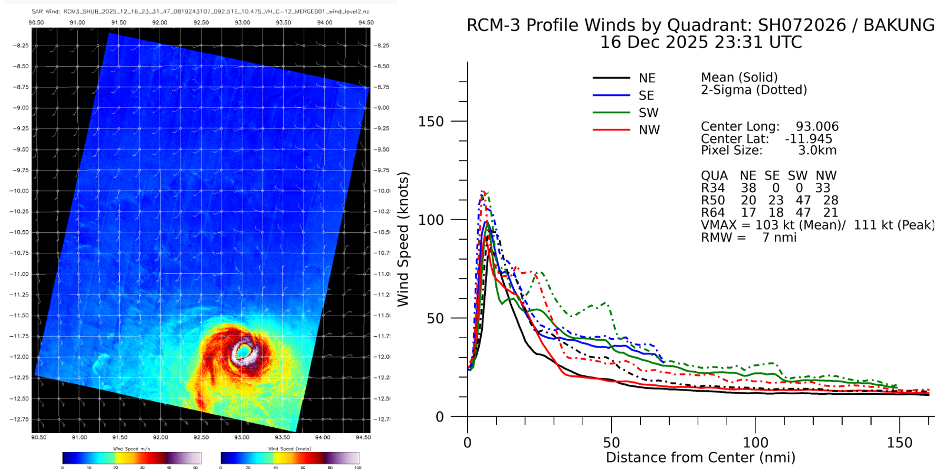
Figure 12. Satellite wind speeds from SAR at 2331 UTC 16 December near the time of the second intensity peak. Hurricane force winds wrap around the system centre. The analysed mean maximum wind (VMAX) is 103 kn, estimated to be consistent with the 10-minute mean of 75 kn. The system is very compact, with an analysed radius of maximum winds of 7 nm (14 km). Image courtesy of NOAA https://www.star.nesdis.noaa.gov/socd/mecb/sar/sarwinds_tropical.php
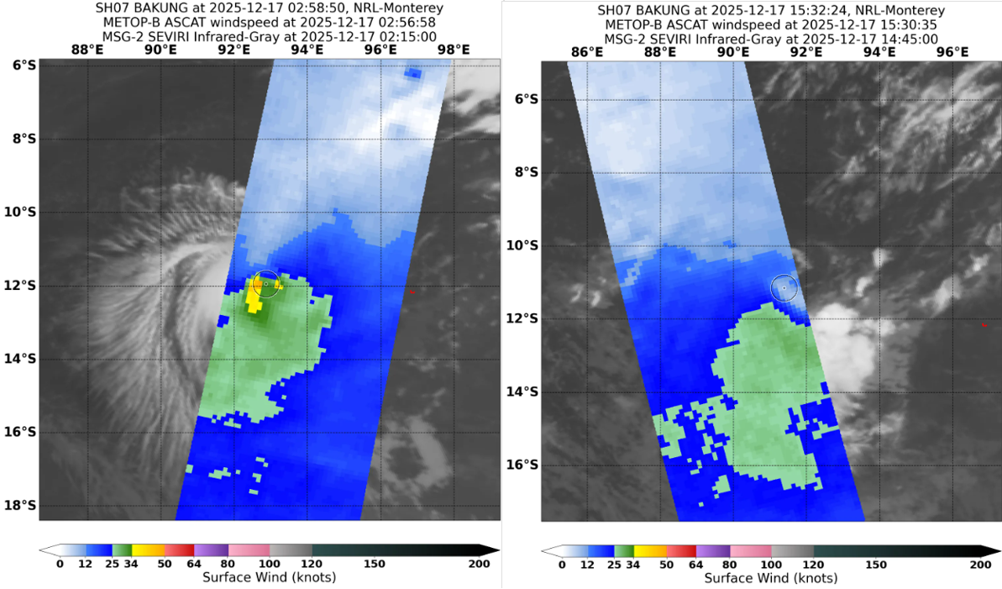
Figure 13. Scatterometry wind speeds from ASCAT-B on 17 December 2025 at 0257 UTC (left); and 1531 UTC (right). The first shows a small area of gales in yellow but the second does not show any gales at all. Images courtesy NRL: https://science.nrlmry.navy.mil/geoips/tcweb/

- Impact
Bakung had no impact to Cocos (Keeling) Islands.

- Observations
Bakung did not pass near any observing sites over its lifetime.

- Forecast Performance
Overall model guidance under-estimated the potential for Bakung to develop. The first 7-day forecast was issued on 6 December when the potential for 05U to develop into a tropical cyclone was assessed as low (5-20%) from 12 December as shown in the matrix in Figure 14. Although forecast ratings increased to moderate (20-50%) for 13 December, ratings for 12 December, the actual day that Bakung developed, did not rise beyond low until 12 December.
Track maps officially commenced at 1200 UTC 12 December when Bakung was named by BMKG Indonesia and continued until the system weakened below gale-force intensity at 0600 UTC 18 December. There were no Tropical Cyclone Advices issued during Bakung.
The accuracy statistics for Severe Tropical Cyclone Bakung are below in Table 2 and shown in Figures 15 and 16. The lead time of 120 hours has been excluded from the plot given the low sample size.
Forecast track position accuracy was slightly worse than the five-year average at all time steps (see Figure 15). This reflects the erratic nature of the track and particularly the sharp turns that Bakung made on 14 and 16 December.
Intensity forecasts in Figure 16 were poorer than the 5-year average for the first 24 hours then better at longer lead times. Note that the sample size decreases after +24h. The rapid changes in intensity, especially around the two intensity peaks (Figure 17) presented significant forecasting challenges.

Time | 00 | 06 | 12 | 18 | 24 | 36 | 48 | 72 | 96 | 120
Position accuracy (km) | 20 | 53 | 73 | 88 | 102 | 122 | 158 | 251 | 311 | 292
Intensity accuracy (knots) | 7.5 | 9.1 | 10.5 | 12.6 | 12.5 | 10.0 | 6.3 | 7.9 | 10.6 | 1.3
Sample Size | 22 | 22 | 22 | 21 | 20 | 18 | 16 | 12 | 8 | 4
Table 2: Verification statistics for Severe Tropical Cyclone Bakung. Note: Verification is performed using the Official Forecast Tracks at the standard times of 00, 06, 12 and 18 UTC.

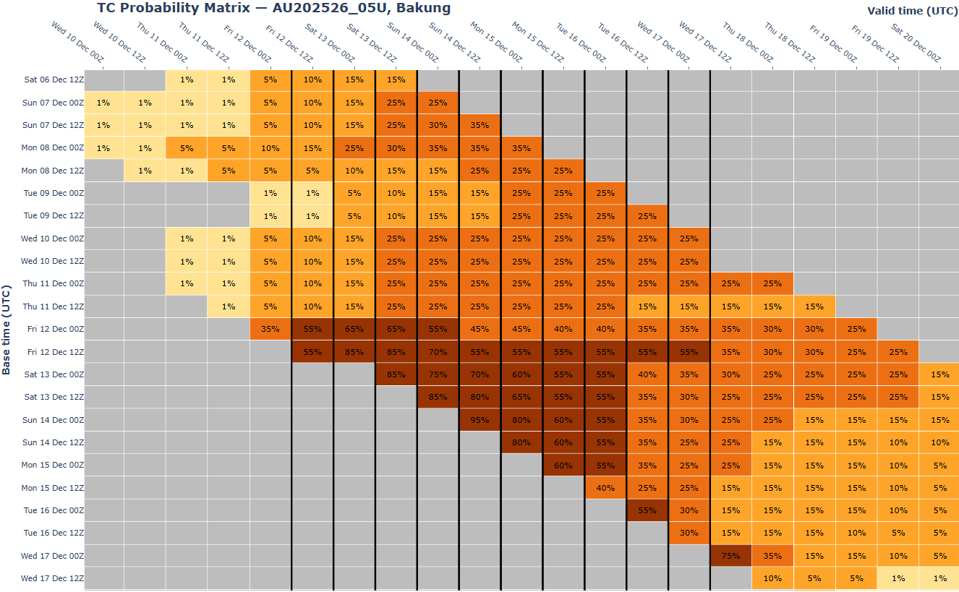Figure 14. The forecast percentage risk of a low developing into a tropical cyclone taken from the 7-day forecast for Bakung from 12 to 17 December. The forecast base time is shown on the horizontal axis and the forecast validity time is shown on the vertical axis. The box colours correspond to the tropical cyclone forecast rating, yellow for Very Low (<5%), light orange for Low (5-15%), orange for Moderate (20-45%) and brown for High (50-100%).
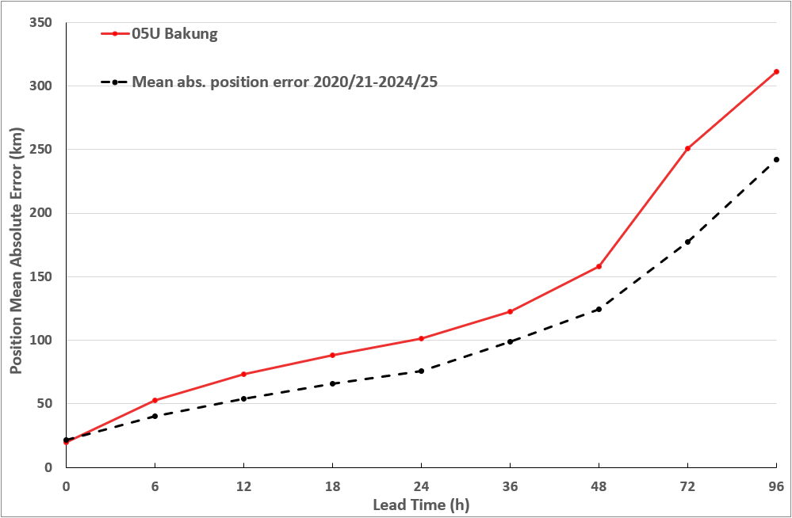
Figure 15. Position accuracy figures for Severe Tropical Cyclone Bakung compared against the 5-year average.
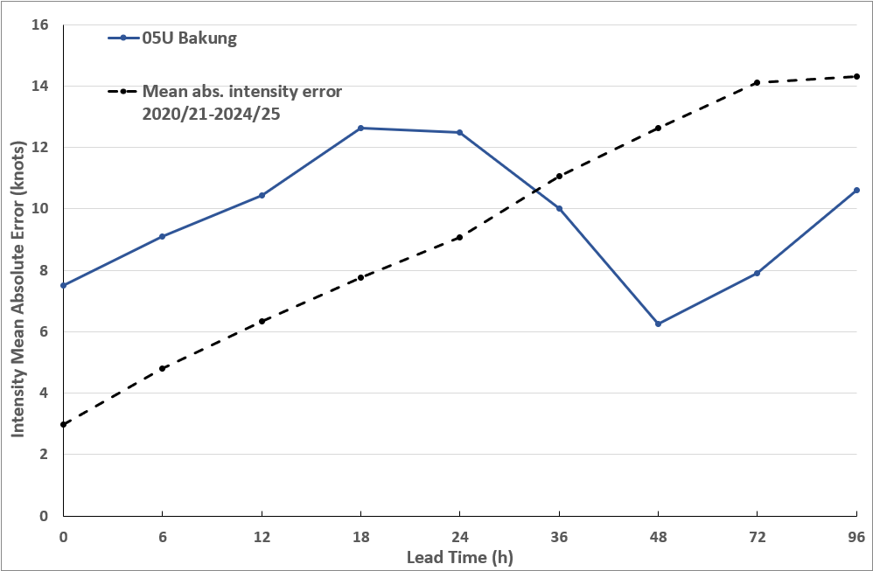
Figure 16. Intensity accuracy figures for Severe Tropical Cyclone Bakung compared against the 5-year average.

Appendix: List of abbreviations
Abbreviation | Term
ADT | Advanced Dvorak Technique
ACST | Australian Central Standard Time
AEST | Australian Eastern Standard Time
AiDT | AI-enhanced Dvorak Technique
AMSR2 | Advanced Microwave Scanning Radiometer
AMSU | Advanced Microwave Sounding Unit
ASCAT | Advanced Scatterometer
ATMS | Advanced Technology Microwave Sounder
AWS | automatic weather station
AWST | Australian Western Standard Time
°C | Celsius
CI | Current intensity
CIMSS | Cooperative Institute for Meteorological Satellite Studies (USA)
CIRA | Cooperative Institute for Research in the Atmosphere (USA)
D-MINT | Deep learning - Multispectral Intensity of TCs (formerly known as DMN)
D-PRINT | Deep learning - IR Intensity of TCs (formerly known as OPEN-AIIR)
DT | Data T-number
EIR | Enhanced InfraRed
ERC | eyewall replacement cycle
FNMOC | Fleet Numerical Meteorology and Oceanography Centre (USA)
FT | Final T-number
GCOM | Global Change Observation Mission
GHz | Gigahertz
GMI | Global Precipitation Measurement Microwave Imager
h | hour
hPa | hectopascal
HSCAT | Hai Yang 2 Scatterometer (HY-2B, HY-2C)
km | kilometres
km/h | kilometres per hour
kn | knot
LLCC | LLCC
MET | Model Expected T-number
METOP | Meteorological Operational Satellite
MJO | Madden-Julian Oscillation
mm | millimetres
MSLP | mean sea level pressure
NESDIS | National Environmental Satellite, Data, and Information Service
nm | nautical mile
NOAA | National Oceanic and Atmospheric Administration
NRL | Navy Research Lab (USA)
OPEN-AiiR | Ordered Pattern Encoding AI Infrared
OSCAT | Ocean Scatteromoter
PAT | Pattern T-number
RCM | RadarSat Constellation Mission – Synthetic Aperture Radar
RH | relative humidity
RMW | radius of maximum winds
RSMC | Regional Specialised Meteorological Centre
SAR | Synthetic Aperture Radar
SATCON | Satellite Consensus
SEN1 | Sentinel-1A – Synthetic Aperture Radar
SMAP | Soil Moisture Active Passive
SMOS | Soil Moisture and Ocean Salinity
SSMIS | Special Sensor Microwave Imager/Sounder
TC | Tropical Cyclone
TCWC | Tropical Cyclone Warning Centre
UTC | Universal Time Co-ordinated

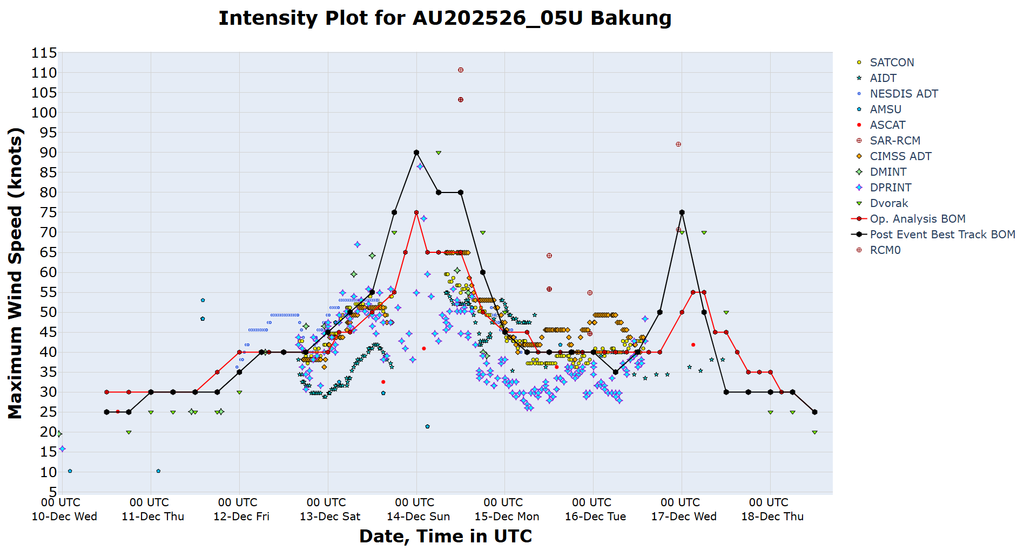
Figure 17. Intensity plot of objective and subjective guidance. SATCON, AiDT, NESDIS ADT, AMSU, ASCAT, SAR-RCM, CIMMS ADT, DMINT, DPRINT, Dvorak subjective estimate, operational analysis (red) and post event best track analysis (black).

