Severe Tropical Cyclone Jenna (11U)

3-8 January 2026

Tropical Cyclone Environmental Prediction Services
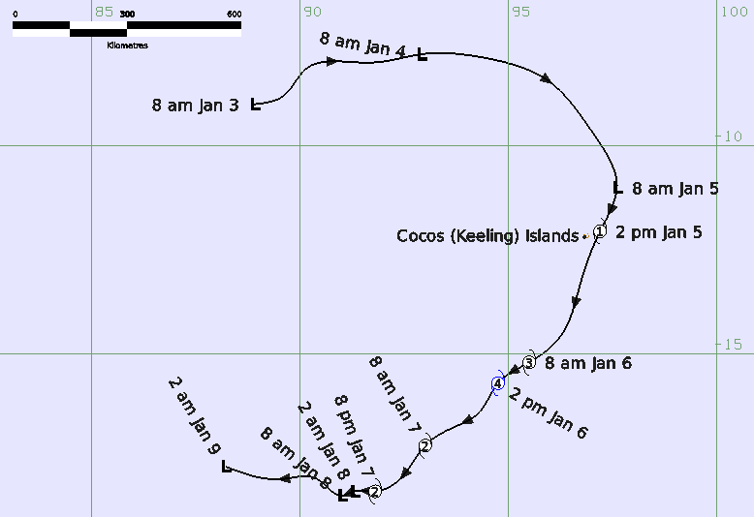

Revision history
Date | Version | Author | Description
5/2/2026 | 1.0 | EPS TC Team | Best track report

Review status
Date | Version | Reviewer | Description
18/2/25 | 1.0 | EPS TC Team | Reviewed Best Track Report

Release history
Date | Version | Status | Approval
24/2/2026 | 1.0 | Approved | Tropical Cyclone Team Lead

Contact details:
Tropical Cyclone Team Lead
Severe Weather Environmental Prediction Services
Bureau of Meteorology
PO Box 1370, West Perth WA 6872
Email: tcwc@bom.gov.au
This work is copyright. Apart from any use as permitted under the Copyright Act 1968, no part may be reproduced without prior written permission from the Bureau of Meteorology. Refer to www.bom.gov.au/other/copyright.shtml for further information. Unless otherwise noted, all images in this document are licensed under the Creative Commons Attribution Australia Licence.
© Commonwealth of Australia 2026
Published by The Bureau of Meteorology
Cover image: Best track of Severe Tropical Cyclone Jenna 3-8 January 2026.

Table of contents

1. Summary 4

2. Meteorological description 8

2.1. Intensity Analysis 8

2.2. Structure 16

2.3. Motion 18

3. Impact 19

4. Observations 19

4.1. Wind 19

4.2. Rainfall 19

4.3. Pressure 19

5. Forecast Performance 20

6. Appendix: List of Abbreviations 23

Figure 1 Best track of Severe Tropical Cyclone Jenna 3 – 9 January 2026, all times are in AWST (AWST=UTC+8 hours, CCT=AWST-1.5hours) 6
Figure 2 Detailed best track of Severe Tropical Cyclone Jenna between 0800 and 2000 AWST 5 January showing gale radii (shaded in pink) and storm radii (shaded in red) while it was close to the Cocos (Keeling) Islands. 7
Figure 3 Hovmoller diagram of tropical waves over the latitude range of 5-15S. The formation of the system is marked with a J and occurred during the passage of a Kelvin wave through the area of genesis. 10
Figure 4 ASCAT pass at 1441 3 January showing a weak trough structure with gales in the strong westerlies to the north of the system. 11
Figure 5 ASCAT pass at 1420 UTC 4 January 2026 showing a system with a more circular structure and gales in the northeast quadrant. 12
Figure 6 An SSMIS microwave pass at 2353 UTC 4 January 2026 showing improved deep convective bands around the low level centre. 13
Figure 7 AMSR2 microwave pass at 0709 UTC 6 January 2026 showing Jenna at peak intensity of 90 kn (165 km/h). 14
Figure 8 A SSMIS microwave pass at 2332 UTC 6 January showing Jenna had lost much of its deep, cold convection some twelve to eighteen hours after reaching peak intensity. 15
Figure 9 A synthetic aperture radar pass at 2309 UTC 6 January 2026 showing the strongest winds in the southeast to northwest quadrants as the system weakened. 16
Figure 10 A GMI microwave pass at 1839 UTC 7 January 2026 showing Jenna had lost all deep, cold convection around the low-level centre. 17
Figure 11 An ASCAT pass at 0243 UTC 8 January 2026 showing gales present in the southeasterly flow to the southwest of the low-level centre. 19
Figure 12 The forecast percentage risk of a low developing into a tropical cyclone taken from the 7-day forecast for 11U, forecast base time is shown on the vertical axis and the forecast validity time is shown on the horizontal axis. 21
Figure 13 Position accuracy figures for Severe Tropical Cyclone Jenna plotted against the 5-year average. 22
Figure 14 Intensity accuracy figures for Severe Tropical Cyclone Jenna plotted against the 5-year average. 23

Table 1 Best track summary for Severe Tropical Cyclone Jenna, 3-8 January 2026. 7
Table 2 Pressure observations recorded during Severe Tropical Cyclone Jenna. 20
Table 3 Verification statistics for Severe Tropical Cyclone Jenna. Note: 22

- Summary
Severe Tropical Cyclone Jenna was small but intense system in the Indian Ocean that passed just to east of the Cocos (Keeling) Islands bringing a period of strong winds and heavy rainfall to the islands.
A low formed on 3 January in an active burst of westerly winds to the northwest of the Cocos (Keeling) Islands. The low was steered rapidly to the east on 4 January, then during 5 January the low turned south and passed very close to the Cocos (Keeling) Islands as it developed into a tropical cyclone. The islands experienced a period of strong winds and heavy rainfall as Jenna passed close by.
As Jenna moved away from the Cocos (Keeling) Islands it rapidly intensified in a favourable environment and reached a maximum 10- minute mean wind speed of 90 kn (165 km/h) between 0600-1200 UTC 6 January (1400- 2000 AWST 6 January where AWST=UTC+8 hours). Dry air and shear caused the system to weaken rapidly, and Jenna decreased below tropical cyclone strength at 1800 UTC 7 January. The circulation then moved west out of the Australian region on 9 January and dissipated over the central Indian Ocean on 11 January.
Cocos Island AWS recorded a maximum wind gust of 49 kn (91 km/h) and the Cocos Island National Tidal Centre AWS recorded a maximum wind gust of 51 kn (94 km/h) during 5 January as Jenna passed very close to the islands. There was 70.2 mm of rain recorded to 9 am CCT 6 January.
Refer to Figure 1 for the full track of Severe Tropical Cyclone Jenna and Figure 2 for an enlarged track showing the detail of gale radii as it passed near the Cocos (Keeling) Islands.
Figure 1 Best track of Severe Tropical Cyclone Jenna 3 – 9 January 2026, all times are in AWST (AWST=UTC+8 hours, CCT=AWST-1.5 hours)
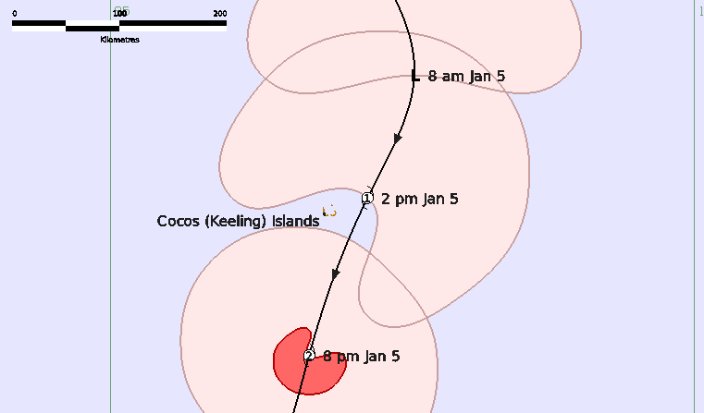
Figure 2 Detailed best track of Severe Tropical Cyclone Jenna between 0800 and 2000 AWST 5 January showing gale radii (shaded in pink) and storm radii (shaded in red) while it was close to the Cocos (Keeling) Islands. All times are in UTC.

Year | Month | Day | Hour UTC | Pos. Lat S | Pos. Long. E | Pos. Acc. Nm | Mean wind kn | Max. gust kn | Cent. Press hPa | Rad of gales (NE/SE/SW/NW) nm | Rad of storm (NE/SE/SW/NW) nm | RMW nm
2026 | 1 | 3 | 0000 | 9.0 | 88.9 | 50 | 25 | 45 | 1002 | 0/0/0/0 | 0/0/0/0 | -
2026 | 1 | 3 | 0600 | 8.8 | 89.6 | 50 | 30 | 45 | 1002 | 0/0/0/0 | 0/0/0/0 | -
2026 | 1 | 3 | 1200 | 8.2 | 90.1 | 30 | 35* | 50 | 1001 | 90/0/0/100 | 0/0/0/0 | -
2026 | 1 | 3 | 1800 | 8.0 | 91.7 | 30 | 40* | 55 | 998 | 80/0/0/90 | 0/0/0/0 | -
2026 | 1 | 4 | 0000 | 7.8 | 92.9 | 20 | 35* | 50 | 998 | 80/0/0/90 | 0/0/0/0 | -
2026 | 1 | 4 | 0600 | 7.9 | 94.5 | 15 | 35* | 50 | 1000 | 70/0/0/100 | 0/0/0/0 | -
2026 | 1 | 4 | 1200 | 8.4 | 95.9 | 15 | 35* | 50 | 1000 | 85/0/0/0 | 0/0/0/0 | -
2026 | 1 | 4 | 1800 | 9.7 | 97.0 | 15 | 35* | 50 | 1002 | 85/0/0/0 | 0/0/0/0 | -
2026 | 1 | 5 | 0000 | 11.0 | 97.6 | 20 | 40* | 55 | 998 | 90/0/0/90 | 0/0/0/0 | -
2026 | 1 | 5 | 0600 | 12.1 | 97.2 | 20 | 45 | 65 | 992 | 90/70/0/80 | 0/0/0/0 | 20
2026 | 1 | 5 | 1200 | 13.4 | 96.7 | 15 | 50 | 70 | 990 | 60/70/60/70 | 0/20/20/15 | 15
2026 | 1 | 5 | 1800 | 14.5 | 96.3 | 20 | 60 | 85 | 991 | 70/90/80/50 | 15/25/25/15 | 12
2026 | 1 | 6 | 0000 | 15.2 | 95.5 | 20 | 70 | 100 | 990 | 90/100/90/60 | 25/30/25/20 | 12
2026 | 1 | 6 | 0600 | 15.7 | 94.7 | 10 | 90 | 125 | 973 | 70/100/80/65 | 25/50/35/30 | 10
2026 | 1 | 6 | 1200 | 16.4 | 94.3 | 10 | 90 | 125 | 967 | 70/110/100/70 | 30/40/40/45 | 10
2026 | 1 | 6 | 1800 | 16.8 | 93.6 | 25 | 70 | 100 | 975 | 60/110/100/50 | 25/50/40/25 | 12
2026 | 1 | 7 | 0000 | 17.2 | 93.0 | 20 | 60 | 85 | 979 | 60/110/100/50 | 25/50/50/40 | 15
2026 | 1 | 7 | 0600 | 18.0 | 92.4 | 20 | 55 | 75 | 989 | 50/140/140/50 | 0/60/50/0 | 20
2026 | 1 | 7 | 1200 | 18.3 | 91.8 | 15 | 50 | 70 | 990 | 60/160/140/50 | 0/80/60/0 | 25
2026 | 1 | 7 | 1800 | 18.3 | 91.3 | 20 | 40* | 55 | 997 | 0/170/140/0 | 0/0/0/0 | -
2026 | 1 | 8 | 0000 | 18.4 | 91.0 | 10 | 35* | 50 | 997 | 0/170/140/0 | 0/0/0/0 | -
2026 | 1 | 8 | 0600 | 18.0 | 90.4 | 10 | 30 | 45 | 999 | 0/0/0/0 | 0/0/0/0 | -
2026 | 1 | 8 | 1200 | 18.0 | 89.6 | 15 | 30 | 45 | 1003 | 0/0/0/0 | 0/0/0/0 | -
2026 | 1 | 8 | 1800 | 17.7 | 88.2 | 15 | 30 | 45 | 1004 | 0/0/0/0 | 0/0/0/0 | -
Table 1 Best track summary for Severe Tropical Cyclone Jenna, 3-8 January 2026. UTC=AWST-8h.
* Not a tropical cyclone as gales less than halfway around centre

- Meteorological description
  - Intensity Analysis
A westwards moving Kelvin wave caused an enhanced burst of westerly winds in the central Indian Ocean which caused a low to form to the northwest of the Cocos (Keeling) Islands (refer Figure 3). Initially the low had an elongated structure with some gales present in the strong westerlies to the north of the system (refer Figure 4). During 4 January convection was located mostly on the western side of 11U with an exposed low-level centre visible on satellite imagery. Microwave imagery showed deep cold convection well separated from the low. A 1420 UTC ASCAT pass (refer Figure 5) showed a low that appeared more circular in structure with gales present in the northeast quadrant. It is possible that through 3 and 4 January the gales appear to be more associated with the strong monsoon to the north of the system rather than with the low itself.
From late on 4 January the structure of Jenna improved, the convective bands spiralling around the centre increased (refer Figure 6) and an early morning SMAP pass at 2317 UTC 4 January indicated gales were developing around the system. Jenna reached tropical cyclone intensity at 0600 UTC 5 January while it was located close to the Cocos (Keeling) Islands. The cyclone was in a favourable environment of warm sea surface temperatures, good moisture, strong upper divergence and moderate vertical wind shear which resulted in the system undergoing rapid intensification. At 0600 UTC 5 January the intensity of Jenna was estimated at 45 kn and by 0600 UTC 6 January the intensity was estimated at 90 kn, an increase of 45 kn over 24 hours. Through the overnight period on 5 January the satellite imagery showed the spiral banding wrapping in tightly and by 0000 UTC 6 January the Dvorak DT number had increased to 4.0. A SSMIS pass at 2103 UTC 5 January (refer Figure 7) showed deep convection wrapping closely around the centre. The morning visible imagery on 6 January revealed an emerging eye and the subsequent EIR imagery between 0000 - 1200 UTC 6 January showed an eye pattern with the central eye temperature varying from off white to light grey. At times the eye appeared clearer on visible imagery than EIR due to an obscuring layer of cirrus, the cirrus likely contributed to the fluctuations in the central eye temperatures on the EIR imagery during this period. Subjective Dvorak DT reached 5.5 at several single time steps between 0300 – 0800 UTC 6 January but the three-hour average peaked at 5.0 at 0600 and 1200 UTC which equates to an intensity in the range of 80 to 85 kn (150-155 km/h). The objective guidance (refer Figure 16 at end of document) ranged from 80-95 kn, SATCON reached a peak of about 90-95 kn between 0600 and 1200 UTC. Using the objective and subjective intensity estimates, Jenna was determined to have reached a 10-minute mean wind peak intensity of 90 kn (165 km/h) between 0600 and 1200 UTC 6 January and Figure 8, a microwave pass at 0709 UTC 6 January, shows a near complete eye wall structure.
From 1200 UTC 6 January Jenna began to weaken as dry air wrapped around the system and was ingested into the core, the weakening was accelerated by Jenna moving over cooler sea surface temperatures. By 0000 UTC 7 January microwave imagery (refer Figure 9) showed the northern eye wall had eroded completely with deep convection confined to the southern side of the system. A 2309 UTC 6 January SAR pass showed a small system with the strongest winds extending from the southeast quadrant around to the northwest quadrant and considerably larger southern gale radii than northern radii (refer Figure 10).
During 7 January a mid-level trough in the central Indian Ocean increased the northwest vertical wind shear, this enhanced the ingestion of dry air and removed the upper circulation from Jenna. Visible imagery during the day showed deep convection on the southern side of the low-level centre and overnight the EIR imagery showed warming cloud top temperatures. A GMI image at 1839 UTC 7 January (refer Figure 11) showed a system completely devoid of any cold convection and with gales only in southern quadrants Jenna was deemed to have weakened below tropical cyclone strength by this time. An 0243 UTC 8 January ASCAT pass showed a swathe of gales in the southeasterlies at a distance from the weak centre. The remnant weak circulation continued to be steered northwest and crossed into La Reunion's area of responsibility, eventually dissipating in the central Indian Ocean during 11 January.
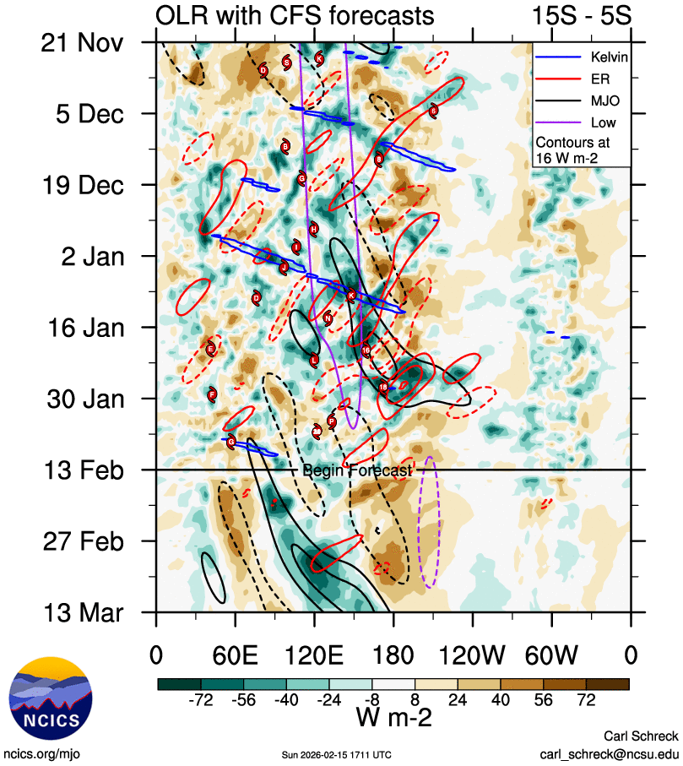
Figure 3 Hovmoller diagram of tropical waves over the latitude range of 5-15S. The formation of Jenna is marked with a J and occurred during the passage of a Kelvin wave through the area of genesis. Image courtesy of the North Carolina Institute for Climate Studies: Tropical Monitoring :: North Carolina Institute for Climate Studies

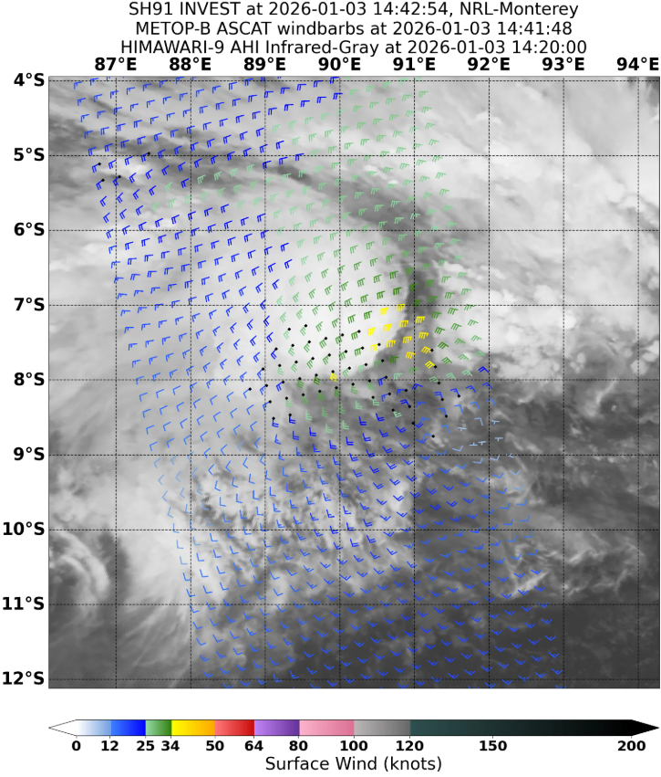
Figure 4 ASCAT pass at 1441 UTC 3 January showing a weak trough structure with gales in the strong westerlies to the north of the system. Image courtesy NRL: https://www.nrlmry.navy.mil/TC.html
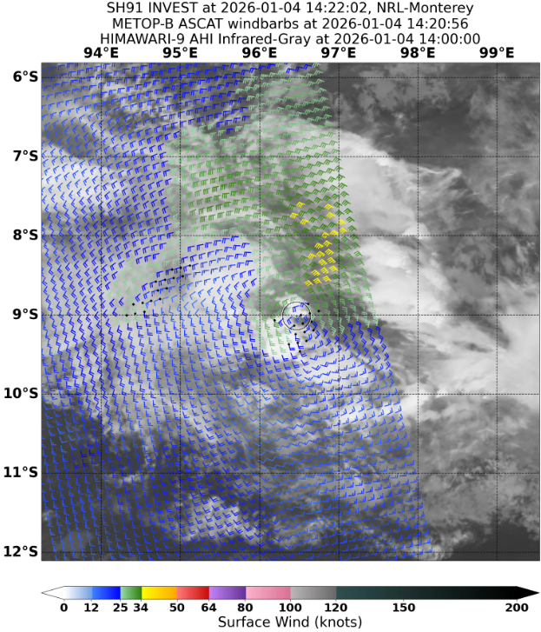
Figure 5 ASCAT pass at 1420 UTC 4 January 2026 showing a system with a more circular structure and gales in the northeast quadrant. Image courtesy NRL: https://www.nrlmry.navy.mil/TC.html

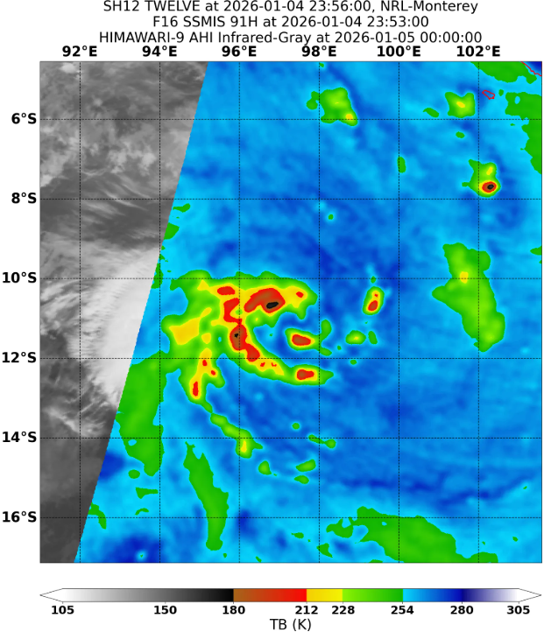
Figure 6 An SSMIS microwave pass at 2353 UTC 4 January 2026 showing improved deep convective bands around the low-level centre. Image courtesy NRL: https://www.nrlmry.navy.mil/TC.html
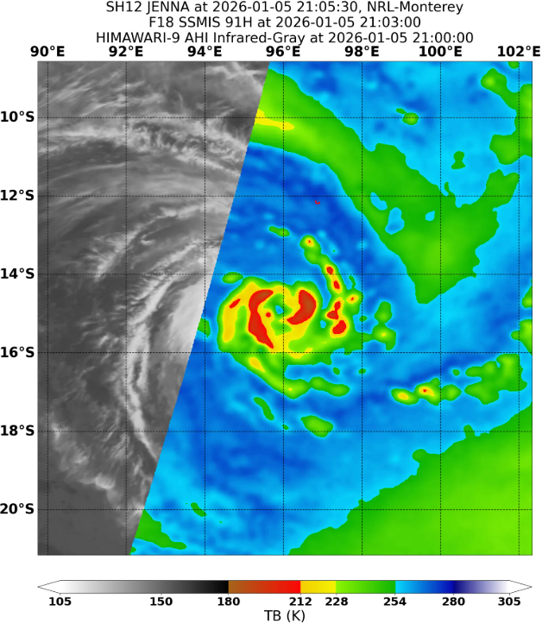
Figure 7 An SSMIS microwave pass at 2103 UTC 5 January showing deep convection wrapped tightly around the centre of Jenna. Image courtesy NRL: https://www.nrlmry.navy.mil/TC.html

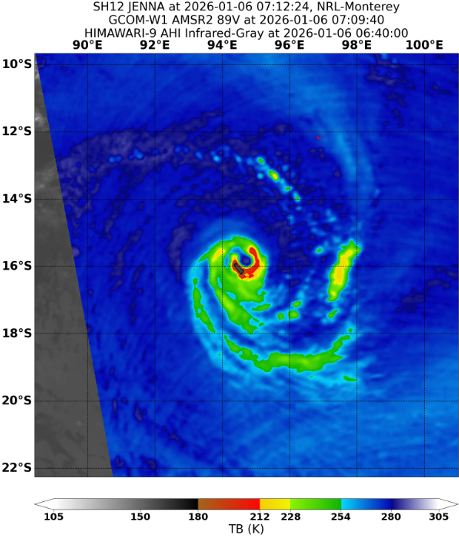
Figure 8 AMSR2 microwave pass at 0709 UTC 6 January 2026 showing Jenna at peak intensity of 90 kn (165 km/h). Image courtesy NRL: https://www.nrlmry.navy.mil/TC.html
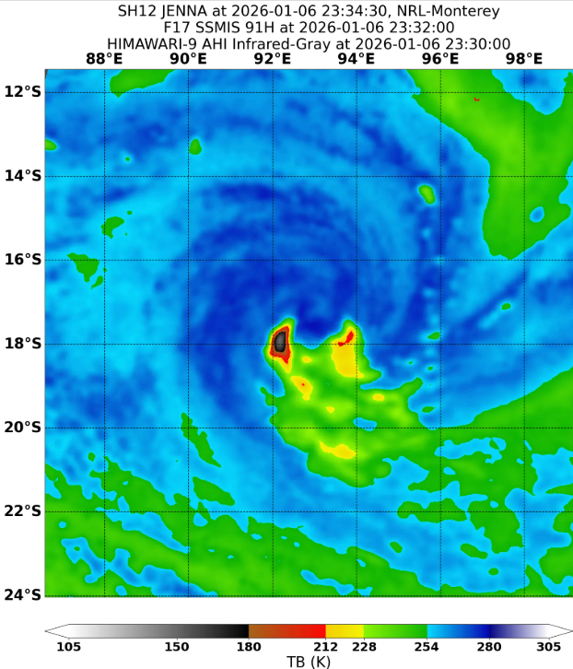
Figure 9 A SSMIS microwave pass at 2332 UTC 6 January showing Jenna had lost much of its deep, cold convection some twelve to eighteen hours after reaching peak intensity. Image courtesy NRL: https://www.nrlmry.navy.mil/TC.html
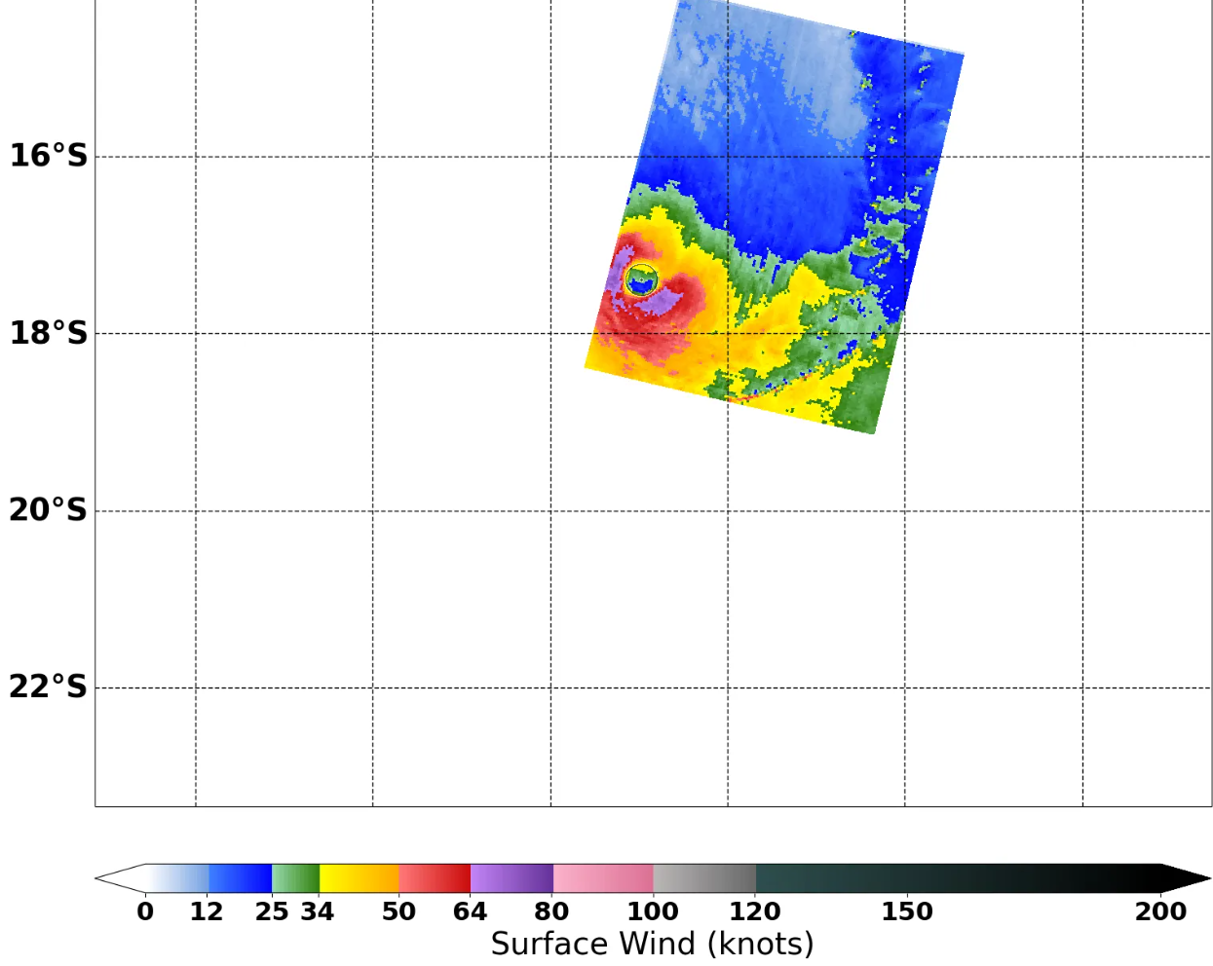
Figure 10 A synthetic aperture radar pass at 2309 UTC 6 January 2026 showing the strongest winds in the southeast to northwest quadrants as the system weakened. Image courtesy NRL: https://www.nrlmry.navy.mil/TC.html

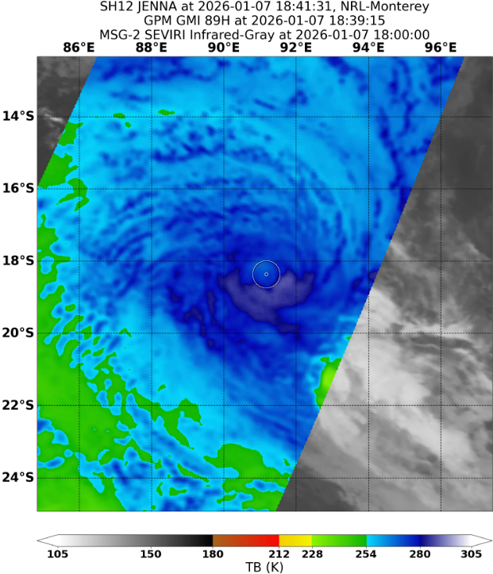
Figure 11 A GMI microwave pass at 1839 UTC 7 January 2026 showing Jenna had lost all deep, cold convection around the low-level centre. Image courtesy NRL: https://www.nrlmry.navy.mil/TC.html
  - Structure
Initially Jenna had gales associated with the strong northerly winds with radii of about 100 nm (185 km) (refer Figure 4). As the system intensified the gale radii contracted to be 90nm (167 km) or smaller with the northern quadrants remaining the larger quadrants. As Jenna neared peak intensity on 6 January the southern gale radii began to extend to 100-110 nm (185-205 km) and the northern radii contracted to be around 65-70 nm (120-130 km). The southern gale radii continued to increase to about 140-170 nm (260-315 km) as Jenna weakened and the gales became gradually more synoptic in nature (refer Figure 12).
The storm radii increased from an initial distance of 15-20nm (30-35 km) to 50-60 nm (95-110 km) in southern quadrants with hurricane radii ranging from 15-30 nm (30-55 km).
The radius to maximum winds decreased from 20 nm (35 km) initially to as small as 10nm (20 km) when Jenna reached peak intensity.
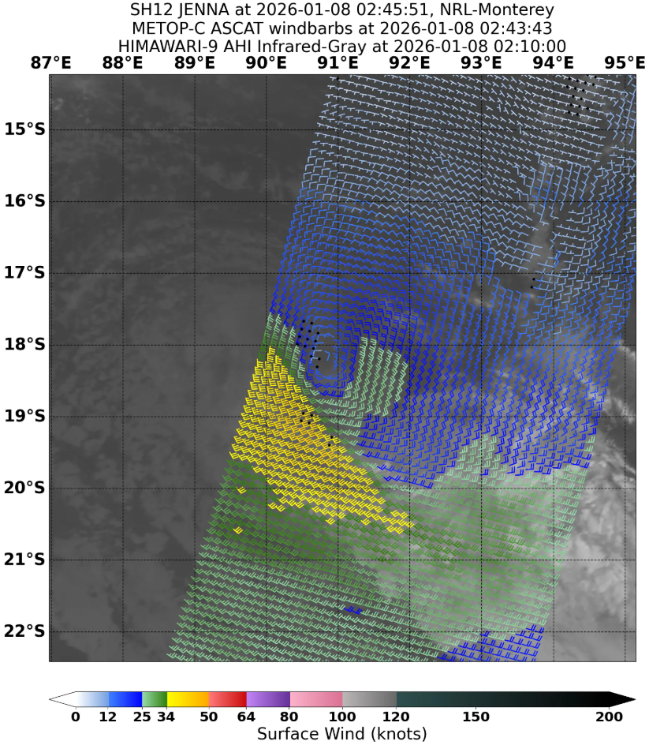
Figure 12 An ASCAT pass at 0243 UTC 8 January 2026 showing gales present in the southeasterly flow to the southwest of the low-level centre. Image courtesy NRL: https://www.nrlmry.navy.mil/TC.html
  - Motion
Initially Jenna was steered to the east by the strong westerly flow north of the developing system. During 4 and 5 January a mid-level trough split the sub-tropical ridge located south of the system and Jenna moved in a generally southerly direction through the col area of the ridge. By 6 January Jenna rounded the flank of the western ridge and began to move to the southwest. During 7 January a second mid-level trough in the Indian Ocean amplified to the south of Jenna and assisted in the destruction of the cyclonic circulation. The upper vorticity was sheared off and steered to the southeast, the remaining low-level centre was then steered to the northwest by the lower level southeasterlies.
- Impact
Following Tropical Cyclone Grant on Christmas Day, Jenna was the second cyclone to impact the Cocos (Keeling) Islands in two weeks. The islands reported only minor damage with fallen trees, water ingress into buildings and minor flooding.
- Observations
  - Wind
Cocos Island Airport AWS reported gale force winds between 0746 – 0748 and 0756-0803 UTC 5 January.
Maximum 10-minute mean wind recorded was 35 kn (65 km/h) at 0801 UTC 5 January.
The maximum 3-second wind gust recorded was 49 kn (91 km/h) at 0757 UTC 5 January.
Cocos Island National Tidal Centre AWS reported gale force winds between 0729 -1043 UTC 5 January.
Maximum 10-minute mean wind recorded was 41 kn (76 km/h) at 0809 and 0810 UTC 5 January.
The maximum 3-second wind gust recorded was 51 kn (94 km/h) at 0733 UTC 5 January.

  - Rainfall
Cocos Island Airport recorded 70.2 mm of rainfall in the 24 hours to 9 am CCT 6 January.
  - Pressure
Location | Pressure hPa | Time UTC
Cocos Island Airport | 992.9 hPa | 0607 5 January
Cocos Island National Tidal Centre | 992.1 hPa | 0600-0605, 0607 UTC 5 January
Table 2 Pressure observations recorded during Severe Tropical Cyclone Jenna.

- Forecast Performance
The initial 7-Day forecast was issued on 29 December 2025. It indicated that the likelihood of 11U developing into a tropical cyclone increased from Very Low (1%) on 2 January to Low (15%) by 4 January. The forecast risk continued to rise gradually, but a high (55-60%) risk was not indicated until 3 January. This period of high likelihood was mainly focussed on 6 and 7 January, while the rating for 5 January did not reach the high category until after Jenna had formed. Jenna was a tropical cyclone between 5-7 January which is marked by the thick black boxes on the rating matrix in Figure 13.
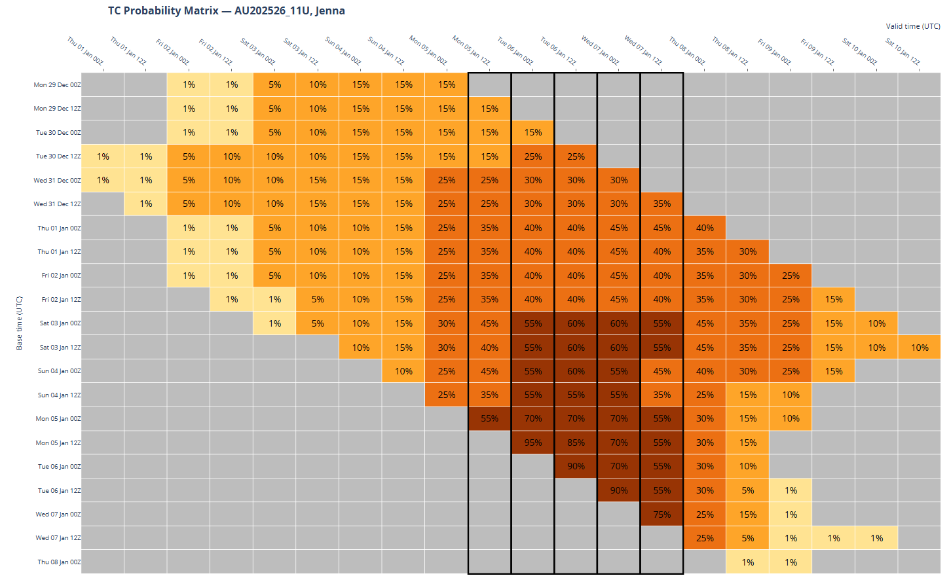
Figure 13 The forecast percentage risk of a low developing into a tropical cyclone taken from the 7-day forecast for 11U, forecast base time is shown on the horizontal axis and the forecast validity time is shown on the vertical axis. The box colours correspond to the tropical cyclone forecast rating, yellow for Very Low, light orange for Low, orange for Moderate and brown for High.
The first track map, Advice for the Cocos Islands and Technical Bulletin were issued at 0600 UTC 3 January. The first Ocean Wind Warning was issued at 0000 UTC 4 January.
The accuracy statistics for Severe Tropical Cyclone Jenna are below in Table 3 Verification statistics for Severe Tropical Cyclone Jenna. Note: Verification is performed using the Official Forecast Tracks at the standard times of 00, 06, 12 and 18 UTC. and shown in Figure 14 (track) and Figure 15 (intensity).
Forecast track accuracy was on par with the 5-year average position error up to 72 hours, at 96 and 120 hours the forecast accuracy was better than the long-term average. The intensity accuracy was slightly poorer than the long-term average up to 24 hours, from 36 hours the forecast accuracy was better. The sample size for the 120-hour verification metrics was 3 which is considered too small to be reliable, this was omitted from the table and plots. The 96-hour metrics have been included with the caveat that a sample size of 7 is also considered too small to be reliable.

Time | 00 | 06 | 12 | 18 | 24 | 36 | 48 | 72 | 96
Position accuracy (km) | 20 | 38 | 50 | 60 | 75 | 104 | 129 | 198 | 192
Intensity accuracy (knots) | 4.8 | 6.0 | 7.6 | 8.0 | 8.4 | 10.0 | 12.0 | 12.7 | 2.9
Sample size | 21 | 21 | 21 | 20 | 19 | 17 | 15 | 11 | 7
Table 3 Verification statistics for Severe Tropical Cyclone Jenna. Note: Verification is performed using the Official Forecast Tracks at the standard times of 00, 06, 12 and 18 UTC.
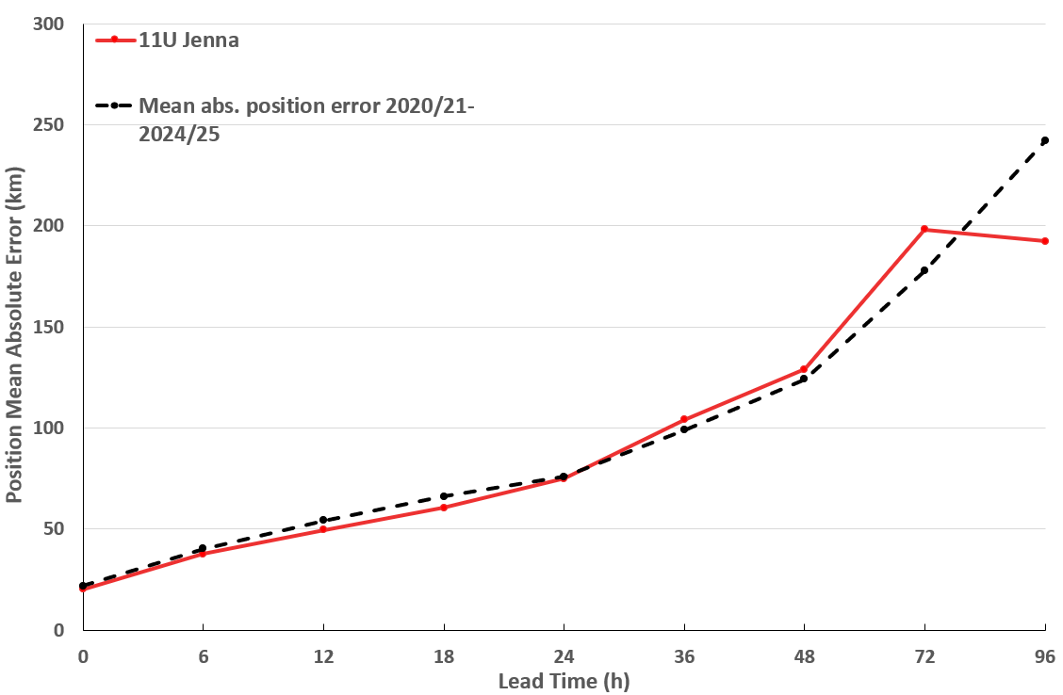
Figure 14 Position accuracy figures for Severe Tropical Cyclone Jenna plotted against the 5-year average.

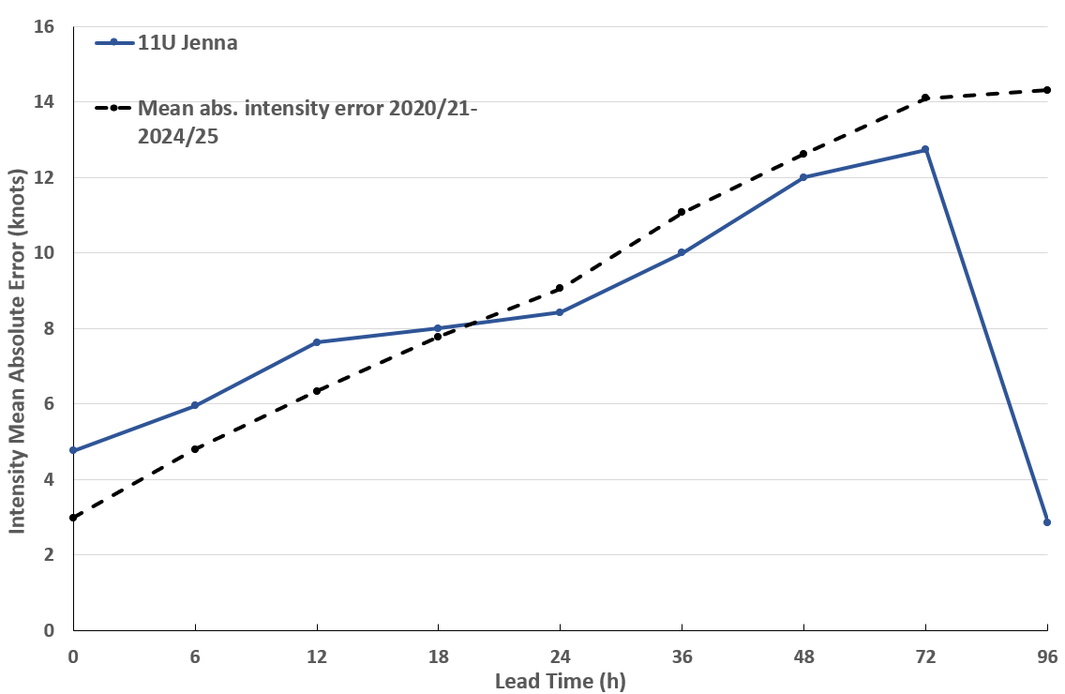
Figure 15 Intensity accuracy figures for Severe Tropical Cyclone Jenna plotted against the 5-year average.

- Appendix: List of Abbreviations
Abbreviation | Term
ADT | Advanced Dvorak Technique
ACST | Australian Central Standard Time
AEST | Australian Eastern Standard Time
AiDT | AI-enhanced Dvorak Technique
AMSR2 | Advanced Microwave Scanning Radiometer
AMSU | Advanced Microwave Sounding Unit
ASCAT | Advanced Scatterometer
ATMS | Advanced Technology Microwave Sounder
AWS | automatic weather station
AWST | Australian Western Standard Time
°C | Celsius
CCT | Cocos (Keeling) Islands Time
CI | Current intensity
CIMSS | Cooperative Institute for Meteorological Satellite Studies (USA)
CIRA | Cooperative Institute for Research in the Atmosphere (USA)
D-MINT | Deep learning - Multispectral Intensity of TCs (formerly known as DMN)
D-PRINT | Deep learning - IR Intensity of TCs (formerly known as OPEN-AIIR)
EIR | Enhanced InfraRed
ERC | eyewall replacement cycle
FNMOC | Fleet Numerical Meteorology and Oceanography Centre (USA)
FT | Final T-number
GCOM | Global Change Observation Mission
GHz | Gigahertz
GMI | Global Precipitation Measurement Microwave Imager
h | hour
hPa | hectopascal
HSCAT | Hai Yang 2 Scatterometer (HY-2B, HY-2C)
km | kilometres
km/h | kilometres per hour
kn | knot
LLCC | Low-Level Cloud Centre
MET | Model Expected T-number
METOP | Meteorological Operational Satellite
MJO | Madden-Julian Oscillation
mm | millimetres
MSLP | mean sea level pressure
NESDIS | National Environmental Satellite, Data, and Information Service
nm | nautical mile
NOAA | National Oceanic and Atmospheric Administration
NRL | U.S. Naval Research Laboratory
OPEN-AiiR | Ordered Pattern Encoding AI Infrared
PAT | Pattern T-number
RCM | RadarSat Constellation Mission – Synthetic Aperture Radar
RH | relative humidity
RMW | radius of maximum winds
RSMC | Regional Specialised Meteorological Centre
SAR | Synthetic Aperture Radar
SATC | CIMSS Advanced Dvorak Technique
SATCON | Satellite Consensus
SEN1 | Sentinel-1A – Synthetic Aperture Radar
SMAP | Soil Moisture Active Passive
SMOS | Soil Moisture and Ocean Salinity
SSMIS | Special Sensor Microwave Imager/Sounder
TC | Tropical Cyclone
TCWC | Tropical Cyclone Warning Centre
UTC | Universal Time Co-ordinated

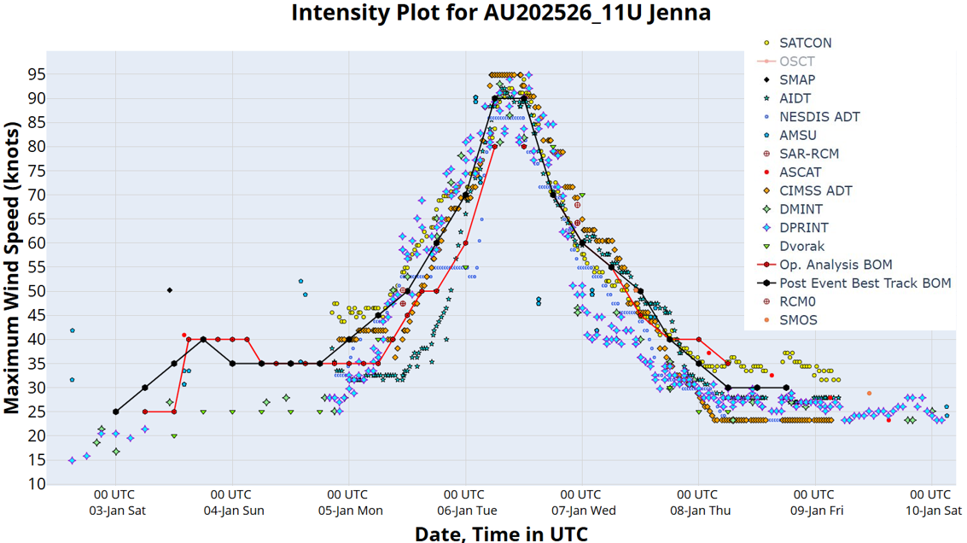
Figure 16 Intensity plot of objective and subjective guidance. SATCON, AiDT, NESDIS ADT, SAR-SEN1, SAR-RCM, ASCAT, CIMMS ADT, DMINT, DPRINT, Dvorak subjective estimate, operational analysis (red) and post event best track analysis (black). All wind speeds are 10-minute mean wind speeds.

