Severe Tropical Cyclone Dinah

23 January – 3 February 1967

Tropical Cyclone Environmental Prediction Services

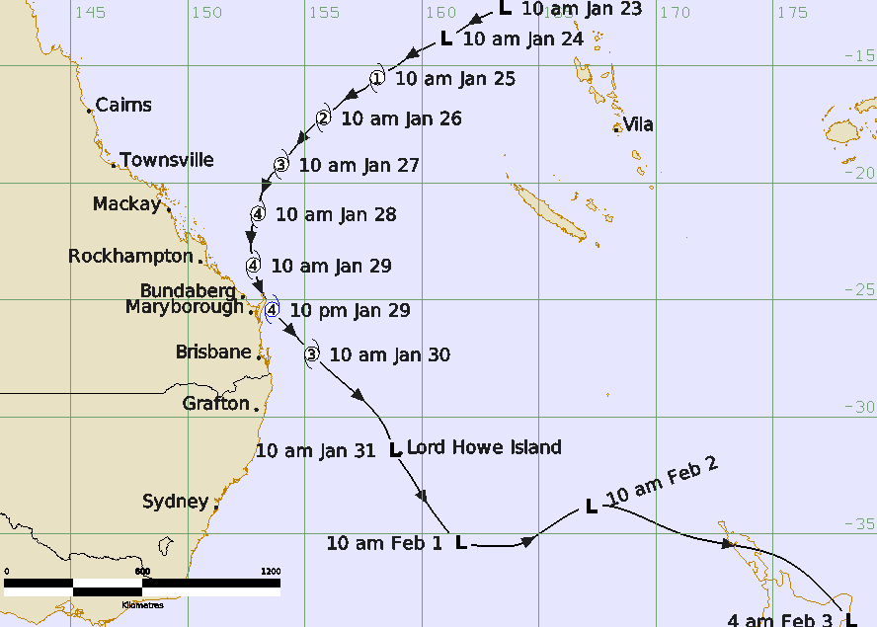

Revision history
Date | Version | Author | Description
12 October 2026 | 1.0 | Lead Meteorologist, TC-EPS | Final Draft

Review status
Date | Version | Reviewer | Description
19 October 2026 | 1.0 | Lead Meteorologist, TC-EPS | Complete

Release history
Date | Version | Status | Approval
19 October 2026 | 1.0 | Approved | Manager, TC-EPS


Contact details:
Tropical Cyclone Team Lead
Severe Weather Environmental Prediction Services
Bureau of Meteorology, PO Box 1370, West Perth WA 6872
Email: tcwc@bom.gov.au
This work is copyright. Apart from any use as permitted under the Copyright Act 1968, no part may be reproduced without prior written permission from the Bureau of Meteorology. Refer to www.bom.gov.au/other/copyright.shtml for further information. Unless otherwise noted, all images in this document are licensed under the Creative Commons Attribution Australia Licence.
© Commonwealth of Australia 2026
Published by The Bureau of Meteorology
Cover image: Track of Severe Tropical Cyclone Dinah 23 January to 3 February 1967. Times in AEST (UTC+10h).

Table of contents

1. Summary 4

2. Meteorological description 7

3. Impacts 15

3.1. Wind 15

3.2. Storm Tide and waves 15

3.3. Flooding 16

4. Observations 16

4.1. Wind 16

4.2. Pressure 16

4.3. Rainfall 17

5. References 20
List of Figures
Figure 1. Best track of Severe Tropical Cyclone Dinah, 23 January - 3 February 1967.. 7
Figure 2. Detailed track of Severe Tropical Cyclone Dinah off the southern Queensland coast on 28-30 January.. 8
Figure 3. MSLP analysis with surface winds overlaid 27-29 January 11
Figure 4. Visible satellite image, 2127 UTC 26 January 1967. 12
Figure 5. Satellite image at 2203 UTC 27 January 1967 when Dinah was nearing peak intensity. 13
Figure 6. Satellite image at 0134 UTC 29 January 1967. 14
Figure 7 Satellite image at 2329 UTC 29 January showing a ragged eye east of Brisbane. 15
Figure 8. Weekly rainfall to 31 January 1967. 18

List of Tables
Table 1. Track data for Severe Tropical Cyclone Dinah.. 7
Table 2. Selected rainfall totals 29-31 January during TC Dinah. 19

- Summary
Severe Tropical Cyclone Dinah is the strongest tropical cyclone to occur off the southern Queensland coast in recorded history. Fortuitously, it turned away from the coast as it reached K'Gari (Fraser Island) at category 4 intensity. Nevertheless, it impacted coastal areas from as far north as Yeppoon to the central New South Wales coast and then went on to impact Lord Howe Island and the North Island of New Zealand after transitioning into a mid-latitude low.
According to McAnerney et al. (2019) Dinah caused nominal losses of $34 million translating to $5.1 billion in normalised (2017) losses, the third largest insurance loss of all Australian natural disaster events on their 1966-2017 list behind the 1998 Sydney hailstorm and Tropical Cyclone Tracy (1974).
A tropical low developed in the Pacific Ocean on the 22-23 January and intensified as it moved southwest across the Coral Sea towards the Queensland coast. By 28 January it had turned towards the south, passing just east of Heron Island on the Great Barrier Reef on the morning of 29 January, and then to the south southeast as it passed over K'gari (Fraser Island) late on 29 January. Sandy Cape Lighthouse recorded a minimum pressure of 944.8 hPa indicating that Dinah was at category 4 intensity. This makes it the most intense tropical cyclone to ever be recorded this far south off the Queensland coast.
Dinah then turned to the southeast further away from the coast and passed near Lord Howe Island and then into the Tasman Sea as an extra-tropical low. Tourists on Lord Howe Island were left stranded. Dinah transitioned into an extra-tropical cyclone to cause torrential rainfall and gales across the North Island of New Zealand.
Although Dinah remained offshore, the rainbands caused heavy rainfall and severe winds damaging areas between Rockhampton and Grafton. Houses were unroofed at Bundaberg, Maryborough and along the Sunshine and Gold Coasts. Banana and cane crops were wiped out on the Tweed Coast and a severe wind gust overturned a car at Evans Head.
One man drowned in floodwaters in Grafton when his car was swept away. In New Zealand in Rotarua a man went missing in floodwaters and was presumed to have drowned.
Huge seas and storm surge caused severe beach erosion from as far north as Mackay south to the central coast of New South Wales including offshore islands such as Heron, Lady Elliott and at K'gari (Fraser Is). At the Sunshine coast a storm surge of about 2 m inundated low-lying areas including cane farms at Bli Bli and around Noosa.
More than 100 houses were flooded around Moreton Bay especially around Sandgate and Nudgee Beach. On the Gold Coast water lapped the decking of the Jubilee Bridge at Southport, about 1.5 m above highest astronomical tide. A section of the esplanade at Surfers Paradise collapsed. The surge on the Tweed River isolated Fingal (near Coolangatta) with six houses 'awash' with seawater. Severe coastal erosion extended into northern NSW.
This report is mostly based upon a reanalysis of the event by Jeff Callaghan of the Bureau in the early 2000s using the published original report (Bureau of Meteorology, 1969) and all the available observations. Further analysis and documentation were completed in 2026. See other information in Callaghan and Helman (2008), and Granger and Hayne (2001).
The post-event best track is shown in Figure 1 with a more detailed track near the Queensland coast in Figure 2; and a data summary is given in Table 1.
Year | Month | Day | Hour UTC | Pos. Lat. S | Pos. Long. E | Max. wind kn | Cent. Press hPa
1967 | 1 | 23 | 0000 | 12.5 | 163.5 | 25 | 1001
1967 | 1 | 23 | 0600 | 12.8 | 162.8 | 25 | 999
1967 | 1 | 23 | 1200 | 13.1 | 162.2 | 30 | 999
1967 | 1 | 23 | 1800 | 13.5 | 161.6 | 30 | 998
1967 | 1 | 24 | 0000 | 13.8 | 161.0 | 30 | 998
1967 | 1 | 24 | 0600 | 14.2 | 160.2 | 30 | 996
1967 | 1 | 24 | 1200 | 14.5 | 159.6 | 35 | 995
1967 | 1 | 24 | 1800 | 15.0 | 158.9 | 35 | 993
1967 | 1 | 25 | 0000 | 15.5 | 158.1 | 40 | 991
1967 | 1 | 25 | 0600 | 16.0 | 157.5 | 40 | 987
1967 | 1 | 25 | 1200 | 16.3 | 156.9 | 45 | 983
1967 | 1 | 25 | 1800 | 16.8 | 156.3 | 50 | 979
1967 | 1 | 26 | 0000 | 17.2 | 155.8 | 55 | 976
1967 | 1 | 26 | 0600 | 17.7 | 155.2 | 60 | 974
1967 | 1 | 26 | 1200 | 18.2 | 154.8 | 60 | 972
1967 | 1 | 26 | 1800 | 18.7 | 154.4 | 65 | 970
1967 | 1 | 27 | 0000 | 19.2 | 154.0 | 65 | 968
1967 | 1 | 27 | 0600 | 19.6 | 153.6 | 70 | 962
1967 | 1 | 27 | 1200 | 20.1 | 153.3 | 80 | 956
1967 | 1 | 27 | 1800 | 20.7 | 153.1 | 85 | 950
1967 | 1 | 28 | 0000 | 21.3 | 153.0 | 90 | 945
1967 | 1 | 28 | 0600 | 21.7 | 152.8 | 90 | 945
1967 | 1 | 28 | 1200 | 22.2 | 152.7 | 90 | 945
1967 | 1 | 28 | 1800 | 22.8 | 152.7 | 90 | 945
1967 | 1 | 29 | 0000 | 23.5 | 152.8 | 90 | 945
1967 | 1 | 29 | 0600 | 24.5 | 153.1 | 90 | 945
1967 | 1 | 29 | 1200 | 25.4 | 153.6 | 90 | 945
1967 | 1 | 29 | 1800 | 26.3 | 154.4 | 85 | 950
1967 | 1 | 30 | 0000 | 27.3 | 155.3 | 80 | 955
1967 | 1 | 30 | 0600 | 28.5 | 156.6 | 70 | 960
1967 | 1 | 30 | 1200 | 29.7 | 157.9 | 65 | 965
1967 | 1 | 30 | 1800 | 30.6 | 158.5 | 65 | 967
1967 | 1 | 31 | 0000 | 31.4 | 158.8 | 60 | 972
1967 | 1 | 31 | 0600 | 32.5 | 159.5 | 60 | 974
1967 | 1 | 31 | 1200 | 33.5 | 160.1 | 60 | 978
1967 | 1 | 31 | 1800 | 34.5 | 160.8 | 55 | 980
1967 | 2 | 1 | 0000 | 35.3 | 161.6 | 55 | 980
1967 | 2 | 1 | 0600 | 35.5 | 163.0 | 55 | 980
1967 | 2 | 1 | 1200 | 35.5 | 163.9 | 55 | 980
1967 | 2 | 1 | 1800 | 35.0 | 165.0 | 55 | 980
1967 | 2 | 2 | 0000 | 33.8 | 167.2 | 55 | 980
1967 | 2 | 2 | 0600 | 35.0 | 171.1 | 55 | 980
1967 | 2 | 2 | 1200 | 36.0 | 175.3 | 60 | 975
1967 | 2 | 2 | 1800 | 38.7 | 178.3 | 60 | 973
Table 1. Track data for Severe Tropical Cyclone Dinah. Note: estimates of central pressure and maximum winds are of a lower confidence than for events when more satellite data was available.

Figure 1. Best track of Severe Tropical Cyclone Dinah, 23 January - 3 February 1967. Times in AEST (UTC+10).

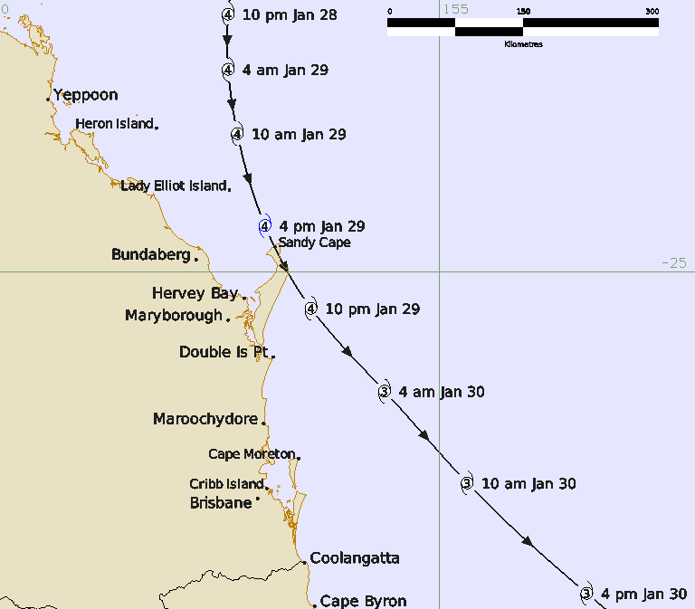
Figure 2. Detailed track of Severe Tropical Cyclone Dinah off the southern Queensland coast on 28-30 January. Times in AEST (UTC+10).

- Meteorological description
The reanalysis utilised twenty-one satellite images over the eleven-day period of monitoring and the range of surface observations. From this information mean seal level pressure analyses were created. Figure 3 is a series of analyses from 28-31 January with surface winds overlaid. It should be noted that wind observations were of a lower quality and frequency during the 1960s, some being estimated and most only once every three hours and less overnight.
The system had its origins in the Pacific Ocean between the Solomon Islands and Vanuatu on 22-23 January (See Figure 1). Tropical cyclone intensity is estimated overnight from 24 -25 January as the system moved southwest over the Coral Sea. The track shows steady intensification over the following days to a severe category 3 cyclone early on 27 January. The satellite image in Figure 4 at 2127 UTC 26 January (07:27 AEST 27 Jan.) shows a clear eye evident when Dinah was east of Townsville, indicative of a severe tropical cyclone.
The satellite image in Figure 5 at 2203 UTC 27 January (08:03 AEST 28 Jan.) shows a clear compact eye indicating a very intense tropical cyclone and likely to be when Dinah was near peak intensity. Dinah is estimated to peak at 90 kn (category 4) intensity from 0000 UTC (10:00 AEST) 28 January and maintain this intensity for 36 hours. The MSLP analysis in Figure 3a shows gales extending a long distance to the south, then increasing as the system approached the coast in Figure 3b.
During 28 January a heavy northeasterly swell arrived at Heron Island. Winds increased during the day and were estimated to be 70 kn from the south southeast and the pressure 988.2 hPa at 1100 UTC (21:00 AEST) 28 January when the centre was about 160 km to the northeast. Dinah passed 80 km to the east of Heron Island on 29 January as shown in Figure 2 and Figure 3c. A marine biologist at Fairfax Is (southeast of Heron Is and adjacent to Lady Musgrave Is) recorded pressures falling to 969.5 hPa when Dinah passed about 50 km to the east at 0200 UTC (12:00 AEST) 29 January.
Lady Elliott Is recorded pressure down to 961.6 hPa at 0300 UTC (13:00 AEST) 29 January when Dinah was 25 km to the east and winds recorded to 65 kn on an anemometer which had an upper limit of 70 kn.
On the mainland, Bundaberg recorded gales in the southeasterlies from 0500-1400 UTC (1500-midnight AEST) 29 January and a minimum pressure of 977.1 hPa at 0500 UTC (15:00 AEST) 29 January. Maryborough's winds were estimated higher at 52 kn from 0800 -1700 UTC 29 January (21:00 29 January – 03:00 AEST 30 January) although the lowest pressure was higher at 980 hPa.
Dinah then passed near Sandy Cape Lighthouse on the northern end of K'gari at 0715 UTC (17:15 AEST) where it was calm for 30 minutes and the pressure was reliably measured at 944.8 hPa. Winds before and after the calm of the eye were estimated at 85 kn. The pressure fell 21.2 hPa from 966 hPa in just over 2 hours from 0500 UTC (15:00 AEST). Applying the standard wind-pressure algorithm using 945 hPa and a pressure of the outermost closed isobar (POCI) of 998 hPa results in a wind speed of 90 kn. This combined with the well-defined eye on the satellite image in Figure 5 are compelling evidence for Dinah to have a peak wind of 90 kn from 0000 UTC 28 January to 1200 UTC 29 January (10:00 28 Jan. – 22:00 AEST 29 Jan.) noting a higher intensity is entirely possible at times during this period.
Dinah then turned towards the southeast away from the coast. Nevertheless, severe southeast to southerly winds were observed on the Queensland coast. The strongest winds in southeast Queensland including Brisbane occurred from late on 29 into 30 January as shown in Figure 3 d – e. The satellite image in Figure 6 at 0134 UTC 29 January when Dinah was northeast of Bundaberg is of low quality and it is difficult to assess the definition of the eye. The subsequent image in Figure 7 from 2329 UTC 29 January shows that an eye remained evident until east of Brisbane.
Double Island Point near the southern tip of K'gari reported very high estimated winds peaking at 98 kn from the south southeast and a lowest pressure of 965.8 hPa at 1400 UTC 29 January (midnight AEST 30 January) when Dinah was passing about 80 km to the east.
Cape Moreton Lighthouse estimated winds peaked at 90 kn from the southeast at 1700-2000 UTC 29 January (03:00-06:00 AEST 30 Jan.) although Cape Moreton observed wind speeds are known to be overestimated in southeasterlies and can be adjusted to 75 kn at standard conditions. Cape Moreton recorded a low pressure of 978.6 hPa at 2000 UTC 29 January (06:00 AEST 30 January). Around this time Dinah was 120 km away to the east northeast.
Dinah is estimated to have weakened slightly to category 3 intensity as it passed 200 km east of Brisbane on the morning of 30 January (Figure 3e). The ship Eastern Moon, sheltering near the Pile Light off Cribb Island in Moreton Bay, reported winds that peaked at 60 kn from the south at 2000 UTC 29 January (06:00 AEST 30 Jan.). Gale to storm force winds were reported further south at Southport, Coolangatta, Byron Bay, and Yamba. The exposed coastal sites such as Cape Byron experienced higher winds in the southerly flow, while winds over the adjacent inland were considerably weaker lessening the wind impact.

Dinah then weakened as it tracked to the southeast over cooler waters. It is estimated to be sub-tropical by the time it passed near Lord Howe Island at 0000 UTC (10:00 AEST) 31 January where pressures fell to 975 hPa and storm-force winds were recorded. From 1 February Dinah moved east across the Tasman Sea passing over the far north of the North Island of New Zealand on 2 February and then moving southeast over the Bay of Plenty. East Cape recorded a pressure of 975 hPa at 1600 UTC and the ship Ruahine recorded a pressure of 973 hPa at 1900 UTC after reporting 50 kn at 1600 UTC when 180 km south southeast of East Cape.

.a. 2300 UTC 27 January 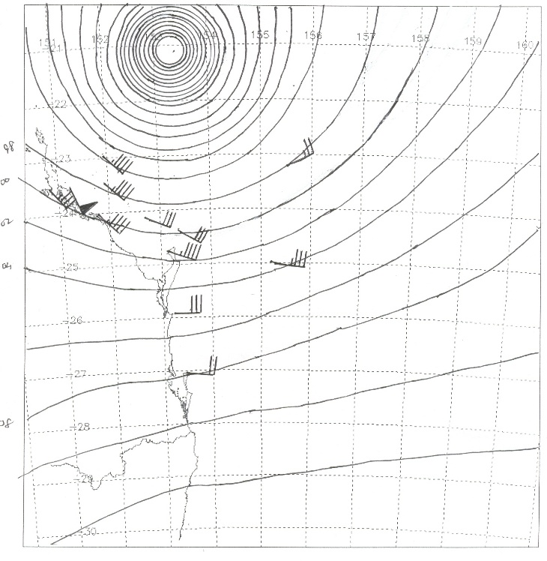 | b. 1100 UTC 28 January 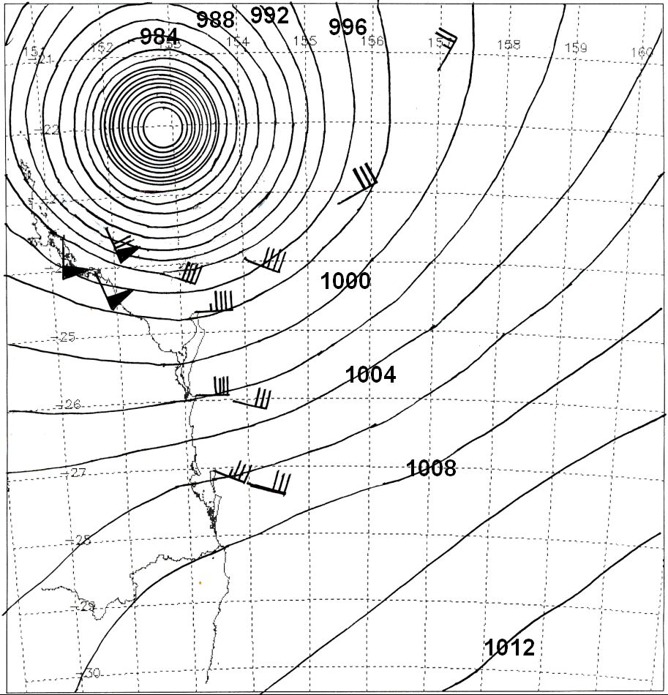
c. 2300 UTC 28 January 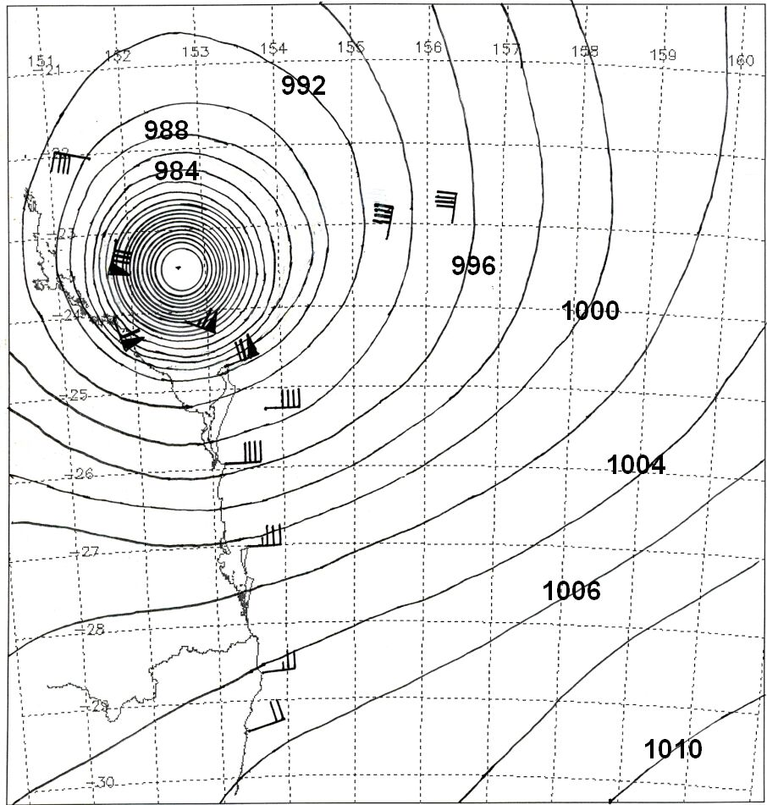 | d. 1100 UTC 29 January 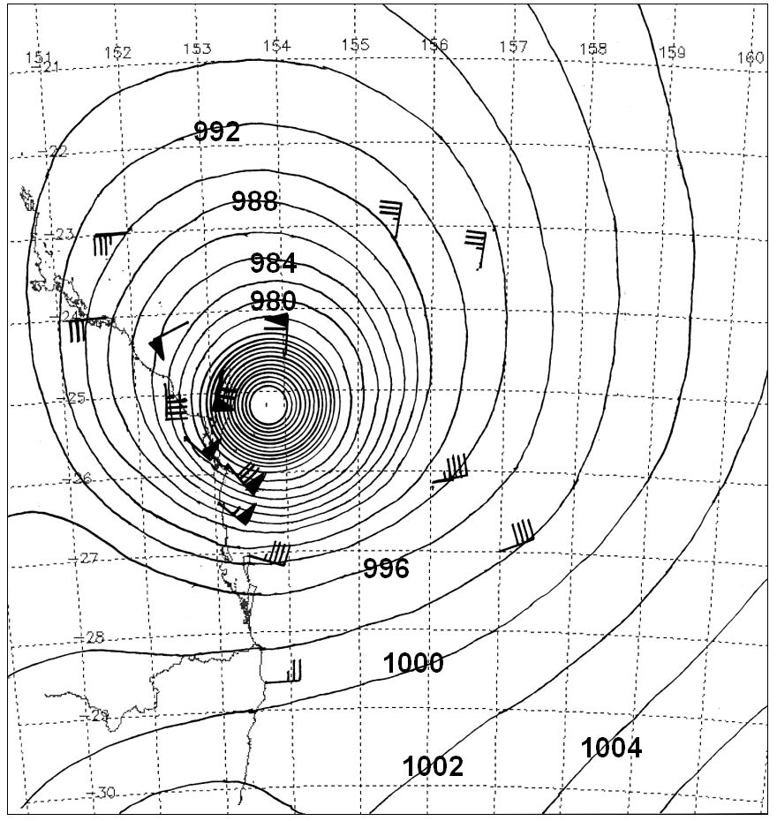
e. 2300 UTC 29 January 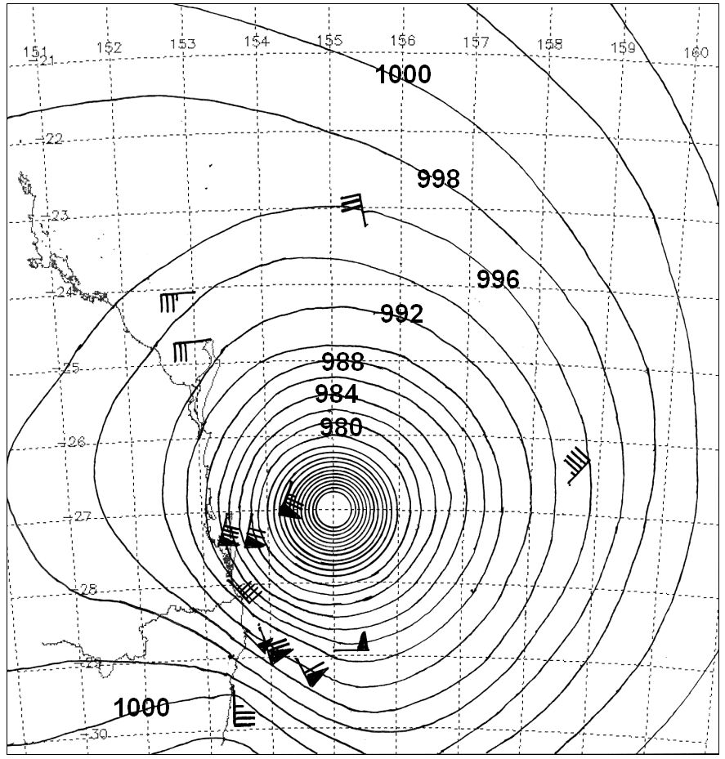 | f. 1100 UTC 30 January 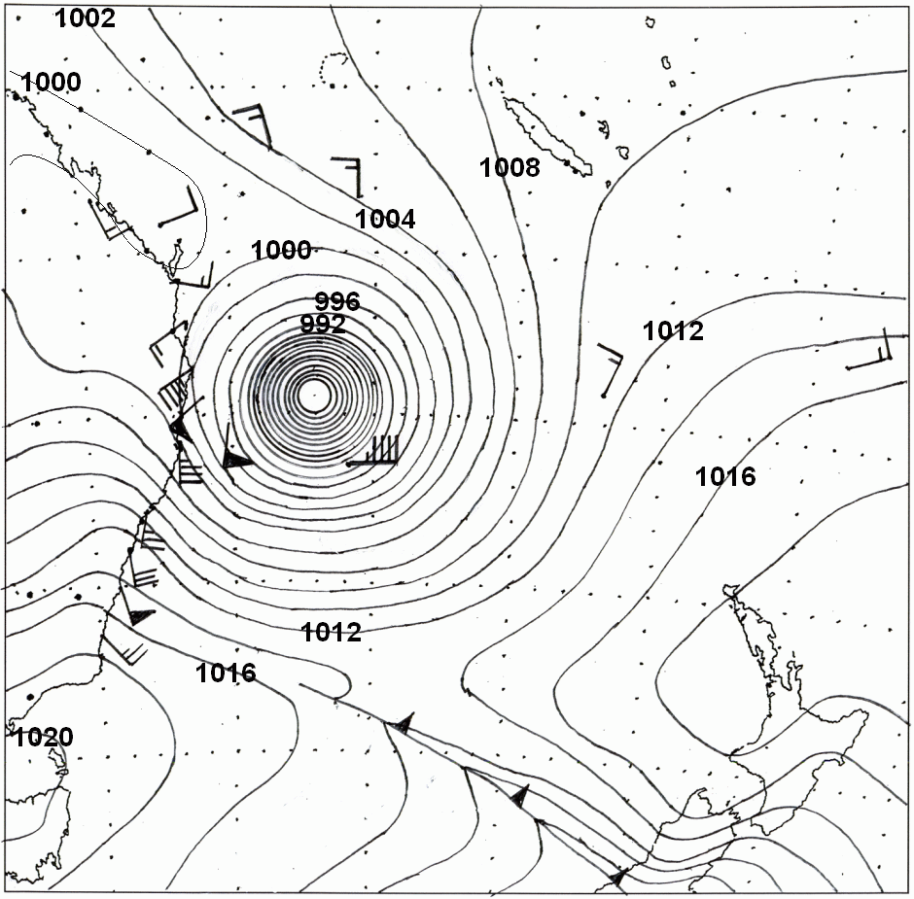

Figure 3. MSLP analysis with surface winds overlaid at a. 2300 UTC 27 January; b. 1100 UTC 28 January; c.2300 UTC 28 January; d.1100 UTC 29 January; e. 2300 UTC 29 January and f. 1100 UTC 30 January. (UTC=AEST-10h).

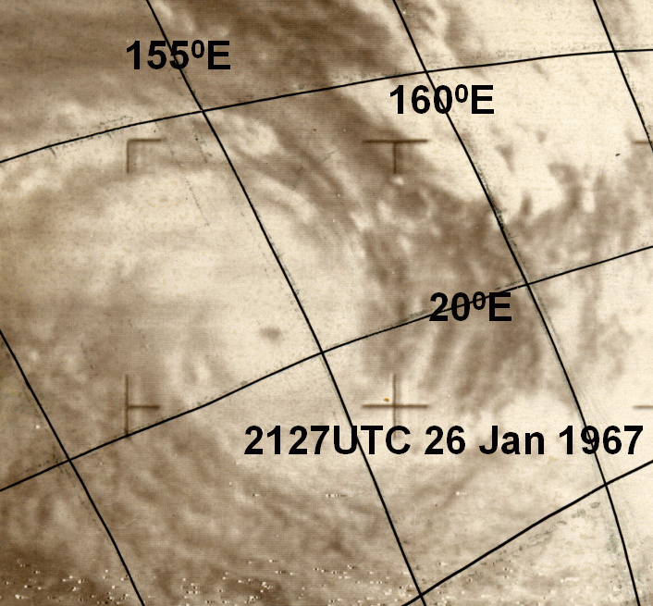
Figure 4. Visible satellite image, 2127 UTC 26 January 1967.
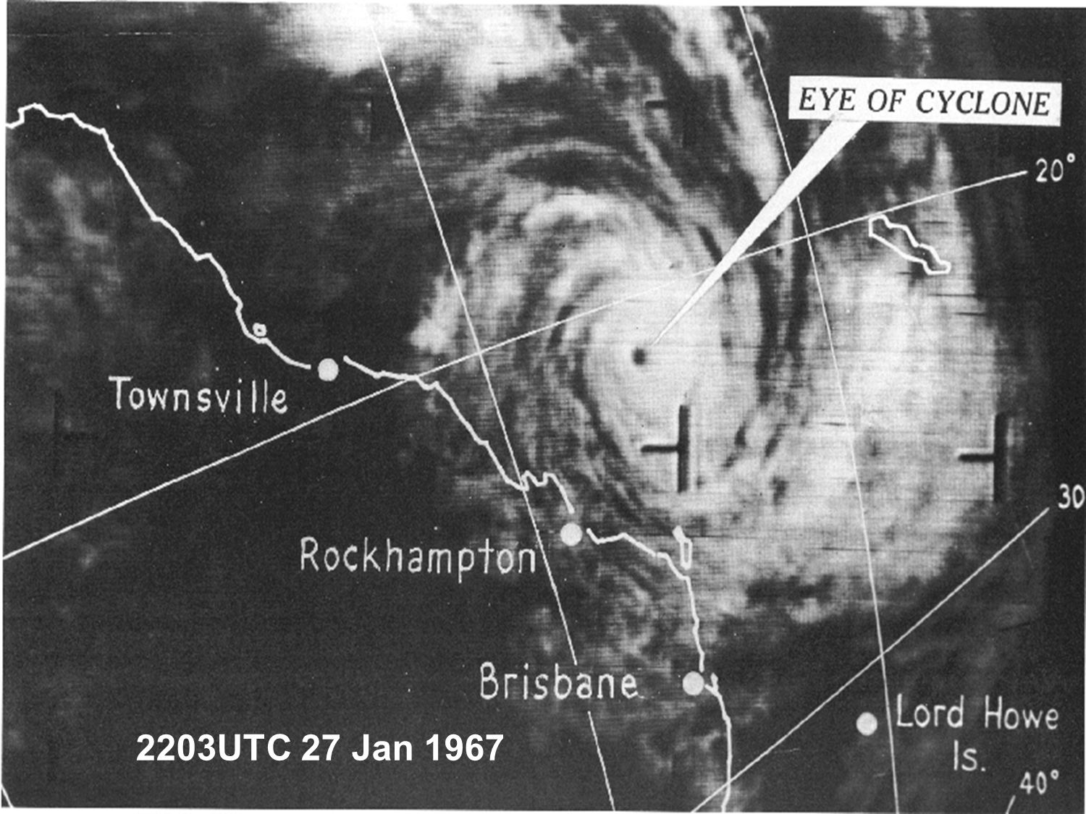
Figure 5. Satellite image at 2203 UTC 27 January 1967 when Dinah was nearing peak intensity.
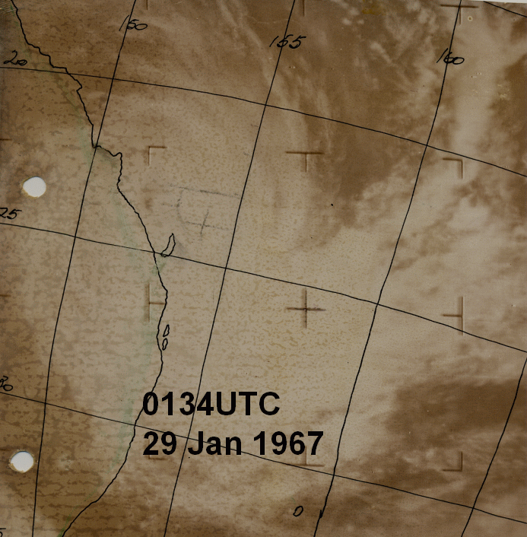
Figure 6. Satellite image at 0134 UTC 29 January 1967.
2203UTC 27 Jan 1967
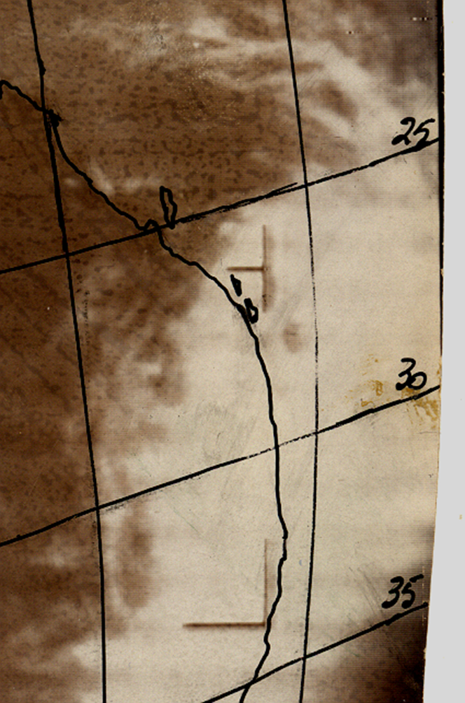
Figure 7 Satellite image at 2329 UTC 29 January showing a ragged eye east of Brisbane.

- Impacts
  - Wind
Although Dinah remained off the coast, strong winds downed many trees over a large area from Rockhampton to Grafton. Houses were unroofed at Bundaberg, Maryborough and along the Sunshine and Gold Coasts. Selected roof damage included the Wintergarden Theatre at Bundaberg and the Catholic Church at Burnett Heads. At Heron Island most trees were damaged and all stripped of their leaves.
Banana and cane crops were wiped out on the Tweed Coast and a severe wind gust overturned a car at Evans Head.
  - Storm Tide and waves
Huge seas and storm surge caused severe beach erosion from as far north as Mackay south to the central coast of New South Wales including offshore islands such as Heron, Lady Elliott and at K'gari (Fraser Is). On 26 and 27 January high seas surged over the Mackay Harbour breakwater and eroded parts of the reclaimed residential area at East Mackay. At Heron Island on 28 January, a heavy northeasterly swell combined with high tide to cause inundation to about 1.7 m above normal with damage to the retaining wall on the north northwest end of the island. Tides the following day were lower but there was significant erosion on the southern side of the island. Very large waves broke completely over Lady Musgrave Island while at nearby Fairfax Island, a Marine Biologist endured seawater covering the island that devastated the local fauna.
On the mainland inundation was extensive. Many low-lying areas were inundated and boats and marina infrastructure damaged. The Sandy Cape Lighthouse Keeper reported that the very heavy easterly swell brought the sea level up 30 feet (10 m) higher than usual, to within 20 feet (6 m) of the boatshed. A report from Lady Elliot Island noted that phenomenal seas broke across the reef all around the island, previous banks of coral above high water were all moved as seas broke over onto the island.
At the Sunshine Coast a storm surge of 2 m covered the flats inland from Double Island Point and inundated cane farms at Bli Bli. Water was knee deep in the main street (Hastings St) at Noosa.
More than 100 houses were flooded around Moreton Bay. Officially the storm surge was measured to 0.46 m at the gauge but high waves at exposed areas caused significant inundation. Around Sandgate seawater 1.5 m deep came into houses and the Nudgee Beach sea wall was destroyed allowing seawater to inundate houses. A house at Cribb Island was washed into the sea. At Bribie Is, wave action undermined two massive concrete World War II gun emplacements (13 x 9 x 4.5 m) which were moved about 2 m from their position.
On the Gold Coast water lapped the decking of the Jubilee Bridge at Southport, about 1.5 m above highest astronomical tide. A section of the esplanade at Surfers Paradise collapsed. The surge on the Tweed River isolated Fingal (near Coolangatta) with six houses 'awash' with seawater. This event was the first of several severe beach erosion episodes on the Gold Coast during 1967. Severe coastal erosion extended into northern NSW.
  - Flooding
Generally flood reports were reported in context of seawater inundation and it is likely the heavy rain exacerbated flooding around river mouths and estuaries. The main Bruce Highway was cut in several places between Maryborough and Nambour. The Mary River rose more than 2m over the bridge at Kenilworth while the Nerang River burst its banks near Surfers Paradise. In NSW the Pacific Highway was cut in places between Woolgoolga and Raleigh.
- Observations
Most sites were only reporting at standard reporting times (hourly or three-hourly) and not continuously. As a result higher winds and lower pressures were possible in between observations.
  - Wind
Heron Island: 70 kn from the south southeast at 1100 UTC (21:00 AEST) 28 January when the centre was about 160 km to the northeast.
Lady Elliott Is: 65 kn from the east southeast and southeast at 2300 UTC 28 January–0000 UTC 29 January (09:00-10:00 AEST 29 Jan.) on an anemometer which had an upper limit of 70 kn.
Maryborough: 52 kn from the southeast from 0800–1700 UTC 29 January (18:00 29 Jan.– 03:00 AEST 30 Jan.).
Bundaberg: 44 kn from the south, 1100 UTC (21:00 AEST) 29 January.
Sandy Cape Lighthouse: recorded 30 min. of calm during the eye at 0715 UTC (17:15 AEST). Maximum winds 85 kn from east and east northeast from 0200– 0500 UTC (noon–15:00 AEST) 29 January before the eye; 85 kn from southwest at 1400 UTC 29 January (midnight AEST 30 January) after the eye.
Double Island Point near the southern tip of K'gari: 98 kn from the south southeast at 1400 UTC 29 January (midnight AEST 30 January) when Dinah was passing about 80 km to the east.
Cape Moreton Lighthouse: 90 kn from the southeast at 1700–2000 UTC 29 January (03:00–06:00 AEST 30 Jan.). Refer comments in section 2 on estimated adjustment of wind speeds.
The ship Eastern Moon, sheltering near the Pile Light off Cribb Island in Moreton Bay, reported winds that peaked at 60 kn from the south at 2000 UTC 29 January (06:00 AEST 30 Jan.).
Coolangatta, Cape Byron and Yamba: recorded gale to storm force winds in southeast to southerly flow but only reported at 09:00 and 15:00 AEST each day.
Lord Howe Island: 50 kn from the east at 1700 UTC 30 January (03:00 AEST 31 Jan.).

  - Pressure
Lowest pressure observations:
Heron Island 988.2 hPa at 1100 UTC (21:00 AEST) 28 January when the centre was about 160 km to the northeast.
Fairfax Is (southeast of Heron Is and adjacent to Lady Musgrave Is): 969.5 hPa when Dinah passed about 50 km to the east at 0200 UTC (12:00 AEST) 29 January.
Lady Elliott Is: 961.6 hPa at 0300 UTC (13:00 AEST) 29 January when Dinah was 25 km to the east
Bundaberg: 977.1 hPa at 0500 UTC (15:00 AEST) 29 January.
Maryborough: 980 hPa at 0800 UTC (18:00 AEST) 29 January.
Sandy Cape 944.8 hPa at 0715 UTC (17:15 AEST) 29 January in the eye of Dinah.
Double Island Point near the southern tip of K'gari: 965.8 hPa at 1400 UTC 29 January (midnight AEST 30 January) when Dinah was passing about 80 km to the east.
Cape Moreton Lighthouse: 978.6 hPa at 2000 UTC 29 January (06:00 AEST 30 January) when Dinah was 120 km away to the east northeast.
Lord Howe Island: 975 hPa at 0000 UTC (10:00 AEST) 31 January near the centre of ex-TC Dinah.
From 1 February Dinah moved east across the Tasman Sea passing over the far north of the North Island of New Zealand on 2 February and then moving southeast over the Bay of Plenty. East Cape recorded 975 hPa at 1600 UTC. The ship Ruahine recorded a pressure of 973 hPa at 1900 UTC after reporting 50 kn at 1600 UTC when 180 km south southeast of East Cape in New Zealand.

  - Rainfall
Heavy rainfall fell over a broad area in near coastal areas between Queensland's Wide Bay-Burnett region south to the New South Wales Central Coast region (see Figure 8). Table 2 shows some of the highest rainfall totals from 29-31 January. This includes locations in the Coffs Harbour region (Aurania 487.2 mm), Gold Coast hinterland (Springbrook Forestry 368.3 mm), and Burnett region (Bundaberg 323.6 mm).
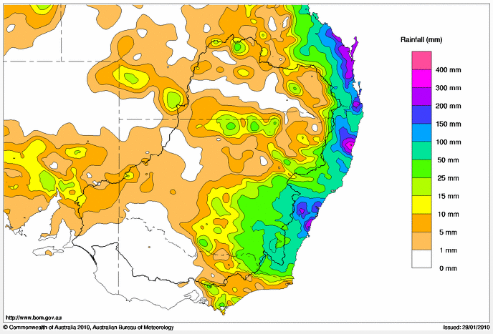
Figure 8. Weekly rainfall, to 31 January 1967.

Name | State | 29 Jan. | 30 Jan. | 31 Jan. | Total 29-31 Jan.
Upper Orara (Aurania) | NSW | 10.2 | 440.7 | 36.3 | 487.2
Coramba (Glenfiddich) | NSW |  |  | 412.8 | 412.8
Springbrook Forestry | Qld | 141 | 214.6 | 12.7 | 368.3
Ungowa Forest Stn | Qld | 156.5 | 210.8 | 0 | 367.3
Baroon Pocket | Qld | 221 | 145.5 | 0 | 366.5
Brooklana | NSW | 6.9 | 314.7 | 40.9 | 362.5
Numimba | Qld | 117.3 | 194.6 | 13.2 | 325.1
Bundaberg P.O. | Qld | 137.4 | 173.5 | 12.7 | 323.6
Urunga (Sunset Place) | NSW |  |  | 309.6 | 309.6
Promised Land (Bellingen) | NSW | 5.6 | 285.8 | 15.2 | 306.6
Upper Urara (The Knob) | NSW | 8.9 | 275.3 | 20.3 | 304.5
Greenlea | Qld | 105.9 | 195.6 |  | 301.5
Coffs Harbour | NSW | 9.1 | 265.7 | 16 | 290.8
Lower Bucca | NSW | 18 | 256 | 7.4 | 281.4
Thora P.O. | NSW | 8.4 | 262.6 | 6.6 | 277.6
Megan (The Mount) | NSW | 5.3 | 232.4 | 35.6 | 273.3
Burnett Heads Neill | Qld | 102.9 | 152.7 | 17.3 | 272.9
Lenore Vale | Qld | 110.5 | 154.7 | 6.4 | 271.6
Lady Elliot Island | Qld | 158 | 66 | 39.9 | 263.9
Table 2. Selected rainfall totals 29-31 January during TC Dinah (mm).

- References
Bureau of Meteorology, 1969. Tropical Cyclones in the northern Australian regions 1966-67. 77p.
Callaghan, J., and P. Helman, 2008. Severe Storms on the East Coast of Australia 1770–2008. Griffith University, 248 pp.
Granger, K., and M. Hayne, 2001; Natural hazards and the risks they pose to South-East Queensland. Geoscience Australia Cities Project, 410 pp.
McAneney, J., Sandercock, B., Crompton, R., Mortlock, T., Musulin, R., Pielke, R., & Gissing, A. 2019. Normalised insurance losses from Australian natural disasters: 1966–2017. Environmental Hazards, 18(5), 414–433. https://doi.org/10.1080/17477891.2019.1609406

Appendix 1: List of Abbreviations
Abbreviation | Term
AEST | Australian Eastern Standard Time
h | hour
hPa | hectopascal
km | kilometres
km/h | kilometres per hour
kn | knot
m | metres
mm | millimetres
nm | nautical mile
UTC | Universal Time Co-ordinated

