Severe Tropical Cyclone Fina (02U)
15 – 26 November 2025
Tropical Cyclone Environmental Prediction Services
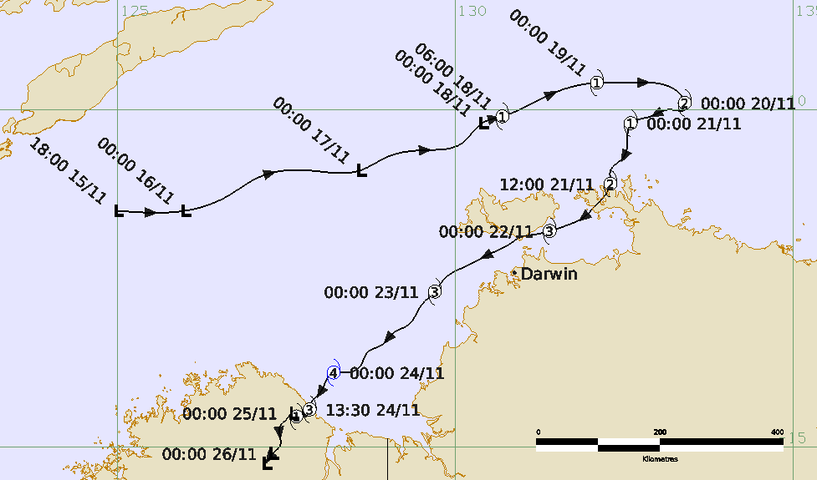

Revision history
Date | Version | Author | Description
21/01/2026 | 1.0 | EPS-TC lead | Final draft

Release history
Date | Version | Status | Approval
28/01/2026 | 1.0 | Approved for release | Manager, EPS-TC.
Contact details:
Tropical Cyclone Team Lead
Severe Weather Environmental Prediction Services
Bureau of Meteorology
PO Box 1370, West Perth WA 6872
Email: tcwc@bom.gov.au

This work is copyright. Apart from any use as permitted under the Copyright Act 1968, no part may be reproduced without prior written permission from the Bureau of Meteorology. Refer to www.bom.gov.au/other/copyright.shtml for further information. Unless otherwise noted, all images in this document are licensed under the Creative Commons Attribution Australia Licence.
© Commonwealth of Australia 2026
Published by the Bureau of Meteorology
Cover image: Track of Severe Tropical Cyclone Fina, 15-26 November 2025. Times in UTC.
Table of Contents

1. Summary 5

2. Meteorological description 9

2.1. Intensity analysis 9

2.2. Structure 10

2.3. Motion 11

3. Impact 25

4. Observations 25

4.1. Wind 25

4.2. Rainfall 26

4.3. Storm Surge 26

5. Forecast Performance 29

Appendix: List of abbreviations 32

List of Figures
Figure 1 Best track of Severe Tropical Cyclone Fina, 11-26 November 2025.. 7
Figure 2 Detailed Best track of Severe Tropical Cyclone Fina as it passed near the NT coast.. 7
Figure 3 Detailed Best track of Severe Tropical Cyclone Fina as it moved over the Joseph Bonaparte Gulf and crossed the WA coast, 23-26 November 2025.. 8
Figure 4. Hovmoller diagram of tropical waves over the latitude range of 5-15S.. 13
Figure 5. Sea surface temperatures for northwest Australia 18 November. 14
Figure 6. AMSR2 89 GHz microwave image at 0449 UTC 18 November 15
Figure 7. SSMIS 91GHz microwave image at 2125 UTC 19 November. 16
Figure 8. AMSR2 89 GHz microwave image at 0436 UTC 20 November. 17
Figure 9. Arafura radar at 1204 UTC 21 November as Fina crossed the Cobourg Peninsula. 18
Figure 10. AMSR2 89 GHz microwave image at 1608 UTC 21 November. 19
Figure 11. Darwin radar images on 22 November at 0119 UTC and at 1754 UTC. 20
Figure 12. SSMIS 91 GHz microwave image at 1035 UTC 23 November. 21
Figure 13. WSFM 89 GHz microwave image at 2128 UTC 23 November. 22
Figure 14. Series of ASCAT images.. 23
Figure 15. Series of satellite wind speeds from SAR during Fina. 24
Figure 16. Wyndham radar at 0829 UTC 24 November. 25
Figure 17. Rainfall analysis for the week ending 27 November 2025. 28
Figure 18. Damage to trees near Tiwi College. 29
Figure 19. Significant damage to the Berkeley River Lodge, WA. 29
Figure 20. Forecast track map of the first Advice issued at 0000 UTC 19 November. 30
Figure 21. Position accuracy figures for Severe Tropical Cyclone Fina 32
Figure 22. Intensity accuracy figures for Severe Tropical Cyclone Fina. 32
Figure 23. Intensity plot of objective and subjective guidance.. 35

List of Tables
Table 1: Best track summary for Severe Tropical Cyclone Fina, 15-26 November 2025.. 8
Table 2: Verification statistics for Severe Tropical Cyclone Fina.. 30

- Summary
Severe Tropical Cyclone Fina was a remarkable early season tropical cyclone, impacting both the western Top End of the Northern Territory and the northeast Kimberley coast in Western Australia. Fina was notable for being the most intense tropical cyclone to occur in the Australian region during November and also equalled the record for earliest landfall in a season by a cyclone on the Australian mainland.
A tropical low (02U) formed on 15 November north of the Kimberley. The low tracked steadily towards the east and slowly consolidated. Environmental conditions were favourable for development and the system developed into Tropical Cyclone Fina on 18 November, around 260 kilometres north of Darwin. Fina moved over waters of 30.5-31°C, about 0.5°C warmer than normal.
Fina intensified into a category 2 system on 19 November, before taking a sharp turn to the south to southwest on 20 November and briefly weakening to category 1 intensity. Fina re-intensified to category 2 prior to crossing the Cobourg Peninsula late on 21 November. This equals the record for the earliest cyclone landfall on the Australian mainland with Severe Tropical Cyclone Ines, which crossed the north Kimberley coast of Western Australia on 21 November 1973.
On 22 November, Fina intensified further into a severe (category 3) tropical cyclone as it moved to the west southwest through the Van Diemen Gulf over the southern tip of Melville Island (of the Tiwi Islands) and to the north of Darwin. Wurrumiyanga on Bathurst Island (Tiwi Islands) was the worst affected community sustaining significant damage. The greater Darwin region missed the very destructive core but still experienced damaging wind gusts estimated to 65 kn (120 km/h) that caused widespread power outages mostly as a result of fallen trees.
Severe Tropical Cyclone Fina continued to track towards the southwest on 23 November and intensified further in favourable environmental conditions. Fina reached a 10-minute mean maximum wind peak intensity of 105 kn (195 km/h) between 2100 UTC 23 November and 0300 UTC 24 November, a high-end category 4 system. This makes it the strongest tropical cyclone to occur in the Australian region during November.
Fina weakened only slightly to a category 3 system as it crossed the northeast Kimberley coast near the Berkely River Mouth late on 24 November. The Berkeley River Lodge suffered significant wind damage to structures and vegetation. Fina rapidly weakened as it moved slowly overland and was below tropical cyclone intensity on the morning of 25 November.
No surface observations were recorded in the destructive core of Fina. The strongest wind gusts reported were 59 kn (109 km/h) at Croker Island Airport on 21 November, and 58 kn (107 km/h) at Darwin Airport on 22 November. The most notable 24-hour rainfall total was at Middle Point (near Darwin), which recorded 430.0 millimetres in the 24 hours to 9am 23 November. Many NT locations including Darwin, set new daily rainfall records for November.
Figure 1 shows the best track of Fina, while Figure 2 and Figure 3 are more detailed tracks showing the extent of strong winds as it passed near the NT and WA coast. Table 1 is a summary of the best track data.
Figure 1 Best track of Severe Tropical Cyclone Fina, 15-26 November 2025. Times are in UTC (ACST-9.5 h, AWST-8h).
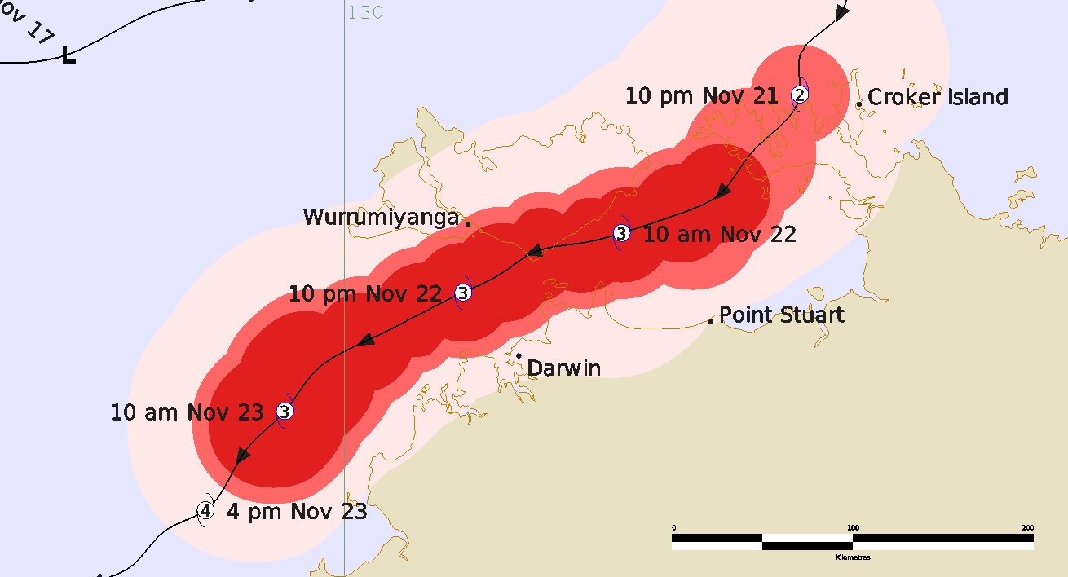
Figure 2 Detailed Best track of Severe Tropical Cyclone Fina as it passed near the NT coast, 21-23 November 2025. The area of gales are shaded pink, storm-force winds in light red and hurricane-force winds in darker red. Times are in ACST (rounded to next hour; UTC+9.5 h).
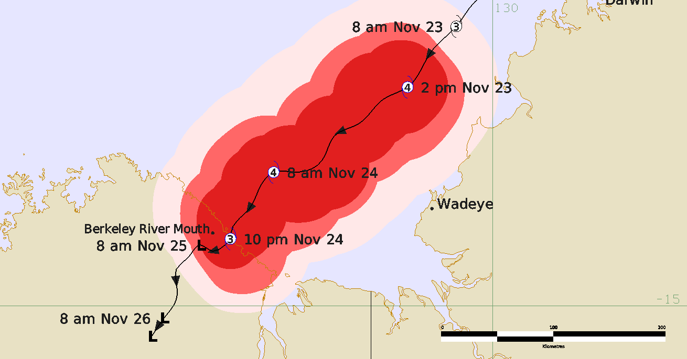
Figure 3 Detailed Best track of Severe Tropical Cyclone Fina as it moved over the Joseph Bonaparte Gulf and crossed the WA coast, 23-26 November 2025. The area of gales are shaded pink, storm-force winds in light red and hurricane-force winds in darker red. Times are in AWST (UTC+8 h).
Year | Month | Day | Hour | Pos. | Pos. | Pos. | Max Wind | Max | Cent. | Rad. of gales | Rad. of storm | RMW
 |  |  | UTC | Lat. | Long. | Acc. | 10min | gust | Press. | (NE/SE/ | (NE/SE/ | nm
 |  |  |  | S | E | nm | kn | kn | hPa | SW/NW) | SW/NW)
2025 | 11 | 15 | 1800 | 11.5 | 125.0 | 40 | 20 | 45 | 1008 | 0/0/0/0 | 0/0/0/0 | -
2025 | 11 | 16 | 0000 | 11.5 | 126.0 | 40 | 25 | 45 | 1005 | 0/0/0/0 | 0/0/0/0 | -
2025 | 11 | 16 | 0600 | 11.3 | 126.6 | 30 | 25 | 45 | 1005 | 0/0/0/0 | 0/0/0/0 | -
2025 | 11 | 16 | 1200 | 11.0 | 127.1 | 30 | 30 | 45 | 1005 | 0/0/0/0 | 0/0/0/0 | -
2025 | 11 | 16 | 1800 | 10.9 | 127.8 | 40 | 30 | 45 | 1005 | 0/0/0/0 | 0/0/0/0 | -
2025 | 11 | 17 | 0000 | 10.9 | 128.6 | 30 | 30 | 45 | 1005 | 0/0/0/0 | 0/0/0/0 | -
2025 | 11 | 17 | 0600 | 10.7 | 129.0 | 30 | 30 | 45 | 1002 | 0/0/0/0 | 0/0/0/0 | -
2025 | 11 | 17 | 1200 | 10.6 | 129.6 | 30 | 30 | 45 | 1002 | 0/0/0/0 | 0/0/0/0 | -
2025 | 11 | 17 | 1800 | 10.5 | 130.1 | 30 | 30 | 45 | 1002 | 0/0/0/0 | 0/0/0/0 | -
2025 | 11 | 18 | 0000 | 10.2 | 130.4 | 30 | 35* | 50 | 999 | 0/0/20/0 | 0/0/0/0 | -
2025 | 11 | 18 | 0600 | 10.1 | 130.7 | 20 | 40 | 55 | 998 | 50/0/20/20 | 0/0/0/0 | 15
2025 | 11 | 18 | 1200 | 9.9 | 131.2 | 20 | 45 | 65 | 996 | 50/20/25/50 | 0/0/0/0 | 15
2025 | 11 | 18 | 1800 | 9.7 | 131.6 | 20 | 45 | 65 | 993 | 50/30/30/60 | 0/0/0/0 | 15
2025 | 11 | 19 | 0000 | 9.6 | 132.1 | 30 | 45 | 65 | 990 | 40/30/35/70 | 0/0/0/0 | 15
2025 | 11 | 19 | 0600 | 9.6 | 132.6 | 20 | 50 | 70 | 985 | 40/30/35/70 | 20/0/0/0 | 15
2025 | 11 | 19 | 1200 | 9.6 | 132.7 | 15 | 55 | 75 | 985 | 60/40/50/60 | 25/25/25/0 | 10
2025 | 11 | 19 | 1800 | 9.6 | 132.9 | 15 | 55 | 75 | 985 | 60/50/50/60 | 30/25/25/25 | 10
2025 | 11 | 20 | 0000 | 9.9 | 133.4 | 15 | 55 | 75 | 985 | 70/50/60/70 | 30/20/20/30 | 10
2025 | 11 | 20 | 0600 | 10.0 | 133.4 | 15 | 50 | 70 | 990 | 50/40/60/70 | 0/0/0/50 | 12
2025 | 11 | 20 | 1200 | 10.0 | 133.2 | 20 | 45 | 65 | 994 | 60/40/50/60 | 0/0/0/0 | 12
2025 | 11 | 20 | 1800 | 10.1 | 132.9 | 20 | 45 | 65 | 992 | 30/40/40/60 | 0/0/0/0 | 12
2025 | 11 | 21 | 0000 | 10.2 | 132.6 | 15 | 45 | 65 | 990 | 35/35/40/40 | 0/0/0/0 | 10
2025 | 11 | 21 | 0600 | 10.7 | 132.5 | 5 | 50 | 70 | 987 | 50/45/40/50 | 25/20/20/25 | 9
2025 | 11 | 21 | 0900 | 10.9 | 132.3 | 5 | 55 | 75 | 985 | 50/45/40/50 | 20/20/20/20 | 8
2025 | 11 | 21 | 1200 | 11.1 | 132.3 | 5 | 55 | 75 | 985 | 50/30/30/50 | 15/15/15/15 | 8
2025 | 11 | 21 | 1500 | 11.4 | 132.1 | 5 | 60 | 85 | 984 | 50/40/40/50 | 20/20/20/20 | 8
2025 | 11 | 21 | 1800 | 11.6 | 131.9 | 5 | 65 | 90 | 980 | 50/35/35/50 | 20/20/20/20 | 8
2025 | 11 | 21 | 2100 | 11.7 | 131.7 | 5 | 75 | 105 | 974 | 50/35/35/50 | 20/25/20/20 | 6
2025 | 11 | 22 | 0000 | 11.8 | 131.4 | 5 | 75 | 105 | 974 | 45/35/30/45 | 20/20/20/20 | 6
2025 | 11 | 22 | 0300 | 11.9 | 131.2 | 5 | 75 | 105 | 966 | 45/45/30/40 | 20/20/20/15 | 6
2025 | 11 | 22 | 0600 | 11.9 | 131.0 | 5 | 75 | 105 | 961 | 45/30/30/40 | 20/20/20/15 | 6
2025 | 11 | 22 | 0900 | 12.0 | 130.8 | 5 | 75 | 105 | 963 | 45/35/30/40 | 20/20/20/20 | 6
2025 | 11 | 22 | 1200 | 12.1 | 130.6 | 5 | 70 | 100 | 972 | 45/30/35/40 | 20/20/20/20 | 8
2025 | 11 | 22 | 1500 | 12.2 | 130.4 | 5 | 70 | 100 | 972 | 45/30/40/35 | 20/15/20/20 | 8
2025 | 11 | 22 | 1800 | 12.4 | 130.1 | 5 | 70 | 100 | 967 | 45/35/45/40 | 20/20/20/20 | 8
2025 | 11 | 22 | 2100 | 12.5 | 129.9 | 5 | 75 | 105 | 963 | 45/35/50/45 | 25/25/30/25 | 8
2025 | 11 | 23 | 0000 | 12.7 | 129.7 | 5 | 80 | 110 | 960 | 45/35/50/45 | 25/25/30/25 | 8
2025 | 11 | 23 | 0300 | 12.9 | 129.5 | 5 | 85 | 120 | 954 | 45/35/55/50 | 25/25/35/25 | 8
2025 | 11 | 23 | 0600 | 13.2 | 129.3 | 5 | 90 | 125 | 953 | 45/45/60/50 | 25/30/40/35 | 8
2025 | 11 | 23 | 0900 | 13.3 | 129.1 | 5 | 100 | 140 | 945 | 45/45/60/50 | 25/30/40/35 | 8
2025 | 11 | 23 | 1200 | 13.5 | 128.9 | 5 | 100 | 140 | 942 | 45/45/60/50 | 25/30/30/30 | 6
2025 | 11 | 23 | 1500 | 13.6 | 128.7 | 5 | 100 | 140 | 942 | 45/45/60/50 | 25/30/30/30 | 6
2025 | 11 | 23 | 1800 | 13.8 | 128.6 | 5 | 100 | 140 | 942 | 45/45/50/50 | 25/30/30/30 | 5
2025 | 11 | 23 | 2100 | 13.9 | 128.4 | 5 | 105 | 145 | 938 | 45/45/45/50 | 25/30/30/30 | 5
2025 | 11 | 24 | 0000 | 13.9 | 128.2 | 5 | 105 | 145 | 938 | 45/45/45/45 | 25/40/40/30 | 5
2025 | 11 | 24 | 0300 | 14.0 | 128.1 | 5 | 105 | 145 | 938 | 40/45/45/45 | 25/35/30/30 | 5
2025 | 11 | 24 | 0600 | 14.2 | 128.0 | 5 | 100 | 140 | 941 | 40/40/35/45 | 25/30/25/30 | 5
2025 | 11 | 24 | 0900 | 14.3 | 127.9 | 5 | 95 | 135 | 946 | 40/40/35/45 | 25/30/25/30 | 5
2025 | 11 | 24 | 1200 | 14.4 | 127.9 | 5 | 85 | 120 | 955 | 40/40/30/30 | 25/30/20/20 | 5
2025 | 11 | 24 | 1350 | 14.4 | 127.8 | 5 | 80 | 110 | 959 | 40/40/30/30 | 25/30/20/20 | 5
2025 | 11 | 24 | 1500 | 14.5 | 127.8 | 5 | 75 | 105 | 964 | 50/40/30/30 | 25/25/15/20 | 5
2025 | 11 | 24 | 1800 | 14.6 | 127.7 | 5 | 55 | 75 | 976 | 50/30/25/30 | 25/20/15/15 | 5
2025 | 11 | 24 | 2100 | 14.5 | 127.6 | 10 | 45 | 65 | 982 | 50/30/25/50 | 0/0/0/0 | 10
2025 | 11 | 25 | 0000 | 14.5 | 127.6 | 10 | 40* | 55 | 987 | 0/30/0/0 | 0/0/0/0 | -
2025 | 11 | 25 | 0300 | 14.6 | 127.5 | 15 | 30 | 45 | 993 | 0/0/0/0 | 0/0/0/0 | -
2025 | 11 | 25 | 0600 | 14.7 | 127.4 | 15 | 30 | 45 | 995 | 0/0/0/0 | 0/0/0/0 | -
2025 | 11 | 25 | 1200 | 14.8 | 127.4 | 25 | 25 | 45 | 998 | 0/0/0/0 | 0/0/0/0 | -
2025 | 11 | 25 | 1800 | 15.0 | 127.4 | 20 | 25 | 45 | 999 | 0/0/0/0 | 0/0/0/0 | -
2025 | 11 | 26 | 0000 | 15.1 | 127.3 | 20 | 20 | 45 | 1004 | 0/0/0/0 | 0/0/0/0 | -
2025 | 11 | 26 | 0600 | 15.3 | 127.2 | 20 | 20 | 45 | 1004 | 0/0/0/0 | 0/0/0/0 | -
Table 1: Best track summary for Severe Tropical Cyclone Fina, 15-26 November 2025. UTC=ACST-9.5h or AWST-8h.
* Not a tropical cyclone as gales less than halfway around centre.
- Meteorological description
  - Intensity analysis
A comparison of the subjective and objective intensity estimates is shown in Figure 23.
An active phase of the MJO combined with an Equatorial Rossby wave to form a low to the north of Western Australia on 15 November (Figure 4). Sea surface temperatures along the track of Fina were 30.5-31°C, about 0.5°C above normal (Figure 5).
The low was steered eastwards during 16 and 17 November and slowly developed in a favourable environment of warm SSTs, abundant moisture and low vertical wind shear. During 17 November deep convection improved around the low-level centre and an 0016 UTC ASCAT pass on 18 November showed gales were present near the centre. From this time, the deep convective band improved rapidly, and Dvorak DT estimates increased from 2.0 at 0000UTC to 3.0 at 0600 UTC 18 November. The subjective Dvorak assessment and microwave imagery (AMSR2 at 0449 UTC in Figure 6) were used to determine Fina had developed into a tropical cyclone at 0600 UTC 18 November. Fina continued to move eastwards and intensify, scatterometry passes around 0000 UTC 19 November showed winds in the 40-45 kn (75-85 km/h) range and this combined with objective guidance determined the intensity at 0000 UTC despite Dvorak reaching DT of 3.5, however the system did reach Category 2 (storm force winds) by 0600 UTC 19 November. The cyclone reached an initial peak of 55 kn (100 km/h) between 1200 UTC 19 November and 0000 UTC 20 November with a SSMIS pass at 2125 UTC 19 November (Figure 7) showing a small, tightly wrapped system with deep convection around the centre.
From 0000 UTC 20 November Fina weakened and decreased to Category 1 intensity. An AMSR2 pass at 0436 UTC 20 November (refer microwave image in Figure 8) showed the symmetric deep convection around the centre had decreased and was now confined to western quadrants and Fina had the appearance of a system suffering the effects of increased northeasterly vertical wind shear and perhaps the ingestion of some dry air.
During 21 November Fina approached the Cobourg Peninsula and re-intensified. The Arafura radar showed a well-developed circulation with a small inner core. Fina passed over the small strip of land of the Peninsula and into the Van Diemen Gulf between 1200 and 1500 UTC 21 December (refer Arafura radar image in Figure 9). As the small system's core moved back over water it continued to intensify and reached 65 kn (120 km/h) (Category 3) at 1800 UTC 21 December. An AMSR2 microwave pass at 1608 UTC 21 November (Figure 10) showed deep cold convection wrapped tightly around a very small centre. At this time the subjective Dvorak was underestimating the intensity and the intensity was biased towards objective guidance. Fina reached a second peak intensity of 75 kn (140 km/h) between 2100 UTC 21 November and 0900 UTC 22 November, as it moved from Van Diemen Gulf to Beagle Gulf, across the very southern tip of the Tiwi Islands and to the north of Darwin (Figure 11). An eye appeared in EIR imagery between 0300 and 0600 UTC 22 November, and the subjective Dvorak DT increased to 5.5, however as Fina passed over the southern Tiwi Islands the eye disappeared, and the system weakened slightly to 70 kn (130 km/h).
Darwin radar and microwave imagery both indicated Fina had retained a small, inner core with very deep convection wrapped tightly around it through this period and once Fina had moved clear of land it began to intensify with an eye apparent in EIR again. During 23 November the small system intensified over the warm waters of the Joseph Bonaparte Gulf (refer microwave image Figure 12) and reached a lifetime 10-minute mean wind peak intensity of 105 kn (195 km/h) between 2100 UTC 23 November and 0300 UTC 24 November (refer microwave image Figure 13). This intensity is consistent with a concurrent SAR pass (refer Figure 15e). Subjective Dvorak peaked at a DT of 6.0 with objective guidance varied through the period 1200 UTC 23 November to 0300 UTC 24 November. At 2100 UTC 23 November SATCON had a slightly lower peak of about 90-95 kn (165-175 km/h) 10-minute mean wind speed but the combination of ADT, AiDT and DPRINT were higher at about 100 kn (185 km/h) 10-minute mean wind. With an RMW of about 5 nm (9 km) it is probable that some of the objective methods underestimated the intensity of Fina at times due to its small size.
Fina maintained a well-defined eye until just before it reached the northeast Kimberley coast as evidenced by the Wyndham radar in Figure 16. Around this time Fina slowed and began to weaken. Fina made final landfall on the northeast Kimberley coast at 1330 UTC 24 November with an estimated intensity of 80 kn (150 km/h, Category 3). It weakened quickly as it moved over land, decreasing below tropical cyclone strength at 0000 UTC 25 November and then dissipating quickly in the next 24 hours.

  - Structure
Fina was a very compact system for most of its lifetime, including at its peak intensity and during weakening, as shown in Figure 2 and Figure 3. The extent of gales was generally less than 60 nm (110 km) throughout. This is shown in the series of ASCAT images in Figure 14 and SAR images in Figure 15.
Gales were initially detected by scatterometry, the ASCAT-C 0018 UTC 18 November showed a small area of gales west of the centre, which became more extensive 12 hours later. Gales were highest in northern quadrants and briefly extended as far as 70 nm (130 km) northwest of the centre on 19 December (from HSCAT-2B at 0059 UTC but not shown) but then contracted with further intensification. ASCAT imagery around 1200 UTC 19 December confirmed storm force winds to about 25 nm (45 km) in extent.
Fina became more symmetric during 21 November prior to being affected by land, initially the Cobourg Peninsula. The extent of strong winds later on 21 and then in following days was well resolved by a series of SAR images that captured the small inner core (Figure 15), matching the Arafura and then Darwin radar signatures (Figure 11). The extent of hurricane force winds was estimated at 15 nm (30 km). At times the gale extent was reduced because of land, from both Tiwi Islands north of the centre, and the mainland on the southern side.
Once over open waters on 23 November and through to landfall on 25 November, Fina was reasonably symmetric, having hurricane-force winds extend to 20-25 nm (35-45 km), storm-force 25-30 nm (45-55 km) and gales to 45-60 nm (85-110 km), until winds reduced upon landfall.
Initially the radius of maximum winds (RMW) was estimated at 15 nm (30 km) but reduced to below 10 nm when it attained storm-force intensity (50 kn or 95 km/h) and further to just 5 nm (10 km) when it was at its strongest overnight on 23-24 November through to landfall. Radar and the series of SAR images were used in estimating RMW, for example Figures 9, 11, 15 and 16.
  - Motion
Fina's track, in Figure 1, Figure 2 and Figure 3, show that initially the low was steered to the east northeast by stronger westerlies in the low to mid-levels with only a weak ridge to the south of the system.
By 20 November Fina had reached category 2 intensity with a deeper vertical extent. As the westerlies weakened Fina slowed and then turned to the south and then southwest as the mid-level ridge to the southeast strengthened.
This pattern remained the dominant steering mechanism over following days although Fina was slow moving at speeds of less than 5 kn (10 km/h). Fina's west southwest motion through Van Diemen Gulf allowed it to remain over water while it passed between Darwin and the Tiwi Islands on 22 November. From 23 November it resumed a southwest track through to landfall on the northeast Kimberley coast late on 24 November. As Fina approached land it slowed to less than 3 kn (5 km/h) which resulted in a prolonged period of gales in coastal parts.

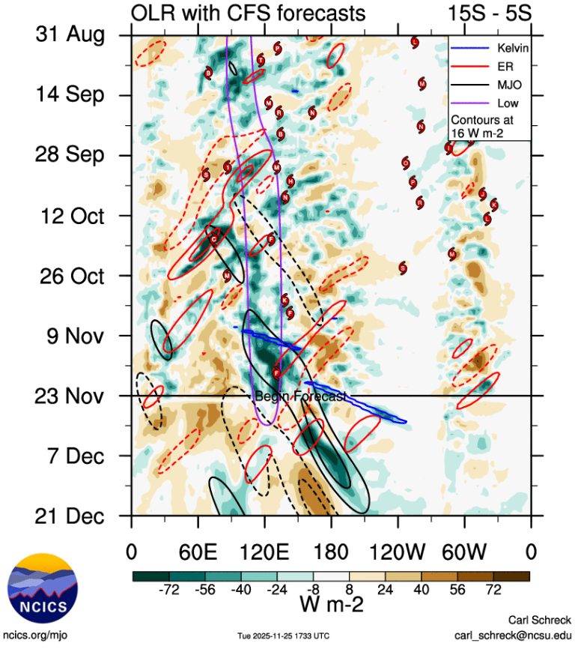
Figure 4. Hovmoller diagram of tropical waves over the latitude range of 5-15S. The formation of Fina (the system annotated F) occurred during the combination of an Equatorial Rossby wave (red) with an active phase of the MJO (black contour), there is also the presence of a background low-frequency wave analysed (denoted by the purple contour). Image courtesy of the North Carolina Institute for Climate Studies: Tropical Monitoring :: North Carolina Institute for Climate Studies

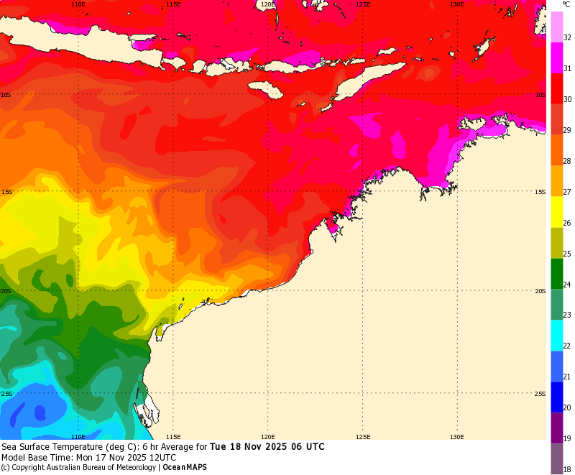
Figure 5. Sea surface temperatures for northwest Australia 18 November showing that temperatures along Fina's track were about 30.5-31°C.
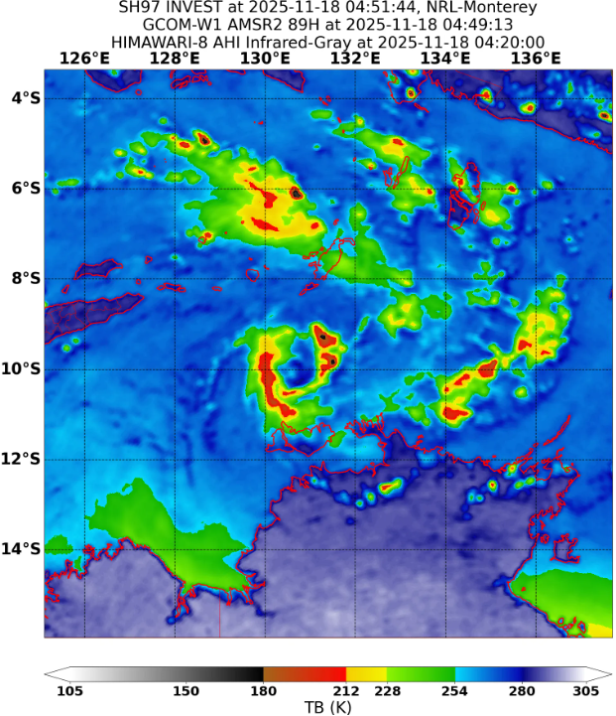
Figure 6. AMSR2 89 GHz microwave image at 0449 UTC 18 November around the time Fina developed into a tropical cyclone. Image courtesy NRL: https://www.nrlmry.navy.mil/TC.html
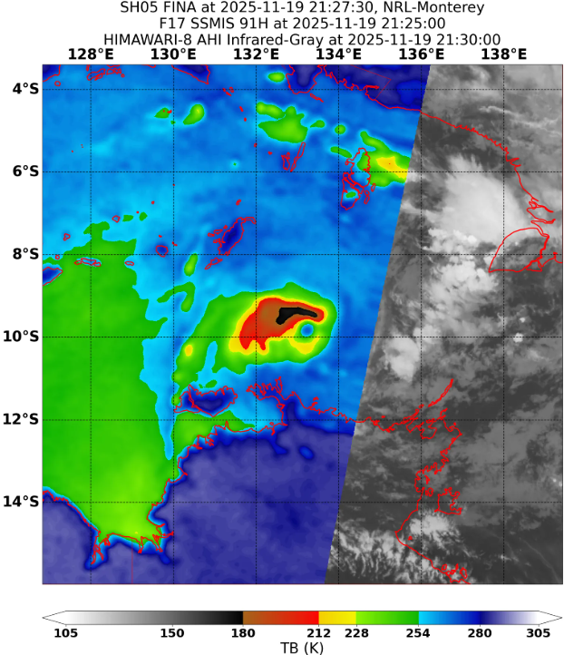
Figure 7. SSMIS 91GHz microwave image at 2125 UTC 19 November showing a defined eye indicating Fina was intensifying. Image courtesy NRL: https://www.nrlmry.navy.mil/TC.html.
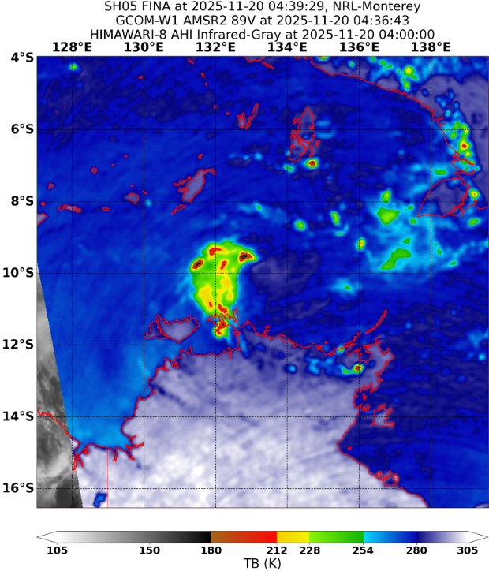
Figure 8. AMSR2 89 GHz microwave image at 0436 UTC 20 November showing a weakening of the deep convection around the centre. Image courtesy NRL: https://www.nrlmry.navy.mil/TC.html.

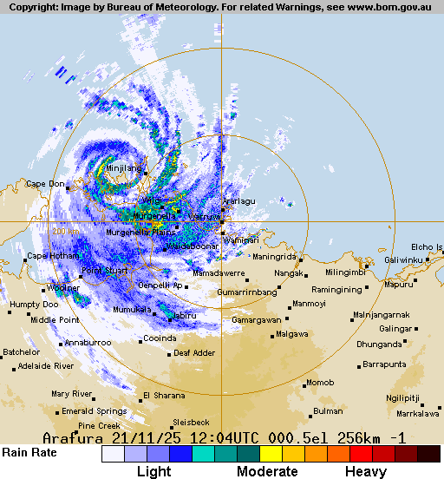
Figure 9. Arafura radar at 1204 UTC 21 November as Fina crossed the Cobourg Peninsula.

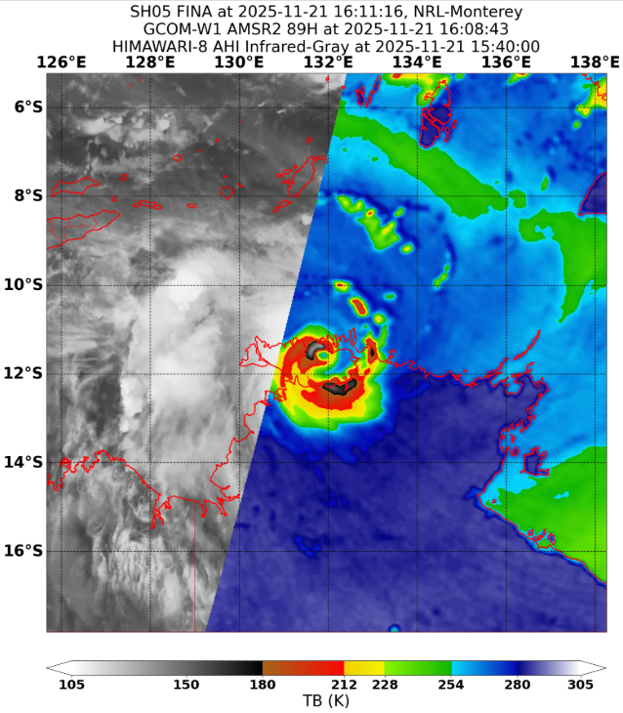
Figure 10. AMSR2 89 GHz microwave image at 1608 UTC 21 November showing a small intense core as Fina crossed Van Diemen Gulf. Images courtesy NRL: https://www.nrlmry.navy.mil/TC.html.
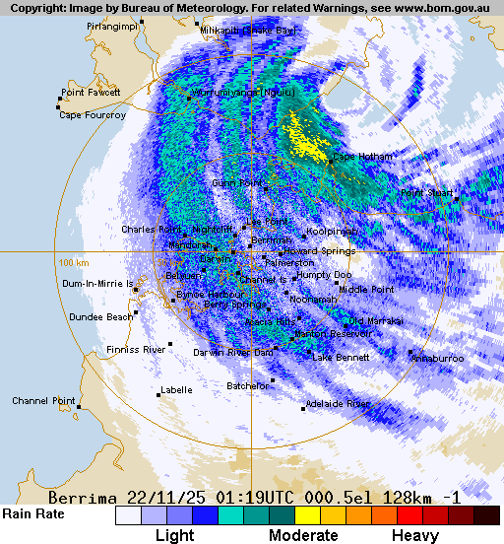 | 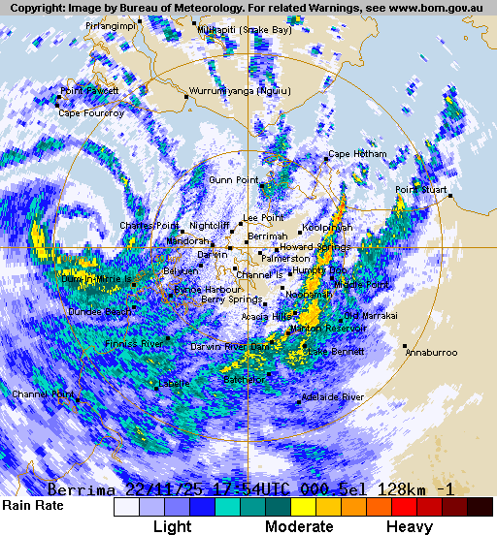
Figure 11. Darwin radar images on 22 November at 0119 UTC (left) when Fina was near the south coast of Melville Island (Tiwi Islands) to the north of Darwin; and at 1754 UTC (right) as Fina was west of Darwin and moving away.

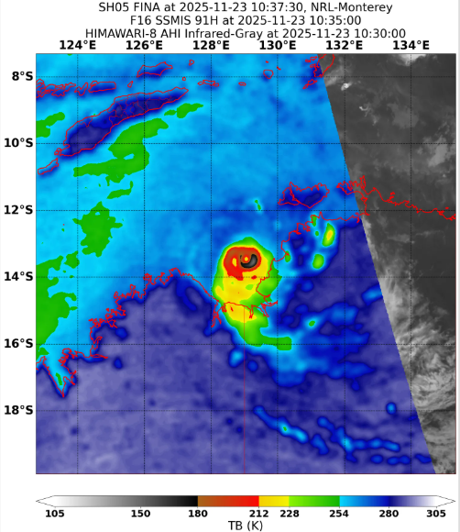
Figure 12. SSMIS 91 GHz microwave image at 1035 UTC 23 November as Fina was intensifying towards peak intensity. Image courtesy NRL: https://www.nrlmry.navy.mil/TC.html.

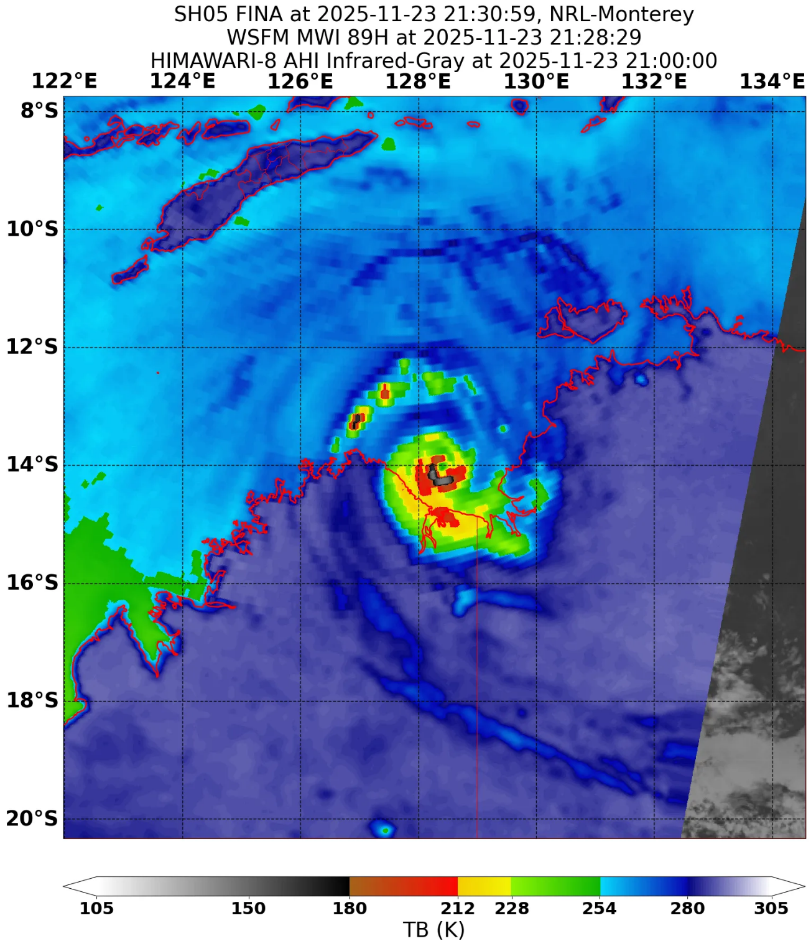
Figure 13. WSFM 89 GHz microwave image at 2128 UTC 23 November showing Fina at peak intensity. The estimated maximum 10-minute mean wind speed was 105 kn (195 km/h) and the radius to maximum winds was very small at only 5 nm (9 km).

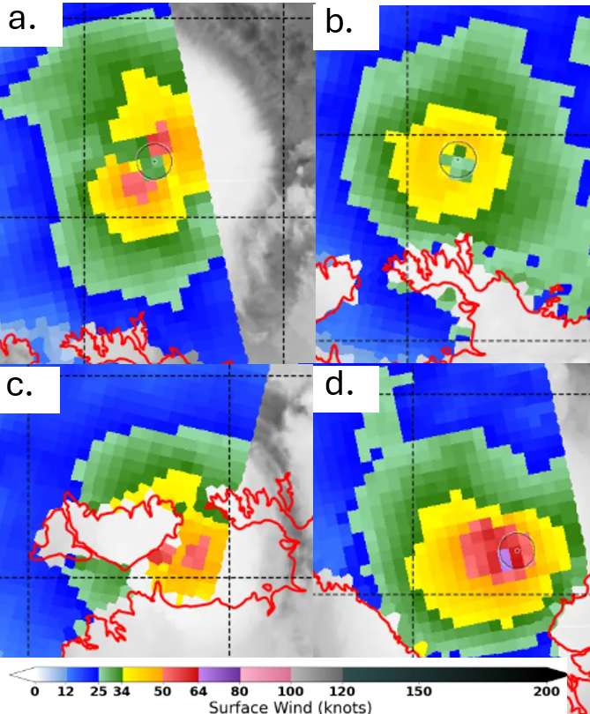
Figure 14. Series of ASCAT images. Dashed lines of lat. and long. every 2 degrees (120 nm). Images courtesy of NRL.
a. ASCAT-C 1228 UTC 19 November when Fina had developed to category 2 intensity.
b. ASCAT-C 0054 UTC 21 November when Fina had weakened to category 1 intensity and moving towards Cobourg Peninsula.
c. ASCAT-B 2350 UTC 21 November when Fina in Van Diemen Gulf near the southern coast of Melville Island.
d. ASCAT-C 1246 UTC 23 November when Fina was intensifying in the Joseph Bonaparte Gulf.
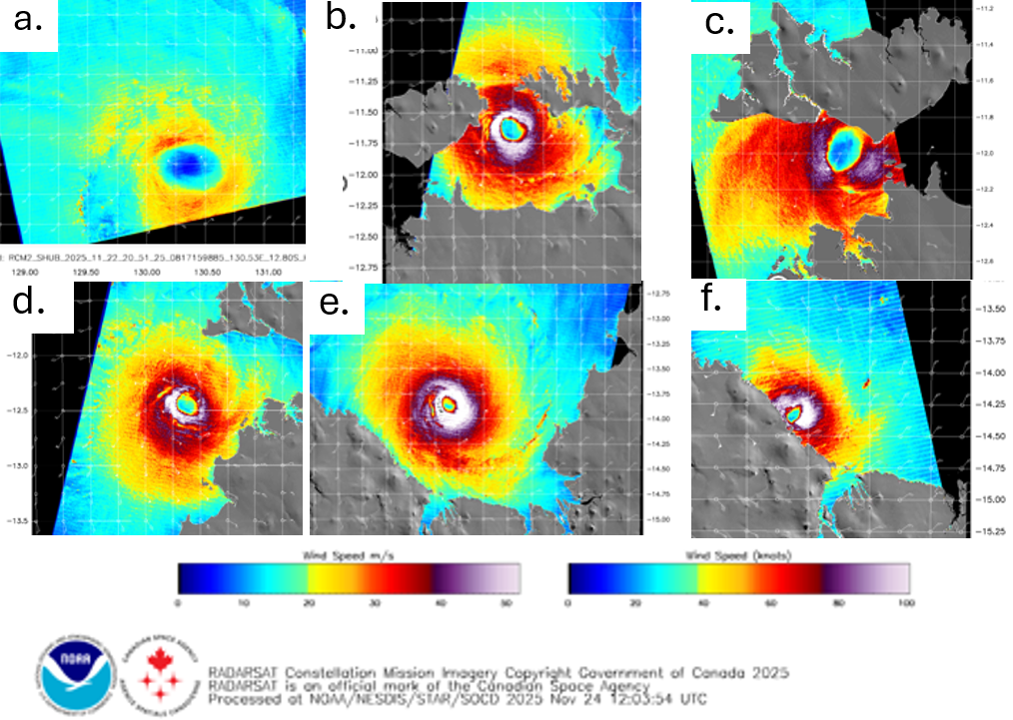
Figure 15. Series of satellite wind speeds from SAR during Fina. Note scale variations. Maximum winds and RMW are NOAA estimates. Images courtesy of NOAA. https://www.star.nesdis.noaa.gov/socd/mecb/sar/sarwinds_tropical.php
a. RCM-3 0929 UTC 20 November, when Fina was north of the Northern Territory. Maximum winds 54 kn. RMW=15 nm.
b. RCM-2 2043 UTC 21 November when Fina was moving over Van Diemen Gulf and intensifying. Maximum winds 108 kn. RMW=7 nm.
c. RCM-3 at 0944 UTC 22 November when Fina near the southern tip of Melville Is. Maximum winds 85 kn. RMW=9 nm.
d. RCM-2 2051 UTC 22 November when Fina was re-intensifying over the Joseph Bonaparte Gulf. Maximum winds 101 kn. RMW= 6 nm.
e. RCM-2 2059 UTC 23 November when Fina was near peak intensity moving over the Joseph Bonaparte Gulf. Maximum winds 118 kn. RMW=8 nm.
f. RCM-3 1000 UTC 24 November, just prior to Fina crossing the northeast Kimberley coast. Maximum winds 109 kn. RMW=5 nm.

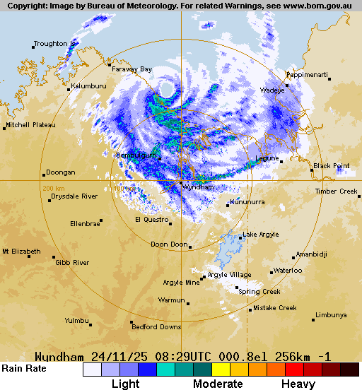
Figure 16. Wyndham radar at 0829 UTC 24 November showing Fina with a well-defined eye as it was nearing the northeast Kimberley coast.

- Impact
Fortunately, there were no deaths or major injuries reported during Fina. However, communities in the path experienced varying levels of damage to infrastructure and vegetation.
Fina initially crossed the Cobourg Peninsula in a sparsely populated area, with no known impacts.
Tiwi Islands
The Tiwi College boarding school on Melville Island sustained significant damage to buildings and water tanks which resulted in an evacuation of the teachers and pupils after the event. There was extensive damage to vegetation reported over southern Melville Island with eucalypt trees snapped and defoliated as shown in the photo in Figure 18. This is indicative of very destructive winds with gusts in excess of 160 km/h likely.
At Wurrumiyanga destructive wind gusts estimated at 125-150 km/h downed many trees which in turn caused widespread power outages that affected water supplies and communications. Wurrumiyanga residents described the experience as terrifying with Tiwi Islands deputy mayor Mary Dunn saying of the wind "It was like a wooing sound and a whistle". Source: https://www.abc.net.au/news/2025-11-25/nt-tiwi-islands-severe-tropical-cyclone-fina-damage-recovery/106044336
All roads between Tiwi Island communities were blocked by felled trees.
Minjilang experienced gales that downed trees and caused minor power disruptions.

Greater Darwin
The destructive core of Fina passed just to the north of Darwin but the city did experience gale force winds. Hundreds of large trees were downed across the greater Darwin area, many over power lines with some houses damaged. An estimated 19,900 homes (out of 67,000) lost power for a prolonged period. Wall cladding failure led to ceiling collapse at Royal Darwin Hospital.

Northeast Kimberley coast
The Berkeley River Lodge suffered significant wind damage to structures and vegetation as shown in Figure 19. The two caretakers sheltered in a bunker for 16 hours due to the prolonged period of gales. They were left stunned by the destruction saying "We went into that bunker, and it had been a paradise, and lush in nature, and then we came out and the landscape was completely bare." Source: https://www.abc.net.au/news/2025-11-27/caretakers-survive-cyclone-fina-in-underground-bunker/106074722

- Observations
  - Wind
Several Northern Territory observation sites recorded gale-force winds but there were no observations recorded within Fina's destructive core.
McCluer Island
Maximum 10-minute mean wind 44 kn (81 km/h) at 0704 UTC 21 November.
Maximum 3-sec wind gust 56 kn (104 km/h) at 1628 UTC 21 November.
Prolonged gales between 0311-1512 UTC 21 November.

Croker Island
Maximum 10-minute mean wind: 39 kn (72 km/h) at 1209 UTC 21 November.
Maximum 3-sec wind gust: 59 kn (109 km/h) at 1138 UTC 21 November.
Prolonged gales between 1138-1248 UTC 21 November.

Point Stuart
Maximum 10-minute mean wind: 35 kn (64 km/h) at 0412 UTC 22 November.
Maximum 3-sec wind gust: 55 kn (102 km/h) at 2252 UTC 21 November.
Prolonged gales between 0412-0416 UTC 22 November.

Darwin Airport
Maximum 10-minute mean wind: 44 kn (81 km/h) at 1035, 1040, 1041, 1042, 1043, 1044 UTC 22 November.
Maximum 3-sec wind gust: 58 kn (107 km/h) at 1041 UTC 22 November.
Prolonged gales between 0848-1238 UTC 22 November.
Charles Point
Maximum 10-minute mean wind: 39 kn (72 km/h) at 1629, 1630, 1633, 1644, 1645 UTC 22 November
Maximum 3-sec wind gust: 55 kn (102 km/h) at 1619 UTC 22 November.
Prolonged gales between 1425-1454 and 1523-1741 22November.

  - Rainfall
Figure 17 shows the rainfall distribution for the week ending 27 November. The heaviest rainfall occurred over the Top End coast on 21-23 November as Fina passed by.
Notable totals for the 24 hours to 9am CST 23 November include:
Middle Point 430 mm; Gunn Point 283.6 mm; Charles Point 265.4 mm; Adelaide River 264.5 mm; Middle Point Rangers 248.8 mm; Girraween 206.4 mm; Knuckey Lagoon 204.8 mm;

  - Storm Surge
No significant storm surge was recorded during this event.

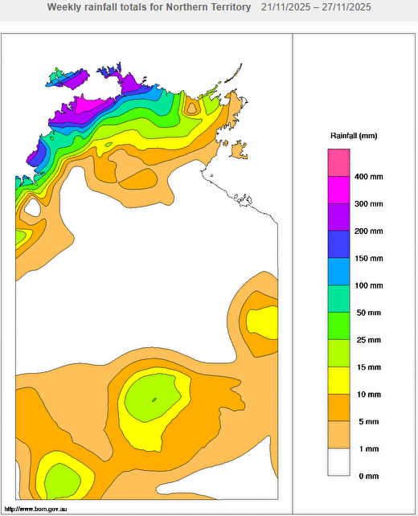
Figure 17. Rainfall analysis for the week ending 27 November 2025.
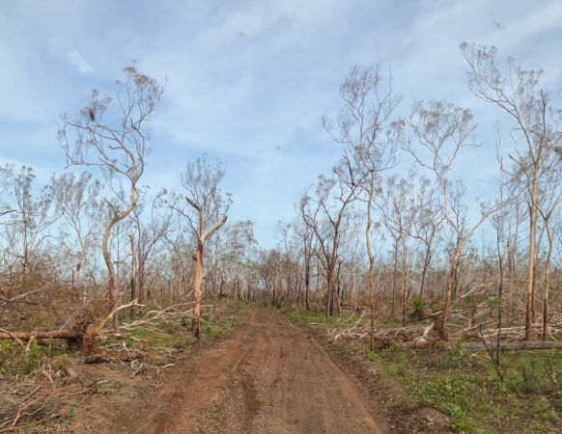
Figure 18. Damage to trees near Tiwi College. Photo courtesy: NT Fire and Emergency Services.
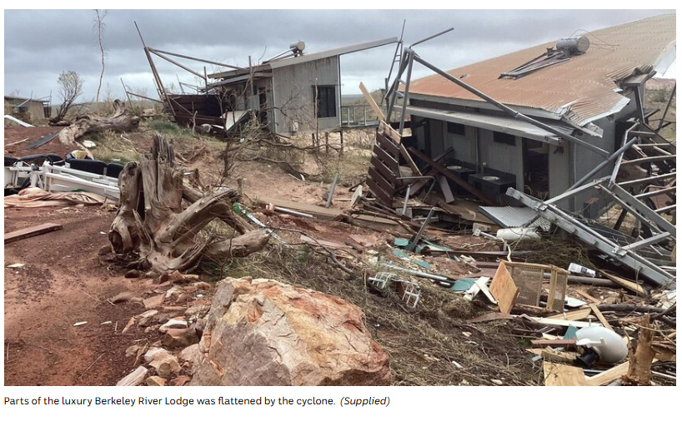
Figure 19. Significant damage to the Berkeley River Lodge, WA. Photo supplied to ABC available: https://www.abc.net.au/news/2025-11-25/tropical-cyclone-fina-impacts-luxury-resort-berkeley-river-/106050682
- Forecast Performance
The potential for a tropical cyclone to develop was first detected on 9 November when 02U was assigned and was then included on 7-Day forecasts from 12 November. Most model guidance underestimated the potential for development and ratings were issued at 'Low' (5-20% probability) in the lead up to 18 November when it reached TC intensity, with higher ratings for following days.
The first track map was issued at 0000 UTC 18 November, coinciding with the first Ocean Wind Warning and Technical Bulletin, and continued until Fina had weakened overland at 0600 UTC 25 November. The first TC Watch for the Northern Territory coast was issued at 0000 UTC 19 November, as shown in Figure 20.
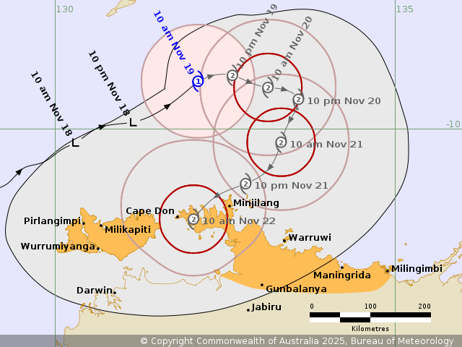
Figure 20. Forecast track map of the first Advice issued at 0000 UTC 19 November showing the area under watch along the northern coast of Northern Territory.
The accuracy statistics for Severe Tropical Cyclone Fina are below in Table 2 and shown in Figure 21 (track) and Figure 22 (intensity).
Forecast track position accuracy was better than the five-year average over the entire verification period. This represents a very good performance given the sharp turn back towards the Northern Territory coast undertaken by Fina on 20 November.
Intensity forecasts were generally poorer than the 5-year average. The forecast intensity through the period from formation to crossing the Cobourg Peninsular were accurate, with a Category 2 impact indicated from the first forecast track. In contrast, the intensity forecasts made for the period that Fina moved through the Van Diemen Gulf and across the Joseph Bonaparte Gulf consistently underestimated its strength. Fina reached Category 3 (65 kn or 120 km/h) intensity at 1800 UTC 21 November while located in Van Diemen Gulf. However, the first Category 3 system indicated on any forecast track wasn't made until 1200 UTC on 20 November, this was for 0600 UTC on 23 November, some 36 hours after it occurred.
Model guidance indicated Fina would begin a rapid weakening trend from late on 23 November or early on 24 November, weakening to below tropical cyclone strength over water by 25 November, well to the north of the eventual coastal impact location. In reality, Fina maintained Category 4 intensity as it impacted the northeast Kimberley coast on 24 November, and this contributed significantly to the poor intensity forecast accuracy.

Time | 00 | 06 | 12 | 18 | 24 | 36 | 48 | 72 | 96 | 120
Position accuracy (km) | 6 | 11 | 15 | 19 | 23 | 32 | 43 | 64 | 77 | 83
Intensity accuracy (knots) | 4.8 | 6.2 | 7.4 | 8.5 | 9.3 | 12.32 | 13.5 | 16.6 | 25.0 | 31.1
Sample Size | 29 | 29 | 29 | 29 | 29 | 28 | 26 | 22 | 18 | 14
Table 2: Verification statistics for Severe Tropical Cyclone Fina. Note: Verification is performed using the Official Forecast Tracks at the standard times of 00, 06, 12 and 18 UTC.
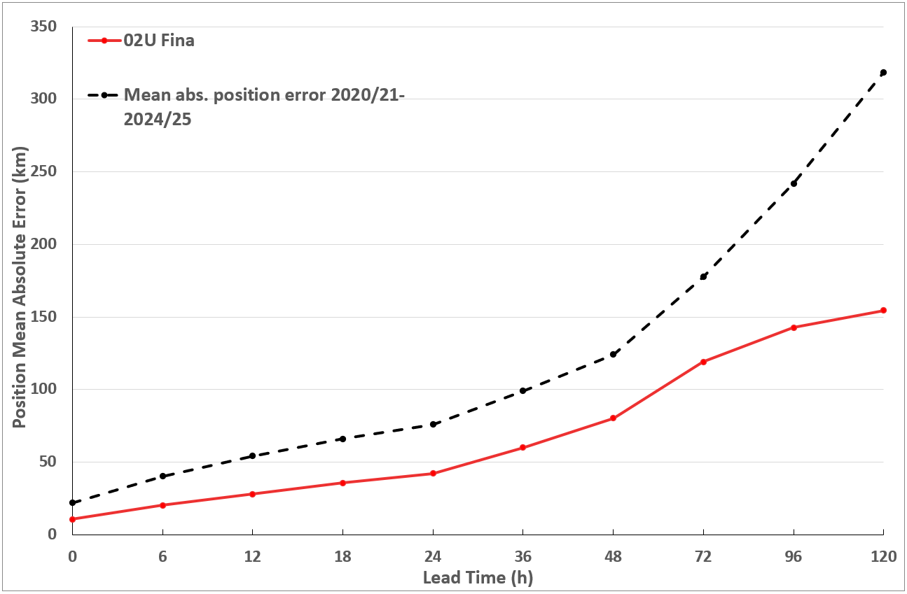
Figure 21. Position accuracy figures for Severe Tropical Cyclone Fina plotted against the 5-year average.
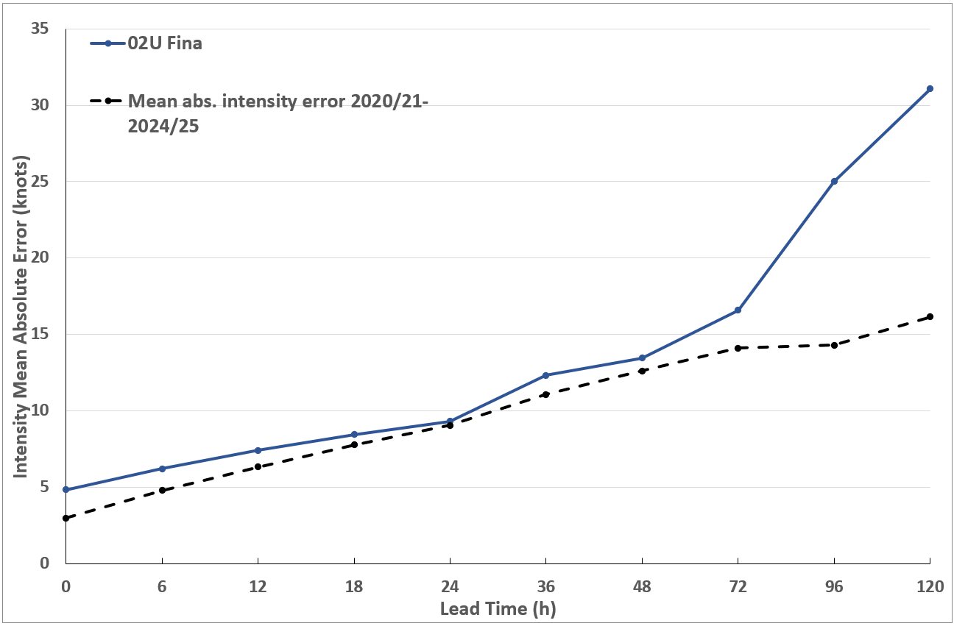
Figure 22. Intensity accuracy figures for Severe Tropical Cyclone Fina potted against the 5-year average.

Appendix: List of abbreviations
Abbreviation | Term
ADT | Advanced Dvorak Technique
ACST | Australian Central Standard Time
AEST | Australian Eastern Standard Time
AiDT | AI-enhanced Dvorak Technique
AMSR2 | Advanced Microwave Scanning Radiometer
AMSU | Advanced Microwave Sounding Unit
ASCAT | Advanced Scatterometer
ATMS | Advanced Technology Microwave Sounder
AWS | automatic weather station
AWST | Australian Western Standard Time
°C | Celsius
CI | Current intensity
CIMSS | Cooperative Institute for Meteorological Satellite Studies (USA)
CIRA | Cooperative Institute for Research in the Atmosphere (USA)
D-MINT | Deep learning - Multispectral Intensity of TCs (formerly known as DMN)
D-PRINT | Deep learning - IR Intensity of TCs (formerly known as OPEN-AIIR)
DT | Data T-number
EIR | Enhanced InfraRed
ERC | eyewall replacement cycle
FNMOC | Fleet Numerical Meteorology and Oceanography Centre (USA)
FT | Final T-number
GCOM | Global Change Observation Mission
GHz | Gigahertz
GMI | Global Precipitation Measurement Microwave Imager
h | hour
hPa | hectopascal
HSCAT | Hai Yang 2 Scatterometer (HY-2B, HY-2C)
km | kilometres
km/h | kilometres per hour
kn | knot
LLCC | LLCC
MET | Model Expected T-number
METOP | Meteorological Operational Satellite
MJO | Madden-Julian Oscillation
mm | millimetres
MSLP | mean sea level pressure
NESDIS | National Environmental Satellite, Data, and Information Service
nm | nautical mile
NOAA | National Oceanic and Atmospheric Administration
NRL | Navy Research Lab (USA)
OPEN-AiiR | Ordered Pattern Encoding AI Infrared
OSCAT | Ocean Scatteromoter
PAT | Pattern T-number
RCM | RadarSat Constellation Mission – Synthetic Aperture Radar
RH | relative humidity
RMW | radius of maximum winds
RSMC | Regional Specialised Meteorological Centre
SAR | Synthetic Aperture Radar
SATC | CIMSS Advanced Dvorak Technique
SATCON | Satellite Consensus
SEN1 | Sentinel-1A – Synthetic Aperture Radar
SMAP | Soil Moisture Active Passive
SMOS | Soil Moisture and Ocean Salinity
SSMIS | Special Sensor Microwave Imager/Sounder
TC | Tropical Cyclone
TCWC | Tropical Cyclone Warning Centre
UTC | Universal Time Co-ordinated

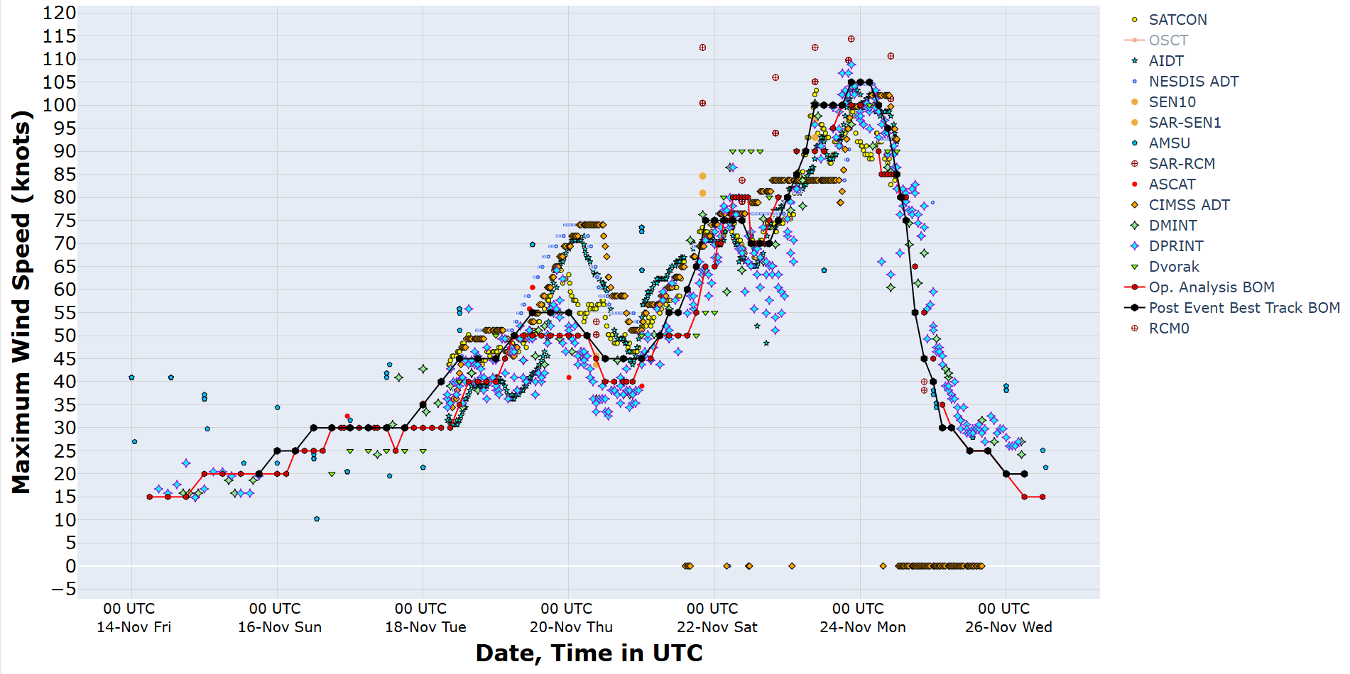
Figure 23. Intensity plot of objective and subjective guidance. SATCON, AiDT, NESDIS ADT, SAR-SEN1, SAR-RCM, ASCAT, CIMMS ADT, DMINT, DPRINT, Dvorak subjective estimate, operational analysis (red) and post event best track analysis (black). All wind speeds are 10-minute mean wind speeds.

