Tropical Cyclone Grant (03U)
16 - 27 December 2025
Tropical Cyclone Environmental Prediction Services
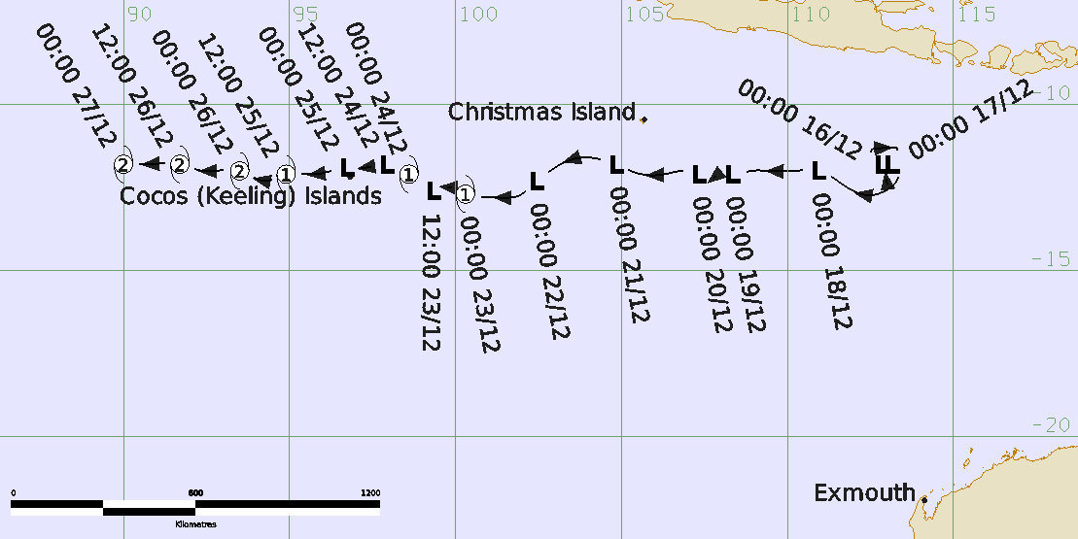

Revision history
Date | Version | Author | Description
09/06/2026 | 1.0 | EPS TC | Final Draft

Release history
Date | Version | Status | Approval
11/06/2026 | 1.0 | Approved for release | Manager, EPS-TC
Contact details:
Tropical Cyclone Team Lead
Weather Environmental Prediction Services
Bureau of Meteorology
PO Box 1370, West Perth WA 6872
Email: tcwc@bom.gov.au

This work is copyright. Apart from any use as permitted under the Copyright Act 1968, no part may be reproduced without prior written permission from the Bureau of Meteorology. Refer to www.bom.gov.au/other/copyright.shtml for further information. Unless otherwise noted, all images in this document are licensed under the Creative Commons Attribution Australia Licence.
© Commonwealth of Australia 2026
Published by the Bureau of Meteorology
Cover image: Best track of Tropical Cyclone Grant, 16-27 December 2025. Times are in UTC (AWST = UTC +8 hours, CCT = UTC +6.5 hours).
Table of Contents

1. Summary 5

2. Meteorological description 8

2.1. Intensity analysis 8

2.2. Structure 18

2.3. Motion 18

3. Impact 19

4. Observations 19

4.1. Pressure 20

4.2. Rainfall 20

4.3. Storm Surge 20

5. Forecast Performance 21

Appendix: List of abbreviations 24

List of Figures
Figure 1: Best track of Tropical Cyclone Grant, 16-27 December 2025.. 6
Figure 2: SAR RCM-3 at 2236 UTC 21 December 10
Figure 3: SAR RCM-3 at 2244 UTC 22 December. 11
Figure 4: OCEANSAT-3 at 0508 UTC 23 December. 12
Figure 5: AMSR2 and SMOS passes on 23 December 13
Figure 6: SAR RCM-3 at 2252 UTC 23 December. 14
Figure 7: SAR RCM-1 at 1153 UTC 24 December. 15
Figure 8: ASCAT at 1525 UTC 24 December 16
Figure 9: SAR RCM-3 at 2300 UTC 24 December . 17
Figure 10. AMSR2 and Himawari-9 satellite image on 25 December 17
Figure 11: SAR RCM-1 at 1209 UTC 26 December. 18
Figure 12 Plot of 10-minute mean wind (kn), wind gusts (kn) and MSLP (hPa) at Cocos (Keeling) Islands 19
Figure 13 The forecast percentage risk of a low developing into a tropical cyclone. 21
Figure 14: Position accuracy figures for Tropical Cyclone Grant. 22
Figure 15: Intensity accuracy figures for Tropical Cyclone Grant. 23
Figure 16: Intensity plot of objective and subjective guidance.. 26
Figure 17: SATCON Intensity plot 27

List of Tables
Table 1: Best track summary for Tropical Cyclone Grant, 16-27 December 2025. 6
Table 2: Verification statistics for Tropical Cyclone Grant. 22

- Summary
Tropical Cyclone Grant developed south of Indonesia and moved generally westward across the southern Indian Ocean. The system passed close to the north of the Cocos (Keeling) Islands on 25 December 2025, with gale-force winds in the southern quadrants affecting the islands on Christmas morning.
Seven-day forecasts for the formation of Tropical Low 03U in the Indian Ocean were issued on the Bureau of Meteorology website from 2 December 2025. The Tropical Low 03U formed south of the Indonesian archipelago on 16 December 2025. The system moved generally westwards and developed into Tropical Cyclone Grant on 23 December 2025.
The gale-force winds contracted to less than halfway around the centre in the next six hours, and Grant was downgraded to a tropical low. The system briefly re-intensified to tropical cyclone strength early on 24 December before weakening again later that day as it approached the Cocos (Keeling) Islands from the east.
Tropical Low 03U (Ex-Grant) approached the Cocos (Keeling) Islands during the early hours of 25 December, with gale-force winds in the southern quadrants. Gales extended to a radius of around 25 nm (46 km) over the Cocos (Keeling) Islands for several hours on 25 December. Minimal damage and impacts were reported on the islands.
After moving past the Cocos (Keeling) Islands, 03U re-intensified to Tropical Cyclone Grant at 1200 UTC 25 December (AWST=UTC+8 hours) and strengthened to a category 2 system in the next 12 hours at 0000 UTC 26 December. Grant maintained category 2 intensity as it moved into La Réunion’s area of responsibility (west of 90°E) on 27 December 2025.
As it continued westward outside the Australian region, Grant intensified further, reaching category 4 intensity on 29 December 2025. It remained a severe tropical cyclone over the southern Indian Ocean before weakening to category 1 intensity on 1 January 2026. The system weakened below tropical cyclone strength on 3 January while located well to the east of Madagascar.

Figure 1: Best track of Tropical Cyclone Grant, 16-27 December 2025. Times are in UTC (AWST=UTC+8 hours, CCT=UTC+6.5 hours).

Year | Month | Day | Hour | Pos. | Pos. | Pos. | Max Wind | Max | Cent. | Rad. of gales | Rad. of storm | RMW
 |  |  | UTC | Lat. | Long. | Acc. | 10min | gust | Press. | (NE/SE/ | (NE/SE/ | nm
 |  |  |  | S | E | nm | kn | kn | hPa | SW/NW) | SW/NW)
2025 | 12 | 15 | 1800 | 12.4 | 113.0 | 35 | 25 | 45 | 1006 | 0/0/0/0 | 0/0/0/0 | -
2025 | 12 | 16 | 0000 | 11.8 | 112.8 | 25 | 30 | 45 | 1006 | 0/0/0/0 | 0/0/0/0 | -
2025 | 12 | 16 | 0600 | 11.4 | 112.5 | 20 | 30 | 45 | 1006 | 0/0/0/0 | 0/0/0/0 | -
2025 | 12 | 16 | 1200 | 11.3 | 113.1 | 30 | 30 | 45 | 1004 | 0/0/0/0 | 0/0/0/0 | -
2025 | 12 | 16 | 1800 | 11.3 | 113.3 | 30 | 30 | 45 | 1004 | 0/0/0/0 | 0/0/0/0 | -
2025 | 12 | 17 | 0000 | 11.8 | 113.1 | 25 | 30 | 45 | 1002 | 0/0/0/0 | 0/0/0/0 | -
2025 | 12 | 17 | 0600 | 12.1 | 113.3 | 10 | 30 | 45 | 1002 | 0/0/0/0 | 0/0/0/0 | -
2025 | 12 | 17 | 1200 | 12.7 | 112.7 | 10 | 30 | 45 | 1002 | 0/0/0/0 | 0/0/0/0 | -
2025 | 12 | 17 | 1800 | 12.5 | 111.8 | 25 | 30 | 45 | 1002 | 0/0/0/0 | 0/0/0/0 | -
2025 | 12 | 18 | 0000 | 12.0 | 110.9 | 25 | 35* | 50 | 998 | 0/0/0/40 | 0/0/0/0 | -
2025 | 12 | 18 | 0600 | 12.0 | 110.2 | 25 | 35* | 50 | 999 | 0/0/0/50 | 0/0/0/0 | -
2025 | 12 | 18 | 1200 | 12.0 | 109.4 | 30 | 35* | 50 | 998 | 0/0/0/50 | 0/0/0/0 | -
2025 | 12 | 18 | 1800 | 12.0 | 108.9 | 30 | 35* | 50 | 999 | 0/0/0/60 | 0/0/0/0 | -
2025 | 12 | 19 | 0000 | 12.1 | 108.3 | 30 | 35* | 50 | 998 | 0/0/0/60 | 0/0/0/0 | -
2025 | 12 | 19 | 0600 | 12.1 | 107.9 | 30 | 35* | 50 | 997 | 0/0/0/80 | 0/0/0/0 | -
2025 | 12 | 19 | 1200 | 12.2 | 107.8 | 30 | 35* | 50 | 997 | 0/0/0/50 | 0/0/0/0 | -
2025 | 12 | 19 | 1800 | 12.2 | 107.6 | 30 | 35* | 50 | 998 | 0/0/0/80 | 0/0/0/0 | -
2025 | 12 | 20 | 0000 | 12.1 | 107.3 | 30 | 35* | 50 | 998 | 0/0/0/30 | 0/0/0/0 | -
2025 | 12 | 20 | 0600 | 12.0 | 106.9 | 30 | 30 | 45 | 998 | 0/0/0/0 | 0/0/0/0 | -
2025 | 12 | 20 | 1200 | 12.1 | 106.3 | 30 | 30 | 45 | 998 | 0/0/0/0 | 0/0/0/0 | -
2025 | 12 | 20 | 1800 | 12.1 | 105.6 | 30 | 30 | 45 | 998 | 0/0/0/0 | 0/0/0/0 | -
2025 | 12 | 21 | 0000 | 11.8 | 104.8 | 30 | 35* | 50 | 999 | 0/0/0/30 | 0/0/0/0 | -
2025 | 12 | 21 | 0600 | 11.6 | 103.8 | 30 | 35* | 50 | 998 | 0/0/0/30 | 0/0/0/0 | -
2025 | 12 | 21 | 1200 | 11.9 | 103.0 | 20 | 35* | 50 | 999 | 40/0/0/0 | 0/0/0/0 | -
2025 | 12 | 21 | 1800 | 12.1 | 102.7 | 25 | 35* | 50 | 997 | 40/0/0/0 | 0/0/0/0 | -
2025 | 12 | 22 | 0000 | 12.3 | 102.4 | 25 | 35* | 50 | 999 | 70/0/0/40 | 0/0/0/0 | -
2025 | 12 | 22 | 0600 | 12.7 | 102.0 | 25 | 35* | 50 | 999 | 0/50/0/0 | 0/0/0/0 | -
2025 | 12 | 22 | 1200 | 12.8 | 101.1 | 20 | 35* | 50 | 998 | 0/60/60/0 | 0/0/0/0 | -
2025 | 12 | 22 | 1800 | 12.8 | 100.7 | 30 | 35* | 50 | 998 | 0/35/40/0 | 0/0/0/0 | -
2025 | 12 | 23 | 0000 | 12.7 | 100.3 | 20 | 40 | 55 | 995 | 40/35/25/25 | 0/0/0/0 | 15
2025 | 12 | 23 | 0600 | 12.5 | 99.7 | 20 | 40* | 55 | 996 | 0/35/0/0 | 0/0/0/0 | -
2025 | 12 | 23 | 1200 | 12.6 | 99.3 | 10 | 35* | 50 | 998 | 0/55/0/0 | 0/0/0/0 | -
2025 | 12 | 23 | 1800 | 12.3 | 99.0 | 15 | 25 | 45 | 996 | 0/0/0/0 | 0/0/0/0 | -
2025 | 12 | 24 | 0000 | 12.1 | 98.6 | 10 | 35 | 50 | 995 | 40/30/30/0 | 0/0/0/0 | 15
2025 | 12 | 24 | 0600 | 11.9 | 98.2 | 10 | 35 | 50 | 995 | 30/30/30/10 | 0/0/0/0 | 15
2025 | 12 | 24 | 1200 | 11.8 | 97.9 | 10 | 35* | 50 | 996 | 0/25/0/0 | 0/0/0/0 | -
2025 | 12 | 24 | 1800 | 11.9 | 97.3 | 15 | 30 | 55 | 996 | 0/0/0/0 | 0/0/0/0 | -
2025 | 12 | 25 | 0000 | 11.9 | 96.7 | 10 | 35* | 55 | 996 | 10/25/0/0 | 0/0/0/0 | -
2025 | 12 | 25 | 0600 | 12.1 | 95.8 | 20 | 35* | 55 | 995 | 15/20/0/0 | 0/0/0/0 | -
2025 | 12 | 25 | 1200 | 12.1 | 94.9 | 20 | 40 | 55 | 994 | 15/20/50/45 | 0/0/0/0 | 15
2025 | 12 | 25 | 1800 | 12.3 | 94.3 | 20 | 45 | 65 | 992 | 20/30/50/45 | 0/0/0/0 | 15
2025 | 12 | 26 | 0000 | 12.0 | 93.5 | 20 | 50 | 70 | 990 | 25/30/50/45 | 0/0/25/0 | 16
2025 | 12 | 26 | 0600 | 12.0 | 92.4 | 20 | 50 | 70 | 990 | 20/30/40/40 | 0/0/25/0 | 18
2025 | 12 | 26 | 1200 | 11.8 | 91.7 | 10 | 50 | 70 | 990 | 30/30/30/35 | 15/15/20/15 | 10
2025 | 12 | 26 | 1800 | 11.8 | 90.8 | 15 | 50 | 70 | 987 | 30/30/30/40 | 15/15/20/15 | 10
2025 | 12 | 27 | 0000 | 11.8 | 90.0 | 15 | 50 | 70 | 987 | 30/30/30/40 | 15/20/20/15 | 15
Table 1: Best track summary for Tropical Cyclone Grant, 16-27 December 2025. UTC=AWST+8h. * Not a tropical cyclone as gales less than halfway around centre.

- Meteorological description
  - Intensity analysis
A comparison of the subjective and objective intensity estimates is shown in Figure 16 and SATCON intensity plot in Figure 17.
Tropical Low 03U formed in the Australian region over the southern Indian Ocean, south of the Indonesian Archipelago on 16 December 2025. The sea surface temperatures in the region were 28-30°C.
Development was slow, with 03U remaining a tropical low for several days while tracking westward under the influence of a broad subtropical ridge. Environmental conditions were only marginally favourable for development, with moderate to strong vertical wind shear and dry air wrapping around the circulation from the north.
Intermittent gales were observed under deep convection, primarily in the northwestern quadrant from 18 December. The SAR RCM-3 pass at 2236 UTC (AWST = UTC +8 hours) 21 December (Figure 2) showed presence of gales wrapping less than halfway around the centre.
The pattern of intermittent quadrant gales continued until 0000 UTC 23 December with the SAR RCM-3 pass at 2244 UTC 22 December (Figure 3) showing gales were wrapping more than halfway around the centre. The system was named Tropical Cyclone Grant at 0000 UTC 23 December. The maximum 10-minute sustained winds were estimated at 35 kn (65 km/h), with wind gusts to 50 kn (95 km/h). Objective guidance estimates at 0020 UTC 23 December included ADT 47 kn (87 km/h), AiDT 35 kn (65 km/h), and DPRINT 39 kn (72 km/h).
The subjective Dvorak intensity analysis was FT and CI of 3.0 at 0000 UTC 23 December. Dvorak intensity analysis proved challenging beyond this time for Grant, as neither a curved band nor a central dense overcast (CDO) pattern could consistently be applied. At times, a shear pattern may have been appropriate; however, the low-level circulation centre (LLCC) generally remained embedded beneath pulsating deep convection and cirrus cloud. Final intensity estimates were made using a combination of subjective Dvorak, objective guidance and additional microwave data.
The OSCAT pass at 0508 UTC 23 December (Figure 4) indicated that gales were no longer wrapping halfway around the centre and, consequently, Grant was downgraded to a tropical low at 0600 UTC 23 December. An AMSR2 pass at 0700 UTC 23 December (Figure 5a) showed gales confined to the southeastern quadrant, followed by SMOS pass at 1116 UTC 23 December (Figure 5b) providing further evidence of gales being restricted to the southeast quadrant. The Dvorak analysis at 1200 UTC 23 December yielded an FT and CI number of 2.5.
The SAR RCM-3 pass at 2252 UTC 23 December (Figure 6) showed gales wrapping more than halfway around the centre and Tropical Low 03U was renamed Tropical Cyclone Grant at 0000 UTC 24 December.
However later that day, Grant weakened once again to a tropical low by 1200 UTC 24 December, with gales contracting to the southeastern quadrant. This was indicated by SAR RCM-1 pass at 1153 UTC 24 December (Figure 7). The weakening trend was further supported by the ASCAT pass at 1526 UTC 24 December (Figure 8), showing gales were no longer present in any of the quadrants.
As Tropical Low 03U (Ex-Tropical Cyclone Grant) approached the Cocos (Keeling) Islands during the early hours of 25 December, gales redeveloped in the southern quadrants, extending to a radius of around 25 nautical miles (46 km). This was confirmed by the SAR RCM-3 pass at 2300 UTC 24 December (Figure 9) showing gales extended over the Cocos (Keeling) Islands.
After Tropical Low 03U passed close to the Cocos (Keeling) Islands, it re-intensified into a tropical cyclone at 1200 UTC 25 December. Six hours later, AMSR2 microwave pass at 1914 UTC 25 December (Figure 10a) showed a compact system with a well-developed low-level closed circulation.
The Dvorak FT and CI numbers at 1800 UTC 25 December were both 3.0, with a developing trend. Himawari-9 Infrared imagery at 1920 UTC 25 December (Figure 10b) showed some evidence of deep convection displaced to the west of the low-level circulation centre, indicating Grant was continuing to be influenced by moderate northeasterly wind shear.
Despite the shear, the system continued to strengthen to category 2 intensity at 0000 UTC 26 December, with maximum 10-minute mean winds estimated at 50 kn (93 km/h). The SAR RCM-1 pass at 1209 UTC 26 December (Figure 11) showed a well-developed category 2 tropical cyclone, with the maximum radius of gale-force winds extending to 40 nautical miles (74 km) in the northwestern quadrant.
Tropical Cyclone Grant maintained category 2 intensity and showed signs of improved organisation and structure as it moved west of 90°E and into the area of responsibility of Météo-France La Réunion shortly after 0000 UTC 27 December.
After leaving the Australian region, analyses from Météo-France La Réunion indicated that Grant continued to intensify, reaching category 4 intensity on 29 December (Figure 17- SATCON intensity) over the southern Indian Ocean, before weakening below tropical cyclone strength on 3 January 2026.
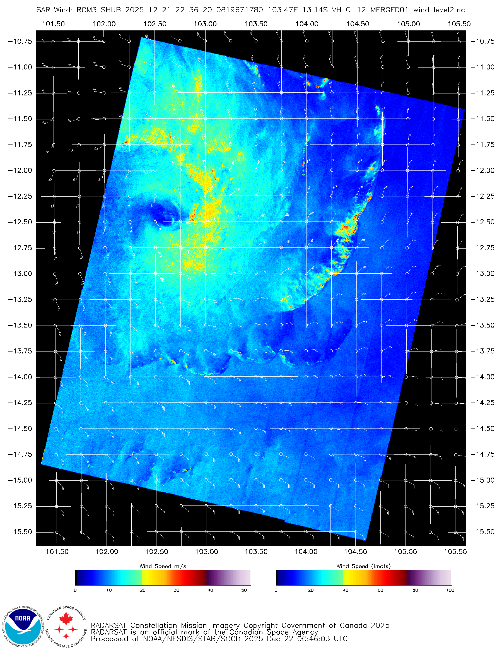
Figure 2: Satellite wind speeds from SAR RCM-3 at 2236 UTC 21 December showing presence of gales in eastern quadrants.
Images courtesy of NOAA: https://www.star.nesdis.noaa.gov/socd/mecb/sar/sarwinds_tropical.php?year=2026&storm=SH092026_GRANT
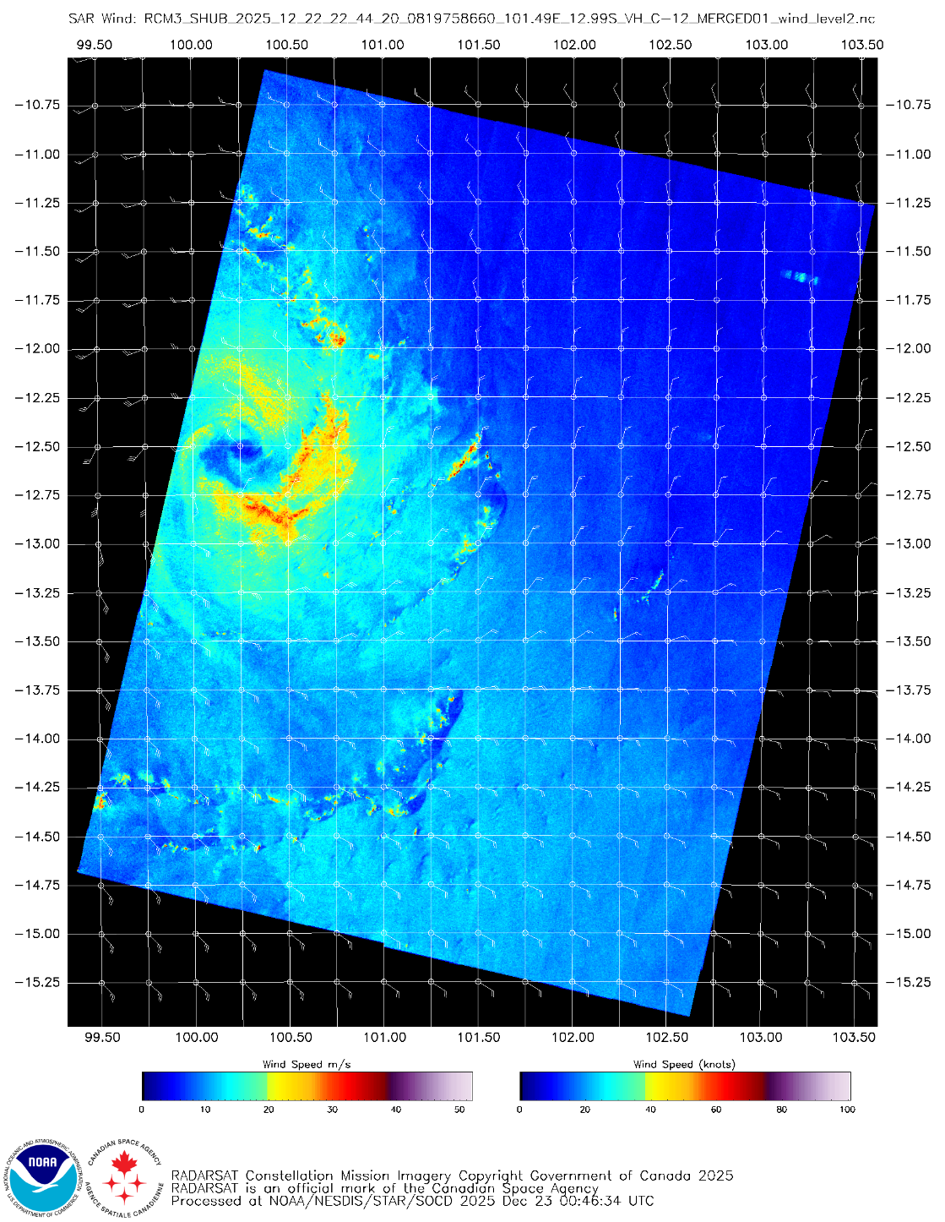
Figure 3: Satellite wind speeds from SAR RCM-3 at 2244 UTC 22 December showing gales wrapping more than halfway around the centre. The subjective Dvorak estimate at this time was FT and CI at 3.0.
Images courtesy of NOAA: https://www.star.nesdis.noaa.gov/socd/mecb/sar/sarwinds_tropical.php?year=2026&storm=SH092026_GRANT

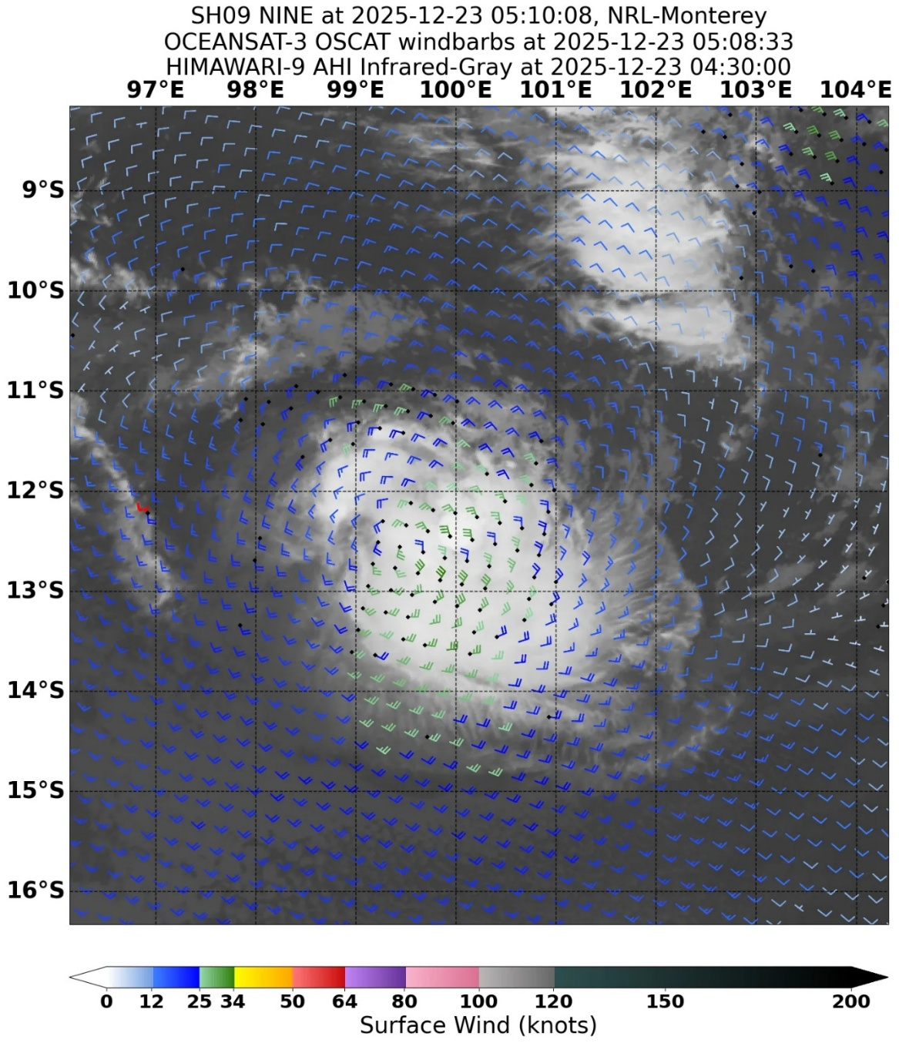
Figure 4: OCEANSAT-3 at 0508 UTC 23 December showing the absence of gale-force winds despite a subjective Dvorak intensity estimate at 0600 UTC 23 December giving a FT and CI of 3.0. Grant was downgraded to a tropical low at 0600 UTC 23 December.
Images courtesy of NRL: https://www.nrlmry.navy.mil/TC.html
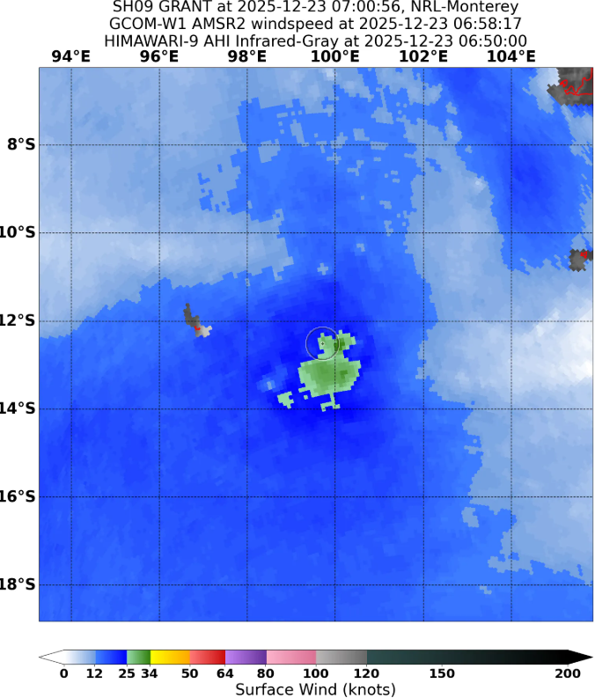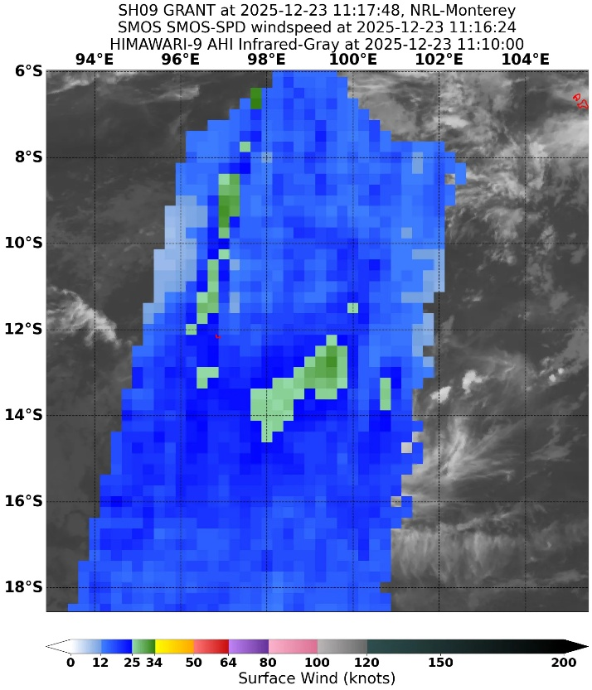
a.
b.
Figure 5: AMSR2 and SMOS passes on 23 December
a. AMSR2 pass at 0700 UTC 23 December showed gales had contracted to the southeast quadrant and Grant was downgraded to a tropical low at 0600 UTC 23 December.
b. SMOS pass at 1116 UTC 23 December with presence of gales in the southeast quadrant. The subjective Dvorak intensity estimate at 1200 UTC 23 December gave a FT and CI of 2.5.
Images courtesy of NRL: https://www.nrlmry.navy.mil/TC.html

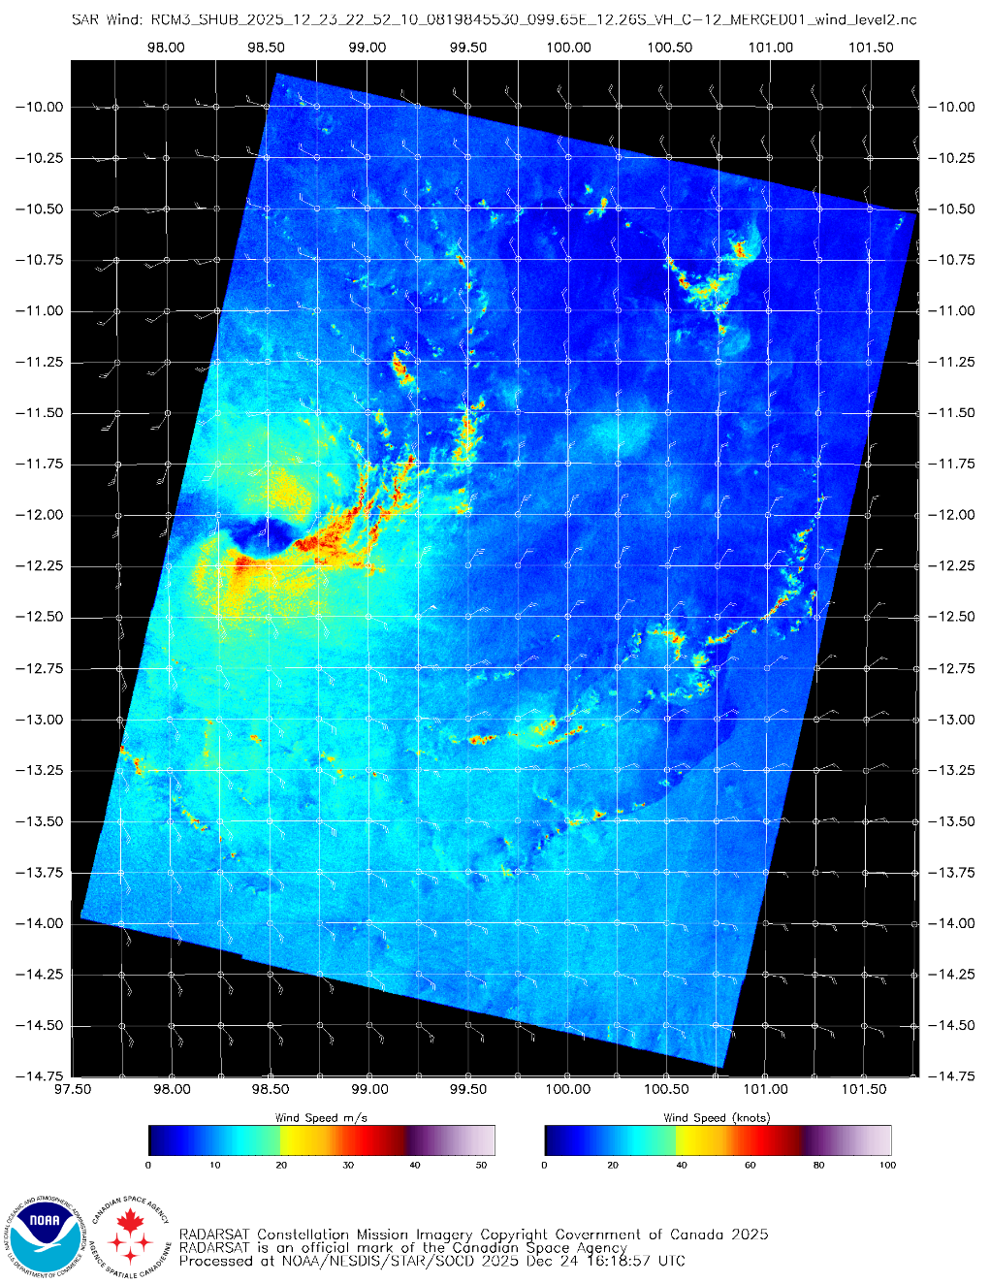
Figure 6: Satellite wind speeds from SAR RCM-3 at 2252 UTC 23 December showed gales wrapped more than halfway around the centre and the system was re-named Tropical Cyclone Grant at 0000 UTC 24 December.
Images courtesy of NOAA: https://www.star.nesdis.noaa.gov/socd/mecb/sar/sarwinds_tropical.php?year=2026&storm=SH092026_GRANT

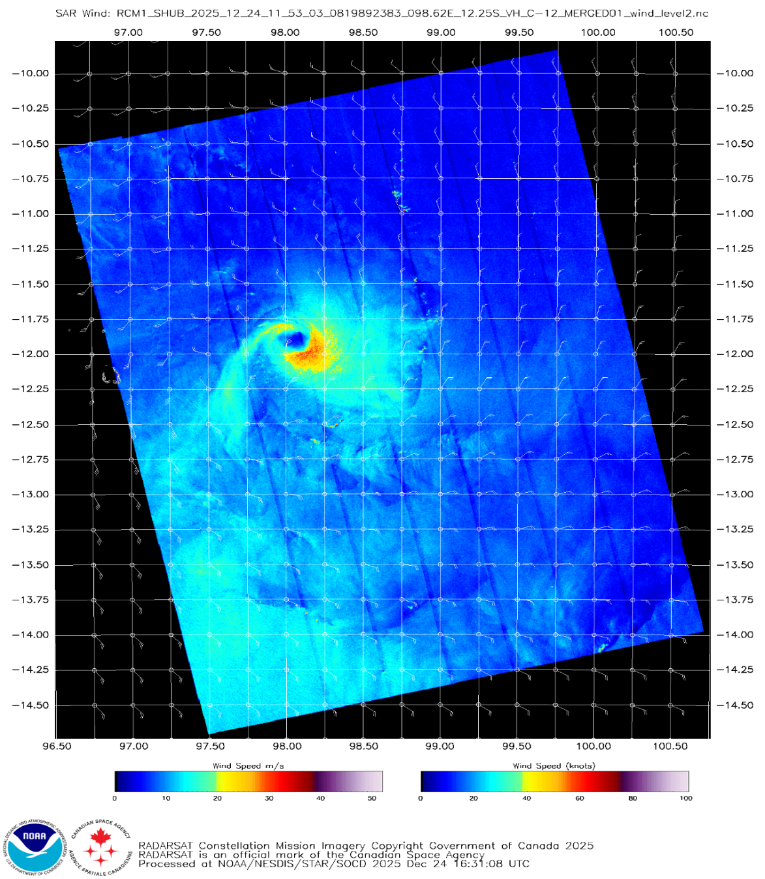
Figure 7: Satellite wind speeds from SAR RCM-1 at 1153 UTC 24 December showed gales had contracted to mostly the southeast quadrant and Grant was downgraded to a tropical low.
Images courtesy of NOAA: https://www.star.nesdis.noaa.gov/socd/mecb/sar/sarwinds_tropical.php?year=2026&storm=SH092026_GRANT

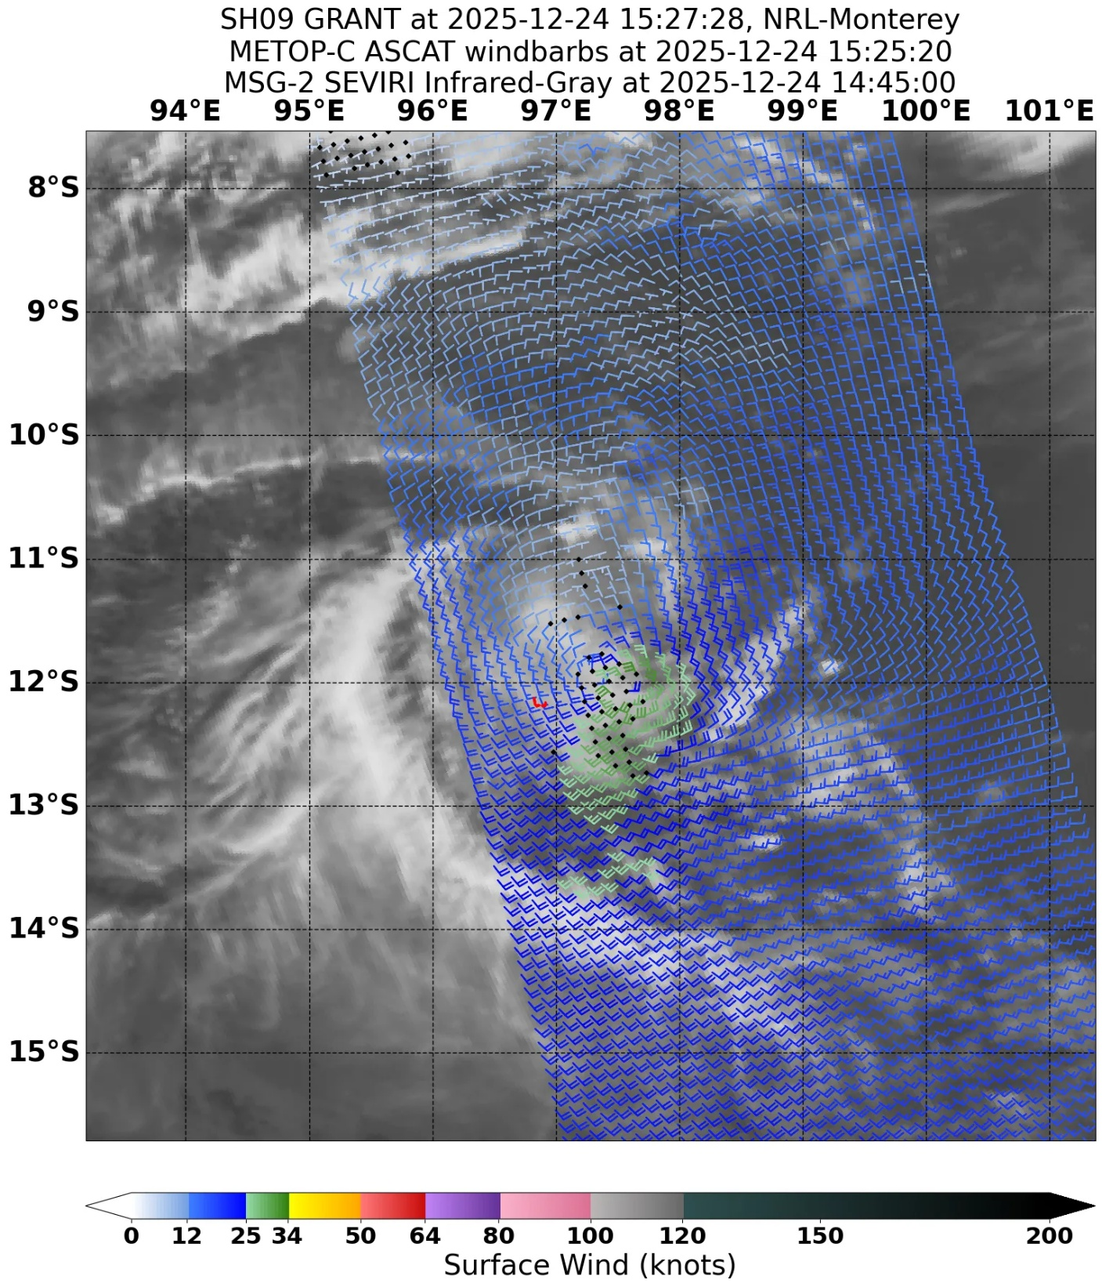
Figure 8: ASCAT pass at 1525 UTC 24 December showed gales had eased in all quadrants.
Images courtesy of NRL: https://www.nrlmry.navy.mil/TC.html
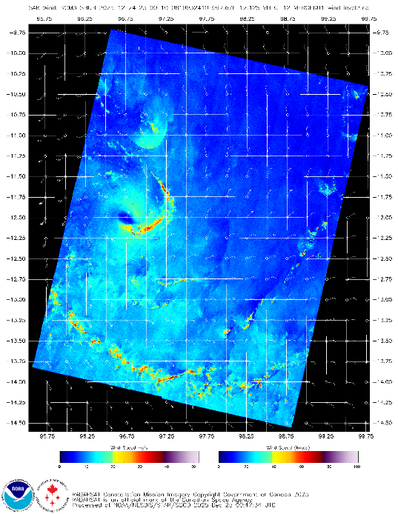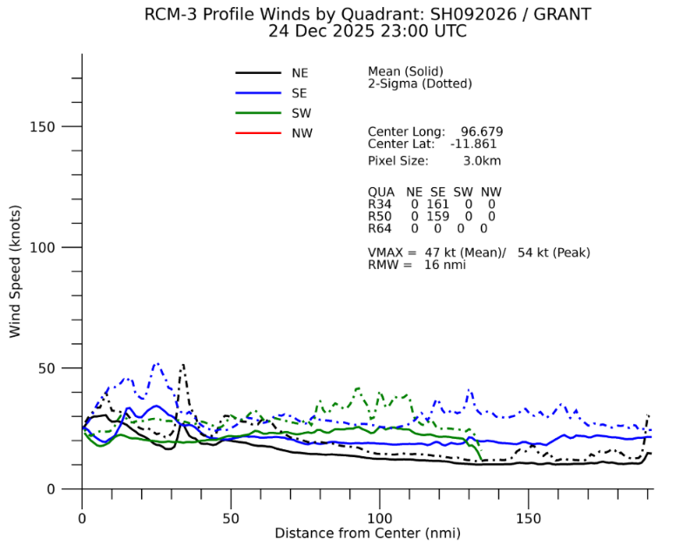
Figure 9: Satellite wind speeds from SAR RCM-3 at 2300 UTC 24 December showed gales had redeveloped in the southeast quadrant as Tropical Low 03U (Ex-Grant) moved close to the north of Cocos (Keeling) Islands. Maximum gale radius was 25 nm (46 km) in the southeast quadrant.
Images courtesy of NOAA: https://www.star.nesdis.noaa.gov/socd/mecb/sar/sarwinds_tropical.php?year=2026&storm=SH092026_GRANT
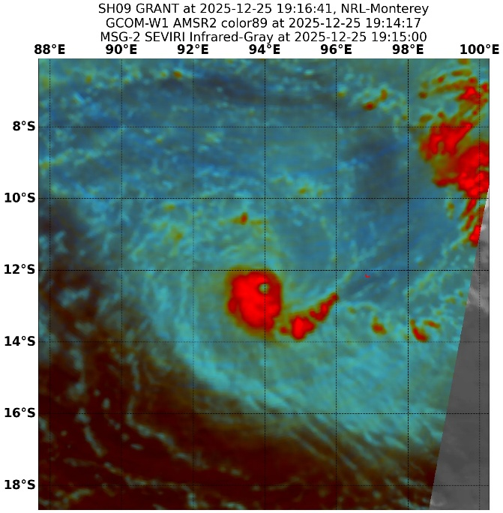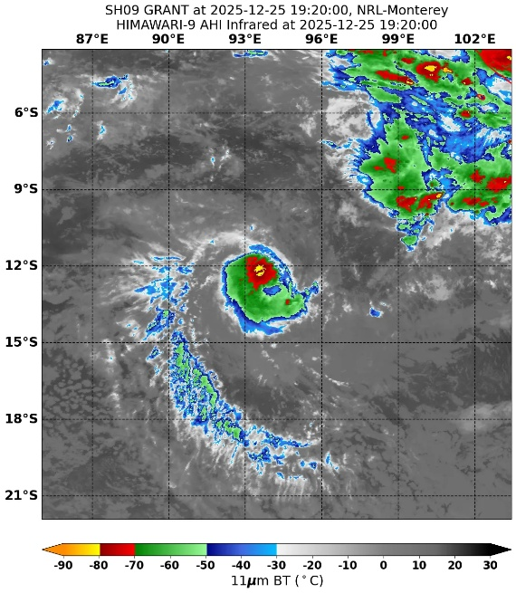
a.
b.
Figure 10. AMSR2 and Himawari-9 satellite image on 25 December
a. AMSR2 90 GHz microwave image at 1916 UTC 25 November of Tropical Cyclone Grant with a small but well-developed structure.
b. Himawari-9 satellite image of Grant with little or no major changes to the cloud pattern despite developing a strong low-level structure. The subjective Dvorak intensity at 1800 UTC 25 December gave a FT and CI of 3.0.
Images courtesy of NRL: https://www.nrlmry.navy.mil/TC.html

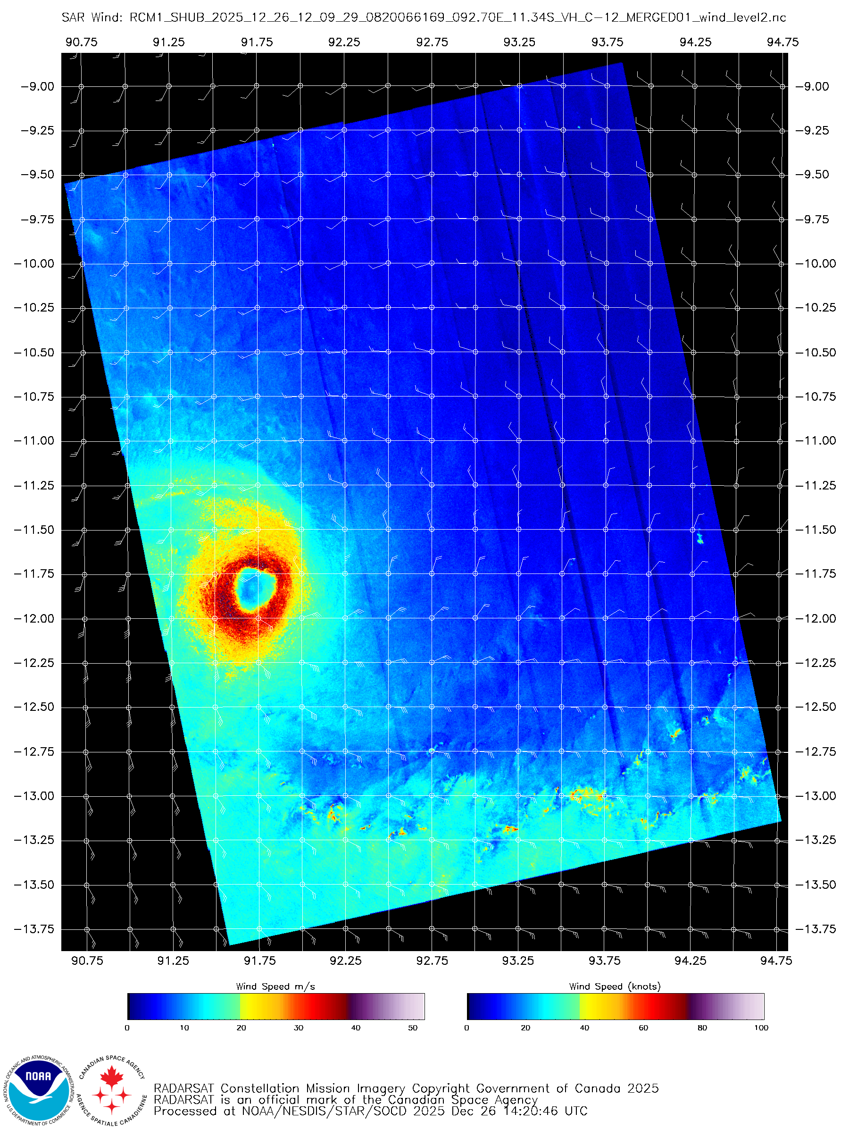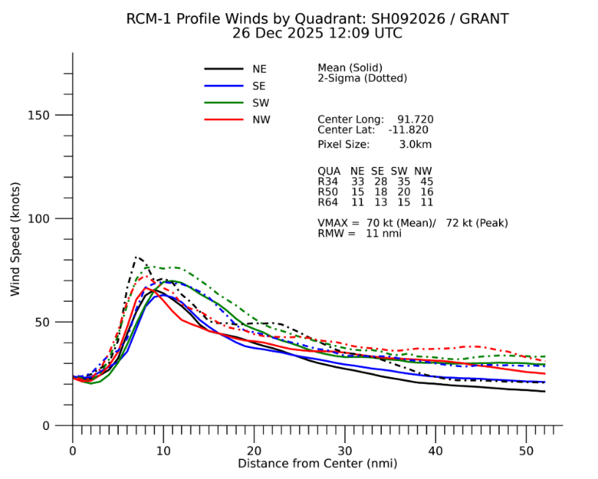
Figure 11: Satellite wind speeds from SAR RCM-1 at 1209 UTC 26 December, showed the small but well-developed structure of a category 2 tropical cyclone. Maximum gale radius was extended to roughly 40 nm (74 km) in the northwest quadrant.
Images courtesy of NOAA: https://www.star.nesdis.noaa.gov/socd/mecb/sar/sarwinds_tropical.php?year=2026&storm=SH092026_GRANT
  - Structure
Tropical Cyclone Grant was a compact small system for its entire lifetime in the Australian region, including during its peak intensity as it moved out of the region. Gale radii generally ranged from 40 to 50 nm (74 to 93 km) to as low as 15 - 20 nm (28 to 37 km).
  - Motion
Tropical Cyclone Grant moved predominantly westward across the southern Indian Ocean throughout its lifetime. This motion was governed by easterly steering flow on the northern flank of a subtropical ridge positioned to the south of the system. The system’s vertical depth was sufficient for it to be steered by the deep-layer mean flow associated with the ridge. Minor deviations in latitude and forward speed occurred at times due to the influence of transient mid-latitude troughs and embedded systems within the westerlies south of the ridge.
- Impact
Tropical Low 03U (Ex-Tropical Cyclone Grant) passed close to the north of Cocos (Keeling) Islands on the morning of 25 December 2025 with little or no impacts reported.
- Observations
The centre of Tropical Low 03U (Ex-Tropical Cyclone Grant) passed close to the north of Cocos (Keeling) Islands on the morning of 25 December 2025.
Plots of wind speed, wind gust and MSLP are presented in Figure 12.
Cocos (Keeling) Islands
Gale-force winds were observed for short periods between 1945 UTC 24 December and 0034 UTC 25 December 2025. The continuous and inclusive time range were:
19:45 to 20:02 UTC (18 minutes)
23:06 to 23:35 UTC (30 minutes)
23:44 to 00:34 UTC (51 minutes)
Maximum 10-minute mean wind of 43.7 kn (81 km/h) was recorded at 0015 UTC 25 December.
Maximum 3-sec wind gust of 55 kn (102 km/h) was recorded at 0005 UTC 25 December.
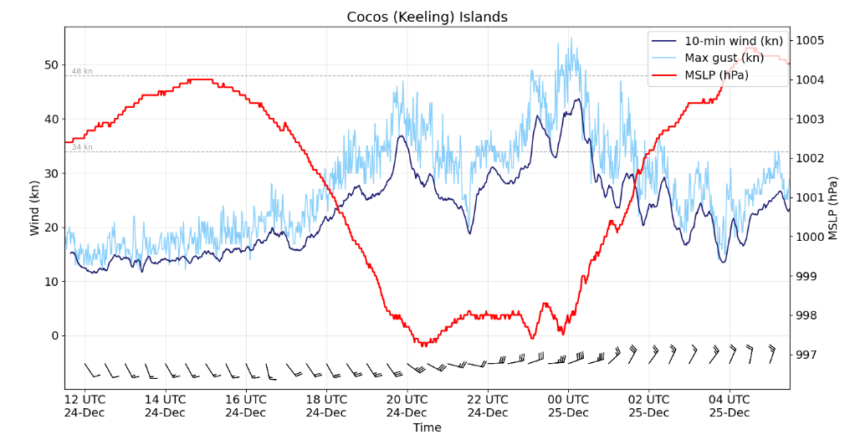
Figure 12 Plot of 10-minute mean wind (kn), wind gusts (kn) and MSLP (hPa) at Cocos (Keeling) Islands during the passage of tropical low 03U (Ex-Grant) on 25 December 2025.

  - Pressure
Cocos (Keeling) Islands
The lowest mean sea level pressure recorded at Cocos (Keeling) Islands was 997.2 hPa at 2022 UTC 24 December 2025 (Figure 12). This occurred a few hours prior to the occurrence of the first onset of gales as Tropical Low 03U (Ex-Grant) passed to the north of the islands.
  - Rainfall
Cocos (Keeling) Islands
A total rainfall of 127.8 mm was recorded over a 24-hour period to 0300 UTC (9 am CCT) 25 December 2025. Most of the rain fell over a short period of time that coincided with the period of the gales recorded. The highest hourly rate of rainfall was 53.6 mm recorded between 2300 UTC 24 December and 0000 UTC 25 December.
  - Storm Surge
A significant storm tide was not observed at Cocos (Keeling) Islands in association with Tropical Low 03U (Ex-Grant) on 25 December. However, total water levels were generally above forecast tidal levels for several days before and after the passage of the tropical system, due to background residual surge (~0.2m) likely to be associated with a prolonged large-scale fetch and swell event.

- Forecast Performance
The first 7-day forecast based on super ensemble guidance for potential formation of a tropical system (03U) with a risk of it developing into a tropical cyclone rated at 10% was issued on 2 December. The forecast rating generally remained below 20% in subsequent 7-day forecasts till 14 December when it was increased to Moderate (25%) for 18 December (Figure 13). The Moderate rating (25-50%) was maintained through till 17 December when it was increased to High (>50%) for 0000 UTC 21 December.
The first Forecast Track Map and Ocean Wind Warning for quadrant gales within 24 hours was issued following the 1200 UTC 16 December analysis, followed by the Technical Bulletin issued for the 1800 UTC 16 December analysis. The first TC Watch Advice for the Cocos (Keeling) Islands was issued at 0600 UTC 22 December (AWST = UTC+8 hours, CCT = UTC+6.5 hours).
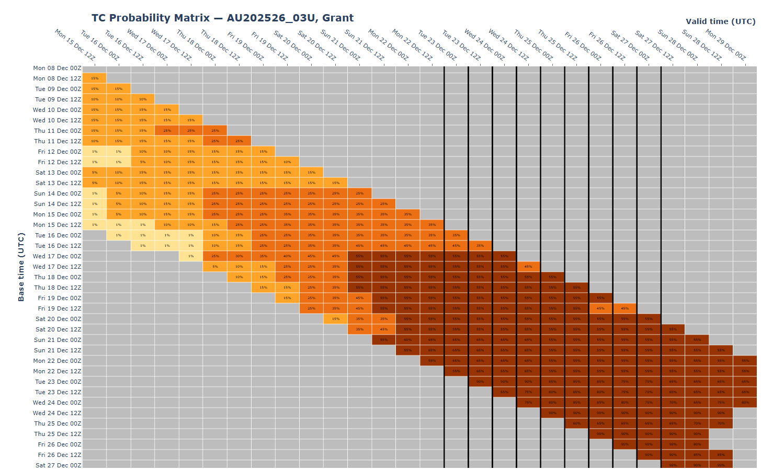
Figure 13 The forecast percentage risk of a low developing into a tropical cyclone taken from the 7-day forecast for 03U, forecast base time is shown on the vertical axis and the forecast validity time is shown on the horizontal axis. The box colours correspond to the tropical cyclone forecast rating, yellow for Very Low (<5%), light orange for Low (5-20%), orange for Moderate (20-50%) and brown for High (>50%).
The accuracy statistics for Tropical Cyclone Grant are in Table 2 and shown in Figure 14 and Figure 15.
Forecast track position accuracy was slightly poorer than the five-year average, except at the 72- and 96-hour forecast periods, as shown in Figure 14. This was mainly due to fluctuations in Grant’s forward speed arising from variations in the strength of the subtropical ridge, combined with the timing and depth of pulsating convection.
Intensity forecasts were significantly better than the five-year average, as shown in Figure 15. This was due to the relatively steady-state nature of Grant, with little overall change in intensity within a marginally favourable environment that lacked strong low-level forcing and was dominated by sufficient vertical wind shear.
Time | 00 | 06 | 12 | 18 | 24 | 36 | 48 | 72 | 96 | 120
Position accuracy (km) | 36 | 55 | 71 | 82 | 94 | 114 | 132 | 147 | 180 | 202
Intensity accuracy (knots) | 2.1 | 3.5 | 4.7 | 6.0 | 7.3 | 9.7 | 11.0 | 12.9 | 14.1 | 11.1
Sample Size | 43 | 42 | 41 | 40 | 39 | 37 | 35 | 31 | 27 | 23
Table 2: Verification statistics for Tropical Cyclone Grant. Note: Verification is performed using the Official Forecast Tracks at the standard times of 00, 06, 12 and 18 UTC.
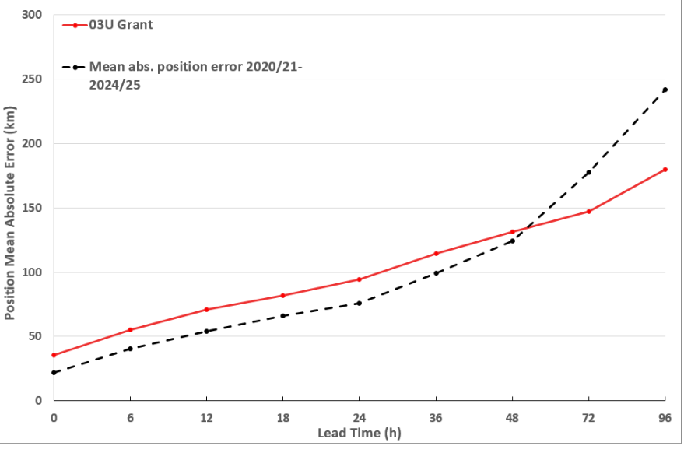
Figure 14: Position accuracy figures for Tropical Cyclone Grant compared against the 5-year average.
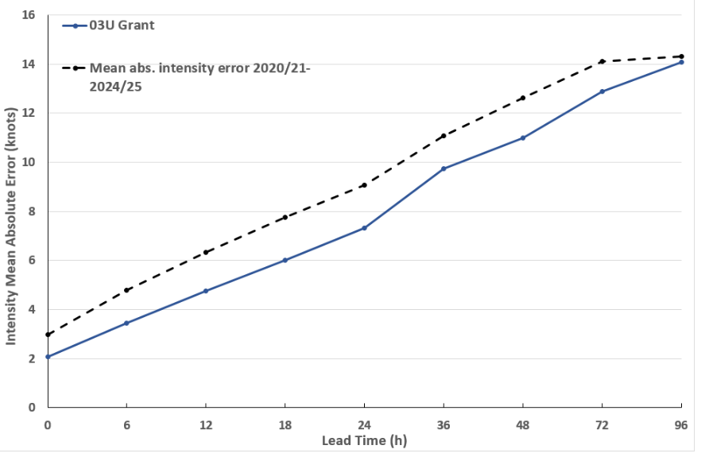
Figure 15: Intensity accuracy figures for Tropical Cyclone Grant compared against the 5-year average.

Appendix: List of abbreviations
Abbreviation | Term
ADT | Advanced Dvorak Technique
ACST | Australian Central Standard Time
AEST | Australian Eastern Standard Time
AiDT | AI-enhanced Dvorak Technique
AMSR2 | Advanced Microwave Scanning Radiometer
AMSU | Advanced Microwave Sounding Unit
ASCAT | Advanced Scatterometer
ATMS | Advanced Technology Microwave Sounder
AWS | Automatic Weather Station
AWST | Australian Western Standard Time (UTC +8 hours)
°C | Celsius
CI | Dvorak Current Intensity
CCT | Cocos (Keeling) Islands Time (UTC +6.5 hours)
CIMSS | Cooperative Institute for Meteorological Satellite Studies (USA)
CIRA | Cooperative Institute for Research in the Atmosphere (USA)
D-MINT | Deep learning - Multispectral Intensity of TCs (formerly known as DMN)
D-PRINT | Deep learning - IR Intensity of TCs (formerly known as OPEN-AIIR)
DT | Dvorak Data T-number
EIR | Enhanced InfraRed
ERC | Eyewall Replacement Cycle
FNMOC | Fleet Numerical Meteorology and Oceanography Centre (USA)
FT | Dvorak Final T-number
GCOM | Global Change Observation Mission
GHz | Gigahertz
GMI | Global Precipitation Measurement Microwave Imager
h | hour
hPa | hectopascal
HSCAT | Hai Yang 2 Scatterometer (HY-2B, HY-2C)
km | kilometres
km/h | kilometres per hour
kn | knot
LLCC | LLCC
MET | Model Expected T-number
METOP | Meteorological Operational Satellite
MJO | Madden-Julian Oscillation
mm | Millimetres
MSLP | Mean Sea Level Pressure
NESDIS | National Environmental Satellite, Data, and Information Service
nm | Nautical Mile
NOAA | National Oceanic and Atmospheric Administration
NRL | Navy Research Lab (USA)
OPEN-AiiR | Ordered Pattern Encoding AI Infrared
OSCAT | Ocean Scatteromoter
PAT | Dvorak Pattern T-number
RCM | RadarSat Constellation Mission – Synthetic Aperture Radar
RH | Relative Humidity
RMW | Radius of Maximum Winds
RSMC | Regional Specialised Meteorological Centre
SAR | Synthetic Aperture Radar
SATC | CIMSS Advanced Dvorak Technique
SATCON | Satellite Consensus
SEN1 | Sentinel-1A – Synthetic Aperture Radar
SMAP | Soil Moisture Active Passive
SMOS | Soil Moisture and Ocean Salinity
SSMIS | Special Sensor Microwave Imager/Sounder
TC | Tropical Cyclone
TCWC | Tropical Cyclone Warning Centre
UTC | Universal Time Co-ordinated

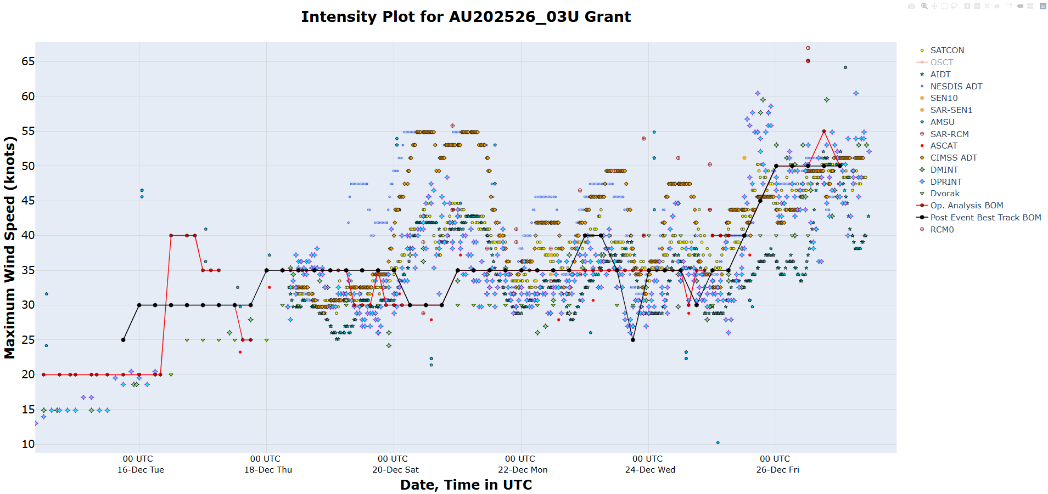
Figure 16: Intensity plot of objective and subjective guidance. SATCON, AiDT, NESDIS ADT, SAR-SEN1, AMSU, SAR-RCM, ASCAT, CIMMS ADT, DMINT, DPRINT, Dvorak subjective estimate, operational analysis (red) and post event best track analysis (black).

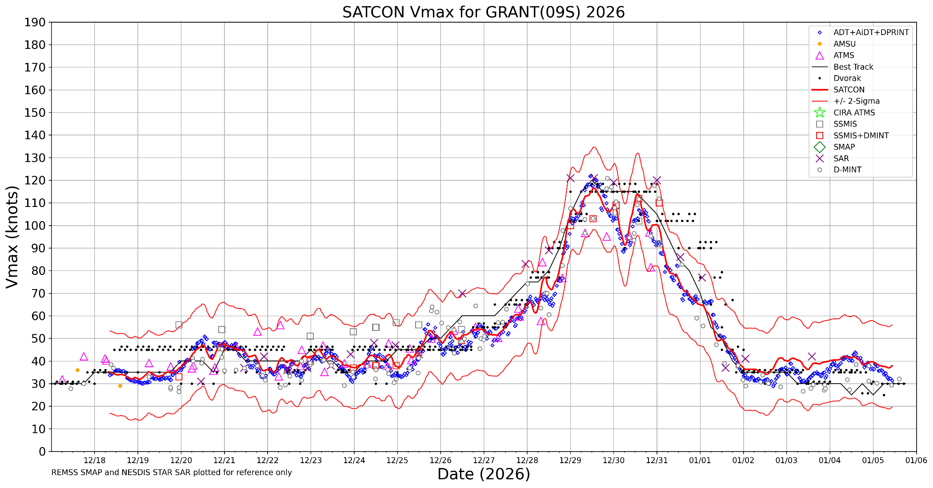
Figure 17: SATCON Intensity plot

