Tropical Cyclone Hayley

27 December 2025 – 01 January 2026

Tropical Cyclone Environmental Prediction Services

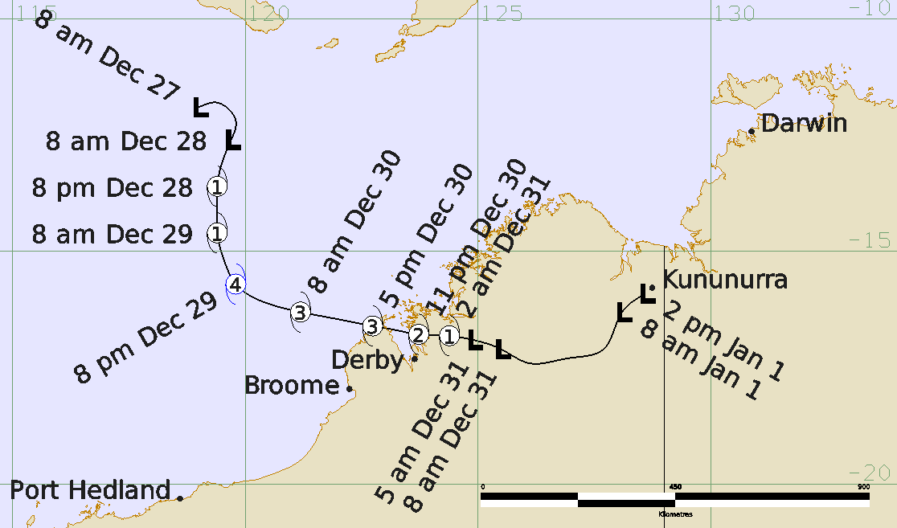

Revision history
Date | Version | Author | Description
08/06/26 | 1.0 | EPS TC | Final Draft

Release history
Date | Version | Status | Approval
09/06/26 | 1.0 | Approved for release | Manager, EPS-TC

Contact details:
Tropical Cyclone Team Lead
Severe Weather Environmental Prediction Services
Bureau of Meteorology
PO Box 1370, West Perth WA 6872
Email: tcwc@bom.gov.au
This work is copyright. Apart from any use as permitted under the Copyright Act 1968, no part may be reproduced without prior written permission from the Bureau of Meteorology. Refer to www.bom.gov.au/other/copyright.shtml for further information. Unless otherwise noted, all images in this document are licensed under the Creative Commons Attribution Australia Licence.
© Commonwealth of Australia 2026
Published by The Bureau of Meteorology
Cover image: Best track of Tropical Cyclone Hayley 27 December 2026 - 01 January 2026. Time in UTC (+8h AWST).
Table of contents

1. Summary 5

2. Meteorological description 8

2.1. Intensity Analysis 8

2.2. Structure 17

2.3. Motion 17

3. Impact 18

4. Observations 19

4.1. Wind 19

4.2. Rainfall 19

4.3. Pressure 19

5. Forecast Performance 21

6. Appendix: List of Abbreviations 24

List of Figures
Figure 1 Best track of Tropical Cyclone Hayley, 27 December 2025 - 01 January 2026 7
Figure 2 Best track of Tropical Cyclone Hayley showing the structure of the system as it approaches and moves over land, 29 – 31 December 2025 7
Figure 3 A weekly OLR (outgoing longwave radiation) display with MJO (Madden-Julian Oscillation) signals highlighted by solid black contours 10
Figure 4 Himawari-9 visible satellite image at 0000 UTC 27 December 2025 showing the weak surface circulation of 08U 11
Figure 5 Oceansat-3 scatterometry winds at 1604 UTC 27 December, overlain over a Himawari-9 infrared satellite image 12
Figure 6 WSFM MWI 89GHz microwave image at 1025 UTC 28 December 2025, showing a small and well defined inner core in the deep convection of 08U 13
Figure 7 Satellite winds from SAR RCM-2 at 1023 UTC 29 December 2025, showing the small but intense structure of Severe Tropical Cyclone Hayley at close to the time of peak intensity 14
Figure 8 WSFM MWI 89GHz microwave image at 0803 UTC 30 December 2025, about one hour before Severe Tropical Cyclone Hayley crossed the coast near Lombadina 15
Figure 9 Reflectivity radar imagery from Broome radar at 0904 UTC 30 December 2025, with the eye of Severe Tropical Cyclone Hayley crossing the coast just south of Lombadina. 16
Figure 10 Reflectivity radar imagery from Broome radar at 1449 UTC 30 December 2025, as Tropical Cyclone Hayley making its second coastal crossing on the eastern side of King Sound 17
Figure 11 Plot of 10-minute mean wind, wind gusts and MSLP at Lombadina during the passage of Severe Tropical Cyclone Hayley 21
Figure 12 Plot of 10-minute mean wind, wind gusts and MSLP at Yampi Sound during the passage of Tropical Cyclone Hayley 21
Figure 13 The forecast percentage risk of a low developing into a tropical cyclone taken from the 7-day forecast for 08U 22
Figure 14 Position accuracy figures for Tropical Cyclone Hayley plotted against the 5-year average. 24
Figure 15 Intensity accuracy figures for Tropical Cyclone Hayley plotted against the 5-year average. 24
Figure 16 Intensity plot of objective and subjective guidance 27

List of Tables
Table 1 Best track summary for Tropical Cyclone Hayley 7
Table 2 Rainfall observations recorded during Tropical Cyclone Hayley 19
Table 3 Pressure observations recorded during Tropical Cyclone Hayley. 20
Table 4 Verification statistics for Tropical Cyclone Hayley 22

- Summary
Severe Tropical Cyclone Hayley was a short lived but intense tropical cyclone that developed north of Broome in late December 2025 before crossing the tip of the Dampier Peninsula as a severe tropical cyclone.
A tropical low (08U) developed about 700 kilometres north northeast of Broome on 27 December and moved southwards. The low intensified into a tropical cyclone late on 28 December in a favourable environment. Hayley underwent rapid intensification and reached a peak intensity of Category 4 with estimated wind gusts up to 125 knots (230 km/h) near the centre at 1200 UTC (8 pm AWST) 29 December (AWST = UTC +8 hours), only 24 hours after it first reached tropical cyclone intensity.
On 30 December Hayley turned and moved on an east southeast path towards the Dampier Peninsula. It weakened slightly as it approached the coast and made landfall as a Category 3 system near the communities of Djarindjin and Lombadina at about 0900 UTC (5 pm AWT) 30 December. Hayley crossed King Sound and then moved inland north of Derby, weakening to below tropical cyclone strength at 2100 UTC on 30 December (5 am AWST on 31 December).
As it crossed the Dampier Peninsula, the cyclone caused damage to property and infrastructure including water ingress, trees and power lines down, and some roof damage. The highest wind gust recorded during the event was 85 knots (157 km/h) at 1013 UTC (6:13 pm WST) 30 December from Lombadina AWS. The highest daily rainfall totals recorded were 131.8 mm in the 24 hours to 2300 UTC 30 December (9 am WST 31 December) at Lombadina AWS and 182.2 mm in the 24 hours to 2300 UTC 31 December (9 am WST 1 January 2026) from Lansdowne as the remnants of Hayley moved over the eastern Kimberley. The Lansdowne total set a new January highest daily rainfall record for the station.
Refer to Figure 1 for the full track of Tropical Cyclone Hayley and Table 1 for track data.

Figure 1 Best track of Tropical Cyclone Hayley, 27 December 2025 - 01 January 2026. Times are in AWST (UTC+8h).

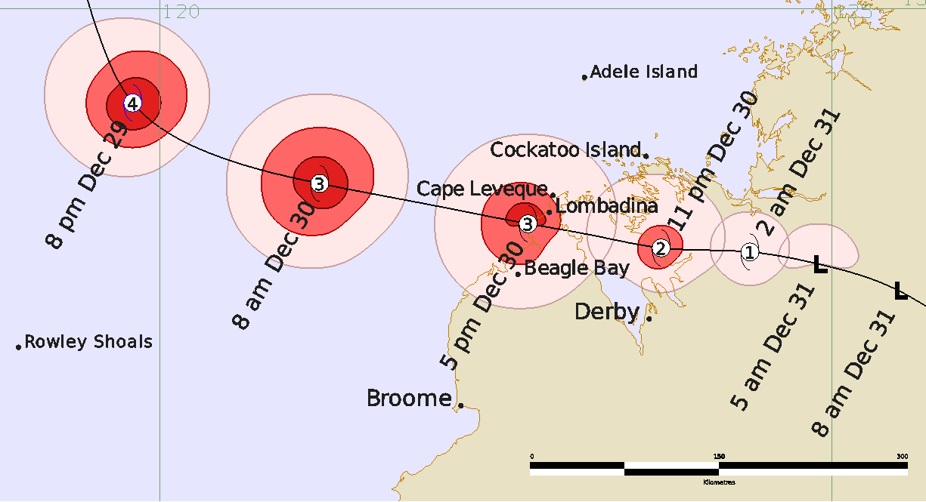
Figure 2 Best track of Tropical Cyclone Hayley showing the structure of the system as it approaches and moves over land, 29 – 31 December 2025. Times are in AWST (UTC+8h). Pink is gale radii, light red is storm force radii and dark red is hurricane force wind radii.

Year | Month | Day | Hour UTC | Pos. Lat. S | Pos. Long. E | Pos. Acc. nm | Max Wind 10min kn | Max gust  kn | Cent. Press. hPa | Rad. of gales (NE/SE/SW/NW) | Rad. of storm  (NE/SE/SW/NW) | RMW nm
2025 | 12 | 27 | 0000 | 11.9 | 119.0 | 30 | 20 | 45 | 1004 | 0/0/0/0 | 0/0/0/0 | -
2025 | 12 | 27 | 0600 | 11.8 | 119.4 | 30 | 20 | 45 | 1003 | 0/0/0/0 | 0/0/0/0 | -
2025 | 12 | 27 | 1200 | 11.9 | 119.6 | 40 | 20 | 45 | 1003 | 0/0/0/0 | 0/0/0/0 | -
2025 | 12 | 27 | 1800 | 12.2 | 119.8 | 20 | 25 | 45 | 1002 | 0/0/0/0 | 0/0/0/0 | -
2025 | 12 | 28 | 0000 | 12.6 | 119.7 | 20 | 30 | 45 | 1002 | 0/0/0/0 | 0/0/0/0 | -
2025 | 12 | 28 | 0600 | 13.1 | 119.5 | 15 | 35* | 45 | 999 | 0/20/0/0 | 0/0/0/0 | -
2025 | 12 | 28 | 1200 | 13.6 | 119.4 | 20 | 35 | 50 | 998 | 20/20/20/20 | 0/0/0/0 | 15
2025 | 12 | 28 | 1800 | 14.1 | 119.4 | 25 | 45 | 65 | 989 | 20/20/30/20 | 0/0/0/0 | 15
2025 | 12 | 29 | 0000 | 14.6 | 119.4 | 20 | 45 | 65 | 990 | 20/20/30/20 | 0/0/0/0 | 15
2025 | 12 | 29 | 0600 | 15.2 | 119.6 | 20 | 55 | 75 | 982 | 30/25/30/30 | 25/20/20/20 | 12
2025 | 12 | 29 | 1200 | 15.7 | 119.8 | 10 | 90 | 125 | 955 | 35/30/35/40 | 25/20/20/20 | 7
2025 | 12 | 29 | 1800 | 16.1 | 120.4 | 10 | 90 | 125 | 953 | 40/35/40/40 | 25/20/25/25 | 7
2025 | 12 | 30 | 0000 | 16.3 | 121.2 | 8 | 85 | 120 | 960 | 40/35/40/40 | 25/20/25/25 | 8
2025 | 12 | 30 | 0600 | 16.5 | 122.1 | 5 | 70 | 100 | 973 | 40/35/40/40 | 20/18/20/20 | 8
2025 | 12 | 30 | 0900 | 16.6 | 122.7 | 5 | 65 | 90 | 976 | 40/35/40/40 | 15/12/20/20 | 6
2025 | 12 | 30 | 1200 | 16.7 | 123.2 | 5 | 60 | 85 | 980 | 30/25/25/30 | 12/12/10/15 | 6
2025 | 12 | 30 | 1500 | 16.8 | 123.7 | 5 | 60 | 85 | 980 | 30/20/20/35 | 10/8/10/10 | 5
2025 | 12 | 30 | 1800 | 16.8 | 124.4 | 5 | 45 | 65 | 991 | 18/15/15/18 | 0/0/0/0 | 7
2025 | 12 | 30 | 2100 | 16.9 | 124.9 | 15 | 35* | 50 | 995 | 18/0/0/18 | 0/0/0/0 | -
2025 | 12 | 31 | 0000 | 17.1 | 125.5 | 20 | 30 | 45 | 1001 | 0/0/0/0 | 0/0/0/0 | -
2025 | 12 | 31 | 0600 | 17.4 | 126.1 | 15 | 20 | 45 | 1000 | 0/0/0/0 | 0/0/0/0 | -
2025 | 12 | 31 | 1200 | 17.3 | 126.9 | 30 | 20 | 45 | 1001 | 0/0/0/0 | 0/0/0/0 | -
2025 | 12 | 31 | 1800 | 17.1 | 127.7 | 45 | 20 | 45 | 1001 | 0/0/0/0 | 0/0/0/0 | -
2026 | 1 | 1 | 0000 | 16.3 | 128.1 | 30 | 20 | 45 | 1002 | 0/0/0/0 | 0/0/0/0 | -
2026 | 1 | 1 | 0600 | 15.9 | 128.6 | 20 | 20 | 45 | 1000 | 0/0/0/0 | 0/0/0/0 | -
Table 1 Best track summary for Tropical Cyclone Hayley, 27 December 2025 - 01 January 2026. UTC=AWST-8h.
* Not a tropical cyclone as gales less than halfway around centre

- Meteorological description
  - Intensity Analysis
A monsoon trough to the northwest of Western Australia was a persistent feature in the lead up to the formation of Tropical Low 08U. This was linked to an MJO pulse that had recently moved through the region (Figure 3). Transient circulations were evident on the monsoon trough as early as 25 December 2025, but it wasn't until 27 December that a circulation persisted and 08U was deemed to have formed (Figure 4).
After slowly consolidating during 27 December, 08U improved in structure significantly overnight and into the morning of 28 December (Figure 5). Tight convective banding developed near the centre during the day, and gales developed in the southeast quadrant at 0600 UTC 28 December. Environmental wind shear decreased during the day, allowing gales to wrap around the compact centre, and 08U reached tropical cyclone intensity at 1200 UTC 28 December (Figure 6). Operationally, the system was named Tropical Cyclone Hayley a little later at 1800 UTC 28 December.
Wind shear remained low during 29 December, and support in the upper atmosphere improved, with increased divergence and poleward outflow linked to an upper trough south of Hayley. Being a small system, it reacted quickly to the improved conditions and went through a period of rapid intensification. Severe Tropical Cyclone Hayley developed into a Category 4 system, reaching a peak intensity of 90 knots (ten-minute mean) at 1200 UTC 29 December (Figure 7).
A subtle increase in wind shear during 30 December, along with the entrainment of some dry air on the eastern side of the system, resulted in some weakening of Hayley as it approached the northwest Kimberley coast. Although the inner core remained well-structured (Figure 8), the intensity steadily decreased, and Hayley crossed the coast at 0900 UTC 30 December as a Category 3 system (Figure 9), with an intensity of 65 knots. This intensity was supported by the observations from Lombadina AWS, which would have experienced close to the maximum winds of Hayley as the centre passed just to the south.
After slight weakening over the Dampier Peninsula, Tropical Cyclone Hayley maintained a 60 knot intensity as it moved across King Sound. It crossed the coast again at 1500 UTC 30 December (Figure 10) to the north of Derby and then weakened further before passing over Yampi Sound AWS as a high-end Category 1 system. At 2100 UTC 30 December, it is estimated that gales became confined to the northern quadrants, and as such the system had weakened below tropical cyclone intensity. Gales has eased completely by 0000 UTC December 31, and the remnants of ex-Tropical Cyclone Hayley tracked across the Kimberley before the system dissipated during 1 January 2026.
A comparison of various objective and subjective intensity estimates is included in Figure 16.

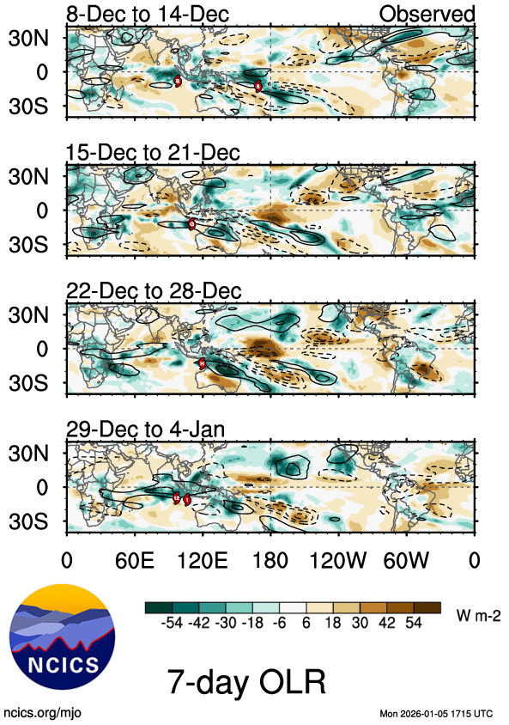
Figure 3 A weekly OLR (outgoing longwave radiation) display with MJO (Madden-Julian Oscillation) signals highlighted by solid black contours. The image shows that Tropical Cyclone Hayley (denoted by the red dot labelled "H") formed on the tail end of an MJO pulse. The image is adapted from an image courtesy of the North Carolina Institute for Climate Studies https://ncics.org/pub/mjo/archive/2026/2026-02-13/v2/
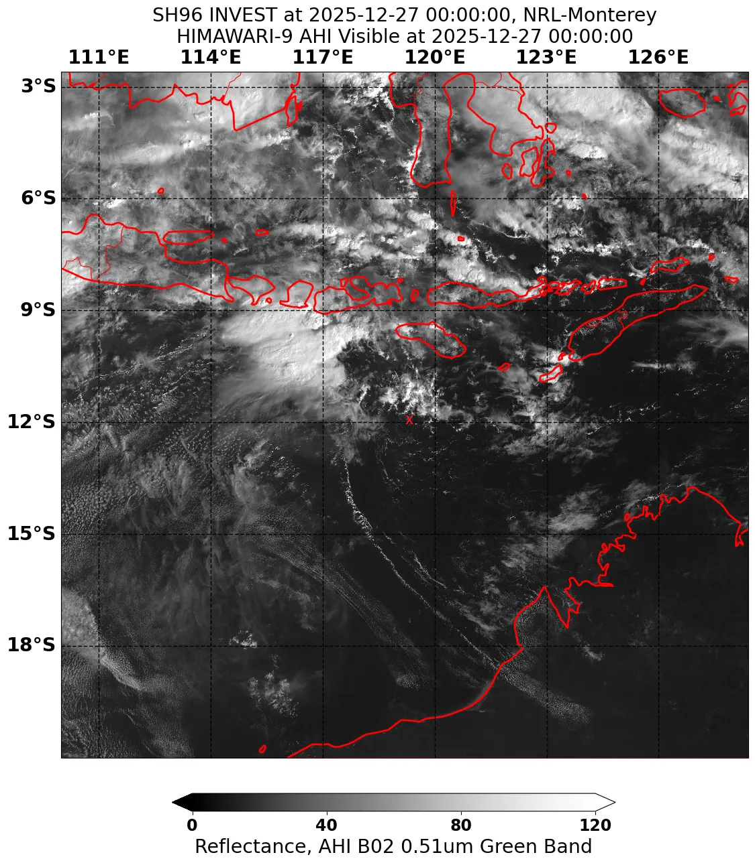
Figure 4 Himawari-9 visible satellite image at 0000 UTC 27 December 2025 showing the weak surface circulation of 08U. The centre is marked by a red cross. From this point on 08U remained a trackable circulation through until the time it developed into TC Hayley. Image courtesy of NRL https://science.nrlmry.navy.mil/geoips/tcweb4/

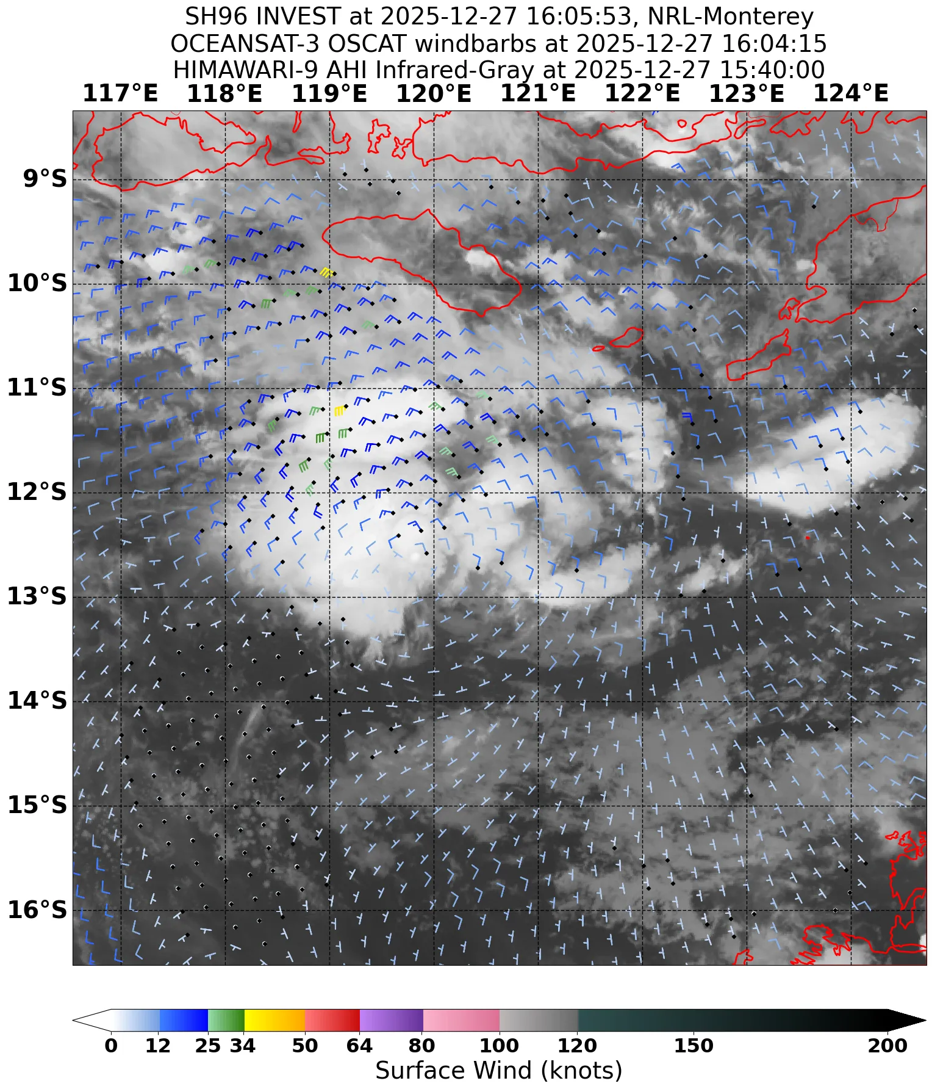
Figure 5 Oceansat-3 scatterometry winds at 1604 UTC 27 December, overlain over a Himawari-9 infrared satellite image. The circulation of 08U has become more defined, and convection is consolidating around the centre. Image courtesy of NRL https://science.nrlmry.navy.mil/geoips/tcweb4/

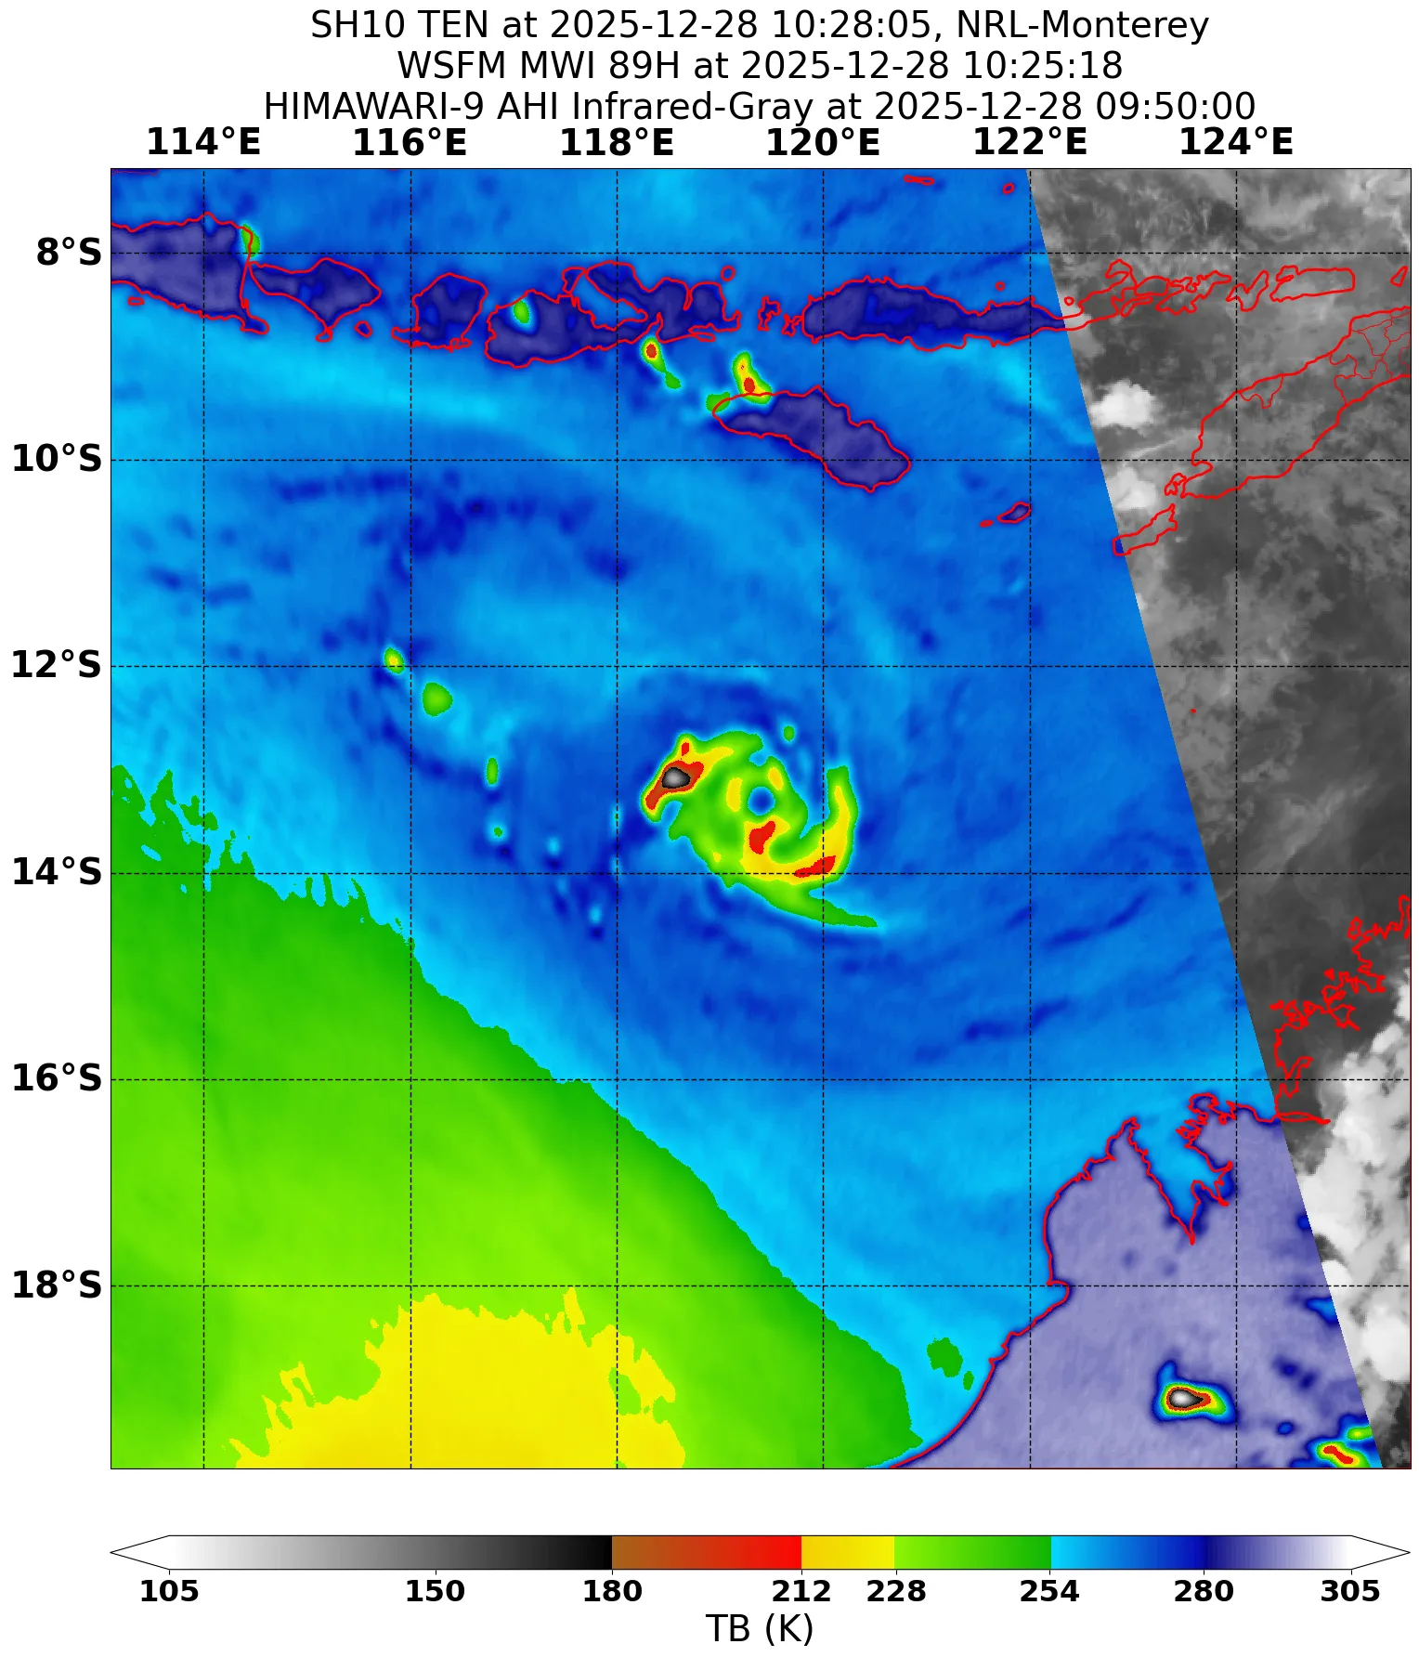
Figure 6 WSFM MWI 89GHz microwave image at 1025 UTC 28 December 2025, showing a small and well-defined inner core in the deep convection of 08U. It is estimated that at this time the gales started to extend around the centre and the system reached tropical cyclone intensity. Image curtsey of NRL https://science.nrlmry.navy.mil/geoips/tcweb4/

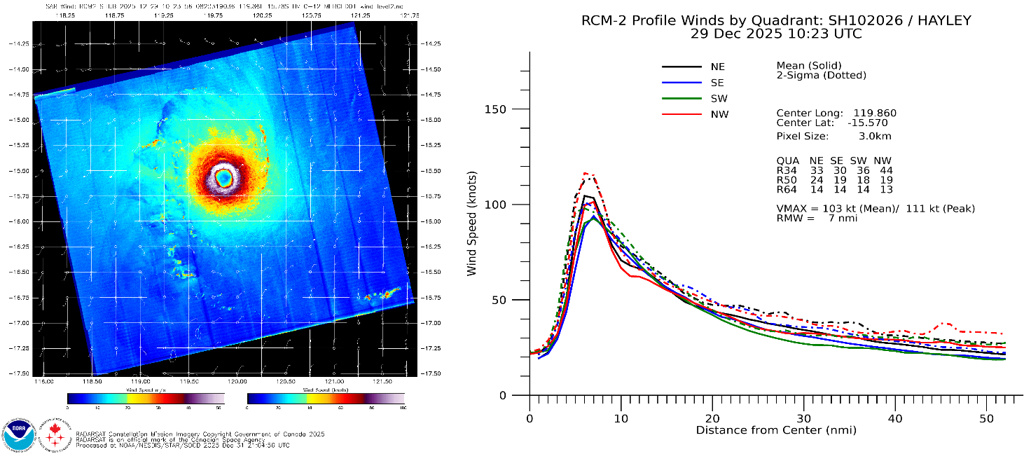
Figure 7 Satellite winds from SAR RCM-2 at 1023 UTC 29 December 2025, showing the small but intense structure of Severe Tropical Cyclone Hayley at close to the time of peak intensity. The radial wind plot on the right-hand side indicates an RMW of only 7 nm, and gales confined to within around 40 nm of the centre. Image courtesy of NOAA https://www.star.nesdis.noaa.gov/socd/mecb/sar/sarwinds_tropical.php?year=2026&storm=SH102026_HAYLEY.
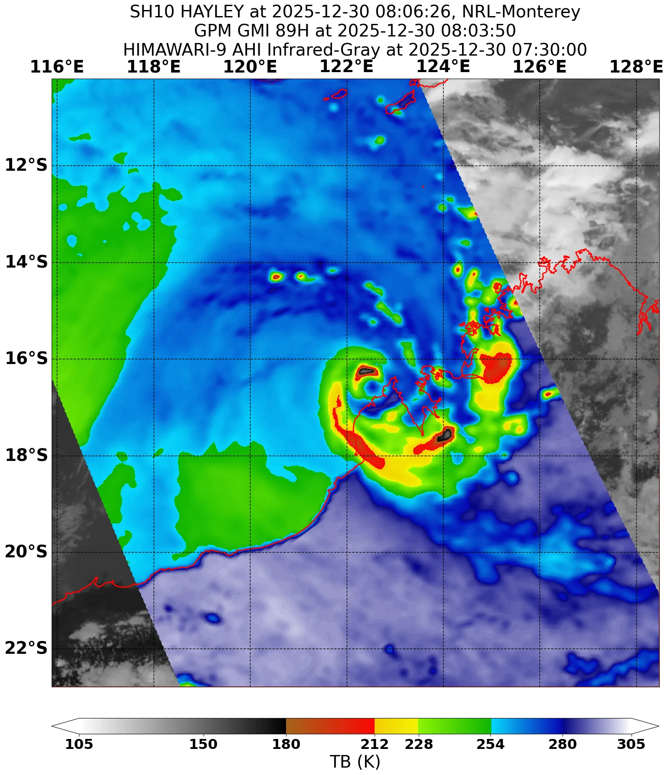
Figure 8 WSFM MWI 89GHz microwave image at 0803 UTC 30 December 2025, about one hour before Severe Tropical Cyclone Hayley crossed the coast near Lombadina. The eye is well-defined, and the deepest convection to the north of the centre corresponds to where the strongest winds were estimated to be located. Image courtesy of NRL https://science.nrlmry.navy.mil/geoips/tcweb4/
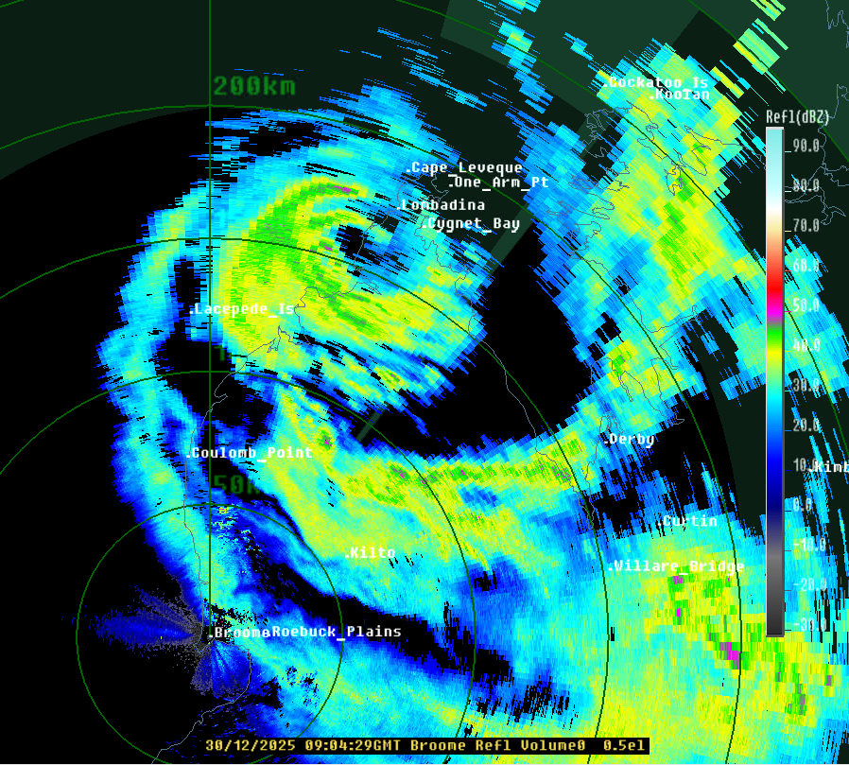
Figure 9 Reflectivity radar imagery from Broome radar at 0904 UTC 30 December 2025, with the eye of Severe Tropical Cyclone Hayley crossing the coast just south of Lombadina.

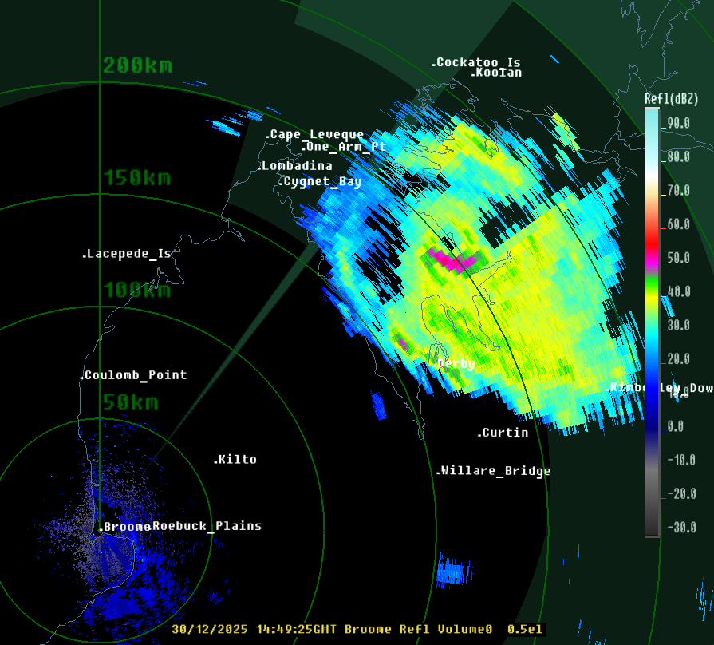
Figure 10 Reflectivity radar imagery from Broome radar at 1449 UTC 30 December 2025, as Tropical Cyclone Hayley making its second coastal crossing on the eastern side of King Sound. Although a small amount of weaking has occurred since the first coastal crossing, the eye is still clearly visible on radar.

  - Structure
The initial circulation of 08U formed within a monsoon surge, and started as a broad circulation, however it rapidly consolidated into a small circulation with tight convective banding by 28 December (Figure 6). After reaching tropical cyclone intensity, Hayley maintained a small structure through its lifetime, with gales never extending more than 40 nm from the centre. At peak intensity, hurricane force winds only extended 12 nm from the centre, and the RMW was 7 nm (Figure 7). The small structure was maintained through until landfall and weakening.
The circulation was generally symmetric through the lifetime of Hayley. The wind field was slightly larger on the northern side at times, enhanced by the east southeast motion as the system approached the coast.
  - Motion
08U formed along a monsoon trough, and the initially shallow circulation was steered towards the east by the monsoon flow. Once the circulation deepened, it started to move towards the south, on the western periphery of a developing mid-level ridge. An amplifying mid-level trough approached from the southwest during 29 December, and once Tropical Cyclone Hayley interacted with this trough, it was steered in an east southeasterly direction until it crossed the coast and eventually weakened.

- Impact
Tropical Cyclone Hayley caused significant damage to property and infrastructure over northern parts of the Dampier Peninsula. Two homes were reported to have lost their roofs, and others suffered water ingress through roofs and walls. Powerlines were damaged in Djarindjin, and a new basketball court was destroyed.
New report from ABC News - https://www.abc.net.au/news/2025-12-31/ex-tropical-cyclone-hayley-clean-up-begins-as-damage-assessed/106189586.

- Observations
The centre of Tropical Cyclone Hayley passed close to Lombadina Airport AWS and Yampi Sound AWS. Plots of wind speed, wind gust and MSLP are presented for these locations in Figure 10 and Figure 11.
  - Wind
Destructive winds (storm force) were observed at Lombadina Airport AWS with the passage of Tropical Cyclone Hayley, and damaging winds (gale force) were reported further east at Yampi Sound AWS.
Lombadina AWS
Maximum 10-minute mean wind: 59 knots (109 km/h) at 1013 UTC 30 December.
Maximum 3-sec wind gust: 85 knots (157 km/h) at 1013 UTC 30 December
Prolonged destructive (storm force) winds between 0912 UTC and 0931 UTC 30 December and between 1004 UTC and 1022 UTC 30 December.
Prolonged damaging (gale force) winds were recorded between 0904 UTC and 1128 UTC 30 December.
Yampi Sound AWS
Maximum 10-minute mean wind: 47 knots (87 km/h) at 1702 UTC 30 December
Maximum 3-sec wind gust: 74 knots (137 km/h) at 1647 UTC 30 December
Prolonged damaging (gale force) winds were recorded between 1549 UTC and 1559 UTC 30 December, between 1607 UTC and 1631 UTC 30 December, and between 1647 UTC and 1722 UTC 30 December.
  - Rainfall
24 hour rainfall totals near the track of Tropical Cyclone Hayley were generally in the rage of 100-150 mm, with the largest total observed being 182.2 mm at Landsdowne Station in the 24 hours until 9am WST 1 January. Significant 24 hour totals are listed in Table 2.
Location | 24 hour rainfall (mm) | Date (24 hours until 9am)
Lombadina | 131.8 | 31 December 2025
Yampi Sound | 125.8 | 31 December 2025
Cygnet Bay | 108.0 | 31 December 2025
Mount Hart Airstrip | 85.0 | 31 December 2025
Landsdowne Station | 182.2 | 1 January 2026
Bedford Downs Airstrip | 100.6 | 1 January 2026
Mount Hart Airstrip | 55.0 | 1 January 2026
Table 2 Selection of rainfall observations recorded during Tropical Cyclone Hayley.
  - Pressure
Table 3 shows the lowest MSLP recorded by sites near the track of Tropical Cyclone Hayley.

Location | MSLP (hPa) | Time (UTC)
Lombadina | 981.3 | 0940 UTC 30 December 2025
Yampi Sound | 980.8 | 1626 UTC 30 December 2025
Table 3 Pressure observations recorded during Tropical Cyclone Hayley.
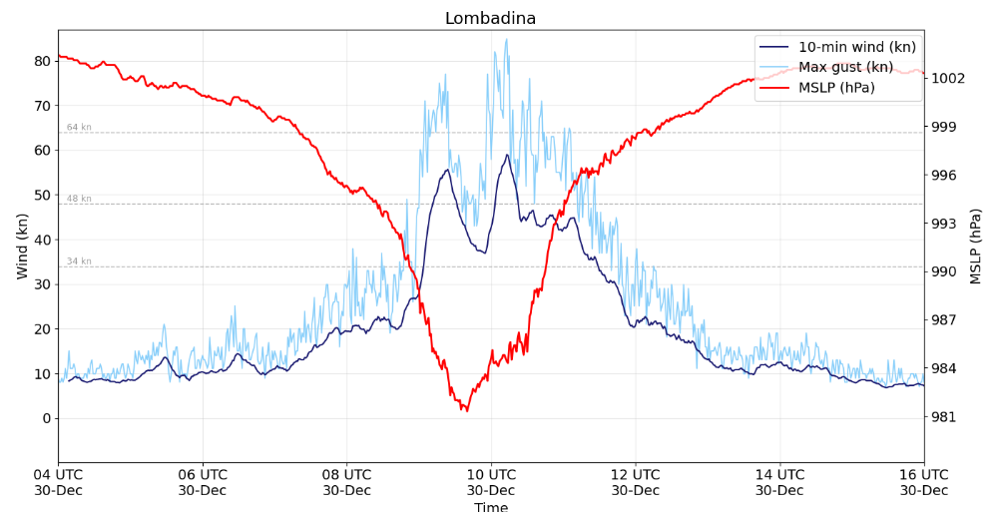
Figure 11 Plot of 10-minute mean wind, wind gusts and MSLP at Lombadina during the passage of Severe Tropical Cyclone Hayley. No wind barbs are shown in this plot as wind direction was not correctly recorded by the equipment. A map showing weather station locations can be found at https://www.bom.gov.au/wa/observations/map.shtml.
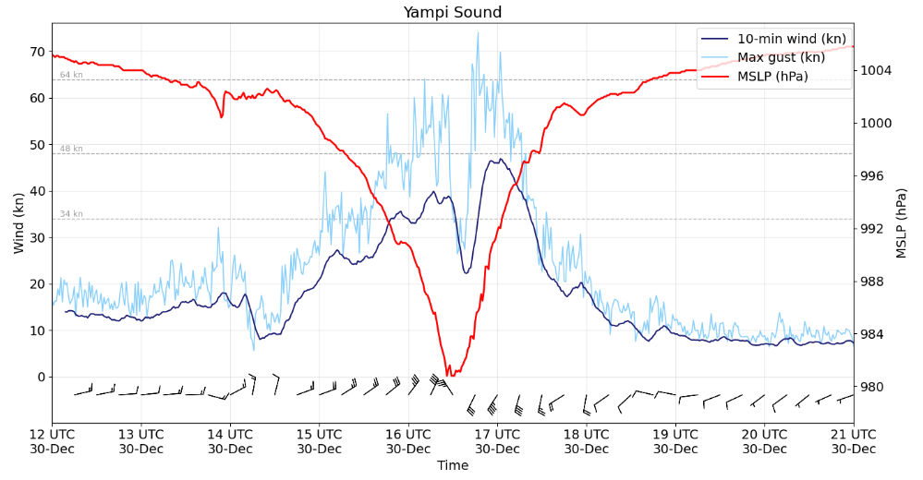
Figure 12 Plot of 10-minute mean wind, wind gusts and MSLP at Yampi Sound during the passage of Tropical Cyclone Hayley. A map showing weather station locations can be found at https://www.bom.gov.au/wa/observations/map.shtml.
- Forecast Performance
The first 7 Day Forecast for 08U was issued on 20 December, with a Low (10%) risk of the system being a tropical cyclone on 27 December. There was large uncertainty in whether 08U would form and its prospects for development, and the assessed risk remained Low (10-15%) until 25 December, when the rating was increased to Moderate (25%) from 29 December. The uncertainty continued over the following days as the initial circulation of 08U struggled to form. However, overnight 27 December into the morning of 28 December, there was a rapid improvement in the circulation, and correspondingly a dramatic increase in the risk of tropical cyclone development. The ratings were increased to High (55%) on 29 December, and the first Forecast Track Map was issued at 0100 UTC Sunday 28 December. Figure 12 shows the forecast risk of 08U developing into a tropical cyclone for each issue of the 7 Day Forecast.
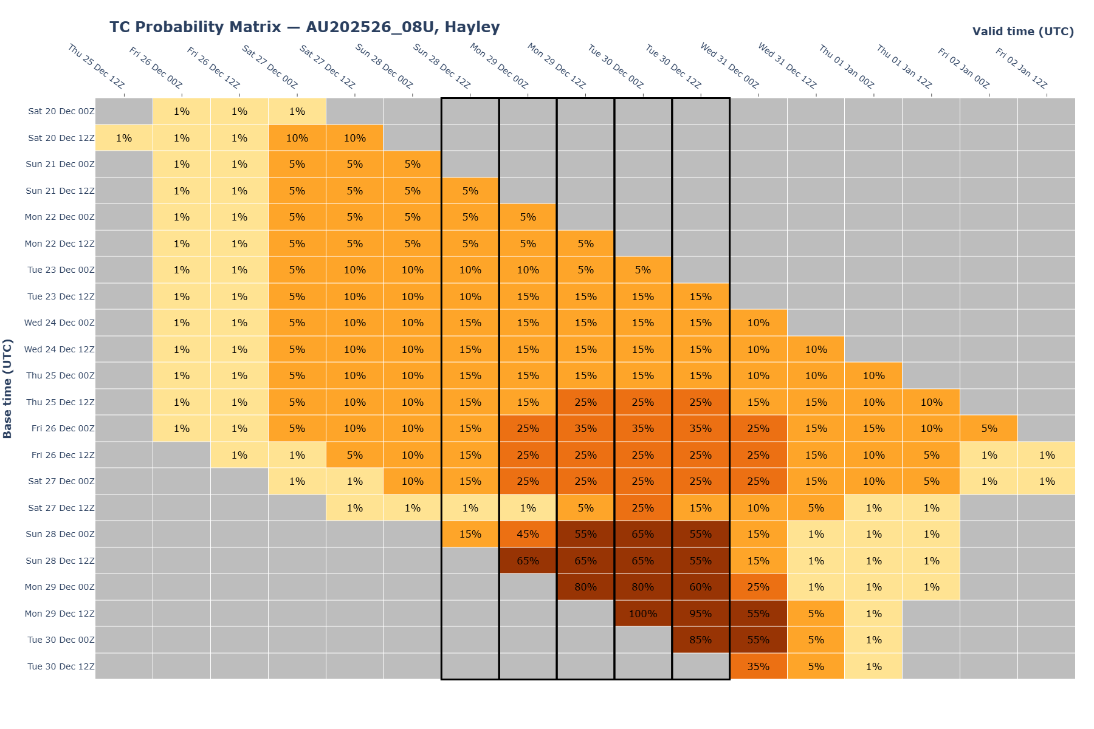
Figure 13 The forecast percentage risk of a low developing into a tropical cyclone taken from the 7-day forecast for 08U, forecast base time is shown on the vertical axis and the forecast validity time is shown on the horizontal axis. The box colours correspond to the tropical cyclone forecast rating, yellow for Very Low, light orange for Low, orange for Moderate and brown for High.
The first Tropical Cyclone Advice was issued at 0700 UTC 28 December, with a Watch declared from Broome to Cockatoo Island. A total of 19 Tropical Cyclone Advices were issued for 08U, up until the cancellation at 2200 UTC 31 December.
The accuracy statistics for Tropical Cyclone Hayley are shown below in Table 4. Note: Verification is performed using the Official Forecast Tracks at the standard times of 00, 06, 12 and 18 UTC. Statistics are also shown in Figure 13 (track) and Figure 14 (intensity). It is worth noting that although the statistics for the 72-hour and 96-hour forecasts are included, they are less indicative of forecast performance due to the small sample size.
The position forecasts for Hayley were more accurate than the 5-year average (2020/21-2024/25) within the first 24 hours, but then the errors grew larger than average for longer lead times. This was predominately due to Hayley travelling faster than forecast, with the first coastal crossing occurring more than eight hours earlier than some of the initial forecasts indicated.
The errors in the intensity forecasts were significantly worse than the long-term average for the first 36 hours, which was due to the rapid intensification that occurred during December 29. Intensity forecasts at longer lead times were much more accurate, beyond the period of rapid intensification.

Time | 00 | 06 | 12 | 18 | 24 | 36 | 48 | 72 | 96
Position accuracy (km) | 8 | 23 | 43 | 58 | 73 | 111 | 161 | 274 | 362
Intensity accuracy (knots) | 2.9 | 6.3 | 8.3 | 10.4 | 15.4 | 17.3 | 10.0 | 9.2 | 10.0
Sample size | 12 | 12 | 12 | 12 | 12 | 11 | 10 | 6 | 2
Table 4 Verification statistics for Tropical Cyclone Hayley. Note: Verification is performed using the Official Forecast Tracks at the standard times of 00, 06, 12 and 18 UTC.

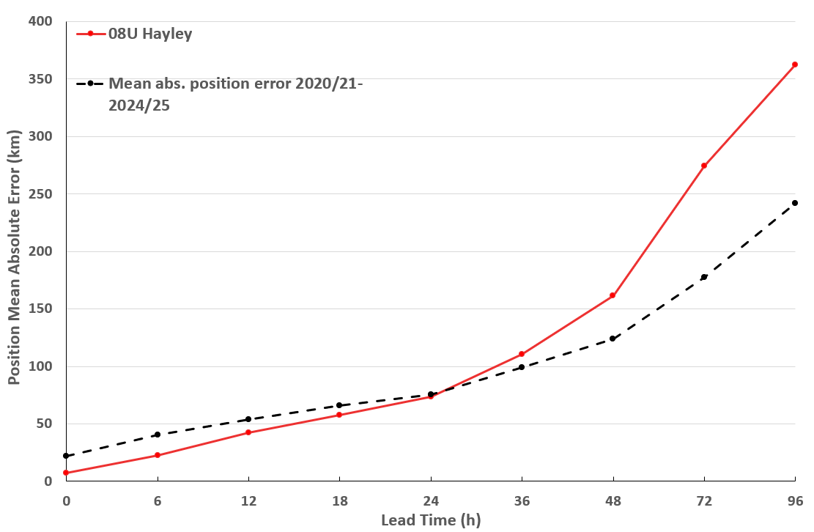
Figure 14 Position accuracy figures for Tropical Cyclone Hayley plotted against the 5-year average.

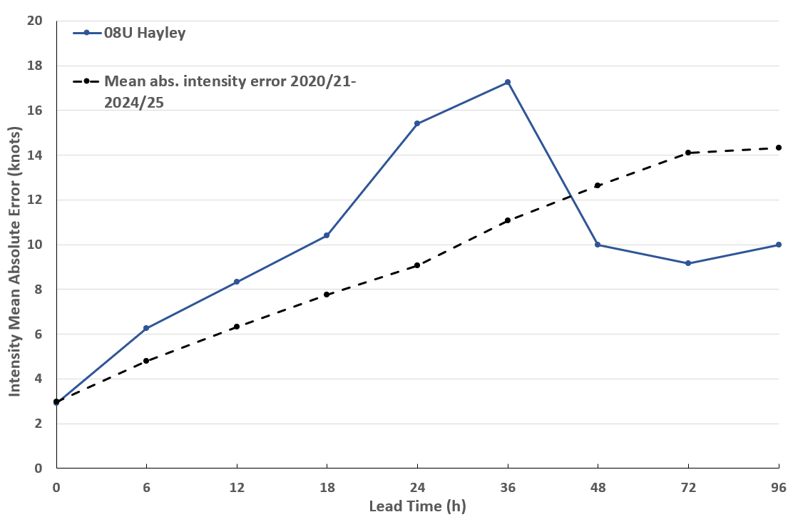
Figure 15 Intensity accuracy figures for Tropical Cyclone Hayley plotted against the 5-year average.

- Appendix: List of Abbreviations
Abbreviation | Term
ADT | Advanced Dvorak Technique
ACST | Australian Central Standard Time
AEST | Australian Eastern Standard Time
AiDT | AI-enhanced Dvorak Technique
AMSR2 | Advanced Microwave Scanning Radiometer
AMSU | Advanced Microwave Sounding Unit
ASCAT | Advanced Scatterometer
ATMS | Advanced Technology Microwave Sounder
AWS | automatic weather station
AWST | Australian Western Standard Time
°C | Celsius
CI | Current intensity
CIMSS | Cooperative Institute for Meteorological Satellite Studies (USA)
CIRA | Cooperative Institute for Research in the Atmosphere (USA)
D-MINT | Deep learning - Multispectral Intensity of TCs (formerly known as DMN)
D-PRINT | Deep learning - IR Intensity of TCs (formerly known as OPEN-AIIR)
EIR | Enhanced InfraRed
ERC | eyewall replacement cycle
FNMOC | Fleet Numerical Meteorology and Oceanography Centre (USA)
FT | Final T-number
GCOM | Global Change Observation Mission
GHz | Gigahertz
GMI | Global Precipitation Measurement Microwave Imager
h | hour
hPa | hectopascal
HSCAT | Hai Yang 2 Scatterometer (HY-2B, HY-2C)
km | kilometres
km/h | kilometres per hour
kn | knot
LLCC | Low-Level Cloud Centre
MET | Model Expected T-number
METOP | Meteorological Operational Satellite
MJO | Madden-Julian Oscillation
mm | millimetres
MSLP | mean sea level pressure
NESDIS | National Environmental Satellite, Data, and Information Service
nm | nautical mile
NOAA | National Oceanic and Atmospheric Administration
NRL | U.S. Naval Research Laboratory
OPEN-AiiR | Ordered Pattern Encoding AI Infrared
PAT | Pattern T-number
RCM | RadarSat Constellation Mission – Synthetic Aperture Radar
RH | relative humidity
RMW | radius of maximum winds
RSMC | Regional Specialised Meteorological Centre
SAR | Synthetic Aperture Radar
SATC | CIMSS Advanced Dvorak Technique
SATCON | Satellite Consensus
SEN1 | Sentinel-1A – Synthetic Aperture Radar
SMAP | Soil Moisture Active Passive
SMOS | Soil Moisture and Ocean Salinity
SSMIS | Special Sensor Microwave Imager/Sounder
TC | Tropical Cyclone
TCWC | Tropical Cyclone Warning Centre
UTC | Universal Time Co-ordinated

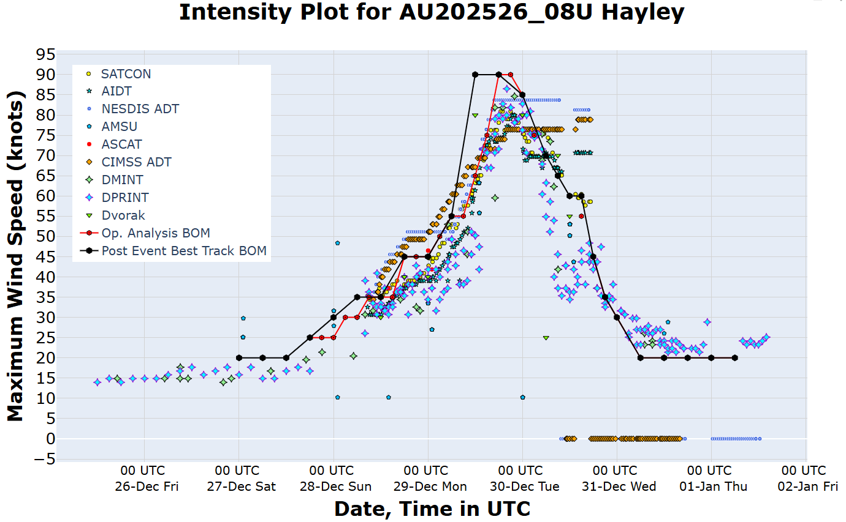
Figure 16 Intensity plot of objective and subjective guidance. SATCON, AiDT, NESDIS ADT, AMSU, ASCAT, CIMMS ADT, DMINT, DPRINT, Dvorak subjective estimate, operational analysis (red) and post event best track analysis (black). All wind speeds are 10-minute mean wind speeds.

