Tropical Cyclone Iggy (10U)
31 December 2025 – 4 January 2026
Tropical Cyclone Environmental Prediction Services

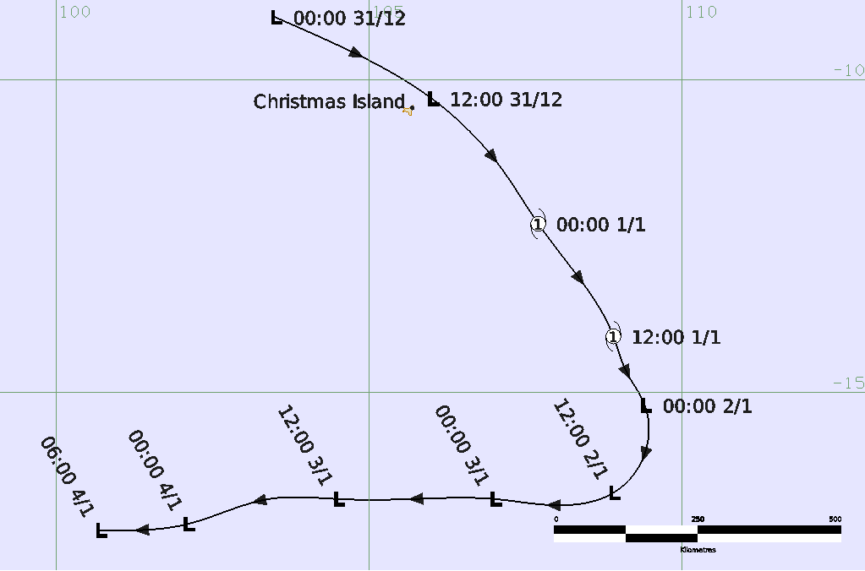

Revision history
Date | Version | Author | Description
21/01/2026 | 1.0 | EPS-TC lead. | Final draft

Release history
Date | Version | Status | Approval
2/02/2026 | 1.0 | Approved for release | Manager, EPS-TC.
Contact details:
Tropical Cyclone Team Lead
Severe Weather Environmental Prediction Services
Bureau of Meteorology
PO Box 1370, West Perth WA 6872
Email: tcwc@bom.gov.au

This work is copyright. Apart from any use as permitted under the Copyright Act 1968, no part may be reproduced without prior written permission from the Bureau of Meteorology. Refer to www.bom.gov.au/other/copyright.shtml for further information. Unless otherwise noted, all images in this document are licensed under the Creative Commons Attribution Australia Licence.
© Commonwealth of Australia 2026
Published by the Bureau of Meteorology
Cover image: Track of Tropical Cyclone Iggy, 31 December 2025 - 4 January 2026. Times in UTC.
Table of Contents

1. Summary 4

2. Meteorological description 6

2.1. Intensity analysis 6

2.2. Structure 6

2.3. Motion 7

3. Impact 7

4. Observations 7

4.1. Wind 7

4.2. Rainfall 7

5. Forecast Performance 15

Appendix: List of abbreviations 18

List of Figures
Figure 1. Best track of Tropical Cyclone Iggy, 31 December 2025- 4 January 2026.. 5
Figure 2. Hovmoller diagram of tropical waves over the latitude range of 5-15S 9
Figure 3. Sea surface temperatures in the eastern Indian Ocean for 30 December 2025. 10
Figure 4. Satellite scatterometry from ASCAT-C at 0148 UTC 1 January 2026 11
Figure 5. Visible image at 0300 UTC 1 January. 12
Figure 6. SSMIS 91 GHz microwave image at 1144 UTC 1 January 2026 13
Figure 7. AMSR2 microwave images at 1742 UTC 1 January. 14
Figure 8. Satellite derived wind speeds from OSCAT 1712 UTC 1 January and ASCAT-C at 0127 UTC 2 January. 15
Figure 9. Position accuracy figures for Tropical Cyclone Iggy 17
Figure 10. Intensity accuracy figures for Tropical Cyclone Iggy. 18
Figure 11. Intensity plot of objective and subjective guidance. 21

List of Tables
Table 1: Best track summary for Tropical Cyclone Iggy, 31 December 2025 - 4 January 2026. 5
Table 2: Verification statistics for Tropical Cyclone Iggy. 15

- Summary
Tropical Cyclone Iggy was a small, short lived tropical cyclone in the Indian Ocean that brought heavy rainfall to Christmas Island.
An increase in westerly winds assisted in the formation of a tropical low (10U) southwest of Sumatra on 30 December. It moved quickly to the southeast and entered the Australian region (10°S) on 31 December. The low passed just to the east of Christmas Island late on 31 December producing heavy rainfall (57.8 mm of rain recorded to 9 am 31 December and further 93.4 mm to 9 am 1 January), however no impacts were reported on the island.
The system intensified into a tropical cyclone at 0800 AWST 1 January and peaked at Category 1 intensity, with estimated maximum wind gusts near the centre of 100 km/h, before weakening below tropical cyclone intensity some 18 hours later at 0200 AWST 2 January. Iggy was a very small cyclone, with the largest extent of gales being 75 km. Overnight from 1 to 2 January, gales became confined to the eastern side of the centre before ceasing completely later on 2 January. The remaining low then turned westward and eventually dissipated over the Indian Ocean.
Figure 1 shows the best track of Iggy while Table 1 is a summary of the best track data.

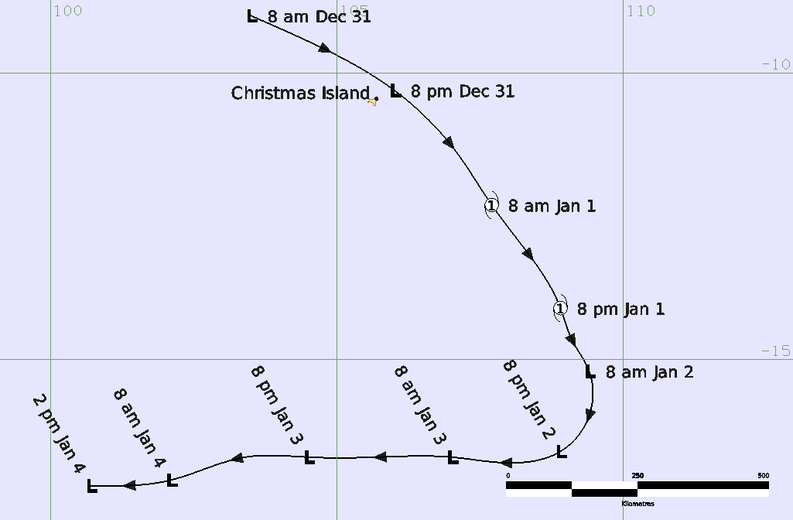
Figure 1. Best track of Tropical Cyclone Iggy, 31 December 2025- 4 January 2026. Times are in AWST (UTC+8h).

Year | Month | Day | Hour | Pos. | Pos. | Pos. | Max Wind | Max | Cent. | Rad. of gales | Rad. of storm | RMW
 |  |  | UTC | Lat. | Long. | Acc. | 10min | gust | Press. | (NE/SE/ | (NE/SE/ | nm
 |  |  |  | S | E | nm | kn | kn | hPa | SW/NW) | SW/NW)
2025 | 12 | 31 | 0000 | 9.0 | 103.5 | 30 | 30 | 45 | 1003 | 0/0/0/0 | 0/0/0/0 | -
2025 | 12 | 31 | 0600 | 9.4 | 104.4 | 50 | 30 | 45 | 1004 | 0/0/0/0 | 0/0/0/0 | -
2025 | 12 | 31 | 1200 | 10.3 | 106.0 | 30 | 35* | 50 | 1001 | 35/0/0/0 | 0/0/0/0 | -
2025 | 12 | 31 | 1800 | 11.4 | 107.1 | 20 | 35* | 50 | 1001 | 20/0/0/0 | 0/0/0/0 | -
2026 | 1 | 1 | 0000 | 12.3 | 107.7 | 25 | 40 | 55 | 998 | 30/30/35/40 | 0/0/0/0 | 12
2026 | 1 | 1 | 0600 | 13.1 | 108.3 | 20 | 40 | 55 | 997 | 30/30/35/40 | 0/0/0/0 | 12
2026 | 1 | 1 | 1200 | 14.1 | 108.9 | 25 | 40 | 55 | 997 | 30/30/35/40 | 0/0/0/0 | 12
2026 | 1 | 1 | 1800 | 14.7 | 109.1 | 15 | 35* | 50 | 998 | 30/30/0/0 | 0/0/0/0 | -
2026 | 1 | 2 | 0000 | 15.2 | 109.4 | 20 | 40* | 55 | 998 | 40/30/0/0 | 0/0/0/0 | -
2026 | 1 | 2 | 0600 | 16.1 | 109.4 | 15 | 35* | 50 | 999 | 30/0/0/0 | 0/0/0/0 | -
2026 | 1 | 2 | 1200 | 16.6 | 108.9 | 15 | 30 | 45 | 1002 | 0/0/0/0 | 0/0/0/0 | -
2026 | 1 | 2 | 1800 | 16.8 | 108.0 | 15 | 25 | 40 | 1004 | 0/0/0/0 | 0/0/0/0 | -
2026 | 1 | 3 | 0000 | 16.7 | 107.0 | 15 | 25 | 35 | 1006 | 0/0/0/0 | 0/0/0/0 | -
2026 | 1 | 3 | 0600 | 16.7 | 105.7 | 15 | 25 | 35 | 1006 | 0/0/0/0 | 0/0/0/0 | -
2026 | 1 | 3 | 1200 | 16.7 | 104.5 | 15 | 25 | 35 | 1006 | 0/0/0/0 | 0/0/0/0 | -
2026 | 1 | 3 | 1800 | 16.7 | 103.4 | 15 | 25 | 35 | 1006 | 0/0/0/0 | 0/0/0/0 | -
2026 | 1 | 4 | 0000 | 17.1 | 102.1 | 15 | 25 | 35 | 1006 | 0/0/0/0 | 0/0/0/0 | -
2026 | 1 | 4 | 0600 | 17.2 | 100.7 | 15 | 25 | 35 | 1006 | 0/0/0/0 | 0/0/0/0 | -
Table 1: Best track summary for Tropical Cyclone Iggy, 31 December 2025 - 4 January 2026. UTC=AWST+8h.
* Not a tropical cyclone as gales less than halfway around centre.

- Meteorological description
  - Intensity analysis
A comparison of the subjective and objective intensity estimates during the event is shown in Figure 11.
In late December a trough developed in the eastern Indian Ocean with an increase in westerly winds southwest of Java. This was possibly associated with an Equatorial Rossby wave although this is not highlighted in the outgoing longwave radiation filtered analysis shown in Figure 2. Sea surface temperatures along the track of Iggy were 28.5-29°C, slightly above normal as shown in Figure 3.
A circulation became defined early on 31 January and scatterometry showed near gale-force northwesterly winds north of the centre. Deep convection increased and became more organised about the centre later on 31 January as the centre accelerated to the southeast passing by Christmas Island. During 1 January, deep convection reduced in extent but persisted near the centre indicating intensification as shown in the visible image at 0300 UTC 1 January in Figure 5. Tropical cyclone intensity was estimated at 0000 UTC 1 January based upon scatterometry that showed gales extended around the centre, ASCAT-B at 0107 UTC and ASCAT-C at 0148 UTC in Figure 4. Subsequent SMOS and SMAP wind solutions supported this analysis and the SSMIS microwave image at 1144 UTC in Figure 6 showed deep convection tightly wrapping around the west and north of the circulation.
However, overnight from 1 to 2 January weakening occurred as deep convection reduced to the east of the circulation as demonstrated on the 1742 UTC AMSR2 89 GHz microwave image (Figure 7). This is despite the circulation having a well-defined low-level circulation shown on 37 GHz (also Figure 7). Figure 8 shows the 1712 UTC OSCAT pass having gales only to the northeast of the circulation and a partial ASCAT-C pass at 0127 UTC 2 January having gales east of the centre.
Further weakening occurred on 2 January as drier air was ingested into the circulation associated with increasing northwesterly wind shear. Deep convection and surface winds reduced as a result. The circulation turned to the west under the influence of a ridge building to the south which maintained strong east southeasterly winds south of the centre for a period until the centre dissipated late on 4 January.

  - Structure
Iggy was a very compact system having gales only extend 40 nm (70 km), as shown in scatterometry in Figures 4 and 8. Gales were most apparent northeast of the centre, lasting from 1200 UTC 31 December to 0600 UTC 2 January. However, gales only extended more than halfway around from 0000 to 1200 UTC 1 January.
The radius of maximum winds (RMW) was estimated at 12 nm (20 km)
  - Motion
Iggy's track, in Figure 1 shows a southeast motion owing to the stronger low level northwesterly flow and then assisted by an upper trough well to the south. The system slowed on 2 January and the weakening circulation turned to the west under the influence of a low to mid-level ridge that strengthened to the south.

- Impact
Christmas Island experienced heavy rain but there were no known impacts.

- Observations
  - Wind
Christmas Island did not record significant winds as the low passed by and there were no other observations in the vicinity of the system.
  - Rainfall
Christmas Island recorded a daily rainfall of 57.8 mm on 31 December and 93.4 mm on 1 January as the developing low passed by.

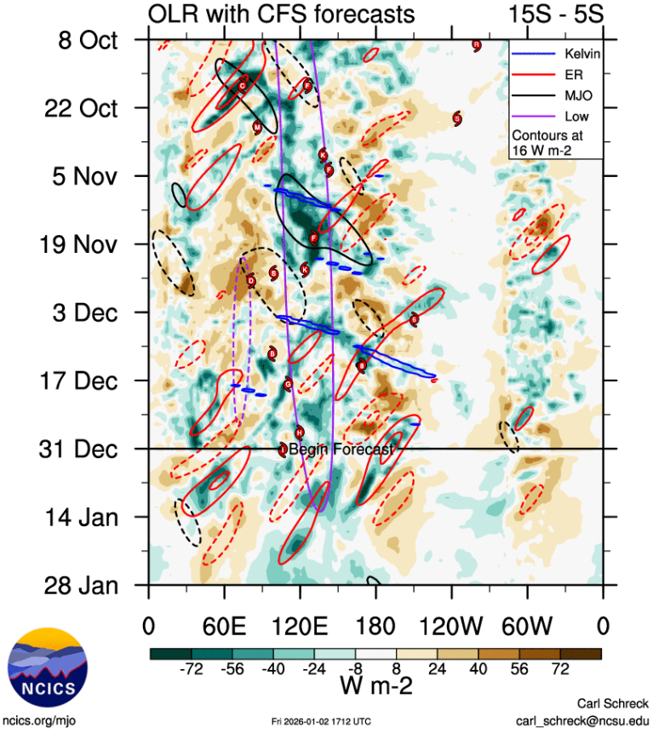
Figure 2. Hovmoller diagram of tropical waves over the latitude range of 5-15S. The influence of tropical waves on Iggy's formation is not immediately clear. Some evidence suggests an Equatorial Rossby (ER) wave and the presence of a background low-frequency wave analysed (denoted by the purple contour) contributed to the development of TC Iggy. Image courtesy of North Carolina Institute for Climate Studies: Tropical Monitoring:: North Carolina Institute for Climate Studies
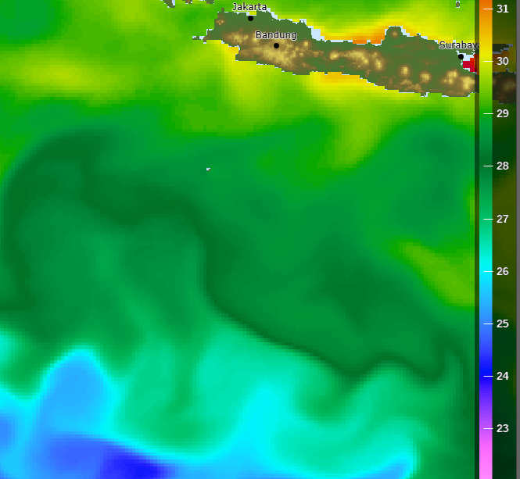
Figure 3. Sea surface temperatures in the eastern Indian Ocean for 30 December 2025 showing that temperatures along Iggy's track were about 28.5-29°C.

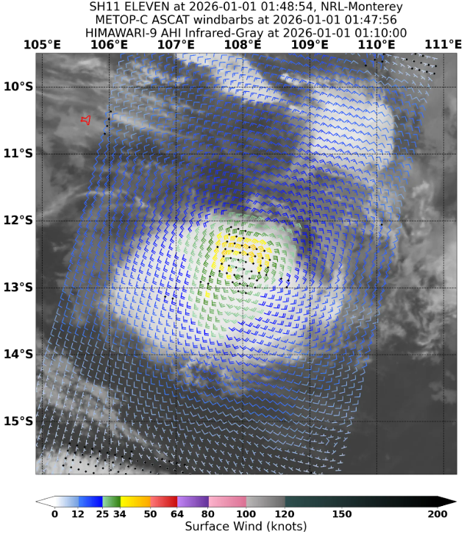
Figure 4. Satellite scatterometry from ASCAT-C at 0148 UTC 1 January 2026 showing gales (in yellow) around the centre. Image courtesy NRL: https://www.nrlmry.navy.mil/TC.html

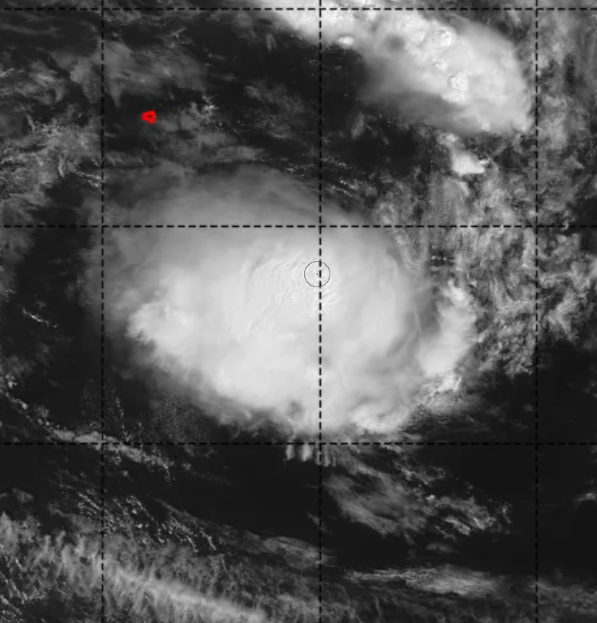
Figure 5. Visible image at 0300 UTC 1 January. The centre is shown as a circle at 12.7°S 108.0°E under the deep convection to the southeast of Christmas Is. (red). Dashed latitude lines every 2 degrees. Image courtesy NRL: https://www.nrlmry.navy.mil/TC.html

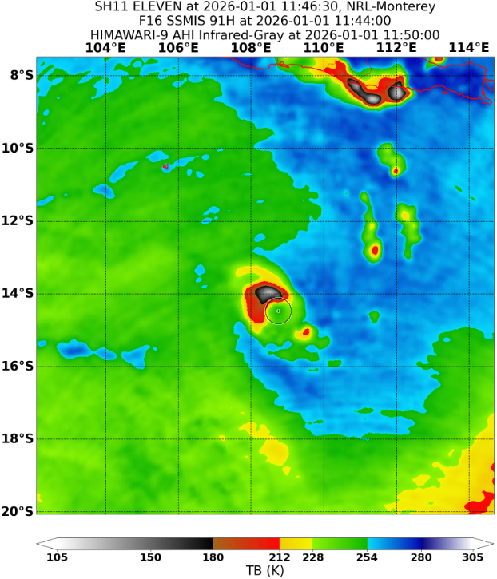
Figure 6. SSMIS 91 GHz microwave image at 1144 UTC 1 January 2026 showing deep convection to the west and north tightly wrapping around the centre (circle). Image courtesy NRL: https://www.nrlmry.navy.mil/TC.html

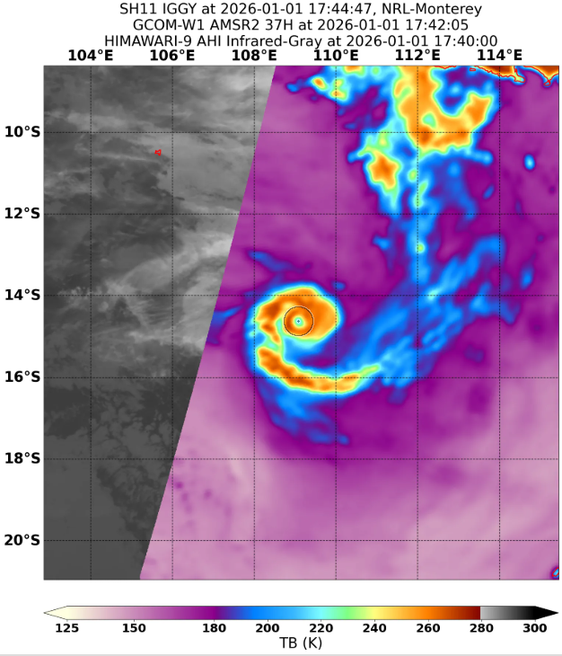 | 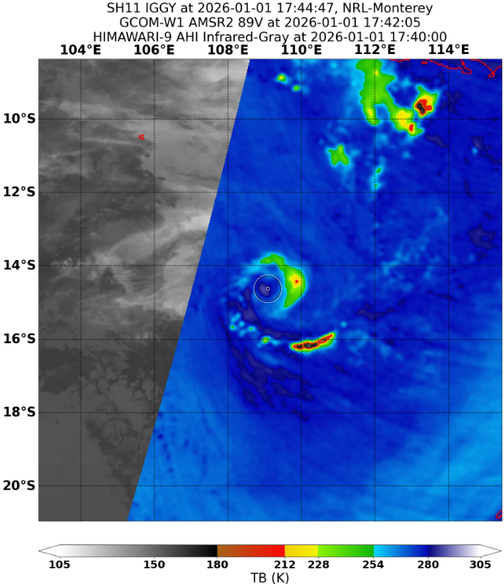

Figure 7. AMSR2 microwave images at 1742 UTC 1 January, left 37 GHz, and right 89 GHz. The circle marks the location of the centre. Images courtesy NRL: https://www.nrlmry.navy.mil/TC.html
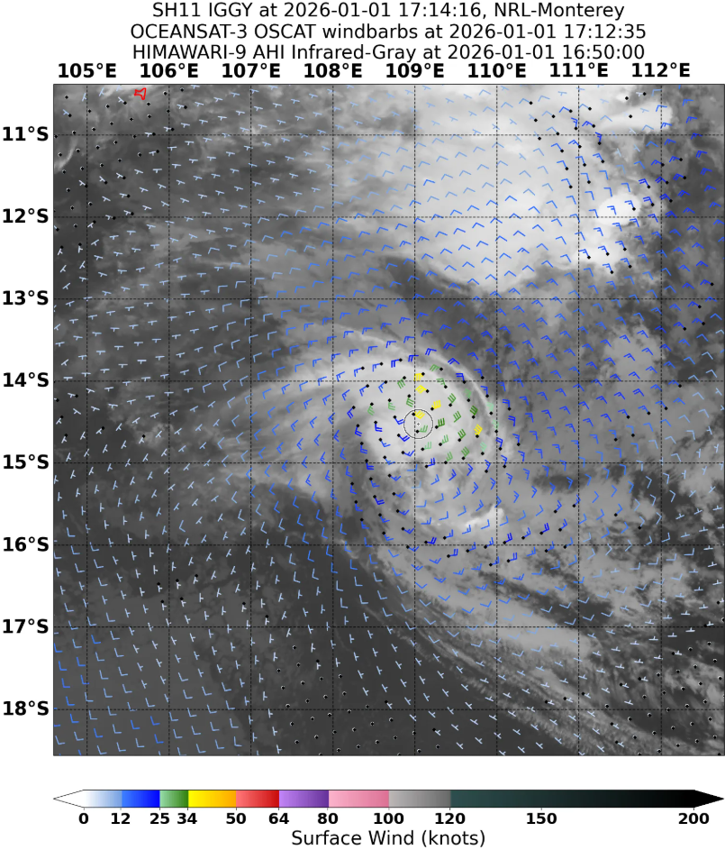 | 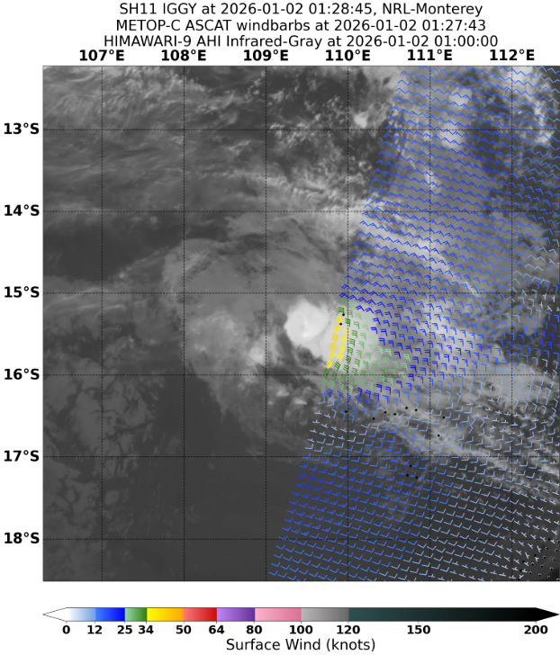

Figure 8. Satellite derived wind speeds from left: OSCAT 1712 UTC 1 January; and right: ASCAT-C at 0127 UTC 2 January. The overlaid circle indicates the centre and winds in yellow denote gales. The OSCAT has an incorrect wind direction solution but nevertheless indicates gales in the northeast quadrant, while the partial ASCAT pass shows gales east of the centre. Image courtesy of NRL: https://www.nrlmry.navy.mil/TC.html

- Forecast Performance
On 28 December the 7 Day forecast indicated the potential for 10U having a Low rating of becoming a tropical cyclone. On 30 December ratings increased to Moderate for 2 January and were further increased to High upon Iggy being named on 1 December.
The first track map was issued at 0000 UTC 1 January, coinciding with the first Ocean Wind Warning and Technical Bulletin being issued, and continued until gales were estimated to have eased at 1200 UTC 2 January.
The accuracy statistics for Tropical Cyclone Iggy are below in Table 2 and shown in Figure 9 and Figure 10. Only a total of 7 tracks were issued so a limited dataset to verify. Overall the track correctly indicated a southeast motion, slowing then moving west. However, the track errors are higher than the 5-year average as the westward turn occurred earlier and faster than the forecast.
The intensity errors were also higher than the 5-year average. The initial forecast underestimated the intensity but for the most part the forecasts were higher than actual. Forecasts issued at 0600 to 1200 UTC 1 January, after Iggy was named, indicated a peak intensity forecast of 60 kn (category 2) on 2 January and then gales continuing south of the centre after 2 January as the system was tracking to the west. The actual peak was 45 kn on 1 January and gales eased by 1200 UTC 2 January.

Time | 00 | 06 | 12 | 18 | 24 | 36 | 48
Position accuracy (km) | 21 | 68 | 111 | 156 | 209 | 311 | 442
Intensity accuracy (knots) | 1.4 | 6.4 | 9.3 | 11.4 | 12.9 | 15.0 | 14.2
Sample Size | 7 | 7 | 7 | 7 | 7 | 7 | 6
Table 2: Verification statistics for Tropical Cyclone Iggy. Note: Verification is performed using the Official Forecast Tracks at the standard times of 00, 06, 12 and 18 UTC.
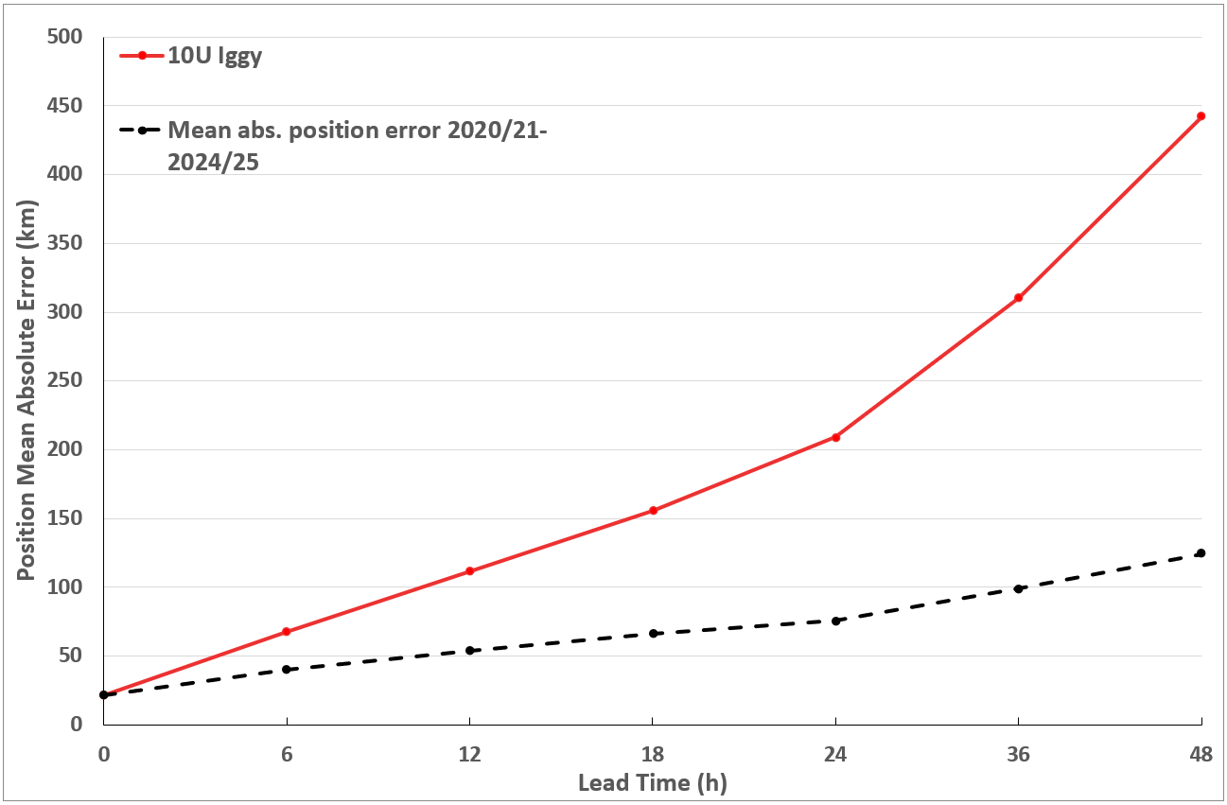
Figure 9. Position accuracy figures for Tropical Cyclone Iggy compared against the 5-year average.

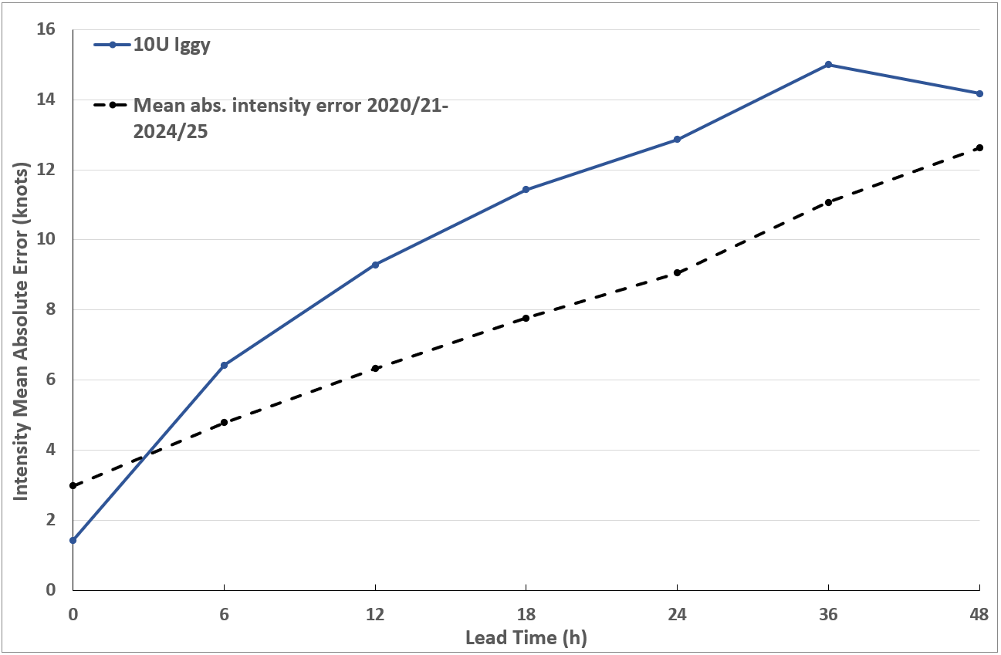
Figure 10. Intensity accuracy figures for Tropical Cyclone Iggy compared against the 5-year average.

Appendix: List of abbreviations
Abbreviation | Term
ADT | Advanced Dvorak Technique
ACST | Australian Central Standard Time
AEST | Australian Eastern Standard Time
AiDT | AI-enhanced Dvorak Technique
AMSR2 | Advanced Microwave Scanning Radiometer
AMSU | Advanced Microwave Sounding Unit
ASCAT | Advanced Scatterometer
ATMS | Advanced Technology Microwave Sounder
AWS | automatic weather station
AWST | Australian Western Standard Time
°C | Celsius
CI | Current intensity
CIMSS | Cooperative Institute for Meteorological Satellite Studies (USA)
CIRA | Cooperative Institute for Research in the Atmosphere (USA)
D-MINT | Deep learning - Multispectral Intensity of TCs (formerly known as DMN)
D-PRINT | Deep learning - IR Intensity of TCs (formerly known as OPEN-AIIR)
DT | Data T-number
EIR | Enhanced InfraRed
ERC | eyewall replacement cycle
FNMOC | Fleet Numerical Meteorology and Oceanography Centre (USA)
FT | Final T-number
GCOM | Global Change Observation Mission
GHz | Gigahertz
GMI | Global Precipitation Measurement Microwave Imager
h | hour
hPa | hectopascal
HSCAT | Hai Yang 2 Scatterometer (HY-2B, HY-2C)
km | kilometres
km/h | kilometres per hour
kn | knot
LLCC | Low Level Closed Circulation
MET | Model Expected T-number
METOP | Meteorological Operational Satellite
MJO | Madden-Julian Oscillation
mm | millimetres
MSLP | mean sea level pressure
NESDIS | National Environmental Satellite, Data, and Information Service
nm | nautical mile
NOAA | National Oceanic and Atmospheric Administration
NRL | Navy Research Lab (USA)
OPEN-AiiR | Ordered Pattern Encoding AI Infrared
OSCAT | Ocean Scatteromoter
PAT | Pattern T-number
RCM | RadarSat Constellation Mission – Synthetic Aperture Radar
RH | relative humidity
RMW | radius of maximum winds
RSMC | Regional Specialised Meteorological Centre
SAR | Synthetic Aperture Radar
SATC | CIMSS Advanced Dvorak Technique
SATCON | Satellite Consensus
SEN1 | Sentinel-1A – Synthetic Aperture Radar
SMAP | Soil Moisture Active Passive
SMOS | Soil Moisture and Ocean Salinity
SSMIS | Special Sensor Microwave Imager/Sounder
TC | Tropical Cyclone
TCWC | Tropical Cyclone Warning Centre
UTC | Universal Time Co-ordinated

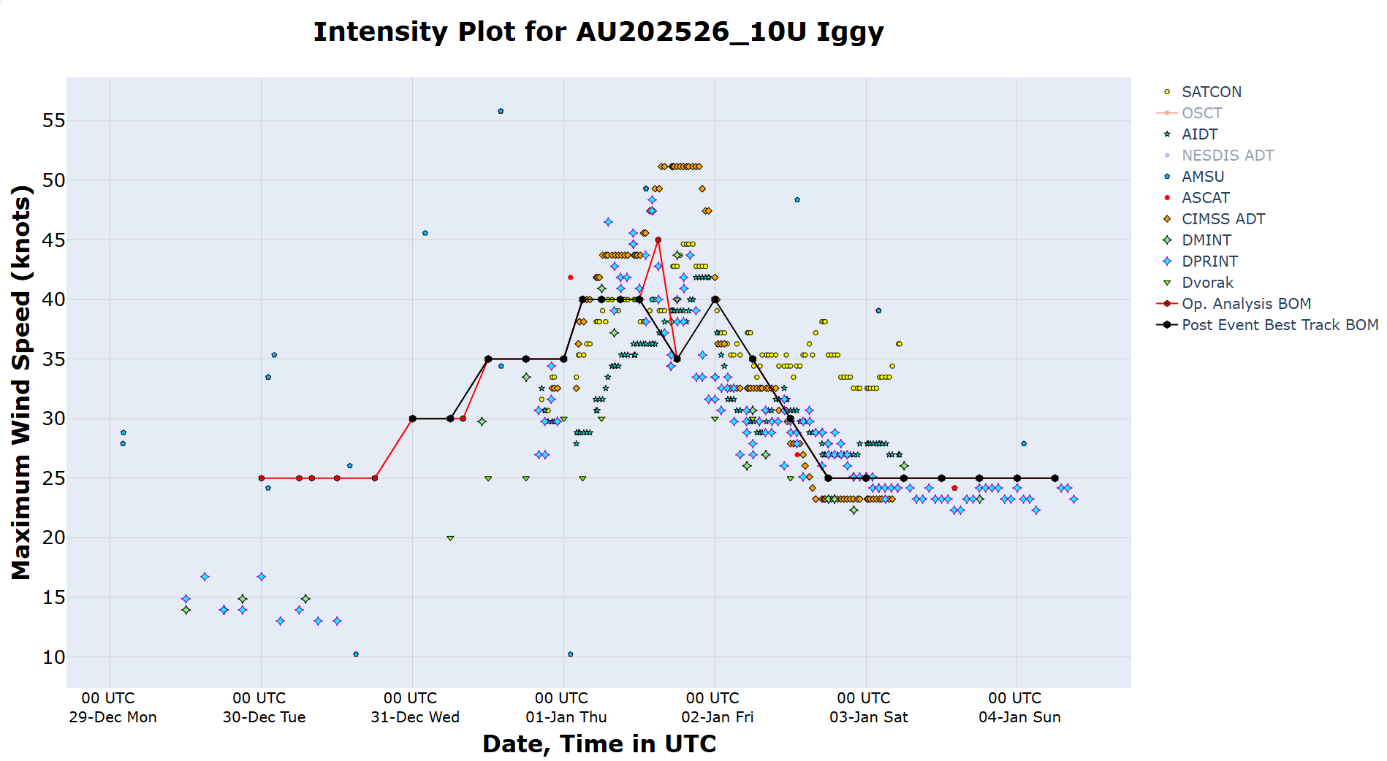
Figure 11. Intensity plot of objective and subjective guidance. SATCON, AiDT, NESDIS ADT, SAR-SEN1, AMSU, SAR-RCM, ASCAT, CIMMS ADT, DMINT, DPRINT, Dvorak subjective estimate, operational analysis (red) and post event best track analysis (black).

