Severe Tropical Cyclone Ilsa

6 – 15 April 2023

Matthew Boterhoven and Linda Paterson
Tropical Cyclone Environmental Prediction Services

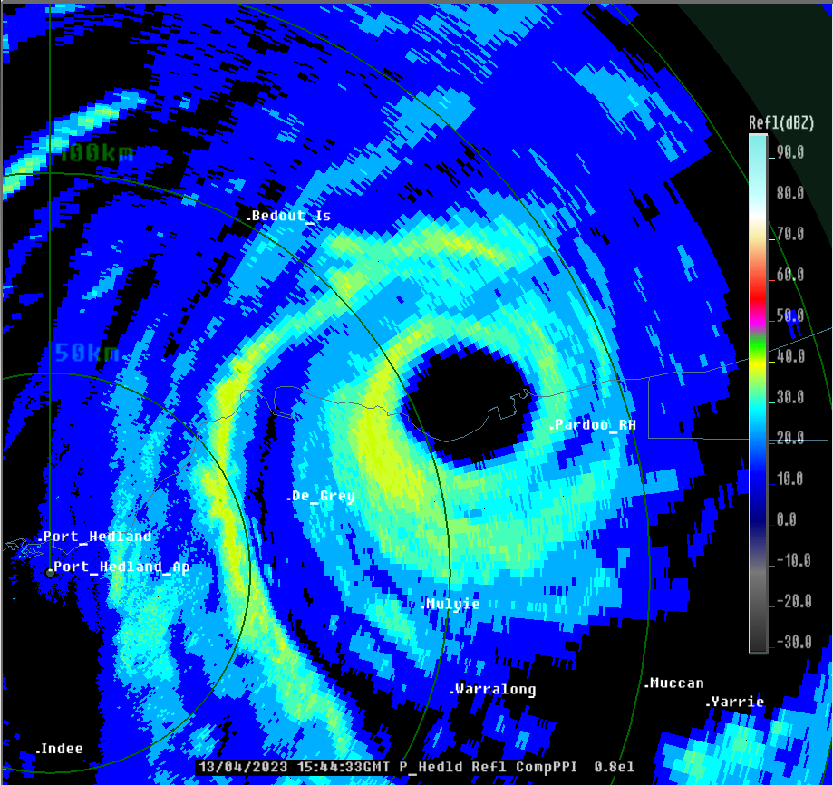
Revision history
Date | Version | Author | Description
25/05/2023 | 1.0 | Matthew Boterhoven  Linda Paterson | Final draft ready
5/2/2026 | 1.1 | Linda Paterson | Revised to include pressure observations at time of coastal crossing

Review status
Date | Version | Reviewer | Description
30/05/2023 | 1.0 | Adam Conroy | Completed

Release history
Date | Version | Status | Approval
6/06/2023 | 1.0 | Approved for release | Andrew Burton
5/2/2026 | 1.1 | Approves for release | Craig Earl-Spurr

Contact details:
Tropical Cyclone Team Lead
Severe Weather Environmental Prediction Services
Bureau of Meteorology
PO Box 1370, West Perth WA 6872
Email: tcwc@bom.gov.au

This work is copyright. Apart from any use as permitted under the Copyright Act 1968, no part may be reproduced without prior written permission from the Bureau of Meteorology. Refer to www.bom.gov.au/other/copyright.shtml for further information. Unless otherwise noted, all images in this document are licensed under the Creative Commons Attribution Australia Licence.
© Commonwealth of Australia 2023
Published by the Bureau of Meteorology
Cover image: Port Hedland radar image of Ilsa crossing the Pilbara coast.

Contents

1. Summary 5

2. Meteorological description 9

2.1 Intensity analysis 9

2.1 Structure 16

2.2 Motion 17

3. Impact 19

4. Observations 20

4.1. Wind 20

4.2. Pressure 21

4.3. Rainfall 21

5. Forecast performance 22

6. Appendix: List of abbreviations 25

- Summary
Severe Tropical Cyclone Ilsa crossed the east Pilbara coast at category 5 intensity just before midnight local time on Thursday 13 April 2023.
A tropical low that formed in the Timor Sea on 6 April moved southwest and developed slowly. It reached tropical cyclone intensity at 0600 UTC 11 April (1400 AWST 11 April, AWST = UTC+8 hours), about 400 km to the north northwest of Broome. During 11 April the environment became more favourable for development and the cyclone underwent rapid intensification. Ilsa reached severe category three strength by 0000 UTC 12 April, only eighteen hours after formation. The movement of Ilsa began to slow during 13 April and it turned south towards the Pilbara coast. Ilsa continued to intensify under favourable conditions and reached category 5 strength at 0600 UTC 13 April, some 180 kilometres to the north of Port Hedland.
Severe Tropical Cyclone Ilsa turned to the southeast from this point and accelerated towards the Pilbara coast, crossing near the Pardoo Roadhouse at 1600 UTC 13 April, around midnight local time, with a peak 10-minute mean wind intensity of 125 kn (230 km/h). Once the tropical cyclone crossed the coast and moved inland it began to weaken, decreasing below Category 3 intensity by 0600 UTC 14 April and then below tropical cyclone intensity by 1200 UTC 14 April over eastern parts of inland Western Australia.
Ilsa crossed the Pilbara coast in a relatively sparsely populated location; which limited the reported damage. However, the Pardoo Roadhouse and pastoral stations, including Pardoo and Warrawagine, sustained severe damage. Other communities along the track further inland such as Telfer, Punmu and Parnngurr experienced mostly minor building damage. Heavy rainfall was recorded along the track but no significant flooding was experienced.
Two Indonesian fishing boats were caught in the path of Ilsa off Rowley Shoals. One boat sank with at least nine fishermen feared drowned. The other boat ran aground at Bedwell Island on the northern end of Rowley Shoals. The eleven Indonesian fishermen survived six days without food and water before being rescued. Ilsa also had a destructive impact on bird colonies particularly the brown boobies and frigate birds on Bedout Island.
Ilsa passed directly over the Bureau of Meteorology's offshore observing sites at Rowley Shoals and Bedout Island as well as the inland site of Telfer. The peak 118 kn (219 km/h) 10-minute mean wind observation and the 155.9 kn (289 km/h) wind gust at Bedout Island are the highest known recorded on a standard Bureau instrument. Although it is still significantly lower than the gust recorded on Barrow Island in Olivia (http://www.bom.gov.au/jshess/docs/2012/courtney_hres.pdf). Ilsa also passed directly over a privately deployed barometer that recorded a minimum mean sea level pressure of 931.9 hPa at 1608 and again at 1637 UTC 13 April.

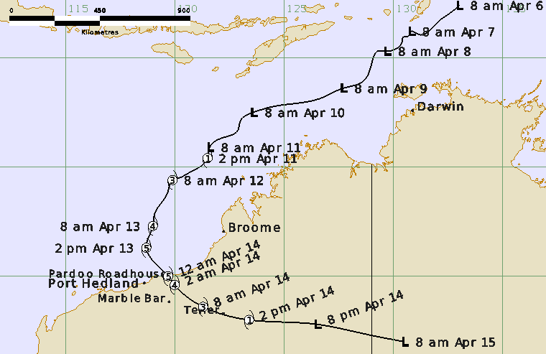
Figure 1a. Best track of Severe Tropical Cyclone Ilsa (times in AWST, UTC +8).

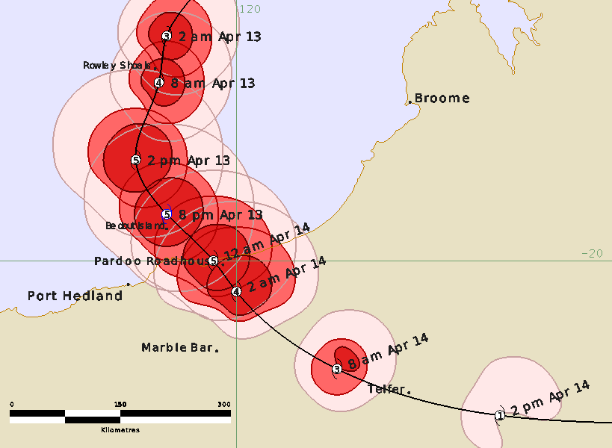
Figure 2b. Detailed best track of Severe Tropical Cyclone Ilsa showing wind radii (gale - pink, storm - red and hurricane force – dark red) 13-14 April 2023 (times in AWST, UTC +8).

Year | Month | Day | Hour | Pos. | Pos. | Pos. | Max Wind | Max | Cent. | Rad. of gales | Rad. of storm | RMW
 |  |  | UTC | Lat. | Long. | Acc. | 10min | gust | Press. | (NE/SE/ | (NE/SE/ | nm
 |  |  |  | S | E | nm | kn | kn | hPa | SW/NW) | SW/NW)
2023 | 4 | 6 | 0000 | 7.6 | 133.0 | 30 | 20 | 45 | 1006 | 0/0/0/0 | 0/0/0/0 | -
2023 | 4 | 6 | 0600 | 7.8 | 132.8 | 30 | 20 | 45 | 1005 | 0/0/0/0 | 0/0/0/0 | -
2023 | 4 | 6 | 1200 | 8.4 | 132.0 | 30 | 25 | 45 | 1005 | 0/0/0/0 | 0/0/0/0 | -
2023 | 4 | 6 | 1800 | 8.9 | 131.1 | 20 | 25 | 45 | 1005 | 0/0/0/0 | 0/0/0/0 | -
2023 | 4 | 7 | 0000 | 8.8 | 130.8 | 15 | 25 | 45 | 1004 | 0/0/0/0 | 0/0/0/0 | -
2023 | 4 | 7 | 0600 | 9.0 | 130.7 | 15 | 25 | 45 | 1002 | 0/0/0/0 | 0/0/0/0 | -
2023 | 4 | 7 | 1200 | 9.1 | 130.4 | 15 | 30 | 45 | 1003 | 0/0/0/0 | 0/0/0/0 | -
2023 | 4 | 7 | 1800 | 9.2 | 130.4 | 25 | 30 | 45 | 1003 | 0/0/0/0 | 0/0/0/0 | -
2023 | 4 | 8 | 0000 | 9.7 | 129.7 | 15 | 35 | 50 | 1003 | 0/0/30/30 | 0/0/0/0 | -
2023 | 4 | 8 | 0600 | 9.7 | 129.3 | 15 | 35 | 50 | 1000 | 0/0/30/30 | 0/0/0/0 | -
2023 | 4 | 8 | 1200 | 10.3 | 129.0 | 30 | 35 | 50 | 1002 | 0/0/30/30 | 0/0/0/0 | -
2023 | 4 | 8 | 1800 | 11.1 | 128.6 | 35 | 35 | 50 | 1000 | 0/0/30/30 | 0/0/0/0 | -
2023 | 4 | 9 | 0000 | 11.4 | 127.7 | 30 | 35 | 50 | 1003 | 0/0/30/30 | 0/0/0/0 | -
2023 | 4 | 9 | 0600 | 11.8 | 126.8 | 25 | 35 | 50 | 1000 | 0/0/30/30 | 0/0/0/0 | -
2023 | 4 | 9 | 1200 | 12.1 | 125.5 | 30 | 30 | 45 | 1002 | 0/0/0/0 | 0/0/0/0 | -
2023 | 4 | 9 | 1800 | 12.2 | 124.7 | 30 | 30 | 45 | 1001 | 0/0/0/0 | 0/0/0/0 | -
2023 | 4 | 10 | 0000 | 12.5 | 123.6 | 30 | 30 | 45 | 1002 | 0/0/0/0 | 0/0/0/0 | -
2023 | 4 | 10 | 0600 | 12.9 | 123.0 | 20 | 30 | 45 | 998 | 0/0/0/0 | 0/0/0/0 | -
2023 | 4 | 10 | 1200 | 13.3 | 122.9 | 15 | 40 | 55 | 994 | 0/0/90/0 | 0/0/0/0 | -
2023 | 4 | 10 | 1800 | 13.7 | 122.1 | 15 | 40 | 55 | 994 | 0/0/90/0 | 0/0/0/0 | -
2023 | 4 | 11 | 0000 | 14.1 | 121.6 | 15 | 35 | 50 | 998 | 0/0/50/0 | 0/0/0/0 | -
2023 | 4 | 11 | 0600 | 14.6 | 121.5 | 15 | 40 | 55 | 993 | 60/90/90/70 | 0/0/0/0 | 20
2023 | 4 | 11 | 1200 | 15.3 | 120.6 | 20 | 50 | 70 | 990 | 60/80/80/60 | 30/30/30/30 | 18
2023 | 4 | 11 | 1800 | 15.5 | 120.2 | 10 | 55 | 75 | 985 | 60/80/80/60 | 35/35/35/35 | 17
2023 | 4 | 12 | 0000 | 15.6 | 119.9 | 10 | 65 | 90 | 981 | 55/75/70/55 | 20/20/25/25 | 14
2023 | 4 | 12 | 0600 | 16.1 | 119.7 | 10 | 70 | 100 | 973 | 50/75/60/50 | 20/20/25/25 | 12
2023 | 4 | 12 | 1200 | 16.5 | 119.5 | 15 | 80 | 110 | 965 | 50/70/35/40 | 20/20/20/20 | 10
2023 | 4 | 12 | 1800 | 17.1 | 119.1 | 10 | 90 | 125 | 955 | 60/50/35/40 | 35/35/20/25 | 10
2023 | 4 | 13 | 0000 | 17.7 | 119.0 | 8 | 100 | 140 | 940 | 60/50/35/40 | 35/35/20/25 | 10
2023 | 4 | 13 | 0600 | 18.7 | 118.7 | 6 | 110 | 155 | 935 | 70/65/50/70 | 40/40/30/40 | 9
2023 | 4 | 13 | 1200 | 19.4 | 119.1 | 6 | 125 | 175 | 930 | 70/65/50/70 | 40/40/30/40 | 8
2023 | 4 | 13 | 1600 | 20.0 | 119.7 | 6 | 125 | 175 | 930 | 70/50/40/70 | 50/30/25/50 | 9
2023 | 4 | 13 | 1800 | 20.4 | 120.0 | 6 | 110 | 155 | 935 | 70/40/30/70 | 50/25/20/50 | 11
2023 | 4 | 14 | 0000 | 21.4 | 121.3 | 15 | 65 | 90 | 965 | 50/35/30/35 | 25/20/20/20 | 15
2023 | 4 | 14 | 0600 | 22.0 | 123.4 | 25 | 45 | 65 | 980 | 50/0/30/30 | 0/0/0/0 | 20
2023 | 4 | 14 | 1200 | 22.2 | 126.5 | 35 | 35 | 50 | 997 | 0/0/30/30 | 0/0/0/0 | -
2023 | 4 | 14 | 1800 | 22.6 | 128.5 | 35 | 30 | 45 | 998 | 0/0/0/0 | 0/0/0/0 | -
2023 | 4 | 15 | 0000 | 23.0 | 130.5 | 35 | 25 | 45 | 1003 | 0/0/0/0 | 0/0/0/0 | -
Table 1. Best track summary for Severe Tropical Cyclone Ilsa, 6 – 15 April 2023.
UTC=AWST-8h. * Not at tropical cyclone intensity as gales less than halfway around centre.
- Meteorological description

2.1 Intensity analysis
The tail end of an active burst of the Madden-Julian Oscillation combined with a westward moving Equatorial Rossby wave to assist the development of a low in the Timor Sea on 6 April. Convection had been present near the circulation for about 12 hours and a Data-T (DT) of 1.0 was also assigned around this time. Initially the low drifted slowly to the southwest with the rate of development below the standard one T-number per day increase due to strong environmental vertical wind shear of about 20-30 kn (35-55 km/h) from the east. During the next 48 hours satellite imagery revealed the low followed a typical cloud pattern cycle that a system affected by strong shear exhibit. Convection would develop to the west of the exposed low-level centre which gave a DT number of about 1.5, as the convection spread out the centre became located under the strong temperature gradient which increased the DT number to 3.0, this cycle repeated several times between 7 and 10 April (refer to Figure 2 for satellite images).
The intensity of Ilsa during this period was largely determined by scatterometry passes rather than Dvorak DT numbers. ASCAT passes on 8 April indicated gales were present in the western quadrants under the deep convection and intensity was estimated at 35 kn (65 km/h) (refer to Figure 2 d). Development was still constrained by strong vertical wind shear and intensity was estimated to have decreased to 30 kn (55 km/h) again late on 9 April. The cycling of the DT between 2.0 and 3.0 continued through 9 and 10 April and the FT continued to be weighted towards pattern adjusted MET, this maintained it at 2.5. Objective guidance available (refer Figure 3) varied, however most appeared biased too high which is a known weakness of objective guidance that are estimating intensity of systems in a high wind shear environment.
On 11 April shear analyses showed that the vertical wind shear decreased from the initial 20-30 kn (35-55 km/h) across the system to about 15 kn (28 km/h) over the developing tropical low. Over the next six hours upper outflow channels improved and the low became more symmetric in appearance in satellite imagery. Tropical cyclone strength was assigned at 0600 UTC 11 April and the 0540 UTC 11 April AMSR2 microwave pass showed a well-developed curved band on the western side and a developing curved band on the eastern side (refer Figure 4). A SMAP pass at 0950 UTC indicated gales were present in all quadrants. From this point Ilsa underwent very rapid intensification and eighteen hours later it was determined to have reached hurricane strength. An early morning microwave pass showed an eye had developed. Most objective estimates were clustered between 65 and 70 kn (130 km/h) at 0000 UTC 12 April, subjective Dvorak was notably low at 55 kn (100 km/h) with only Open AiiR (now renamed D-PRINT) lower at 53 kn (98 km/h).
The environment of Ilsa had become very conducive for development with shear analysed to have decreased to 10 kn (18 km/h) and upper-level outflow evident in all quadrants. The 0742 UTC 12 April GMI microwave pass (refer Figure 5) showed a well-developed eye and by 0900 UTC 12 April the enhanced infrared imagery (EIR) also began to show that a cold medium grey eye had formed within a ring of surrounding white. Ilsa passed over the Bureau of Meteorology's offshore observing site at Rowley Shoals which measured a peak 10-minute mean wind speed of 83 kn (154 km/h) at 2224 UTC 12 April. The instrument failed not long after the eye wall passed directly over the site.
A cold eye persisted overnight on 12 April but the eye steadily warmed (intensified) during 13 April. Ilsa reached a maximum Dvorak 3-hour average DT-number of 6.5 between 0700 and 1200 UTC 13 April with a single time step peak of 7.0 at 0900 UTC before the eye began to cool and the T-number decreased. As Ilsa approached the Pilbara coast is passed directly over the Bureau's offshore observing site located on Bedout Island where a minimum pressure of 931.2 hPa at 1243 UTC 13 April was recorded within the eye. As the rear northwest eye wall passed over the island a peak 10-minute mean wind of 118 kn (218 km/h) was recorded at 1328 UTC 13 April before the instrument failed (refer Figure 6 and 8). A maximum 10-minute mean wind of 125 kn (230 km/h) was estimated between 1200 and 1600 UTC 13 April using objective guidance and the Bedout Island observation (refer Figure 7). After making landfall Ilsa began to weaken quickly, falling below hurricane strength by 0300 UTC 14 April and then below tropical cyclone strength by 1200 UTC 14 April. The remnants of the low moved east and dissipated over central Australia.

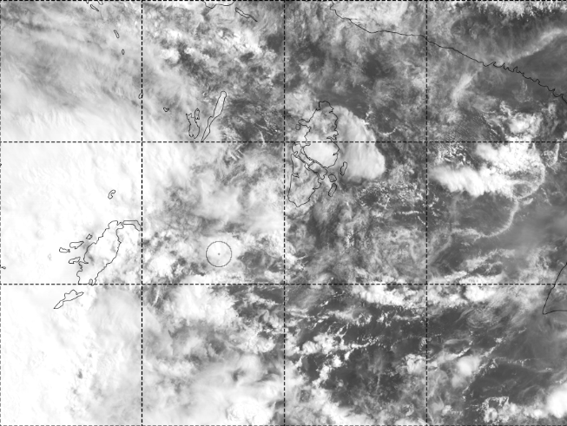 | 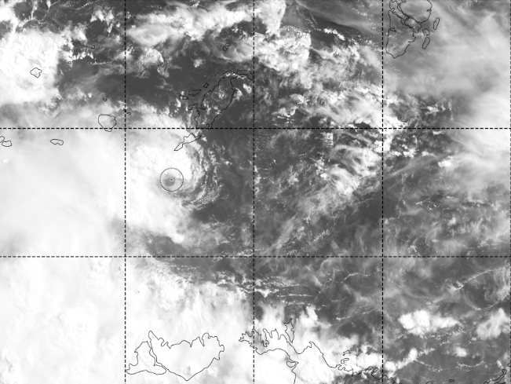
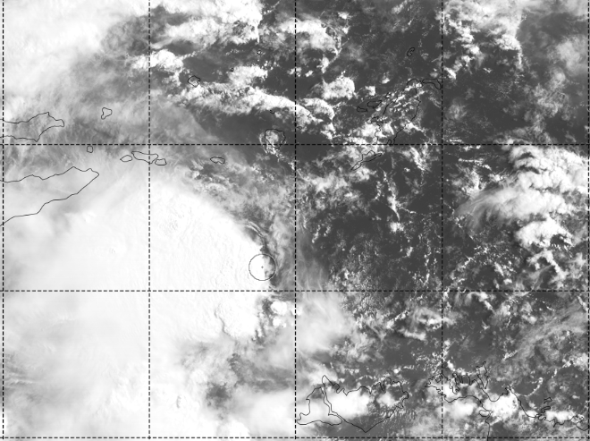 | 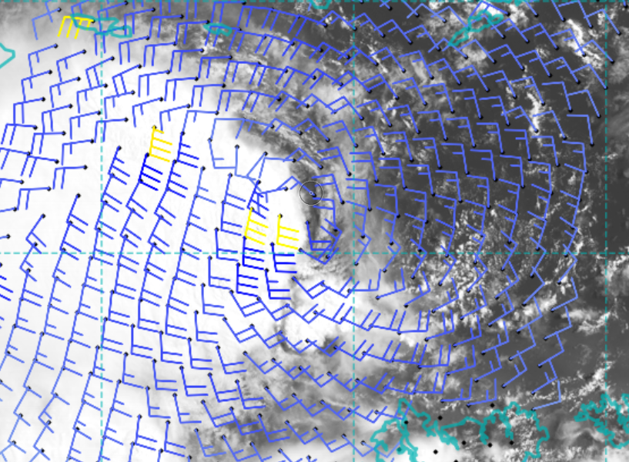
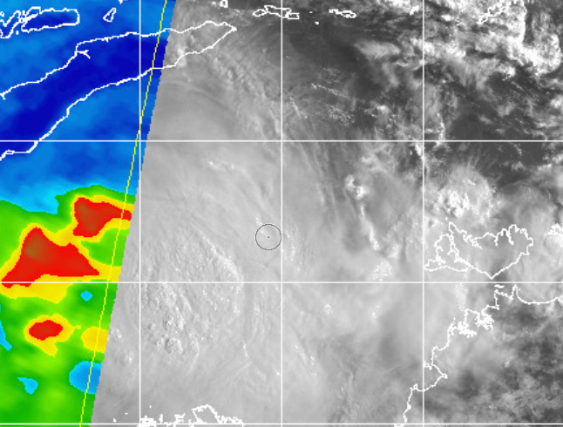 | 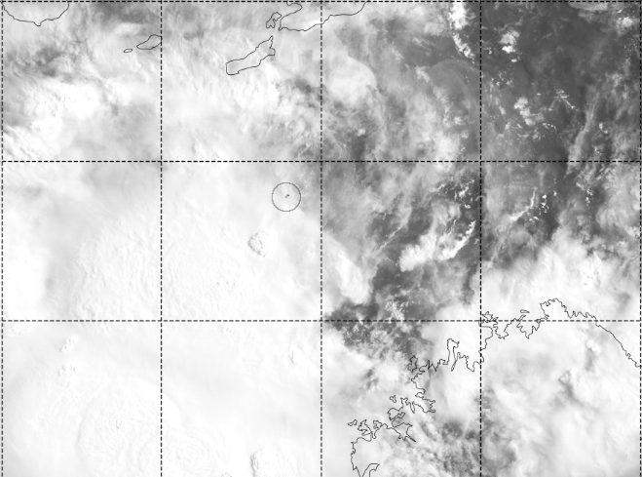
Figure 2.Visible imagery from a) 0000 UTC 6 April b) 0000 UTC 7 April c) 0000 UTC 8 April and d) ASCAT pass at 0021 UTC 8 April e) 2225 UTC 8 April f) 0000 UTC 10 April showing the slow development over four days. The centre location is indicated by the circle.

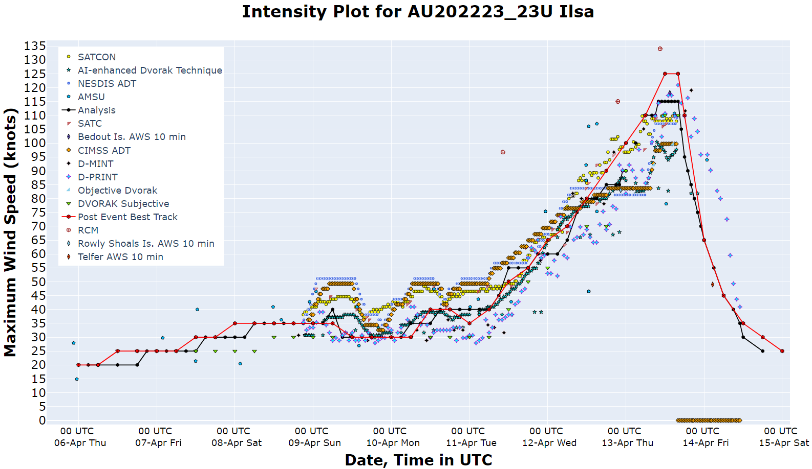Figure 3. Intensity plot of objective and subjective guidance. SATCON, AiDT, NEDIS ADT, AMSU, SATC, CIMSS ADT, D-MINT, D-PRINT, Objective Dvorak have been adjusted from 1-minute to 10-minute maximum mean winds. The RCM SAR analysis has been re-analysed by NOAA post event (via email correspondence) and the values have been adjusted.

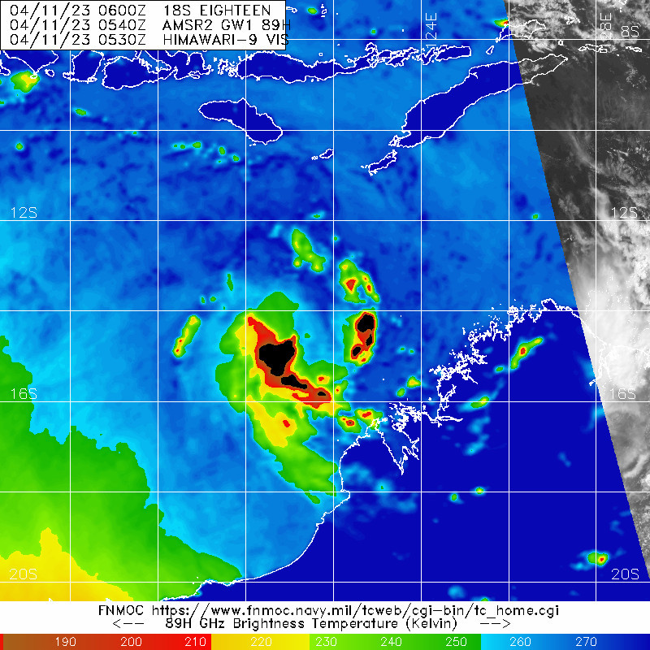
Figure 4. 91 GHz microwave image from the SSMIS sensor at 0540 UTC 11 April showing an improved curved band structure and Ilsa reached tropical cyclone intensity near this time.
Image courtesy NRL: https://www.nrlmry.navy.mil/TC.html

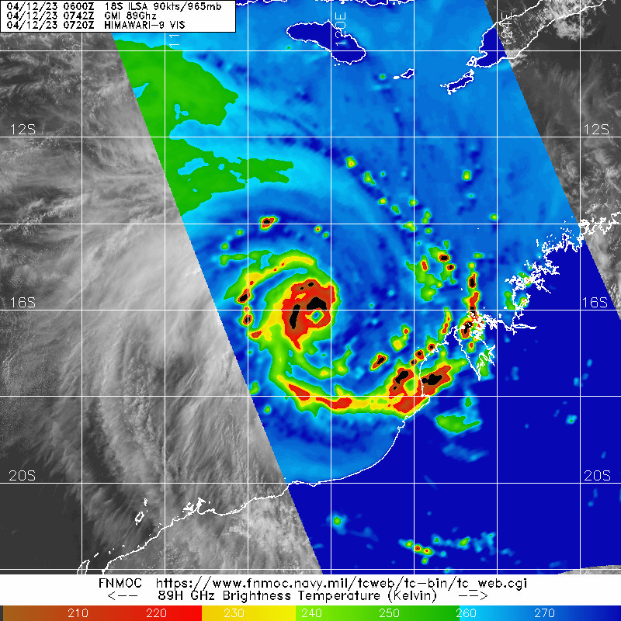
Figure 5. 0742 UTC 12 April 2023 GMI microwave image showing a small eye had formed
Image courtesy NRL: https://www.nrlmry.navy.mil/TC.html

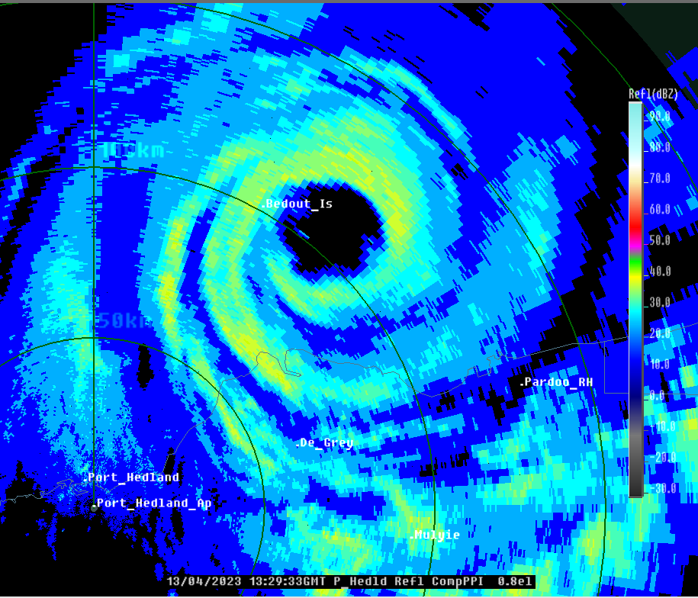
Figure 6. The Port Hedland radar image at 1329 UTC 13 April. Bedout Island recorded a maximum 10-minute mean wind of 118 kn (218km/h) at 1328 UTC 13 April.

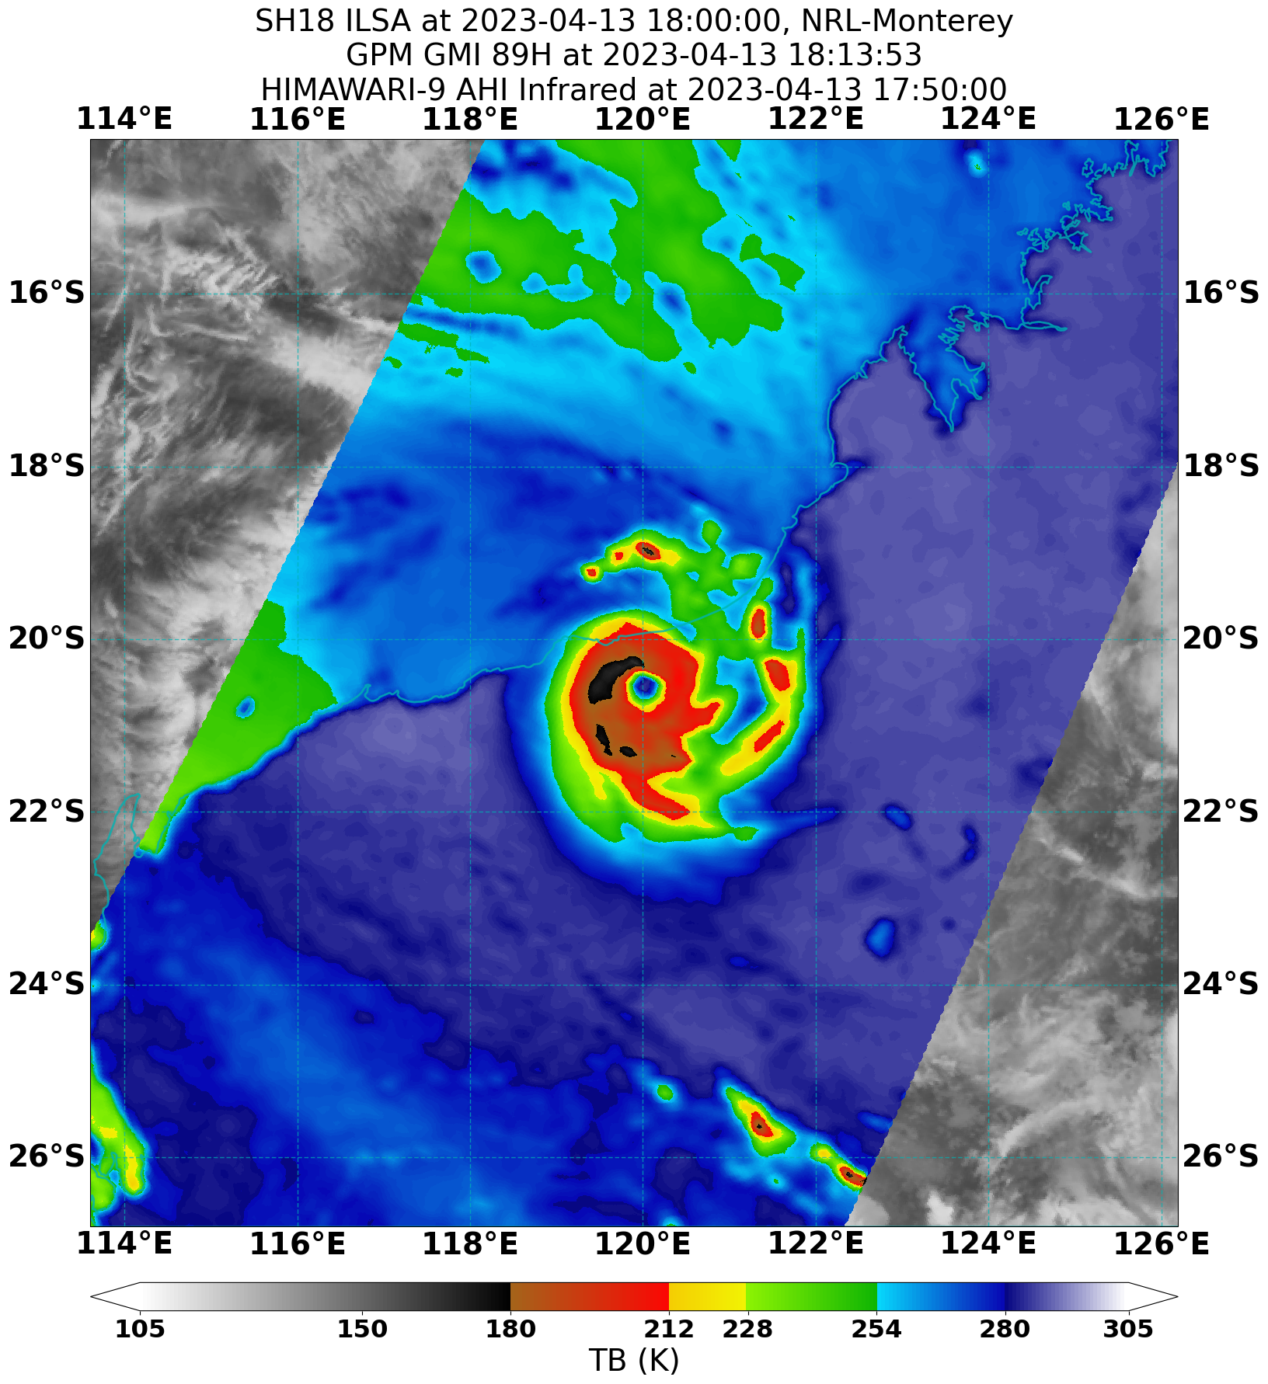
Figure 7. 89 GHz GPM microwave pass at 1813 UTC 13 April approximately 2 hours after Ilsa reached peak intensity and crossed the coast.
Image courtesy NRL: https://www.nrlmry.navy.mil/TC.html

2.1 Structure
Ilsa was an average to smaller than average sized system for the Western Australian region. The radius to gales varied from about 90 nm (165 km) initially to as small as 35 nm (65 km) in the southwest quadrant as it passed by Rowley Shoals. The radii were observed in the range of scatterometry and SAR passes such as Figure 8 and in surface observations.
The radius to maximum winds (RMW) was small being just 8 nm (15 km) at peak intensity as observed on the Port Hedland radar. The eye diameter was also estimated from the Port Hedland radar decreasing from an initial 22 nm at 1800 UTC 12 April down to 14 nm (26 km) at its smallest between 0600 and 1200 UTC 13 April.

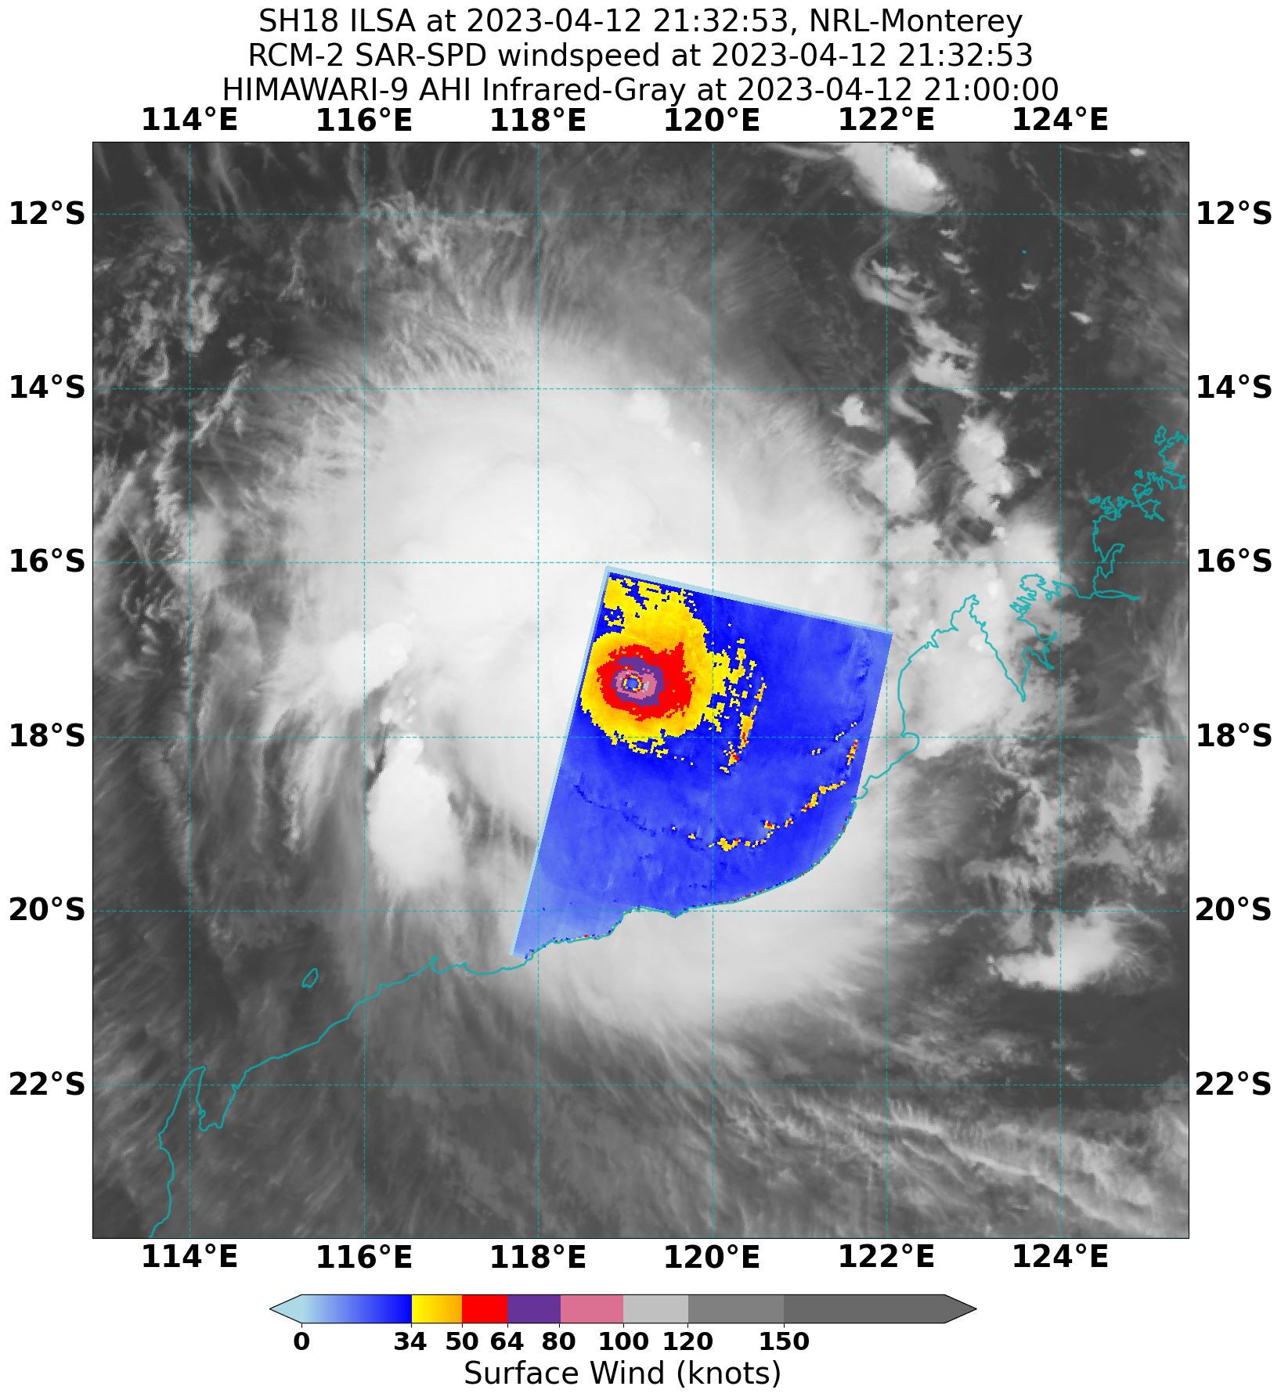
Figure 8. SAR pass at 2132 UTC 12 April.
Image courtesy NRL: https://www.nrlmry.navy.mil/TC.html

2.2 Motion
Between 6 and 12 April Ilsa was steered generally to the southwest around the mid-level ridge located over north-eastern Australia. A mid-level trough passed to the south of Ilsa during 11 April which assisted in eroding the influence of the ridge and during 12 April the motion of Ilsa became more southerly. A second mid-level trough amplified over Western Australia during 14 April which captured Ilsa under a north northwesterly steering regime and the cyclone turned to the south and then the southeast just before crossing the Pilbara coast. During 14 April Ilsa was steered to the southeast over inland Australia ahead of the mid-level trough.

- Impact
Severe Tropical Cyclone Ilsa caused significant damage in Western Australia's Pilbara region. Pardoo Roadhouse, a major establishment in the area, experienced severe destruction, with buildings and accommodation dongas completely destroyed. The estimated damage bill for Pardoo Roadhouse alone exceeded $4 million. Additionally, widespread infrastructure damage was observed, including uprooted trees, damaged windmills, solar panels, and irrigation systems, as well as roads and fences. The financial repercussions resulting from the cyclone are expected to be substantial, requiring long-term recovery efforts and financial support. The current estimate of the total damage bill lies between $4-26 million.
As a precautionary measure, evacuations were carried out in certain locations based on the expected path of Ilsa over vulnerable, inland communities. Approximately 100 people were flown out of Telfer, while about 68 individuals sought refuge in evacuation centres in Marble Bar, Nullagine, and South Hedland. All inland locations affected by the path of Ilsa experienced only minor damage and some road closures due to minor flooding.
Two Indonesian fishing boats were caught in the path of Ilsa off Rowley Shoals. One of the boats sank with at least nine fishermen feared drowned. The other boat ran aground at Bedwell Island on the northern end of Rowley Shoals. The eleven fishermen managed to survive the cyclone with one of the men staying afloat using a jerry can for 30 hours before reaching an island with the others. The Australian Border Force, conducting surveillance, spotted the distressed survivors, leading to a successful rescue operation. Their survival under challenging circumstances highlights human resilience.
Ilsa also had a destructive impact on bird colonies particularly the brown boobies and frigate birds on Bedout Island.
Source: https://www.abc.net.au/news/2023-04-19/indonesian-fisherman-left-stranded-after-cyclone-ilsa-rescued/102238822
https://www.abc.net.au/news/2023-04-15/cylone-ilsa-clean-up-continues-in-the-pilbara/102223024
https://www.abc.net.au/news/rural/2023-04-17/pilbara-station-owners-clean-up-after-tropical-cyclone-ilsa/102231364
https://www.abc.net.au/news/2023-04-14/pardoo-roadhouse-bears-brunt-of-cyclone-ilsa/102223426
https://www.insurancenews.com.au/local/wa-dodges-billion-dollar-bullet-with-cyclone-ilsa-risk-frontiers

- Observations
  - Wind
Rowley Shoals AWS recorded gales from 1708 UTC 12 April, storm force from 1949 UTC 12 April and hurricane force winds between 2103-2130 UTC, 2152-2155 UTC and 2212-2230 UTC 12 April. A peak 10-minute mean wind of 83 kn (154 km/h) was recorded at 2224 UTC 12 April. Between 2231 – 2259 UTC 12 April the wind speed dropped rapidly below gale force as the eye passed over the site. At 2300 UTC the wind speed increased to 38 kn (70 km/h) and a peak 3-second maximum wind gust of 126.9 kn (235 km/h) was recorded, from here the 10-minute wind speed decreased and the instrument was deemed unreliable from this point on due to wind damage. Note the Rowley Shoals anemometer is at a non-standard height of 6m (rather than 10m).
Bedout Island AWS recorded gales between 0128 – 0440 UTC and from 0500 UTC 13 April. Storm force winds were recorded from 0819 UTC 13 April. Hurricane force winds were recorded between 1004 – 1240 UTC and from 1308 UTC 13 April until the instrument failed. The eye passed over the island between 1241 and 1307 when winds fell the below hurricane strength. A peak 10-minute mean wind of 118 kn (218 km/h) was recorded at 1327 and 1328 UTC 13 April. A peak 3-second maximum wind gust of 155.9 kn (289 km/h) was recorded at 1323 UTC 13 April.
Pardoo AWS recorded gales from 1237 UTC 13 April, storm force winds at 1336 UTC, 1341 – 1358 UTC and from 1405 UTC 13 April. Hurricane winds were recorded between 1047-1050 UTC, 1512 UTC, 1516 UTC and from 1519 UTC 13 April until the instrument stopped reporting at 1721 UTC 13 April. A peak 10-minute mean wind of 111.6 kn (207 km/h) was recorded at 1703 UTC 13 April.
The Pardoo AWS is owned by the Department of Primary Industry and Regional Development (DPIRD) and is at a non-Bureau standard height of 3m (rather than 10m).
Telfer AWS recorded gales between 0125 – 0317 UTC and 0343-0457 UTC 14 April and storm force winds between 0235 – 0241 UTC 14 April. A peak 10-minute mean wind of 49 kn (91 km/h) was recorded between 0237-0239 UTC 14 April. A peak 3-second maximum wind gust of 67.1 kn (124 km/h) was recorded at 0237 UTC 14 April.

  - Pressure
The eye of Ilsa passed directly over the location of a privately deployed barometer which measured a minimum mean sea level pressure of 931.9 hPa at 1608 and 1637 UTC 13 April.
A minimum mean sea level pressure (MSLP) was recorded at the following sites.
Location | Pressure | Time UTC
Rowley Shoals AWS | 942.3 hPa | 2224 UTC 12 April
Bedout Island AWS | 931.2 hPa | 1243 UTC 13 April
Pardoo AWS | 960.8 hPa | 1637 UC 13 April
Telfer AWS | 972.7 hPa | 0317 UTC 14 April
Table 2 Lowest mean sea level pressure recorded from selected observing sites.
  - Rainfall
Bamboo Creek recorded 194.8 mm and Marble Bar 62.8 mm to 9 am AWST 14 April. Telfer recorded 51.2 mm to 9 am AWST 15 April.

Figure 8. A plot of the 10-minute mean wind speed and the mean sea level pressure recorded at Bedout Island AWS between 0000 UTC and 1328 UTC 13 April.

- Forecast Performance
Ocean Wind Warnings for Ilsa began at 0000 UTC on 8 April and concluded at 0000 UTC on 14 April as Ilsa transitioned over land. Tropical Cyclone Advices and official Tropical Cyclone Forecast Tracks started at the same time, 0000 UTC on 8 April, and ended later at 1100 UTC on 14 April as Ilsa weakened over the Interior of Western Australia. Throughout the event, a total of 53 Tropical Cyclone Advices were issued. The frequency of these advisories increased to an hourly rate between 0800 UTC 13 April and ceased at 2200 UTC 13 April as Severe TC Ilsa approached and crossed the east Pilbara coast.
The accuracy figures for Severe Tropical Cyclone Ilsa are below in Table 3 and also shown in Figure 9.
From forecast hours 12 to 120, the forecast track positions exhibited exceptional accuracy, surpassing the five-year average by a significant margin (refer to Figure 9 a.). The error for the 72-hour (3 day) forecast was 61 km exceeding historical performance for 18-hour forecast (71 km). The forecasts accounted for the influence of the mid-level ridge located over northeastern Australia, steering Ilsa to the southwest initially. As the mid-level troughs passed to the south of Ilsa, during 11 April and again on the 14 April, the forecasts accurately accounted for their effects, resulting in a southward and then southeastward motion of the cyclone.
The intensity forecast was comparable or better than the five-year average for the first 36 hours of the forecast, and only slightly poorer than or near the five-year average from forecast hours 48 to 120. This is a very good result given the very rapid intensification Severe TC Ilsa underwent during 11-13 April. During this period the intensity of Ilsa increased 30-40 kn per day.
Table 3. Verification statistics for Severe Tropical Cyclone Ilsa. * Note, verification is performed using the Official Forecast Tracks at the standard times of 00UTC, 06UTC,12UTC and 18UTC.
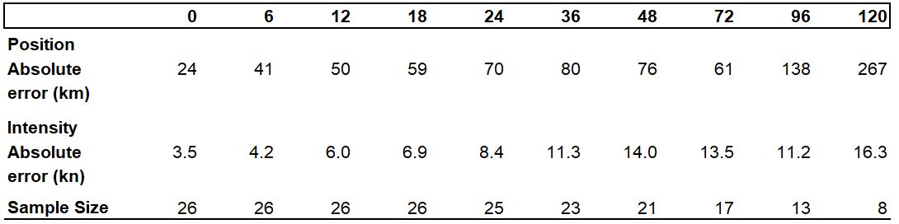

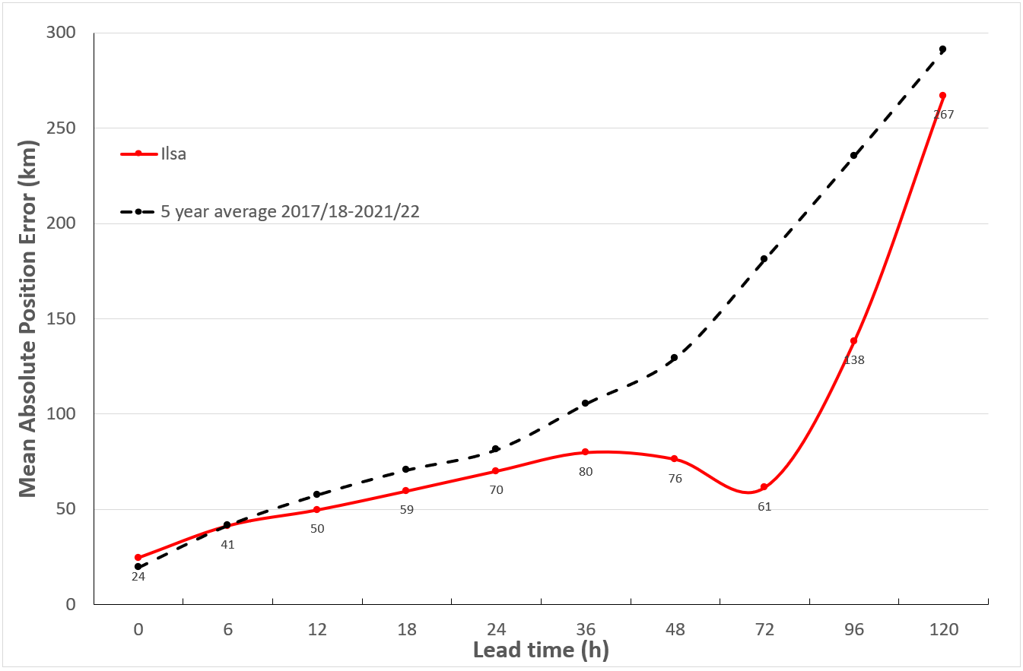
Figure 9 a. Position accuracy figures for Severe Tropical Cyclone Ilsa.
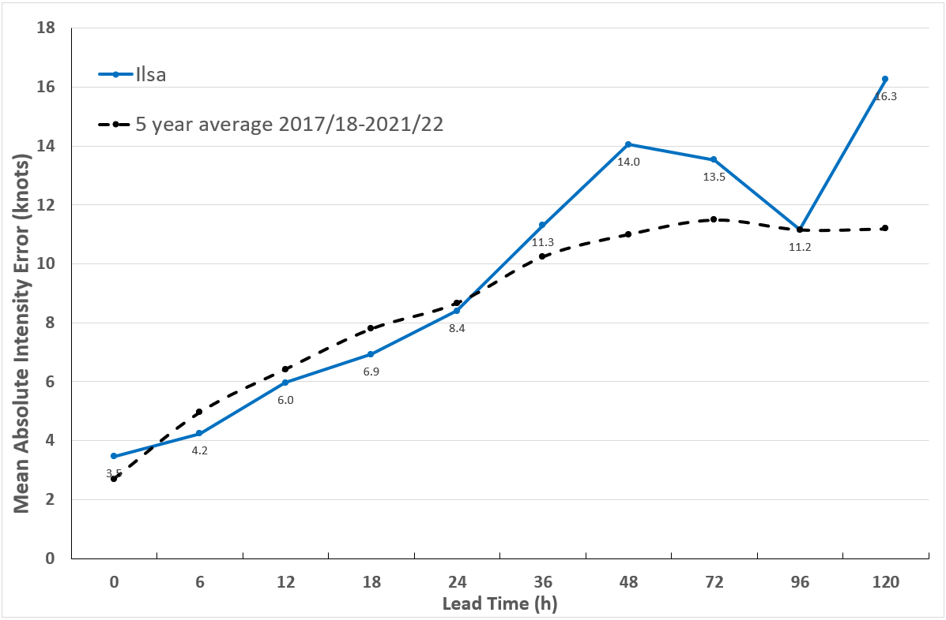
Figure 9 b. Intensity accuracy figures for Severe Tropical Cyclone Ilsa.

- Appendix: List of abbreviations
Abbreviation | Term
ADT | Advanced Dvorak Technique
ACST | Australian Central Standard Time
AEST | Australian Eastern Standard Time
AiDT | AI-enhanced Dvorak Technique
AMSR2 | Advanced Microwave Scanning Radiometer
AMSU | Advanced Microwave Sounding Unit
ASCAT | Advanced Scatterometer
ATMS | Advanced Technology Microwave Sounder
AWS | automatic weather station
AWST | Australian Western Standard Time
°C | Celsius
CI | Current intensity
CIMSS | Cooperative Institute for Meteorological Satellite Studies (USA)
CIRA | Cooperative Institute for Research in the Atmosphere (USA)
D-MINT | Deep learning - Multispectral Intensity of TCs (formerly known as DMN)
D-PRINT | Deep learning - IR Intensity of TCs (formerly known as OPEN-AIIR)
EIR | Enhanced InfraRed
ERC | eyewall replacement cycle
FNMOC | Fleet Numerical Meteorology and Oceanography Centre (USA)
FT | Final T-number
GCOM | Global Change Observation Mission
GHz | Gigahertz
GMI | Global Precipitation Measurement Microwave Imager
h | hour
hPa | hectopascal
HSCAT | Hai Yang 2 Scatterometer (HY-2B, HY-2C)
km | kilometres
km/h | kilometres per hour
kn | knot
LLCC | LLCC
MET | Model Expected T-number
METOP | Meteorological Operational Satellite
MJO | Madden-Julian Oscillation
mm | millimetres
MSLP | mean sea level pressure
NESDIS | National Environmental Satellite, Data, and Information Service
nm | nautical mile
NOAA | National Oceanic and Atmospheric Administration
NRL | Navy Research Lab (USA)
OPEN-AiiR | Ordered Pattern Encoding AI Infrared
PAT | Pattern T-number
RCM | RadarSat Constellation Mission – Synthetic Aperture Radar
RH | relative humidity
RMW | radius of maximum winds
RSMC | Regional Specialised Meteorological Centre
SAR | Synthetic Aperture Radar
SATC | CIMSS Advanced Dvorak Technique
SATCON | Satellite Consensus
SEN1 | Sentinel-1A – Synthetic Aperture Radar
SMAP | Soil Moisture Active Passive
SMOS | Soil Moisture and Ocean Salinity
SSMIS | Special Sensor Microwave Imager/Sounder
TC | Tropical Cyclone
TCWC | Tropical Cyclone Warning Centre
UTC | Universal Time Co-ordinated

