Tropical Cyclone Koji (12U)

7-14 January 2026

Tropical Cyclone Environmental Prediction Services
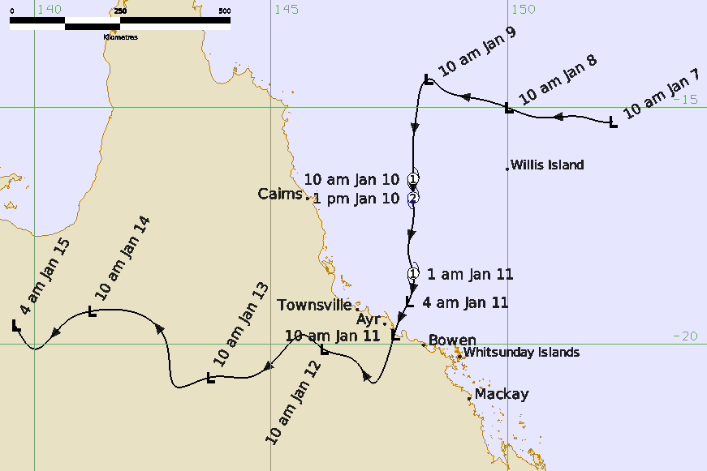

Revision history
Date | Version | Author | Description
15/06/2026 | 1.0 | EPS TC team | Final Best Track Report Draft

Review status
Date | Version | Reviewer | Description
24/06/2026 | 1.0 | EPS TC Team | Review Best Track Report

Release history
Date | Version | Status | Approval
26/06/2026 | 1.0 | Approved for release | Tropical Cyclone Team Lead


Contact details:
Tropical Cyclone Team Lead
Severe Weather Environmental Prediction Services
Bureau of Meteorology
PO Box 1370, West Perth WA 6872
Email: tcwc@bom.gov.au
This work is copyright. Apart from any use as permitted under the Copyright Act 1968, no part may be reproduced without prior written permission from the Bureau of Meteorology. Refer to www.bom.gov.au/other/copyright.shtml for further information. Unless otherwise noted, all images in this document are licensed under the Creative Commons Attribution Australia Licence.
© Commonwealth of Australia 2026
Published by The Bureau of Meteorology
Cover image: Track of Tropical Cyclone Koji 7 – 14 January 2026. Times in AEST, UTC +10h.

Table of contents

1. Summary 6

2. Meteorological description 8

2.1. Intensity Analysis 8

2.2. Structure 12

2.3. Motion 14

3. Impact 15

4. Observations 18

4.1. Wind 18

4.2. Rainfall 21

4.3. Pressure 25

4.4. Storm Surge 26

5. Forecast Performance 26

6. Appendix: List of Abbreviations 31

List of Figures
Figure 1 Track of Tropical Cyclone Koji 7-15 January 2026. Times are in AEST (UTC+10h). 7
Figure 2 Mean Sea Level Pressure (MSLP) Analysis with a background of satellite imagery, showing a developing Tropical Low 12U. Left: At 0000 UTC 7 January 2026. Right: 0000UTC 8 January 2026 9
Figure 4 Hovmöller diagram of tropical waves showing the formation of Koji occurred with a pulse of the MJO (black) and a Kelvin Wave (blue). This image is courtesy of the North Carolina institute for climate studies. https://ncics.org/portfolio/monitor/mjo/ 10
Figure 5 AMSR2 at 0337 UTC 10 January showing a broad Koji, with a large region of light winds near its centre. Image courtesy NRL: https://science.nrlmry.navy.mil/geoips/tcweb4/ 11
Figure 6 Radiometry, SMAP at 0759 UTC 10 January, showing Tropical Cyclone Koji in the Coral Sea. Also highlights the large region of light winds near the centre of Koji. Image courtesy NRL: https://science.nrlmry.navy.mil/geoips/tcweb4/ 12
Figure 7 Radiometry, SMAP at 1949 UTC 9 January, showing Tropical Cyclone Koji in the Coral Sea. Also highlights the large region of light winds near the centre of Koji. Image courtesy NRL: https://science.nrlmry.navy.mil/geoips/tcweb4/ 14
Figure 8 Unmoored boats near Airlie Beach, Qld. (Source: Jasmine Himes, ABC News) 16
Figure 9 Bruce Highway closure, traffic at Merinda, near Bowen (source: Meghan Dansie, ABC News) 17
Figure 10 Flooding at Clermont (source: Ronel Aban Bingco via ABC NEWS) 17
Figure 11 Flooding impacting Clermont. (source: Bush Heli-Services via ABC News) 18
Figure 12 Willis Island 10min-mean wind speed, wind gust and pressure observations. 19
Figure 13 Arlington Reef 10min-mean wind speed, wind gust and pressure observations. 19
Figure 14 Flinders Reef 10min-mean wind speed, wind gust and pressure observations. 20
Figure 15 Hamilton Island 10min-mean wind speed, wind gust and pressure observations. 20
Figure 16 Rainfall across Queensland during the week between 8-14 January 2026 24
Figure 17 Rainfall deciles for January 2026 25
Figure 18 The forecast percentage risk of a low developing into a tropical cyclone taken from the 7-day forecast for 12U. Forecast base time is shown on the horizontal axis, and the forecast validity time is shown on the vertical axis. The box colours correspond to the tropical cyclone forecast rating: yellow for Very Low, light orange for Low, orange for Moderate and brown for High. 27
Figure 19 Forecast Track Map accompanying the first Tropical Cyclone Advice, including a Warning from Port Douglas to Tully and a Watch from Tully to Airlie Beach. Issued with analysis time of 0000 UTC (10 am AEST) 9 January. 28
Figure 20 Position accuracy figures for Tropical Cyclone Koji plotted against the 5-year average. 29
Figure 21 Intensity accuracy figures for Tropical Cyclone Koji plotted against the 5-year average. 30
Figure 22 Intensity plot (10-min mean) of objective and subjective guidance. SATCON AIDT, NESDIS ADT, AMSU, ASCAT, CIMSS ADT, DMINT, DPRINT, Dvorak (subjective estimate), operational analysis (red), and post event best track analysis (black) 33

List of Tables
Table 1 Best Track summary for Tropical Cyclone Koji, 7-14 January 2026. UTC=AEST-10. *Not at tropical cyclone intensity as gales less than halfway around centre. 7
Table 2 Observations of record daily rainfall 21
Table 3 Observations of record daily rainfall for January 21
Table 4 Observations of intense rainfall 21
Table 5 Daily rainfall totals for 11 January 22
Table 6 Daily rainfall totals for 12 January 22
Table 7 Minimum pressure observations associated with the passage of Tropical Cyclone Koji. 24
Table 8: Verification statistics for Tropical Cyclone Koji. Note: Verification is performed using the Official Forecast Tracks at the standard times of 00, 06, 12 and 18 UTC. 27

- Summary
Tropical Cyclone Koji was a short-lived tropical cyclone that peaked as a category 2 tropical cyclone in the Coral Sea, then weakened before crossing the Queensland coast between Ayr and Bowen as a tropical low. The duration and impact of this weather event over north and western Queensland was extensive.
On 7 January 2026, Tropical Low 12U formed within a monsoon trough in the northern Coral Sea. Initially, Tropical Low 12U moved slowly westwards until 9 January, when the monsoon and a mid-level ridge to the east steered the tropical low towards the south. From 0000 UTC (10 am AEST) 9 January gales began to intermittently occur in the southeast quadrant. An increase in monsoon flow to the north, combined with an increase in southeasterly winds to the south of the low, resulted in the tropical low's broad structure.
Overnight on 9 January and into the morning of 10 January, gales began to extend around the centre. At 0000 UTC (10 am AEST) 10 January (AEST=UTC+10), Tropical Cyclone Koji was named, while located about 330 km north northeast of Townsville. Later during 10 January, Tropical Cyclone Koji intensified, and storm force, category 2, winds were observed at Willis Island.
As Koji approached the Queensland coast to the south of Townsville, the strongest winds were recorded to the south of the centre, at the Whitsunday Islands. A wind gust of 63 kn (117 kilometres per hour) was recorded at Hamilton Island at 2236 UTC 10 January (8:36 am AEST 11 January), and northeast of the Whitsundays at Hardy Reef at 0100 UTC (11 am AEST) 11 January. Prior to Koji making landfall, the extent of gales reduced to less than halfway around the centre, resulting in the system being classified as a tropical low. Ex-Tropical Cyclone Koji crossed the coast between Ayr and Bowen at around 0000 UTC (10 am AEST) 11 January, then proceeded to move inland over the following days.
Strong winds brought down trees and branches causing some structural damage and power outages, mostly in the Mackay and Whitsunday region. Some boats broke their moorings and were damaged.
Heavy rainfall was extensive, with several sites in the Pioneer River catchment observing more than 350 mm of rainfall in 24 hours to 2300 UTC 10 January (9 am AEST 11 January). Heavy rainfall continued through 12 January. The highest rainfall observed was at Mt William with 601 mm recorded in the 48 hours to 2300 UTC 11 January (9 am AEST 12 January).
Major flooding occurred south of Mackay in the Pioneer catchment. Ex-Tropical Cyclone Koji could be tracked for several days as it moved inland, enhancing rainfall along its path. As Ex-Tropical Cyclone Koji moved inland, moderate to major flooding occurred in basins along the track, all the way to the Northern Territory border.
Figure 1 is the best track of Koji while Table 1 is a summary of the best track data.

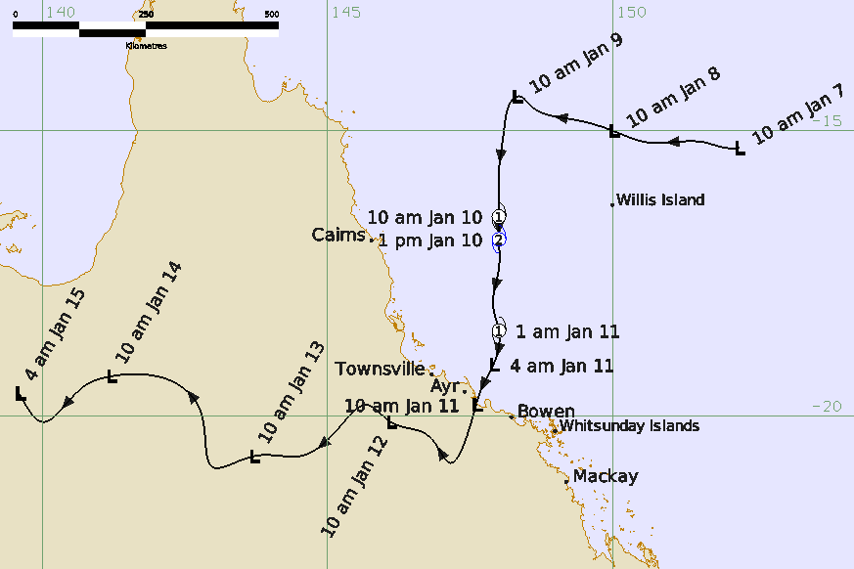
Figure 1 Track of Tropical Cyclone Koji 7-15 January 2026. Times are in AEST (UTC+10h).

Year | Month | Day | Hour UTC | Pos. Lat S | Pos. Long. E | Pos. Acc. Nm | Max. gust kn | Max. gust kn | Cent. Press hPa | Rad of gales (NE/SE/SW/NW) nm | Rad of storm (NE/SE/SW/NW) nm | RMW nm
2026 | 1 | 7 | 0000 | 15.3 | 152.2 | 20 | 30 | 45 | 1003 | 0/0/0/0 | 0/0/0/0 | -
2026 | 1 | 7 | 0600 | 15.3 | 152.0 | 35 | 30 | 45 | 1003 | 0/0/0/0 | 0/0/0/0 | -
2026 | 1 | 7 | 1200 | 15.2 | 151.6 | 25 | 25 | 45 | 1003 | 0/0/0/0 | 0/0/0/0 | -
2026 | 1 | 7 | 1800 | 15.2 | 150.6 | 35 | 25 | 45 | 1003 | 0/0/0/0 | 0/0/0/0 | -
2026 | 1 | 8 | 0000 | 15.0 | 150.0 | 40 | 25 | 45 | 1002 | 0/0/0/0 | 0/0/0/0 | -
2026 | 1 | 8 | 0600 | 14.8 | 149.3 | 40 | 25 | 45 | 1002 | 0/0/0/0 | 0/0/0/0 | -
2026 | 1 | 8 | 1200 | 14.5 | 148.5 | 40 | 25 | 45 | 1000 | 0/0/0/0 | 0/0/0/0 | -
2026 | 1 | 8 | 1800 | 14.4 | 148.4 | 40 | 30 | 45 | 998 | 0/0/0/0 | 0/0/0/0 | -
2026 | 1 | 9 | 0000 | 14.4 | 148.3 | 35 | 35* | 50 | 992 | 0/150/0/0 | 0/0/0/0 | -
2026 | 1 | 9 | 0600 | 14.5 | 148.2 | 35 | 35* | 50 | 990 | 0/140/0/0 | 0/0/0/0 | -
2026 | 1 | 9 | 1200 | 14.9 | 148.1 | 40 | 30 | 50 | 994 | 0/0/0/0 | 0/0/0/0 | -
2026 | 1 | 9 | 1800 | 15.7 | 148.0 | 45 | 40* | 55 | 990 | 0/120/120/0 | 0/0/0/0
2026 | 1 | 10 | 0000 | 16.5 | 148.0 | 35 | 45 | 65 | 992 | 150/140/110/0 | 0/0/0/0 | 90
2026 | 1 | 10 | 0300 | 16.9 | 148.0 | 25 | 55 | 75 | 991 | 150/150/100/80 | 120/0/0/0 | 70
2026 | 1 | 10 | 0600 | 17.4 | 148.0 | 25 | 50 | 70 | 990 | 150/160/90/80 | 100/0/0/0 | 70
2026 | 1 | 10 | 1200 | 18.1 | 147.9 | 30 | 50 | 70 | 990 | 110/155/80/0 | 0/100/0/0 | 70
2026 | 1 | 10 | 1500 | 18.5 | 148.0 | 30 | 45 | 65 | 988 | 110/140/60/0 | 0/0/0/0 | 50
2026 | 1 | 10 | 1800 | 19.1 | 147.9 | 25 | 45* | 65 | 987 | 80/120/0/0 | 0/0/0/0 | -
2026 | 1 | 10 | 2100 | 19.5 | 147.7 | 20 | 40* | 55 | 990 | 0/85/0/0 | 0/0/0/0 | -
2026 | 1 | 11 | 0000 | 19.8 | 147.6 | 25 | 30 | 45 | 992 | 0/0/0/0 | 0/0/0/0 | -
2026 | 1 | 11 | 0600 | 20.8 | 147.1 | 25 | 25 | 45 | 992 | 0/0/0/0 | 0/0/0/0 | -
2026 | 1 | 11 | 1200 | 20.5 | 146.9 | 30 | 20 | 45 | 996 | 0/0/0/0 | 0/0/0/0 | -
2026 | 1 | 11 | 1800 | 20.3 | 146.7 | 25 | 20 | 45 | 994 | 0/0/0/0 | 0/0/0/0 | -
2026 | 1 | 12 | 0000 | 20.1 | 146.1 | 15 | 20 | 45 | 997 | 0/0/0/0 | 0/0/0/0 | -
2026 | 1 | 12 | 0600 | 19.8 | 145.7 | 30 | 20 | 45 | 995 | 0/0/0/0 | 0/0/0/0 | -
2026 | 1 | 12 | 1200 | 20.2 | 145.2 | 40 | 15 | 45 | 996 | 0/0/0/0 | 0/0/0/0 | -
2026 | 1 | 12 | 1800 | 20.7 | 144.5 | 40 | 15 | 45 | 997 | 0/0/0/0 | 0/0/0/0 | -
2026 | 1 | 13 | 0000 | 20.7 | 143.7 | 25 | 15 | 45 | 999 | 0/0/0/0 | 0/0/0/0 | -
2026 | 1 | 13 | 0600 | 20.9 | 143.0 | 15 | 20 | 45 | 996 | 0/0/0/0 | 0/0/0/0 | -
2026 | 1 | 13 | 1200 | 20.0 | 142.8 | 25 | 20 | 45 | 998 | 0/0/0/0 | 0/0/0/0 | -
2026 | 1 | 13 | 1800 | 19.4 | 142.3 | 30 | 15 | 45 | 997 | 0/0/0/0 | 0/0/0/0 | -
2026 | 1 | 14 | 0000 | 19.3 | 141.2 | 30 | 15 | 45 | 998 | 0/0/0/0 | 0/0/0/0 | -
2026 | 1 | 14 | 0600 | 19.5 | 141.2 | 30 | 15 | 45 | 996 | 0/0/0/0 | 0/0/0/0 | -
2026 | 1 | 14 | 1200 | 20.1 | 140.0 | 40 | 10 | 45 | 999 | 0/0/0/0 | 0/0/0/0 | -
2026 | 1 | 14 | 1800 | 19.6 | 139.6 | 40 | 10 | 45 | 997 | 0/0/0/0 | 0/0/0/0 | -
Table 1 Best Track summary for Tropical Cyclone Koji, 7-14 January 2026. UTC=AEST-10. *Not at tropical cyclone intensity as gales less than halfway around centre.
- Meteorological description
  - Intensity Analysis
A comparison of subjective and objective intensity estimates is shown in Figure 21.
Tropical low 12U was first analysed along the monsoon trough in the Coral Sea on 7 January while approximately 250 km east northeast of Willis Island, Figure 2. During January, an active phase of the Madden Julian Oscillation (MJO) moved through the western Pacific, refer to Figure 3. In addition to the active MJO, a Kelvin wave moved through the region, refer to Figure 3.

Monsoon flow increased through the northern Coral Sea, and along with a firm ridge to the south, encouraged the very broad low centre of Tropical Low 12U to became more established, and intensity fluctuated from 25-30 knots (45-55 km/h) during 7 and 8 January. Curvature and convection increased, and a Dvorak T-number of 1.0 was assigned at 1200 UTC (10 pm AEST) 8 January. Given the large monsoon low structure of this system, both initially and throughout its life (refer to section 2.2), the Dvorak method was of limited use in terms of assessing intensity and for the most part remained below the assessed maximum mean winds (Figure 21). Observations, from sites including, Willis Island, and Hamilton Island, along with radiometry and scatterometry, were relied upon for intensity estimates throughout Koji's life.

Gales associated with the synoptic flow to the south of 12U had earlier been observed intermittently at Willis Island, and from 0000 UTC (10 am AEST) 9 January gales were assessed to be occurring as part of the circulation to the southeast. Gales to the southeast of the centre were short lived with intensity fluctuating in this quadrant during 9 January. Throughout 9 January and into the morning of 10 January, to the north of the centre gales associated with the synoptic monsoon flow began to gradually curve into the circulation. Overnight 9 January gales in the south become more established and intensity gradually increased, reaching 40 kn (75 km/h) at 1800 UTC 9 January.

At 0000 UTC (10 am AEST) 10 January, gales extended more than halfway around the circulation, and also were analysed as part of the circulation, not just associated with synoptic flow. 12U intensified into Tropical Cyclone Koji. At this time, the strongest winds were occurring in the northeast and Koji was at category 1, 45 kn (85 km/h) intensity. AMSR2 and SMAP imagery from later (Figure 4, and Figure 5), together with an improved satellite presentation, showed that Koji continued to intensify. Koji reached its peak 10-minute mean wind intensity of 55 kn (100 km/h) at 0300 UTC (1 pm AEST) 10 January. Willis Island recorded a peak 10-minute mean wind of 54 kn (100 km/h) (refer section 4.14.1). Dvorak intensity estimates continued to lag, with a CI number of 2.0 at this time. During 10 January, objective guidance was available, and these too also had difficulties with Koji’s unconventional structure, remaining generally below the analysed intensity (Figure 21).

During 10 January, gales on the periphery of Koji began about parts of the Central Coast and Whitsunday Islands with gales observed at Hamilton Island (refer section 4.1). Easing flow to the north, some dry air wrapping to the north, and land interactions aided in weakening Koji, becoming a category 1 system at 1500 UTC 10 January (1 am AEST 11 January). Shortly after at 1800 UTC 10 January (4am AEST 11 January) gales were only detected in eastern quadrants, and Koji was reclassified as a tropical low. Ex-Tropical Cyclone Koji continued to weaken as land interactions increased, crossing the Queensland coast just south of Ayr, as a tropical low with intensity of 30 kn (55 km/h). Ex-Tropical Cyclone Koji moved further inland during 11 to 14 January and gradually weakened over land.

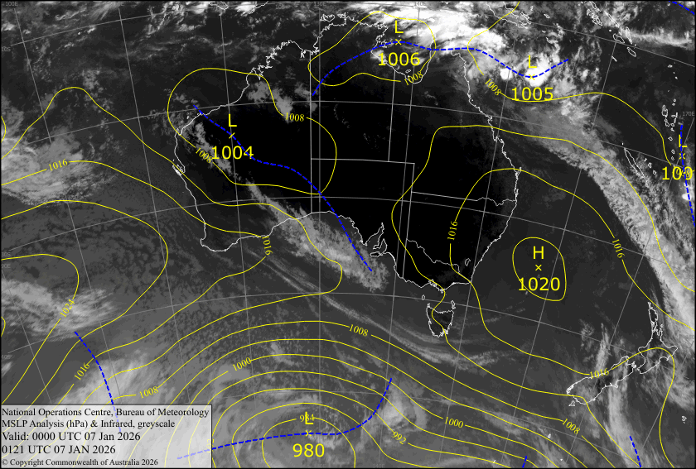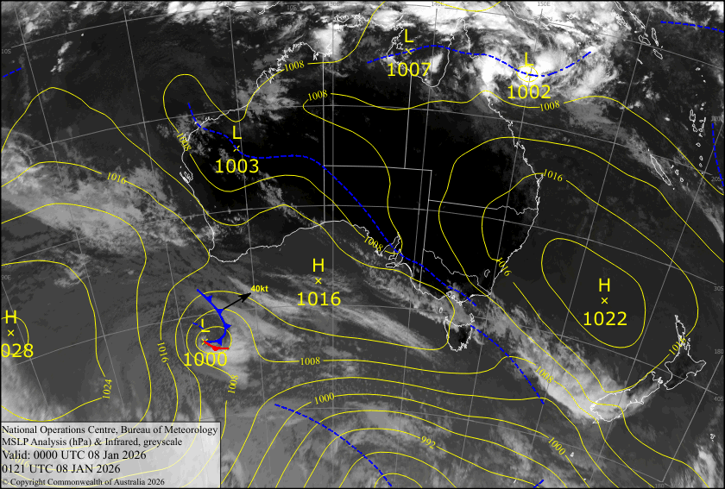
Figure 2 Mean Sea Level Pressure (MSLP) Analysis with a background of satellite imagery, showing a developing Tropical Low 12U. Left: At 0000 UTC 7 January 2026. Right: 0000UTC 8 January 2026
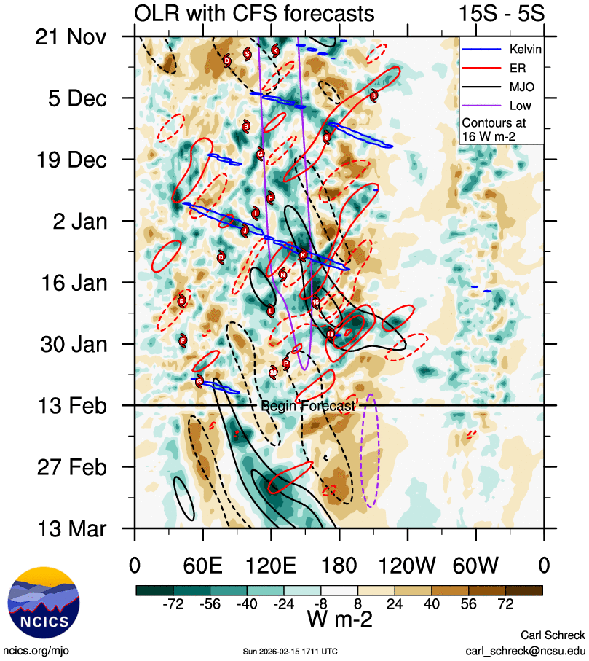
Figure 3 Hovmöller diagram of tropical waves showing the formation of Koji occurred with a pulse of the MJO (black) and a Kelvin Wave (blue). This image is courtesy of the North Carolina institute for climate studies. https://ncics.org/portfolio/monitor/mjo/
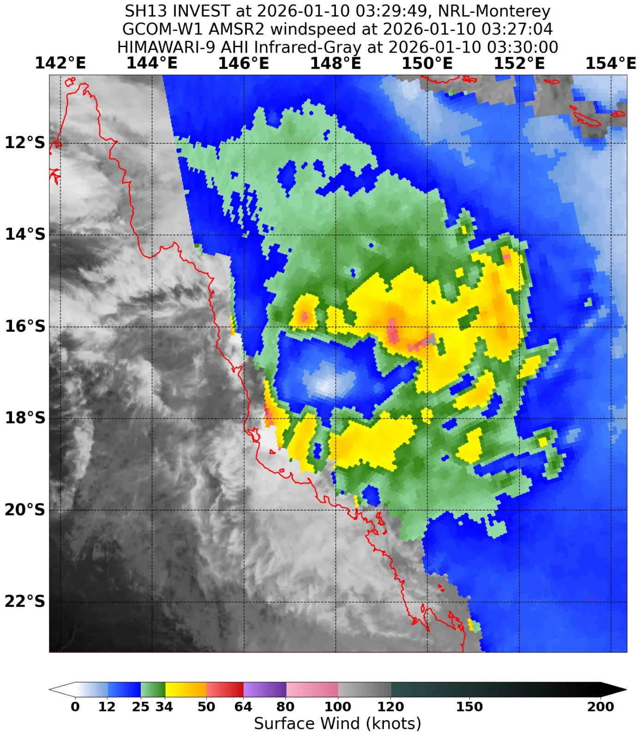
Figure 4 AMSR2 at 0337 UTC 10 January showing a broad Koji, with a large region of light winds near its centre. Image courtesy NRL: https://science.nrlmry.navy.mil/geoips/tcweb4/

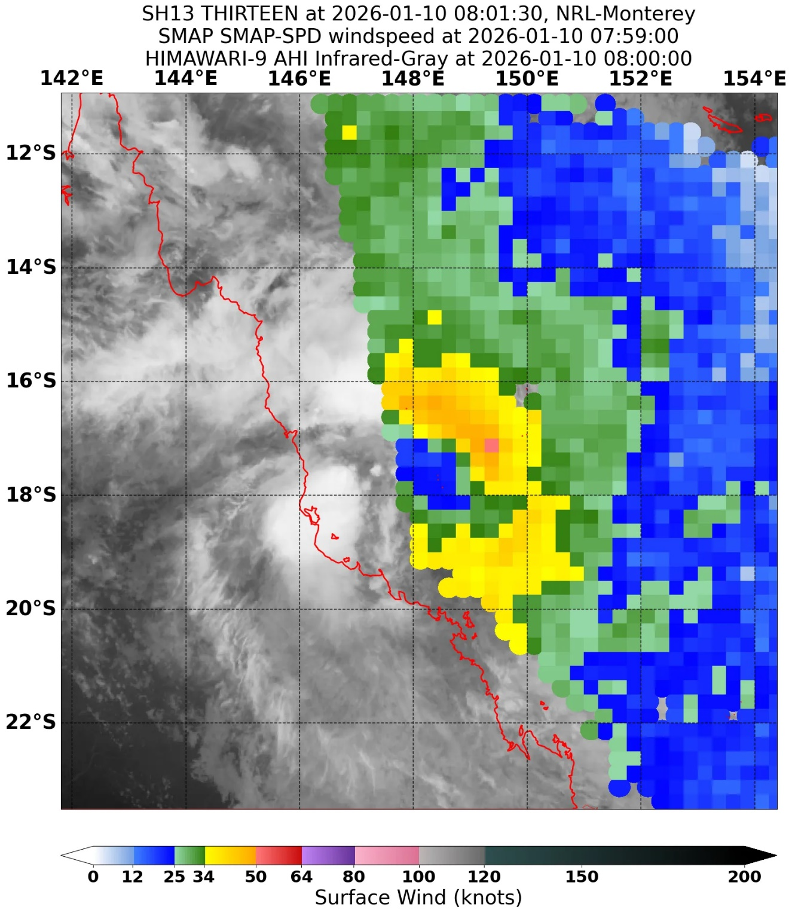
Figure 5 Radiometry, SMAP at 0759 UTC 10 January, showing Tropical Cyclone Koji in the Coral Sea. Also highlights the large region of light winds near the centre of Koji. Image courtesy NRL: https://science.nrlmry.navy.mil/geoips/tcweb4/

  - Structure
Throughout the development and life of Koji, Koji had an unusually broad structure with synoptic elements both to the north and south of the system influencing its wind radii. Monsoon winds to the north and trade winds to the south of a trough lying through the Coral Sea increased, and eventually broad rotation and the low centre of 12U emerged on 7 January. The broad structure associated with the formation of Tropical Low 12U persisted, and consolidation of the circulation was slow.
During the morning of 9 January, gales assessed to be part of the circulation were observed at Willis Island, to the southeast of the centre. Quadrant gales were analysed out to a maximum of 150 nm (278 km) in the southeast quadrant from 0000 UTC (10 am AEST) 9 January based on this observation. Gales were observed to be intermittent, brief, and likely only occurred in a small portion of the southeast quadrant at this time. Gales to the southeast continued to be intermittent and even eased for a time overnight on 9 January.
Monsoon flow to the north began to curve into the northeastern quadrant. By 0000 UTC (10 am AEST) 10 January gales associated with Tropical Cyclone Koji were occurring in both eastern quadrants, and to the southwest. At this time, gales extended to 110 nm (204 km) in the southwest and 140 to 150 nm (259 to 278 km) in eastern quadrants. This is evidenced by SMAP at 1949 UTC 9 January (5:49 am AEST 10 January) (Figure 6) and later AMSR2 at 0327 UTC (1:27 AEST) 10 January (Figure 4). However, this imagery shows gales to be more extensive with some gales associated with the synoptic monsoon flow in the northwest rather than the circulation. Additionally, there continued to be a large area of light winds with Koji's centre, and the RMW was 90 nm at this time. It is unusual for a tropical cyclone to have a RMW this large, and equals the largest RMW of any previous tropical cyclone in the Australian database (equal with Tropical Cyclone Emma 2006).

At 0300 UTC (1 pm AEST) 10 January, Koji was at its peak intensity, and the RMW contracted to 70 nm (130 km), measured from AMSR2 at 0327 UTC (Figure 4) and later SMAP at 0759 UTC (Figure 5). Storm force winds were observed at Willis Island and had a radii of 120 nm (222 km) to the northeast. However, the same dearth of winds associated with Koji's large centre continued. Radiometer passes, Figure 4 and Figure 5 highlight this structure.

Gales in the southwest contracted to 90 nm (167 km) by 0600 UTC (4 pm AEST) 10 January, and interactions with land resulted in further contractions and easing of gales overnight on 10 January. By 1800 UTC 10 January (4 am AEST 11 January) gales only extended to 80-120 nm (148-222 km) in eastern quadrants. Gales continued to contract and ease, though persisted in the southeast quadrant until shortly before Ex-Tropical Cyclone Koji crossed the coast.
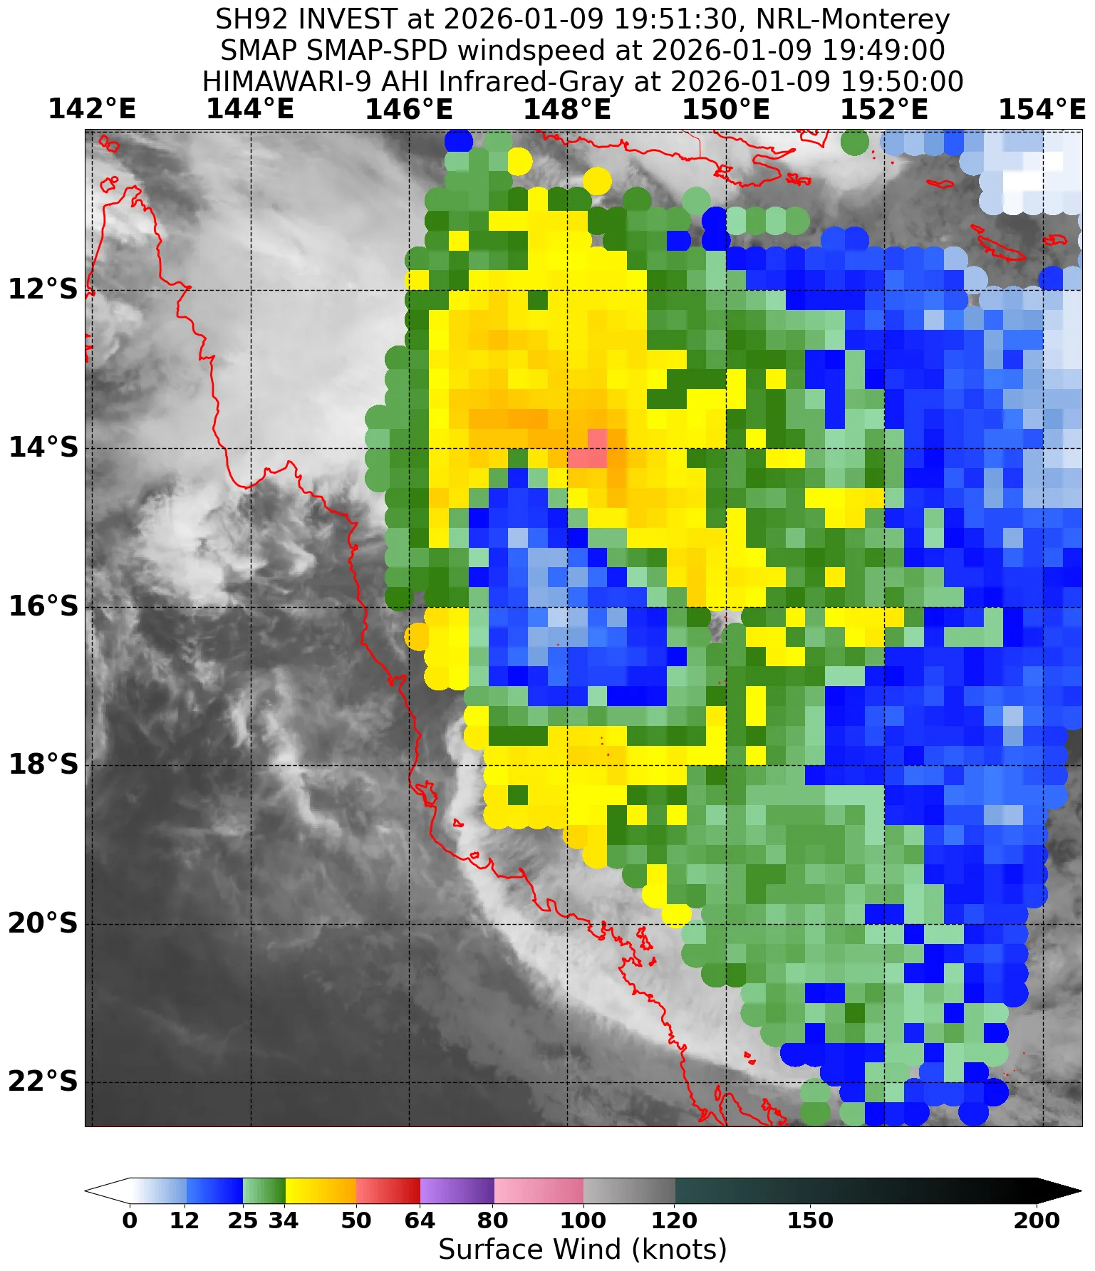
Figure 6 Radiometry, SMAP at 1949 UTC 9 January, showing Tropical Cyclone Koji in the Coral Sea. Also highlights the large region of light winds near the centre of Koji. Image courtesy NRL: https://science.nrlmry.navy.mil/geoips/tcweb4/

  - Motion
Once formed, 12U was initially steered west by a high in the Tasman Sea extending a firm ridge over the Coral Sea to the south of the developing tropical low. The southeast flow on the southern side of 12U was stronger than the monsoon flow to the north and consequently 12U moved westwards during 7 and 8 January.

The monsoon flow to the north increased, balancing with the winds to the south of 12U, and from overnight on 8 January 12U became slow moving. Late at night on 9 January 12U was developing, and deepening, and its steering began to be influenced by a mid-level ridge to the east. This mid-level ridge, along with some influence from vigorous north-northwest flow, was the dominant steering influence from 10 January until after landfall. Koji moved to the south during this time.

From 11 January Ex-Tropical Cyclone Koji was over land and was steered generally to the west by a low to mid-level ridge that developed to the south of the system.

- Impact
As Koji approached and crossed the Queensland coast, power outages impacted tens of thousands of residents, mostly around the Mackay and Whitsundays regions. Roads, including the Bruce Highway, were closed and/or damaged due to flooding and flash flooding, (Figure 8). Along the beaches, mostly about the Central Coast and Whitsunday Islands, large waves and winds caused some boats to lose their moorings, Figure 7.
In the days following landfall, a weakening Ex-Tropical Cyclone Koji moved well inland bringing heavy rainfall to central west and northwest Queensland. This caused widespread flooding and flash flooding, community isolation, and impacts to transportation Figure 9, Figure 10. Major flooding occurred south of Mackay in the Fitzroy River (Qld) and Pioneer River catchments. This led to significant inundation of rural land, and flooding and flash flooding in Clermont. There was disruption across the affected region, including delays to road transport and interruptions to essential services. Additionally, floodwaters impacted the agriculture industry with livestock losses in the tens of thousands.
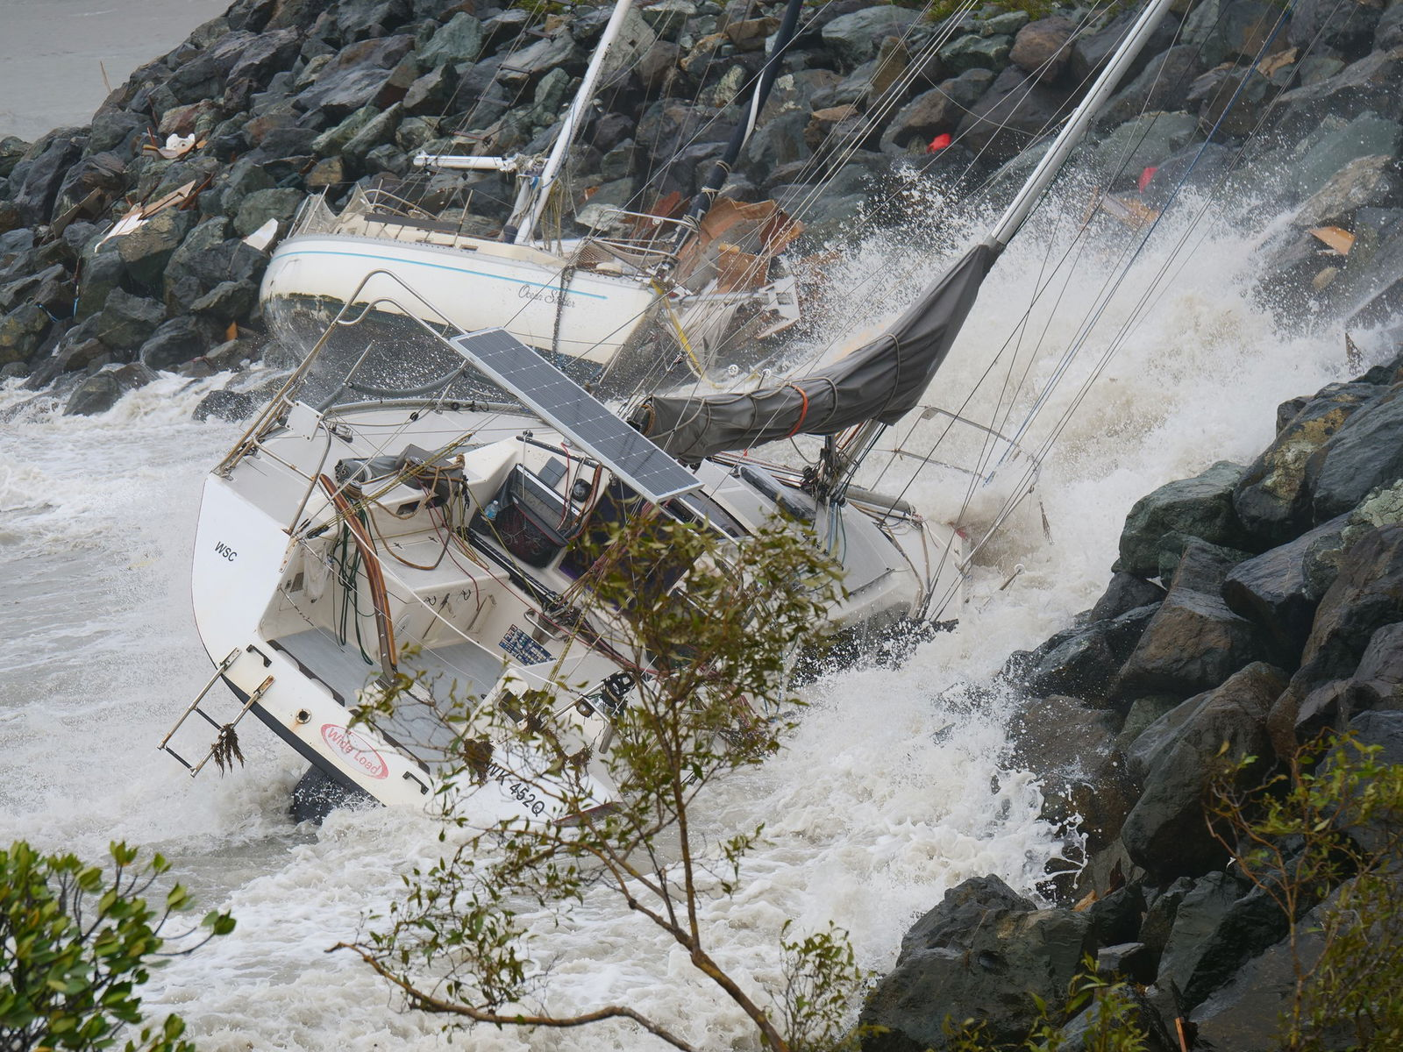
Figure 7 Unmoored boats near Airlie Beach, Qld. (Source: Jasmine Himes, ABC News)
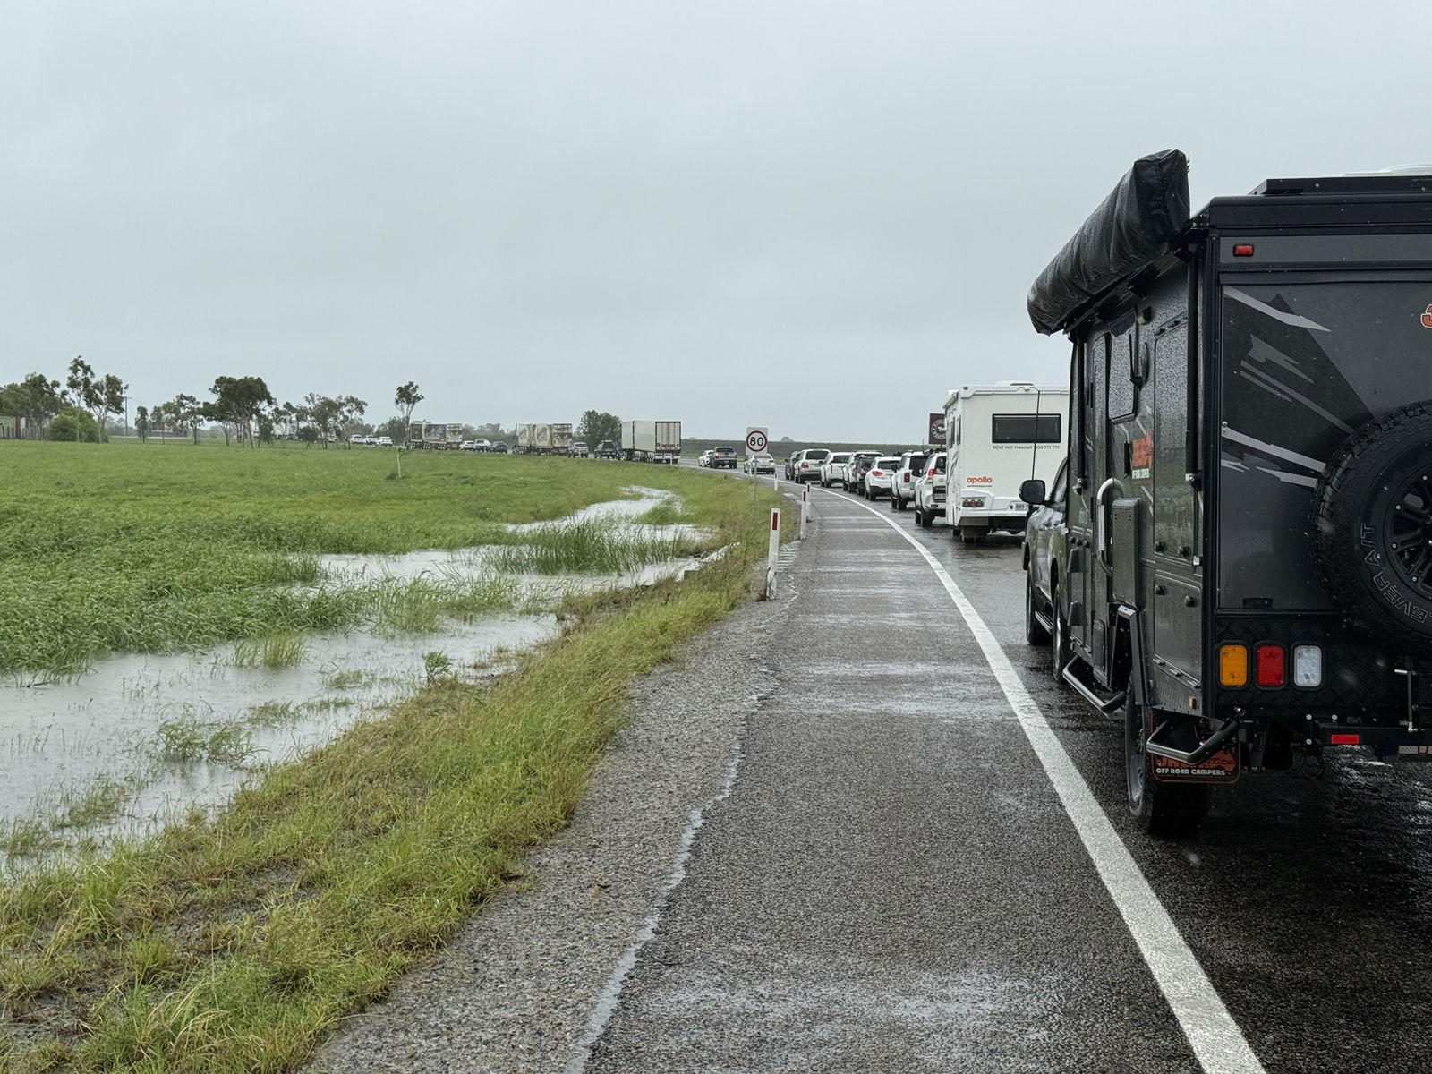
Figure 8 Bruce Highway closure, traffic at Merinda, near Bowen (source: Meghan Dansie, ABC News)
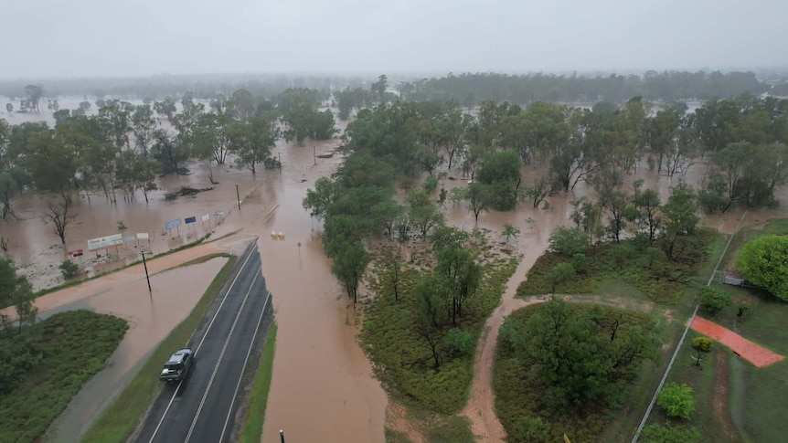
Figure 9 Flooding at Clermont (source: Ronel Aban Bingco via ABC NEWS)
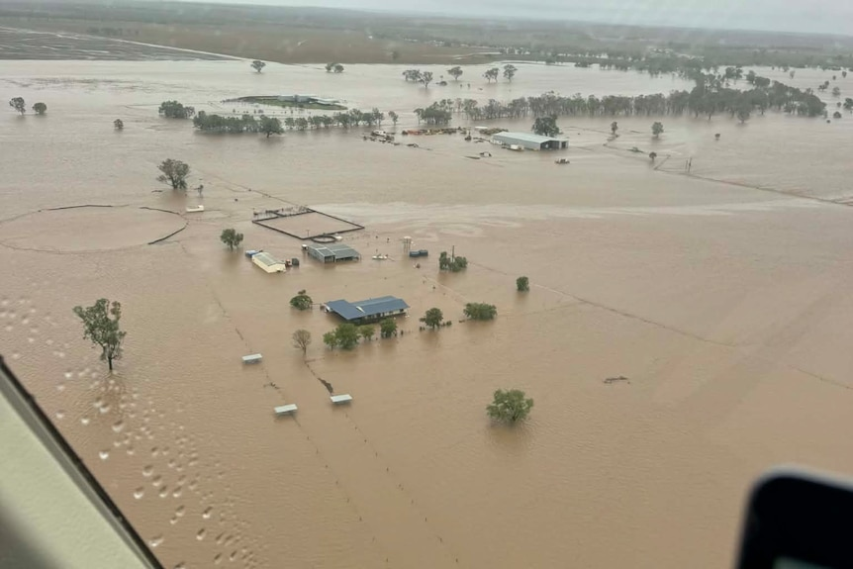
Figure 10 Flooding impacting Clermont. (source: Bush Heli-Services via ABC News)

- Observations
  - Wind
As Koji tracked south through the Coral Sea and approached the Queensland coast, Willis Island, Flinders Reef, Arlington Reef, and Hamilton Island Automatic Weather Stations (AWS) recorded associated gale force winds. Additionally, Davies Reef and Hardy Reef, Australian Institute of Marine Science (AIMS) weather stations, also recorded gales. Willis Island AWS recorded storm force winds during 10 January and a maximum wind gust of 72 kn (133 km/h) at 0241 UTC (1241 pm AEST) 10 January.

Time series of the observations from Willis Island, Arlington Reef, Flinders Reef and Hamilton Island are shown below.
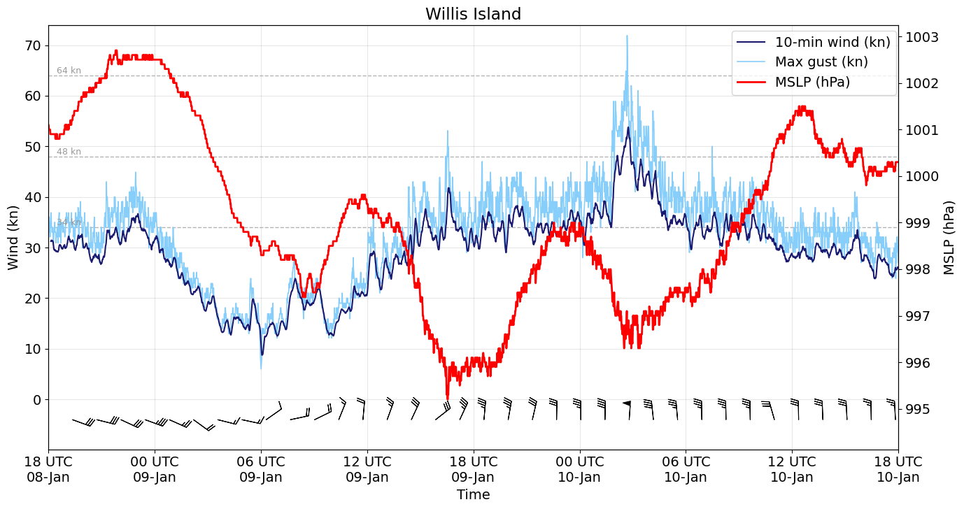
Figure 11 Willis Island 10min-mean wind speed, wind gust and pressure observations.

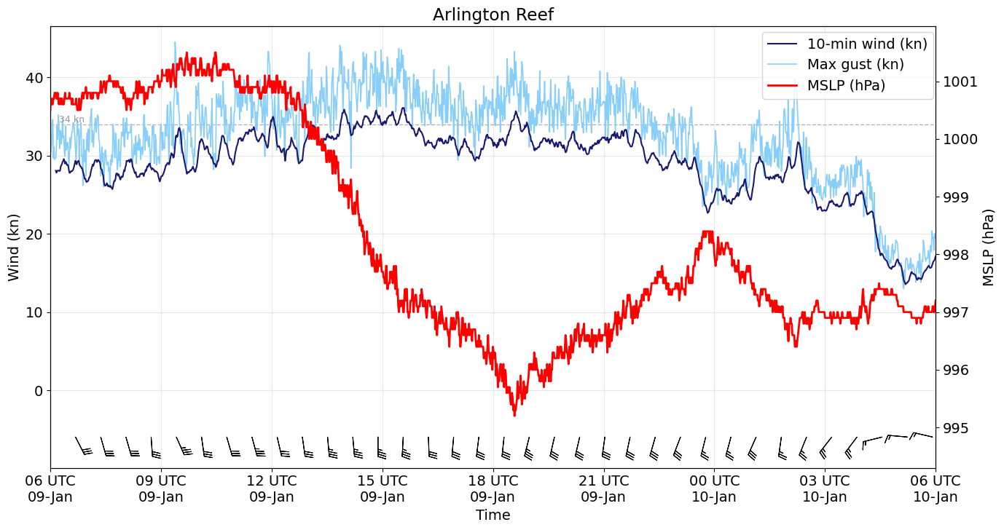
Figure 12 Arlington Reef 10min-mean wind speed, wind gust and pressure observations.
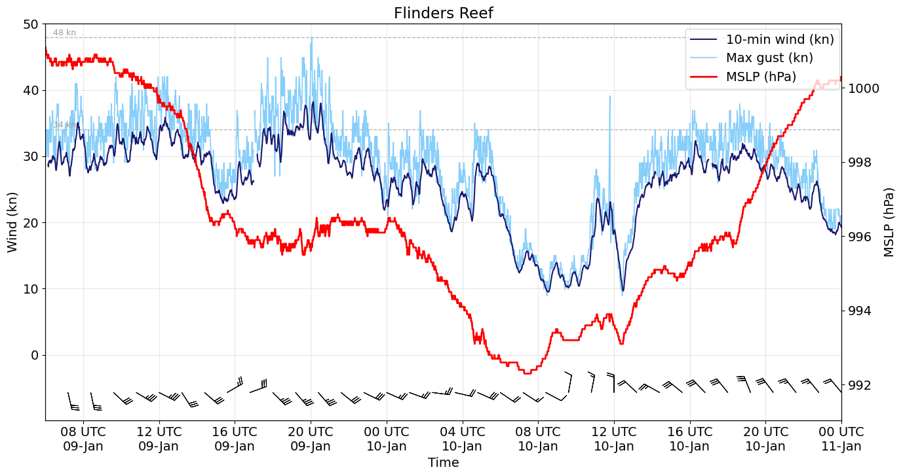
Figure 13 Flinders Reef 10min-mean wind speed, wind gust and pressure observations.

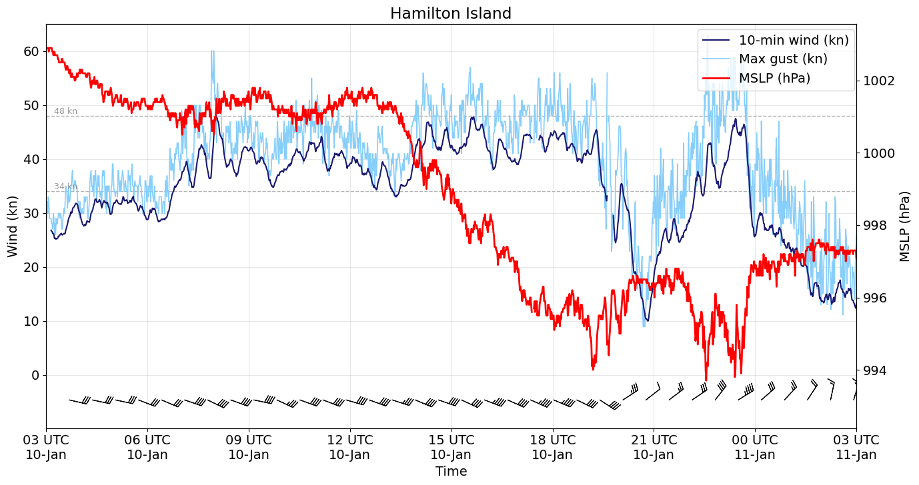
Figure 14 Hamilton Island 10min-mean wind speed, wind gust and pressure observations.

Wind observations - further details and additional observations:
Willis Island
Gales were briefly recorded associated with Koji from around 2200 UTC 8 January (8 am AEST 9 January). Gales were more persistently recorded for periods between about 1500 UTC 9 January and 1000 UTC 10 January (1 am and 8 pm AEST 10 January).
Storm force winds were recorded for times between 0208 and 0253 UTC (1208 and 1253 pm AEST) 10 January.
Arlington Reef
Gales were recorded at times between about 1200 and 1900 UTC 9 January (10 pm AEST 9 January and 4 am AEST 10 January).
Flinders Reef
Brief gales were recorded during 9 January that were initially associated with synoptic southeasterly flow. Later, from between about 1700 and 2100 UTC 9 January (1 am and 7 am AEST 10 January) gales associated with Koji were at times recorded. After these gales were recorded, during 10 January the centre of Koji passed close by Flinders Reef, however, it was in the large region of lighter winds near Koji's centre. As Koji's centre moved further south, overnight on 10 January, winds at Flinders Reef increased, though they remained below gale intensity.
Hamilton Island
Brief gales were recorded associated with synoptic southeasterly flow prior to Koji's approach. Gales associated with Koji were recorded between about 0700 UTC 10 January and 0000 UTC 11 January (5 pm AEST 10 January and 10 am AEST 11 January). Gales eased at Hamilton Island shortly before Ex-Tropical Cyclone Koji crossed the coast.
Davis Reef
Gales were recorded briefly near approximately 0200 UTC (12 pm AEST) 10 January. After this time the centre of Koji, and its region of lighter winds, moved into the vicinity of Davies Reef and winds eased.
Hardy Reef
Gales were recorded between approximately 0700 UTC (5 pm AEST) 10 January to 2300 UTC 10 January (9 am AEST 11 January).

  - Rainfall
Ex-Tropical Cyclone Koji brought heavy to intense rainfall from 11 January to Central Coast and Whitsundays, and inland to northern parts of the Central Highlands and Coalfields. Heavy to intense rainfall continued during 12 January and extended further inland to parts of the Central West, Figure 15. These regions experienced above or well above average rainfall for the month of January due to the passage of Koji, Figure 16.

Sites that recorded their highest daily rainfall of any month included:
Location | Day | New Record (mm) | Years of Record
St Lawarence | 12 January | 218.0 | 22
Clermont | 12 January | 203.2 | 16
Table 2 Observations of record daily rainfall
Sites that recorded their highest daily rainfall of January included:
Location | Day | New Record (mm) | Years of Record
Roma Peak Alert | 11 January | 211.0 | 26
Moranbah Airport | 12 January | 158.6 | 14
Upper Don Alert | 11 January | 154.0 | 25
Yeppoon The Esplanade | 12 January | 114.8 | 32
Emerald radar Alert | 12 January | 90.4 | 17
Blackwater Airport | 12 January | 69.0 | 13
Table 3 Observations of record daily rainfall for January
Sites that recorded intense rainfall (higher than their 2% Annual Exceedance Probabilities (AEP)), included:
Location | Amount (mm) | Time period
Dysart Road TM | 259.0 | In the 24 hours to 2231 UTC 11 January
Fitzroy Developmental Road TM | 234.0 | In the 24 hours to 2155 UTC 11 January
Sandy Creek Bridge | 231.5 | In the 24 hours to 0452 UTC 12 January
Sunny Park Alert | 232.6 | In the 24 hours to 0544 UTC 12 January
Clermont Airport | 211.2 | In the 24 hours to 0449 UTC 12 January
Mattie O'Neill Br Alert | 396.0 | In the 12 hours to 0801 UTC 11 January
ISAAC River Bridge | 162.5 | In the 12 hours to 1105 UTC 11 January
Mt William TM | 301.0 | In the 6 hours to 0200 UTC 11 January
Upper Finch Hatton Alert | 265.0 | In the 6 hours to 0130 UTC 11 January
Eungella Alert | 245.0 | In the 6 hours to 0141 UTC 11 January
Netherdale Alert | 245.0 | In the 6 hours to 0224 UTC 11 January
Ridgelands Alert | 242.2 | In the 6 hours to 0253 UTC 11 January
Table 4 Observations of intense rainfall

Some notable daily rainfall recorded 11 January included:
Location | Amount (mm)
Clarke Range Alert2 | 382
Mt William TM | 368
Eungella Alert | 292
Cannonvale Alert | 258
Bowen Pump Station Alert | 205
Table 5 Daily rainfall totals for 11 January
Some notable daily rainfall recorded 12 January included:
Location | Amount (mm)
East Funnel Creek TM | 276
Mattie O'Neill Br Alert | 265
Mt William TM | 233
Clermont Airport | 203.2
Capella (Rowes Hill) Alert | 180.4
Mackay Airport | 150.2
Table 6 Daily rainfall totals for 12 January
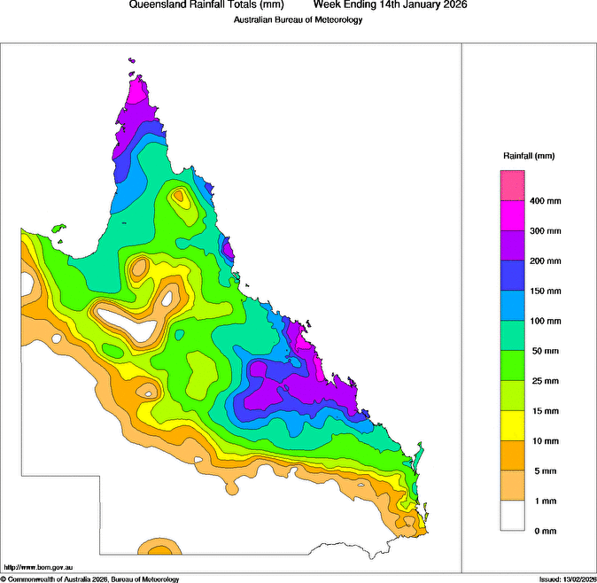
Figure 15 Rainfall across Queensland during the week between 8-14 January 2026
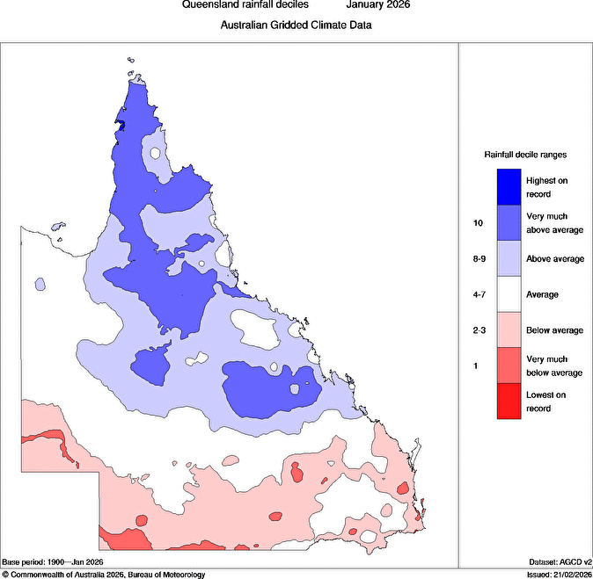
Figure 16 Rainfall deciles for January 2026

  - Pressure
Pressure observations for Willis Island (Figure 11), Arlington Reef (Figure 12), Flinders Reef (Figure 13), and Hamilton Island (Figure 14) are shown in section 4.1. Minimum pressure observations are summarised in Table 7 below.

Table 7 Minimum pressure observations associated with the passage of Tropical Cyclone Koji.
Location | Pressure hPa | Time
Willis Island | 995 | 1633 UTC 9 January
Arlington Reef | 995 | 1835 UTC 9 January
Flinders Reef | 992 | 0716 UTC 10 January
Hamilton Island | 994 | 2233 UTC 10 January
Davies Reef | 990 | 1800 UTC 10 January
Hardy Reef | 998 | 1100 UTC 11 January

  - Storm Surge
The highest storm tides observed were between 0.5 and 1.0 metres near Bowen and Airlie Beach, but the resulting tides were well below the highest astronomical tides.

- Forecast Performance
The 7 Day Forecast referring to Koji was first issued on 1 January, with a Low (15%) risk of the system being a tropical cyclone for the seven day forecast period. The percentage change remained similar for a number of days as with the risk of development being delayed. From 4 January the percentage chance increased to Moderate (25%). Over subsequent issues the percentage chance increased, increasing to High on the forecast issued 9 January.
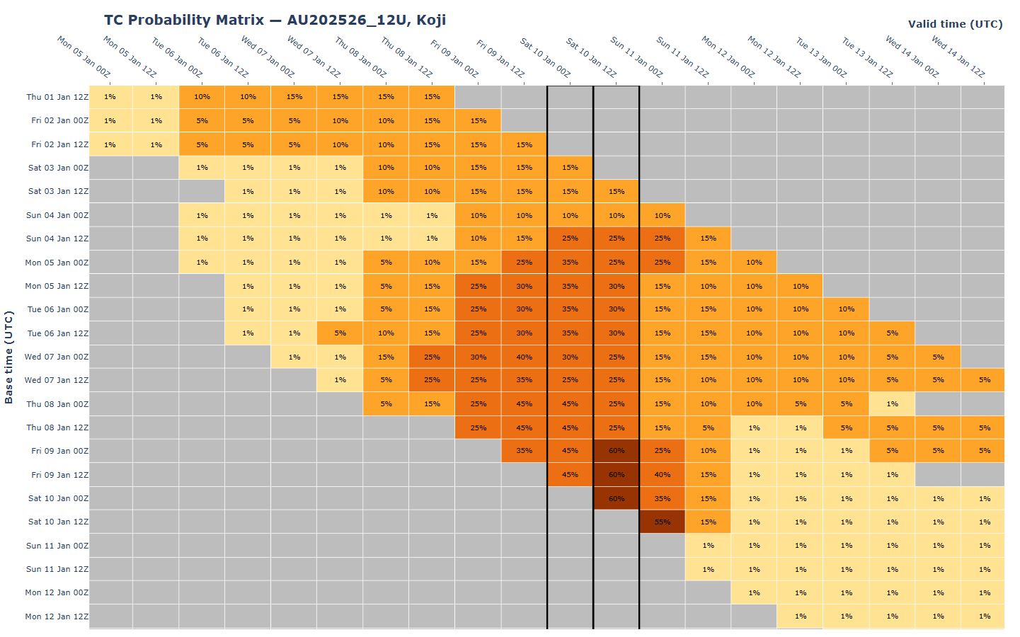
Figure 17 The forecast percentage risk of a low developing into a tropical cyclone taken from the 7-day forecast for 12U. Forecast base time is shown on the horizontal axis, and the forecast validity time is shown on the vertical axis. The box colours correspond to the tropical cyclone forecast rating: yellow for Very Low, light orange for Low, orange for Moderate and brown for High.
The first Forecast Track Map was issued at 0700 UTC (5 pm AEST) 8 January and the first Ocean Wind Warning was issued later that night at 1300 UTC (11 pm AEST). Related Severe Weather Warnings were also issued from 7 January. The first Tropical Cyclone Advice was issued at 0100 UTC (11 am AEST) 9 January, and included a Warning from Port Douglas to Tully and a Watch from Tully to Airlie Beach (Figure 18). Seventeen Tropical Cyclone Advice's were sent, with the final one sent on the morning of 11 January, as Ex-Tropical Cyclone Koji crossed the Queensland coast.

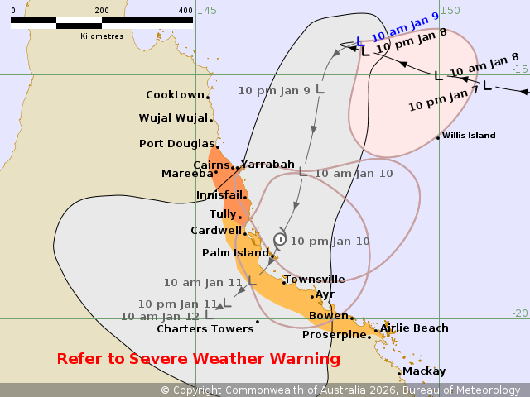
Figure 18 Forecast Track Map accompanying the first Tropical Cyclone Advice, including a Warning from Port Douglas to Tully and a Watch from Tully to Airlie Beach. Issued with analysis time of 0000 UTC (10 am AEST) 9 January.

The accuracy statistics for Tropical Cyclone Koji are below in Table 8. Note: Verification is performed using the Official Forecast Tracks at the standard times of 00, 06, 12 and 18 UTC. Statistics are shown in Figure 19 (track) and Figure 20 (intensity). Note: statistics for a lead time of 120 hours are not plotted due to the small sample size.
The position error plot shows that position forecasts for Koji were near the 5-year average to 48 hours and better than the average at lead times beyond 48 hours to 96 hours. The intensity error plot shows that intensity forecasts for Koji were near the 5-year average in the very short term, to about 12 hours, and much better than the average at all lead times from 18 to 96 hours.

Table 8: Verification statistics for Tropical Cyclone Koji. Note: Verification is performed using the Official Forecast Tracks at the standard times of 00, 06, 12 and 18 UTC.
Time (hours) | 0 | 6 | 12 | 18 | 24 | 36 | 48 | 72 | 96 | 120
Position Absolute error (km) | 21 | 40 | 54 | 62 | 74 | 107 | 120 | 113 | 143 | 234
Intensity Absolute error (kn) | 2.3 | 4.1 | 6.8 | 6.8 | 6.4 | 5.0 | 5.0 | 3.2 | 6.0 | 3.8
Sample Size | 11 | 11 | 11 | 11 | 11 | 11 | 11 | 11 | 10 | 4

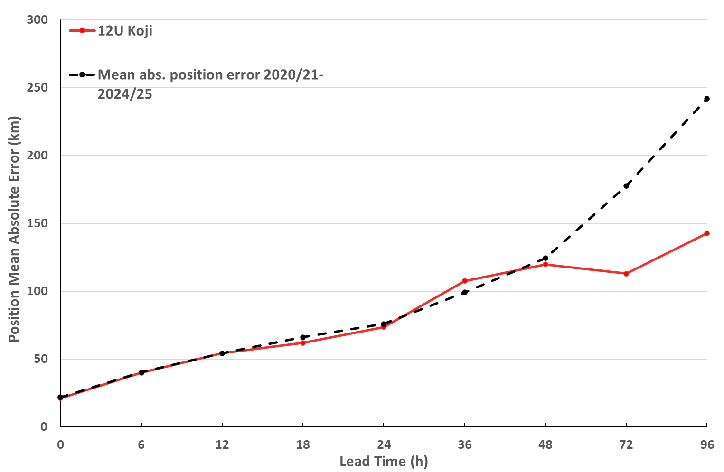
Figure 19 Position accuracy figures for Tropical Cyclone Koji plotted against the 5-year average.

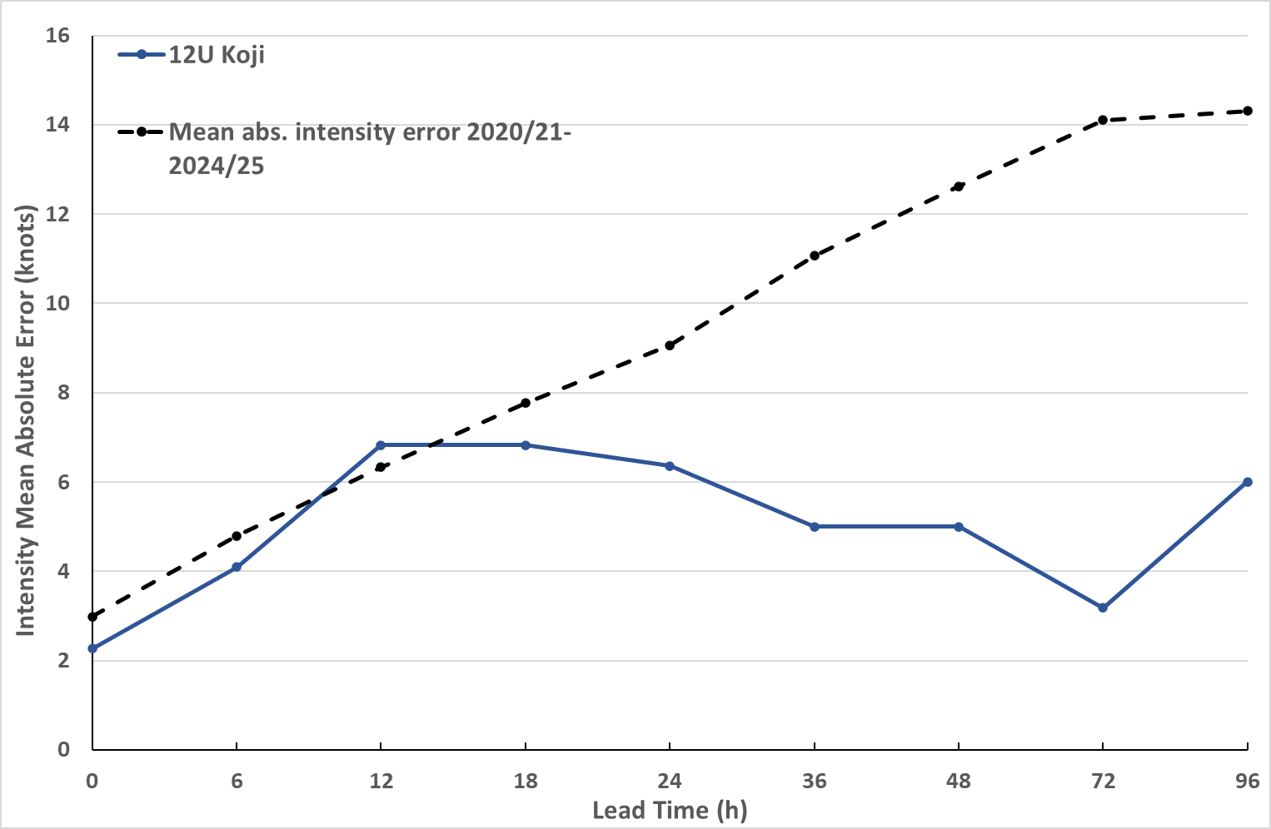
Figure 20 Intensity accuracy figures for Tropical Cyclone Koji plotted against the 5-year average.

- Appendix: List of Abbreviations
Abbreviation | Term
ADT | Advanced Dvorak Technique
ACST | Australian Central Standard Time
AEST | Australian Eastern Standard Time
AiDT | AI-enhanced Dvorak Technique
AMSR2 | Advanced Microwave Scanning Radiometer
AMSU | Advanced Microwave Sounding Unit
ASCAT | Advanced Scatterometer
ATMS | Advanced Technology Microwave Sounder
AWS | automatic weather station
AWST | Australian Western Standard Time
°C | Celsius
CI | Current intensity
CIMSS | Cooperative Institute for Meteorological Satellite Studies (USA)
CIRA | Cooperative Institute for Research in the Atmosphere (USA)
D-MINT | Deep learning - Multispectral Intensity of TCs (formerly known as DMN)
D-PRINT | Deep learning - IR Intensity of TCs (formerly known as OPEN-AIIR)
EIR | Enhanced InfraRed
FT | Final T-number
GHz | Gigahertz
GMI | Global Precipitation Measurement Microwave Imager
h | hour
hPa | hectopascal
HSCAT | Hai Yang 2 Scatterometer (HY-2B, HY-2C)
km | kilometres
km/h | kilometres per hour
kn | knot
LLCC | Low-Level Cloud Centre
MET | Model Expected T-number
METOP | Meteorological Operational Satellite
MJO | Madden-Julian Oscillation
mm | millimetres
MSLP | mean sea level pressure
NESDIS | National Environmental Satellite, Data, and Information Service
nm | nautical mile
NOAA | National Oceanic and Atmospheric Administration
NRL | U.S. Naval Research Laboratory
OPEN-AiiR | Ordered Pattern Encoding AI Infrared
PAT | Pattern T-number
RCM | RadarSat Constellation Mission – Synthetic Aperture Radar
RH | relative humidity
RMW | radius of maximum winds
RSMC | Regional Specialised Meteorological Centre
SAR | Synthetic Aperture Radar
SATC | CIMSS Advanced Dvorak Technique
SATCON | Satellite Consensus
SEN1 | Sentinel-1A – Synthetic Aperture Radar
SMAP | Soil Moisture Active Passive
TC | Tropical Cyclone
TCWC | Tropical Cyclone Warning Centre
UTC | Universal Time Co-ordinated

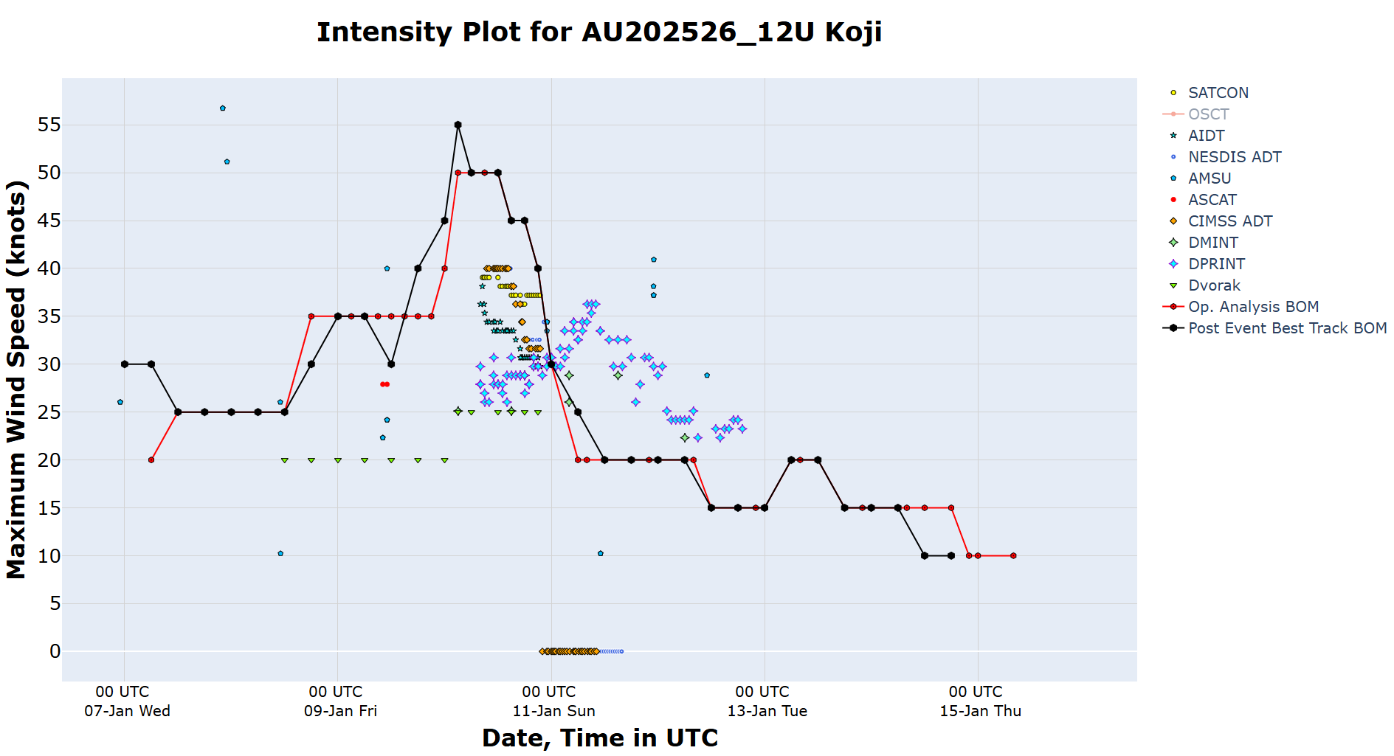
Figure 21 Intensity plot (10-min mean) of objective and subjective guidance. SATCON AIDT, NESDIS ADT, AMSU, ASCAT, CIMSS ADT, DMINT, DPRINT, Dvorak (subjective estimate), operational analysis (red), and post event best track analysis (black)

Ex-Tropical Cyclone Koji crosses north Queensland coast south of Ayr bringing intense rainfall - ABC News
Central Queensland graziers share livestock survival stories amid flood devastation - ABC News

