Severe Tropical Cyclone Larry

14 - 21 March 2006

Tropical Cyclone Environmental Prediction Services

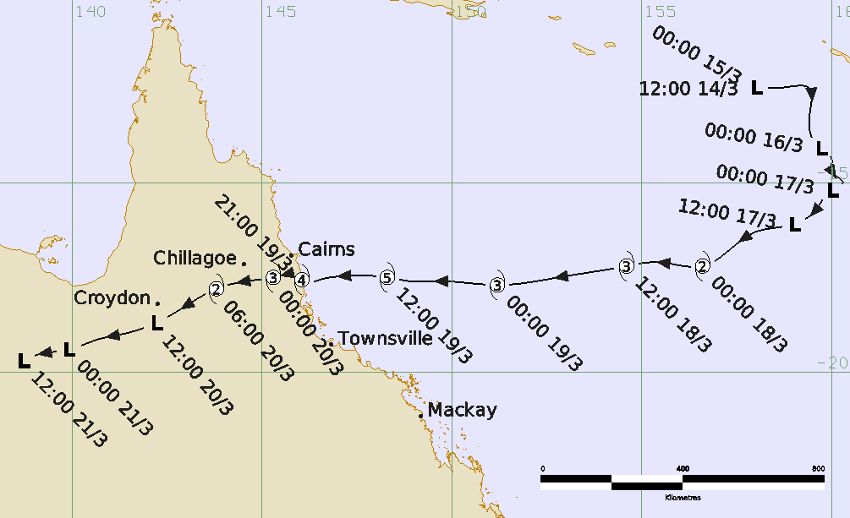

Revision history
Date | Version | Authors | Description
30/04/2026 | 1.0 | EPS Tropical Cyclone Lead | Final draft ready. Based on information primarily collated during 2006.

Review status
Date | Version | Reviewer | Description
05/05/2026 | 1.0 | EPS Tropical Cyclone Lead | Completed

Release history
Date | Version | Status | Approval
05/05/2026 | 1.0 | Approved for release | EPS Tropical Cyclone Manager

Contact details:
Tropical Cyclone Team Lead
Severe Weather Environmental Prediction Services
Bureau of Meteorology
PO Box 1370, West Perth WA 6872
Email: tcwc@bom.gov.au
This work is copyright. Apart from any use as permitted under the Copyright Act 1968, no part may be reproduced without prior written permission from the Bureau of Meteorology. Refer to www.bom.gov.au/other/copyright.shtml for further information. Unless otherwise noted, all images in this document are licensed under the Creative Commons Attribution Australia Licence.
© Commonwealth of Australia 2026
Published by The Bureau of Meteorology
Cover image: Track of Severe Tropical Cyclone Larry 14 – 21 March 2006. Times in UTC (AEST-10h).

Table of Contents

1. Summary 5

2. Meteorological description 8

2.1. Intensity Analysis 8

2.2. Structure 10

2.3. Motion 10

3. Impact 17

4. Observations 22

4.1. Wind 22

4.2. Pressure 22

4.3. Rainfall 23

4.4. Storm Surge 27

5. References 28

6. Appendix: List of Abbreviations 29

List of Figures
Figure 1. Best track of Severe Tropical Cyclone Larry 6
Figure 2. Detailed best track of Severe Tropical Cyclone Larry showing wind radii 6
Figure 3. QSCAT scatterometry winds at 0727 UTC 16 March; and at 1931 UTC 17 March. 11
Figure 4. Visible images at 0030 UTC during development from 15 - 18 March. 12
Figure 5. Series of microwave images on 17-18 March 2006. 13
Figure 6. Series of enhanced IR images 0000 UTC 18 March to 2100 UTC 19 March. 14
Figure 7. Series of microwave images on 19 March 2006 15
Figure 8. Willis Island radar at 1020 UTC and 1120 UTC 19 March. 16
Figure 9. Morphed Microwave Imagery sequence from 1500 to 2200 UTC 19 March 2006. 16
Figure 10. Series of merged radar images on 19 March near landfall 17
Figure 11. Map showing significant areas of wind damage. 19
Figure 12. Photo of damage to houses in Mourilyan. 20
Figure 13. Photo of snapped power pole along Mourilyan Harbour road. 20
Figure 14. Photo of tree damage at Ella Bay, totally levelled by winds from the west southwest. 21
Figure 15. Photo of the South Johnstone AWS and radar image at 2050 UTC 19 March 21
Figure 16. Photo of Etty Bay 22
Figure 17. Photo of banana crop damage near Innisfail. 22
Figure 18. Daily rainfall analysis for north Queensland, 20 March 2006. 26
Figure 19. Rainfall analysis for Queensland for week ending 23 March 2006. 27
Figure 20. 3D Tops radar reflectivity from Cairns radar at 20:50 UTC and IR image at 2045 UTC. 29

List of Tables
Table 1. Best track summary for Severe Tropical Cyclone Larry 14 - 21 March 2006 7
Table 2. Storm tide levels, and observed surge heights from tide gauges 28

- Summary
Severe Tropical Cyclone Larry crossed the far north Queensland coast near Innisfail south of Cairns early on 20 March 2006 at category 4 intensity causing major impacts to the region. Fortunately, no deaths or life-threatening injuries were directly attributable to the cyclone. However, between Babinda and Tully, damage to infrastructure and crops was extensive with the total estimated loss upwards of half a billion dollars. Significant damage also occurred in areas north to Cairns, south to Cardwell and on the Atherton Tablelands.
A tropical low formed in the eastern Coral Sea on 14-15 March assisted by a strong monsoon flow initially. Although the monsoon flow eased on 17 March, a strengthening high pressure ridge increased winds south of the centre. Deep convection became more organised overnight from 17 to 18 March. Tropical cyclone intensity was estimated at 0000 UTC 18 March.
Larry rapidly intensified into a severe tropical cyclone late on 18 March and then peaked at category 5 intensity on 19 March. Larry moved west towards the Queensland coast at faster than normal speeds (25 km/h) towards landfall. Larry was undergoing an eyewall replacement cycle (ERC) in the ten hours prior to landfall which resulted in a slight reduction in maximum winds and a complex wind field.
Larry made landfall at category 4 intensity near Innisfail around daybreak at 0700 AEST on Monday 20 March (2100 UTC 19 March). A marked variation in wind gusts was observed, both in a spatial sense and across elevated terrain. This was clearly evidenced by varying levels of damage across relatively small distances. Wind damage and flooding rainfall was much less than otherwise could have occurred, due to the rapid motion of the cyclone through the area.
Larry was at category 3 intensity as it moved over the Atherton Tablelands, then below tropical cyclone intensity late on 20 March much further inland than is normal and its remnants produced severe flooding in the northwest of the state.
In total 10 000 homes were damaged, most of which were constructed prior to the introduction of higher cyclone rating standards. More modern houses in the main impact zone remained structurally intact. Many powerlines were felled resulting in prolonged power outages.
Larry caused extensive damage to forests and destroyed 80–90% of Australia's banana crop resulting in a short supply throughout Australia for the remainder of 2006.
Larry was the first severe tropical cyclone to cross the Queensland coast south of Cairns since Aivu in 1989.
Figure 1 shows the overall track of Larry, Figure 2 the more detailed track near land, while Table 1 is a summary of the best track data.

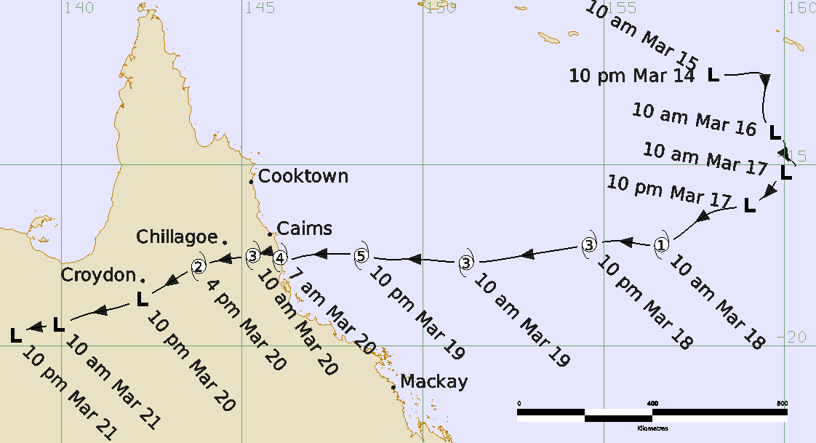
Figure 1. Best track of Severe Tropical Cyclone Larry (times in AEST, UTC +10).

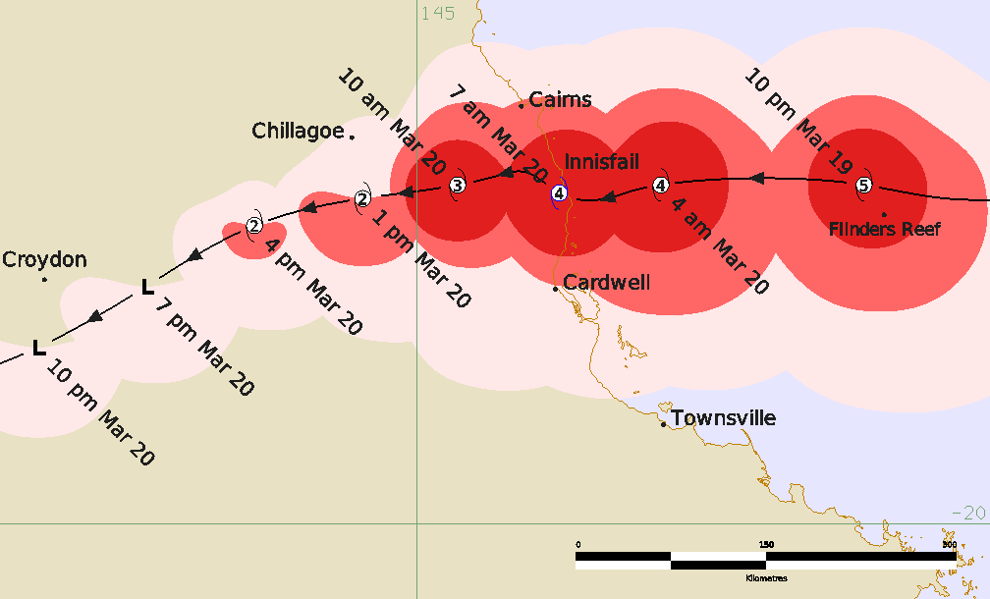
Figure 2. Detailed best track of Severe Tropical Cyclone Larry showing wind radii (gale - pink, storm - red and hurricane force – dark red) 19-20 March 2006 (times in AEST, UTC +10).

Year | Month | Day | Hour UTC | Pos. Lat. S | Pos. Long. E | Pos. Acc. nm | Max. wind kn | Max. gust kn | Cent. Press hPa | Rad of gales NE/SE/SW/NW nm | Rad of storm NE/SE/SW/NW nm | RMW nm
2006 | 3 | 14 | 1200 | 12.5 | 158.0 | 40 | 25 | 45 | 1003 | 0/0/0/0 | 0/0/0/0 | -
2006 | 3 | 14 | 1800 | 12.5 | 158.0 | 40 | 25 | 45 | 1003 | 0/0/0/0 | 0/0/0/0 | -
2006 | 3 | 15 | 0000 | 12.5 | 158.0 | 40 | 25 | 45 | 1005 | 0/0/0/0 | 0/0/0/0 | -
2006 | 3 | 15 | 0600 | 12.5 | 158.7 | 30 | 25 | 45 | 1003 | 0/0/0/0 | 0/0/0/0 | -
2006 | 3 | 15 | 1200 | 12.5 | 159.4 | 40 | 25 | 45 | 1003 | 0/0/0/0 | 0/0/0/0 | -
2006 | 3 | 15 | 1800 | 13.4 | 159.4 | 40 | 25 | 45 | 1003 | 0/0/0/0 | 0/0/0/0 | -
2006 | 3 | 16 | 0000 | 14.1 | 159.7 | 30 | 25 | 45 | 1002 | 0/0/0/0 | 0/0/0/0 | -
2006 | 3 | 16 | 0600 | 14.4 | 160.0 | 30 | 30 | 45 | 1000 | 0/0/0/0 | 0/0/0/0 | -
2006 | 3 | 16 | 1200 | 14.7 | 160.0 | 30 | 30 | 45 | 998 | 0/0/0/0 | 0/0/0/0 | -
2006 | 3 | 16 | 1800 | 15.0 | 160.3 | 25 | 30 | 45 | 998 | 0/0/0/0 | 0/0/0/0 | -
2006 | 3 | 17 | 0000 | 15.2 | 160.0 | 20 | 30 | 45 | 998 | 0/0/0/0 | 0/0/0/0 | -
2006 | 3 | 17 | 0600 | 15.7 | 159.6 | 20 | 30 | 45 | 997 | 0/0/0/0 | 0/0/0/0 | -
2006 | 3 | 17 | 1200 | 16.1 | 159.0 | 20 | 30 | 45 | 995 | 0/0/0/0 | 0/0/0/0 | -
2006 | 3 | 17 | 1800 | 16.3 | 158.0 | 20 | 40* | 55 | 992 | 0/110/80/0 | 0/0/0/0 | -
2006 | 3 | 18 | 0000 | 17.2 | 156.6 | 15 | 45 | 65 | 990 | 60/110/80/60 | 0/40/30/0 | 25
2006 | 3 | 18 | 0600 | 17.1 | 155.4 | 15 | 55 | 80 | 985 | 60/110/80/70 | 30/50/40/30 | 25
2006 | 3 | 18 | 1200 | 17.2 | 154.6 | 15 | 65 | 90 | 979 | 70/110/80/70 | 30/50/40/40 | 20
2006 | 3 | 18 | 1800 | 17.5 | 152.8 | 15 | 70 | 100 | 974 | 70/110/80/70 | 30/50/50/40 | 20
2006 | 3 | 19 | 0000 | 17.7 | 151.2 | 10 | 80 | 110 | 967 | 70/110/80/70 | 40/60/50/40 | 20
2006 | 3 | 19 | 0600 | 17.6 | 149.7 | 10 | 90 | 125 | 959 | 70/110/80/70 | 40/60/50/40 | 20
2006 | 3 | 19 | 0900 | 17.6 | 148.9 | 10 | 100 | 140 | 950 | 70/110/80/70 | 40/60/50/40 | 20
2006 | 3 | 19 | 1200 | 17.5 | 148.3 | 10 | 110 | 155 | 949 | 70/110/80/70 | 40/60/50/40 | 15
2006 | 3 | 19 | 1500 | 17.5 | 147.6 | 10 | 105 | 145 | 950 | 70/100/80/70 | 40/55/50/40 | 13
2006 | 3 | 19 | 1800 | 17.5 | 146.8 | 10 | 100 | 140 | 950 | 70/100/60/70 | 45/60/55/40 | 15
2006 | 3 | 19 | 1900 | 17.5 | 146.6 | 10 | 100 | 140 | 950 | 70/100/60/60 | 45/60/45/40 | 15
2006 | 3 | 19 | 2000 | 17.6 | 146.4 | 10 | 100 | 140 | 950 | 70/100/50/60 | 40/50/40/45 | 15
2006 | 3 | 19 | 2100 | 17.6 | 146.1 | 10 | 100 | 140 | 950 | 70/100/50/60 | 40/45/35/45 | 15
2006 | 3 | 19 | 2200 | 17.4 | 145.8 | 10 | 100 | 140 | 950 | 70/100/50/60 | 40/45/30/45 | 12
2006 | 3 | 19 | 2300 | 17.4 | 145.6 | 15 | 95 | 135 | 955 | 70/100/50/50 | 40/45/30/40 | 12
2006 | 3 | 20 | 0000 | 17.5 | 145.3 | 20 | 85 | 120 | 965 | 70/100/50/40 | 40/40/30/30 | 15
2006 | 3 | 20 | 0300 | 17.6 | 144.6 | 25 | 60 | 95 | 978 | 40/70/45/30 | 0/30/30/0 | 15
2006 | 3 | 20 | 0600 | 17.8 | 143.8 | 25 | 55 | 70 | 984 | 20/50/40/20 | 0/15/15/0 | 15
2006 | 3 | 20 | 0900 | 18.3 | 143.0 | 30 | 45* | 60 | 988 | 0/45/40/0 | 0/0/0/0 | 15
2006 | 3 | 20 | 1200 | 18.7 | 142.2 | 30 | 40* | 55 | 992 | 0/40/40/0 | 0/0/0/0 | 15
2006 | 3 | 20 | 1500 | 19.0 | 141.3 | 30 | 30 | 45 | 995 | 0/0/0/0 | 0/0/0/0 | -
2006 | 3 | 20 | 1800 | 19.1 | 140.8 | 30 | 30 | 40 | 997 | 0/0/0/0 | 0/0/0/0 | -
2006 | 3 | 21 | 0000 | 19.4 | 139.9 | 30 | 25 | 40 | 998 | 0/0/0/0 | 0/0/0/0 | -
2006 | 3 | 21 | 0600 | 19.6 | 138.9 | 30 | 25 | 40 | 998 | 0/0/0/0 | 0/0/0/0 | -
2006 | 3 | 21 | 1200 | 19.7 | 138.7 | 30 | 20 | 40 | 1000 | 0/0/0/0 | 0/0/0/0 | -
Table 1. Best track summary for Severe Tropical Cyclone Larry 14 - 21 March 2006. UTC=AEST-10h. * Not at tropical cyclone intensity as gales less than halfway around centre.
- Meteorological description
  - Intensity Analysis
Formation
A tropical low formed in the northeast Coral Sea southwest of the Solomon Islands from within a trough on 14 March associated with strong westerly monsoon flow to the north. Scatterometry (QSCAT) showed near gale-force winds to the north on 16 March but then easing on 17 March as shown in Figure 3. Dvorak estimates rose from T1.0 at 0000 UTC 16 March to 2.0 at 0000 UTC 17 March and then to 3.0 at 1800 UTC 17 March as deep convection became more organised. The series of daily visible images from 15 to 18 March in Figure 4 show the development of cloud patterns towards a well-defined circulation. The TMI 85 GHz microwave image at 1828 UTC 17 March in Figure 5a shows well defined curvature south of the centre. However, a QSCAT pass at 1933 UTC only showed gales south of the centre (Figure 3).
Tropical cyclone intensity was estimated at 0000 UTC 18 March when cloud features had become further organised and gales were estimated surrounding the centre. At this time, Dvorak estimates reached 3.5 consistent with category 2 intensity, and storm-force winds were estimated south of the centre.
Intensification
Larry rapidly intensified during 18-19 March under favourable environmental conditions of high sea surface temperatures, high moisture levels in low to mid-levels, low vertical wind shear and upper-level outflow. The series of microwave images in Figure 5 and enhanced IR images in Figure 6 shows the developing cloud pattern signatures including the emergence of a microwave eye evident in low and mid-levels. Larry was estimated to reach 65 kn (120 km/h, category 3) intensity at 1200 UTC 18 March and then 90 kn (165 km/h, category 4) at 0600 UTC 19 March by which time an eye was clearly evident on visible and IR imagery.
Peak intensity
Maximum winds were estimated to peak at 110 kn (205 km/h), category 5 intensity, briefly at 1200 UTC 19 March prior to landfall nine hours later. The peak was based upon Dvorak CI estimates, with the DT averaging 6.5 from 0830 UTC 19 March (refer Figure 6).
Around this time Larry had just passed within 30 km north of Flinders Reef which recorded maximum mean winds of 84 kn (155 km/h) gusting to 114 kn (211 km/h) in the southern eyewall at 1110 UTC. The Willis Island radar images in Figure 8 at 1020 and 1120 UTC show Flinders Reef very close to the maximum reflectivity in the sampled sectors of the cyclone (western and southern). However, the inner edge of the eyewall where the maximum winds occur, was likely closer to the centre given Willis Island radar is some 240 km away and hence the radar showed the reflectivity well above the surface. Additionally, the TRMM microwave image in Figure 7a at 1001 UTC, showed considerably stronger convection on the northern side. Flinders Reef, located southwest of the centre at this time, experienced the southern eyewall and hence, did not sample the strongest inner edge of the eyewall. Larry was moving west at 25 km/h which would suggest higher winds south of the centre, but the deepest convection was north of the centre.

Landfall intensity
Following the intensity peak at 1200 UTC winds were estimated to have reduced slightly as Larry commenced an ERC that only completed just after landfall. This is consistent with general ERC studies e.g. Sitkowski et al. 2011, Kossin 2015, and with the subsequent landfall intensity estimate supported by other evidence. Figure 9 shows a series of hourly morphed microwave images from 1500 to 2200 UTC 19 March that shows the evolution of the secondary outer eyewall becoming the dominant eyewall after landfall, although the sequence of radar imagery shows greater detail near landfall. Dvorak estimates remained at 6.5 but the technique is known to struggle during an ERC as high cloud on infrared imagery obscures variations in eyewall structure.
The landfall intensity of 100 kn 10-minute mean winds was estimated utilising a range of information from satellite, radar, wind and pressure observations and storm tide and damage surveys. These highlighted the complexities of the wind field at landfall including localised extreme winds within the eyewall and terrain-enhanced winds (see structure discussion in the next section).
Subjective Dvorak estimates remained at CI=6.5 equivalent to 110-115 kn, despite slight weakening of the DT and FT to 6.0 based on a slightly weaker eye signature at landfall. Objective ADT and SATCON intensity estimates increased through to landfall, SATCON peaking at 107 kn (adjusted to 10-min. mean) and ADT peaking at CI=6.2 equivalent to about 105 kn (10-min. mean).
The only Bureau of Meteorology wind recording station in the impact site was at South Johnstone which recorded peak gust of 98 kn (181 km/h) at 2040 UTC in the southerly flow just inside the radar eyewall. An upper bound wind gust was also estimated from street sign damage nearby. However, both sites were sheltered from the strongest wind in the area by densely forested terrain, and in the case of the weather station, also by nearby buildings. Consequently, neither can indicate the strength of the strongest wind in the area.
There were various measurements of pressure from within the eye. About 30-60 minutes after landfall two official Innisfail measurements (see Observations) measured 959 hPa but the barograph was adjusted to 955 hPa and the AWS did not quite sample the true minimum pressure. Several unofficial barometers that were verified after the event measured minimum pressures from 950 to 959 hPa. Two other unofficial barometers measured pressures considerably lower at less than 937 hPa, one of which was able to be verified after the event. Using the CKZ wind-pressure relationship (WPR), a central pressure of 955 hPa would match winds of 95 kn while 950 hPa matches 100 kn based on other parameters at the time. Larry's central pressures were estimated at 950 hPa prior to landfall based on the WPR and then 955 hPa at 2100 UTC once over land consistent with the observations at Innisfail. Kossin (2015) indicated higher scatter than normal in the WPR with maximum winds tending to be lower for a given pressure during the mid to end stages of an ERC.
An analysis of the eyewall structure variations is discussed in the structure section and in detail in Otto (2012) including analysis of extreme winds based on radar, observations and storm surge variations. Otto and Soderholm (2012) analysed the rotation of radar reflectivity anomalies around the eyewall to propose Larry's structure and intensity was affected by vortex Rossby wave activity. They also noted these features moved at speeds consistent with expectations derived from linear barotropic theory, with an implied maximum mean windspeed of the cyclone at landfall of ~107 knots, however the uncertainty in this value was high. Figure 10 shows the series of radar images near landfall demonstrating the complexity of the structure.
Extreme winds were also experienced well north of the centre as far as Cairns associated with high terrain. These downslope westerly winds included measured gusts to 294 km/h at Mt Bellenden Ker and 178 km/h at a Cairns Skyrail tower. These observations are discussed in sections on damage and observations.
Post event modelling of the storm surge (Boswood et al. 2007) used a central pressure of 940 hPa to derive levels to 85% of the surveyed inundation level, however this does not discount a lower or higher central pressure given Larry's complex wind field.
Inland weakening
The contraction of the outer eyewall near landfall as evident on radar and microwave (Figure 7d) was likely to have caused higher winds to extend further inland than would be typical and consistent with eye-witness reports around Innisfail that the second experience of the eastern eyewall following the lull in winds in the eye was stronger than the initial eyewall. It is also consistent with extensive forest damage extending a considerable distance inland as documented in Pohlman et al. (2008) and the many downed powerlines inland.
Once past the Atherton Tablelands, weakening accelerated over inland Queensland. Larry was estimated to reduce to 60 kn (category 2) at 0300 UTC 20 March then at 0900 UTC to 45 kn but with gales limited to southern quadrants assisted by the rapid 30 km/h translation speed. Gales were estimated to cease by 1500 UTC 20 March by which time Larry had moved 500 km inland.
  - Structure
Larry was very asymmetric throughout its lifetime, with gales extending further south of the centre due to a combination of its fast westerly motion and a ridge to the south enhancing the east to southerly flow. Table 1 shows that gales extended to 100-110 nm (185-205 km) to the southeast, 80 nm (150 km) to the southwest, and about 70 nm (130 km) to the north until land attenuated the gale extent. Storm-force winds extended 50-60 nm (95-110 km) to the south and about 40 nm (75 km) to the north while hurricane-force winds were mostly 25-30 nm (45-55 km) in extent.
For approximately ten hours before making landfall Larry possessed two concentric eyewalls, and they changed in radius often on short time scales. By landfall, one dominant outer eyewall was contracting rapidly as it spiralled into the centre. The inner eyewall was still present, but storm surge modelling and inundation heights indicate it was relatively weak.
The RMW was mainly estimated using microwave imagery, Willis Island, Cairns and Mt Stuart (Townsville) radars and observations. In the developing stages the RMW was 20-25 nm (35-45 km) reducing to 13-15 nm (24-28 km) as Larry intensified.
Near landfall, a detailed analysis between 1800-2200 UTC 19 March showed the RMW varying from 7 nm (13 km) at 2040 UTC to 15 nm (28 km) at other times. The South Johnstone AWS recorded its highest wind gusts just inside the inner edge of the eyewall on the radar as shown in Figure 10c and in Figure 15, a feature of the radar sampling the eye at an elevation of 2900 m. This is significant because the eyewall slopes outwards with increasing elevation known as the “stadium effect”.
Eyewall variations at landfall
A comparison of the radar imagery with observations and damage and storm tide assessments indicated a complex eyewall structure which is discussed in detail in Otto (2012). Figure 10 shows the series of radar images every 10 minutes from 2020 UTC to 2110 UTC (0620-0710 AEST). At 2020 UTC the eye was quite symmetrical but soon became elongated. It was evident that two separate localised strips of damage occurred within mesovortices in the eyewall. These mesovortices formed in a polygonally shaped eyewall edge near the site of the two lowest pressure readings below 937 hPa, almost 20 hPa lower than other pressure observations within the eye. These features are known to produce winds 20 to 40 per cent higher than the parent tropical cyclone and help to explain the separate extremely high storm tide peaks from inundation surveys at Etty Bay/Flying Fish Point and further south at Bingil Bay.
Fortunately, the extreme strips of damage did not occur in populated areas.

  - Motion
Initially the tropical low moved to the south southeast during 14-17 March. On 18 March Larry turned to the west and accelerated to above 20 km/h being steered by a prevailing mid-level ridge to the south. This motion continued on 19 March and Larry was moving west at 25 km/h as it made landfall. Later on 20 March as Larry weakened over land, motion was to the west southwest which persisted until the circulation dissipated late on 21 March.
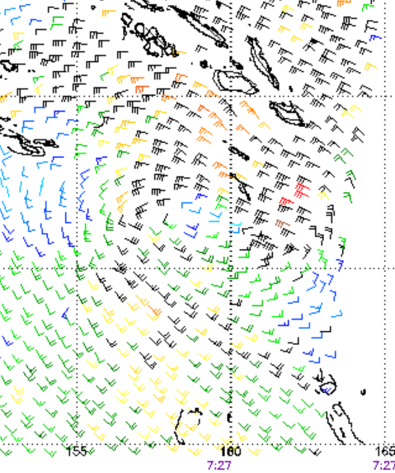 | 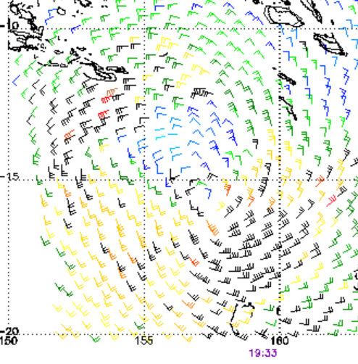

Figure 3. QSCAT scatterometry winds left at 0727 UTC 16 March; and right at 1931 UTC 17 March. Images courtesy of STAR, NOAA: https://manati.star.nesdis.noaa.gov/datasets/QuikSCATData.php
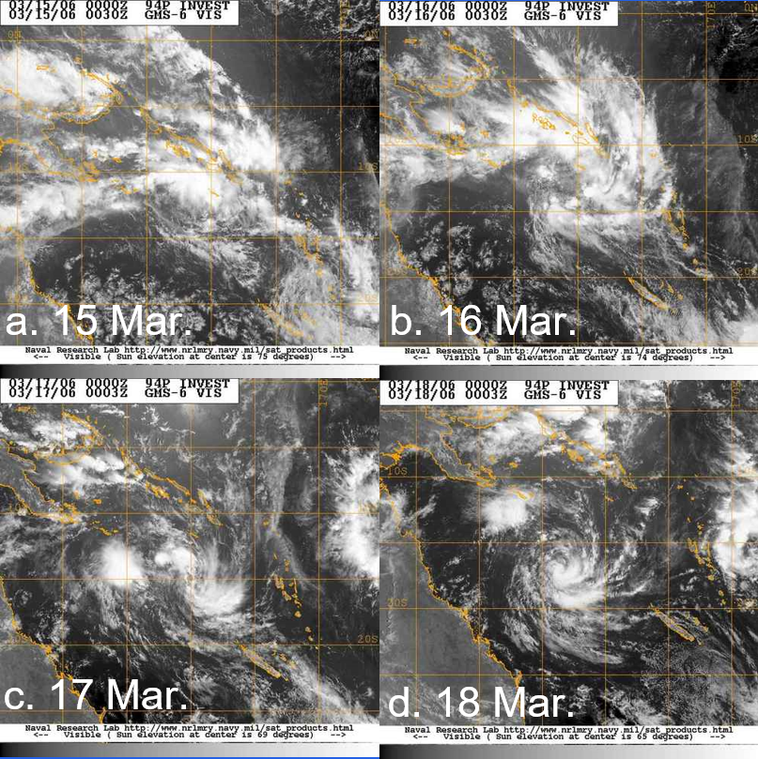
Figure 4. Series of visible images at 0030 UTC showing the developing cloud patterns from a. 15 March; b. 16 March; c. 17 March; and d. 18 March. The series shows the development from a broad area of thunderstorms on 15 March contracting and focusing towards a well-defined central area on 18 March when Larry reached tropical cyclone intensity. Images from MTSAT 1R satellite from JMA via NRL: https://www.nrlmry.navy.mil/TC.html

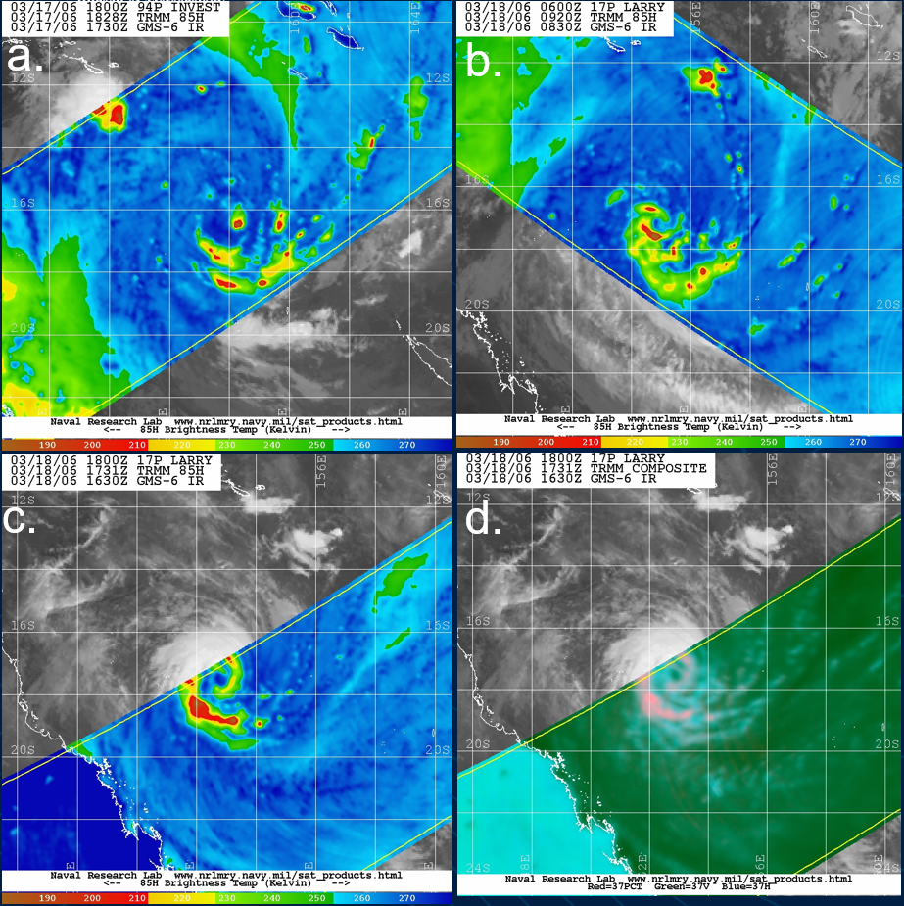
Figure 5. Series of microwave images on 17-18 March 2006 a.TMI 85GHz H at 1828 UTC 17 March; b. TMI 85GHz H at 0920 UTC 18 March c. TMI 85 GHz H at 1731 UTC 18 March; and d. TMI 37GHZ Composite at 1731 UTC 18 March. Images courtesy of NRL

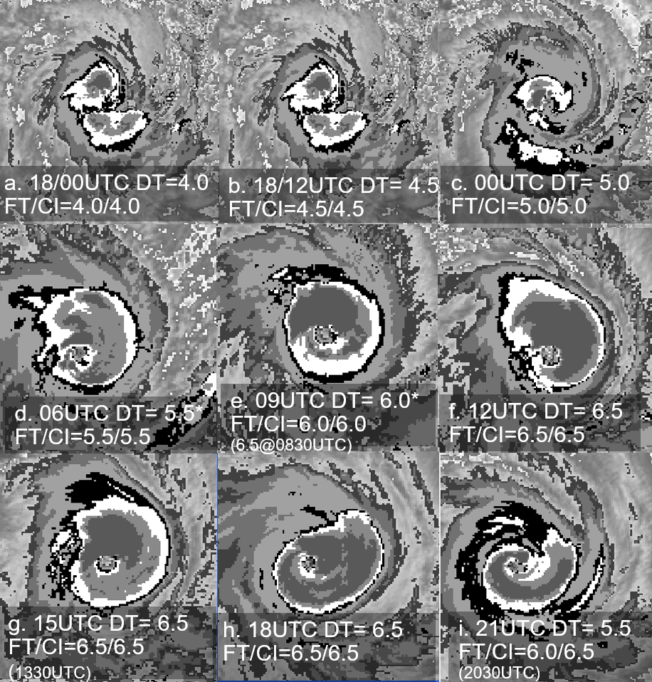
Figure 6. Series of enhanced IR images with Dvorak estimates superimposed at a.0000 UTC 18 March; b. 1200 UTC 18 March; c. 0000 UTC 19 March; d. 0600 UTC 19 March; e. 0900 UTC 19 March; f 1200 UTC 19 March; g.1500 UTC 19 March; h. 1800 UTC 19 March; and i. 2100 UTC 19 March. The DT numbers are three-hour averaged noting at 0900 UTC 19 March in e. the image shown is at 0830 UTC and although the three-hour average is 6.0, the DT for this image is 6.5.
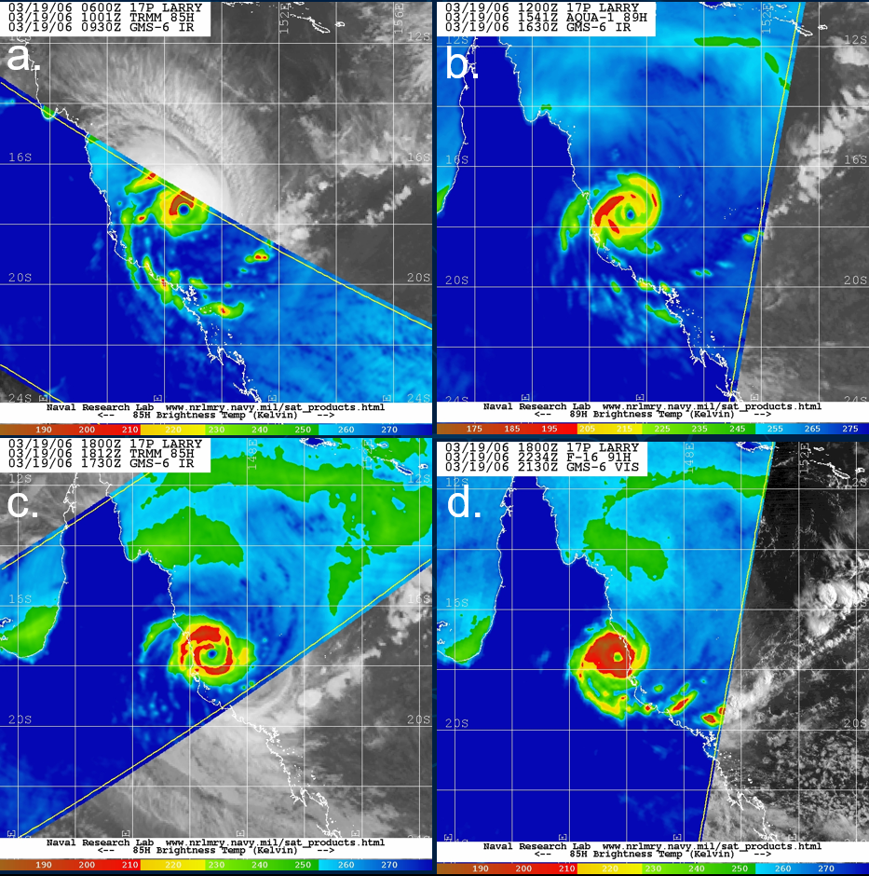
Figure 7. Series of microwave images on 19 March 2006 a.TMI 85 GHz H at 1001 UTC; b. AMSRE 89 GHz H at 1541 UTC; c. TMI 85 GHz H at 1812 UTC; and d. SSMIS 91 GHz H at 2234 UTC. Images courtesy of NRL: https://www.nrlmry.navy.mil/TC.html

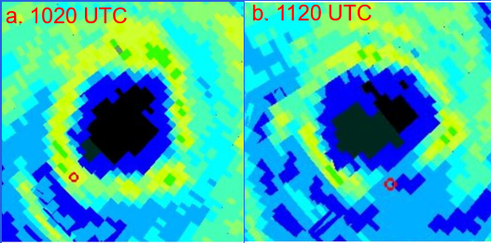
Figure 8. Willis Island radar at a. 1020 UTC and b. 1120 UTC 19 March overlaid with the position of Flinders Reef which recorded SSE winds 79 kn at 1020 UTC; E winds 79 kn at 1120 UTC; and peak of 84 kn gusting to 114 kn at 1110 UTC.

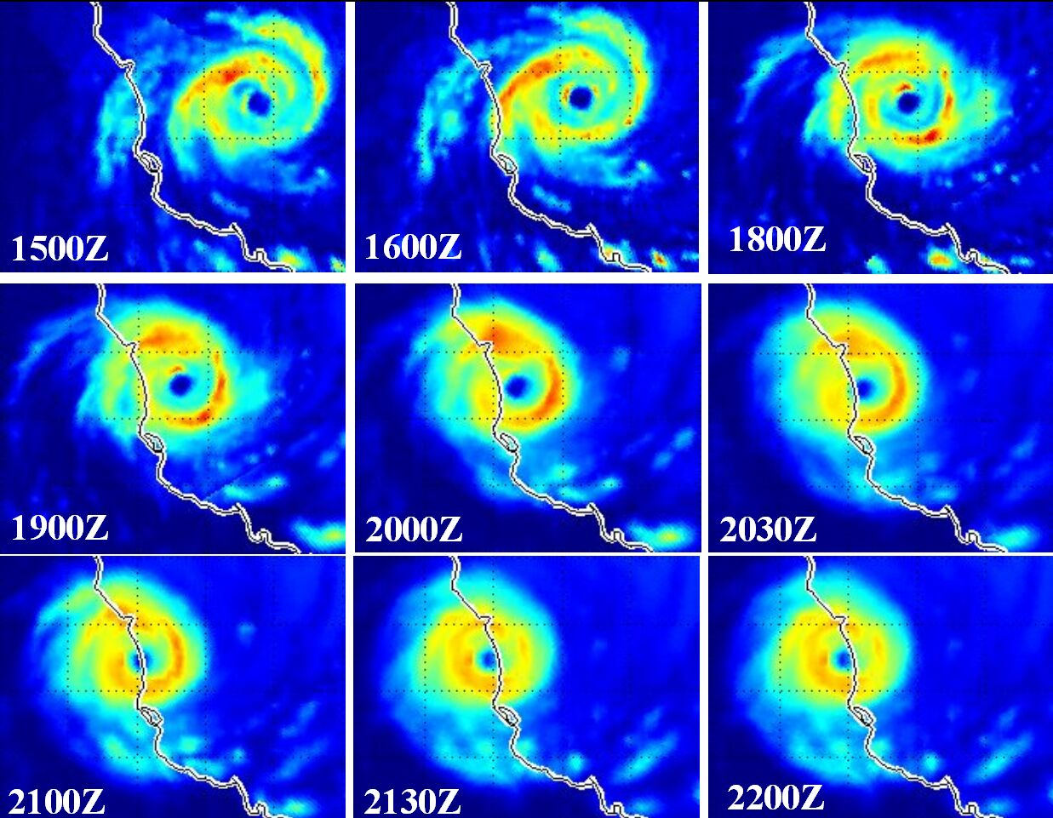
Figure 9. Morphed Integrated Microwave Imagery sequence from 1500 to 2200 UTC 19 March 2006. (Morphed Integrated Microwave Imagery, courtesy of Cooperative Institute for Meteorological Satellite Studies, University of Wisconsin).
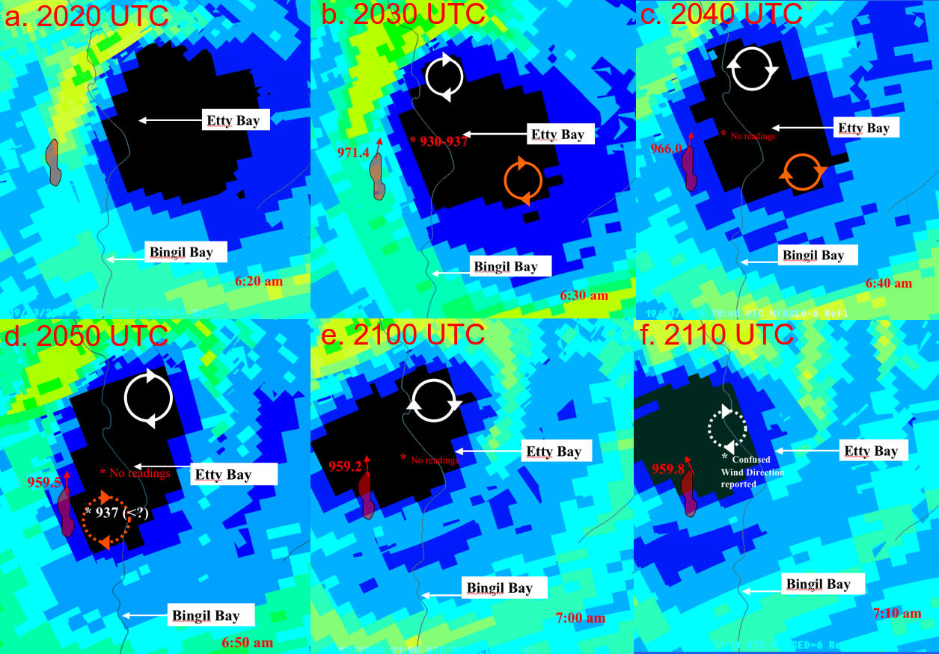
Figure 10. Series of merged (Mt Stuart and Cairns) radar images on 19 March near landfall: a. 2020 UTC; b. 2030 UTC; c. 2040 UTC; d. 2050 UTC; e. 2100 UTC; and f. 2110 UTC. These show the change in eyewall patterns to identify mesovortices within the eyewall to explain anomalously low pressures (937 hPa) and high storm surge estimated at Etty Bay and Bingil Bay. South Johnstone observations are also overlaid. South Johnstone's peak winds occurred at 2040 UTC just inside the radar eyewall, a feature of the radar sampling they eye at an elevation of 2900 m.

- Impact
Larry caused extensive damage to infrastructure and crops in the area around Innisfail. The Insurance Council of Australia estimated the 2006 damage at $540 million (Australian Institute for Disaster Resilience: Cyclone Larry, 2006). About 10 000 houses were damaged. Flooding disrupted road and rail access for several days.
An extensive damage survey is described in detail in Henderson et al. (2006) and Ginger et al. (2007) while damage to forests is discussed in detail in Pohlman, Goosem and Turton (2008).
The rapid motion of the cyclone limited the duration of the strongest winds and hence lessened the wind and water damage. Fortunately, the storm surge occurred when the astronomical tide was not at its peak, greatly reducing any tidal surge impact to coastal locations.
The damage survey showed substantial variation in wind-related damage throughout the impact zone. Figure 11 shows the location of some notable wind damage. The Silkwood and Mourilyan areas sustained the worst building damage, noting variation in construction strengths.
In the immediate coastal fringe, the tree damage in low-lying Ella Bay, and elevated areas of Etty Bay was clearly the worst, with severe tree damage on hills and beaches between Garners Beach and Clump Point. The worst damage was associated with mesovortices in the eyewall as described in the intensity section. Fortunately, neither mesovortex unleased its full strength upon a populated area.
The extent of the tree damage inland in the Jappoonvale, Nerada and Yungaburra areas was particularly serious, and severe tree damage was evident as far inland as 100 km. Four high voltage towers were blown down when the western eyewall passed through the Palmerston Highway region.
Destructive winds were also evident in the lee of the ranges as far north as Cairns where powerlines and the Cairns Skyrail were damaged.
Larry caused extensive damage to forests and destroyed 80–90% of Australia's banana crop resulting in a short supply throughout Australia for the remainder of 2006.
The series of photos in Figures 12-17 show a range of damage across the impact zone.
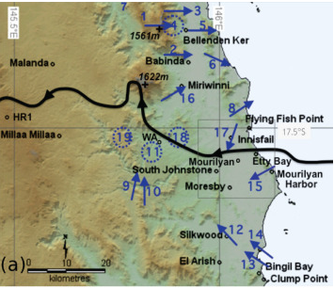
Figure 11. Map showing significant areas of wind damage. Reproduced from Figure 1a in Otto (2012).
1 294 km/h gust measured 600m from the peak (on the lee side) of Mount Bellenden Ker
2 High voltage transmission tower down in westerlies.
3 Severe tree damage at the base of the range (well inland from the Bruce Highway)
4 Severe tree damage in gullies (well inland from the Bruce Highway)
5 Trees in valleys badly damaged.
6 Trees mostly thrown towards ESE.
7 Some of the worst forest damage (totally stripped, most trees down).
8 Extreme tree damage. Nearly all lying flat and facing ENE.
9 95-100% of trees stripped and 90% trees down facing N-NNE.
10 4 high voltage transmission towers down.
11 Entire roof assembly thrown north over tall trees; severe tree damage along river (all stripped and felled).
12 Worst building damage at Silkwood (source: State Emergency Service).
13 Widespread defoliation. 20% coconut palms uprooted or snapped. Highest storm tide impact at Bingil Bay.
14 Severe building and vegetation damage.
15 Trees on south side of hill stripped of all leaves and small branches.
16 Strongest winds were from the SW.
17 Tornado photographed 2-3km NE of Innisfail; 12 reports that the strongest winds in Innisfail were from the NNE
18-19 Severe forest damage

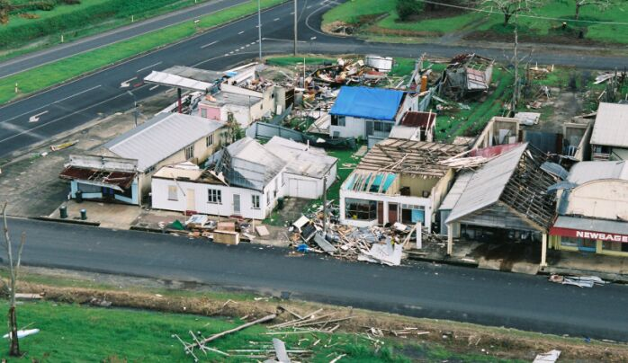
Figure 12. Damage to houses in Mourilyan. Credit: Peter Otto.
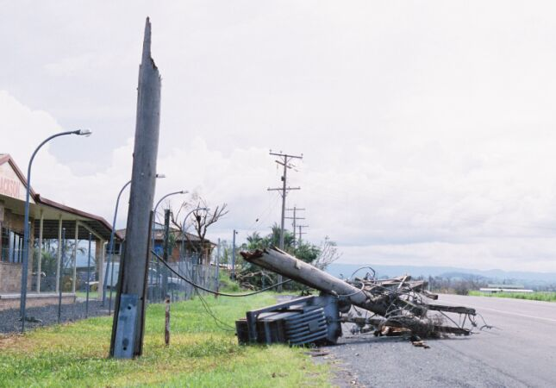
Figure 13. Snapped power pole along Mourilyan Harbour road. Credit: Peter Otto.

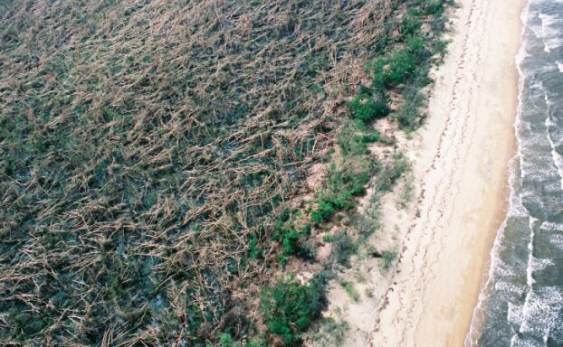
Figure 14. Tree damage at Ella Bay, totally levelled by winds from the west southwest. Credit: Peter Otto.

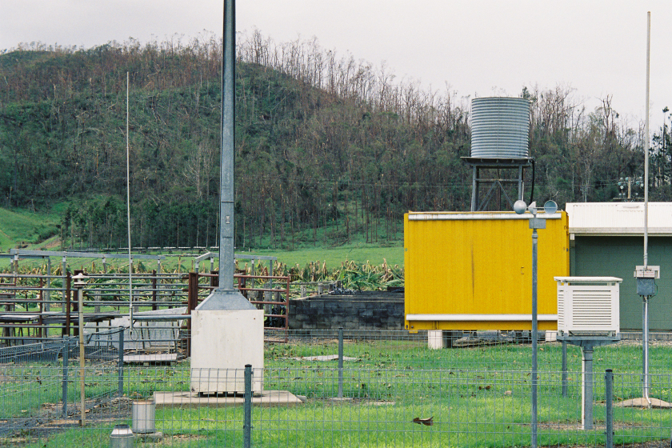 | 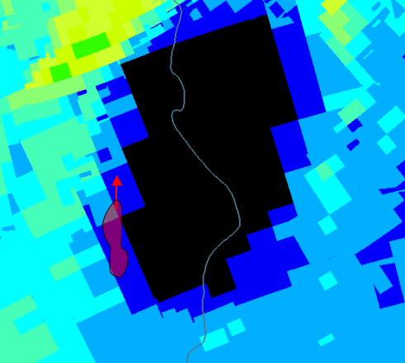
Figure 15. Left: The South Johnstone AWS looking south to south southwest. Note the stripped vegetation on the hill. The hill and the buildings very close by protected the instrument from what theory and past observations attest should have been cyclone Larry’s strongest winds. Right: Radar image at 2050 UTC 19 March of the inner eye, overlaid with red arrow denoting southerly winds at South Johnstone AWS and the steep forested terrain (red area). Credit: Peter Otto.

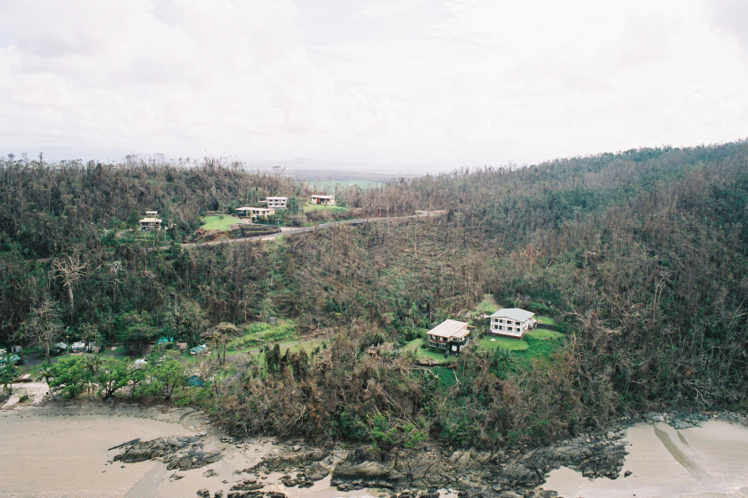
Figure 16. Etty Bay, with the steep terrain on the left hand side in particular very close to the caravan park’s beach. Trees are still evident on the beachfront, offering further protection. Credit: Peter Otto.
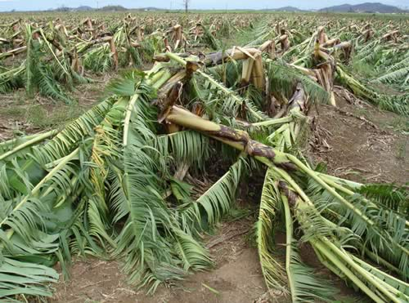
Figure 17. Banana crop damage near Innisfail. Credit: Peter Otto.
- Observations
  - Wind
Flinders Reef recorded a maximum 10-minute mean of 84 kn (155 km/h) and a maximum gust of 114 kn (211 km/h) at 1110 UTC 19 March in the southern eyewall but did not sample the highest winds. Gales were observed for over 11 hours from 0510 to 1630 UTC 19 March; storm-force winds for just under 4 hours from 0830 to 1420 UTC; and hurricane-force (above 63 kn) for just under 3 hours from 0940 to 1230 UTC 19 March.
The only Bureau of Meteorology wind recording station in the landfall impact zone was at South Johnstone. South Johnstone recorded peak wind gusts of 98 kn (181 km/h) at 6:40 am AEST 20 March (2040 UTC 19 March) as it experienced the southwest part of the eyewall. However, this site was sheltered from the strongest winds by a large densely forested hill just 200-250 m away as shown in Figure 15. Additionally, very high gust factors (ratio of the wind gust to the mean winds) to above 2 occurred when winds were southerly. Hence the observations cannot be relied upon to estimate landfall intensity. As winds turned to be easterly there were less obstructions however the station was not sampling the strongest winds at this point.
Severe wind gusts were measured by many non-Bureau instruments and supported by damage data as far inland as Ravenshoe, and as far north as the Cairns Skyrail facility.
A wind gust of 225 km/h on a yacht on Mourilyan Harbour before the instrument failed when the mast snapped coincided with the arrival of the outer eye.
A tower on the lee slope of Mt Bellenden Ker (600m from the peak and 200m below) recorded a wind gust of 294 km/h at 2118 UTC 19 March in the westerly flow north of the centre of the circulation.
A tower on the Cairns Skyrail recorded a wind gust of 178 km/h at the base of the McAllister Range.
The observations north of the eyewall are evidence of downslope wind activity produced by the cyclone that are supported by damage surveys. Similar wind enhancements in the lee of terrain have been noted in many other events in this area and were forecast during this event.
An anemometer atop a 20m tower on an elevated site at the Ravenshoe wind farm, about 50km inland from Innisfail, registered a peak gust of 187 km/h in the southerly flow. Although this appears very high for a site well inland, there was widespread power pole damage on the Atherton tablelands and a post event forest survey that indicated extensive damage as far as 100 km inland.
  - Pressure
The eye passed over Innisfail between 6:50-7:20 am AEST 20 March (2050-2120 UTC 19 March). Innisfail recorded a minimum pressure of 959 hPa at the two official Innisfail sites: the barograph was deemed to read high upon calibration and was corrected to 955 hPa; while the AWS site did not experience the true calm of the eye and was deemed not to sample the lowest pressure of the eye.
A total of 20 pressure readings were collected from within the community in the impact zone and examined for reliability. There were several minimum estimates in the 950 – 959 hPa range from instruments that were assessed as reliable. There were two pressure readings below 937 hPa at eastern Mourilyan and in Moresby which were deemed to be associated with mesovortices.
Flinders Reef recorded a minimum pressure of 974.8 hPa at 1120 UTC 19 March but this was in the southern eyewall and not indicative of the lowest central pressure at the time (See Figure 8).
  - Rainfall
The rapid movement of Larry reduced the potential rainfall upon landfall. Nevertheless, falls exceeded 200 mm over elevated terrain near the coast as shown in the daily rainfall analysis to 9 am AEST 20 March in Figure 18. Significant rainfall also fell in the following days as the system moved inland. This included higher falls in the Innisfail region than at landfall which disrupted recovery efforts. The weekly rainfall distributions are shown in Figure 19 for the week ending 23 March 2006 over Queensland
Significant daily falls to 9am AEST included:
20 March
273 mm - Mourilyan Mill Alert (Johnstone River catchment)
230 mm - Babinda (Mulgrave-Russell catchment)
230 mm - Saltwater Creek Alert (Johnstone River catchment)
220 mm - Bulgun Creek Alert (Tully River catchment)
213 mm - The Boulders (Mulgrave-Russell catchment)
212 mm - Jarra Creek Alert (Tully River catchment)
190 mm - Sutties Creek Alert (Johnstone River catchment)
21 March
169 mm - Paluma Dam Alert (Upper Burdekin River)
149 mm - Abergowrie Bridge Alert (Herbert River d/s Glen Eagle)
140 mm - Elphinstone Pkt (Herbert River d/s Glen Eagle)
128 mm - Bilyana Alert (Tully River catchment)
127 mm - Bolinda Estate Alert (Tully River catchment)
121 mm - Euramo Alert (Tully River catchment)
110 mm - Koombooloomba Dam Alert (Tully River catchment)
22 March
436 mm - Gereta Station (Leichhardt River catchment)
279 mm - Kamilaroi (Leichhardt River catchment)
230 mm - Gunpowder (Leichhardt River catchment)
301 mm - Sweeney Creek U/S Alert (Johnstone River catchment)
284 mm - Bulgun CReek Alert (Tully River catchment)
289 mm - Innisfail (Johnstone River catchment)
285 mm - Murray Flats Alert (Tully River catchment)
275 mm - Innisfail Wharf Alert (Johnstone River catchment)
258 mm - Tung Oil Alert (Johnstone River catchment)
258 mm - Euramo Alert (Tully River catchment)
248 mm - Marco Street Alert (Johnstone River catchment)
240 mm - Bilyana Alert (Tully River catchment)
237 mm - Nerada Alert (Johnstone River catchment)
228 mm - Corsis Alert (Johnstone River catchment)
225 mm - Upper Murray Alert (Tully River catchment)
223 mm - Tully Alert (Tully River catchment)
221 mm - Tully Sugar Mill (Tully River catchment)
217 mm - Jarra Creek Alert (Tully River catchment)
215 mm - Cardwell (Tully River catchment)
206 mm - Central Mill (Johnstone River catchment)
201 mm - Bartle View Alert (Johnstone River catchment)
192 mm - Topaz Alert (Johnstone River catchment) 24 hr rainfall to 9am 22 March 2006

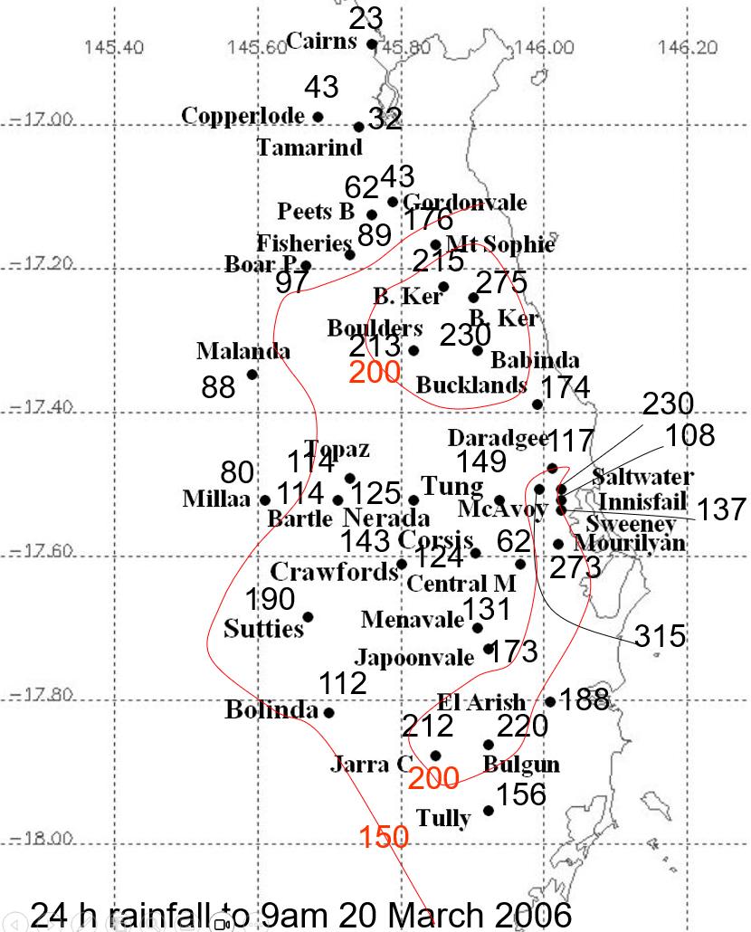

Figure 18. Daily rainfall analysis for north Queensland, 20 March 2006.
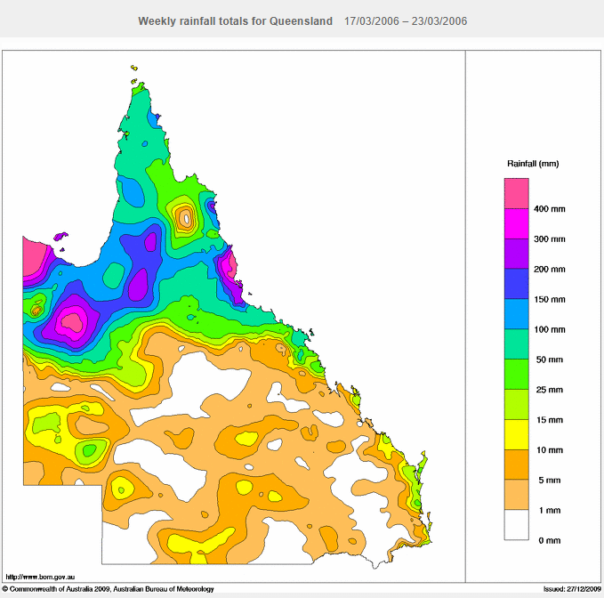
Figure 19. Rainfall analysis for Queensland for week ending 23 March 2006.

  - Storm Surge
Larry crossed the coast whilst the astronomical tide was reasonably low (only 0.3 m above Australian Height Datum (AHD) during a neap tide cycle). The rapid translation speed and relatively short distance of open water inside the reef combined to reduce wave heights on the coast and hence coastal erosion. The lack of erosion was evident from the deposition of flotsam in distinct lines and lack of gouging.
A post event multi-agency survey inspected 11 sites between Tully Heads and Flying Fish Point as shown in Table 2. These show considerable variations in storm surge levels (inundation level less 0.3 m). This included three sites with tide gauges: Mourilyan Harbour, Clump Point and Cardwell. Clump Point gauge measured a peak surge of 2.3 m.
There were two sites with significantly higher surge peaks: 4.2 m at Etty Bay Beach and 4.9 m further south at Bingil Bay, although these values are less accurate than gauges being derived from debris lines. These aligned with the locations of the onshore impact of the inner and outer eyewalls respectively as indicated in the Cairns radar (3D tops view) and IR image in Figure 20. The strengthening outer eyewall was prominent at Bingil Bay for at least 30 minutes while the inner eyewall was invigorated having extended cyclonically from the deep convective tower in the north northeast sector.
Post-event modelling was able to reproduce storm surge at some sites wind field highlighting the complexity of the wind field as discussed previously.

Location | Data Type | Storm tide  (m above AHD) | Storm surge  (m)
Flying Fish Point | Inundation | 3.5
Etty Bay | Inundation | 4.5
Mourilyuan Harbour | Tide Gauge | 1.6 | 1.3
Cowley Beach | Inundation | 3.7
Kurrimine Beach | Inundation | 3.5
Bingil Bay | Inundation | 5.2 | 4.9
Clump Point | Tide Gauge | 2.6 | 2.3
Mission Beach | Inundation | 3.5
Wongaling Beach | Inundation | 3.4
South Mission Beach | Inundation | 3.1
Tully Heads | Inundation | 3.2
Cardwell | Tide Gauge | 2.2
Table 2. Storm tide levels, and observed surge heights from tide gauges (less 0.3 m from tide levels). Source Environmental Protection Agency.

aa. 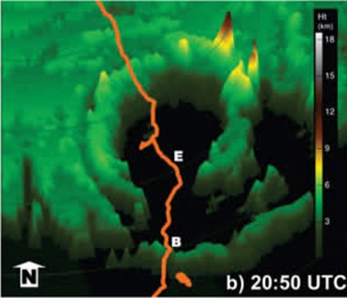 | b. 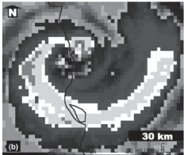

Figure 20. a. 3D Tops radar reflectivity from Cairns radar at 20:50 UTC just prior to landfall. The inner eyewall was discernible near Etty Bay (E), and outer eyewall near Bingil Bay (B), the two sites that measured the highest storm surge levels; and b. IR image at 2045 UTC. Reproduced from Figures 14 b and 9 b in Otto and Soderholm (2012).

- References
Australian Institute for Disaster Resilience: Cyclone Larry, 2006. www.knowledge.aidr.org.au/resources/cyclone-cyclone-larry-north-queensland-2006/ accessed 11 March 2026.
Boswood, P., Cleaves, N., Mohoupt, J. 2007. Storm Tide Inundation Levels during Tropical Cyclone Larry. Australasian Coasts and Ports Conference, Melbourne, Australia.https://www.researchgate.net/publication/321603096_Storm_Tide_Inundation_Levels_during_Tropical_Cyclone_Larry
Otto, P. 2012. Tropical Cyclone Wind Field Determination: Challenges and Possibilities, Tropical Cyclone Research and Review, Volume 1, Issue 1, 2012, Pages 118-129, https://doi.org/10.6057/2012TCRR01.13.
Otto,P. and Soderholm, J..2012. The Convective Features within and Surrounding Severe Tropical Cyclone Larry (2006),Tropical Cyclone Research and Review, Volume 1, Issue 2, Pages 143-162,
https://doi.org/10.6057/2012TCRR02.07.
Ginger, J.D., Henderson, D.J., Leitch, C.J., and Boughton, G.N. 2007. Tropical Cyclone Larry: Estimation of wind field and assessment of building damage. Australian Journal of Structural Engineering, 7 (3). pp. 209-224.
Henderson D., J. Ginger, C. Leitch, G. Boughton, D. Falck. 2006. Tropical Cyclone Larry – Damage to buildings in the Innisfail area. Cyclone Testing Station Technical report: TR51. James Cook University (2006), p. 96.
Kossin, J. P., 2015: Hurricane Wind–Pressure Relationship and Eyewall Replacement Cycles. Wea. Forecasting, 30, 177–181, https://doi.org/10.1175/WAF-D-14-00121.1.
Pohlman, C., Goosem, M., and Turton, S. M. 2008. Effects of Severe Tropical Cyclone Larry on rainforest vegetation and understorey microclimate near roads, powerlines and streams. Austral Ecology: a journal of ecology in the Southern Hemisphere, 33, 503–515. https://doi.org/10.1111/j.1442-9993.2008.01905.x
Sitkowski, M., Kossin J. P., and Rozoff C. M., 2011: Intensity and structure changes during hurricane eyewall replacement cycles. Mon. Wea. Rev., 139, 3829–3847, doi:10.1175/MWR-D-11-00034.1.
- Appendix: List of Abbreviations
Abbreviation | Term
ADT | Advanced Dvorak Technique
AEST | Australian Eastern Standard Time
AWS | automatic weather station
°C | Celsius
CI | Current intensity
CIMSS | Cooperative Institute for Meteorological Satellite Studies (USA)
EIR | Enhanced InfraRed
ERC | eyewall replacement cycle
FT | Final T-number
GHz | Gigahertz
h | hour
hPa | hectopascal
km | kilometre
km/h | kilometres per hour
kn | knot
LLCC | LLCC
MET | Model Expected T-number
mm | millimetre
MSLP | mean sea level pressure
nm | nautical mile
NOAA | National Oceanic and Atmospheric Administration
NRL | Navy Research Lab (USA)
PAT | Pattern T-number
QSCAT | Quickscat scatterometer
RH | relative humidity
RMW | radius of maximum winds
SATCON | Satellite Consensus
SSMIS | Special Sensor Microwave Imager/Sounder
TC | Tropical Cyclone
UTC | Universal Time Co-ordinated

