Tropical Cyclone Luana

21 – 28 January 2026

Tropical Cyclone Environmental Prediction Services
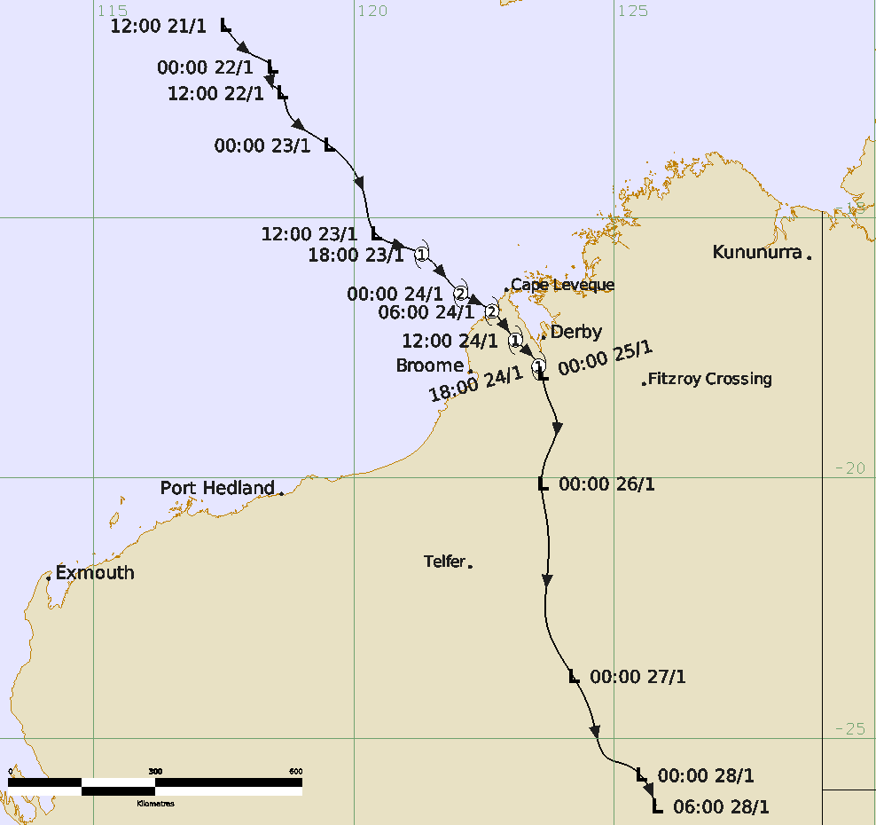

Revision history
Date | Version | Author | Description
1/4/26 | 1.0 | Steph Bond | Final Draft

Release history
Date | Version | Status | Approval
14/4/26 | 1.0 | Approved for release | Manager, EPS-TC

Contact details:
Tropical Cyclone Team Lead
Severe Weather Environmental Prediction Services
Bureau of Meteorology
PO Box 1370, West Perth WA 6872
Email: tcwc@bom.gov.au
This work is copyright. Apart from any use as permitted under the Copyright Act 1968, no part may be reproduced without prior written permission from the Bureau of Meteorology. Refer to www.bom.gov.au/other/copyright.shtml for further information. Unless otherwise noted, all images in this document are licensed under the Creative Commons Attribution Australia Licence.
© Commonwealth of Australia 2026
Published by The Bureau of Meteorology
Cover image: Best track of Tropical Cyclone Luana 21 – 28 January 2026. Time in UTC (+8h AWST).
Table of contents

1. Summary 6

2. Meteorological description 10

2.1. Intensity Analysis 10

2.2. Structure 17

2.3. Motion 17

3. Impact 17

4. Observations 17

4.1. Wind 17

4.2. Rainfall 18

4.3. Pressure 18

4.4. Storm Surge 19

5. Forecast Performance 19

Appendix: List of Abbreviations 21

Figure 1 Best track of Tropical Cyclone Luana, 21 - 28 January 2026. 7
Figure 2 Best track of Tropical Cyclone Luana showing the structure of the system. 8
Figure 3 Hovmoller diagram of tropical waves showing the formation of Luana 11
Figure 4 WSFM MWI 89 GHz Microwave imagery at 2134 UTC 22 January 2026 12
Figure 5 ASCAT-C scatterometry winds from 23 January 2026 at 0053 UTC 13
Figure 6 AMSR2 pass at 1705 UTC 23 January 14
Figure 7 Microwave imagery (colour composite 89 GHz sensor) during 24 January 15
Figure 8 Reflectivity radar imagery from Broome radar at 0514 UTC 24 January. 15
Figure 9 Visible satellite imagery from Himawari at 0600 UTC. 16
Figure 10 Position accuracy figures for Tropical Cyclone Luana 20
Figure 11 Intensity accuracy figures for Tropical Cyclone Luana 20
Figure 12 Intensity plot of objective and subjective guidance. 23

Table 1 Best track summary for Tropical Cyclone Luana, 21 – 28 January 2026 9
Table 2 Pressure observations recorded during Tropical Cyclone Luana. 18
Table 3 Verification statistics for Tropical Cyclone Luana.. 19

- Summary
Tropical Cyclone Luana was a short-lived system that developed to the northwest of Broome and crossed the Dampier Peninsula at category 2 intensity on 24 January 2026. It brought strong winds and heavy rainfall to the western Kimberley with heavy rainfall extending through inland central Australia over subsequent days.
A tropical low formed in the Indian Ocean, south of Indonesia, during 21 January and moved southeast towards the Kimberley coast. It steadily intensified, with gales developing to the north of the centre at 1400 AWST 23 January and reaching tropical cyclone intensity at 0200 AWST 24 January, to the northwest of Broome.
Tropical Cyclone Luana continued to move to the southeast during 24 January. It briefly reached category 2 intensity with peak 10-minute mean winds of 50 kn (93 km/h) occurring over water, before crossing the Dampier Peninsula between Beagle Bay and Cape Leveque, at 1400 AWST 24 January. Luana continued to move to the southeast, passing just to the west of Derby overnight from 24 to 25 January. Luana was downgraded to a tropical low on the morning of 25 January as it moved further inland. Despite moving over land, the system retained its structure over following days over inland Western Australia until it dissipated on 28 January.
Strong winds caused some minor damage and power outages, mostly relating to fallen trees and branches. Mercedes Cove Retreat located near the crossing point sustained major roof damage. Heavy rain caused some road closures but in general was welcomed over inland areas that had experienced prolonged dry conditions. Tide levels exceeded the highest tides of the year at Derby causing inundation to the port area.
Gales were recorded at Adele Island, Lombadina Airstrip, Koolan Island Airport, Derby and Curtin Airport. The gales at Derby between 2000 AWST 24 January to 0400 AWST 25 January were the highest winds from a tropical cyclone since the start of reliable tropical cyclone records in 1972. Damaging wind gusts were recorded at Lombadina, Curtain Airport, Derby Airport and Koolan Island, with a peak wind gust of 57 kn (106km/h) recorded at Lombadina at 1648 AWST and Curtin Airport at 2124 AWST 24 January. Significant 24 hour rainfall totals of 100 – 200 mm were recorded over the Dampier Peninsula and west Kimberley to 9am AWST 25 January, with Curtain Airport recording 231.8 mm. Country Downs also recorded a three-day rainfall total of 344.4 mm to 9am 26 January.
Tropical Cyclone Luana was the eighth tropical cyclone tropical cyclone in the Australian region for the 2025/26 season and the 3rd tropical cyclone to cross the Western Australian coastline following Fina (November) and Hayley (December). Remarkably Luana crossed the coast at almost the same location near Lombadina as Hayley.
Refer to Figure 1 for the full track of Tropical Cyclone Luana and Table 1 for track data.

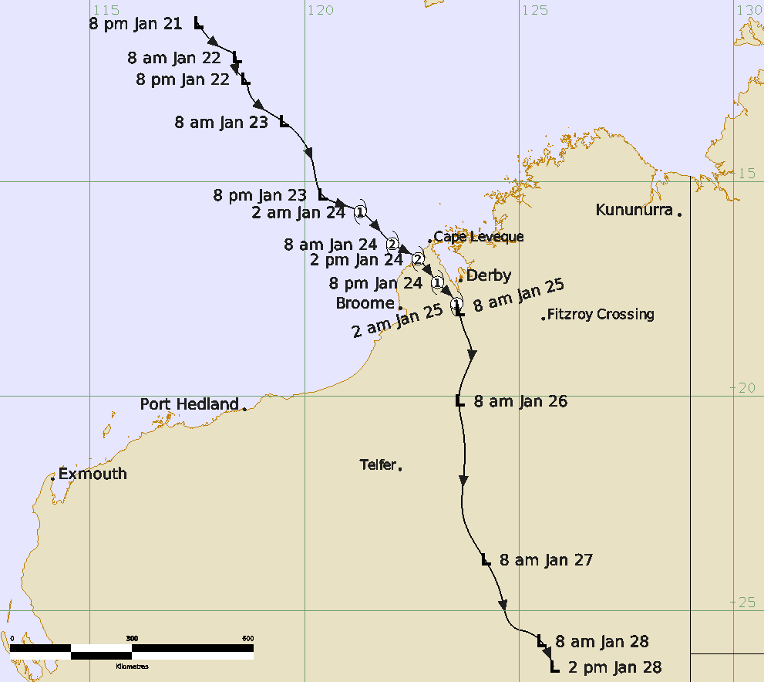
Figure 1 Best track of Tropical Cyclone Luana, 21 - 28 January 2026. Times are in AWST (UTC+8h).

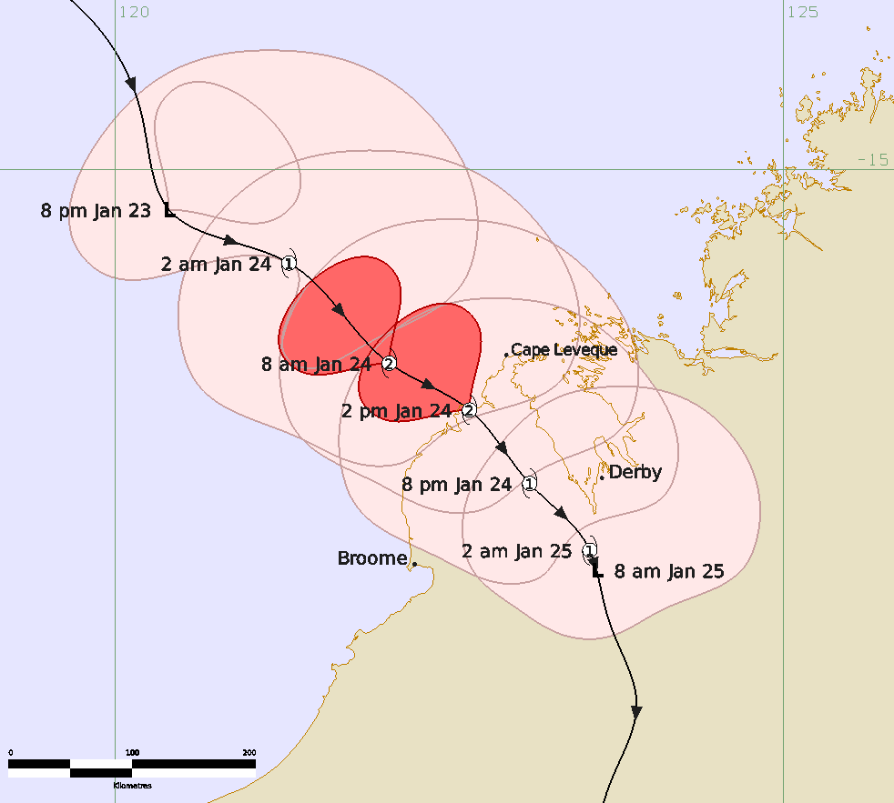
Figure 2 Best track of Tropical Cyclone Luana showing the structure of the system as it approaches and moves over land, 23 - 25 January 2026. Times are in AWST (UTC+8h). Pink is gale radii, red is storm force radii.

Year | Month | Day | Hour UTC | Pos. Lat. S | Pos. Long. E | Pos. Acc. nm | Max Wind 10min kn | Max gust  kn | Cent. Press. hPa | Rad. of gales (NE/SE/SW/NW) | Rad. of storm  (NE/SE/SW/NW) | RMW nm
2026 | 1 | 21 | 1200 | 11.3 | 117.5 | 40 | 15 | 45 | 1003 | 0/0/0/0 | 0/0/0/0 | -
2026 | 1 | 21 | 1800 | 11.9 | 118.1 | 40 | 20 | 45 | 1002 | 0/0/0/0 | 0/0/0/0 | -
2026 | 1 | 22 | 0000 | 12.1 | 118.4 | 30 | 20 | 45 | 1002 | 0/0/0/0 | 0/0/0/0 | -
2026 | 1 | 22 | 0600 | 12.4 | 118.4 | 30 | 20 | 45 | 1003 | 0/0/0/0 | 0/0/0/0 | -
2026 | 1 | 22 | 1200 | 12.6 | 118.6 | 45 | 25 | 45 | 999 | 0/0/0/0 | 0/0/0/0 | -
2026 | 1 | 22 | 1800 | 12.9 | 118.7 | 35 | 25 | 45 | 1000 | 0/0/0/0 | 0/0/0/0 | -
2026 | 1 | 23 | 0000 | 13.6 | 119.5 | 35 | 30 | 45 | 1001 | 0/0/0/0 | 0/0/0/0 | -
2026 | 1 | 23 | 0600 | 14.6 | 120.2 | 30 | 35* | 50 | 997 | 60/0/0/60 | 0/0/0/0 | -
2026 | 1 | 23 | 1200 | 15.3 | 120.4 | 30 | 35* | 50 | 997 | 60/0/0/0 | 0/0/0/0 | -
2026 | 1 | 23 | 1800 | 15.7 | 121.3 | 20 | 40 | 55 | 993 | 90/50/0/100 | 0/0/0/0 | 25
2026 | 1 | 24 | 0000 | 16.5 | 122.1 | 15 | 50 | 70 | 988 | 90/40/50/100 | 0/0/0/50 | 22
2026 | 1 | 24 | 0600 | 16.8 | 122.7 | 10 | 50 | 70 | 985 | 80/40/50/90 | 0/0/0/50 | 16
2026 | 1 | 24 | 1200 | 17.4 | 123.1 | 10 | 45 | 65 | 986 | 70/30/50/90 | 0/0/0/0 | 22
2026 | 1 | 24 | 1800 | 17.9 | 123.6 | 15 | 40 | 55 | 987 | 80/40/40/60 | 0/0/0/0 | 30
2026 | 1 | 25 | 0000 | 18.0 | 123.6 | 20 | 30 | 45 | 990 | 0/0/0/0 | 0/0/0/0 | -
2026 | 1 | 25 | 0600 | 18.4 | 123.7 | 25 | 30 | 45 | 990 | 0/0/0/0 | 0/0/0/0 | -
2026 | 1 | 25 | 1200 | 19.0 | 123.9 | 30 | 30 | 45 | 991 | 0/0/0/0 | 0/0/0/0 | -
2026 | 1 | 25 | 1800 | 19.6 | 123.7 | 30 | 30 | 45 | 992 | 0/0/0/0 | 0/0/0/0 | -
2026 | 1 | 26 | 0000 | 20.1 | 123.6 | 25 | 30 | 45 | 992 | 0/0/0/0 | 0/0/0/0 | -
2026 | 1 | 26 | 0600 | 20.8 | 123.7 | 30 | 25 | 45 | 992 | 0/0/0/0 | 0/0/0/0 | -
2026 | 1 | 26 | 1200 | 22.0 | 123.7 | 30 | 25 | 45 | 992 | 0/0/0/0 | 0/0/0/0 | -
2026 | 1 | 26 | 1800 | 22.8 | 123.7 | 25 | 25 | 45 | 993 | 0/0/0/0 | 0/0/0/0 | -
2026 | 1 | 27 | 0000 | 23.8 | 124.2 | 20 | 25 | 45 | 994 | 0/0/0/0 | 0/0/0/0 | -
2026 | 1 | 27 | 0600 | 24.7 | 124.6 | 10 | 25 | 45 | 992 | 0/0/0/0 | 0/0/0/0 | -
2026 | 1 | 27 | 1200 | 25.4 | 124.9 | 15 | 25 | 45 | 996 | 0/0/0/0 | 0/0/0/0 | -
2026 | 1 | 27 | 1800 | 25.5 | 125.2 | 15 | 25 | 40 | 998 | 0/0/0/0 | 0/0/0/0 | -
2026 | 1 | 28 | 0000 | 25.7 | 125.5 | 15 | 20 | 35 | 1002 | 0/0/0/0 | 0/0/0/0 | -
2026 | 1 | 28 | 0600 | 26.3 | 125.8 | 15 | 20 | 35 | 1002 | 0/0/0/0 | 0/0/0/0 | -
Table 1 Best track summary for Tropical Cyclone Luana, 21 – 28 January 2026. UTC=AWST-8h.
* Not a tropical cyclone as gales less than halfway around centre

- Meteorological description
  - Intensity Analysis
On 21 January a tropical low formed in the westerly flow, over waters south of Indonesia and northwest of the Kimberley coast of Western Australia. The formation was aided by a pulse of the Madden Julian Oscillation (MJO) moving through the area (Figure 3). The sea surface temperatures were warm at 28-30°C.
Patchy but deep convection persisted to the southwest of the weak and broad low level centre on 21 and 22 January. The system reached T1.0 at 1800 UTC 21 January and gradually developed. Overnight on 22 January and 23 January conditions improved as Luana moved under the upper ridge, decreasing northeasterly shear to less than 10 kn and increasing upper divergence. WSFM MWI microwave imagery at 2134 UTC 22 January shows deep convection developed to the southwest but eased by 1007 UTC 23 January (Figure 4) as the system reacted strongly to diurnal influences. However, patchy spiralling convective bands became more tightly wrapped around a defined low level centre, as a strengthening northwesterly monsoon flow fed into the system from the north (Figure 5). Gales were observed in the northern quadrants from 0600 UTC 23 January.
An upper trough approaching Western Australia improved upper poleward outflow on 23 January and combined with low shear and tightly wrapped convection around the low level centre, the system continued to develop. Luana reached tropical cyclone strength at 1800 UTC 23 January with gales developing over 3 quadrants, as shown by AMSR2 pass at 1703 UTC (Figure 6).
On 24 January a burst of deep convection once again occurred to the south of the system during the diurnal maximum time of day. Tighter banding and convection increased to the north during the afternoon, however was patchy in nature with deep convection weakening, likely due to the system reacting strongly to diurnal fluctuations and interactions with the land (Figure 7). Despite this, it continued to strength in the favourable environment, reaching a peak of 50 kn (category 2) over water between 0000 and 0600 UTC 23 January, prior to making landfall (Figure 2). At Luana's peak intensity, radar signatures on the Broome radar (Figure 8) and visible satellite imagery (Figure 9) show convection increasing near the centre in all sectors, but land interaction limiting further development. Peak intensity was based on subjective Dvorak reaching FT/CI of 3.5.
Luana moved across the Dampier Peninsula with an intensity of 40 to 45 kn during the remainder of 24 January. As it moved inland, it slightly weakened further due to land interaction, weakening into a tropical low at 0000 UTC 25 January. The system retained its structure as it continued to move south over the next few days, through the interior of Western Australia, dissipating on 28 January.
During the event, some objective guidance struggled with intensity, compared to the best track from 23 January to landfall on 24 January (refer to Figure 12 at end of document). ADT (CIMMS and NESDIS), using curved band or CDO pattern overestimated the intensity, a common bias for the early stages of developing systems. DMINT and DPRINT underestimated the intensity up to landfall. AiDT was slightly more consistent with subjective Dvorak and the best track intensity. For the peak intensity, ADT did have a similar peak intensity when adjusted to a 10 minute mean, but 6 to 9 hours earlier. One explanation for the discrepancy between subjective and objective Dvorak estimates was possibly due to the subjective guidance considering more breaks in convective bands, thus biasing towards a lower DT.
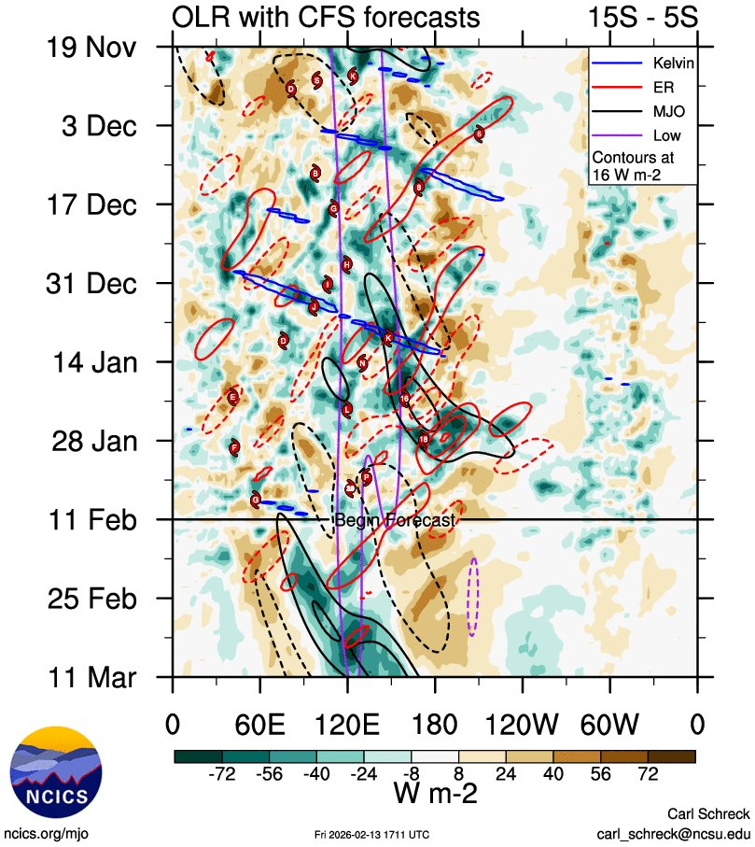
Figure 3 Hovmoller diagram of tropical waves showing the formation of Luana (denoted by the red dot labelled "L") occurred as an MJO pulse (black) moved through the eastern Indian Ocean and Indonesia. The image is courtesy of the North Carolina Institute for Climate Studies https://ncics.org/pub/mjo/archive/2026/2026-02-13/v2/

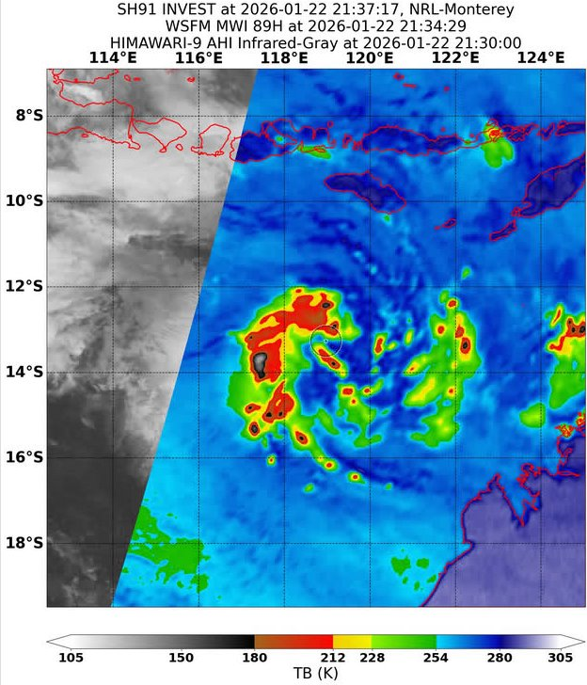 | 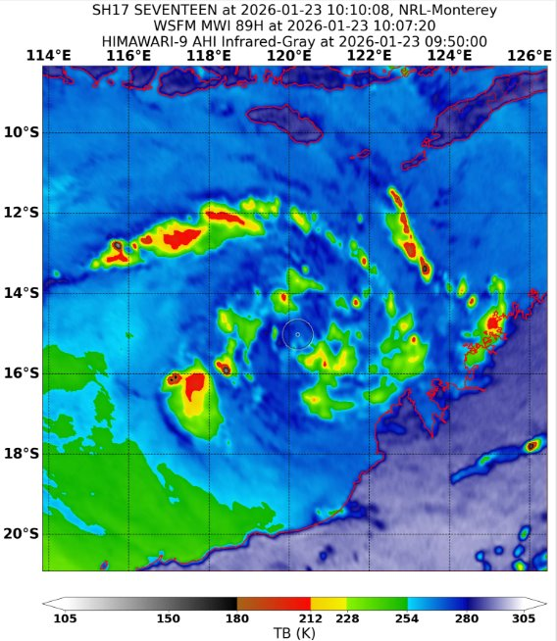
Figure 4 WSFM MWI 89 GHz Microwave imagery at 2134 UTC 22 January 2026 (left) shows convective bands in the western quadrants tightly wrapping around the low level centre. The circle marks the position of the low level centre. The right image (WSFM MWI 89 GHz, 1007 UTC 23 January) shows spiralling bands have increased in the northeast during the 23 January, but the western quadrants has lost deep persistent convection and became quite patchy during the diurnal unfavourable time of the day. Images courtesy of NRL https://science.nrlmry.navy.mil/geoips/tcweb4/

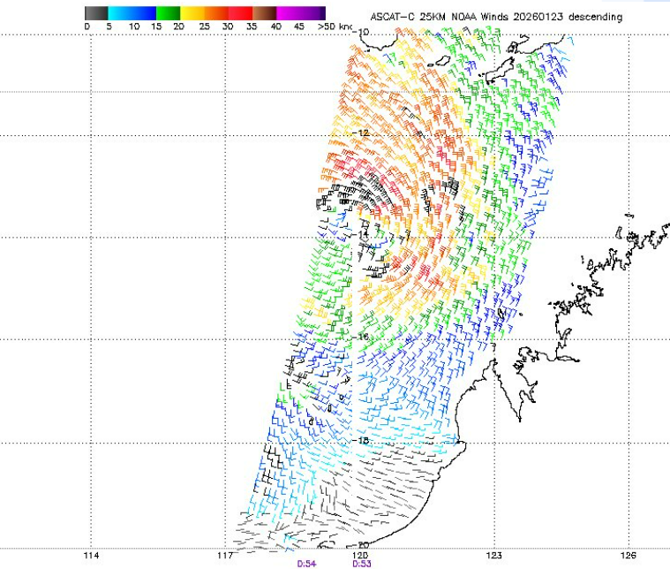
Figure 5 ASCAT-C scatterometry winds from 23 January 2026 at 0053 UTC (+8h AWST), showing a strengthening monsoon flow feeding into 21U. Maximum wind speed around the system are 30-35 kn. Image courtesy of NOAA STAR https://manati.star.nesdis.noaa.gov/datasets/ASCATCData.php

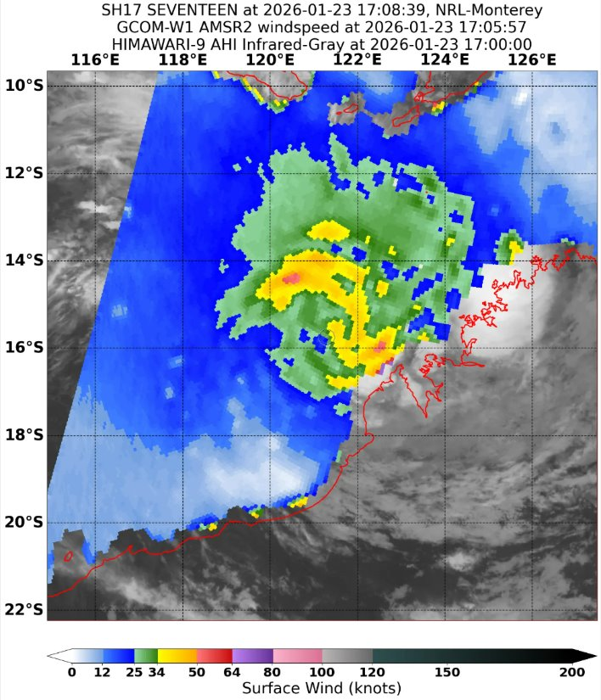
Figure 6 AMSR2 pass at 1705 UTC 23 January showing gales of 40 to 45 kn wrapping around 3 quadrants of Luana (centre marked by circle), which was named at 1800 UTC 23 January. The maximum winds shown in AMSR2 is greater than 48 kn, however this is under intense deep convection and not representative of the maximum sustained wind speeds. Image curtsey of NRL https://science.nrlmry.navy.mil/geoips/tcweb4/

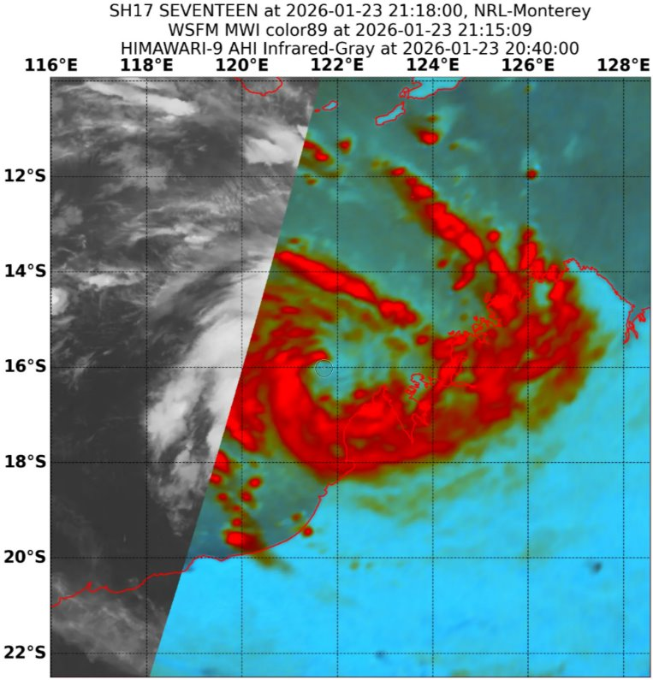 | 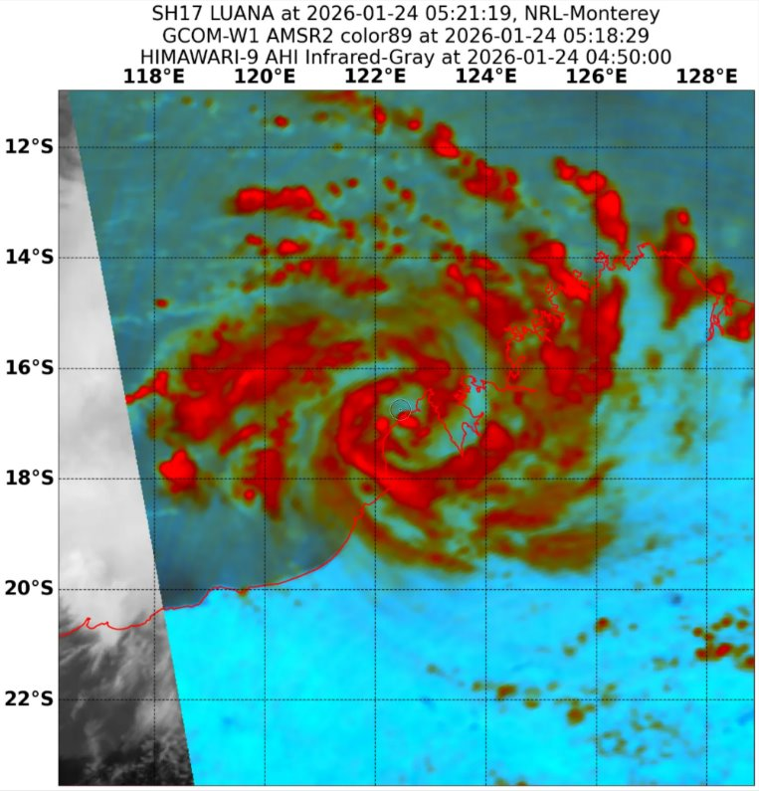
Figure 7 Microwave imagery (colour composite 89 GHz sensor) showing the convection increasing near the centre of Luana during 24 January as it approaches the Dampier Peninsula in Western Australia. The left image, WSFM MWI at 2115 UTC 23 January shows tight bands of strong deep convection to the south of the low level centre, during the diurnally favourable time. The right image of AMSR2 at 0518 UTC 24 January shows increased spiralling convection in the north, but deep convection in bands weakening and patchy as it interacts with land and reacts to the diurnal trends. Images courtesy of NRL https://science.nrlmry.navy.mil/geoips/tcweb4/
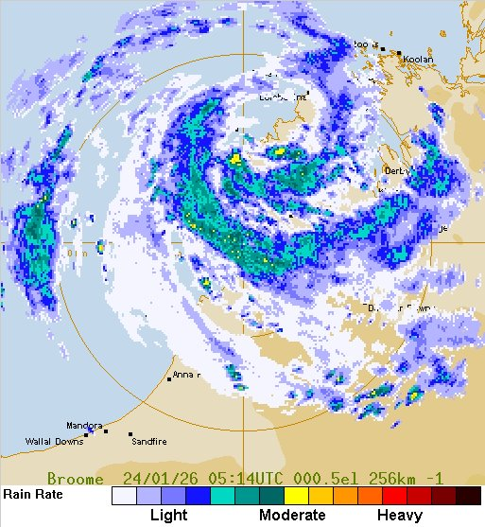
Figure 8 Reflectivity radar imagery from Broome radar at 0514 UTC 24 January, just prior to making landfall at 0600 UTC 24 January. Luana peaked with an intensity of 50 kn.
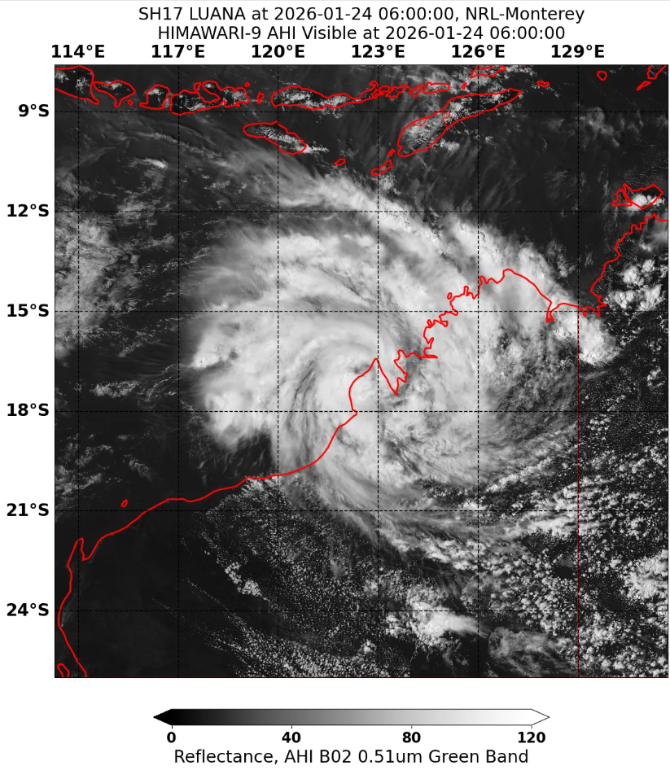
Figure 9 Visible satellite imagery from Himawari at 0600 UTC as Luana peaked in intensity at 50 kn and crossed the coast over the Dampier Peninsula. It shows the tightly wrapped deep convective near the centre in all sectors. Image courtesy of Japan Meteorology Agency (JMA).

  - Structure
Gales developed within 60 nm (110 km) of the northeast quadrant from 0300 UTC 23 January before extending across all quadrants by 2100 UTC 23 January. While Luana was a tropical cyclone, the northern quadrant gales were generally 90 to 100 nm (165 – 185 km), with a stronger monsoon flow to the north of the system. Southern quadrant gales remained between 30 and 50 nm (55 – 95 km).
Storm force winds occurred within 50 nm (95 km) in the northwest quadrant as it made landfall.
The radius of maximum winds (RMW) varied from 25 nm (45 km), decreasing to 16 nm (30 km) as the system strengthened and made landfall.
  - Motion
The system initially moved slowly to the south southeast, on 21 and 22 January due to a mid-level ridge over Western Australia weakening. From 23 January the system took a track to the southeast in response to an upper trough approaching Western Australia from the southwest. As Luana moved over land it took a more southerly track as the upper trough moved over Western Australia.
- Impact
Strong winds caused some minor damage and power outages, mostly relating to fallen trees and branches to communities on the Dampier Peninsula and at Derby. Mercedes Cove Retreat located near the crossing point sustained major roof damage. Heavy rain caused some road closures but in general was welcomed over inland areas that had experienced prolonged dry conditions. Tide levels exceeded the highest tides of the year at Derby causing inundation to the Port area.
News reports from ABC News (https://www.abc.net.au/news/2026-01-28/rain-relief-for-inland-pastoralists/106275402 and Mercedes Cove coastal retreat home destroyed by Tropical Cyclone Luana - ABC News)
- Observations
  - Wind
Damaging winds were first recorded at Adele Island on 24 January. As the system moved towards the Dampier Peninsula and inland, damaging winds were recorded at Koolan Island, Lombadina, Derby and Curtin.
No destructive winds were recorded by automatic weather stations.
A summary of the stations that reported gales or damaging winds or stronger is included below.
Adele Island, an offshore island recorded gales between 2142 UTC and 0328 UTC 24 January (0542 AWST 23 January and 1128 AWST 24 January), peaking at 36 kn (67 km/h) at 0030 UTC (0930 AWST) 24 January. The highest wind gust recorded was 45 kn (83 km/h) at 0029 UTC (0929 AWST) 24 January.
Koolan Island recorded a longer period of damaging winds between 0349 UTC and 1710 UTC 24 January (1149 AWST 24 January and 0110 AWST 25 January). The highest mean wind speed and gust at Koolan Island were 37 kn (83 km/h) at 0649 UTC (14:49 AWST) and 48 kn (89 km/h) at 0340 UTC (1140 AWST) 24 January, respectively.
Lombadina was located about 22 nm (40 km) to the northeast of the system as it crossed the Dampier Peninsula as a 50 kn system. It did not record any storm force winds, thus being able to restrict the destructive winds to being over the water in the northwest quadrant. Lombadina experienced gales from 0740 UTC (1540 AWST) to 1036 UTC (1836 AWST) 24 January, with a maximum mean wind speed of 38 kn (70 km/h) at 0831 UTC (1631 AWST) 24 January. A top gust of 57 kn (106 km/h) was recorded at 0848 UTC (1648 AWST) 24 January.
Derby recorded the highest mean wind speed of any weather station. A maximum mean wind speed of 41 kn (76 km/h) was recorded at 1600 UTC 24 January (0000 AWST 25 January) as the system moved 22 nm (40 km) to the southwest of Derby. A top gust of 53 kn (98 km/h) at 1334 UTC (2134 AWST) 24 January. The gales Derby experienced for about 7 hours between 1215 UTC and 1951 UTC 24 January (2015 AWST 24 January and 0351 AWST 25 January), were the highest winds from a tropical cyclone since the start of reliable tropical cyclone records in 1972.
Curtin, located just inland of Derby experience gales for a much short time, less than half an hour between 1410 UTC (2210 AWST) to 1413 UTC (2213 AWST) 24 January. It recorded a maximum wind gust of 57 kn (106 km/h) at 1334 UTC (2124 AWST) 24 January.
  - Rainfall
Near the system centre, 100-250 mm fell over a 24 hour period as it crossed the coast on 24 January. Country Downs on the Dampier Peninsula recorded a three-day rainfall total of 344.4 mm to 9 am AWST 26 January. As the system moved through the interior of WA, there were limited rainfall gauges but two day totals of 50-100 mm likely occurred, with Carnagie recording 76 mm in the 48 hours to 9 am on 28 January.
Some significant daily rainfall totals to 9am AWST included:
25 January: Curtin Airport 231.8 mm (new January daily record); Derby Airport 191.2 mm; Udialla 185.0 mm (new January daily record); Lombadina 158.4 mm; Dampier Downs Airstrip 158.2 mm; Cygnet Bay 121.5 mm; Yampi Sound 119.0 mm; Kilto 118.0 mm.
26 January: Country Downs 130.2 mm
  - Pressure
Table 2 shows the lowest pressure recorded by sites near the track of Luana.
Location | Pressure hPa | Time UTC
Adele Island | 999.0 | 0625 UTC 24 January
Lombadina | 991.0 | 0700 UTC 24 January
Derby | 987.0 | 1358 UTC 23 January
Curtin | 987.1 | 1607 UTC 24 January
Koolan Island | 998.0 | 2000 UTC 24 January
Table 2 Pressure observations recorded during Tropical Cyclone Luana.
  - Storm Surge
No tidal observations were located within the affected area of Luana. However, video evidence shows tide levels exceeded the highest tides of the year at Derby causing inundation to the port area.
- Forecast Performance
The 7 Day Forecast referring to Luana was first issued on 19 January, with a Moderate (25%) risk of the system being a tropical cyclone on 24 January. The percentage chance for 24 January increased over subsequent issues, increasing to High on the forecast issued on 22 January.
The first Tropical Cyclone Advice, Forecast Track Map and Ocean Wind Warning were issued at 0100 UTC on Thursday 22 January. Twenty-three advices were issued, with the final one sent on the morning of 23 January, as the system was downgraded to a tropical low.
The accuracy statistics for Tropical Cyclone Luana are below in Table 3 Verification statistics for Tropical Cyclone Luana. Note: Verification is performed using the Official Forecast Tracks at the standard times of 00, 06, 12 and 18 UTC. Statistics are also shown in Figure 10 (track) and Figure 11 (intensity).
The intensity and position error plots up to 72 hours show the forecasts for Luana were more accurate than the 5-year average (2020-2024). This is likely due to the small number of forecasts (but still large enough sample size), the short time frame it was a tropical cyclone for (24 hours) and the generally consistent track to the southeast. Beyond 72 hours the sample size is too small to comment on.

Time | 00 | 06 | 12 | 18 | 24 | 36 | 48 | 72 | 96 | 120
Position accuracy (km) | 21 | 37 | 49 | 48 | 46 | 59 | 62 | 46 | 81 | 124
Intensity accuracy (knots) | 0.4 | 2.5 | 3.8 | 4.2 | 2.9 | 2.9 | 2.1 | 2.1 | 5.8 | 5.0
Sample size | 12 | 12 | 12 | 12 | 12 | 12 | 12 | 10 | 6 | 1
Table 3 Verification statistics for Tropical Cyclone Luana. Note: Verification is performed using the Official Forecast Tracks at the standard times of 00, 06, 12 and 18 UTC.

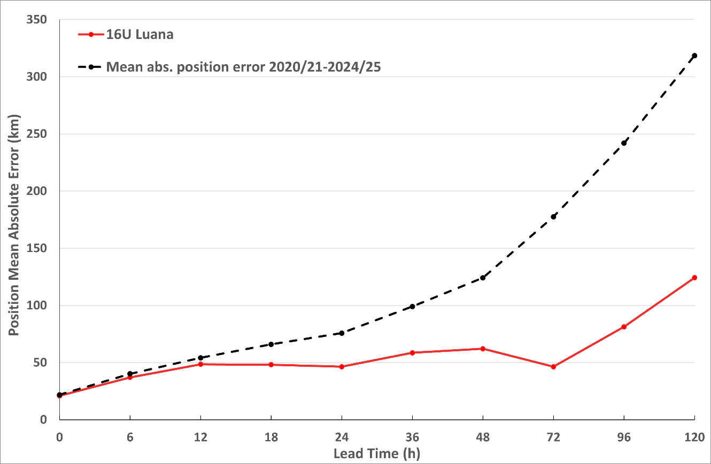
Figure 10 Position accuracy figures for Tropical Cyclone Luana plotted against the 5-year average.

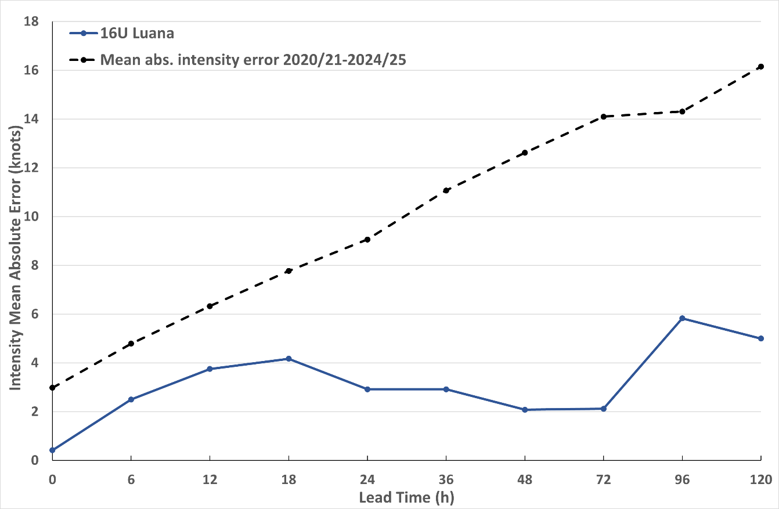
Figure 11 Intensity accuracy figures for Tropical Cyclone Luana plotted against the 5-year average.

- Appendix: List of Abbreviations
Abbreviation | Term
ADT | Advanced Dvorak Technique
ACST | Australian Central Standard Time
AEST | Australian Eastern Standard Time
AiDT | AI-enhanced Dvorak Technique
AMSR2 | Advanced Microwave Scanning Radiometer
AMSU | Advanced Microwave Sounding Unit
ASCAT | Advanced Scatterometer
ATMS | Advanced Technology Microwave Sounder
AWS | automatic weather station
AWST | Australian Western Standard Time
°C | Celsius
CI | Current intensity
CIMSS | Cooperative Institute for Meteorological Satellite Studies (USA)
CIRA | Cooperative Institute for Research in the Atmosphere (USA)
D-MINT | Deep learning - Multispectral Intensity of TCs (formerly known as DMN)
D-PRINT | Deep learning - IR Intensity of TCs (formerly known as OPEN-AIIR)
EIR | Enhanced InfraRed
ERC | eyewall replacement cycle
FNMOC | Fleet Numerical Meteorology and Oceanography Centre (USA)
FT | Final T-number
GCOM | Global Change Observation Mission
GHz | Gigahertz
GMI | Global Precipitation Measurement Microwave Imager
h | hour
hPa | hectopascal
HSCAT | Hai Yang 2 Scatterometer (HY-2B, HY-2C)
km | kilometres
km/h | kilometres per hour
kn | knot
LLCC | Low-Level Cloud Centre
MET | Model Expected T-number
METOP | Meteorological Operational Satellite
MJO | Madden-Julian Oscillation
mm | millimetres
MSLP | mean sea level pressure
NESDIS | National Environmental Satellite, Data, and Information Service
nm | nautical mile
NOAA | National Oceanic and Atmospheric Administration
NRL | U.S. Naval Research Laboratory
OPEN-AiiR | Ordered Pattern Encoding AI Infrared
PAT | Pattern T-number
RCM | RadarSat Constellation Mission – Synthetic Aperture Radar
RH | relative humidity
RMW | radius of maximum winds
RSMC | Regional Specialised Meteorological Centre
SAR | Synthetic Aperture Radar
SATC | CIMSS Advanced Dvorak Technique
SATCON | Satellite Consensus
SEN1 | Sentinel-1A – Synthetic Aperture Radar
SMAP | Soil Moisture Active Passive
SMOS | Soil Moisture and Ocean Salinity
SSMIS | Special Sensor Microwave Imager/Sounder
TC | Tropical Cyclone
TCWC | Tropical Cyclone Warning Centre
UTC | Universal Time Co-ordinated

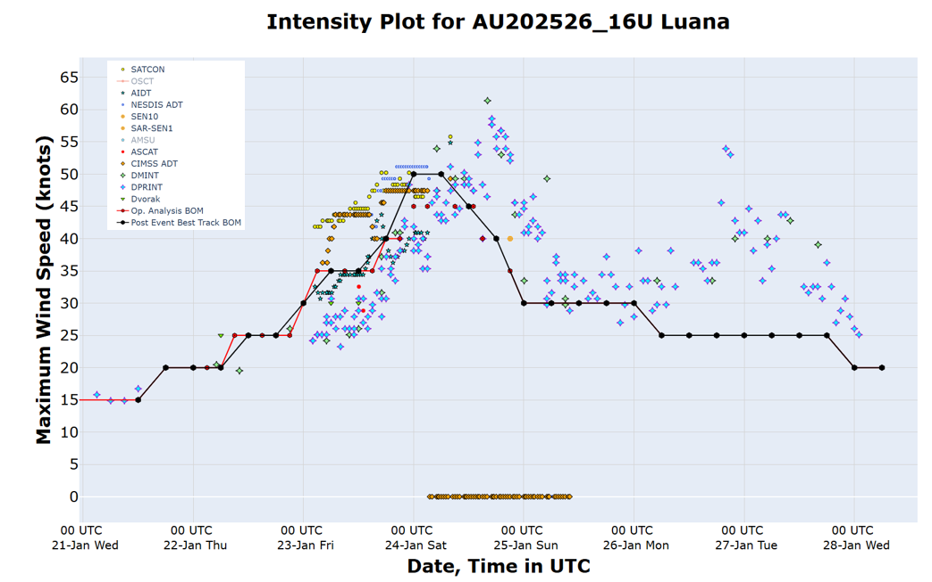
Figure 12 Intensity plot of objective and subjective guidance. SATCON, AiDT, NESDIS ADT, SAR-SEN1, SAR-10, ASCAT, CIMMS ADT, DMINT, DPRINT, Dvorak subjective estimate, operational analysis (red) and post event best track analysis (black). All wind speeds are 10-minute mean wind speeds.

