Severe Tropical Cyclone Maila (37U)

1-12 April 2026

Tropical Cyclone Environmental Prediction Services
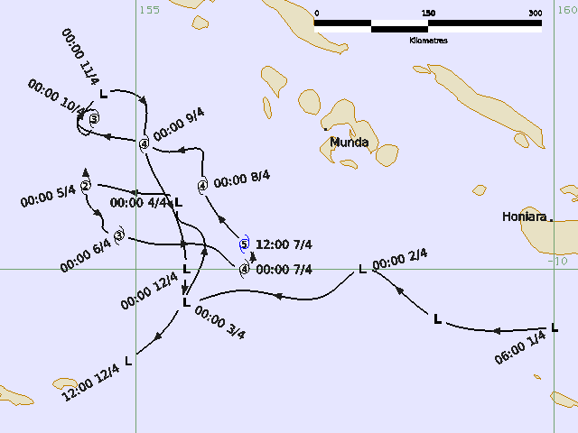

Revision history
Date | Version | Author | Description
15/7/2026 | 1.0 | EPS TC Team | Best track report

Review status
Date | Version | Reviewer | Description
16/7/2026 | 1.0 | EPS TC Team | Reviewed Best Track Report

Release history
Date | Version | Status | Approval
20/7/2026 | 1.0 | Approved | Tropical Cyclone Team Lead

Contact details:
Tropical Cyclone Team Lead
Severe Weather Environmental Prediction Services
Bureau of Meteorology
PO Box 1370, West Perth WA 6872
Email: tcwc@bom.gov.au
This work is copyright. Apart from any use as permitted under the Copyright Act 1968, no part may be reproduced without prior written permission from the Bureau of Meteorology. Refer to www.bom.gov.au/other/copyright.shtml for further information. Unless otherwise noted, all images in this document are licensed under the Creative Commons Attribution Australia Licence.
© Commonwealth of Australia 2026
Published by The Bureau of Meteorology
Cover image: Best track of Severe Tropical Cyclone Maila, 1-12 April 2026. Times are in UTC.

Table of contents

1. Summary 5

2. Meteorological description 8

2.1. Intensity Analysis 8

2.2. Structure 9

2.3. Motion 9

3. Impact 22

4. Observations 23

5. Forecast Performance 23

Appendix: List of Abbreviations 28

List of Figures
Figure 1 Best track of Severe Tropical Cyclone Maila, 1-12 April 2026 6
Figure 2. Hovmoller diagram of tropical waves during the formation of Maila 10
Figure 3. Sea surface temperatures for the Solomon Sea 30 March 11
Figure 4. METOP-B ASCAT winds image at 1020 UTC 3 April 12
Figure 5. OSCAT winds image at 1402 UTC 4 April showing gales halfway around 13
Figure 6. Microwave image from AMSR2 (37GHz) at 1531 UTC 4 April 14
Figure 7 Microwave image from WSFM MWI 37 GHz at 0732 UTC 5 April 15
Figure 8 A series of 37GHz microwave imagery over 6 and 7 April 16
Figure 9. Visible satellite image (Himawari-9) at 0600 UTC 7 April 17
Figure 10. Infrared satellite image (Himawari-9) at 0900UTC 7 April 18
Figure 11. SAR-SPD image at 1914 UTC 7 April close to the time of peak intensity 19
Figure 12. Infrared satellite image (Himawari-9) showing the asymmetry of the eye 20
Figure 13. Graph of vertical wind shear magnitude and direction affecting Maila from 4-12 April 21
Figure 14. Sea surface temperature in the Solomon Sea due to upwelling 22
Figure 15. Track Map from 9 April 1800 UTC 24
Figure 16. Position accuracy figures for Severe Tropical Cyclone Maila 25
Figure 17. Intensity accuracy for Severe Tropical Cyclone Maila 26
Figure 18 TC Probability Matrix for the 7-Day Forecast for Severe Tropical Cyclone Maila. 26
Figure 19. Intensity plot of objective and subjective guidance. 30

List of Tables
Table 1: Best track summary for Severe Tropical Cyclone Maila, 1-12 April 2026. 7
Table 2. Verification statistics for Severe Tropical Cyclone Maila. 25

- Summary
Severe Tropical Cyclone Maila peaked as a category 5 system all while located within the Solomon Sea. Maila is the strongest system on record within the Solomon Sea and resulted in some significant impacts to parts of the Solomon Islands and Papua New Guinea (PNG).
A tropical low (37U) developed south of Honiara in the Solomon Sea, at 0600 UTC 1 April. The tropical low initially tracked northwest, over waters to the south of the New Georgia Islands and west of Guadalcanal (Solomon Islands). The system gradually intensified, and it reached tropical cyclone intensity at 1500 UTC 4 April, while located about 615km west of Honiara and 800km east of Port Moresby. At this time, the system was within the Papua New Guinea Area of Responsibility and was named Maila.
Maila remained slow-moving and continued to intensify, reaching severe tropical cyclone strength at 1200 UTC 5 April. Rapid intensification followed, with the system peaking at 110 kn (205 km/h), category 5 at 1200 UTC 7 April. The system weakened slightly on 8 April before intensifying again, reaching a second peak of 100 kn (185 km/h), category 4 late on 8 April.
The system started to weaken from 9 April and by the morning of 11 April, gales were confined to the northern quadrants of the circulation. In line with the Australian definition of a tropical cyclone requiring gales to extend more than halfway around the system, Maila was reclassified as Ex-Tropical Cyclone Maila. At this time, the system was located over waters between Muyua Island (also known as Woodlark Island), Papua New Guinea and the New Georgia Islands, Solomon Islands. Ex-Tropical Cyclone Maila continued to weaken with gales easing by 1200 UTC 11 April. During 12 April, the remnants of Maila adopted a southwesterly track before weakening into a trough.

Figure 1 Best track of Severe Tropical Cyclone Maila, 1-12 April 2026. Times are in UTC.

Year | Month | Day | Hour UTC | Pos. Lat. S | Pos. Long. E | Pos. Acc. Nm | Max Wind 10min kn | Max gust kn | Cent. Press hPa | Rad of gales (NE/SE/SW/NW) nm | Rad of storm (NE/SE/SW/NW) nm | RMW nm
2026 | 4 | 1 | 0600 | 10.7 | 160.0 | 60 | 15 | 45 | 1003 | 0/0/0/0 | 0/0/0/0 | -
2026 | 4 | 1 | 1200 | 10.6 | 158.6 | 60 | 15 | 45 | 1003 | 0/0/0/0 | 0/0/0/0 | -
2026 | 4 | 1 | 1800 | 10.3 | 158.2 | 60 | 15 | 45 | 1003 | 0/0/0/0 | 0/0/0/0 | -
2026 | 4 | 2 | 0000 | 10.0 | 157.7 | 60 | 15 | 45 | 1003 | 0/0/0/0 | 0/0/0/0 | -
2026 | 4 | 2 | 0600 | 10.3 | 157.3 | 40 | 20 | 45 | 1002 | 0/0/0/0 | 0/0/0/0 | -
2026 | 4 | 2 | 1200 | 10.3 | 156.6 | 40 | 20 | 45 | 1004 | 0/0/0/0 | 0/0/0/0 | -
2026 | 4 | 2 | 1800 | 10.3 | 156.0 | 30 | 20 | 45 | 1002 | 0/0/0/0 | 0/0/0/0 | -
2026 | 4 | 3 | 0000 | 10.4 | 155.6 | 35 | 25 | 45 | 1003 | 0/0/0/0 | 0/0/0/0 | -
2026 | 4 | 3 | 0600 | 9.9 | 155.8 | 30 | 30 | 45 | 997 | 0/0/0/0 | 0/0/0/0 | -
2026 | 4 | 3 | 1200 | 9.5 | 155.7 | 30 | 30 | 45 | 998 | 0/0/0/0 | 0/0/0/0 | -
2026 | 4 | 3 | 1800 | 9.4 | 155.5 | 30 | 35* | 50 | 993 | 60/0/0/70 | 0/0/0/0 | -
2026 | 4 | 4 | 0000 | 9.2 | 155.5 | 25 | 35* | 50 | 995 | 0/0/60/90 | 0/0/0/0 | -
2026 | 4 | 4 | 0600 | 9.1 | 155.1 | 25 | 40* | 55 | 991 | 80/0/0/100 | 0/0/0/0 | -
2026 | 4 | 4 | 1200 | 9.0 | 154.6 | 30 | 40* | 55 | 991 | 80/0/0/110 | 0/0/0/0 | -
2026 | 4 | 4 | 1500 | 8.9 | 154.4 | 25 | 45 | 65 | 988 | 80/0/80/130 | 0/0/0/0 | 25
2026 | 4 | 4 | 1800 | 8.8 | 154.4 | 25 | 50 | 70 | 984 | 100/50/80/130 | 60/40/20/70 | 20
2026 | 4 | 5 | 0000 | 9.0 | 154.4 | 20 | 55 | 75 | 982 | 100/60/90/130 | 60/30/20/70 | 15
2026 | 4 | 5 | 0600 | 9.3 | 154.5 | 25 | 60 | 85 | 977 | 110/80/90/130 | 60/30/30/70 | 15
2026 | 4 | 5 | 1200 | 9.4 | 154.6 | 25 | 65 | 90 | 974 | 120/90/90/130 | 60/40/40/50 | 18
2026 | 4 | 5 | 1800 | 9.5 | 154.6 | 15 | 65 | 90 | 972 | 120/90/90/130 | 60/40/40/50 | 17
2026 | 4 | 6 | 0000 | 9.6 | 154.8 | 15 | 70 | 100 | 970 | 130/90/90/130 | 60/40/50/70 | 15
2026 | 4 | 6 | 0600 | 9.7 | 155.2 | 20 | 70 | 100 | 967 | 130/90/90/130 | 70/50/50/70 | 16
2026 | 4 | 6 | 1200 | 9.7 | 155.7 | 15 | 80 | 110 | 961 | 120/90/100/140 | 60/40/50/50 | 15
2026 | 4 | 6 | 1800 | 9.8 | 156.0 | 20 | 80 | 110 | 960 | 120/90/100/130 | 80/55/60/80 | 15
2026 | 4 | 7 | 0000 | 10.0 | 156.3 | 20 | 90 | 125 | 953 | 100/80/100/110 | 60/40/50/50 | 19
2026 | 4 | 7 | 0600 | 9.9 | 156.4 | 20 | 100 | 140 | 938 | 100/80/100/110 | 60/45/45/50 | 19
2026 | 4 | 7 | 1200 | 9.7 | 156.3 | 15 | 110 | 155 | 929 | 100/80/100/110 | 60/45/45/50 | 19
2026 | 4 | 7 | 1800 | 9.4 | 156.1 | 15 | 110 | 155 | 930 | 90/80/90/110 | 60/45/45/50 | 17
2026 | 4 | 8 | 0000 | 9.0 | 155.8 | 15 | 100 | 140 | 943 | 110/100/90/120 | 60/50/45/55 | 15
2026 | 4 | 8 | 0600 | 8.7 | 155.8 | 15 | 85 | 120 | 956 | 100/90/80/100 | 60/45/45/55 | 15
2026 | 4 | 8 | 1200 | 8.6 | 155.8 | 15 | 100 | 140 | 942 | 90/80/70/110 | 50/35/35/40 | 15
2026 | 4 | 8 | 1800 | 8.6 | 155.4 | 15 | 100 | 140 | 941 | 90/90/70/110 | 60/45/45/50 | 15
2026 | 4 | 9 | 0000 | 8.5 | 155.1 | 15 | 100 | 140 | 941 | 100/90/90/110 | 60/50/50/50 | 15
2026 | 4 | 9 | 0600 | 8.4 | 154.6 | 15 | 90 | 125 | 950 | 100/90/90/120 | 60/60/55/50 | 16
2026 | 4 | 9 | 1200 | 8.2 | 154.3 | 15 | 85 | 120 | 956 | 100/90/90/120 | 50/50/50/50 | 16
2026 | 4 | 9 | 1800 | 8.1 | 154.5 | 20 | 80 | 110 | 960 | 90/80/80/120 | 45/40/50/50 | 18
2026 | 4 | 10 | 0000 | 8.2 | 154.5 | 25 | 70 | 100 | 970 | 90/70/80/120 | 45/40/50/55 | 20
2026 | 4 | 10 | 0600 | 8.4 | 154.4 | 25 | 60 | 85 | 975 | 90/70/80/120 | 50/45/55/60 | 25
2026 | 4 | 10 | 1200 | 8.3 | 154.3 | 35 | 45 | 65 | 989 | 90/70/60/90 | 0/0/0/0 | 25
2026 | 4 | 10 | 1800 | 8.1 | 154.4 | 35 | 40 | 55 | 990 | 70/50/70/90 | 0/0/0/0 | 25
2026 | 4 | 11 | 0000 | 7.9 | 154.6 | 20 | 35* | 50 | 995 | 70/0/0/80 | 0/0/0/0 | -
2026 | 4 | 11 | 0600 | 8.0 | 155.1 | 10 | 35* | 50 | 994 | 50/0/0/60 | 0/0/0/0 | -
2026 | 4 | 11 | 1200 | 8.4 | 155.1 | 25 | 30 | 45 | 998 | 0/0/0/0 | 0/0/0/0 | -
2026 | 4 | 11 | 1800 | 9.2 | 155.4 | 30 | 30 | 45 | 997 | 0/0/0/0 | 0/0/0/0 | -
2026 | 4 | 12 | 0000 | 10.0 | 155.6 | 15 | 25 | 45 | 1004 | 0/0/0/0 | 0/0/0/0 | -
2026 | 4 | 12 | 0600 | 10.5 | 155.5 | 15 | 20 | 45 | 1003 | 0/0/0/0 | 0/0/0/0 | -
2026 | 4 | 12 | 1200 | 11.1 | 154.9 | 25 | 20 | 45 | 1006 | 0/0/0/0 | 0/0/0/0 | -
Table 1: Best track summary for Severe Tropical Cyclone Maila, 1-12 April 2026.
*Not a tropical cyclone as gales less than halfway around the centre.

- Meteorological description
  - Intensity Analysis
A comparison of the subjective and objective intensity estimates is shown in Figure 19.
A tropical low formed along a trough near the Solomon Islands on 1 April, with both MJO and Equatorial Rossby Wave support (Figure 2). Sea surface temperatures in the Solomon Sea were 30-31 °C (Figure 3) and the depth of the 26°C isotherm was greater than 125 meters. The low was initially broad and slow to consolidate and, between 1 and 3 April, was hindered by easterly wind shear. Figure 4 shows convection confined to the western and northern sides of the system with the strongest winds (30 kn, 55 km/h) in the northwest quadrant.
The system moved slowly north and intensified on 3 and 4 April and as the wind shear (Figure 13) decreased the system consolidated quickly in a very favourable environment. Gales developed from 1800 UTC 3 April while in TCWC Port Moresby's area of responsibility and operationally was named Maila at 1200UTC 4 April, based on PNG's definition of a tropical cyclone of gales in one quadrant. Maila reached tropical cyclone strength (by the Australian definition of a tropical cyclone and best track purposes) at 1500 UTC 4 April as gales wrapped into a third quadrant. An OSCAT pass at 1402 UTC 4 April (Figure 5) shows gales approximately halfway around the system shortly before it was named, with tightly wrapped convection consolidated around the low level centre (Figure 6).
24 hours later, at 1200 UTC 5 April Maila reached category 3 intensity, with an eye evident on the WFSM MWI microwave image at 0752 UTC 5 April (Figure 7). A CDO pattern was applied overnight on 5 April, and the FT/CI was biased to the MET/PAT. The first clear eye did not emerge until 0000 UTC 6 April on visible satellite imagery and over the next 24 hours was intermittent or not clear cut in EIR imagery. This resulted in objective aids fluctuating (Figure 19), in particular the ADT aids which varied between a spiral and CDO pattern and underestimated the intensity. However, other aids like DMINT and DPRINT overestimated the intensity compared to the best track. SATCON provided the best overall trend and intensity from the consensus of objective aids, and the intensity reached 80 kn by 1200 UTC 6 April.
Maila underwent rapid intensification between 1200 UTC 6 April and 1200 UTC 7 April, developing 30 kn over 24 hours. It reached a peak intensity of 110 kn (205 km/h), category 5 from 1200 to 1800 UTC 7 April (Figure 9). By 0300 UTC 7 April a symmetrical system had formed (Figure 11) and a well defined eye (Figure 10) meant subjective Dvorak and objective guidance provided good intensity estimates. The subjective Dvorak peaked at 0900 UTC 7 April with a DT of 7.0 and a FT/CI of 6.5 with the FT constrained. Despite the slow motion (less than 8 knots), the system was able to reach category 5 strength partly due to the deep extent of very warm waters (26° isotherm greater than 120m and the ocean heat content greater than 115 kJ cm⁻²) preventing colder upwelling from occurring.
During 8 April Severe Tropical Cyclone Maila moved northwest again and weakened before reaching a second peak of 100 kn (185km/h) late on 8 April. The structure of the system showed fluctuations in symmetry consistent with an increase in easterly wind shear (Figure 12). Upwelling of cooler waters (Figure 14) due to the slow motion of Maila also potentially contributed to this fluctuation in intensity, but still warm enough for the system to intensify again.
During 9 April the wind shear increased to a peak of 25 kn (46 km/h), and Maila weakened to category 3 intensity. During 10 April Maila become very slow-moving and weakened rapidly from a category 3 to an ex-tropical cyclone by 0000 UTC 11 April. Over the next day and a half ex-tropical cyclone Maila moved south with the low-level centre exposed and eventually elongated into a trough while still within the Solomon Sea.
  - Structure
Maila was an average-sized system.
Gales were initially observed around 1800 UTC 3 April. Maila was generally an asymmetric system with gale radii in the northern quadrants ranging from 110 - 140 nm (204 – 259 km). The southern quadrants were slightly smaller ranging from 70 - 100 nm (130 – 185 km). Storm force winds had a radii between 30 and 70 nm. The largest extent of hurricane force winds was 40nm.
Around the time of peak intensity Maila had good symmetry but at times convection was more lopsided due to the influence of wind shear.
The radius of maximum winds (RMW) averaged around 18 nm.

  - Motion
Steering was initially very weak with Maila located between a ridge to the south and northwesterly flow to the north. Due to the weak steering Maila was slow-moving for most of its life and remained within the Solomon Sea, repeatedly crossing its own path.

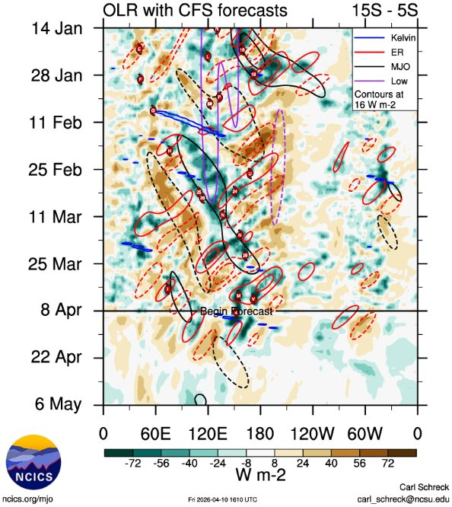
Figure 2. Hovmoller diagram of tropical waves over the latitude range of 5-15S. The formation of Maila (the system annotated M) occurred at the end of an active MJO phase (black) and during an Equatorial Rossby wave (red). Image courtesy of the North Carolina Institute for Climate Studies: Tropical Monitoring :: North Carolina Institute for Climate Studies

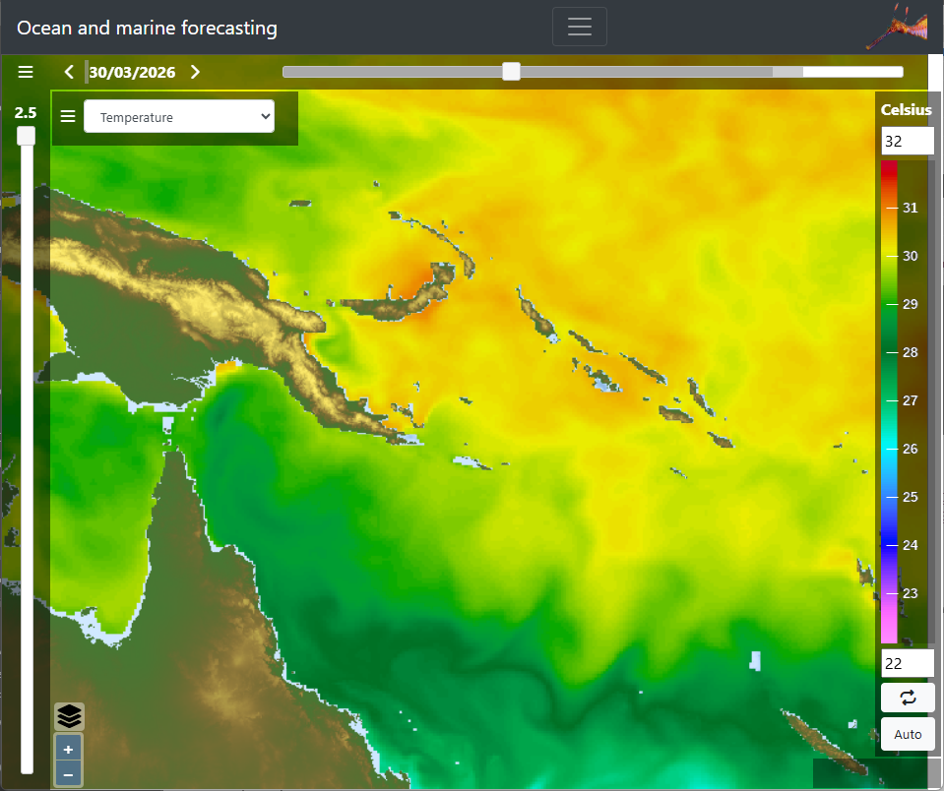
Figure 3. Sea surface temperatures for the Solomon Sea 30 March showing that temperatures for Maila's formation were around 30-31C. Image courtesy of Seedragon - Ocean and marine forecasting web data services.

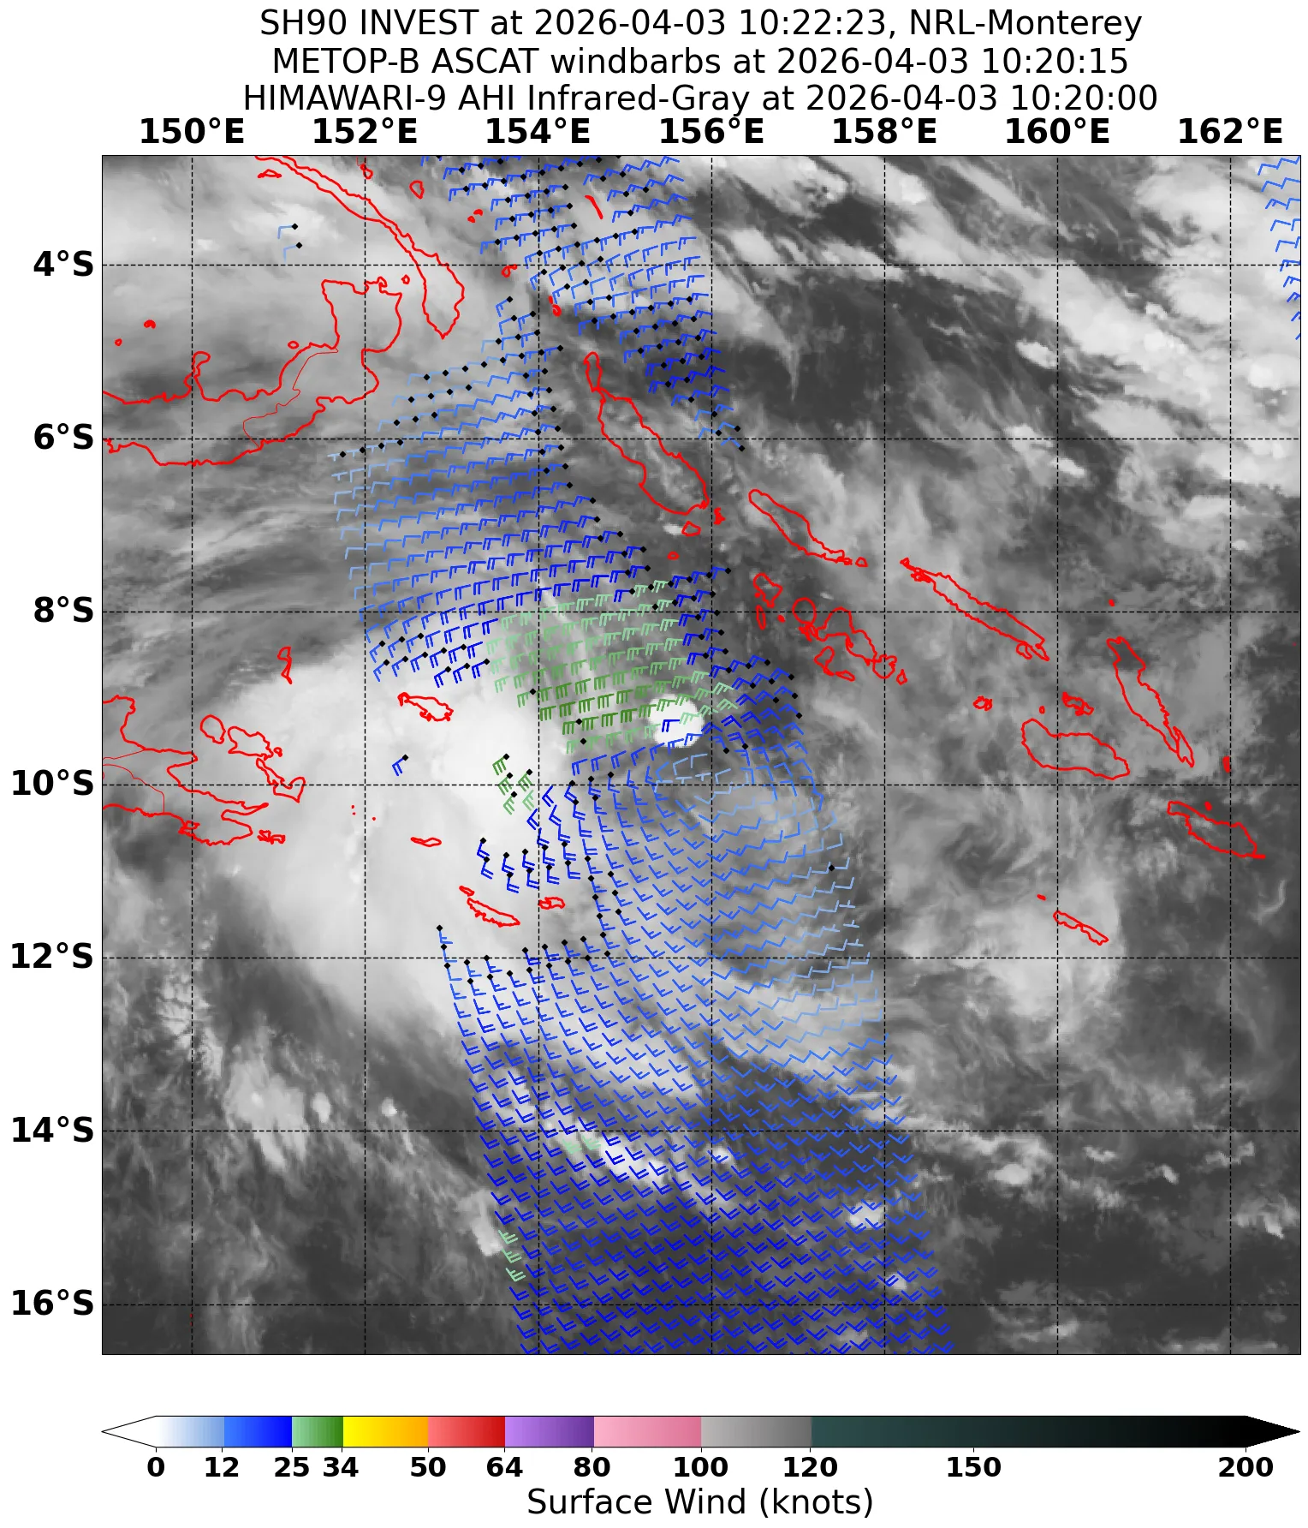
Figure 4. METOP-B ASCAT winds image at 1020 UTC 3 April showing sheared convection before the system developed gales. Image courtesy NRL: https://www.nrlmry.navy.mil/TC.html

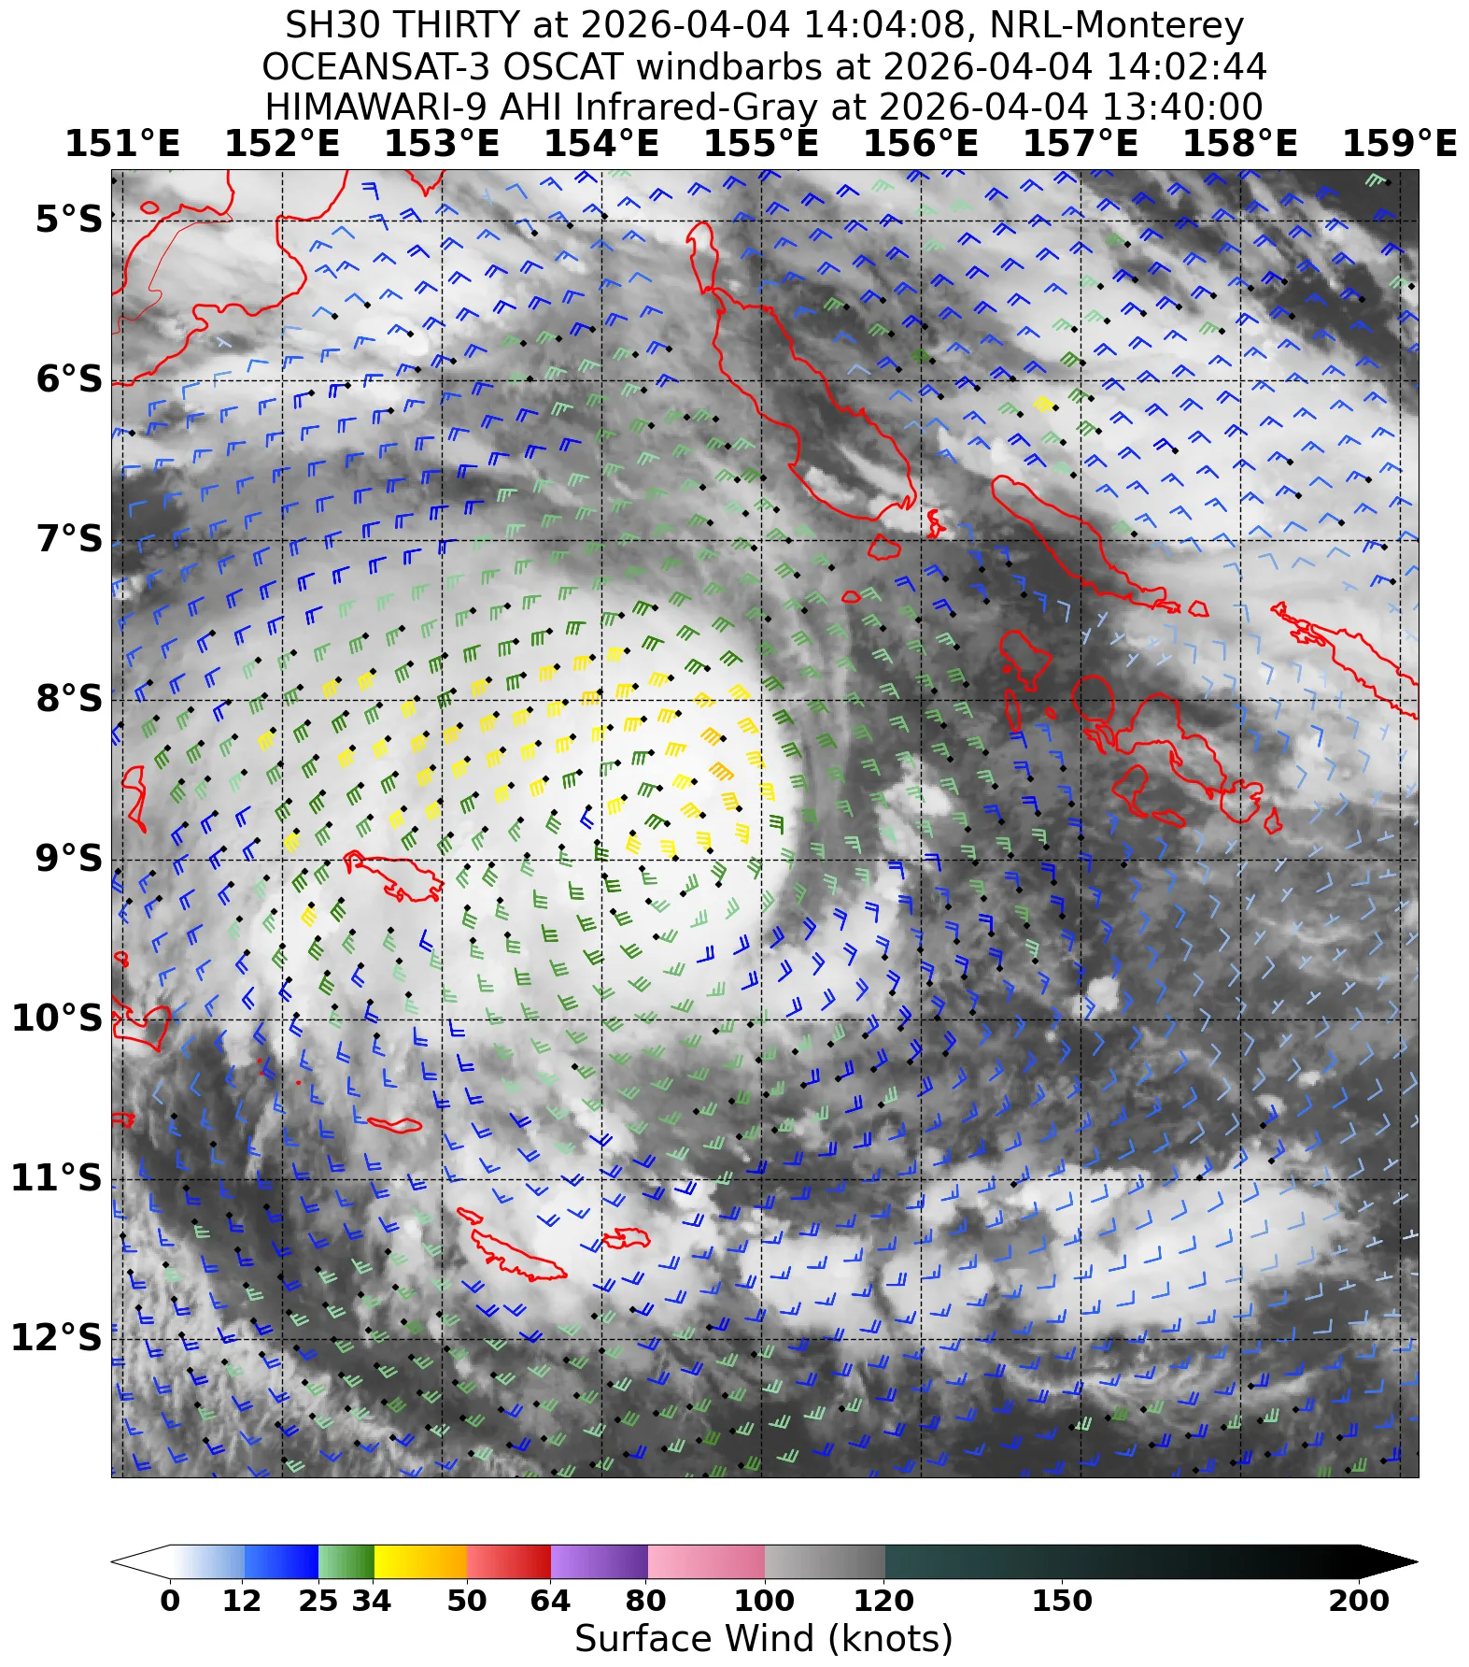
Figure 5. OSCAT winds image at 1402 UTC 4 April showing gales approximately halfway around the system in the northern quadrants, with max wind 40 knots on the northern side, around the time Maila developed into a tropical cyclone. Image courtesy NRL: https://www.nrlmry.navy.mil/TC.html

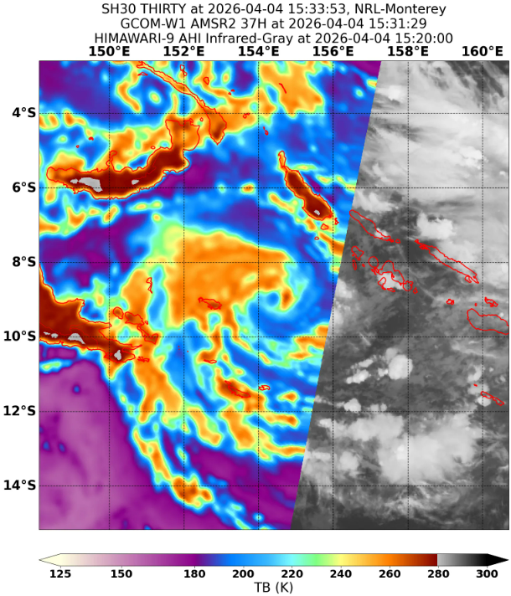
Figure 6. Microwave image from AMSR2 (37GHz) at 1531 UTC 4 April showing tightly wrapped convection closer to the low-level circulation of Maila around the time it developed into a tropical cyclone. Image courtesy NRL: https://www.nrlmry.navy.mil/TC.html

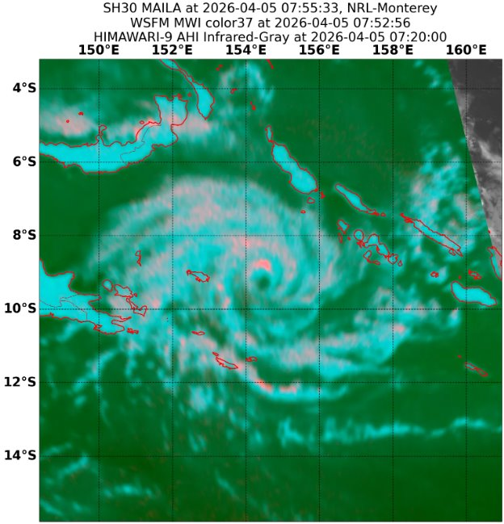
Figure 7 Microwave image from WSFM MWI 37 GHz colour composite at 0752 UTC 5 April showing an eye formed. A defined eye was not visible on EIR satellite imagery and the system reached category 3 intensity at 1200 UTC 5 April. Image courtesy NRL: https://www.nrlmry.navy.mil/TC.html

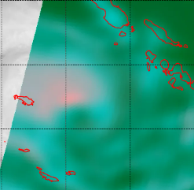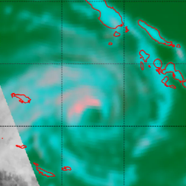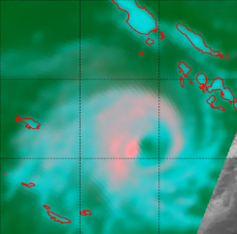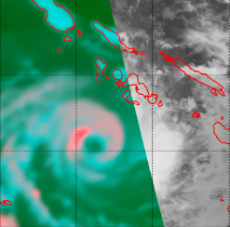
Figure 8 A series of 37GHz microwave imagery over 6 and 7 April showing tighter banding developing closer to the centre, despite some weakening of the convection in the east at times during this period. Top left SSMIS 1904 UTC 5 April, top right GMI 0127 UTC 6 April, bottom left GMI 1301 UTC 6 April, bottom right AMSR2 0335 UTC 7 April. Image courtesy NRL: https://www.nrlmry.navy.mil/TC.html

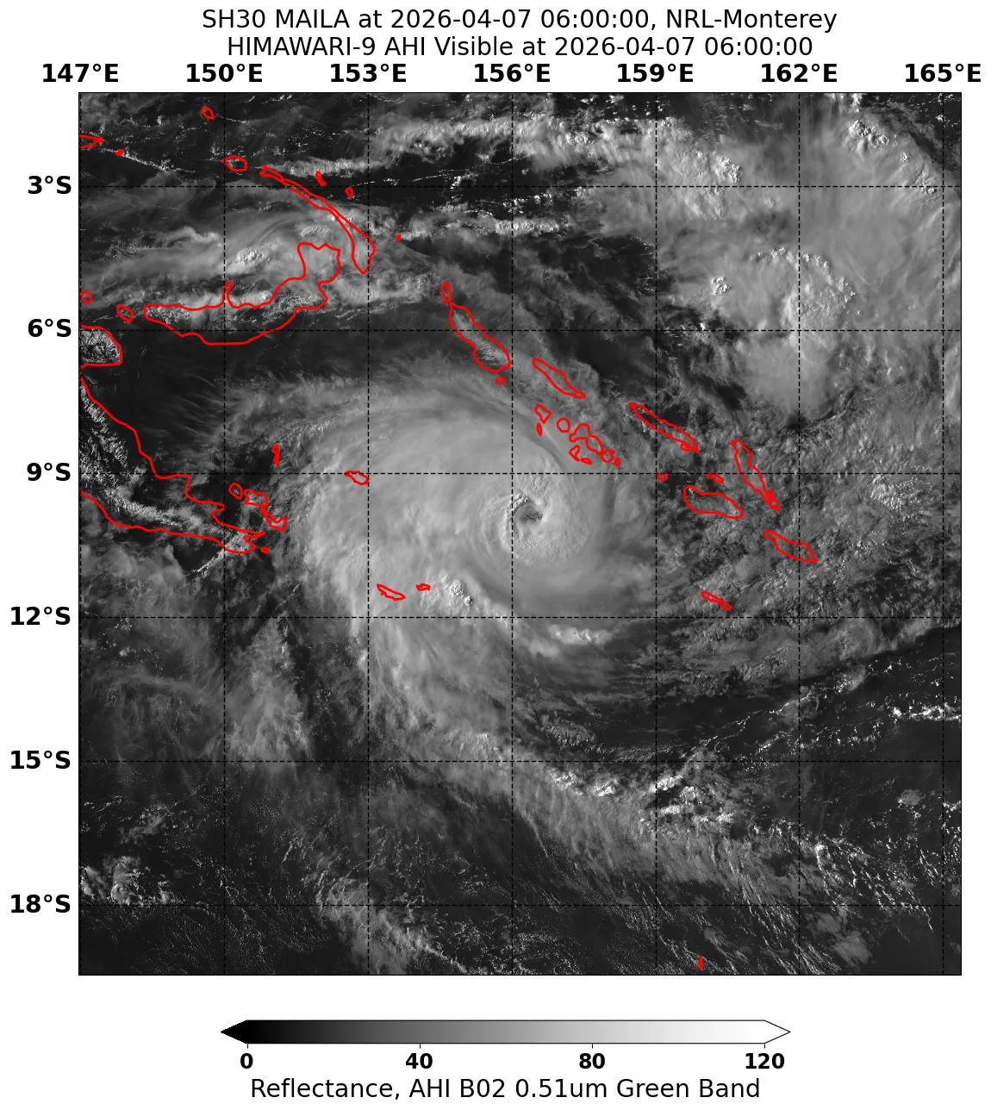
Figure 9. Visible satellite image (Himawari-9) at 0600 UTC 7 April showing the eye of Severe Tropical Cyclone Maila. Image courtesy NRL: https://www.nrlmry.navy.mil/TC.html

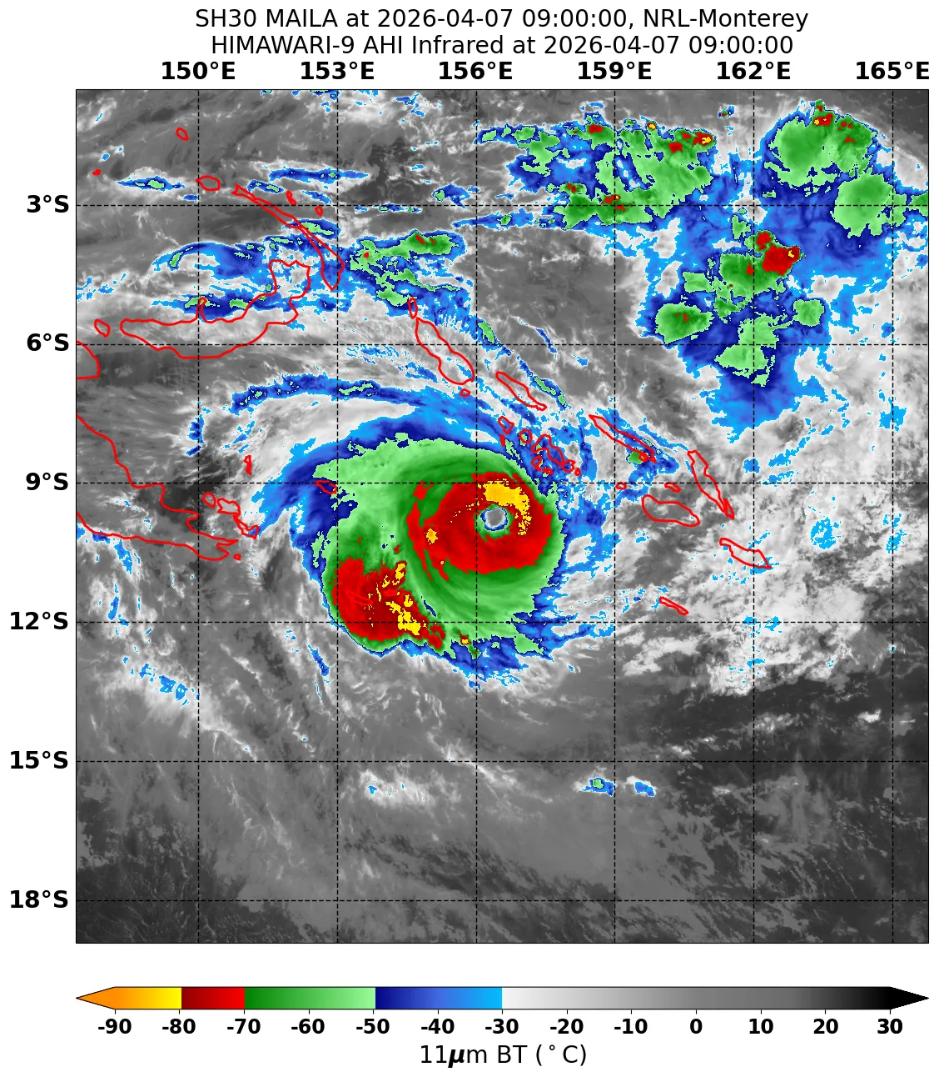
Figure 10. Infrared satellite image (Himawari-9) at 0900UTC 7 April showing symmetrical convection around a distinct eye of Maila during the period of rapid intensification before peak intensity. Image courtesy NRL: https://www.nrlmry.navy.mil/TC.html
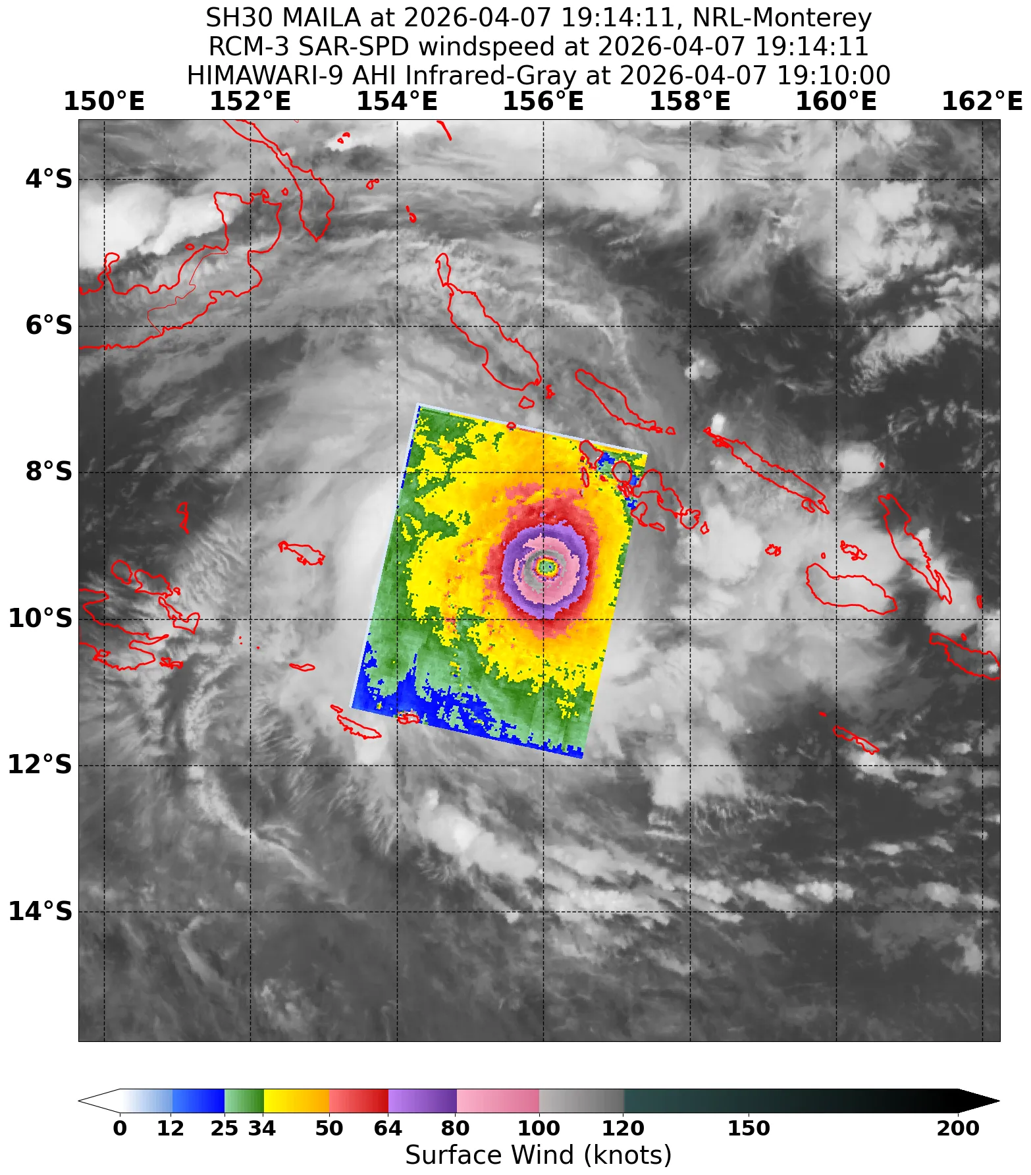
Figure 11. SAR-SPD image at 1914 UTC 7 April close to the time of peak intensity of 110 kn. Image courtesy NRL: https://www.nrlmry.navy.mil/TC.html

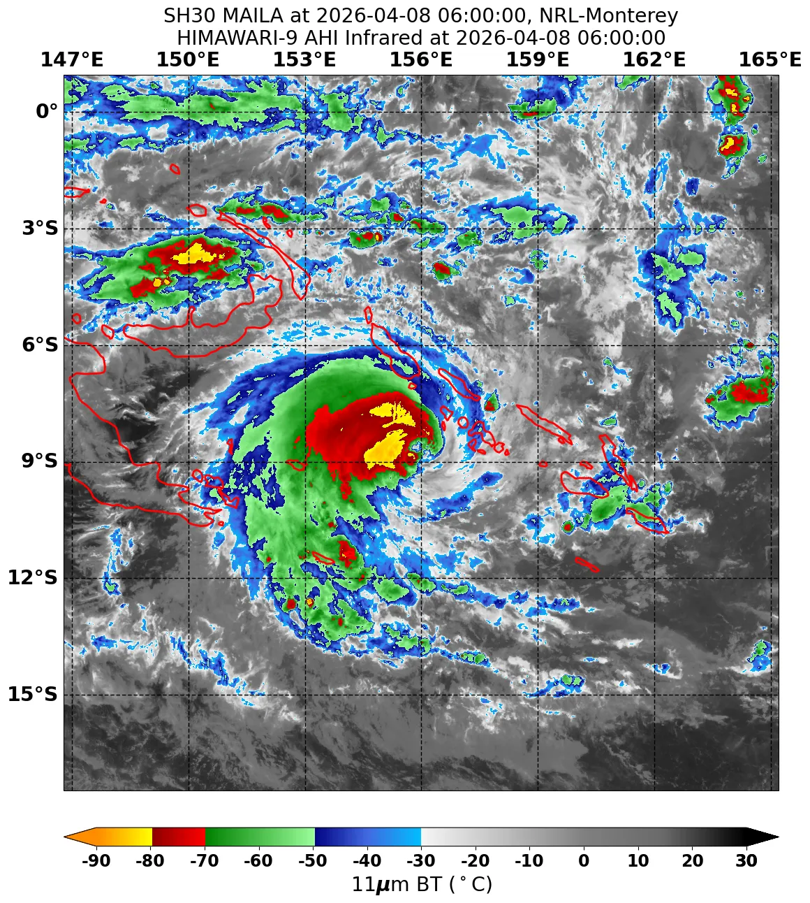
Figure 12. Infrared satellite image (Himawari-9) showing the asymmetry of the eye caused by wind shear during a period of weakening at 0600 UTC 8 April. Image courtesy NRL: https://www.nrlmry.navy.mil/TC.html

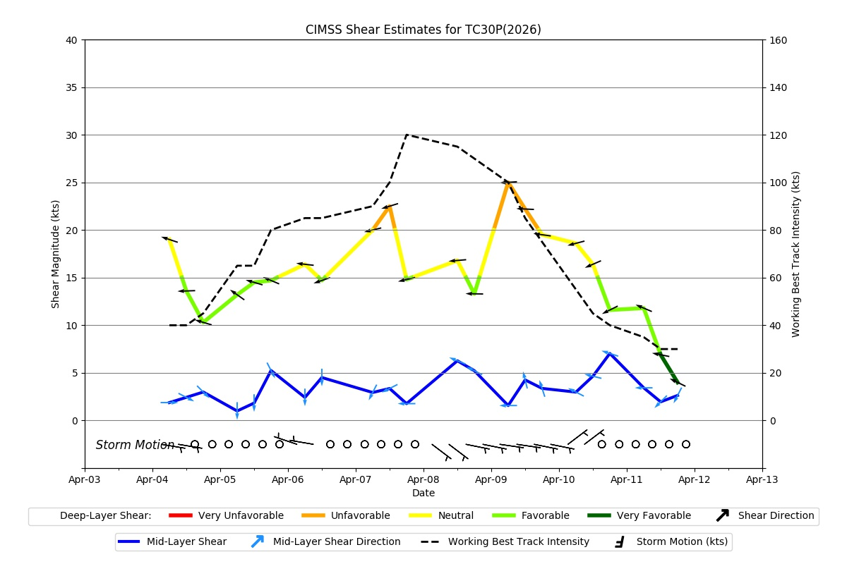
Figure 13. Graph of vertical wind shear magnitude and direction affecting Maila from 4-12 April. The dotted black line is the working best track of JTWC. Image courtesy of CIMMS Tropical Cyclones Group CIMSS Tropical Cyclones
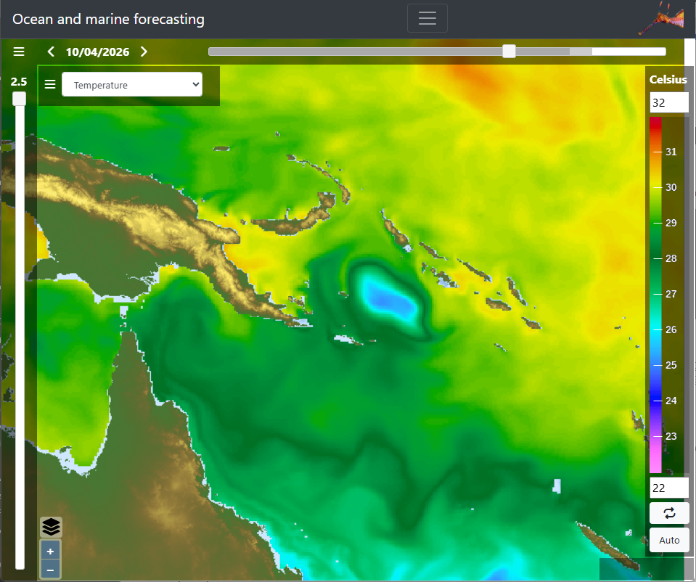
Figure 14. Image showing the change in sea surface temperature in the Solomon Sea due to upwelling caused by Maila, with temperatures decreasing to below 26 degrees. Image courtesy of Seedragon - Ocean and marine forecasting web data services.

- Impact
While Severe Tropical Cyclone Maila remained over water, strong winds and heavy rainfall caused flooding, landslides and coastal inundation across Papua New Guinea and the Solomon Islands. The impact of Tropical Cyclone Maila was considerable, especially for low-lying and atoll communities, and resulted in deaths, injuries and widespread damage to infrastructure.
Solomon Islands
A State of Disaster was declared for Western and Choiseul provinces (Solomon Islands).
Buildings in Solomon Islands' Western Province were destroyed and many villages reported severe flooding as the system caused huge waves and storm surges.
https://www.abc.net.au/news/2026-04-10/cyclone-maila-moves-through-png-towards-queensland/106520154
Papua New Guinea
Flooding and heavy rainfall were reported in communities and islands about the Milne Bay Province. At least 11 people were reported killed due to flooding and landslides. In Bougainville (an autonomous region of PNG) Maila destroyed roads and bridges.
https://www.abc.net.au/news/2026-04-13/tc-maila-kills-11-people-as-australia-provides-millions/106557122
https://australianhumanitarianpartnership.org/response-1/1u0072zoi73i62g4yrhiju1b01z6pw-zzcxe

- Observations
There were no observations recorded by Australian weather stations.

- Forecast Performance
The potential for a tropical cyclone to develop was first included on the 7-Day forecast from 30 March, with a High chance from 5 April (Figure 18).
The first Solomon Islands Advisory was issued on 2 April.
The first Ocean Wind Warning and Forecast Track Map were issued at 0100 UTC 3 April and continued until the last issue at 0700 UTC 11 April. The first Ocean Wind Warning was issued 18 hours before gales first occurred.
Many of the model ensembles were tracking the system to the southwest, past the southern point of PNG where interaction with land would weaken the system (Figure 15), before taking it through the Coral Sea to cross the Queensland coast. There was a large spread in the speed of the models, and hence the intensity, as it approached Queensland. There was also a bifurcation with some models keeping the system within the Solomon Sea, though these were the minority. During 8 April Maila moved further north than expected, which may have prevented it from being captured by the ridge. Most model guidance started to shift on 8-9 April, forecasting the system to remain in the Solomon Sea and weaken.

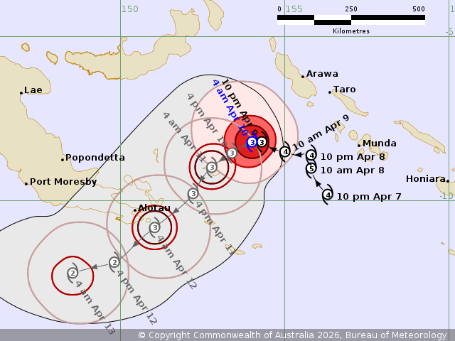
Figure 15. Track Map from 9 April 18UTC – Showing the expected movement of Severe Tropical Cyclone Maila to the southwest, crossing the southern extent of PNG and moving into the Coral Sea and towards the Queensland Coast.
The accuracy statistics for Severe Tropical Cyclone Maila are below in Table 2 and Figure 16 (position) and Figure 17 (intensity).
Forecast track position accuracy was close to the 5-year average (2020/21-2024/25) in the short-term, but very poor in the long term (beyond 48 hours) due to the expectation of the system moving towards Queensland, rather than remaining within the Solomon Sea. This also affected the intensity forecast accuracy.
Intensity forecasts were generally poorer than the 5-year average. Peak intensity was higher than expected, as the effects of upwelling were difficult to quantify, and the expectation was for Maila to move closer to the islands of PNG which would have likely resulted in a lower peak intensity.

Time | 0 | 6 | 12 | 18 | 24 | 36 | 48 | 72 | 96 | 120
Position Absolute error (km) | 13 | 39 | 61 | 77 | 92 | 135 | 191 | 329 | 474 | 627
Intensity Absolute error (knots) | 2.8 | 6.3 | 8.2 | 10.3 | 11.3 | 14.4 | 16.6 | 20.6 | 25.0 | 25.0
Sample Size | 36 | 36 | 36 | 36 | 35 | 33 | 31 | 27 | 23 | 19
Table 2. Verification statistics for Severe Tropical Cyclone Maila. Note: Verification is performed using the Official Forecast Tracks at the standard times of 00, 06, 12 and 18 UTC.

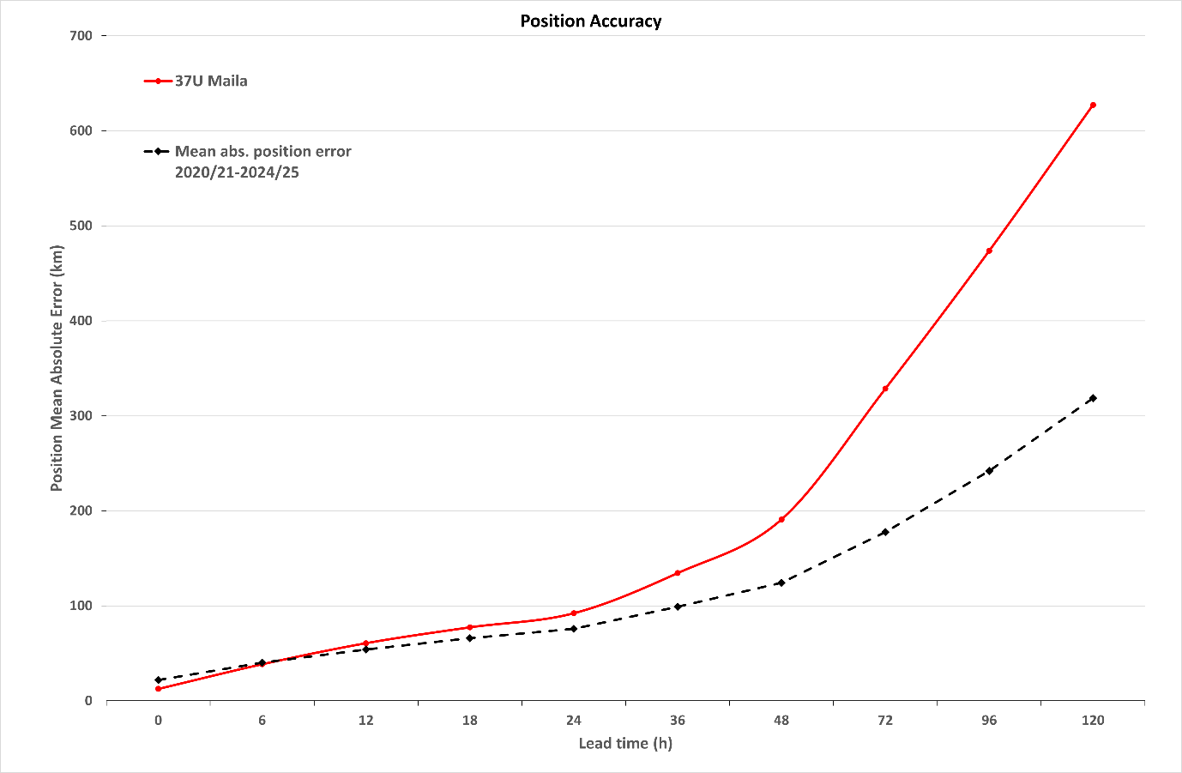
Figure 16. Position accuracy figures for Severe Tropical Cyclone Maila plotted against the 5-year average.

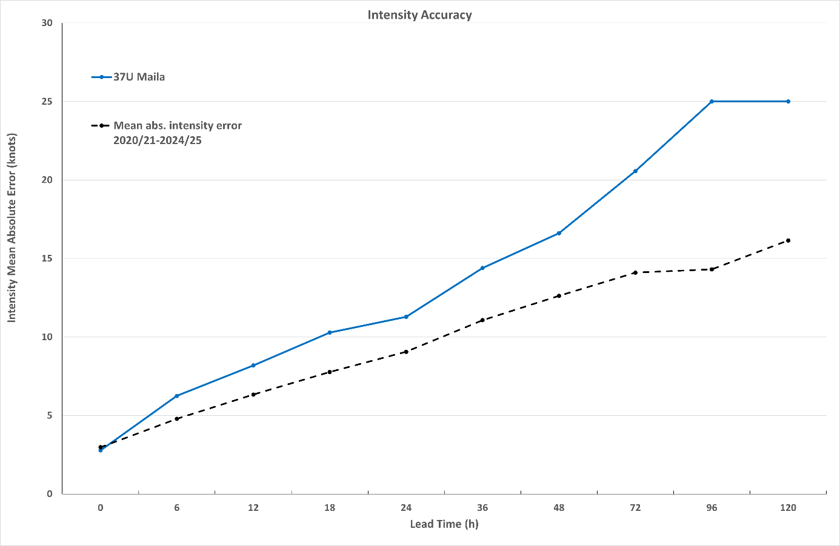
Figure 17. Intensity accuracy for Severe Tropical Cyclone Maila plotted against the 5-year average.

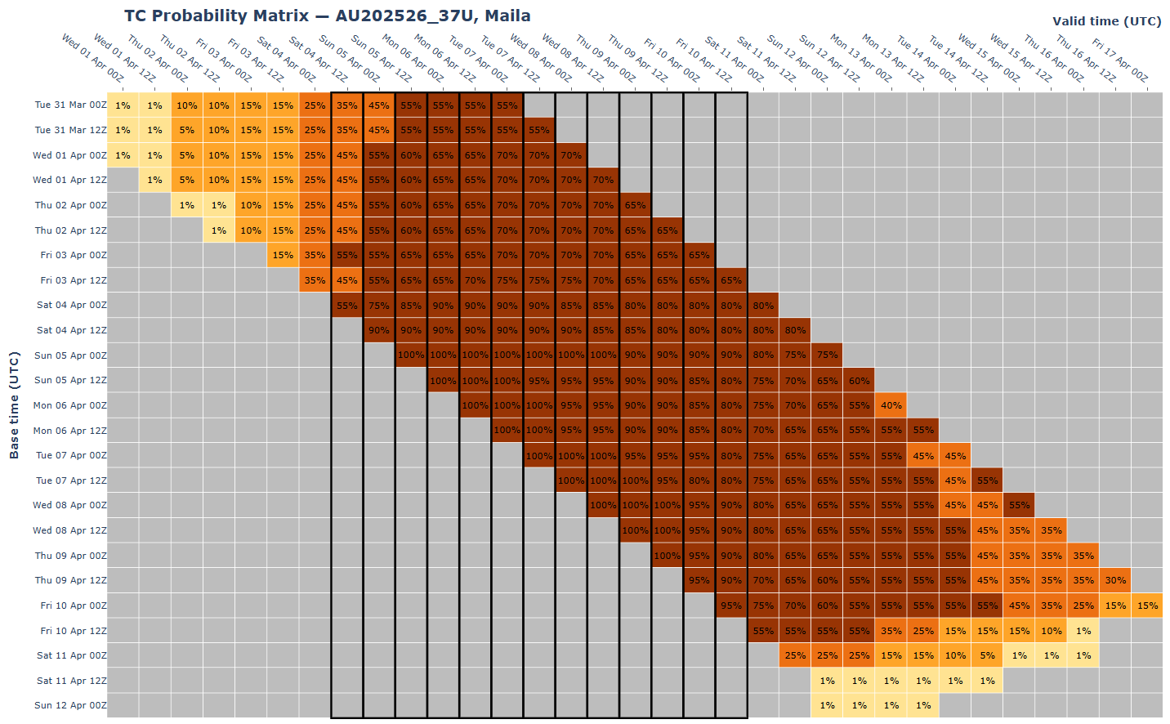
Figure 18 The forecast percentage risk of a low developing into a tropical cyclone taken from the 7-day forecast for Maila from 31 March to 12 April 2026. The forecast base time is shown on the vertical axis and the forecast validity time is shown on the horizontal axis. The box colours correspond to the tropical cyclone forecast rating, yellow for Very Low (<5%), light orange for Low (5-15%), orange for Moderate (20-45%) and brown for High (50-100%). The thick black lines indicate the period Maila was a tropical cyclone.

- Appendix: List of Abbreviations
Abbreviation | Term
ADT | Advanced Dvorak Technique
ACST | Australian Central Standard Time
AEST | Australian Eastern Standard Time
AiDT | AI-enhanced Dvorak Technique
AMSR2 | Advanced Microwave Scanning Radiometer
AMSU | Advanced Microwave Sounding Unit
ASCAT | Advanced Scatterometer
ATMS | Advanced Technology Microwave Sounder
AWS | automatic weather station
AWST | Australian Western Standard Time
°C | Celsius
CI | Current intensity
CIMSS | Cooperative Institute for Meteorological Satellite Studies (USA)
CIRA | Cooperative Institute for Research in the Atmosphere (USA)
D-MINT | Deep learning - Multispectral Intensity of TCs (formerly known as DMN)
D-PRINT | Deep learning - IR Intensity of TCs (formerly known as OPEN-AIIR)
EIR | Enhanced InfraRed
ERC | eyewall replacement cycle
FNMOC | Fleet Numerical Meteorology and Oceanography Centre (USA)
FT | Final T-number
GCOM | Global Change Observation Mission
GHz | Gigahertz
GMI | Global Precipitation Measurement Microwave Imager
h | hour
hPa | hectopascal
HSCAT | Hai Yang 2 Scatterometer (HY-2B, HY-2C)
km | kilometres
km/h | kilometres per hour
kn | knot
LLCC | Low-Level Cloud Centre
MET | Model Expected T-number
METOP | Meteorological Operational Satellite
WFSM MWI | Weather System Follow-on Microwave Microwave Image
MJO | Madden-Julian Oscillation
mm | millimetres
MSLP | mean sea level pressure
NESDIS | National Environmental Satellite, Data, and Information Service
nm | nautical mile
NOAA | National Oceanic and Atmospheric Administration
NRL | U.S. Naval Research Laboratory
OPEN-AiiR | Ordered Pattern Encoding AI Infrared
PAT | Pattern T-number
RCM | RadarSat Constellation Mission – Synthetic Aperture Radar
RH | relative humidity
RMW | radius of maximum winds
RSMC | Regional Specialised Meteorological Centre
SAR | Synthetic Aperture Radar
SATC | CIMSS Advanced Dvorak Technique
SATCON | Satellite Consensus
SEN1 | Sentinel-1A – Synthetic Aperture Radar
SMAP | Soil Moisture Active Passive
SMOS | Soil Moisture and Ocean Salinity
SSMIS | Special Sensor Microwave Imager/Sounder
TC | Tropical Cyclone
TCWC | Tropical Cyclone Warning Centre
UTC | Universal Time Co-ordinated

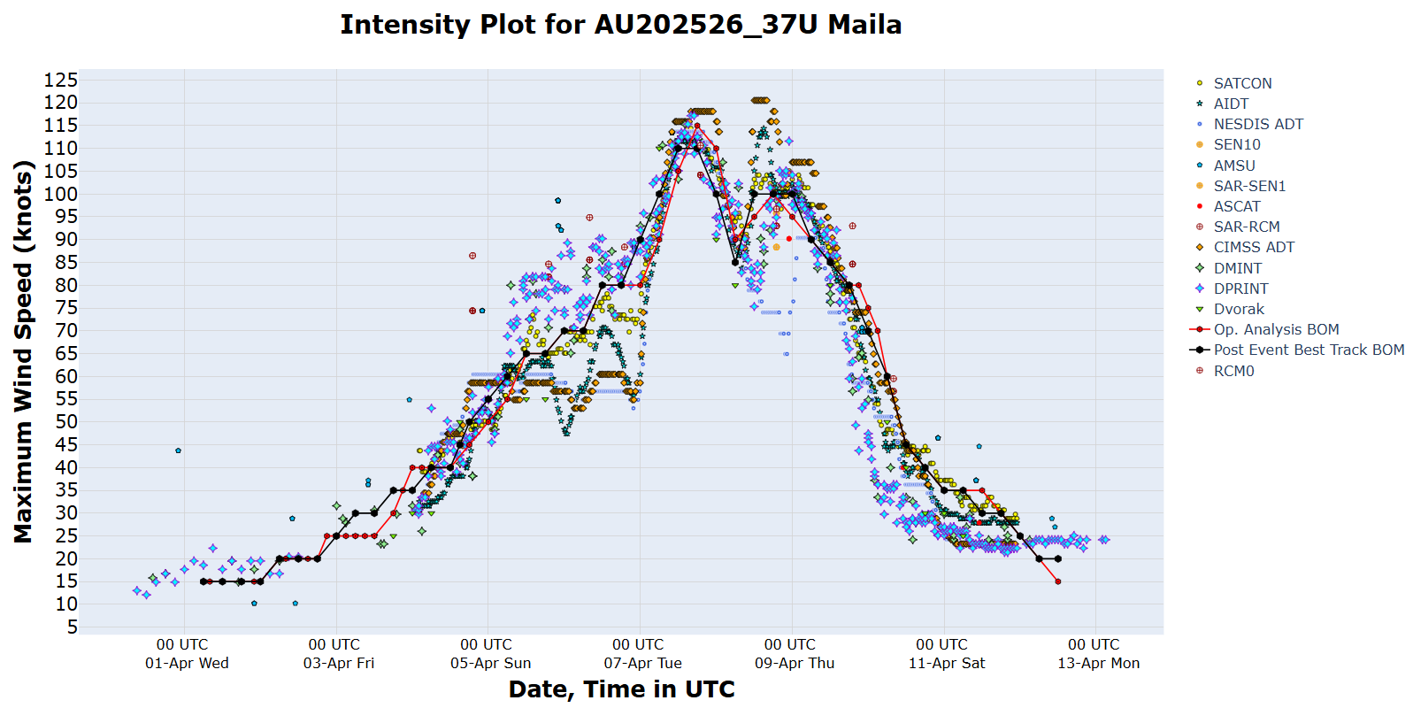
Figure 19. Intensity plot of objective and subjective guidance. SATCON, AiDT, NESDIS ADT, SEN10, SAR-SEN1, SAR-RCM, RCM0, ASCAT, CIMMS ADT, DMINT, DPRINT, Dvorak subjective estimate, operational analysis (red) and post event best track analysis (black). All wind speeds are 10-minute mean wind speeds.

