Severe Tropical Cyclone Mitchell (21U)

29 January – 10 February 2026

Tropical Cyclone Environmental Prediction Services
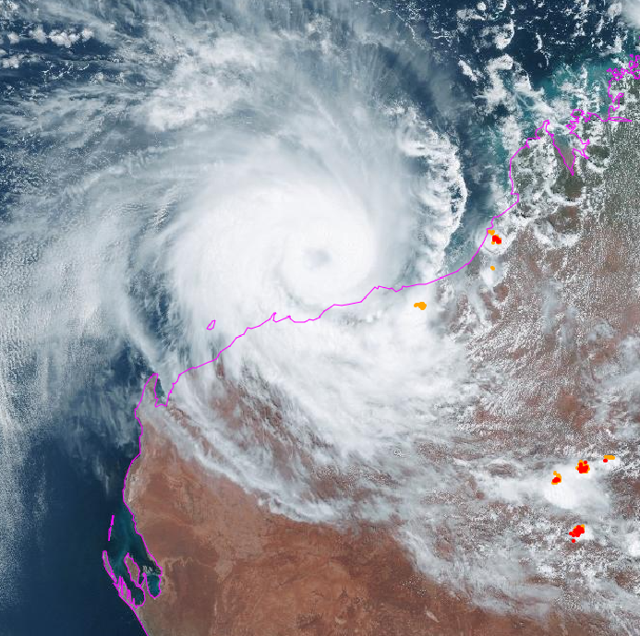

Revision history
Date | Version | Author | Description
6/7/2026 | 1.0 | EPS TC Team | Best track report

Review status
Date | Version | Reviewer | Description
9/7/2026 | 1.0 | EPS TC Team | Reviewed Best Track Report

Release history
Date | Version | Status | Approval
13/7/2026 | 1.0 | Approved | Tropical Cyclone Team Lead

Contact details:
Tropical Cyclone Team Lead
Severe Weather Environmental Prediction Services
Bureau of Meteorology
PO Box 1370, West Perth WA 6872
Email: tcwc@bom.gov.au
This work is copyright. Apart from any use as permitted under the Copyright Act 1968, no part may be reproduced without prior written permission from the Bureau of Meteorology. Refer to www.bom.gov.au/other/copyright.shtml for further information. Unless otherwise noted, all images in this document are licensed under the Creative Commons Attribution Australia Licence.
© Commonwealth of Australia 2026
Published by The Bureau of Meteorology
Cover image: Himawari-9 visible satellite image of Severe Tropical Cyclone Mitchell at 0300 UTC 7 February. Image courtesy of the Japan Meteorological Agency.

Table of Contents

1. Summary 5

2. Meteorological description 9

2.1. Intensity Analysis 9

2.2. Structure 19

2.3. Motion 20

3. Impact 21

4. Observations 22

4.1. Wind 22

4.2. Rainfall 26

4.3. Flooding 28

4.4. Pressure 28

4.5. Storm Surge 28

5. Forecast Performance 30

6. Appendix: List of Abbreviations 33

List of Figures
Figure 1. Best track of Severe Tropical Cyclone Mitchell 6
Figure 2. Detailed best track of Severe Tropical Cyclone Mitchell showing wind radii.. 7
Figure 3. Broome radar reflectivity at 2159 UTC 5 February 11
Figure 4. ASCAT pass at 1256 UTC 6 February 2026 12
Figure 5. WSFM MWI microwave images at 2137 UTC 6 February 13
Figure 6. WSFM MWI microwave images at 1007 UTC 7 February 13
Figure 7. A synthetic aperture radar (SAR) pass at 1054 UTC 7 February 2026 14
Figure 8. AMSR2 microwave images at 1802 UTC 7 February 2026 15
Figure 9. AMSR2 radiometry wind speeds at 1802 UTC 7 February 16
Figure 10. ASCAT and ASCATUHR passes at 0126 UTC and 0125 UTC 8 February 17
Figure 11. A synthetic aperture radar (SAR) pass at 1109 UTC 9 February 2026 18
Figure 12. Plot of observations at Legendre Island. 22
Figure 13. Plot of observations at Varanus Island. 23
Figure 14. Plot of observations at Barrow Island Airport 24
Figure 15. Plot of observations at Thevenard Island 25
Figure 16. Plot of observations at Carnarvon Airport 26
Figure 17. Rainfall analysis for the week ending 4 February 2026 27
Figure 18. Plot of the tide and residual in metres 29
Figure 19. The forecast percentage risk of a low developing into a tropical cyclone taken from the 7-day forecast for 21U 30
Figure 20. Position accuracy figures plotted against the 5-year average 31
Figure 21. Intensity accuracy figures plotted against the 5-year average 32
Figure 22. Full intensity plot of objective and subjective guidance 35
Figure 23. Zoomed in intensity plot of objective and subjective guidance 36

List of Tables
Table 1. Best track summary for Severe Tropical Cyclone Mitchell 8
Table 2. Daily rainfall observations 27
Table 3. Pressure observations 28
Table 4. Verification statistics for Severe Tropical Cyclone Mitchell 31

- Summary
Severe Tropical Cyclone Mitchell began as a tropical low (21U) over the Northern Territory. It produced significant inland flooding before moving west and offshore near Broome. Once over water, it tracked west-southwest roughly parallel to the Pilbara coast and rapidly intensified to reach category 3 strength before weakening and eventually crossing the coast as a tropical low near Shark Bay.
Initially forming as a tropical low over land west of the Gulf of Carpentaria on 29 January, the system produced days of heavy rainfall across the Northern Territory as it moved slowly westwards. This resulted in the Daly River reaching major flood levels and caused the evacuation of 447 people from the nearby community of Nauiyu/Daly River.
Continuing to head generally westwards across the Kimberley, the tropical low moved offshore near Broome around 2200 UTC 5 February. It intensified to tropical cyclone strength by 1500 UTC 6 February and was named Mitchell. The system then moved west-southwest, roughly parallel to the Pilbara coastline where it rapidly intensified, reaching its peak intensity as a 75 kn (140 km/h) category 3 system at 1200 UTC 7 February over water north of Karratha.
During 8 February, Mitchell weakened to category 2 strength and moved around the North West Cape, offshore from Exmouth, before then turning south. The system moved down the upper west coast as a category 1 tropical cyclone before weakening to a tropical low with quadrant gales offshore south of Carnarvon. It finally crossed the coast near Shark Bay around 1600 UTC 9 February before weakening inland and dissipating after 1200 UTC 10 February.
Mitchell did not pass close enough to coastal communities to cause any significant wind damage on the Pilbara coast. However, there were downed trees, power outages and significant disruptions to offshore industry operations for several days. Further south, strong winds caused significant banana crop losses in the Carnarvon area, while localised winds impacted some structures in the Wheatbelt.
Refer to Figure 1 for the full track of Severe Tropical Cyclone Mitchell and Table 1 for the track data. Refer to Figure 2 for an enlarged track showing gale, storm and hurricane radii.
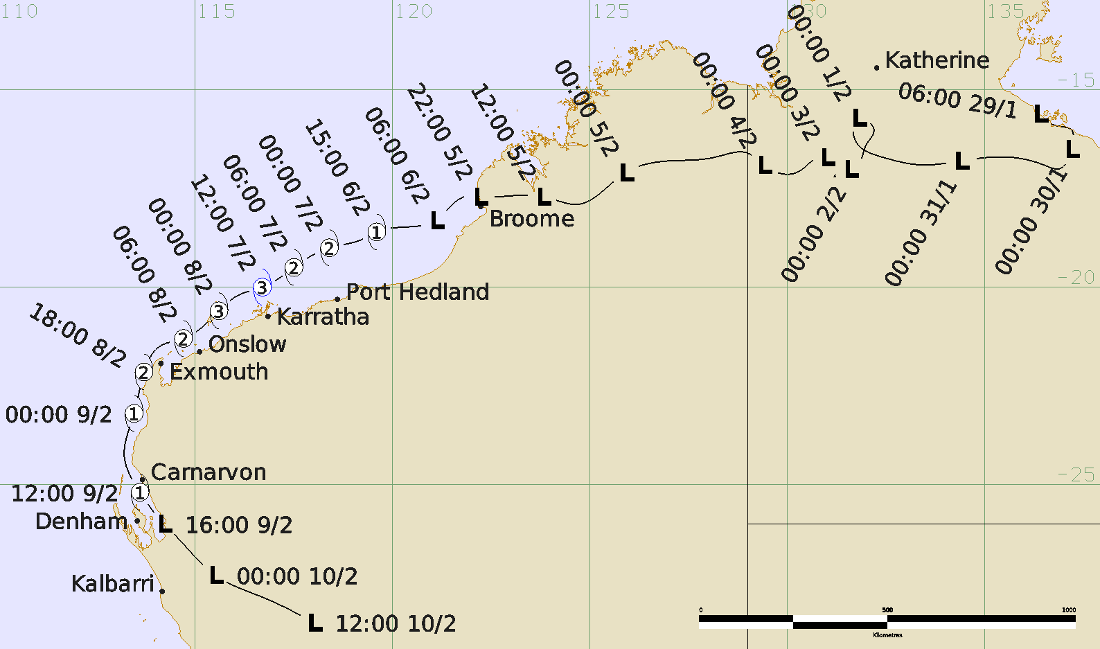
Figure 1. Best track of Severe Tropical Cyclone Mitchell, 29 January – 10 February 2026. All times are in UTC (UTC=AWST-8 hours, UTC=ACST-9.5 hours).
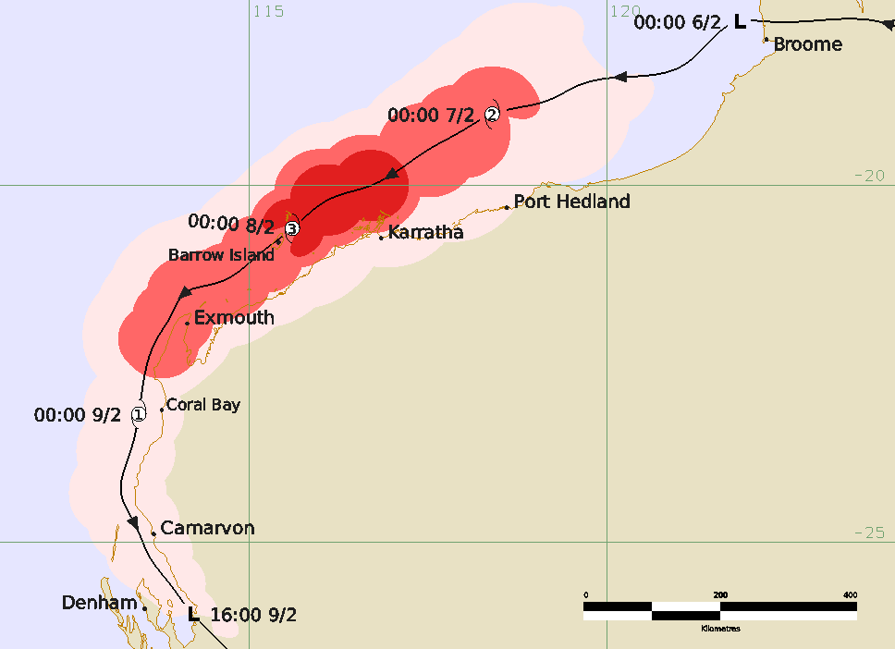
Figure 2. Detailed best track of Severe Tropical Cyclone Mitchell between 6 – 9 February showing wind radii. Gale force winds are shaded in pink, storm force in light red and hurricane force in darker red. All times are in UTC.

Year | Month | Day | Hour UTC | Pos. Lat S | Pos. Long. E | Pos. Acc. Nm | Mean wind kn | Max. gust kn | Cent. Press hPa | Rad of gales (NE/SE/SW/NW) nm | Rad of storm (NE/SE/SW/NW) nm | RMW nm
2026 | 1 | 29 | 0600 | 15.6 | 136.4 | 40 | 20 | 45 | 1001 | 0/0/0/0 | 0/0/0/0 | -
2026 | 1 | 29 | 1200 | 15.9 | 136.8 | 45 | 15 | 45 | 1003 | 0/0/0/0 | 0/0/0/0 | -
2026 | 1 | 29 | 1800 | 16.0 | 137.2 | 30 | 15 | 45 | 1001 | 0/0/0/0 | 0/0/0/0 | -
2026 | 1 | 30 | 0000 | 16.5 | 137.2 | 30 | 15 | 45 | 1003 | 0/0/0/0 | 0/0/0/0 | -
2026 | 1 | 30 | 0600 | 17.0 | 136.9 | 30 | 15 | 45 | 1001 | 0/0/0/0 | 0/0/0/0 | -
2026 | 1 | 30 | 1200 | 16.9 | 136.5 | 40 | 15 | 45 | 1002 | 0/0/0/0 | 0/0/0/0 | -
2026 | 1 | 30 | 1800 | 16.7 | 135.3 | 50 | 10 | 45 | 1000 | 0/0/0/0 | 0/0/0/0 | -
2026 | 1 | 31 | 0000 | 16.8 | 134.4 | 25 | 15 | 45 | 999 | 0/0/0/0 | 0/0/0/0 | -
2026 | 1 | 31 | 0600 | 16.9 | 133.4 | 30 | 15 | 45 | 998 | 0/0/0/0 | 0/0/0/0 | -
2026 | 1 | 31 | 1200 | 16.7 | 132.4 | 30 | 10 | 45 | 998 | 0/0/0/0 | 0/0/0/0 | -
2026 | 1 | 31 | 1800 | 16.2 | 131.7 | 30 | 10 | 45 | 998 | 0/0/0/0 | 0/0/0/0 | -
2026 | 2 | 1 | 0000 | 15.7 | 131.8 | 35 | 15 | 45 | 996 | 0/0/0/0 | 0/0/0/0 | -
2026 | 2 | 1 | 0600 | 16.0 | 132.2 | 25 | 15 | 45 | 996 | 0/0/0/0 | 0/0/0/0 | -
2026 | 2 | 1 | 1200 | 16.4 | 132.0 | 25 | 15 | 45 | 998 | 0/0/0/0 | 0/0/0/0 | -
2026 | 2 | 1 | 1800 | 16.7 | 131.9 | 25 | 15 | 45 | 998 | 0/0/0/0 | 0/0/0/0 | -
2026 | 2 | 2 | 0000 | 17.0 | 131.6 | 30 | 15 | 45 | 998 | 0/0/0/0 | 0/0/0/0 | -
2026 | 2 | 2 | 0600 | 17.0 | 131.6 | 20 | 20 | 45 | 997 | 0/0/0/0 | 0/0/0/0 | -
2026 | 2 | 2 | 1200 | 17.2 | 131.2 | 25 | 15 | 45 | 999 | 0/0/0/0 | 0/0/0/0 | -
2026 | 2 | 2 | 1800 | 16.8 | 131.4 | 30 | 20 | 45 | 995 | 0/0/0/0 | 0/0/0/0 | -
2026 | 2 | 3 | 0000 | 16.7 | 131.0 | 20 | 20 | 45 | 999 | 0/0/0/0 | 0/0/0/0 | -
2026 | 2 | 3 | 0600 | 16.9 | 130.9 | 30 | 20 | 45 | 998 | 0/0/0/0 | 0/0/0/0 | -
2026 | 2 | 3 | 1200 | 16.8 | 130.8 | 35 | 15 | 45 | 1000 | 0/0/0/0 | 0/0/0/0 | -
2026 | 2 | 3 | 1800 | 17.0 | 130.4 | 30 | 15 | 45 | 999 | 0/0/0/0 | 0/0/0/0 | -
2026 | 2 | 4 | 0000 | 16.9 | 129.4 | 20 | 15 | 45 | 1002 | 0/0/0/0 | 0/0/0/0 | -
2026 | 2 | 4 | 0600 | 16.6 | 129.0 | 20 | 15 | 45 | 999 | 0/0/0/0 | 0/0/0/0 | -
2026 | 2 | 4 | 1200 | 16.7 | 128.2 | 35 | 10 | 45 | 1002 | 0/0/0/0 | 0/0/0/0 | -
2026 | 2 | 4 | 1800 | 16.8 | 127.0 | 40 | 10 | 45 | 1000 | 0/0/0/0 | 0/0/0/0 | -
2026 | 2 | 5 | 0000 | 17.1 | 125.9 | 40 | 15 | 45 | 1001 | 0/0/0/0 | 0/0/0/0 | -
2026 | 2 | 5 | 0600 | 17.9 | 124.7 | 30 | 15 | 45 | 999 | 0/0/0/0 | 0/0/0/0 | -
2026 | 2 | 5 | 1200 | 17.7 | 123.8 | 30 | 15 | 45 | 999 | 0/0/0/0 | 0/0/0/0 | -
2026 | 2 | 5 | 1800 | 17.7 | 122.8 | 20 | 20 | 45 | 998 | 0/0/0/0 | 0/0/0/0 | -
2026 | 2 | 5 | 2200 | 17.7 | 122.2 | 15 | 25 | 45 | 997 | 0/0/0/0 | 0/0/0/0 | -
2026 | 2 | 6 | 0000 | 17.7 | 121.9 | 10 | 25 | 45 | 997 | 0/0/0/0 | 0/0/0/0 | -
2026 | 2 | 6 | 0600 | 18.3 | 121.1 | 15 | 30 | 45 | 997 | 0/0/0/0 | 0/0/0/0 | -
2026 | 2 | 6 | 1200 | 18.5 | 120.0 | 15 | 35* | 50 | 994 | 0/40/40/0 | 0/0/0/0 | -
2026 | 2 | 6 | 1500 | 18.6 | 119.6 | 20 | 40 | 55 | 990 | 0/50/60/70 | 0/0/0/0 | 23
2026 | 2 | 6 | 1800 | 18.8 | 119.2 | 20 | 45 | 65 | 988 | 50/70/70/90 | 0/0/0/0 | 22
2026 | 2 | 7 | 0000 | 19.0 | 118.4 | 15 | 50 | 70 | 984 | 70/70/70/70 | 40/0/0/40 | 20
2026 | 2 | 7 | 0600 | 19.5 | 117.5 | 12 | 60 | 85 | 974 | 70/85/60/60 | 40/40/40/40 | 18
2026 | 2 | 7 | 1200 | 20.0 | 116.7 | 12 | 75 | 105 | 963 | 70/75/55/60 | 40/40/40/45 | 15
2026 | 2 | 7 | 1800 | 20.2 | 116.1 | 12 | 70 | 100 | 966 | 70/65/55/60 | 40/40/40/45 | 17
2026 | 2 | 8 | 0000 | 20.6 | 115.6 | 13 | 65 | 90 | 971 | 75/70/65/60 | 35/35/30/35 | 17
2026 | 2 | 8 | 0600 | 21.3 | 114.7 | 13 | 60 | 85 | 974 | 65/55/60/60 | 30/35/30/30 | 19
2026 | 2 | 8 | 1200 | 21.5 | 114.1 | 14 | 60 | 85 | 974 | 65/55/60/60 | 30/35/30/30 | 19
2026 | 2 | 8 | 1800 | 22.2 | 113.7 | 10 | 55 | 75 | 978 | 65/50/55/60 | 30/35/30/30 | 21
2026 | 2 | 9 | 0000 | 23.2 | 113.5 | 15 | 45 | 65 | 984 | 35/35/40/45 | 0/0/0/0 | 22
2026 | 2 | 9 | 0600 | 24.3 | 113.2 | 15 | 45 | 65 | 984 | 35/35/40/40 | 0/0/0/0 | 22
2026 | 2 | 9 | 1200 | 25.2 | 113.6 | 15 | 45 | 65 | 984 | 35/30/30/35 | 0/0/0/0 | 23
2026 | 2 | 9 | 1600 | 26.0 | 114.2 | 20 | 35* | 50 | 992 | 20/0/0/25 | 0/0/0/0 | -
2026 | 2 | 9 | 1800 | 26.3 | 114.5 | 20 | 35* | 50 | 994 | 20/0/0/0 | 0/0/0/0 | -
2026 | 2 | 10 | 0000 | 27.3 | 115.5 | 25 | 30 | 45 | 997 | 0/0/0/0 | 0/0/0/0 | -
2026 | 2 | 10 | 0600 | 27.9 | 116.8 | 25 | 25 | 45 | 998 | 0/0/0/0 | 0/0/0/0 | -
2026 | 2 | 10 | 1200 | 28.5 | 118.0 | 25 | 20 | 45 | 1002 | 0/0/0/0 | 0/0/0/0 | -
Table 1. Best track summary for Severe Tropical Cyclone Mitchell, 29 January to 10 February 2026. UTC=AWST-8 hours, UTC=ACST-9.5 hours.
* Not a tropical cyclone as gales less than halfway around centre.

- Meteorological description
  - Intensity Analysis
The tropical low that became Severe Tropical Cyclone Mitchell formed over the Northern Territory during 29 January 2026. It remained a tropical low while moving generally westwards across the Northern Territory and the Kimberley, though with periods of deep convection and significant rotation.
Before moving offshore near Broome at 2200 UTC 5 February, the system had developed a significant rotating vortex evident on satellite and radar imagery (refer Figure 3) that had been enhanced by earlier convection near the northwest Kimberley coast. As substantial structure had already developed when the system was over land, the standard initial application of the Dvorak technique was not considered appropriate. Thus, it was given a starting Dvorak DT number of 2.0 using a curved band pattern at 0000 UTC 6 February.
Once over the warm waters offshore of the Kimberley, the system began rapidly developing. By 1200 UTC 6 February, the system had a DT of 3.0 based on a curved band pattern, with gales confirmed in the southern quadrants by a 1256 UTC ASCAT pass (refer Figure 4) and an intensity of 35 kn (65 km/h). At 1500 UTC, Mitchell was a 40 kn (75 km/h) category 1 tropical cyclone based on observations of gales beginning from 1534 UTC at Rowley Shoals to the northwest.
Mitchell intensified rapidly during the remainder of 6 and 7 February as convection consolidated around the centre and the inner circulation tightened. WSFM microwave imagery at 2137 UTC 6 February showed a well-developed low-level structure, including an eye-like feature, with the deepest convection in the northern quadrants (refer Figure 5).
By 1200 UTC 7 February, Mitchell was at its peak intensity as a category 3 system at 75 kn (140 km/h), representing a 40 kn (75 km/h) increase in intensity in just 24 hours. At the time, the closest observations site was about 23 nm (43 km) to the south-southeast at the exposed site of Legendre Island. It observed a maximum 10-minute mean wind of 71 kn (132 km/h) at 1149 UTC (refer Figure 12), though with an RMW of just 15 nm (28 km) and the deepest convection north of the system (refer Figure 6) it is assumed Legendre Island did not sample the strongest winds. Dvorak FT also reached its peak at 4.5 based on a 3-hour averaged eye pattern with an adjustment for an elongated eye. Objective estimates were also in line, with their general consensus around 75 kn (140 km/h) (refer Figure 23). A SAR pass at 1054 UTC (refer Figure 7) indicated peak mean winds may have been higher at over 80 kn (150 km/h) but was discounted on suspicion of overestimating wind speeds.
During the remainder of 7 February, increasing easterly to northeasterly vertical wind shear caused dry air to intrude into the system core and by 1800 UTC Mitchell had started to weaken. The eye had become erratic and unusable for Dvorak analysis, with a transition to embedded centre pattern for DT. Radar imagery showed a weak to incomplete eastern eyewall, consistent with dry air wrapping in. An AMSR2 pass at 1802 UTC 7 February further confirmed this weak eastern eyewall (refer Figure 8), though still with hurricane force winds (refer Figure 9). Overall, intensity was biased to Dvorak with CI held at 4.5 and thus an intensity of 70 kn (130 km/h).
Mitchell continued to steadily weaken during 8 February. During the morning, Mitchell passed very close to the observation stations at Varanus Island and Barrow Island Airport, and both were able to sample the southern eyewall (refer Figure 13 and Figure 14). Peak 10-minute mean winds were 56 kn (103 km/h) at Varanus Island at 2206 UTC 7 February, and 59 kn (109 km/h) at Barrow Island Airport at 0001 UTC 8 February. Neither site observed hurricane force winds, though the strongest winds were likely still in northern parts of the eyewall. An ASCAT and ASCATUHR pass around 0125 UTC showed no hurricane force winds remaining (refer Figure 10), and Mitchell was analysed at 60 kn (110 km/h) at 0600 UTC 8 February.
By 0000 UTC 9 February, Mitchell had weakened to a 45 kn (85 km/h) category 1 system due to the combined factors of vertical wind shear, dry air, land effects and reducing sea surface temperatures. It was last at tropical cyclone strength at 1200 UTC 9 February while still offshore in Shark Bay. Quadrant gales were estimated to have persisted until shortly after landfall up to 1800 UTC 9 February. This was based on an earlier SAR pass at 1109 UTC 9 February (refer Figure 11) that showed mean wind speeds over 45 kn (85 km/h) and observations at Carnarvon Airport (refer Figure 16) showing southeasterly then northwesterly gales as the system passed, peaking at 38 kn (71 km/h), and ceasing only at 1329 UTC 9 February.
Once over land, Mitchell began to dissipate into a broader trough and could not be tracked after 1200 UTC 10 February.
A full comparison of subjective and objective intensity estimates is included in Figure 22, with a zoomed in version included in Figure 23.
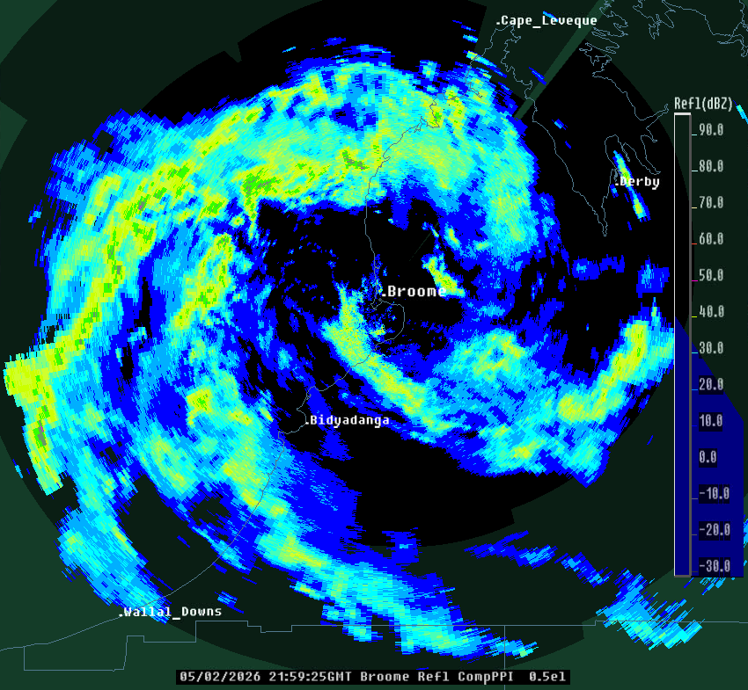
Figure 3. Broome radar reflectivity at 2159 UTC 5 February showing a well-developed vortex already formed as the tropical low that was to become Severe Tropical Cyclone Mitchell first transitioned from land to water.
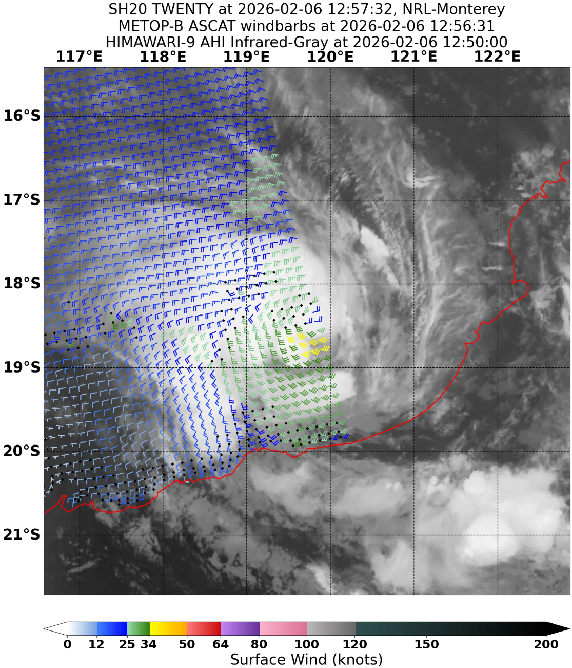
Figure 4. ASCAT pass at 1256 UTC 6 February 2026 showing gales in the southern quadrants. Image courtesy NRL: https://www.nrlmry.navy.mil/TC.html
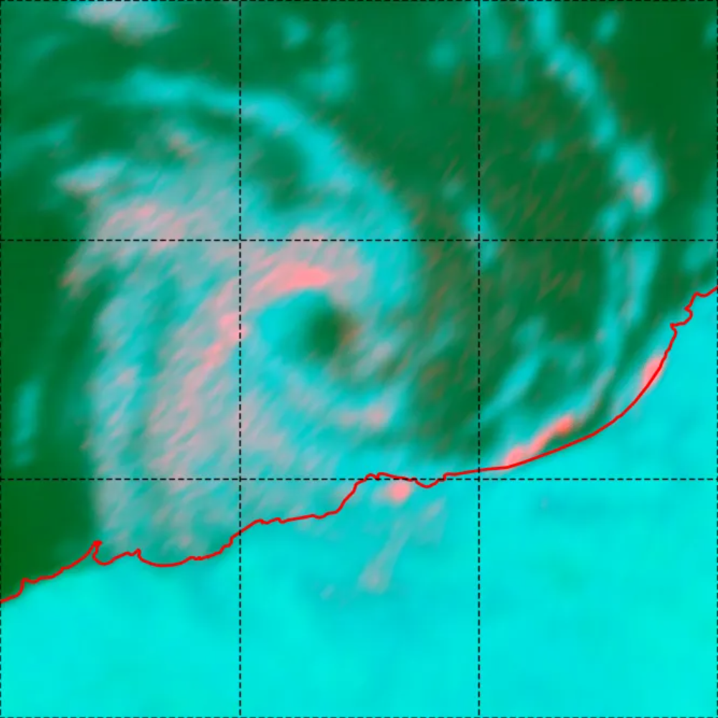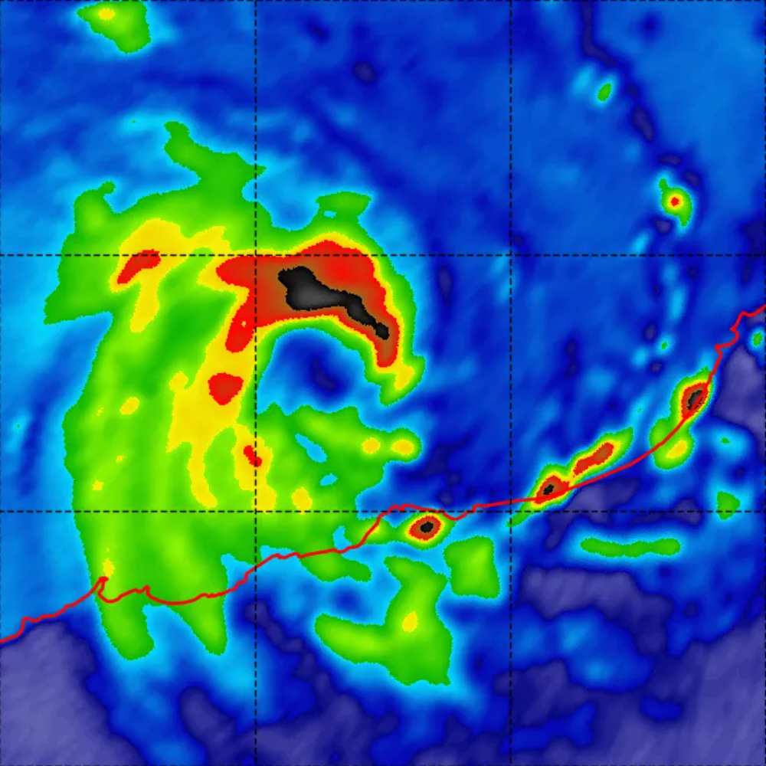
Figure 5. Color37GHz (left) and 89GHz (right) WSFM MWI microwave images at 2137 UTC 6 February showing an eye like feature and the deepest convection in northern quadrants. Images courtesy NRL: https://www.nrlmry.navy.mil/TC.html

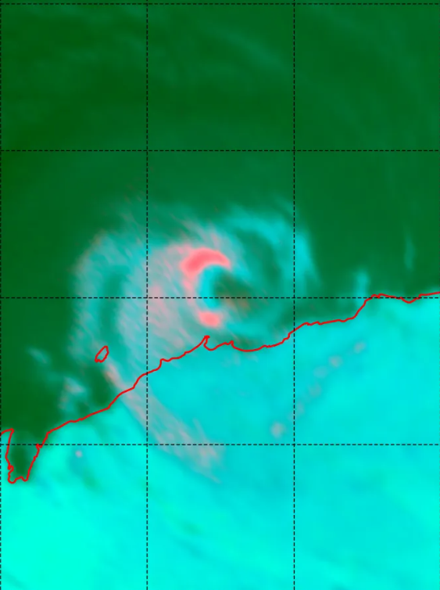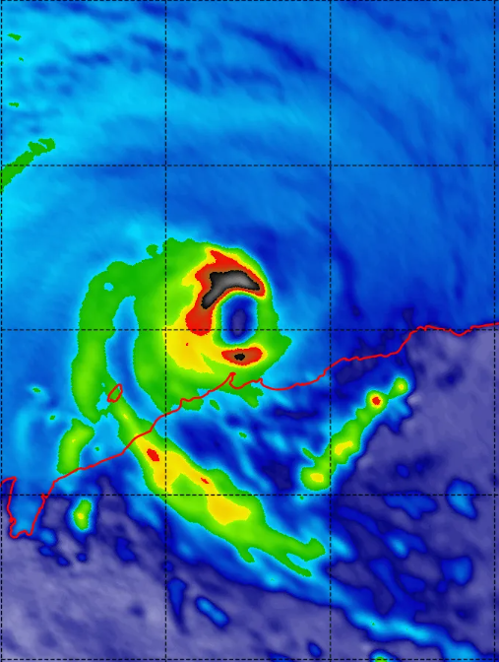
Figure 6. Color37GHz (left) and 89GHz (right) WSFM MWI microwave images at 1007 UTC 7 February near the time of peak intensity showing the deepest convection in the northern part of the eyewall. Images courtesy NRL: https://www.nrlmry.navy.mil/TC.html
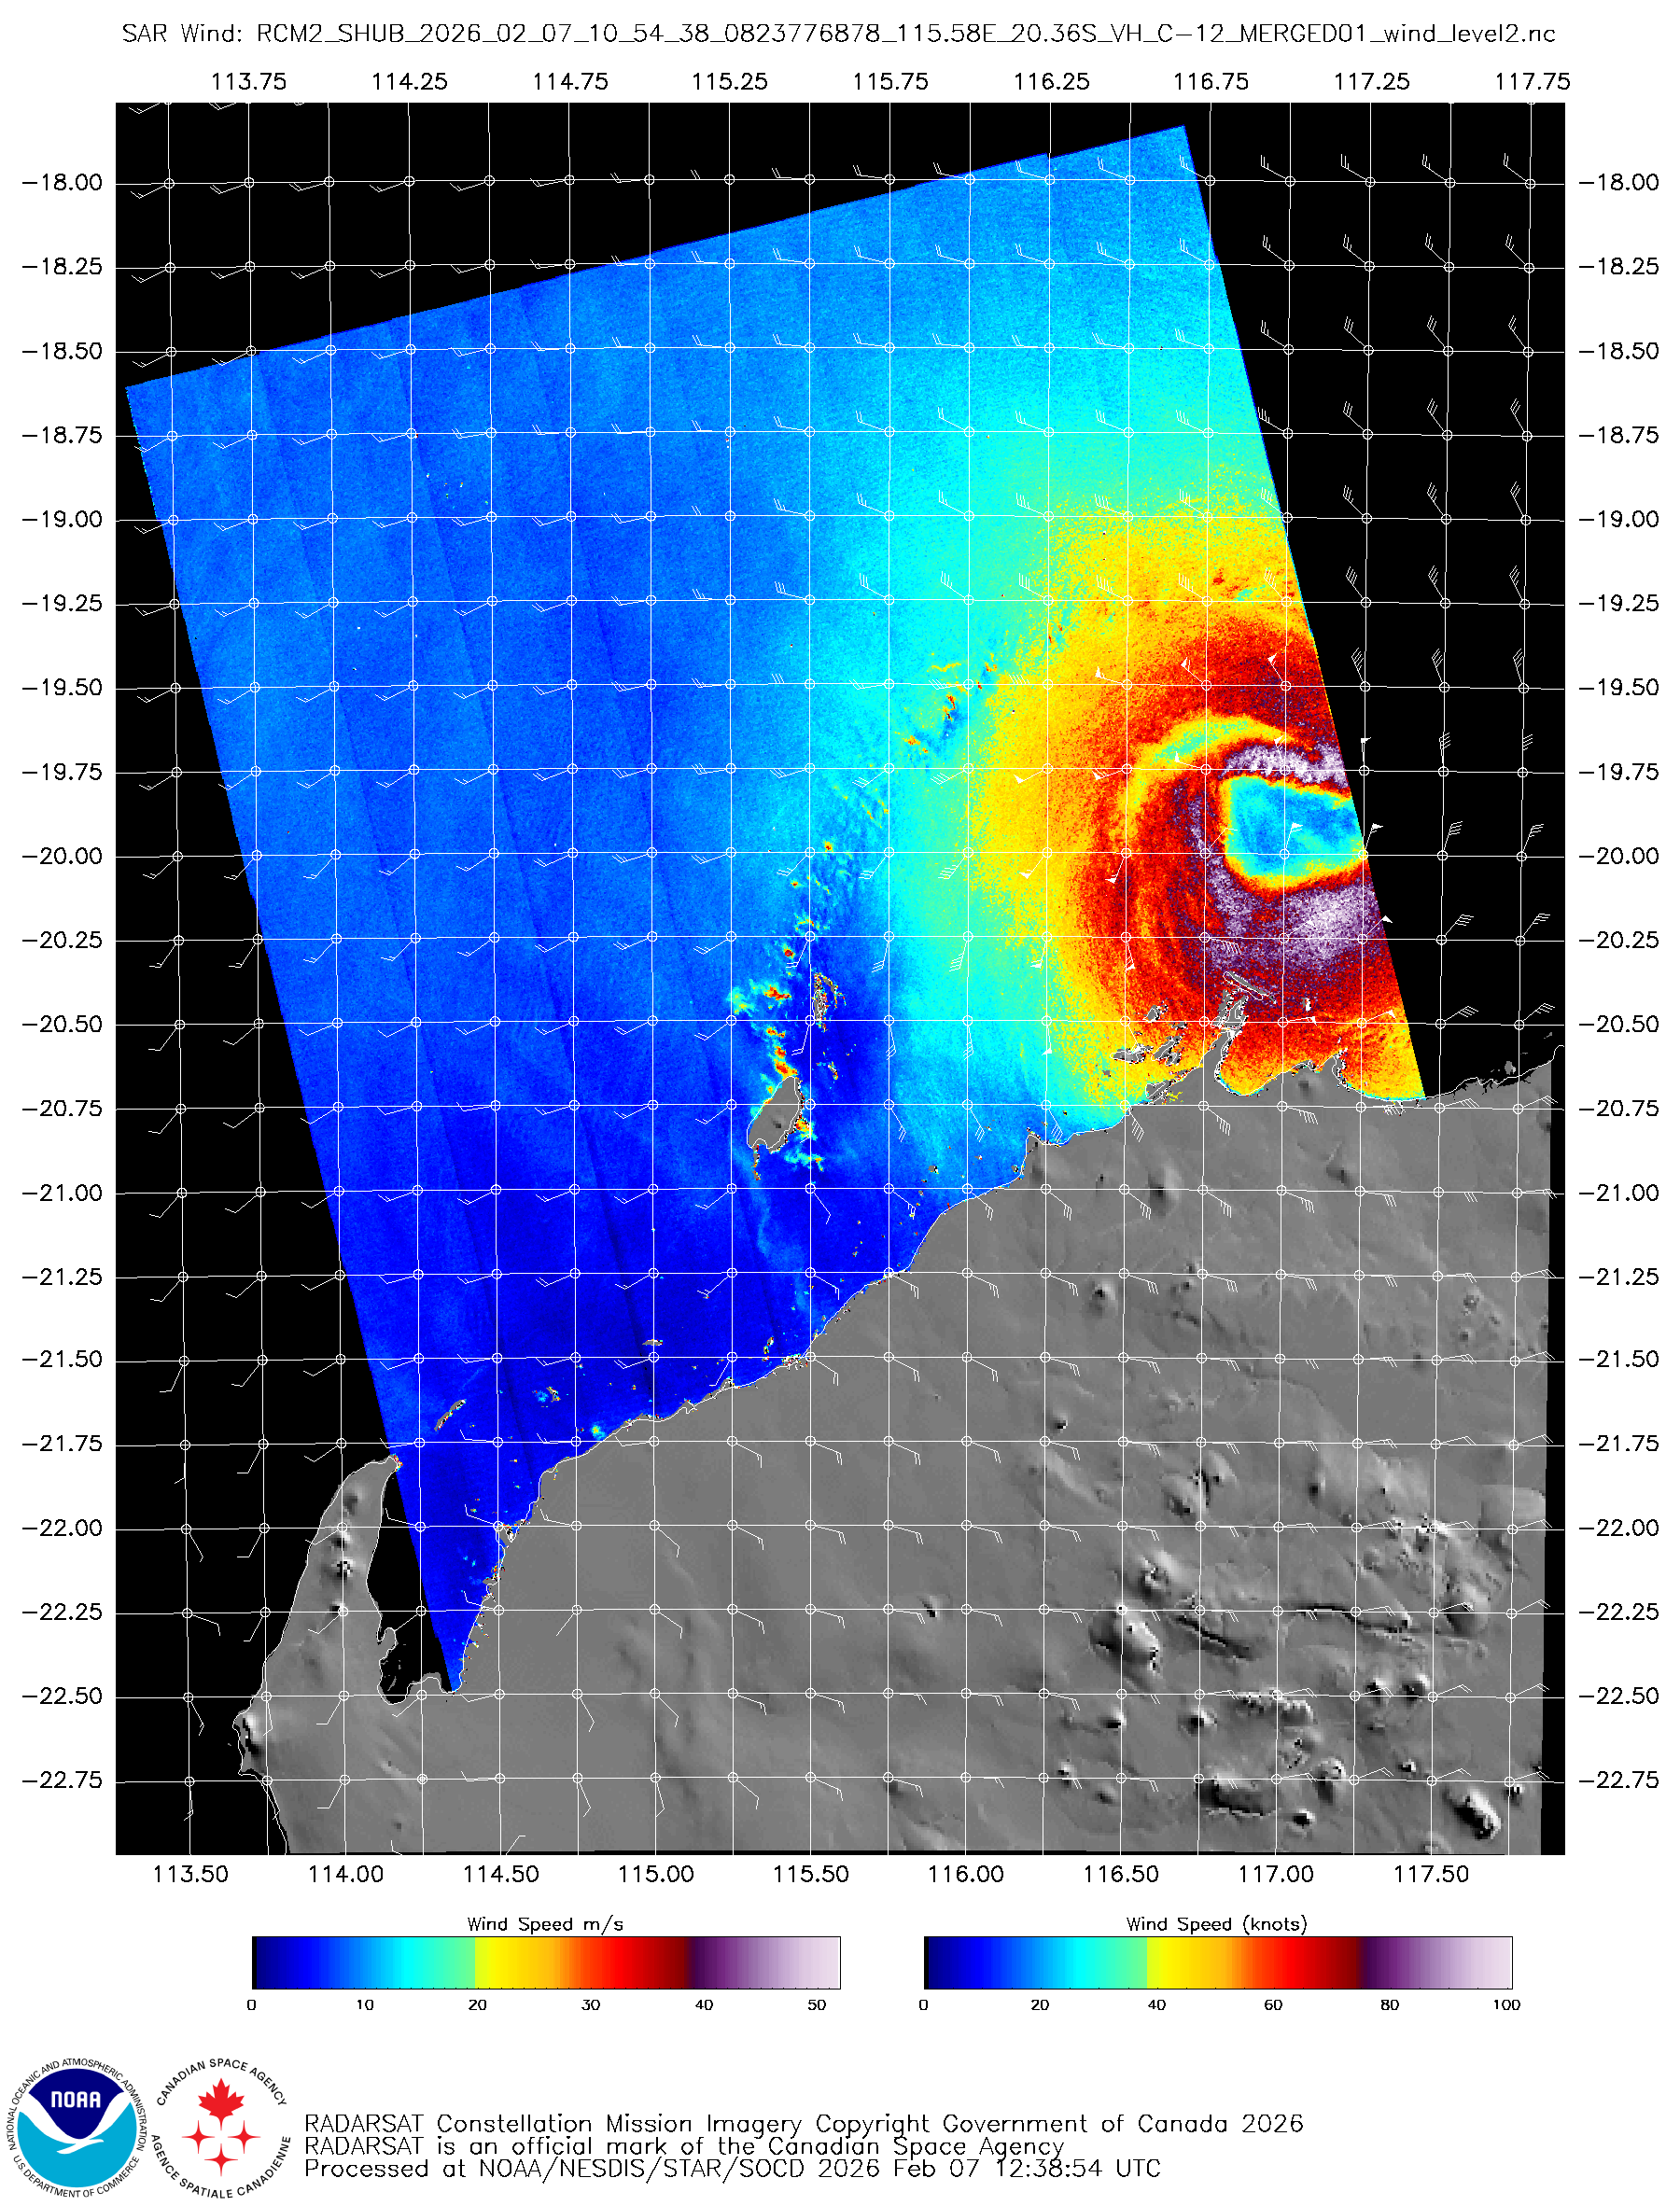
Figure 7. A synthetic aperture radar (SAR) pass at 1054 UTC 7 February 2026 showing Severe Tropical Cyclone Mitchell at or near peak intensity. Image courtesy NOAA: https://www.star.nesdis.noaa.gov/socd/mecb/sar/sarwinds_tropical.php?year=2026&storm=SH202026_MITCHELL
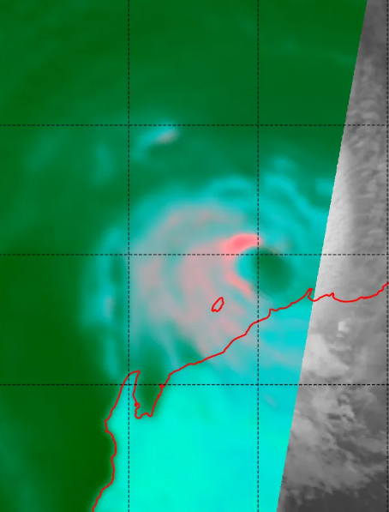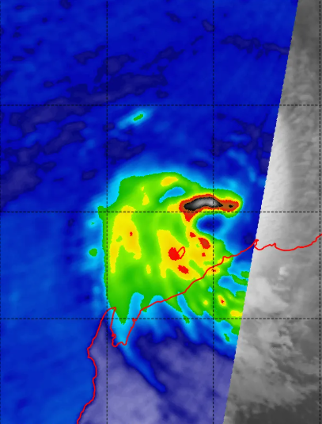
Figure 8. Color37GHz (left) and 89 GHz (right) AMSR2 microwave images at 1802 UTC 7 February 2026 showing a comparatively weak eastern eyewall through depth. Images courtesy NRL: https://www.nrlmry.navy.mil/TC.html
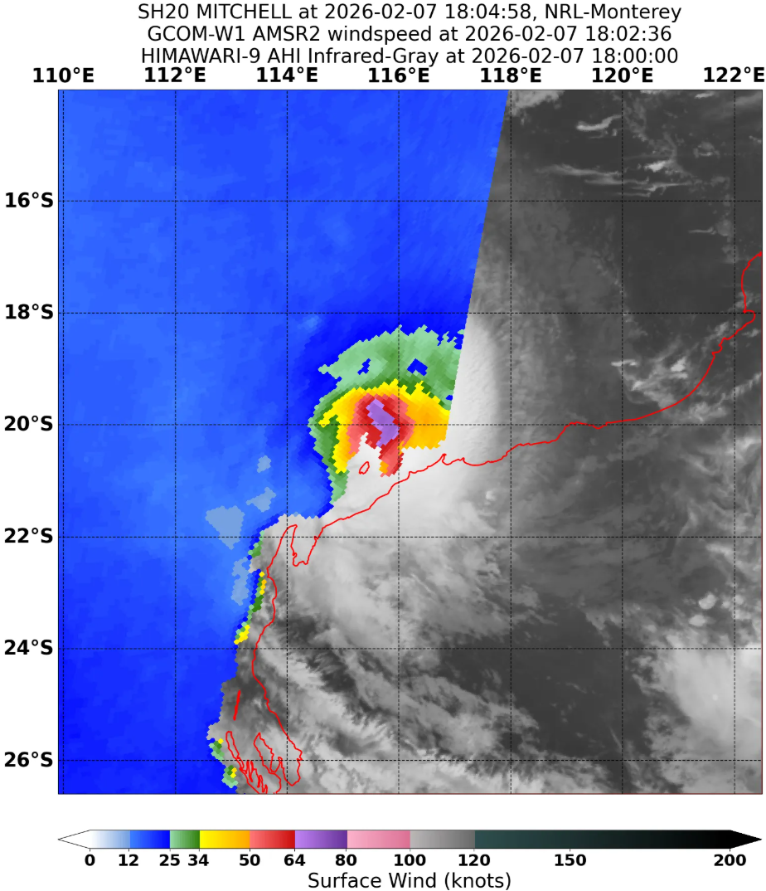
Figure 9. AMSR2 radiometry wind speeds at 1802 UTC 7 February showing hurricane force winds. Image courtesy NRL: https://www.nrlmry.navy.mil/TC.html
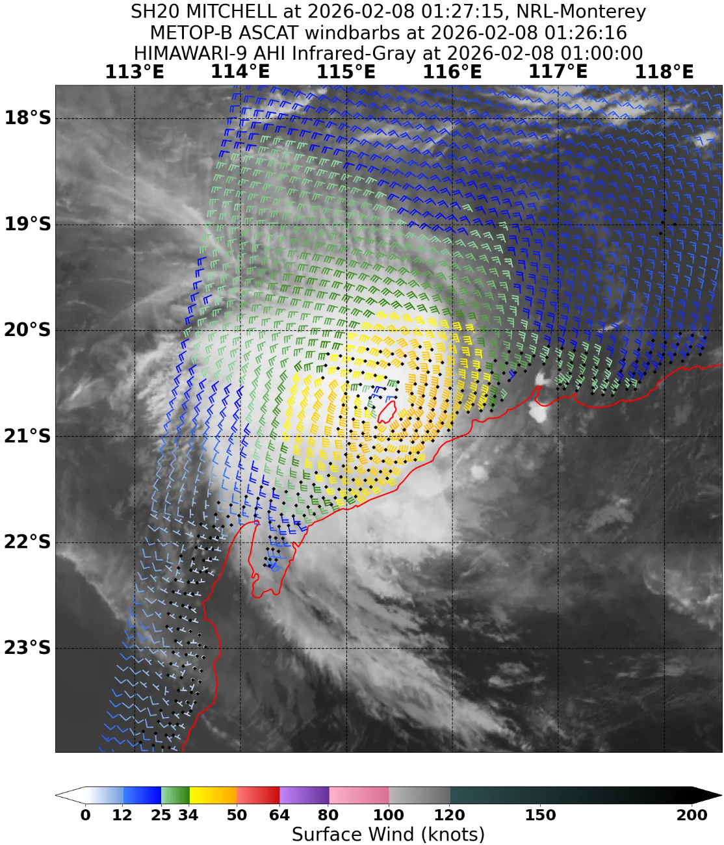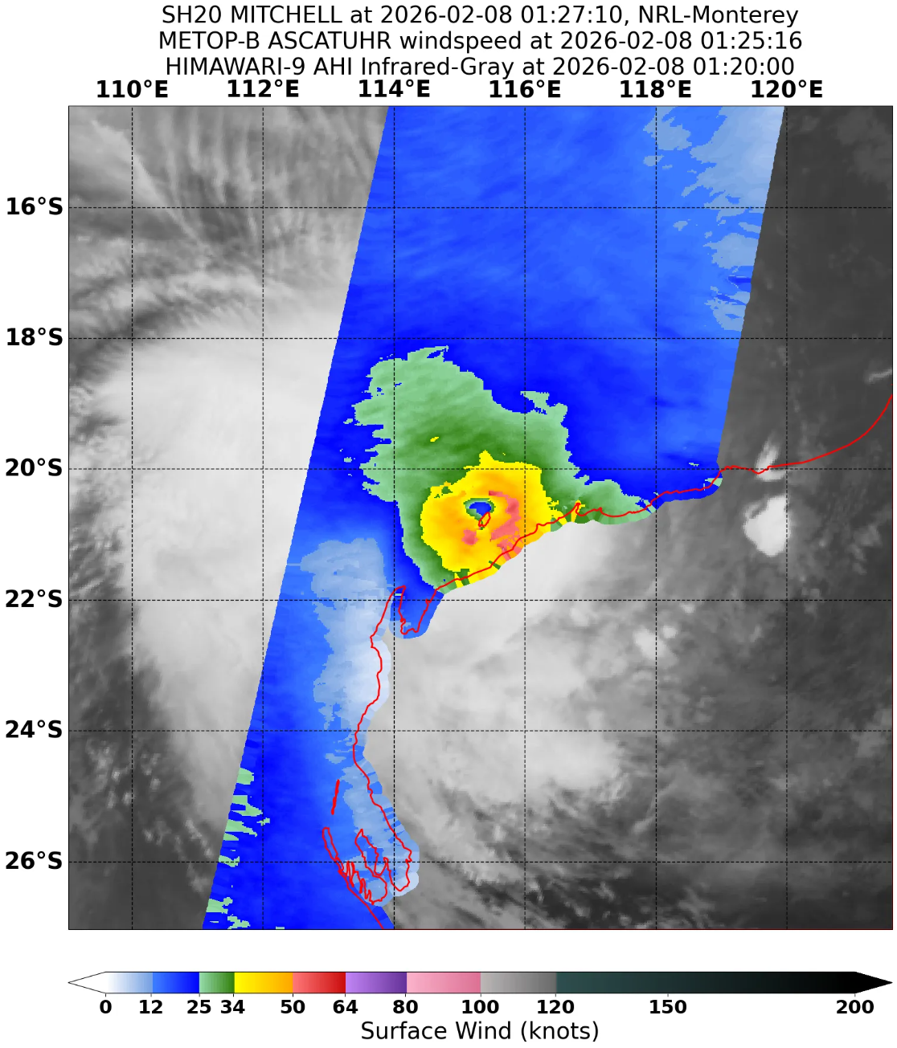
Figure 10. ASCAT (left) and ASCATUHR (right) passes at 0126 UTC and 0125 UTC 8 February from the Metop-B satellite showing gale radii and a well-developed system. Images courtesy NRL: https://www.nrlmry.navy.mil/TC.html

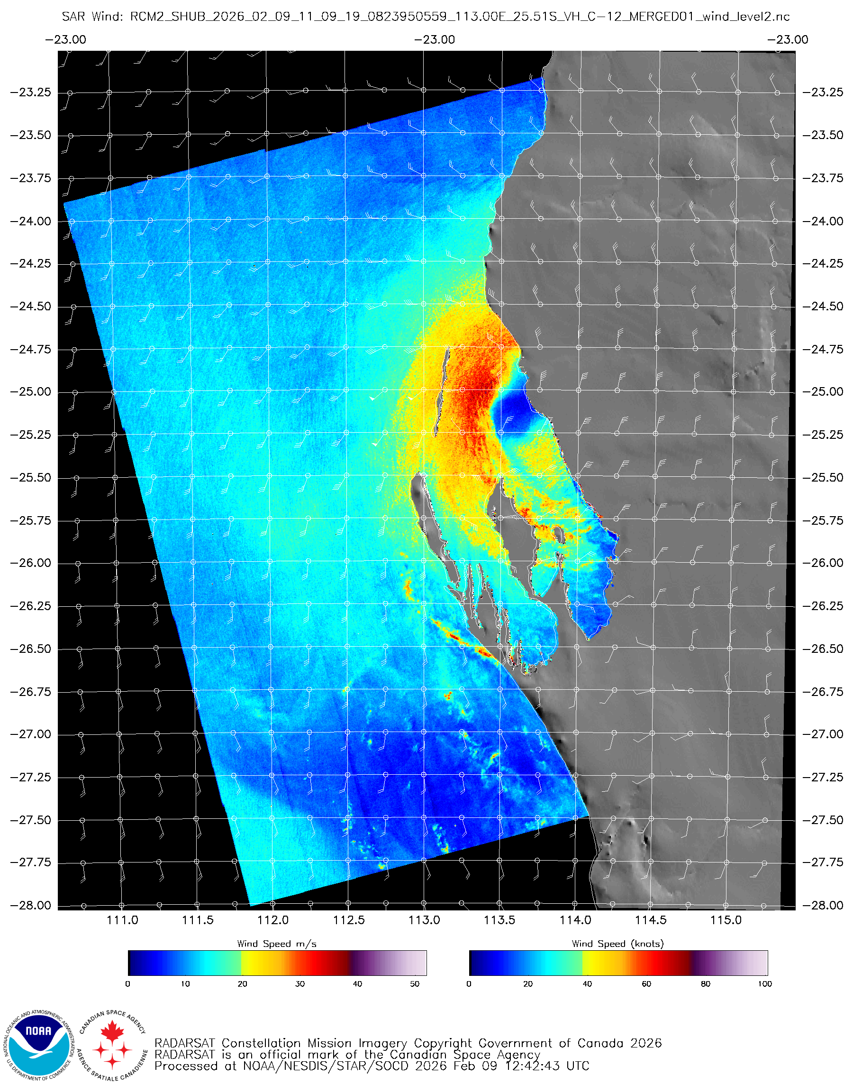
Figure 11. A synthetic aperture radar (SAR) pass at 1109 UTC 9 February 2026 showing gales in at least three quadrants, though weakest in the southeast. Image courtesy NOAA: https://www.star.nesdis.noaa.gov/socd/mecb/sar/sarwinds_tropical.php?year=2026&storm=SH202026_MITCHELL
  - Structure
Mitchell was unusual in that much of its low-level structure developed over land before the system moved offshore west of Broome late on 5 February. Prior to moving over water, radar and satellite imagery showed a well-developed vortex (see Figure 3), but gale-force winds were not analysed around the circulation. Once offshore, the system organised quickly. At 1200 UTC 6 February, gales were analysed in the southern quadrants to 40 nm (75 km) but did not yet extend more than halfway around the centre (see Figure 4). By 1500 UTC, gales had expanded into the northwest quadrant and wrapped more than halfway around the circulation, and Mitchell was classified as a tropical cyclone. This was supported by gale force wind observations at Rowley Shoals from 1534 UTC.
Microwave and radar imagery showed a well-defined eye and eyewall structure during 7 February, although the eye was at times ragged or transient on infrared imagery. As Mitchell intensified, the gale force wind field expanded, reaching 60–85 nm (110–155 km) by 0600 UTC. The radius of maximum winds (RMW) contracted to around 15 nm (28 km) by 1200 UTC 7 February. A SAR pass at 1054 UTC (see Figure 7) supported the analysed inner core and the extent of the gale, storm and hurricane force winds near peak intensity. At 1200 UTC, gale radii extended to 55–75 nm (100–140 km), storm-force winds to 40–45 nm (75–85 km), and hurricane-force winds were confined to within about 30 nm (55 km) of the centre.
After peak intensity, the inner-core structure began to slowly degrade. Radar, microwave and SAR data suggested some expansion and disruption of the eyewall. Consistent with this, the RMW expanded slightly to around 17 nm (31 km) by 1800 UTC 7 February. Despite this weakening trend, Mitchell maintained a reasonably coherent structure, with gale radii still generally 55–75 nm (100–140 km) and storm-force radii about 30–45 nm (55–85 km) through early 8 February. Hurricane force winds were no longer analysed after 0000 UTC 8 February.
During 8 February, Mitchell moved close to the Pilbara and upper west coast. Easterly to northeasterly vertical wind shear allowed dry air to intrude into the system core with the strongest deep convection confined to western and northern parts of the circulation, while land interaction began weakening the southeastern quadrant of the wind field. Scatterometry (see Figure 10) and SAR data during 8 February supported gales in all quadrants, generally 55–65 nm (100–120 km), with storm-force winds still present to about 30–35 nm (55–65 km).
By 0000 UTC 9 February, Mitchell’s gale radii had contracted markedly to around 35–45 nm (65–85 km), and storm-force winds were no longer analysed. The smallest gale radii were generally in the eastern quadrants, where land interaction and weakening convection had the greatest influence. Although the system was weakening, an RCM-2 SAR pass near 1109 UTC 9 February (see Figure 11) and gale-force observations at Carnarvon supported the analysis that gales still extended around the circulation at 1200 UTC, though the eastern side of the wind field was less certain. The RMW had expanded to around 23 nm (43 km) by this time.
Mitchell lost tropical cyclone structure as it approached the Gascoyne coast near Shark Bay late on 9 February. By 1600 UTC, gales were analysed only in the northern quadrants. By 1800 UTC, only a small area of gales remained in the northeast quadrant, and by 0000 UTC 10 February no gale-force winds were analysed in any quadrant. The remnant circulation became diffuse over inland Western Australia and could no longer be tracked after 1200 UTC 10 February.
  - Motion
After forming as a tropical low on 29 January, Mitchell moved generally westwards across northern Australia under the steering influence of a mid-level ridge to the south. At times, this westward steering was opposed by monsoonal northwesterlies to the north. The competing steering influences caused Mitchell to stall over the central Northern Territory between 1 and 3 February. Its slow movement was a major factor in the prolonged heavy rainfall and flooding across the region.
Mitchell moved offshore to the west of Broome late on 5 February and subsequently tracked west-southwest, approximately parallel to the Pilbara coast, along the northern and western periphery of a mid-level ridge located to the southeast. During 8 February, an approaching mid-level trough from the southwest weakened the ridge and caused Mitchell to gradually turn southwestwards and then southwards along the upper west coast.
On 9 February, this trough increasingly influenced Mitchell, steering it towards the south-southeast. Mitchell crossed the Gascoyne coast at 1600 UTC 9 February near Shark Bay as a tropical low. The remnant low continued southeastwards across inland Western Australia on 10 February before dissipating.

- Impact
Severe Tropical Cyclone Mitchell caused significant inland flooding in the Northern Territory before intensifying off the west Kimberley coast and tracking roughly parallel to the Pilbara coast. The Daly River reached major flood level, peaking at 14.26 m on 11 February, with 447 people evacuated and registered by the Australian Red Cross from the Nauiyu/Daly River community.
Coastal impacts in the Pilbara and Gascoyne were generally less severe than feared, with mostly minor structural damage, downed trees, localised flooding, road and school closures, power outages, and disruption to offshore industry operations. Community preparedness helped mitigate impacts otherwise. The most significant damage in Western Australia was agricultural, with strong winds causing substantial banana crop losses around Carnarvon.
Reports from ABC News:
- https://www.abc.net.au/news/2026-02-04/emergency-evacuation-for-daly-river-ahead-of-major-flooding/106305594
- https://www.abc.net.au/news/2026-02-09/tropical-cyclone-mitchell-downgraded-to-category-one-system/106319648
- https://www.abc.net.au/news/2026-02-09/tropical-cyclone-mitchell-has-crossed-the-wa-north-west-coast/106322566
- https://www.abc.net.au/news/2026-02-11/strong-winds-wreak-havoc-on-farm-properties-wheatbelt-region/106329960

- Observations
  - Wind
Many observation sites along and offshore of the Pilbara and Gascoyne coasts observed gale force winds or higher during Severe Tropical Cyclone Mitchell (refer Figure 2). Listed in order of onset time, a summary of each is included below. All times are in UTC (UTC=AWST-8h).
Rowley Shoals observed intermittent gale force winds between 1534 UTC and 2144 UTC 6 February, with a total time in gales of 57 minutes. The maximum 10-minute mean wind was 38 kn (69 km/h) at 2120 UTC 6 February, and the maximum wind gust was 46 kn (85 km/h) at 2113 UTC 6 February.
Port Hedland Airport observed a brief period of intermittent gale force winds between 0601 UTC and 0618 UTC 7 February, with a total time in gales of 9 minutes. The maximum 10-minute mean wind was 37 kn (68 km/h) at 0603 UTC 7 February, and the maximum wind gust was 50 kn (93 km/h) at 0614 UTC 7 February.
Legendre Island observed intermittent gale force winds between 0627 UTC 7 February and 0114 UTC 8 February, for a total of 18 hours and 11 minutes. Intermittent storm force winds were observed between 0901 UTC and 1705 UTC 7 February, for a total of 7 hours and 47 minutes. Intermittent hurricane force winds were recorded between 1043 UTC and 1221 UTC 7 February, for a total of 1 hour and 22 minutes. The maximum 10-minute mean wind was 71 kn (132 km/h) at 1149 UTC 7 February, and the maximum wind gust was 91 kn (169 km/h) at 1106 UTC 7 February. A plot of these winds is included in Figure 12.
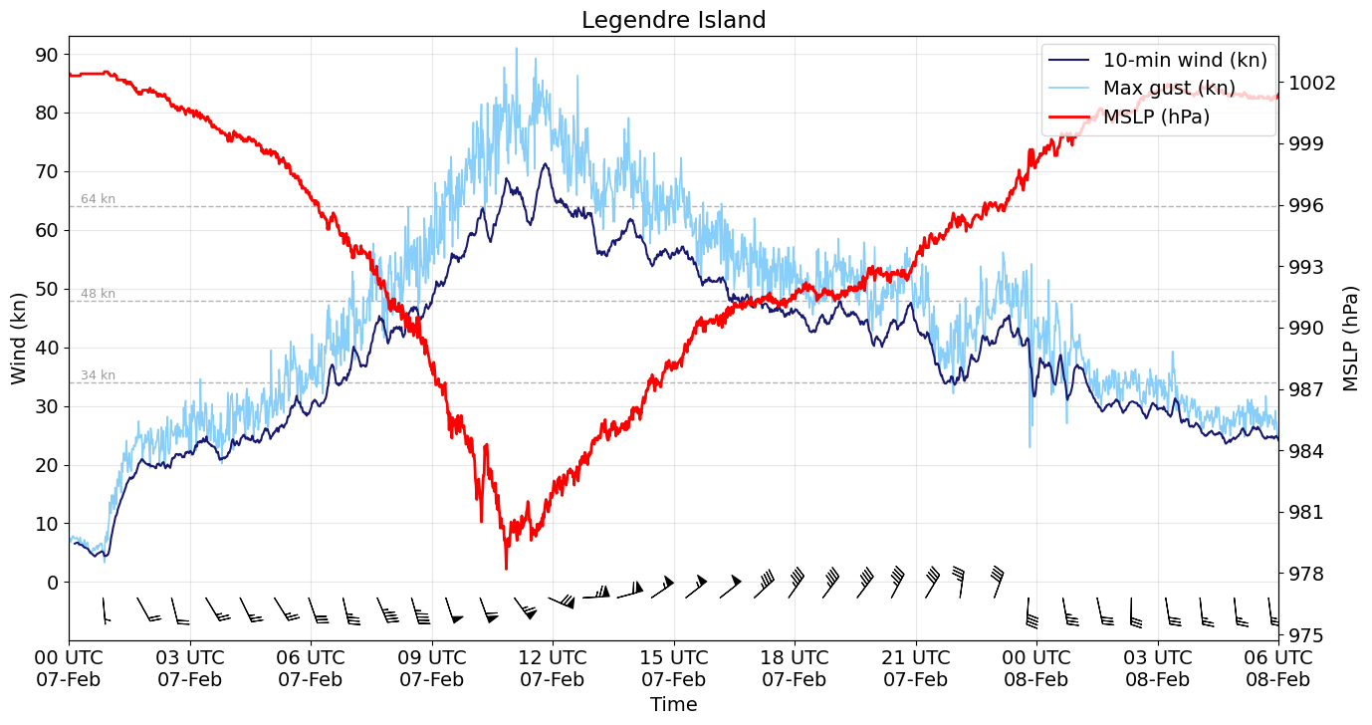
Figure 12. Plot of 10-minute mean winds (dark blue), maximum 3-second wind gusts (light blue), wind barbs and MSLP (red) observations at Legendre Island during the passage of Severe Tropical Cyclone Mitchell.
Roebourne Aerodrome observed intermittent gale force winds between 0920 UTC and 1215 UTC 7 February, for a total of 2 hours and 18 minutes. The maximum 10-minute mean wind was 39 kn (71 km/h) at 1112 UTC 7 February, and the maximum wind gust was 51 kn (94 km/h) at 1140 UTC 7 February.
Karratha Aerodrome observed intermittent gale force winds between 1018 UTC 7 February and 0005 UTC 8 February, for a total of 11 hours and 39 minutes. The maximum 10-minute mean wind was 42 kn (78 km/h) at 1251 UTC 7 February, and the maximum wind gust was 54 kn (100 km/h) at 1240 UTC 7 February.
Varanus Island observed intermittent gale force winds between 1522 UTC 7 February and 0647 UTC 8 February, for a total of 12 hours and 22 minutes. Intermittent storm force winds were observed between 1823 UTC 7 February and 0308 UTC 8 February, for a total of 2 hours and 42 minutes. The maximum 10-minute mean wind was 56 kn (103 km/h) at 2206 UTC 7 February, and the maximum wind gust was 73 kn (135 km/h) at 2204 UTC 7 February. A plot of these winds is included in Figure 13.
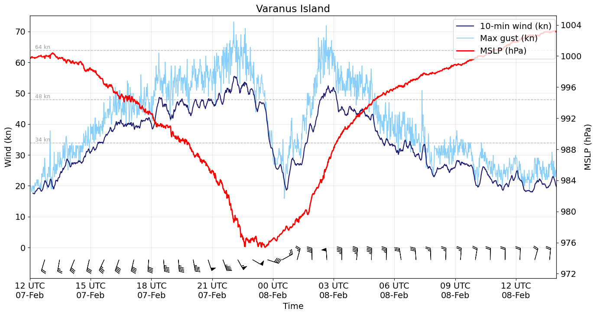
Figure 13. Plot of 10-minute mean winds (dark blue), maximum 3-second wind gusts (light blue), wind barbs and MSLP (red) observations at Varanus Island during the passage of Severe Tropical Cyclone Mitchell.
Barrow Island Airport observed intermittent gale force winds between 1748 UTC 7 February and 0634 UTC 8 February, for a total of 12 hours and 21 minutes. Intermittent storm force winds were observed between 2221 UTC 7 February and 0440 UTC 8 February, for a total of 3 hours and 32 minutes. The maximum 10-minute mean wind was 59 kn (109 km/h) at 0001 UTC 8 February, and the maximum wind gust was 80 kn (148 km/h) at 0009 UTC 8 February. A plot of these winds is included in Figure 14.
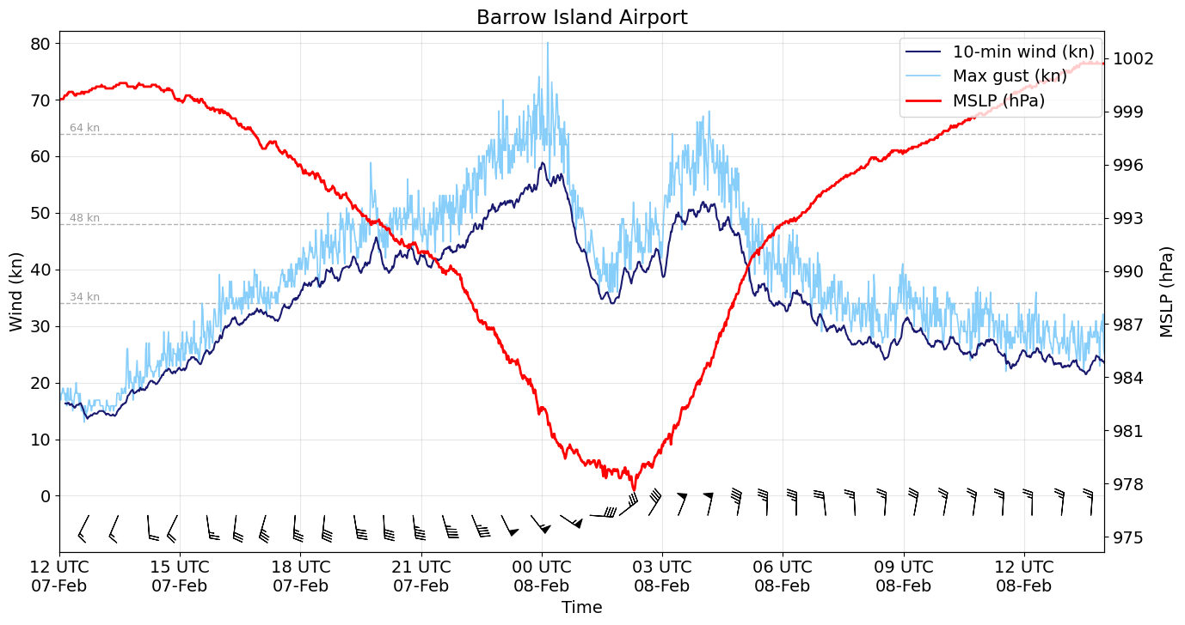
Figure 14. Plot of 10-minute mean winds (dark blue), maximum 3-second wind gusts (light blue), wind barbs and MSLP (red) observations at Barrow Island Airport during the passage of Severe Tropical Cyclone Mitchell.
Mardie observed quite intermittent gale force winds between 2231 UTC 7 February and 0353 UTC 8 February, for a total of 1 hour and 12 minutes. The maximum 10-minute mean wind was 36 kn (67 km/h) at 0244 UTC 8 February, and the maximum wind gust was 52 kn (95 km/h) at 0212 UTC 8 February.
Thevenard Island observed intermittent gale force winds between 2249 UTC 7 February and 1728 UTC 8 February, for a total of 17 hours and 24 minutes. Intermittent storm force winds were observed briefly between 0516 UTC and 0537 UTC 8 February, for a total of 10 minutes. The maximum 10-minute mean wind was 49 kn (90 km/h) at 0519 UTC 8 February, and the maximum wind gust was 67 kn (124 km/h) at 0532 UTC 8 February. A plot of these winds is included in Figure 15.
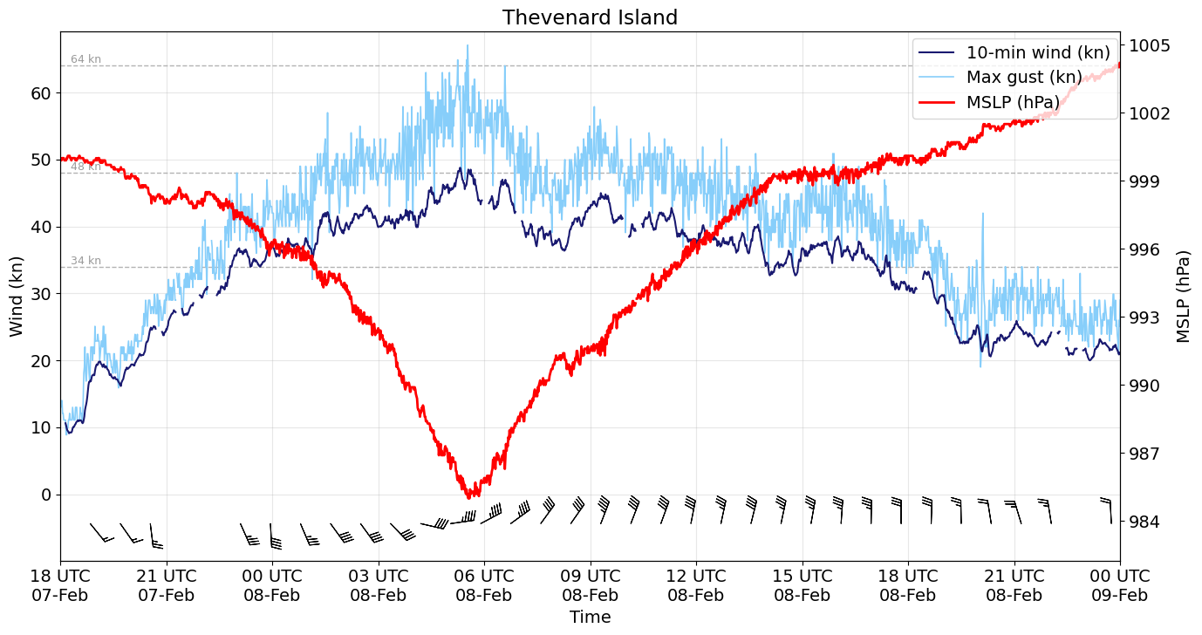
Figure 15. Plot of 10-minute mean winds (dark blue), maximum 3-second wind gusts (light blue), wind barbs and MSLP (red) observations at Thevenard Island during the passage of Severe Tropical Cyclone Mitchell.
Onslow Airport observed intermittent gale force winds between 0111 UTC and 1614 UTC 8 February, for a total of 11 hours and 26 minutes. Intermittent storm force winds were observed between 0536 UTC and 0624 UTC 8 February, for a total of 36 minutes. The maximum 10-minute mean wind was 51 kn (94 km/h) at 0559 UTC 8 February, and the maximum wind gust was 65 kn (120 km/h) at 0528 UTC 8 February.
Learmonth Airport observed intermittent gale force winds between 0754 UTC and 2016 UTC 8 February, for a total of 10 hours and 7 minutes. The maximum 10-minute mean wind was 47 kn (87 km/h) at 1538 UTC 8 February, and the maximum wind gust was 64 kn (119 km/h) at 1529 UTC 8 February.
Carnarvon Airport observed intermittent gale force winds between 0731 UTC and 1329 UTC 9 February, for a total of 2 hours and 34 minutes. The maximum 10-minute mean wind was 38 kn (71 km/h) at 0812 UTC 9 February, and the maximum wind gust was 58 kn (107 km/h) at 0737 UTC 9 February. A plot of these winds is included in Figure 16.
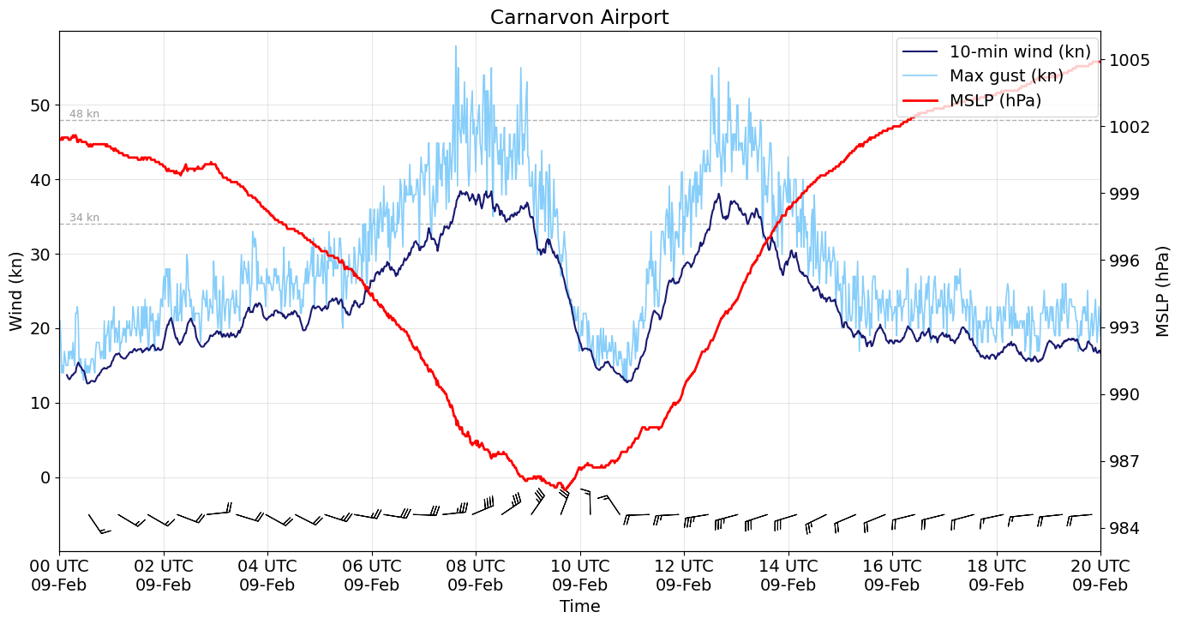
Figure 16. Plot of 10-minute mean winds (dark blue), maximum 3-second wind gusts (light blue), wind barbs and MSLP (red) observations at Carnarvon Airport during the passage of Severe Tropical Cyclone Mitchell.
  - Rainfall
Severe Tropical Cyclone Mitchell began as tropical low 21U, which formed over land on the western side of the Gulf of Carpentaria. The low stalled over the Northern Territory, producing several days of heavy rainfall before moving west. Later, Mitchell brought notable falls to coastal parts of the Pilbara and Gascoyne regions while still offshore but did not break local records again until it had weakened to a tropical low near Shark Bay and started heading to the southeast over inland WA. See Table 2 for the daily rainfall records broken and other notable rainfall totals.
Location | 24-hour rainfall (mm) | Date (24 hours until 9am local time)
Gilnockie (NT) | 183.0* | 2 February 2026
Bradshaw (NT) | 154.2** | 2 February 2026
Old Delamere (NT) | 131.6 | 2 February 2026
Delamere Weapons Range (NT) | 126.6 | 2 February 2026
Mathison (NT) | 119.8 | 2 February 2026
Cattle Creek (NT) | 144.2* | 3 February 2026
Lajamanu Airport (NT) | 154.8 | 4 February 2026
Sophie Downs (NT) | 109.0 | 5 February 2026
Sherlock (WA) | 109.0 | 8 February 2026
Varanus Island (WA) | 92.4 | 8 February 2026
Karratha Aerodrome (WA) | 90.6 | 8 February 2026
Barrow Island Airport (WA) | 81.2 | 8 February 2026
Hamelin Station (WA) | 93.9 | 9 February 2026
Shark Bay Airport (WA) | 103.6** | 10 February 2026
Mount Gibson (WA) | 93.2** | 10 February 2026
Yuin (WA) | 74.6 | 10 February 2026
Kalbarri (WA) | 54.4** | 10 February 2026
Table 2. Daily rainfall observations associated with Severe Tropical Cyclone Mitchell (21U). *New record for annual highest daily rainfall. **New record for highest daily rainfall during February.
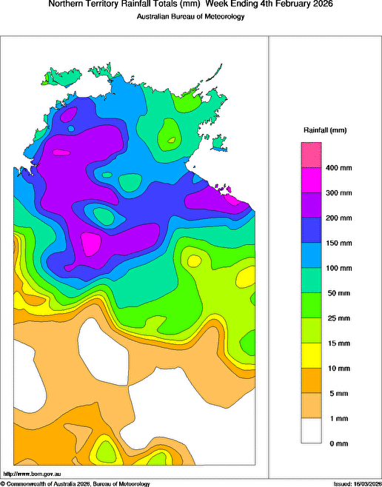
Figure 17. Rainfall analysis for the week ending 4 February 2026.
  - Flooding
The passage of Mitchell as a low across the Northern Territory produced heavy rainfall (refer Figure 17) that caused significant flooding. The Daly River reached major flood level, peaking at 14.26 m on 11 February.
  - Pressure
The lowest pressure observed near the passage of Severe Tropical Cyclone Mitchell was at Varanus Island (refer Figure 13). Table 3 shows the lowest MSLP recorded by sites near the track of Severe Tropical Cyclone Mitchell. Times in UTC (UTC=ACST-9.5h, UTC=AWST-8h).
Location | Pressure (hPa) | Time
Daly Waters Airstrip (NT) | 998.8 | 0534 UTC 31 January
Victoria River Downs (NT) | 996.4 | 1756 UTC 2 February
Broome Wharf (WA) | 997.0 | 2126 UTC 5 February
Rowley Shoals (WA) | 996.9 | 1904 UTC 6 February
Legendre Island (WA) | 978.2 | 1051 UTC 7 February
Varanus Island (WA) | 975.4 | 2326 to 2338 UTC 7 February*
Barrow Island Airport (WA) | 977.6 | 0218 UTC 8 February
Thevenard Island (WA) | 985.0 | 0533 UTC 8 February
Onslow Airport (WA) | 991.1 | 0558 UTC 8 February
Learmonth Airport (WA) | 984.2 | 1832 UTC 8 February
Carnarvon Airport (WA) | 985.7 | 0942 UTC 9 February
Shark Bay Airport (WA) | 996.3 | 1202 UTC 9 February
Table 3. Pressure observations recorded (at 1-min frequency) during Severe Tropical Cyclone Mitchell. A map showing weather station locations can be found at https://www.bom.gov.au/wa/observations/map.shtml. *One-minute observations fluctuated within the given range.
  - Storm Surge
Severe Tropical Cyclone Mitchell tracked roughly parallel to the Pilbara and Gascoyne coasts before crossing near Shark Bay. Elevated sea levels were observed across the Pilbara and Gascoyne coasts, although tide gauge observations south of the cyclone track showed no evidence of a coastally trapped wave.
Department of Transport tide gauge data recorded a maximum storm surge of 1.0 m at Exmouth during the evening of 8 February (refer Figure 18), when Mitchell was located approximately 25 nm (50 km) north of the town. The peak residual sea level occurred shortly after low tide. As a result, the total sea level remained well below the highest astronomical tide level of 2.94 m.
A storm surge of around 0.70–0.75 m was recorded at Onslow and Port Hedland, but with no exceedance of highest astronomical tide observed.
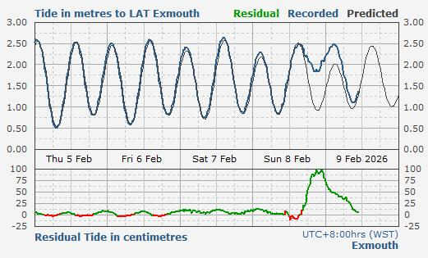
Figure 18. Plot of the tide and residual in metres as compared to the Lowest Astronomical Tide (LAT) for Exmouth. Courtesy of the Department of Transport and Major Infrastructure (DTMI).

- Forecast Performance
The initial 7-Day forecast was issued on 30 January 2026. It indicated that the likelihood of 21U developing into a tropical cyclone increased to Low (15%) by 6 February. The forecasts up to 2 February gave a Moderate chance between 7 and 9 February (Mitchell was a tropical cyclone during this period, refer Figure 19). Later, during 3-4 February the forecast chance was decreased to Low for 7 February due to ensemble guidance reacting to the system weakening whilst moving over land through the Northern Territory and Kimberley. On 5 February, the forecast chance was increased to High for 7-9 February as tropical low 21U strengthened and showed a significant vortex while still over land in the Kimberley.
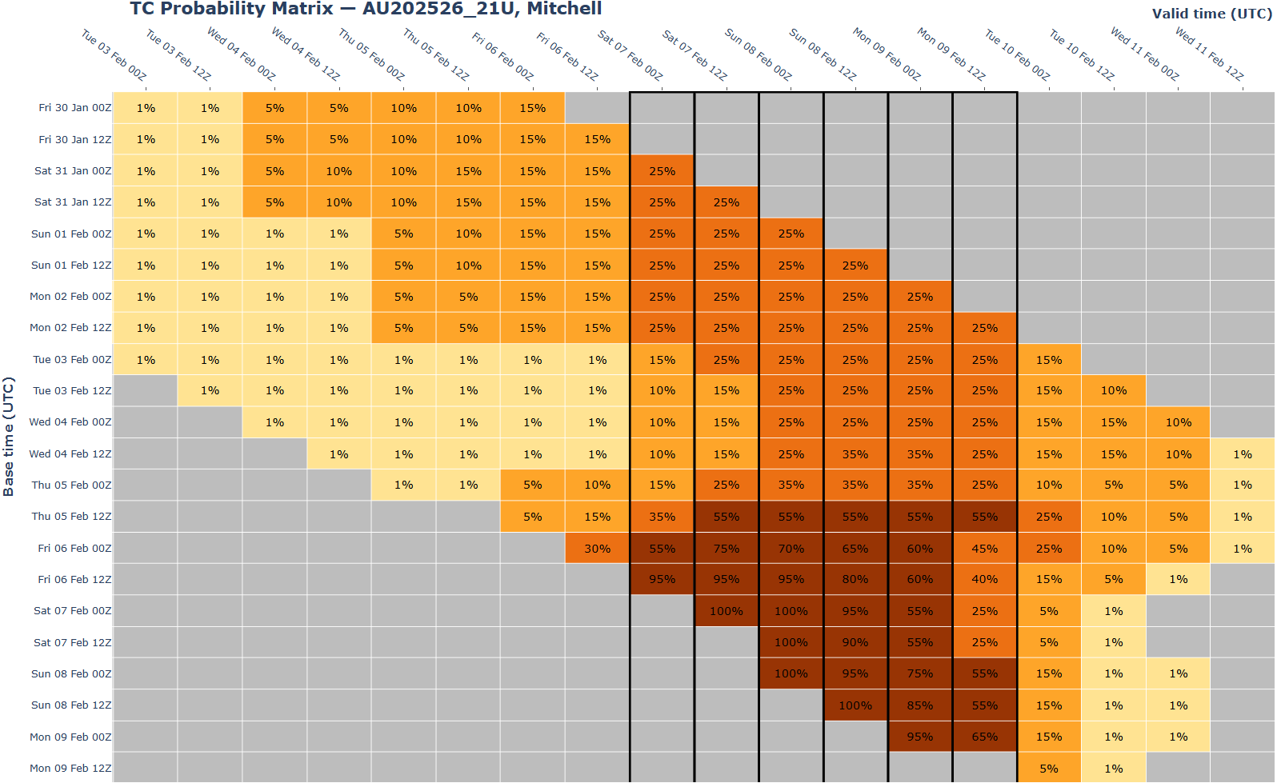
Figure 19. The forecast percentage risk of a low developing into a tropical cyclone taken from the 7-day forecast for 21U. Forecast base time is shown on the vertical axis with the forecast validity time shown on the horizontal axis. The box colours correspond to the tropical cyclone forecast rating, yellow for Very Low, light orange for Low, orange for Moderate and brown for High. The black outlined days between 7-9 February correspond to the days in which Mitchell was eventually defined as a tropical cyclone.
The first Forecast Track Map and Advice was issued at 0600 UTC 5 February, roughly two days before gale force winds were first observed at Port Hedland Airport. The first Ocean Wind Warning was issued at 1800 UTC 5 February, about 18 hours before quadrant gale force winds were first analysed in southern quadrants.
The accuracy statistics for Severe Tropical Cyclone Mitchell are included in Table 4, and shown in Figure 20 (position) and Figure 21 (intensity).
Forecast position accuracy was better than the 5-year long term average for position error. The intensity accuracy was mixed in the first 18 hours, but better than the long-term average from 24 hours onwards. The sample size for the 120-hour verification metrics was 1 which is considered too small to be reliable and was omitted from the table and plots. The 96-hour metrics have been included with the caveat that a sample size of 6 is also considered too small to be reliable.

Time | 00 | 06 | 12 | 18 | 24 | 36 | 48 | 72 | 96
Position accuracy (km) | 15 | 26 | 31 | 43 | 47 | 58 | 78 | 99 | 178
Intensity accuracy (knots) | 1.9 | 3.9 | 6.9 | 8.9 | 8.1 | 10.0 | 12.2 | 8.0 | 4.2
Sample size | 18 | 18 | 18 | 18 | 18 | 16 | 14 | 10 | 6
Table 4. Verification statistics for Severe Tropical Cyclone Mitchell. Note: Verification is performed using the Official Forecast Tracks at the standard times of 00, 06, 12 and 18 UTC.

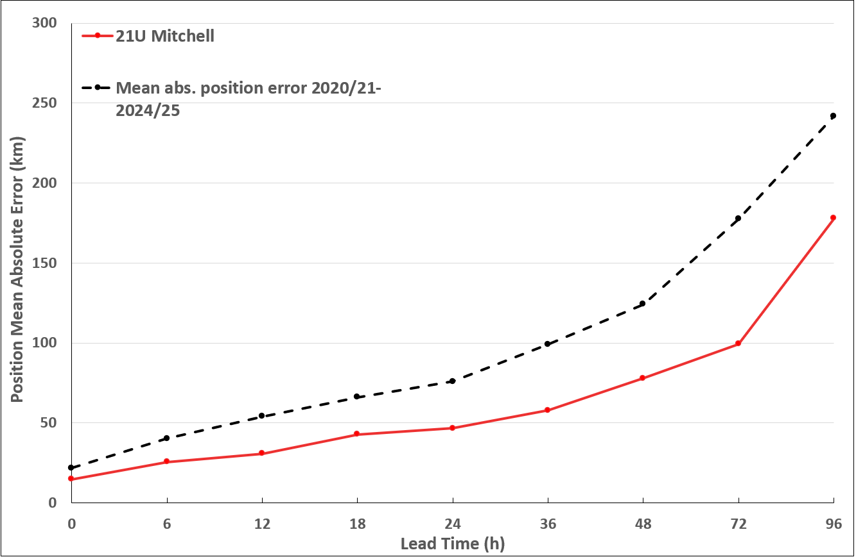
Figure 20. Position accuracy figures for Severe Tropical Cyclone Mitchell plotted against the 5-year average.
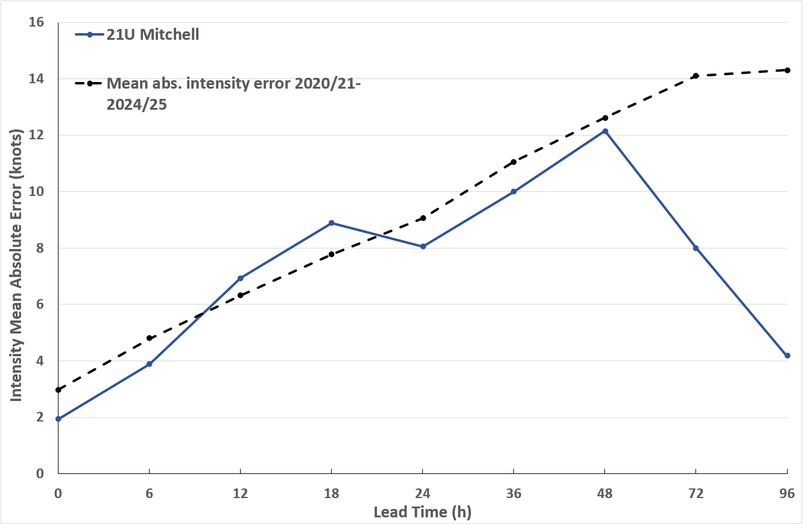
Figure 21. Intensity accuracy figures for Severe Tropical Cyclone Mitchell plotted against the 5-year average.
- Appendix: List of Abbreviations
Abbreviation | Term
ADT | Advanced Dvorak Technique
ACST | Australian Central Standard Time
AEST | Australian Eastern Standard Time
AiDT | AI-enhanced Dvorak Technique
AMSR2 | Advanced Microwave Scanning Radiometer
AMSU | Advanced Microwave Sounding Unit
ASCAT | Advanced Scatterometer
ATMS | Advanced Technology Microwave Sounder
AWS | automatic weather station
AWST | Australian Western Standard Time
°C | Celsius
CCT | Cocos (Keeling) Islands Time
CI | Current intensity
CIMSS | Cooperative Institute for Meteorological Satellite Studies (USA)
CIRA | Cooperative Institute for Research in the Atmosphere (USA)
D-MINT | Deep learning - Multispectral Intensity of TCs (formerly known as DMN)
D-PRINT | Deep learning - IR Intensity of TCs (formerly known as OPEN-AIIR)
EIR | Enhanced InfraRed
ERC | eyewall replacement cycle
FNMOC | Fleet Numerical Meteorology and Oceanography Centre (USA)
FT | Final T-number
GCOM | Global Change Observation Mission
GHz | Gigahertz
GMI | Global Precipitation Measurement Microwave Imager
h | hour
hPa | hectopascal
HSCAT | Hai Yang 2 Scatterometer (HY-2B, HY-2C)
km | kilometres
km/h | kilometres per hour
kn | knot
LLCC | Low-Level Cloud Centre
MET | Model Expected T-number
METOP | Meteorological Operational Satellite
MJO | Madden-Julian Oscillation
mm | millimetres
MSLP | mean sea level pressure
NESDIS | National Environmental Satellite, Data, and Information Service
nm | nautical mile
NOAA | National Oceanic and Atmospheric Administration
NRL | U.S. Naval Research Laboratory
OPEN-AiiR | Ordered Pattern Encoding AI Infrared
PAT | Pattern T-number
RCM | RadarSat Constellation Mission – Synthetic Aperture Radar
RH | relative humidity
RMW | radius of maximum winds
RSMC | Regional Specialised Meteorological Centre
SAR | Synthetic Aperture Radar
SATC | CIMSS Advanced Dvorak Technique
SATCON | Satellite Consensus
SEN1 | Sentinel-1A – Synthetic Aperture Radar
SMAP | Soil Moisture Active Passive
SMOS | Soil Moisture and Ocean Salinity
SSMIS | Special Sensor Microwave Imager/Sounder
TC | Tropical Cyclone
TCWC | Tropical Cyclone Warning Centre
UTC | Universal Time Co-ordinated

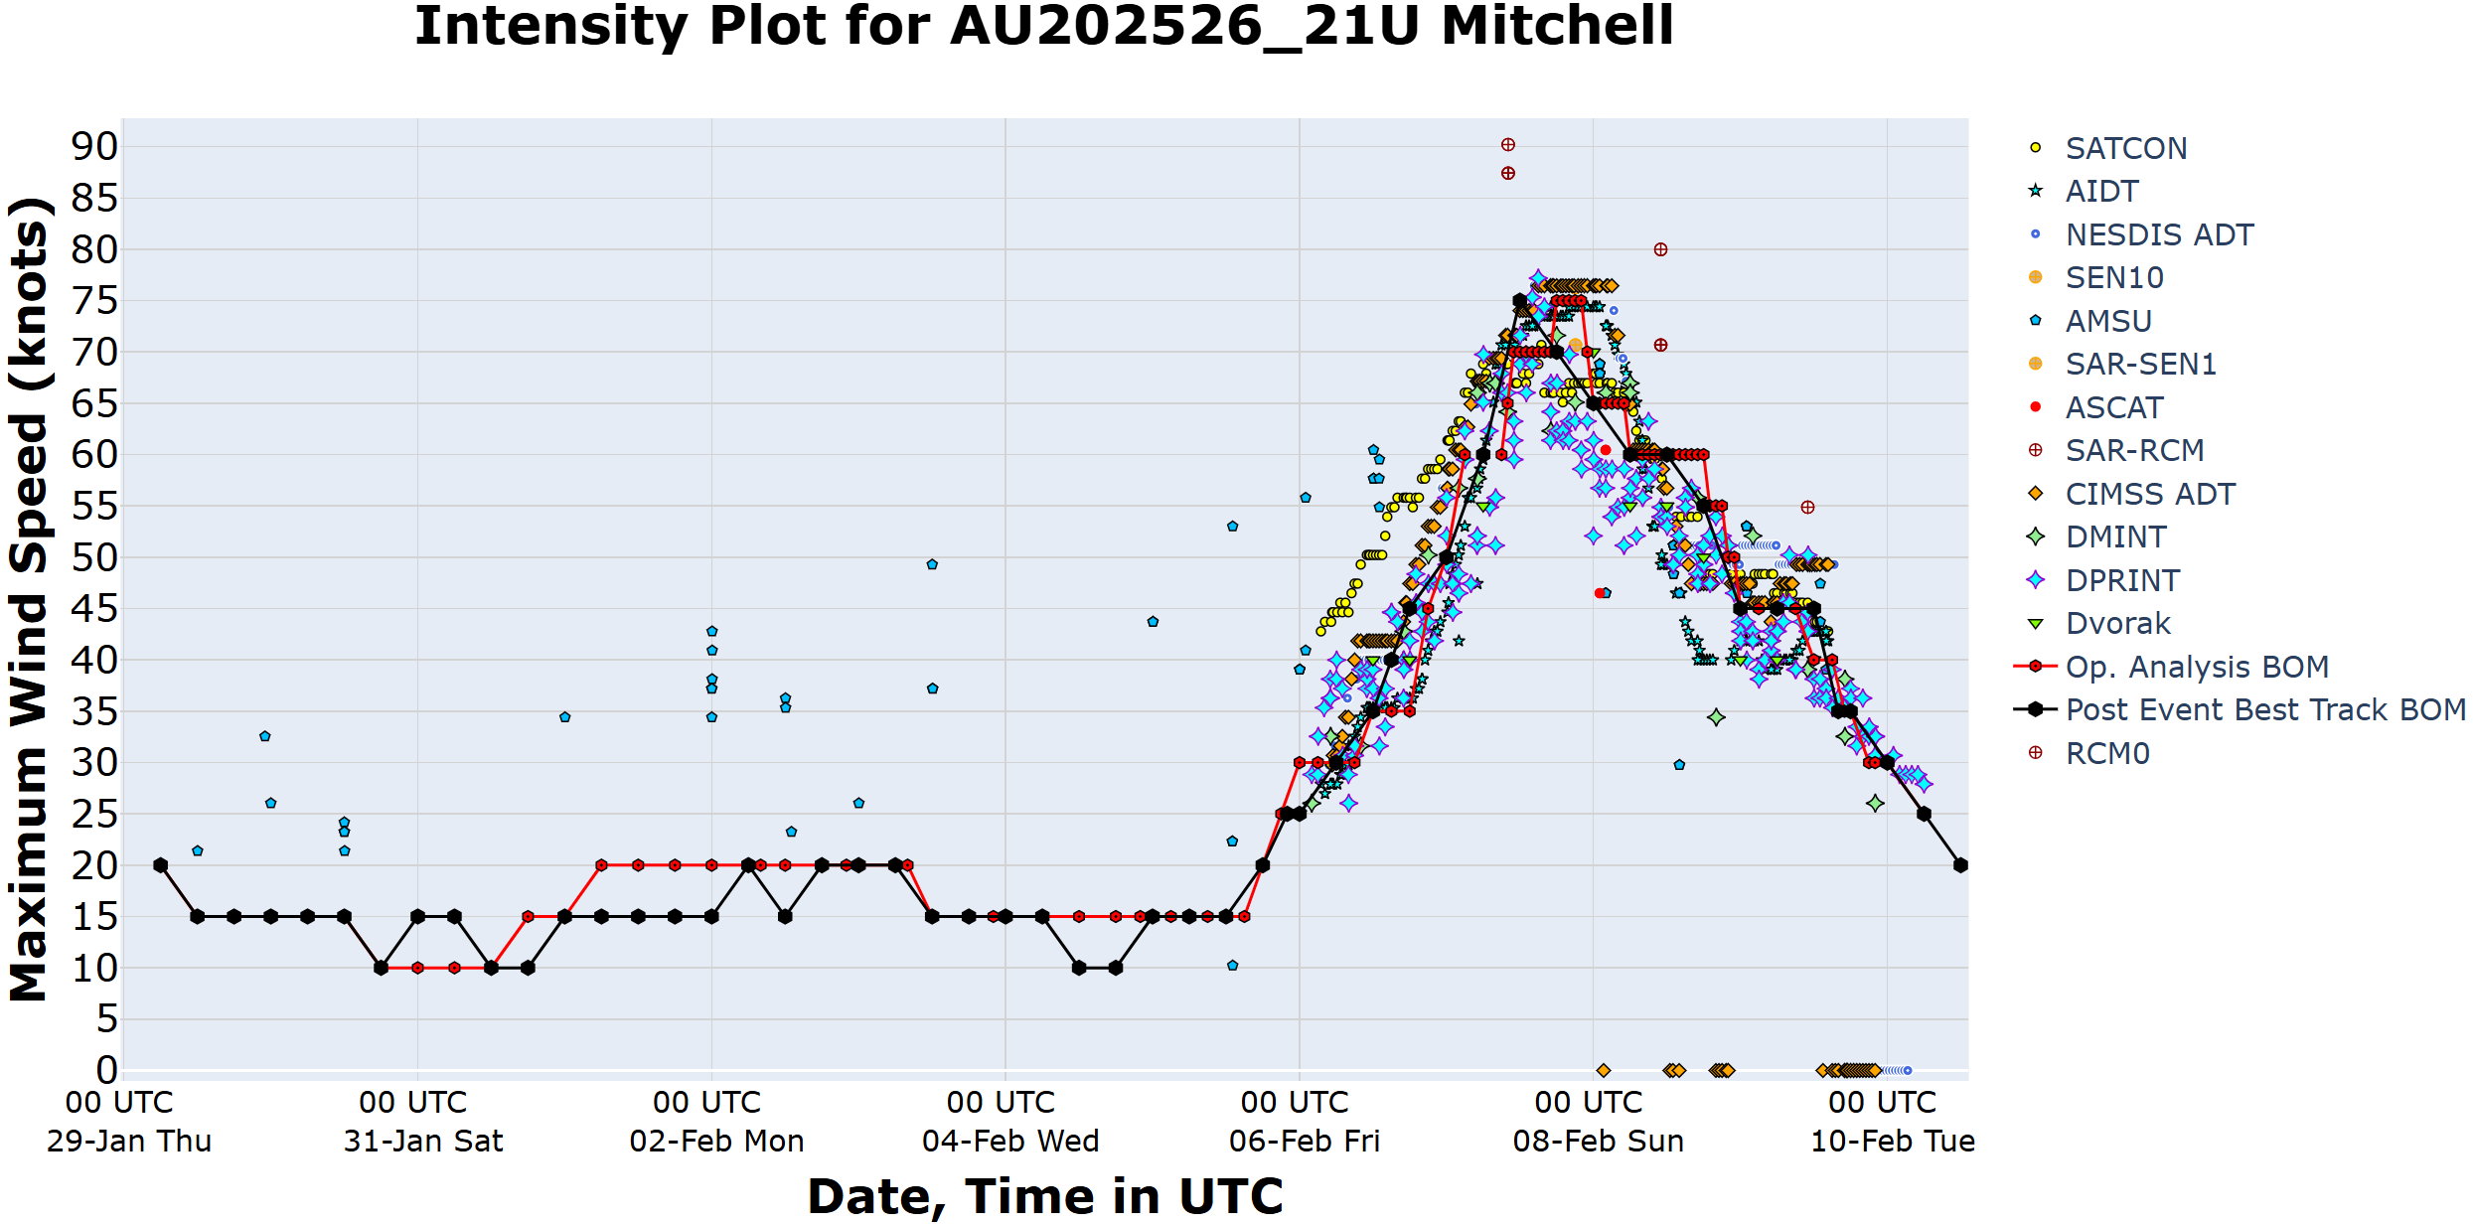
Figure 22. Full intensity plot of objective and subjective guidance for Severe Tropical Cyclone Mitchell. SATCON, AiDT, NESDIS ADT, SEN10, AMSU, SAR-SEN1, ASCAT, SAR-RCM, CIMMS ADT, DMINT, DPRINT, Dvorak subjective estimate, operational analysis (red), post event best track analysis (black) and RCM0. All wind speeds are 10-minute mean wind speeds.
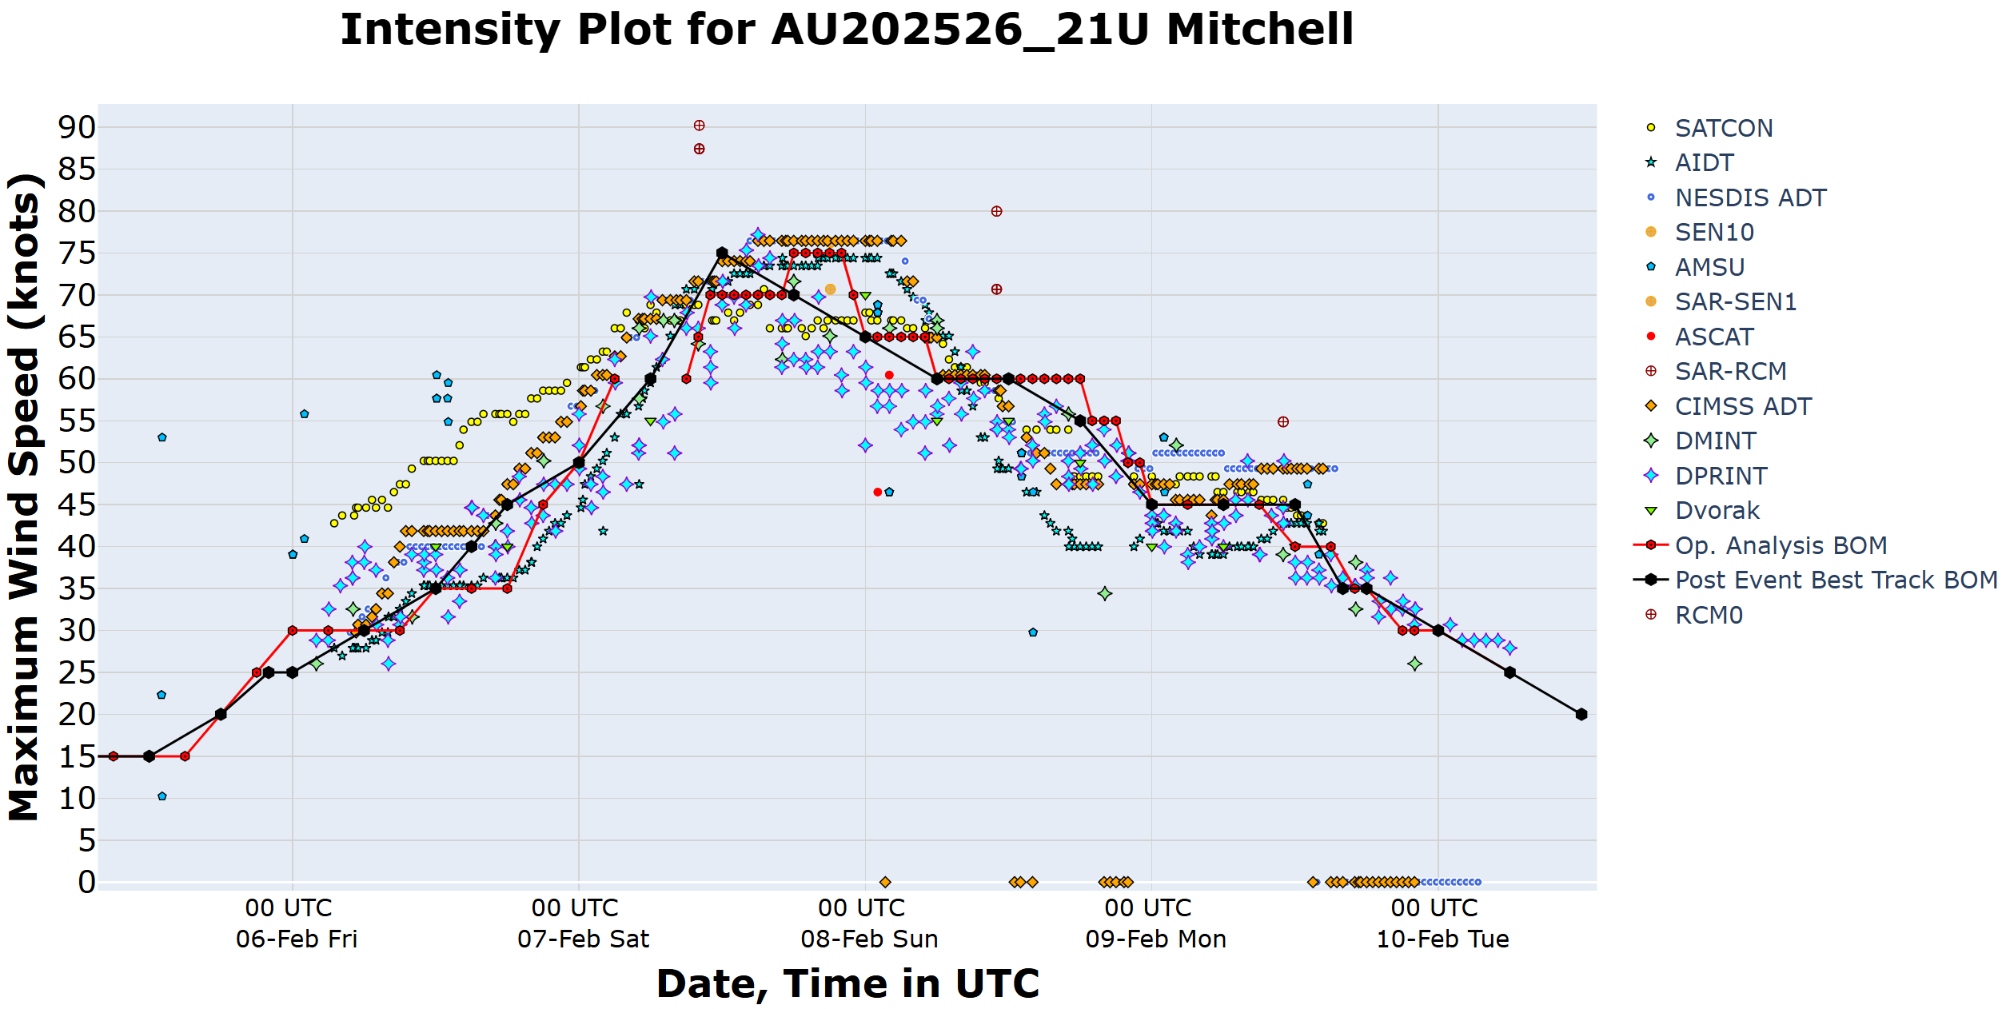
Figure 23. Zoomed in intensity plot of objective and subjective guidance for Severe Tropical Cyclone Mitchell. SATCON, AiDT, NESDIS ADT, SEN10, AMSU, SAR-SEN1, ASCAT, SAR-RCM, CIMMS ADT, DMINT, DPRINT, Dvorak subjective estimate, operational analysis (red), post event best track analysis (black) and RCM0. All wind speeds are 10-minute mean wind speeds.

Atta, G. (2026). Daly River residents being evacuated to Darwin ahead of predicted major flooding. ABC News. Available at: https://www.abc.net.au/news/2026-02-04/emergency-evacuation-for-daly-river-ahead-of-major-flooding/106305594

