Severe Tropical Cyclone Narelle (34U)
15 – 28 March 2026
Tropical Cyclone Environmental Prediction Services
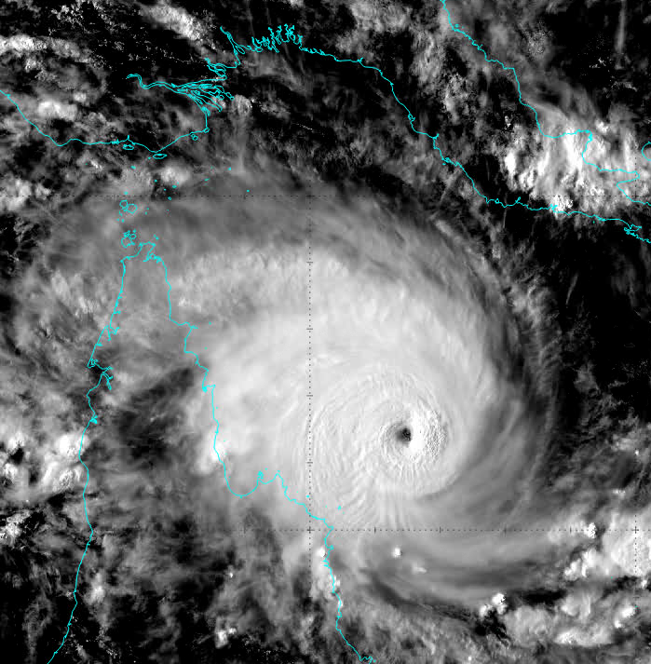

Revision history
Date | Version | Author | Description
1/07/2026 | 1.0 | EPS Tropical Cyclones | Final draft

Review status
Date | Version | Reviewer | Description
03/07/2026 | 1.0 | EPS Tropical Cyclones | Completed

Release history
Date | Version | Status | Approval
xx/04/2026 | 1.0 | Approved for release | Manager, EPS Tropical Cyclones
Contact details:
Tropical Cyclone Team Lead
Severe Weather Environmental Prediction Services
Bureau of Meteorology
PO Box 1370, West Perth WA 6872
Email: tcwc@bom.gov.au

This work is copyright. Apart from any use as permitted under the Copyright Act 1968, no part may be reproduced without prior written permission from the Bureau of Meteorology. Refer to www.bom.gov.au/other/copyright.shtml for further information. Unless otherwise noted, all images in this document are licensed under the Creative Commons Attribution Australia Licence.
© Commonwealth of Australia 2026
Published by the Bureau of Meteorology
Cover image: Visible Himawari 9 satellite image of Narelle near peak intensity of 115 knots (category 5) at 0600 UTC 19 March.

Table of Contents

1. Summary 8

2. Meteorological description 15

2.1. Intensity analysis 15

2.2. Structure 17

2.3. Motion 18

3. Impacts 34

4. Observations 41

4.1. Wind observations 41

4.1.1. Queensland 41

4.1.2. Northern Territory 41

4.1.3. Western Australia 42

4.2. Pressure 47

4.3. Rainfall 47

4.3.1. Queensland 47

4.3.2. Northern Territory 48

4.3.3. Western Australia 50

4.4. Flooding 52

4.5. Storm tide 53

4.5.1. Queensland 53

4.5.2. Northern Territory 53

4.5.3. Western Australia 53

5. Forecast Performance 55

Appendix: List of abbreviations 59

List of Figures
Figure 1 Best track of Severe Tropical Cyclone Narelle, 15-28 March 2026. Times are in UTC (AWST-8h, ACST-9.5h, AEST-10h). 10
Figure 2 Detailed best track of Severe Tropical Cyclone Narelle crossing the Queensland coast with wind radii shown. The area of gales is shaded pink, storm-force winds in light red and hurricane-force winds in darker red. Times are in AEST (UTC+10 h). 11
Figure 3 Detailed best track of Severe Tropical Cyclone Narelle crossing the Northern Territory coast with wind radii shown. The area of gales is shaded pink, storm-force winds in light red and hurricane-force winds in darker red. Times are in ACST (rounded to next hour; UTC+9.5 h). 12
Figure 4 Detailed best track of Severe Tropical Cyclone Narelle crossing the Western Australia coast with wind radii shown. The area of gales is shaded pink, storm-force winds in light red and hurricane-force winds in darker red. Times are in AWST (UTC+8 h). 13
Figure 5: Hovmoller diagram of tropical waves over the latitude range of 5-15S. The formation of Narelle (the system annotated N around 16 March near 160E) coincided with an active phase of the MJO and an Equatorial Rossby wave. 20
Figure 6: Sequence of Himawari 9 visible images at 0000 UTC on 16 March (top left, 6a), 17 March (top middle, 6b), 18 March (top right, 6c), 19 March (bottom left, 6d), 20 March (bottom middle, 6e), and 21 March 2026 (bottom right, 6f). 21
Figure 7: ASCAT-C pass at 2312 UTC 16 March, showing gales extending into three quadrants around the circulation of TC Narelle. 22
Figure 8: Analysed deep layer wind shear (left) and upper Atmospheric Motion Vectors (right) over eastern Australia at 0000 UTC 18 March 2026. Narelle lies in an area of low deep layer wind shear (green contours) and diffluent upper atmospheric wind vectors. 23
Figure 9: Visible Himawari 9 satellite image of Narelle near peak intensity of 115 knots (category 5) at 0600 UTC 19 March. 24
Figure 10: SAR pass over Narelle at peak intensity at 0847 UTC 19 March, indicating maximum 10-minute winds around 115 knots and a nearly symmetrical structure. 25
Figure 11: 89 GHz AMSR2 microwave image of Narelle at 1532 UTC 19 March, showing a well-defined eye. 26
Figure 12: Colour enhanced 89 GHz SSMIS microwave image of Narelle at 1844 UTC 20 March over the Gulf of Carpentaria, showing redevelopment of a new, larger eye wall. 27
Figure 13: ASCAT-C pass over Narelle over the western Gulf of Carpentaria at 1203 UTC 21 March. Wind barbs are in knots. 28
Figure 14: Infrared Himawari 9 image of Narelle at category 3 over the western Gulf of Carpentaria, approaching the Northern Territory coast, at 1500 UTC 21 March. 29
Figure 15: Sequence of Himawari 9 visible images at 0000 UTC on 22 March (top left, 15a), 23 March (top middle, 15b), 24 March (top right, 15c), 25 March (bottom left, 15d), 26 March (bottom middle, 15e), and 27 March 2026 (bottom right, 15f). 30
Figure 16: AMSR2 89 GHz microwave image at 1733 UTC 24 March around the time the system redeveloped into a tropical cyclone for the third time. 31
Figure 17: A sequence of microwave imagery illustrating the evolution of the double ring structure Narelle developed on 26 March during an eye wall replacement cycle. The image on the left (17a) is an SSMIS 91 GHz at 1021 UTC, the middle image (17b) is an AMSR2 89 GHz at 1722 UTC and the image on the right (17c) is an SSMIS 91 GHz at 2042 UTC. 32
Figure 18: Satellite wind speeds from SAR at 1039 UTC 25 March (left, 18a), 2149 UTC 25 March (middle, 18b), and 1046 UTC 26 March 2026 (right, 18c). These images show the evolution of the ragged, elongated eye on 25 March into a large though regular eye by 26 March with hurricane strength winds surrounding the centre. The right-hand image shows the wind maximum occurring in the eye wall close to the centre. 32
Figure 19: Satellite wind speeds from SAR at 2157 UTC 26 March showing the large extent of hurricane force winds. 33
Figure 20: Maximum wind profiles for the 2157 UTC SAR pass in Figure 19 showing a broad area of the strongest winds between about 20-40 nm from the centre. 34
Figure 21: Very high resolution satellite imagery of the area east of Weipa prior to Narelle (left) and after Narelle's passage (right), showing a suspected tornado track. 38
Figure 22: Wave data from the buoy at Palm Cove, showing significant wave height rising from 0.5m to more than 2m on the 19th and 20th of March as Narelle passed to the north. 38
Figure 23: Map showing the gap between Tongue Reef and Norman Reef in the Great Barrier Reef, allowing the NNE swell to impact beaches north of Cairns. 39
Figure 24: Significant damage to houses in Exmouth. Photo supplied to the ABC, available: Tropical Cyclone Narelle heads inland amid reports of widespread damage in Exmouth - ABC News. 40
Figure 25: Coastal inundation at Exmouth Marina due to the storm surge caused by Narelle. Photo supplied to the ABC, available: Tropical Cyclone Narelle heads inland amid reports of widespread damage in Exmouth - ABC News. 40
Figure 26: Flood damage to Minilya-Exmouth Road. Image credit: ABC, available: Cyclone Narelle isolates Exmouth, destroys airport and cuts essential services - ABC News. 41
Figure 27: Data from Lochart River Airport AWS plotted between1200 UTC 19 March and 1200 UTC 20 March. 46
Figure 28: Data from the Karratha Airport AWS plotted between 1200 UTC 25 March and 0000 UTC 27 March. 46
Figure 29: Data from the Barrow Island Airport AWS plotted between 1200 UTC 25 March and 1200 UTC 27 March. 47
Figure 30: Data from the Learmonth Airport AWS plotted between 1200 UTC 26 March and 0942 UTC 27 March. 47
Figure 31: Weekly rainfall totals for Queensland for the period 16-22 March 2026. 49
Figure 32: Weekly rainfall totals for Northern Territory for the period 18-24 March 2026. 50
Figure 33: Daily rainfall total for Western Australia for the 24 hours to 9 am AWST 27 March 2026. 52
Figure 34: Daily rainfall total for Western Australia for the 24 hours to 9 am AWST 28 March 2026. 53
Figure 35 Storm surge recorded at Exmouth on 27 March 2026 as Narelle moved west of the North West Cape. 55
Figure 36: The forecast percentage risk of a low developing into a tropical cyclone taken from the 7-day forecast for Narelle from 10 to 29 March 2026. 57
Figure 37: Position accuracy figures for Severe Tropical Cyclone Narelle compared against the 5-year average. 58
Figure 38: Intensity accuracy figures for Severe Tropical Cyclone Narelle compared against the 5-year average. 59
Figure 39: Intensity plot of objective and subjective guidance. SATCON, AiDT, NESDIS ADT, AMSU, ASCAT, SAR-RCM, CIMMS ADT, DMINT, DPRINT, Dvorak subjective estimate, operational analysis (red) and post event best track analysis (black). 63

List of Tables
Table 1. Best track summary for Severe Tropical Cyclone Narelle, March 2026. Times are in UTC (AWST-8h, ACST-9.5h, AEST-10h). 14
Table 2 Residual heights from Western Australian tide gauges in relation to storm surge associated with Narelle. 53
Table 3 Residual heights from Western Australian tide gauges in relation to a shelf wave associated with Narelle. 54
Table 4: Verification statistics for Severe Tropical Cyclone Narelle. Note: Verification is performed using the Official Forecast Tracks at the standard times of 00, 06, 12 and 18 UTC. 55

- Summary
Severe Tropical Cyclone Narelle was a long-lived system that crossed the coasts of far north Queensland, Northern Territory and Western Australia at severe intensity, only the second cyclone to do so following Ingrid (2005).
Tropical Low 34U formed near the southern Solomon Islands on 15 March and moved on a general westerly track over following days. Tropical Cyclone Narelle was named on 17 March and reached category 3 intensity the following day, then began a period of rapid intensification to peak at a maximum 10-minute mean wind of 115 kn (215 km/h, category 5 intensity) on 19 March. Narelle weakened slightly to category 4 intensity as it crossed the Far North Queensland coast between Coen and Lockhart River on the morning of 20 March, sparing those communities from the worst conditions. Strong winds extended across Cape York Peninsula to Weipa on the eastern Gulf of Carpentaria coast and caused mostly minor building damage and power outages with many trees and branches down. The strongest gust recorded was at 62 kn (115 km/h) at 2258 UTC 19 March from Lockhart River. Heavy rainfall caused flooding of properties and roads.
Narelle weakened as it moved over Cape York Peninsula and emerged into the Gulf of Carpentaria near Aurukun, south of Weipa, at category 2 intensity late on 20 March. The tropical cyclone continued on a steady westward track and redeveloped into a severe tropical cyclone once it was back over open water. Narelle reached a second peak maximum 10-minute mean wind intensity of 70 kn (130 km/h, category 3) before crossing the Northern Territory coast in a sparsely populated area between Nhulunbuy and Groote Eylandt early on 22 March at category 3 strength. Reports of wind damage were mostly related to trees and branches down and power outages. The strongest gust recorded was 49 kn (91 km/h) at 1832 UTC 21 March from Ngayawili.
Narelle then moved west across the Top End of the Northern Territory. Despite weakening below tropical cyclone intensity soon after landfall, the system produced heavy rain over already saturated catchments, especially the Daly River region which had previously experienced record flooding only weeks earlier. On 23 March, the low moved across Joseph Bonaparte Gulf and over land across the north Kimberley causing heavy rain before moving offshore on 24 March.
Narelle redeveloped into a tropical cyclone northwest of Broome early on 25 March and quickly reached severe category 3 intensity later that day, north of Port Hedland, as it moved west southwest parallel to the Pilbara coast. The system had developed into a large circulation and despite being located about 150 kilometres to the north of the Pilbara coast, many coastal locations experienced a prolonged period of gale force, and at times storm force winds as Narelle moved west. This caused mostly minor damage to the communities east of Onslow but there was significant disruption to the ports, airports and industry.
On 26 March, Narelle turned to the southwest and moved closer to the west Pilbara coast. Narelle reached a third and final peak maximum 10-minute mean wind intensity of 85 kn (155 km/h, category 3) between 0600 and 1800 UTC 26 March. The tropical cyclone then turned south and passed just west of Exmouth early on 27 March before turning south southeast to make landfall just south of Coral Bay and passing to the east of Carnarvon. The tropical cyclone quickly weakened as it accelerated to the south southeast and was downgraded to below tropical cyclone intensity early on 28 March as it moved over land east of Kalbarri and Geraldton.
Exmouth suffered widespread, substantial damage as Narelle passed about 35 kilometres to the west of the town. Roofs were ripped off houses and buildings suffered water ingress from wind driven rain. The stretch of coast between Onslow and Ningaloo experienced a large storm surge, measured at 3 metres at Exmouth, which inundated the coast even though it coincided with tides well below high tide. Pastoral stations in the west Pilbara and Gascoyne experienced significant flooding, building and infrastructure damage, and livestock losses. Despite weakening as it moved south, Narelle caused substantial damage to the banana plantations at Carnarvon however the town experienced only minor damage. The strongest gust recorded was 108 kn (200 km/h) at 2231 UTC 26 March from Learmonth Airport. The heavy rain caused flooding and some damage to roads between Carnarvon and Exmouth resulting in road closures. For many areas of the Gascoyne and Murchison region the heavy rainfall brought an end to prolonged dry conditions.
Figure 1 shows the entire best track of Narelle, Figure 2, Figure 3 and Figure 4 are more detailed tracks showing the three coastal crossings, while Table 1 is a summary of the best track data.
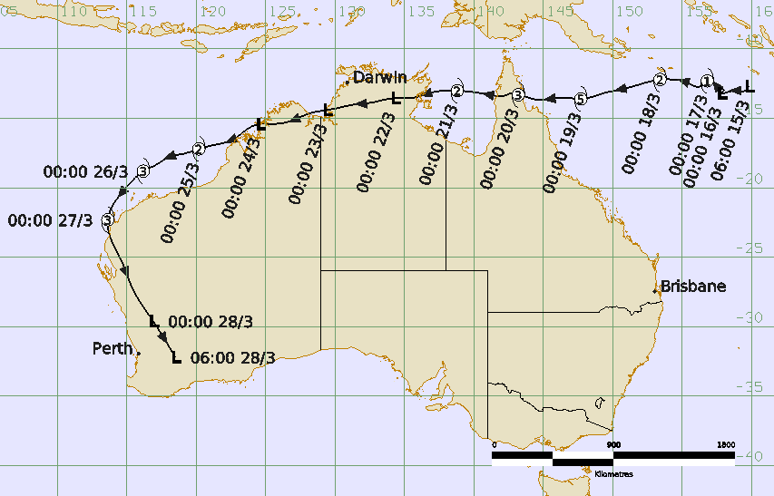
Figure 1 Best track of Severe Tropical Cyclone Narelle, 15-28 March 2026. Times are in UTC (AWST-8h, ACST-9.5h, AEST-10h).
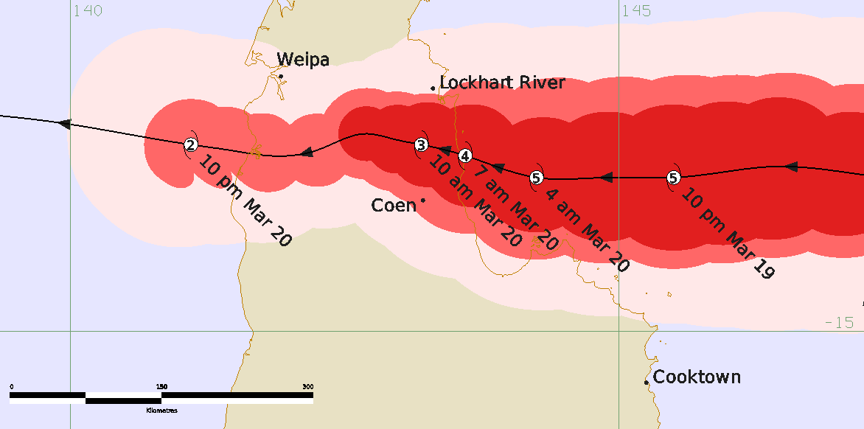
Figure 2 Detailed best track of Severe Tropical Cyclone Narelle crossing the Queensland coast with wind radii shown. The area of gales is shaded pink, storm-force winds in light red and hurricane-force winds in darker red. Times are in AEST (UTC+10 h).

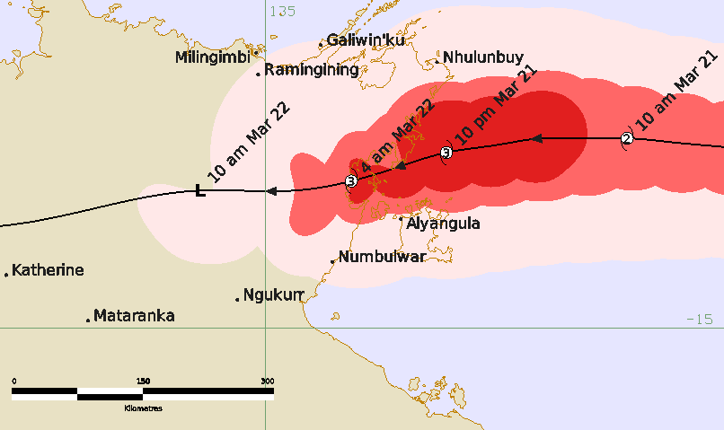
Figure 3 Detailed best track of Severe Tropical Cyclone Narelle crossing the Northern Territory coast with wind radii shown. The area of gales is shaded pink, storm-force winds in light red and hurricane-force winds in darker red. Times are in ACST (rounded to next hour; UTC+9.5 h).

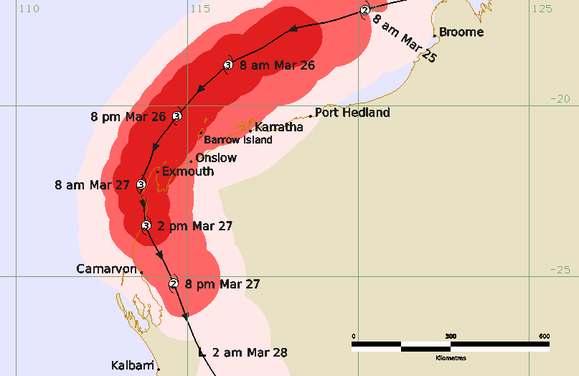
Figure 4 Detailed best track of Severe Tropical Cyclone Narelle crossing the Western Australia coast with wind radii shown. The area of gales is shaded pink, storm-force winds in light red and hurricane-force winds in darker red. Times are in AWST (UTC+8 h).
Year | Month | Day | Hour | Pos. | Pos. | Pos | Max Wind | Max | Cent. | Rad. of gales | Rad. of storm | RMW
 |  |  | UTC | Lat. | Long. | Acc | 10min | gust | Press. | (NE/SE/ | (NE/SE/ | nm
 |  |  |  | S | E | nm | kn | kn | hPa | SW/NW) | SW/NW)
2026 | 3 | 15 | 0600 | 12.7 | 159.8 | 30 | 15 | 45 | 1006 | 0/0/0/0 | 0/0/0/0 | -
2026 | 3 | 15 | 1200 | 13.1 | 159.3 | 20 | 15 | 45 | 1008 | 0/0/0/0 | 0/0/0/0 | -
2026 | 3 | 15 | 1800 | 13.0 | 158.9 | 25 | 20 | 45 | 1007 | 0/0/0/0 | 0/0/0/0 | -
2026 | 3 | 16 | 0000 | 13.2 | 157.8 | 20 | 25 | 45 | 1005 | 0/0/0/0 | 0/0/0/0 | -
2026 | 3 | 16 | 0600 | 13.0 | 158.0 | 20 | 25 | 45 | 1003 | 0/0/0/0 | 0/0/0/0 | -
2026 | 3 | 16 | 1200 | 12.7 | 157.5 | 30 | 25 | 45 | 1005 | 0/0/0/0 | 0/0/0/0 | -
2026 | 3 | 16 | 1800 | 12.3 | 157.2 | 20 | 30 | 45 | 1002 | 0/0/0/0 | 0/0/0/0 | -
2026 | 3 | 17 | 0000 | 12.3 | 156.8 | 15 | 40 | 55 | 997 | 75/65/45/0 | 0/0/0/0 | 45
2026 | 3 | 17 | 0600 | 12.7 | 156.3 | 15 | 50 | 70 | 989 | 60/70/60/  45 | 0/25/0/0 | 20
2026 | 3 | 17 | 1200 | 12.4 | 155.3 | 20 | 55 | 75 | 988 | 60/70/60/  45 | 0/25/30/25 | 17
2026 | 3 | 17 | 1800 | 12.2 | 154.3 | 15 | 60 | 85 | 981 | 60/65/60/  50 | 25/25/25/25 | 17
2026 | 3 | 18 | 0000 | 12.2 | 153.4 | 25 | 60 | 85 | 982 | 60/65/60/  50 | 25/25/25/25 | 17
2026 | 3 | 18 | 0600 | 12.6 | 151.8 | 15 | 70 | 100 | 975 | 80/75/70/  75 | 35/35/35/30 | 13
2026 | 3 | 18 | 1200 | 12.9 | 150.6 | 25 | 80 | 110 | 968 | 80/90/80/  80 | 40/40/40/30 | 13
2026 | 3 | 18 | 1800 | 13.2 | 149.3 | 15 | 95 | 135 | 952 | 85/90/85/  85 | 50/45/45/40 | 13
2026 | 3 | 19 | 0000 | 13.6 | 147.7 | 15 | 110 | 155 | 938 | 85/90/85/  85 | 50/45/45/40 | 13
2026 | 3 | 19 | 0600 | 13.5 | 146.4 | 10 | 115 | 160 | 931 | 85/90/90/  85 | 55/50/50/45 | 10
2026 | 3 | 19 | 1200 | 13.6 | 145.5 | 10 | 115 | 160 | 931 | 90/80/80/  80 | 60/50/50/50 | 9
2026 | 3 | 19 | 1800 | 13.6 | 144.3 | 15 | 115 | 160 | 931 | 90/75/70/  70 | 60/45/45/40 | 7
2026 | 3 | 19 | 2100 | 13.4 | 143.6 | 10 | 105 | 145 | 942 | 80/70/65/  50 | 45/45/40/30 | 8
2026 | 3 | 20 | 0000 | 13.3 | 143.2 | 15 | 80 | 110 | 965 | 70/65/55/  45 | 30/35/30/25 | 14
2026 | 3 | 20 | 0300 | 13.2 | 142.7 | 15 | 65 | 100 | 978 | 40/45/40/  40 | 25/25/25/25 | 14
2026 | 3 | 20 | 0600 | 13.4 | 142.3 | 15 | 55 | 75 | 983 | 45/45/40/  50 | 20/20/20/20 | 15
2026 | 3 | 20 | 0900 | 13.4 | 141.8 | 15 | 50 | 70 | 986 | 35/45/50/  70 | 20/20/20/25 | 20
2026 | 3 | 20 | 1200 | 13.3 | 141.1 | 20 | 50 | 70 | 988 | 45/50/60/  70 | 25/0/25/25 | 22
2026 | 3 | 20 | 1800 | 13.1 | 139.9 | 20 | 60 | 85 | 980 | 60/70/70/  70 | 30/30/30/30 | 26
2026 | 3 | 21 | 0000 | 13.0 | 138.8 | 25 | 60 | 85 | 982 | 70/80/75/  70 | 35/35/30/30 | 22
2026 | 3 | 21 | 0600 | 13.0 | 137.9 | 20 | 65 | 90 | 976 | 85/75/85/  80 | 45/40/40/40 | 18
2026 | 3 | 21 | 1200 | 13.2 | 136.9 | 15 | 70 | 100 | 974 | 100/80/80/80 | 45/40/35/45 | 14
2026 | 3 | 21 | 1500 | 13.3 | 136.4 | 10 | 70 | 100 | 973 | 80/70/70/  85 | 40/30/30/30 | 12
2026 | 3 | 21 | 1800 | 13.5 | 135.9 | 15 | 65 | 90 | 978 | 80/70/65/  95 | 35/30/20/20 | 12
2026 | 3 | 21 | 2100 | 13.6 | 135.3 | 20 | 50 | 70 | 986 | 80/60/40/  55 | 25/30/0/0 | 20
2026 | 3 | 22 | 0000 | 13.6 | 134.3 | 25 | 40* | 55 | 988 | 0/50/40/0 | 0/0/0/0 | -
2026 | 3 | 22 | 0600 | 13.9 | 132.4 | 20 | 30 | 45 | 990 | 0/0/0/0 | 0/0/0/0 | -
2026 | 3 | 22 | 1200 | 14.0 | 131.4 | 20 | 30 | 45 | 993 | 0/0/0/0 | 0/0/0/0 | -
2026 | 3 | 22 | 1800 | 14.3 | 130.0 | 20 | 30 | 45 | 993 | 0/0/0/0 | 0/0/0/0 | -
2026 | 3 | 23 | 0000 | 14.4 | 129.4 | 20 | 30 | 45 | 992 | 0/0/0/0 | 0/0/0/0 | -
2026 | 3 | 23 | 0600 | 14.7 | 128.0 | 20 | 30 | 45 | 994 | 0/0/0/0 | 0/0/0/0 | -
2026 | 3 | 23 | 1200 | 15.2 | 126.8 | 25 | 30 | 45 | 995 | 0/0/0/0 | 0/0/0/0 | -
2026 | 3 | 23 | 1800 | 15.4 | 125.3 | 20 | 30 | 45 | 995 | 0/0/0/0 | 0/0/0/0 | -
2026 | 3 | 24 | 0000 | 15.4 | 124.6 | 25 | 35* | 50 | 994 | 30/0/0/90 | 0/0/0/0 | -
2026 | 3 | 24 | 0600 | 15.7 | 123.8 | 20 | 35* | 50 | 993 | 60/0/0/90 | 0/0/0/0 | -
2026 | 3 | 24 | 1200 | 16.5 | 122.7 | 15 | 35* | 50 | 990 | 70/0/0/90 | 0/0/0/0 | -
2026 | 3 | 24 | 1800 | 16.9 | 121.4 | 15 | 45 | 65 | 987 | 80/50/80/120 | 0/0/0/0 | 25
2026 | 3 | 25 | 0000 | 17.2 | 120.2 | 20 | 50 | 70 | 984 | 110/120/50/120 | 40/0/0/30 | 25
2026 | 3 | 25 | 0600 | 17.6 | 119.1 | 15 | 60 | 85 | 973 | 120/130/130/110 | 60/80/80/60 | 25
2026 | 3 | 25 | 1200 | 17.8 | 118.0 | 15 | 70 | 100 | 970 | 120/150/130/100 | 70/100/90/  60 | 25
2026 | 3 | 25 | 1800 | 18.3 | 117.2 | 15 | 80 | 110 | 958 | 140/150/140/120 | 70/110/90/  70 | 25
2026 | 3 | 26 | 0000 | 18.8 | 116.2 | 15 | 80 | 110 | 958 | 140/180/130/110 | 80/110/80/  70 | 25
2026 | 3 | 26 | 0600 | 19.5 | 115.4 | 10 | 85 | 120 | 945 | 140/180/100/110 | 80/110/80/  70 | 25
2026 | 3 | 26 | 1200 | 20.3 | 114.7 | 10 | 85 | 120 | 955 | 140/150/100/110 | 70/75/60/70 | 23
2026 | 3 | 26 | 1800 | 21.1 | 114.1 | 10 | 85 | 120 | 958 | 140/90/100/110 | 80/70/50/70 | 23
2026 | 3 | 27 | 0000 | 22.3 | 113.7 | 15 | 85 | 120 | 958 | 130/90/110/100 | 95/70/60/70 | 23
2026 | 3 | 27 | 0600 | 23.5 | 113.8 | 20 | 70 | 100 | 965 | 130/120/120/80 | 80/70/60/60 | 25
2026 | 3 | 27 | 1200 | 25.2 | 114.6 | 20 | 60 | 85 | 974 | 120/110/60/60 | 80/65/30/30 | 25
2026 | 3 | 27 | 1800 | 27.2 | 115.4 | 25 | 45* | 65 | 984 | 120/80/0/0 | 0/0/0/0 | -
2026 | 3 | 28 | 0000 | 29.6 | 116.9 | 20 | 35* | 50 | 995 | 90/0/0/0 | 0/0/0/0 | -
2026 | 3 | 28 | 0600 | 32.2 | 118.5 | 20 | 25 | 45 | 998 | 0/0/0/0 | 0/0/0/0 | -
Table 1. Best track summary for Severe Tropical Cyclone Narelle, March 2026. Times are in UTC (AWST-8h, ACST-9.5h, AEST-10h).
* Not a tropical cyclone as gales less than halfway around centre.

- Meteorological description
  - Intensity analysis
A comparison of the subjective and objective intensity estimates is shown in Figure 39.
Severe Tropical Cyclone Narelle developed during an active phase of the Madden-Julian Oscillation across the Australian Region. As shown in Figure 5, a pair of Equatorial Rossby waves were analysed over the eastern Australian Region during early and mid to late March, roughly coincident with the initial vorticity maximum, and the later rapid intensification of the cyclone in the Coral Sea.
The precursor tropical low, 34U, was first identified and tracked on 15 March south of Rennell Island in the Solomon Islands. The low drifted in a general westerly direction over the next 36 hours while gradually strengthening. A surge of east-southeasterly winds to the south from a high in the Tasman Sea contributed to the strengthening, as did a moderate cross-equatorial surge of northwesterly winds across the Solomon Islands. Tropical cyclone strength was assessed at 0000 UTC 17 March (Figure 6(b)). Figure 7 shows the ASCAT-C pass shortly before this at 2312 UTC 16 March, with gales extending just over halfway around the circulation. At this point, the Dvorak Data T (DT) and Current Intensity (CI) were both analysed at 2.5. Six hours after forming, at 0600 UTC 17 March, the Dvorak DT and CI had increased to 3.5, and Tropical Cyclone Narelle had strengthened to category 2.
Over the next three days, Tropical Cyclone Narelle continued to move to the west while strengthening. Conditions became particularly favourable for development on 18 March with the system located under a strongly diffluent area of the upper ridge (Figure 8). During the 24 hours from 0000 UTC 18 March to 0000 UTC 19 March, Narelle underwent a period of rapid intensification, strengthening by 50 kn (95 km/h) from category 2 to category 5 (Figure 6(c)-(d)). A peak 10-minute mean maximum intensity of 115 kn (215 km/h) was estimated between 0600 UTC and 1800 UTC 19 March (Figure 9). This was based on the subjective Dvorak CI which was steady at 6.5 during this period, as well as a pair of Synthetic Aperture Radar (SAR) retrievals at 0847 UTC and 1955 UTC 19 March (Figure 10), both indicating maximum winds around 115 kn (215 km/h) when adjusted to a 10-minute average.
Some weakening was evident in the cloud signature by the time Narelle crossed the Queensland coast, and the Dvorak CI had reduced to 6.0. Hence Narelle was estimated to have weakened slightly to 105 kn (195 km/h) (category 4) by the time it crossed the eastern Cape York Peninsula coast at 2100 UTC 19 March (7am AEST 20 March) about 60 km northeast of Coen and 75 km south-southeast of Lockhart River, sparing those communities from the worst winds
During the day on 20 March, Narelle tracked westwards over land across Cape York Peninsula while weakening. At around 0900 UTC (7pm AEST) 20 March it passed close to Aurukun on the western Cape York Peninsula coast at estimated category 2 strength, producing peripheral gales at Weipa, around 80 km to the north.
On the night of 20 March, Narelle moved back over water into the Gulf of Carpentaria, continuing its steady westward track. It spent roughly the next 24 hours over water and had strengthened back to a category 3 system by 0600 UTC 21 March. A SAR pass at 0918 UTC 21 March (not shown) depicted maximum 10-minute mean winds around 80 kn (150 km/h), however the subjective Dvorak CI (4.5 between 1200 and 1800 UTC 21 March) and other objective estimates suggested a slightly lower intensity. Narelle was estimated to have peaked at 70 kn (130 km/h) (category 3) over the Gulf of Carpentaria between 1200 and 1500 UTC 21 March (Figure 14).
Narelle maintained category 3 intensity through to its second coastal crossing on the eastern Top End coast in the Northern Territory, about 70 km northwest of Groote Eylandt, at 1800 UTC 21 March (3:30 am ACST 22 March). Once over land it continued moving west and rapidly weakened. Narelle weakened to below tropical cyclone strength by 0000 UTC (9:30 am ACST) 22 March.
After being downgraded to below tropical cyclone strength on 22 March, Narelle quickly crossed the Northern Territory and northern Western Australia as a low that maintained good vertical structure with well-defined convective bands around the centre. Refer to Figure 15 for a sequence of visible imagery at 0000 UTC 22-27 March 2026. By 0000 UTC 24 March Narelle (refer Figure 15c) was located near the west Kimberley coast with gales present in northern quadrants. The system continued to move quickly west southwest out over open water and was assigned a DT of 2.5 by 0600 UTC. Increased curved banding pushed the DT to 3.0 by 1800 UTC 24 March and Narelle redeveloped into a tropical cyclone at this time (refer Figure 16).
The environment was favourable for development with warm SSTs along the forecast track, and good upper outflow and upper divergence. The moderate easterly shear present did not inhibit the development of the system, possibly due to the fast west southwest movement of Narelle. By 0000 UTC 25 March the curved banding had increased to 1 degree and Narelle reached category 2 intensity (10-minute mean wind 50 kn (95 km/h)) (refer Figure 15e). A broad, ragged eye developed in the EIR imagery around 0600 UTC 25 March which increased the DT to 4.0. The eye pattern was transient until around 1400 UTC when it became more permanent, however it was still ragged and elongated at times which decreased the DT number. Despite this, the average DT peaked at 5.5 at 1800 UTC but FT was constrained to 5.0. Narelle reached category 3 at 1200 UTC 25 March and climbed to 80 kn (150 km/h) by 1800 UTC 25 March. The estimated intensity is well under the objective guidance at this time due to two SAR passes (refer Figure 18 a and b) which indicated the maximum wind speed was between 80-90 kn (150-165 km/h) during this period. Between 1200 and 1800 UTC 25 March SATCON ranged from 90-105 kn (165-195 km/h), influenced by the very high values contributed by AiDT, which had been using an eye pattern since 0100 UTC 25 March. During the period between 1200 UTC 25 March and 0000 UTC 27 March the hourly subjective DTs fluctuated between 4.0 and a peak of 6.5 at 1500 UTC 26 March. From about 1500-1800 UTC 25 March the MPERC probabilities indicate Narelle may have commenced an eye wall replacement cycle. Consequently, the fluctuations in the subjective DTs were likely due to changes in the structure of the surrounding outer band and the eye temperature associated with the eyewall replacement process.
Narelle was estimated to have reached a 10-minute mean peak intensity of around 85 kn (155 km/h) (category 3) between 0600 UTC 26 March and 0000 UTC 27 March. This is well below the subjective Dvorak and objective guidance, as the final estimated peak intensity was biased towards the SAR derived intensity estimates.
The eye wall replacement cycle may also be the reason objective guidance was significantly higher than the estimates obtained from SAR passes. A 1021 UTC 26 March SSMIS (refer Figure 17a) confirmed Narelle had developed a double ring structure. Figure 17b shows a weakening of the cold, deep convection of the inner ring and a strengthening of the outer ring, Figure 17c shows that weakening trend in the convective rings continued as Narelle approached the North West Cape. A system may undergo weakening of the wind field in the inner eye wall during an ERC but as Narelle was intensifying when the ERC started this may not have occurred, rather the intensity may have plateaued at 85 kn (155 km/h) in the inner eye wall while a secondary wind maximum developed at about 75 km from the centre, eventually resulting in broadening of the area of the maximum wind field by the end of the process when it is near the North West Cape at 0000 UTC 27 March. As Narelle passed to the west of Learmonth, the AWS recorded a peak 10-minute mean wind of 78 kn (144 km/h) in the southeast quadrant, consistent with the estimated intensity of 85 kn (155 km/h).
By 0000 UTC 27 March, Narelle was located to the west of the North West Cape and land interaction and increased vertical wind shear associated with an upper trough in the Indian Ocean to the southwest began to weaken the system. Narelle crossed the coast at 0600 UTC 27 March at an intensity of 70 kn (130 km/h) and was steered to the southeast, further inland. Convection decreased rapidly and the system weakened below tropical cyclone strength by 1800 UTC 27 March with gales persisting in the eastern quadrants.
  - Structure
Narelle's wind structure underwent considerable variation over its long lifetime. Initially, over the Coral Sea, it developed into a compact and reasonably symmetric tropical cyclone (Table 1, Figure 10). The radius of gales peaked at 90 nm (165 km) during this phase of its life, with little asymmetry evident until the system was near landfall. The Radius of Maximum Winds (RMW) was initially large (45 nm, 85 km) when Narelle was named (Figure 7) but contracted rapidly as the system strengthened and convection became more consolidated around the centre. Soon after reaching category 2, Narelle's RMW had shrunk to 17 nm (31 km). The RMW continued to decrease as Narelle strengthened. Figure 11 shows an 89 GHz microwave image of Narelle at 1532 UTC 19 March, some 6 hours prior to landfall. By this stage the compact eye wall was very well defined and the RMW was estimated at 7-8 nm (13-15 km).
The radius of gales shrank rapidly as Narelle moved over land across Cape York Peninsula, reaching an estimated minimum of 45 nm (85 km). The RMW likewise expanded to approximately 20 nm (35 km). Once Narelle was back over the waters of the Gulf of Carpentaria, scatterometry indicated the circulation began to expand again. However, the RMW also continued to expand for several hours, reaching a maximum of 26 nm (48 km) at 1800 UTC 20 March, by which time Narelle had redeveloped a new, larger eye wall (Figure 12).
Narelle's circulation expanded further as it moved across the Gulf of Carpentaria, but it remained a relatively compact system with a similar size to its Coral Sea incarnation. The gale radius peaked at around 85 nm (155 km) over open water, and again the system was approximately circular. However, asymmetries developed on approach to the complex coastline and islands of the eastern Top End (Figure 13), and the northeastern gale radius increased to 100 nm (185 km). Once a new eye developed the RMW steadily contracted and reached a minimum of 12 nm (22 km) at landfall in the Northern Territory.
Once again, the gale radius shrank rapidly as the system weakened over land, and gales were estimated to be confined to southern quadrants only when the system was downgraded to a tropical low near Bulman at 0000 UTC 22 March. By 0600 UTC 22 March gales associated with the system were determined to have ceased.
As Narelle redeveloped west of the Kimberley coast the largest gale radii was initially about 90 nm (165 km). As the system intensified the largest gale radii increased to about 130 nm (240 km) in southern quadrants. Figure 18 presents a sequence of SAR passes which illustrate the unusually large wind field associated with Narelle with gales extending 150 nm in the southeast quadrant, reaching the Pilbara coast, from around 1200 UTC 25 March.
On 26 March, the southeast quadrant remained very large at around 180 nm (335 km) as Narelle tracked westward parallel to the Pilbara coast. However, despite the large radii, gale-force winds were confined to the coastal fringe and offshore areas; they did not extend inland. The storm force wind radii were also large, ranging from 60 nm (110 km) in the northwest quadrant to 110 nm (205 km) in the southeast quadrant. As Narelle approached the North West Cape the southeastern radii became restricted by land interactions and contracted to 90 nm (165 km). Once Narelle crossed the west coast the largest gale radii was in the northeast quadrant where wind speeds were enhanced by the speed of motion.
The RMW of Narelle was initially at 25 nm (45 km), this reduced to 23 nm (43 km) during peak intensity while off the WA coast. Surface observations from offshore sites indicated a double peak wind structure had developed during the morning of 26 March with the strongest wind located in the inner eye. The 1046 UTC 26 March SAR pass (Figure 18c) confirmed this, showing the primary wind maximum in the inner eye wall (at a range of about 20-25 nm, 35-45 km) along with a secondary, weaker peak at approximately 50 nm (95 km) from the centre. A later SAR pass (2157 UTC 26 March, refer Figure 19) showed that Narelle's structure had undergone some change over the preceding 12 hours. In the southwest quadrant, the RMW remained at about 23 nm (43 km) with a well-defined eye wall, but in the eastern quadrants the RMW had expanded to about 40-43 nm (75-80 km). In the southeast quadrant the increase was due to the eye wall impacting the North West Cape while in the northeast quadrant the maximum wind was more pronounced at a distance from the centre. Figure 20 presents the quadrant-based wind profile which shows a broad wind maximum between 20 and 40 nm (35 to 75 km) from the centre.
  - Motion
Narelle's track in Figure 1 shows that for most of the event, Narelle was moving under the steering influence of a mid-level anti-cyclone. This resulted in persistent west to west-southwesterly motion for more than a week as the system crossed Cape York Peninsula, the Top End, Joseph Bonaparte Gulf, and the northern Kimberley and into the Indian Ocean. An approaching mid-level trough caused Narelle to recurve and start moving more southwesterly during 26 March, before moving to the south and then southeast during 27 March. The trough also caused the system motion to increase from about 11 kn (20 km/h) in the days prior, to 16-20 kn (30-40 km/h) as it moved rapidly to the southeast through western and southern WA during 27 and 28 March.

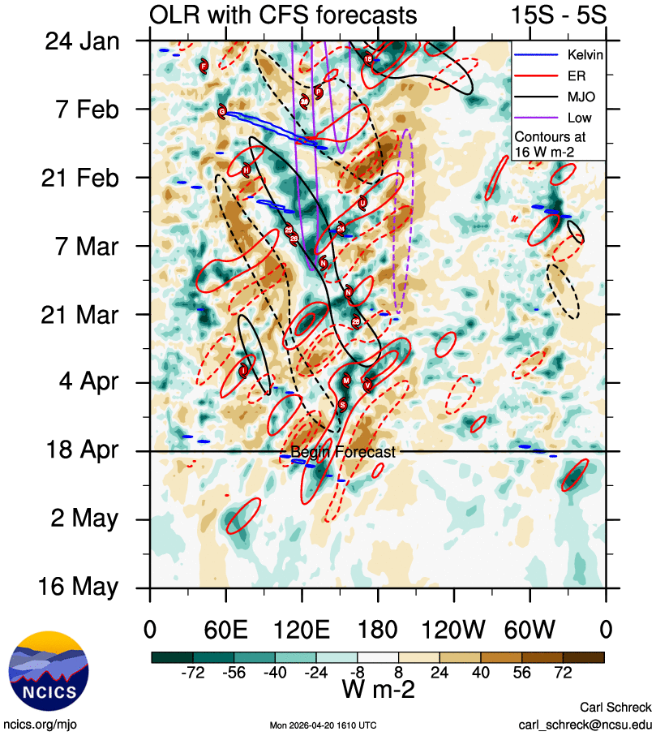
Figure 5: Hovmoller diagram of tropical waves over the latitude range of 5-15S. The formation of Narelle (the system annotated N around 16 March near 160E) coincided with an active phase of the MJO and an Equatorial Rossby wave. The image is courtesy of the North Carolina Institute for Climate Studies: https://ncics.org/pub/mjo/archive/2025/2025-11-25/v2/.
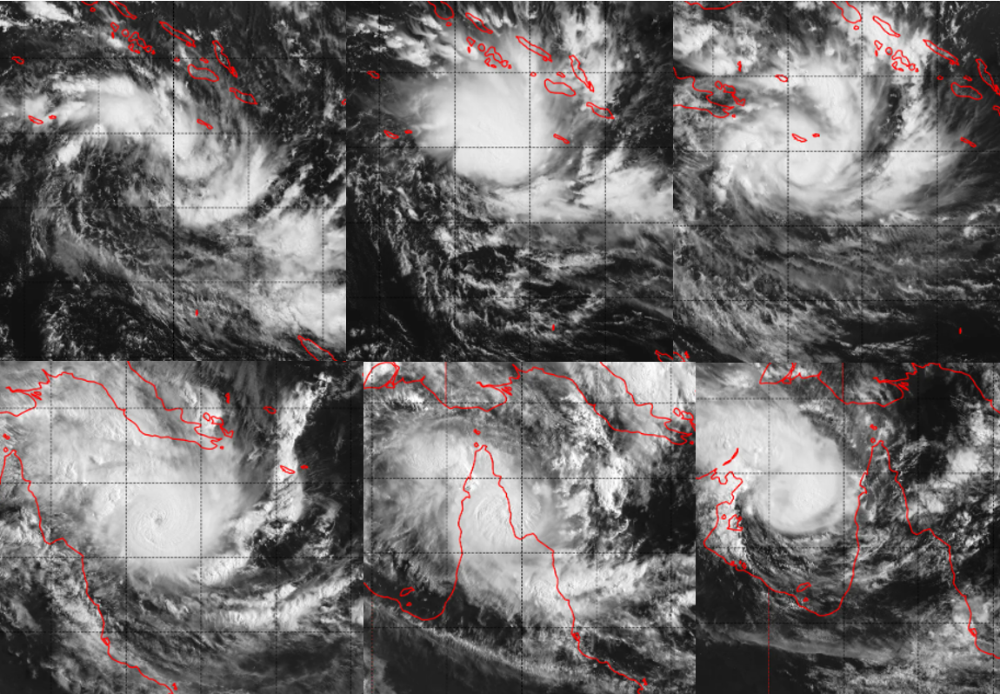
Figure 6: Sequence of Himawari 9 visible images at 0000 UTC on 16 March (top left, 6a), 17 March (top middle, 6b), 18 March (top right, 6c), 19 March (bottom left, 6d), 20 March (bottom middle, 6e), and 21 March 2026 (bottom right, 6f).
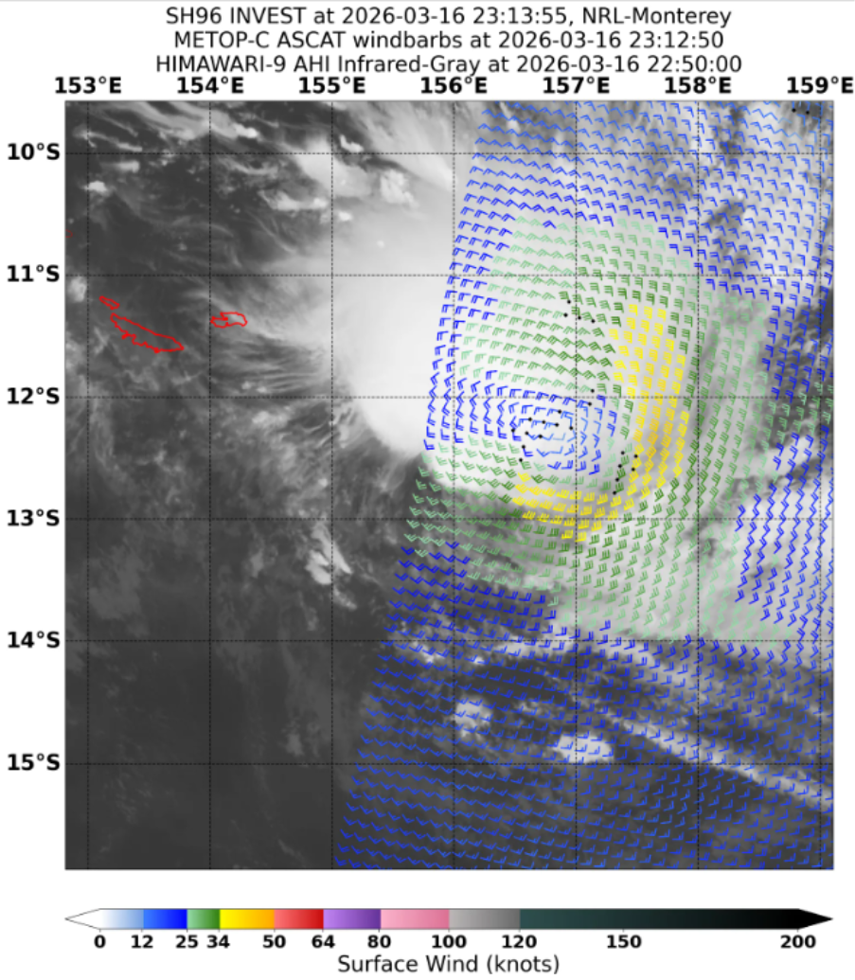
Figure 7: ASCAT-C pass at 2312 UTC 16 March, showing gales extending into three quadrants around the circulation of TC Narelle. Image courtesy NRL: https://science.nrlmry.navy.mil/geoips/tcweb/.

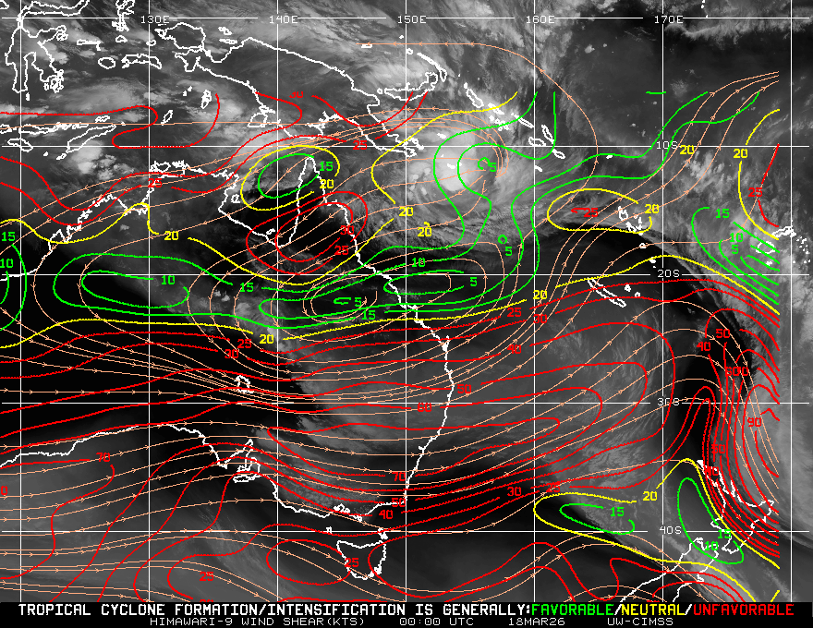 | 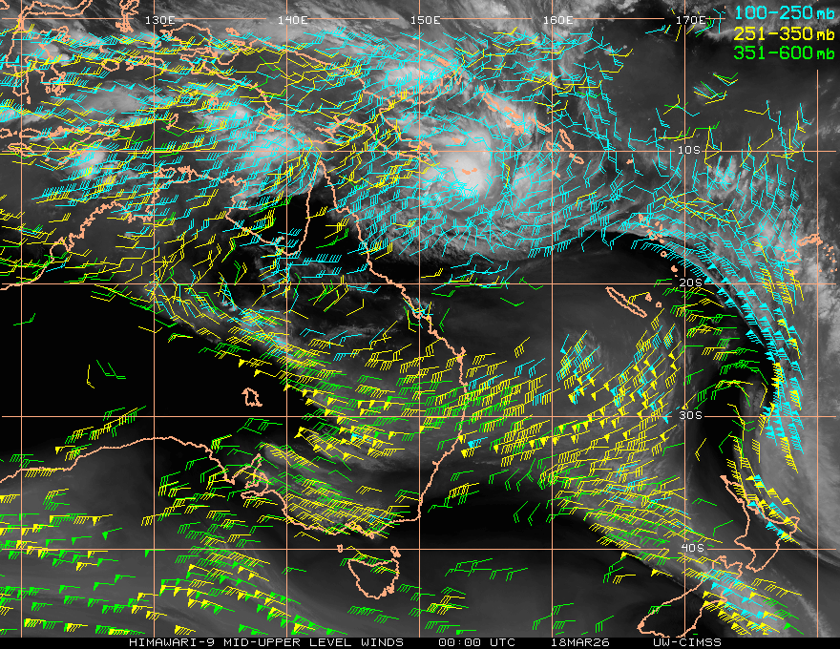

Figure 8: Analysed deep layer wind shear (left) and upper Atmospheric Motion Vectors (right) over eastern Australia at 0000 UTC 18 March 2026. Narelle lies in an area of low deep layer wind shear (green contours) and diffluent upper atmospheric wind vectors. Images courtesy CIMMS: https://tropic.ssec.wisc.edu/tropic.php

Figure 9: Visible Himawari 9 satellite image of Narelle near peak intensity of 115 knots (category 5) at 0600 UTC 19 March.

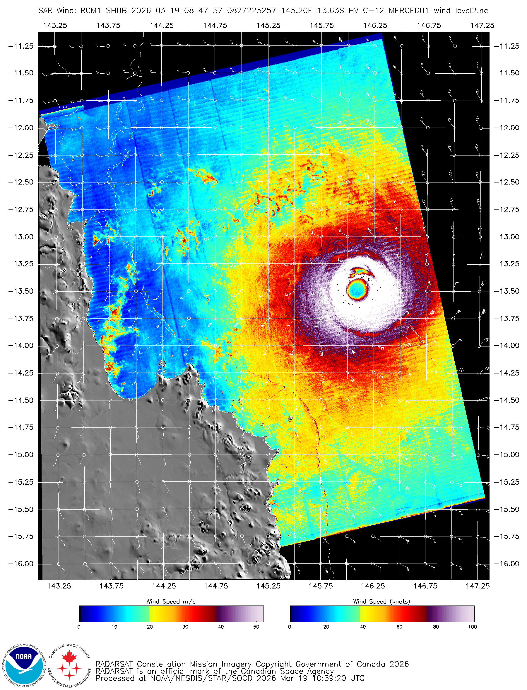
Figure 10: SAR pass over Narelle at peak intensity at 0847 UTC 19 March, indicating maximum 10-minute winds around 115 knots and a nearly symmetrical structure. Image courtesy of NOAA: https://www.star.nesdis.noaa.gov/socd/mecb/sar/sarwinds_tropical.php.

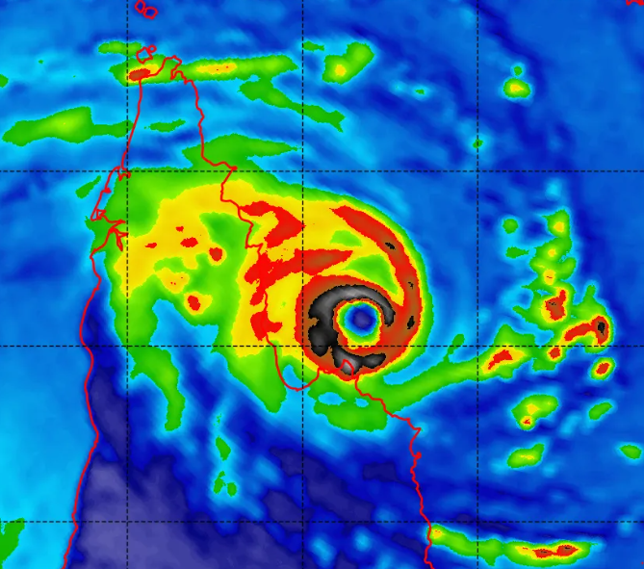
Figure 11: 89 GHz AMSR2 microwave image of Narelle at 1532 UTC 19 March, showing a well-defined eye. Image courtesy NRL: https://science.nrlmry.navy.mil/geoips/tcweb/.

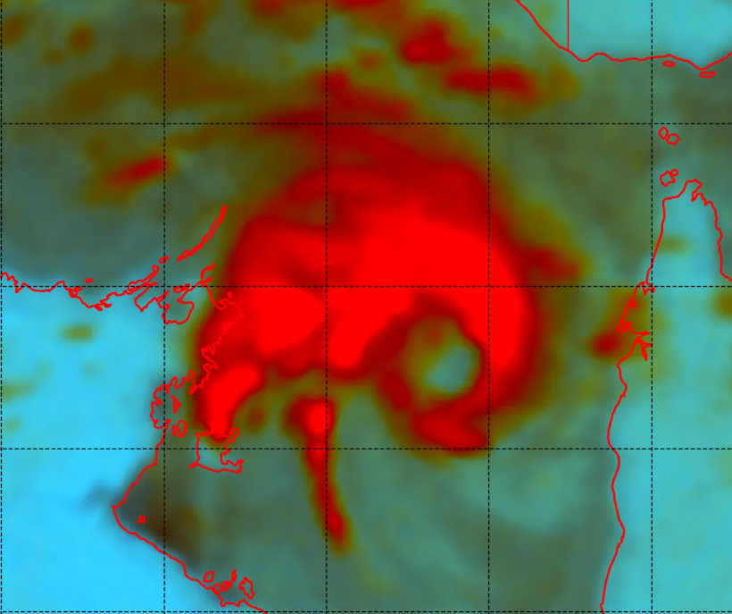
Figure 12: Colour enhanced 89 GHz SSMIS microwave image of Narelle at 1844 UTC 20 March over the Gulf of Carpentaria, showing redevelopment of a new, larger eye wall. Image courtesy NRL: https://science.nrlmry.navy.mil/geoips/tcweb/.

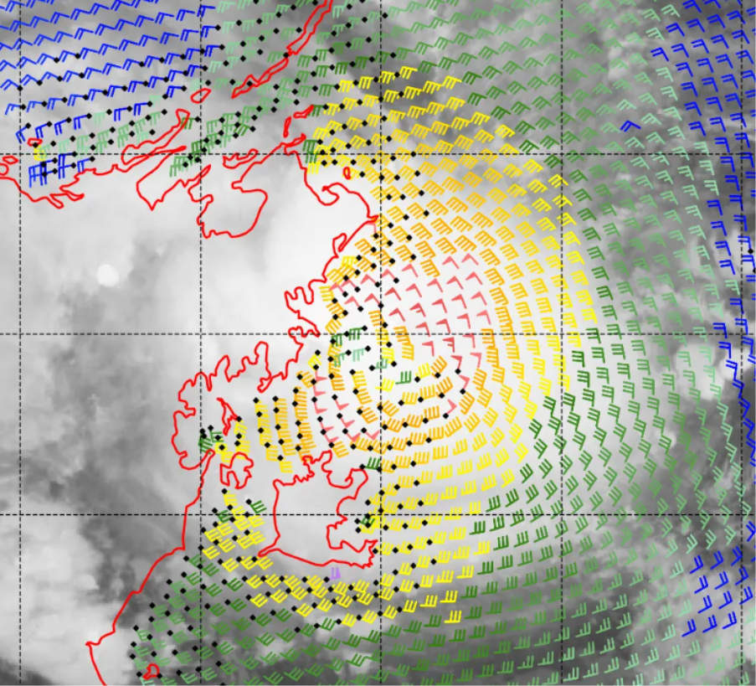
Figure 13: ASCAT-C pass over Narelle over the western Gulf of Carpentaria at 1203 UTC 21 March. Wind barbs are in knots. Image courtesy NRL: https://science.nrlmry.navy.mil/geoips/tcweb/.

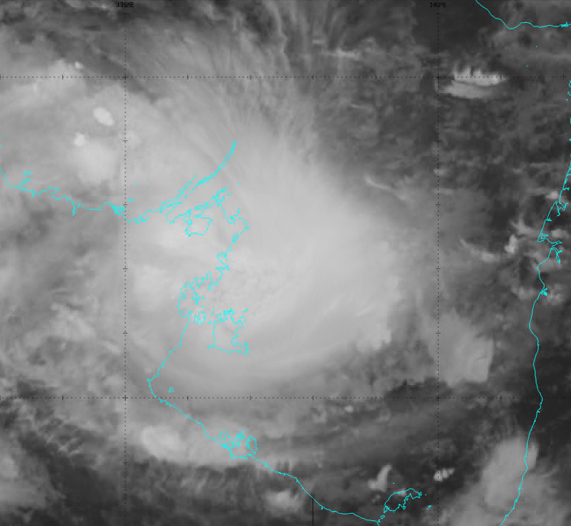
Figure 14: Infrared Himawari 9 image of Narelle at category 3 over the western Gulf of Carpentaria, approaching the Northern Territory coast, at 1500 UTC 21 March.

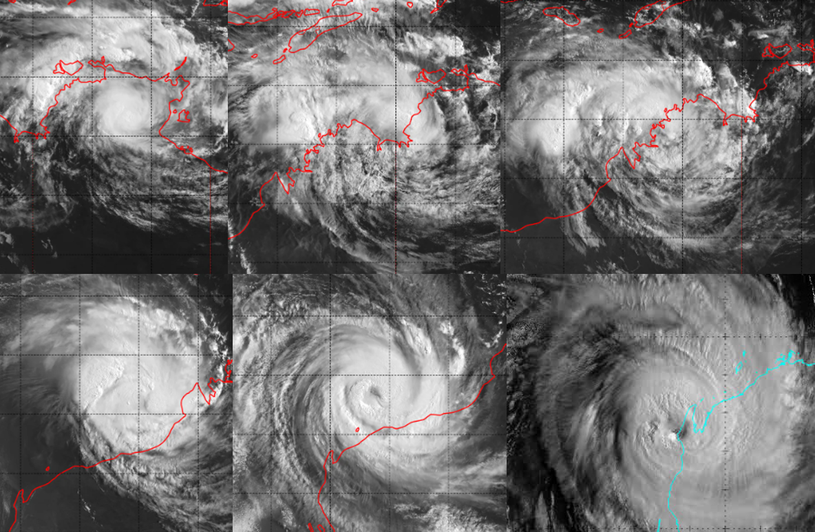
Figure 15: Sequence of Himawari 9 visible images at 0000 UTC on 22 March (top left, 15a), 23 March (top middle, 15b), 24 March (top right, 15c), 25 March (bottom left, 15d), 26 March (bottom middle, 15e), and 27 March 2026 (bottom right, 15f).
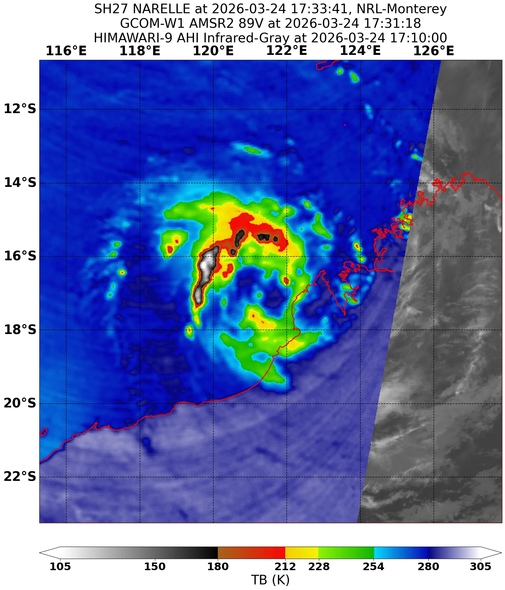
Figure 16: AMSR2 89 GHz microwave image at 1733 UTC 24 March around the time the system redeveloped into a tropical cyclone for the third time. Image courtesy NRL: https://science.nrlmry.navy.mil/geoips/tcweb/.

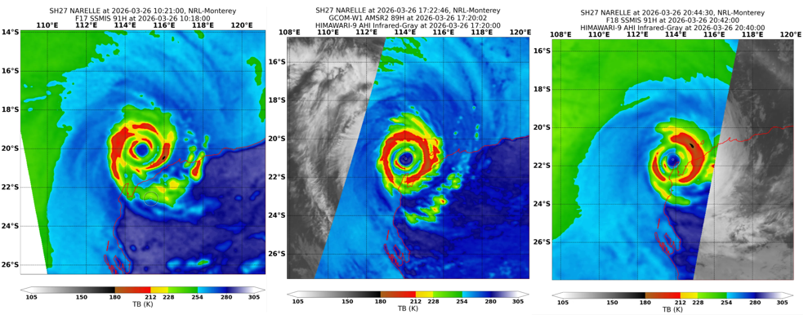
Figure 17: A sequence of microwave imagery illustrating the evolution of the double ring structure Narelle developed on 26 March during an eye wall replacement cycle. The image on the left (17a) is an SSMIS 91 GHz at 1021 UTC, the middle image (17b) is an AMSR2 89 GHz at 1722 UTC and the image on the right (17c) is an SSMIS 91 GHz at 2042 UTC. Images courtesy NRL: https://science.nrlmry.navy.mil/geoips/tcweb/.

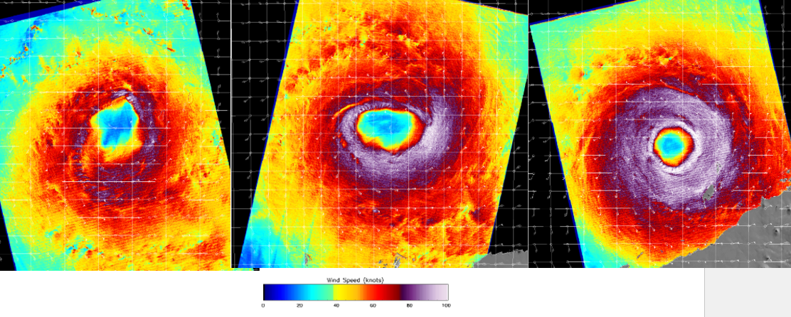
Figure 18: Satellite wind speeds from SAR at 1039 UTC 25 March (left, 18a), 2149 UTC 25 March (middle, 18b), and 1046 UTC 26 March 2026 (right, 18c). These images show the evolution of the ragged, elongated eye on 25 March into a large though regular eye by 26 March with hurricane strength winds surrounding the centre. The right-hand image shows the wind maximum occurring in the eye wall close to the centre. Images courtesy of NOAA https://www.star.nesdis.noaa.gov/socd/mecb/sar/sarwinds_tropical.php.

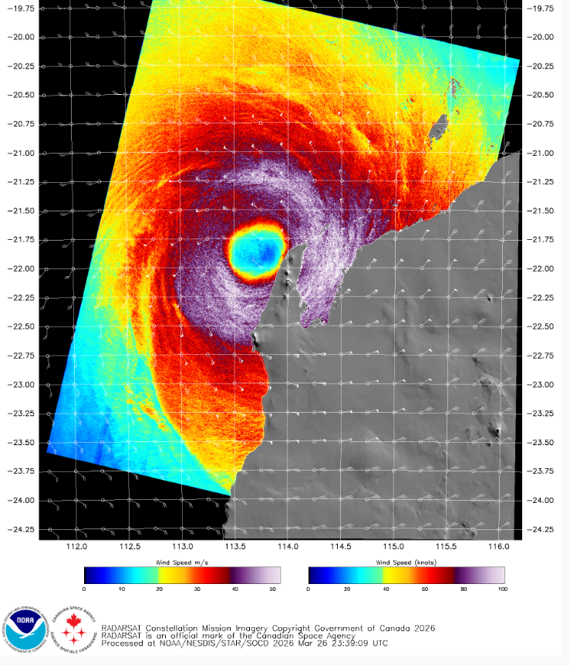
Figure 19: Satellite wind speeds from SAR at 2157 UTC 26 March showing the large extent of hurricane force winds. Image courtesy of NOAA: https://www.star.nesdis.noaa.gov/socd/mecb/sar/sarwinds_tropical.php.
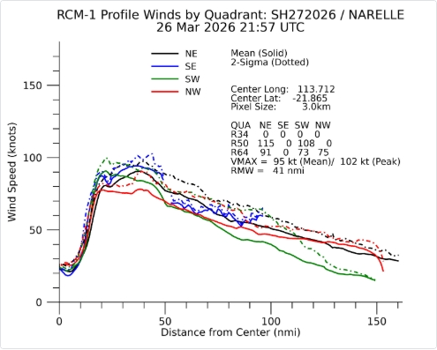
Figure 20: Maximum wind profiles for the 2157 UTC SAR pass in Figure 19 showing a broad area of the strongest winds between about 20-40 nm from the centre. Image courtesy of NOAA https://www.star.nesdis.noaa.gov/socd/mecb/sar/sarwinds_tropical.php.

- Impacts
  - Queensland
Watch and Act warnings were issued for multiple regions across Cape York Peninsula ahead of Narelle's impact. These were upgraded to Take Shelter Now Emergency Warnings for many communities as Narelle approached the coast. Several schools across Cape York Peninsula were closed, and flights into Lockhart River and Coen were cancelled. The small community of Port Stewart, east of Coen on the eastern Cape York Peninsula coast, was evacuated. Source: Severe Tropical Cyclone Narelle to cross Qld coast as category five system - ABC News
The compact inner core of the cyclone fortuitously passed between Coen and Lockhart River while at category 3-4 strength, sparing both communities from the worst wind impacts. In the Coen area, many trees were brought down by wind and several structures were unroofed. Trees were also brought down at Lockhart River. The Archer River Roadhouse, 65 km north of Coen, was isolated by floodwaters as well as trees and debris covering the Peninsula Development Road. Nearby, Upsan Downs Station also suffered significant damage to infrastructure. Source: Tropical Cyclone Narelle downgraded to a category two - ABC News, Tropical Cyclone Narelle leaves trail of damage as residents shelter in boats, shipping containers, WWII bunker - ABC News, Cape York stations hit by Cyclone Narelle call for army's help to clean up - ABC News
Many power lines were brought down across Cape York Peninsula, and about 3000 properties were left without power. Over western Cape York Peninsula, trees and power lines were brought down in Aurukun but no major structural damage was reported. Further north in Weipa, winds tore off the Carpentaria Golf Club's electrical board and felled trees and power lines. A protective roof over a petrol station was torn to shreds. Source: Cyclone Narelle dumps hundreds of millimetres of rain, cuts power, communities on flood watch - ABC News, Cape York communities begin clean-up and recovery after Tropical Cyclone Narelle - ABC News, Far North Queensland residents re-open businesses after ex-Tropical Cyclone Narelle - ABC News
Evidence suggests that at least six tornadoes occurred to the east of Weipa in the outer convective bands of Narelle's circulation as the cyclone approached and crossed the eastern Cape York Peninsula coast early on 20 March (AEST). Very high-resolution satellite imagery from Planet Labs (Planet Team 2026, https://api.planet.com) showed tracks of vegetation damage east of Weipa after Narelle's passage (Figure 21). A review of reflectivity and Doppler data from the Weipa weather radar correlates these tracks with convective cells possessing mesocyclones, and suggests the tornadoes occurred between approximately 1800 UTC and 2200 UTC 19 March (4 am and 8 am AEST 20 March), while the centre of Narelle was approaching and crossing Cape York Peninsula coast some 200 kilometres to the east-southeast. There are otherwise no eyewitness reports or reports of structural damage due to the tornadoes.
The northern beaches of Cairns, about 350 km south of Narelle's track, experienced a significant erosion event associated with Narelle's passage. This is despite observed storm tide levels remaining below Highest Astronomical Tide (HAT), as measured by the tide gauge at Palm Cove, 20 km northwest of Cairns. Evidence suggests the erosion was due to a powerful north-northeast swell from Narelle (Figure 22) passing through a small gap in the Great Barrier Reef (between Tongue Reef and Norman Reef, Figure 23) to the northeast of Cairns.

Northern Territory
About 500 people from the community of Numbulwar, on the eastern Top End coast west of Groote Eylandt, were evacuated to Darwin ahead of Narelle's impact. A field hospital was set up in Katherine, which had been affected by disastrous flooding two weeks earlier. Source: Numbulwar evacuated as other NT communities prepare to shelter from Cyclone Narelle - ABC News, Katherine residents brace for second major flood in two weeks as Severe Tropical Cyclone Narelle approaches NT - ABC News
No significant damage or injuries were reported associated with Narelle's crossing of the eastern Northern Territory coastline. Once again, no population centres were directly impacted by the core of the cyclone. The major impact of Narelle in the Northern Territory was further flooding (see 4.4 Flooding). Source: Ex-Tropical Cyclone Narelle tracks across NT, communities brace for flooding - ABC News
Western Australia
Narelle caused significant impacts to the Pilbara and northern Gascoyne regions of WA. Several towns were placed under Watch and Act, and areas between Onslow and Coral Bay were placed under Emergency Warning as the system neared the WA coast. Flights to the Pilbara region were cancelled, several national parks were closed, and around 50 schools were closed in the area. Source: Tropical Cyclone Narelle smashes west Pilbara coast, tearing off roofs in Exmouth - ABC News
The most significant impacts were recorded at Exmouth and adjacent areas of the North West Cape, where the town lost power and water supply was impacted. Several buildings had roofs completely torn off, and at least five buildings sustained significant damage. The evacuation centre also sustained damage to its roof. The one sealed road into Exmouth was damaged due to flooding, and Learmonth Airport sustained extensive damage to the commercial terminal and apron, impacting the ability for commercial and defence aircraft to access the town. Fuel supplies were also impacted as service stations were damaged. The marina in Exmouth and nearby areas reported significant flooding impacts due to the storm surge. Source: Cyclone Narelle isolates Exmouth, destroys airport and cuts essential services - ABC News. The main street of Onslow was inundated due to heavy rain, and there were several reports of homes being flooded. Water infrastructure was also damaged in Onslow. Sources: Tropical Cyclone Narelle heads inland amid reports of widespread damage in Exmouth - ABC News, Tropical Cyclone Narelle smashes west Pilbara coast, tearing off roofs in Exmouth - ABC News. Bullara Station also had significant flooding impacts and livestock losses. Source: Bullara Station feels 'intense' full force of category four Tropical Cyclone Narelle near Exmouth - ABC News.
As Narelle made landfall and weakened while moving southeast, impacts were also reported across the Gascoyne and northern Mid West. Red skies were observed in Shark Bay as the wind from the cyclone caused large dust storms to engulf the region. Several pastoral properties suffered extensive flood and wind damage, including Hill Springs Station which reported one homestead destroyed and others damaged, damage to infrastructure such as windmills, solar pumps and panels, and extensive fence damage. Sources: Red sky seen in WA ahead of Cyclone Narelle makes global headlines - ABC News, Ex-Tropical Cyclone Narelle brings floods to WA cattle stations after years of drought - ABC News. Narelle also destroyed several banana crops in Carnarvon, with other crops such as pumpkins and mangoes also impacted. Source: Cyclone Narelle destroys WA banana crops, Carnarvon growers hit hard - ABC News. Other areas of the Gascoyne were impacted by significant flooding, with Gascoyne Junction being cut off by road. Several people were stranded on the North West Coastal Highway and needed to be rescued by helicopter. Source: Drivers winched to safety after ignoring road closures in WA's flooded Gascoyne following Cyclone Narelle - ABC News.
Due to its timing one week before the Easter long weekend and the damage inflicted on popular tourist destinations, Narelle had a significant impact on the tourism sector in this part of WA. The towns of Exmouth, Onslow, and Coral Bay were closed to visitors and tourists were asked to stay away so that damage assessment and repairs could be undertaken. Several tourism businesses in this region lost hundreds of thousands of dollars in cancelled bookings, and several backpackers were left without work. Sources: Tourists told to stay away from cyclone-ravaged Exmouth, Coral Bay and Onslow - ABC News, Coral Coast tourism hit with mass cancellations after Cyclone Narelle - ABC News, Backpackers jobless after ex-Tropical Cyclone Narelle shuts down Exmouth ahead of Easter holiday - ABC News. Housing impacts in Exmouth also continued in the months after Narelle. Source: Cyclone Narelle pushes housing shortages deeper into crisis in Exmouth - ABC News.
Narelle caused significant ecological and environmental damage to the Ningaloo Reef stretching along hundreds of kilometres of coastline. The reef was vulnerable after a mass coral bleaching event in 2025, and the cyclone arrived just after the first large coral spawning event since the marine heatwave. The beaches along the coast of the North West Cape were strewn with thousands of baby turtles and turtle eggs, dead fish, sea snakes, dolphins and seabirds. Source: Fears for Ningaloo Reef after ex-cyclone decimates region amid coral spawning season - ABC News ‘Harrowing’: Cyclone Narelle leaves graveyard of turtles, dolphins and seabirds in Western Australia | Tropical Cyclone Narelle | The Guardian
There were also significant impacts to the oil and gas industry, and several ports in the Pilbara were forced to close due to Narelle. Santos, Chevron, and Woodside suspended operations and suffered damage to infrastructure at various onshore and offshore facilities. The port at Dampier suffered damage to the cargo shipping area, and the Port of Ashburton, Cape Preston West and Varanus Island ports were closed during the event, affecting iron ore and LNG exports. Sources: Ex-Tropical Cyclone Narelle disrupts WA's domestic gas supply, port operations - ABC News, Tropical Cyclone Narelle smashes west Pilbara coast, tearing off roofs in Exmouth - ABC News.
A storm surge of about 3m, associated with Narelle, produced water levels of approximately 4.4 m above the lowest astronomical tide at Exmouth (refer Figure 35), resulting in coastal inundation. Homes along the town's canals and marina infrastructure were flooded and boats damaged or sunk. Severe Tropical Cyclone Narelle wreaks havoc across Western Australia | news.com.au — Australia’s leading news site for latest headlines

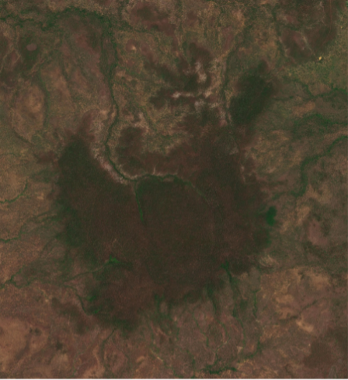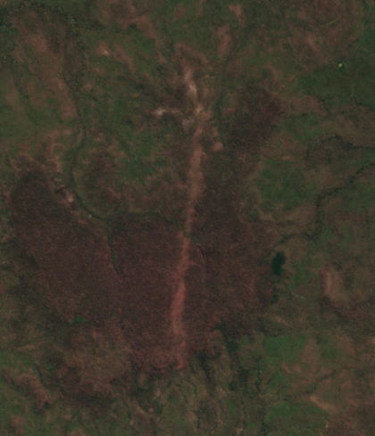
Figure 21: Very high resolution satellite imagery of the area east of Weipa prior to Narelle (left) and after Narelle's passage (right), showing a suspected tornado track. Imagery © 2026 Planet Labs PBC.

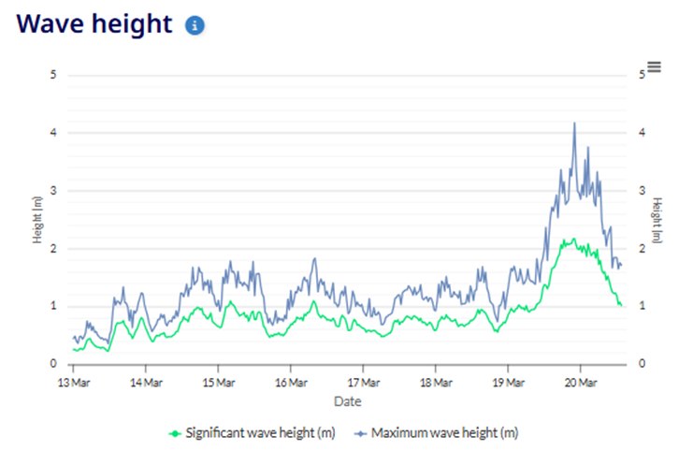
Figure 22: Wave data from the buoy at Palm Cove, showing significant wave height rising from 0.5m to more than 2m on the 19th and 20th of March as Narelle passed to the north. Image courtesy of Qld Government DETSI.

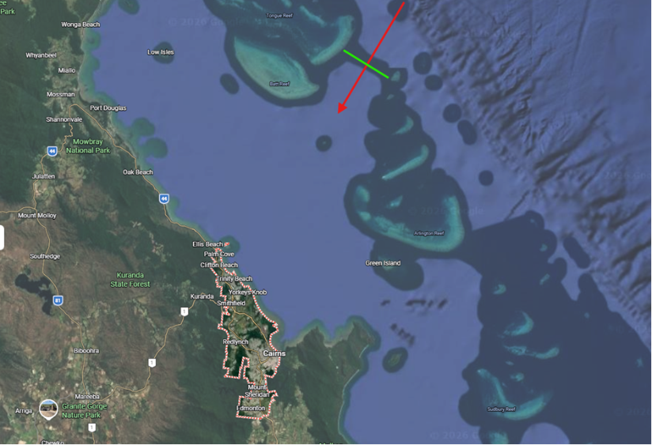
Figure 23: Map showing the gap between Tongue Reef and Norman Reef in the Great Barrier Reef, allowing the NNE swell to impact beaches north of Cairns.

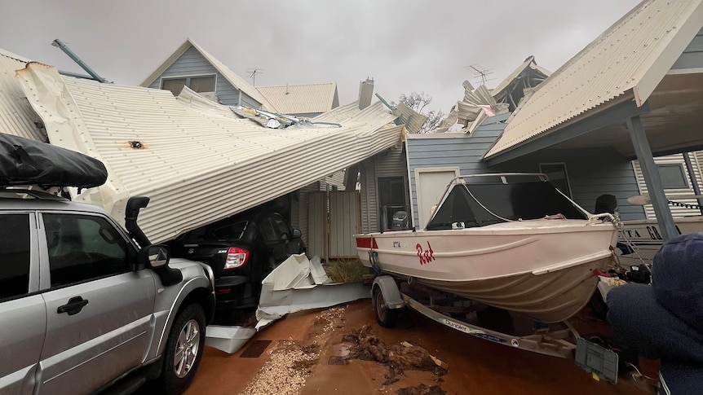
Figure 24: Significant damage to houses in Exmouth. Photo supplied to the ABC, available: Tropical Cyclone Narelle heads inland amid reports of widespread damage in Exmouth - ABC News.

Figure 25: Coastal inundation at Exmouth Marina due to the storm surge caused by Narelle. Photo supplied to the ABC, available: Tropical Cyclone Narelle heads inland amid reports of widespread damage in Exmouth - ABC News.
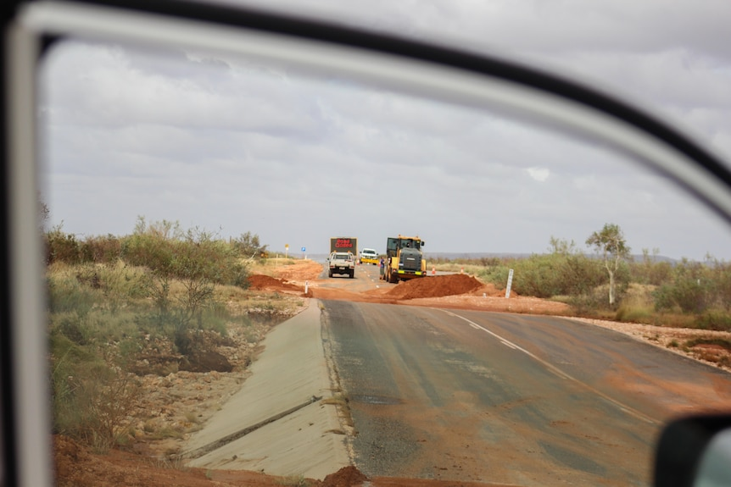
Figure 26: Flood damage to Minilya-Exmouth Road. Image credit: ABC, available: Cyclone Narelle isolates Exmouth, destroys airport and cuts essential services - ABC News.

- Observations
  - Wind observations
The maximum 10-minute(min) mean wind, maximum 3-second(sec) wind gust, and the total time these sites recorded gale, storm, and hurricane force winds are listed below. All times are listed in UTC (AEST=UTC+10h, ACST=UTC+9.5h, AWST=UTC+8h). Note that periods of gales (and storm/hurricane force winds) are not always continuous and were usually recorded intermittently during the time periods listed.
    - Queensland
Lockhart River:
- Maximum 10-min mean wind was 39 kn (73 km/h) at 2258 and 2259 UTC 19 March.
- Maximum 3-sec wind gust was 62 kn (115 km/h) at 2258 UTC 19 March.
- Recorded gale force winds for a total of 1 h and 9 m between 2214 and 2322 UTC 19 March.
Weipa
- Maximum 10-min mean wind was 37 kn (69 km/h) between 0659-0703 UTC 20 March.
- Maximum 3-sec wind gust was 59 kn (109 km/h) at 0654 UTC 20 March.
- Recorded gale force winds for a total of 34 m between 0645-0707 and 0732-0742 UTC on 20 March.
Cape Flattery:
- Maximum 10-min mean wind was 31 kn (57 km/h) at 0755 UTC 19 March.
- Maximum 3-sec wind gust was 45 kn (83 km/h) at 1019 UTC 19 March.
Low Isles Lighthouse:
- Maximum 10-min mean wind was 35 kn (64 km/h) at 1119 UTC 19 March.
- Maximum 3-sec wind gust was 51 kn (94 km/h) at 1111 UTC 19 March.
- Recorded gale force winds for a total of 17 m between 0633 and 1636 UTC 19 March.
Arlington Reef:
- Maximum 10-min mean wind was 34 kn (62 km/h) at 1023 UTC 19 March.
- Maximum 3-sec wind gust was 45 kn (84 km/h) at 1019 UTC 19 March.
    - Northern Territory
Groote Eylandt:
- Maximum 10-min mean wind was 30 kn (56 km/h) at 1737 UTC 21 March.
- Maximum 3-sec wind gust was 45 kn (83 km/h) at 1649 UTC 21 March.
Centre Island:
- Maximum 10-min mean wind was 38 kn (70 km/h) at 1324 UTC 21 March.
- Maximum 3-sec wind gust was 47 kn (87 km/h) at 1319 UTC 21 March.
- Recorded gale force winds for a total of 1 h and 58 m between 0546 and 1827 UTC 21 March.
Ngayawili:
- Maximum 10-min mean wind was 36 kn (67 km/h) at 1911 UTC 21 March.
- Maximum 3-sec wind gust was 49 kn (91 km/h) at 1832 UTC 21 March.
- Recorded gale force winds for 1 h and 31 m between 1735 and 1919 UTC 21 March.
Cape Wessel:
- Maximum 10-min mean wind was 34 kn (63 km/h) at 1258 UTC 21 March.
- Maximum 3-sec wind gust was 46 kn (85 km/h) at 1044 UTC 21 March.
- Recorded gale force winds for 1 m at 1258 UTC 21 March.
Darwin Airport:
- Maximum 10-min mean wind was 29 kn (54 km/h) at 1250 UTC 22 March.
- Maximum 3-sec wind gust was 41 kn (76 km/h) at 1248 UTC 22 March.
Dum In Mirrie:
- Maximum 10-min mean wind was 19 kn (36 km/h) at 1725 UTC 22 March.
- Maximum 3-sec wind gust was 43 kn (79 km/h) at 1722 UTC 22 March.
    - Western Australia
Troughton Island:
- Maximum 10-min mean wind was 39 kn (73 km/h) at 1646 UTC 23 March.
- Maximum 3-sec wind gust was 50 kn (93 km/h) at 1642 UTC 23 March.
- Recorded gale force winds for 2 h and 14 m between 1329 and 2100 UTC 23 March.
Port Hedland:
- Maximum 10-min mean wind was 37 kn (68 km/h) at 0157 UTC 26 March.
- Maximum 3-sec wind gust was 52 kn (96 km/h) at 0151 UTC 26 March.
- Recorded gale force winds for 11 m between 0152 and 0202 UTC on 26 March.
Rowley Shoals:
- Maximum 10-min mean wind was 53 kn (98 km/h) at 1019 UTC 25 March.
- Maximum 3-sec wind gust was 78 kn (144 km/h) at 1019 UTC 25 March.
- Recorded gale force winds for a total of 13 h 41 m between 0209 and 2229 UTC 25 March.
- Recorded storm force winds for a total of 3 h 3 m between 0259 and 1222 UTC 25 March.
Bedout Island:
- Maximum 10-min mean wind was 52 kn (97 km/h) at 1553 UTC 25 March.
- Maximum 3-sec wind gust was 81 kn (151 km/h) at 2351 UTC 25 March.
- Recorded gale force winds for a total of 26 h 26 m between 2342 UTC 24 March and 0835 UTC 26 March.
- Recorded storm force winds for a total of 1 h 22 m between 1055 and 2358 UTC 25 March.
Roebourne Airport (station stopped reporting between 0747 UTC 26 March and 0026 UTC 27 March):
- Maximum 10-min mean wind was 45 kn (82 km/h) at 0652 UTC 26 March.
- Maximum 3-sec wind gust was 64 kn (119 km/h) at 0723 UTC 26 March.
- Recorded gale force winds for a total of 7 h 9 m between 2232 UTC 25 March and 0746 UTC 26 March.
Karratha Airport:
- Maximum 10-min mean wind was 51 kn (94 km/h) at 0654 UTC 26 March.
- Maximum 3-sec wind gust was 67 kn (124 km/h) at 0739 UTC 26 March.
- Recorded gale force winds for a total of 19 h 7 m between 2001 UTC 25 March and 1759 UTC 26 March.
- Recorded storm force winds for a total of 1 h 7 m between 0518-0748 UTC 26 March.
Legendre Island:
- Maximum 10-min mean wind was 61 kn (114 km/h) at 0420 UTC 26 March.
- Maximum 3-sec wind gust was 79 kn (146 km/h) at 0649 UTC 26 March.
- Recorded gale force winds for a total of 30 h 5 m between 1310 UTC 25 March and 2125 UTC 26 March.
- Recorded storm force winds for 14 h 10 m between 1822 UTC 25 March and 1418 UTC 26 March.
Mardie:
- Maximum 10-min mean wind was 44 kn (81 km/h) at 0822 UTC 26 March.
- Maximum 3-sec wind gust was 63 kn (116 km/h) at 0821 UTC 26 March.
- Recorded gale force winds for a total of 13 h 40 m between 0333-2050 UTC 26 March.
Varanus Island:
- Maximum 10-min mean wind was 80 kn (148 km/h) at 0845 UTC 26 March.
- Maximum 3-sec wind gust was 100 kn (185 km/h) at 1011 UTC 26 March
- Recorded gale force winds for a total of 25 h 45 m between 2011 UTC 25 March and 2327 UTC 26 March.
- Recorded storm force winds for a total of 14 h 51 m between 0108 and 1706 UTC 26 March.
- Recorded hurricane force winds for a total of 5 h 11 m between 0644 and 1200 UTC 26 March.
Barrow Island:
- Maximum 10-min mean wind was 66 kn (123 km/h) at 0905 UTC 26 March.
- Maximum 3-sec wind gust was 92 kn (170 km/h) at 0900 UTC 26 March.
- Recorded gale force winds for a total of 22 h 4 m between 2142 UTC 25 March and 2335 UTC 26 March.
- Recorded storm force winds for a total of 13 h 9 m between 0411 and 1950 UTC 26 March.
- Recorded hurricane force winds for a total of 1 h 38 m between 0900 and 1548 UTC 26 March.
Thevenard Island:
- Maximum 10-min mean wind was 65 kn (121 km/h) at 1928 UTC 26 March.
- Maximum 3-sec wind gust was 88 kn (163 km/h) at 1741 UTC 26 March. This is the annual highest daily wind gust record for this station.
- Recorded gale force winds for a total of 19 h 31 m between 0644 UTC 26 March and 0416 UTC 27 March.
- Recorded storm force winds for a total of 9 h and 19 m between 1345 UTC 26 March and 0108 UTC 27 March.
- Recorded hurricane force winds for a total of 10 m between 1749 and 1930 UTC 26 March.
Onslow Airport:
- Maximum 10-min mean wind was 61 kn (113 km/h) at 1642 UTC 26 March.
- Maximum 3-sec wind gust was 81 kn (150 km/h) at 1729 UTC 26 March.
- Gale force winds were recorded for a total of 16 h 52 m from 1426 UTC 26 March to 0743 UTC 27 March.
- Storm force winds for 9 h 18 m between 1224 UTC 26 March and 0023 UTC 27 March.
Learmonth Airport (station stopped reporting from 0942 UTC 27 March):
- Maximum 10-min mean wind was 78 kn (145 km/h) at 2338 UTC 26 March.
- Maximum 3-sec wind gust was 108 kn (200 km/h) at 2231 UTC 26 March.
- Gale force winds were recorded for a total of 16 h 52 m from 1426 UTC 26 March to 0743 UTC 27 March.
- Storm force winds for a total of 9 h 26 m between 1815 UTC 26 March and 0442 UTC 27 March.
- Hurricane force winds for a total of 5 h 38 m between 2012 UTC 26 March and 0149 UTC 27 March.
Carnarvon Airport:
- Maximum 10-min mean wind was 47 kn (86 km/h) at 0813 UTC 27 March.
- Maximum 3-sec wind gust was 72 kn (133 km/h) at 0740 UTC 27 March.
- Recorded gale force winds for a total of 6 h 5 m between 0259 and 0945 UTC 27 March.

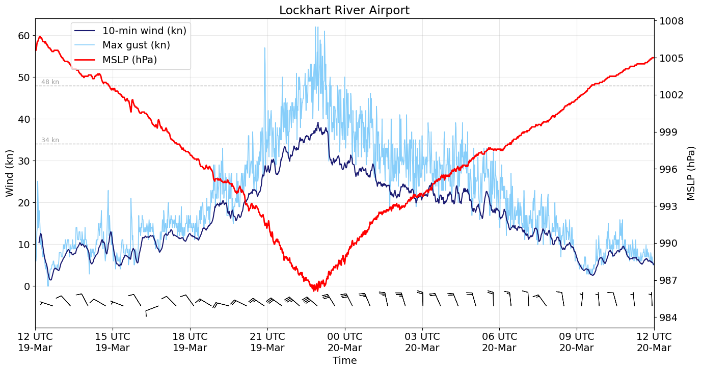
Figure 27: Data from Lochart River Airport AWS plotted between1200 UTC 19 March and 1200 UTC 20 March. The 10-minute mean wind (in knots) is shown in dark blue, the maximum 3-second wind gust (in knots) is shown in light blue, and the mean sea-level pressure (in hPa) is shown in red. A brief period of gale force winds (>34 kn) was recorded for a total of 1 h 9 min between 2214 and 2322 UTC 19 March.
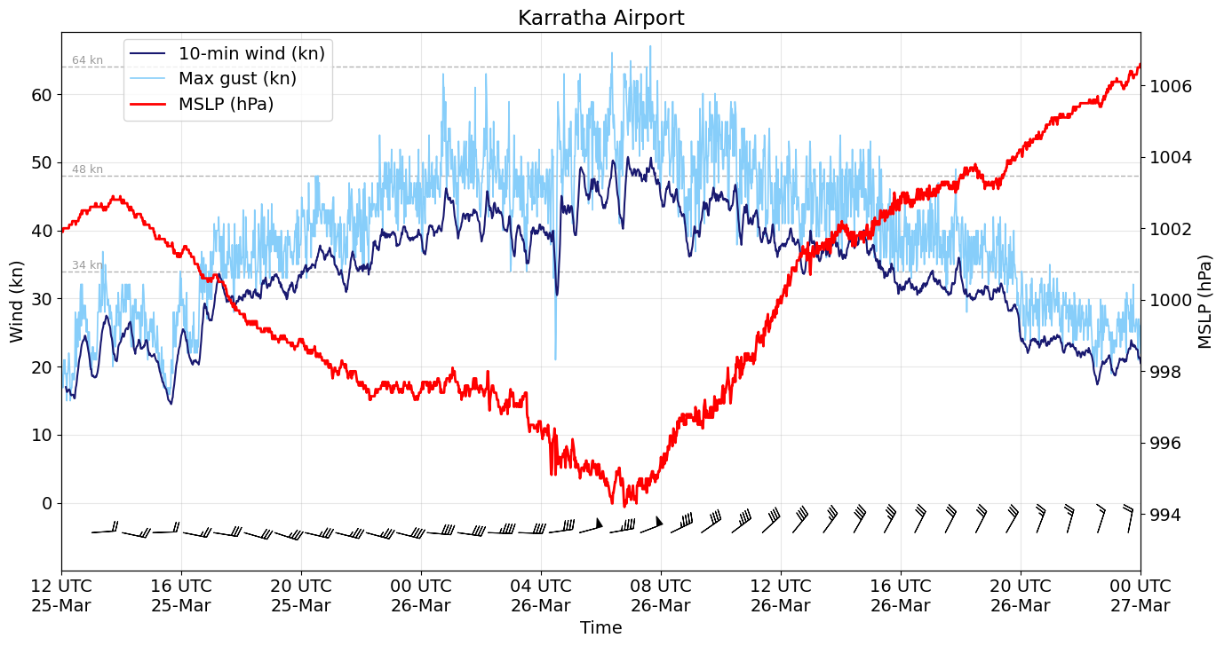
Figure 28: Data from the Karratha Airport AWS plotted between 1200 UTC 25 March and 0000 UTC 27 March. The 10-minute mean wind (in knots) is shown in dark blue, the maximum 3-second wind gust (in knots) is shown in light blue, and the mean sea-level pressure (in hPa) is shown in red. A brief period of mean storm force winds (>48 kn) was recorded for a total of 1 h 7 min between 0518-0748 UTC 26 March.
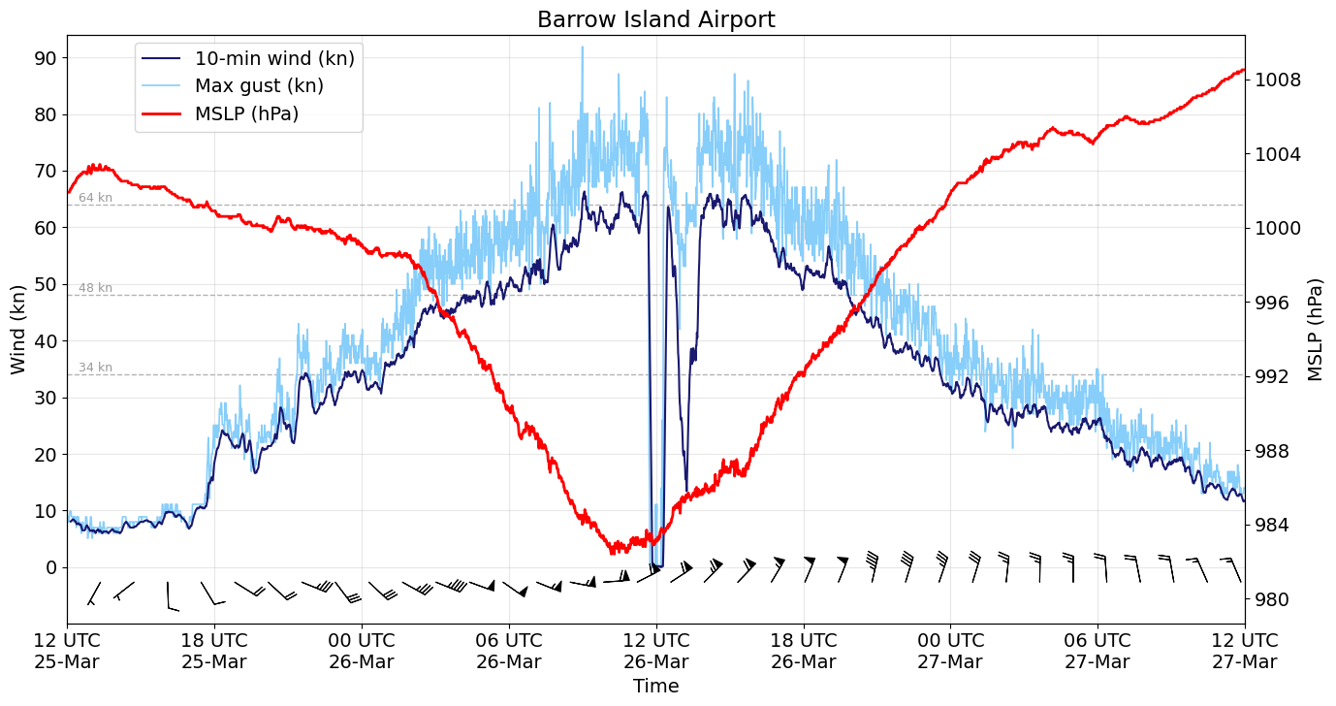
Figure 29: Data from the Barrow Island Airport AWS plotted between 1200 UTC 25 March and 1200 UTC 27 March. The 10-minute mean wind (in knots) is shown in dark blue, the maximum 3-second wind gust (in knots) is shown in light blue, and the mean sea-level pressure (in hPa) is shown in red. The drop in wind speed is suspected to have been caused by an area of lighter winds between the outer band of strong convection and the inner eye wall as Narelle went through an eye wall replacement cycle.
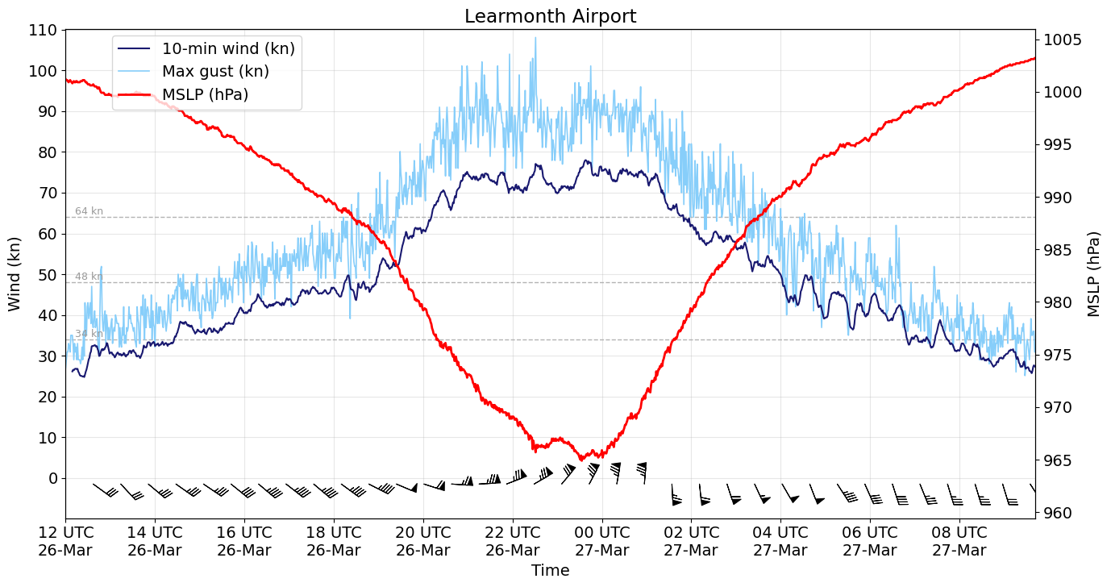
Figure 30: Data from the Learmonth Airport AWS plotted between 1200 UTC 26 March and 0942 UTC 27 March. The 10-minute mean wind (in knots) is shown in dark blue, the maximum 3-second wind gust (in knots) is shown in light blue, and the mean sea-level pressure (in hPa) is shown in red. This site stopped reporting at 0942UTC 27 March.

  - Pressure
Notable minimum mean sea-level pressure measurements recorded are listed below:
Location | Pressure (hPa) | Time (UTC)
Lockhart River | 986.1 hPa | 2248 UTC 19 March
Weipa | 991.9 hPa | 0605 UTC 20 March
Groote Eylandt | 989.3 hPa | 1614 UT 21 March
Rowley Shoals | 974.1 hPa | 0727 UTC 25 March
Varanus Island | 977.5 hPa | 0836 UTC 26 March
Barrow Island | 982.4 hPa | 1011 UTC 26 March
Thevenard Island | 984.9 hPa | 1821 UTC 26 March
Learmonth | 964.9 hPa | 2333 UTC 26 March
Carnarvon | 979.5 hPa | 0929 UTC 27 March

  - Rainfall
    - Queensland
Figure 27 shows the rainfall distribution for the week ending 22 March. The heaviest rainfall occurred along the Queensland coast to the south of the system centre and around Weipa as Narelle moved across Cape York Peninsula.
Notable totals include:
24 hours to 9am AEST 20 March
- Scherger RAAF 120.8 mm
- Lockhart River Airport 108.0 mm
24 hours to 9am AEST 21 March
- Weipa Aero 226.0 mm
- Scherger RAAF 225.0 mm
- Weipa Eastern Ave 209.0 mm

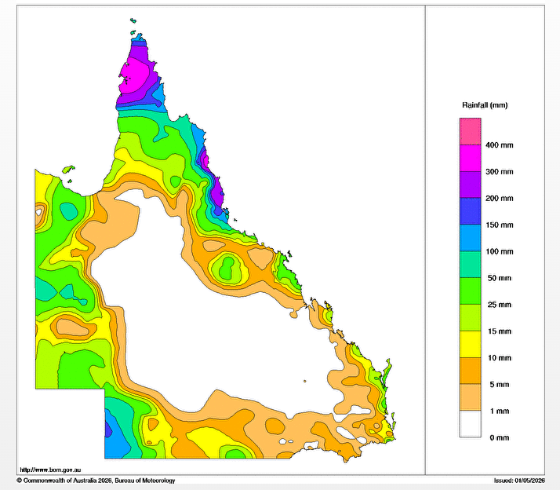
Figure 31: Weekly rainfall totals for Queensland for the period 16-22 March 2026.
    - Northern Territory
Figure 29 shows the rainfall distribution for the week ending 24 March. The heaviest rainfall occurred over the western Top End as Narelle tracked westward across the Northern Territory.
Notable totals include:
24 hours to 9am ACST 23 March
- Burrells Creek 279.7 mm
- Channel Point 244.0 mm
- Adelaide River Post Office and Buley Rockhole 195.0 mm
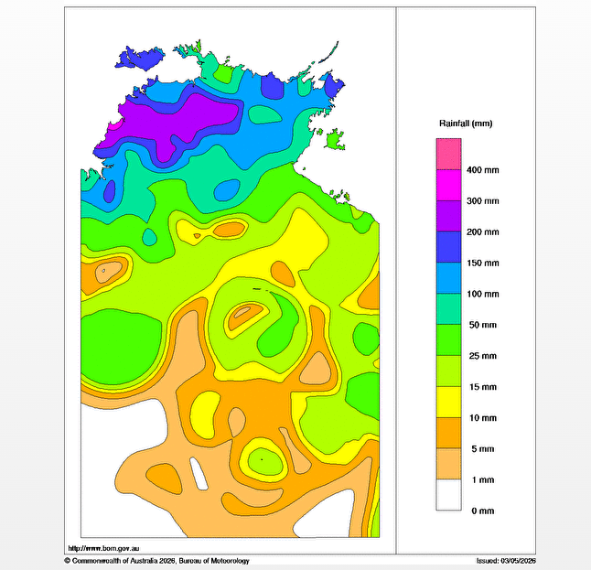Figure 32: Weekly rainfall totals for Northern Territory for the period 18-24 March 2026.

    - Western Australia
Widespread heavy to intense rainfall was recorded through parts of the Pilbara in the 24 hours to 9am AWST 27 March as Narelle move along the Pilbara coast. This rainfall extended into the Gascoyne and parts of the Mid West in the 24 hours to 9am AWST 28 March as Narelle crossed the WA coast and moved rapidly to the southeast. Refer to Figure 33 and Figure 34 for rainfall maps for 27 and 28 March. Notable rainfall totals are listed below, with several stations recording annual and March daily rainfall records.
24 hours to 9am AWST 27 March
- Learmonth Airport: 231.4 mm
- Barrow Island Airport: 208 mm (March daily rainfall record)
- Thevenard Island: 196.6 mm (March daily rainfall record)
- Varanus Island: 181 mm
- Roebourne Airport: 148.8 mm (March daily rainfall record)
- Onslow Airport: 117.8 mm
24 hours to 9am AWST 28 March
- Winning: 328 mm (annual daily rainfall record, previous record was 178.6 mm on 20 January 1909)
- Williambury: 208 mm
- Learmonth Airport: 116.6 mm
- Dalgety Downs Airstrip: 112.2 (annual daily rainfall record, previous record was 80.8 mm on 15 January 2018)
- Winderie Airstrip: 108 mm (annual daily rainfall record, previous record was 90.2 mm on 4 February 2021)
- Carey Downs: 91 mm
- Lyons River Airstrip: 79.8 mm (annual daily rainfall record, previous record was 71.8 mm on 31 March 2015)
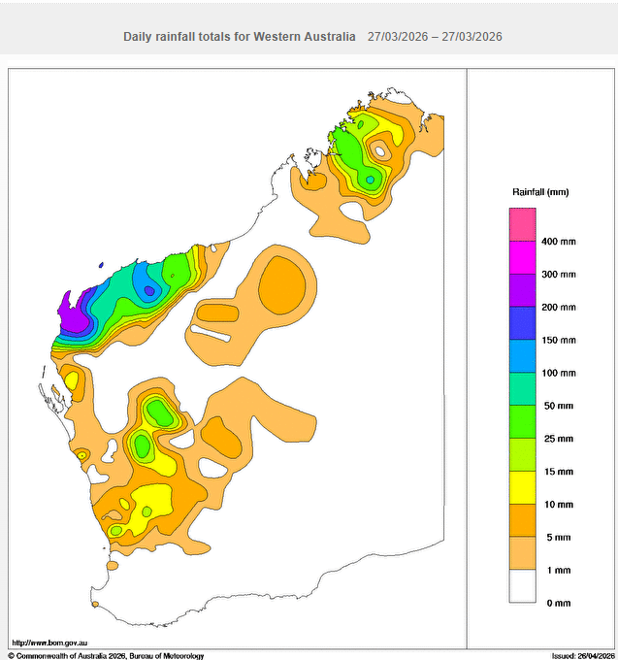
Figure 33: Daily rainfall total for Western Australia for the 24 hours to 9 am AWST 27 March 2026.
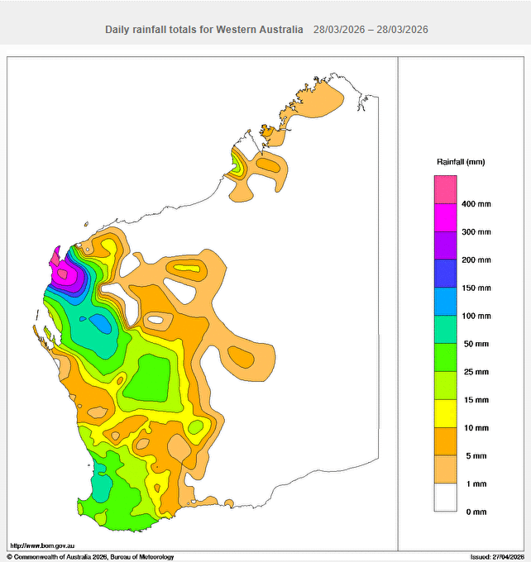
Figure 34: Daily rainfall total for Western Australia for the 24 hours to 9 am AWST 28 March 2026.
  - Flooding
Severe Tropical Cyclone Narelle caused riverine flooding across parts of Queensland, the Northern Territory and Western Australia, with Flood Watches and Warnings issued across each of these regions during March.
In Queensland, minor to moderate flooding occurred across parts of the North Tropical Coast, while flooding also occurred across large parts of Cape York Peninsula.
In the Northern Territory, flooding occurred in many catchments across the Top End. Major flooding occurred in the Katherine River and the Adelaide River, while moderate flooding occurred in the Waterhouse River. Major flooding was already occurring in the Daly River, but rainfall from Narelle brought renewed rises that extended the period of major flooding.
In Western Australia, minor to moderate flooding occurred in the Gascoyne River and Lyndon-Minilya River catchment, while flooding also occurred across large parts of the Pilbara and Kimberley.
  - Storm tide
    - Queensland
Weipa recorded a storm surge of 0.9 m at 0600 UTC 20 March before the tide gauge stopped reporting.
    - Northern Territory
Groote Eylandt (Alyangula and Milner Bay) recorded a storm surge of 1.6 m at 1700 UTC 21 March as Narelle moved north of the island.
    - Western Australia
Locations between Port Hedland and Carnarvon recorded a storm surge. These are shown in Table 2. Refer to Figure 35 for a plot of the storm surge recorded at the Exmouth tide gauge.
Location | Height (m) | Time
Port Hedland | 1.1 m | 0200 UTC 26 March
Karratha (Lambert Wharf) | 1.3 m | 0900 UTC 26 March
Barrow Island | 2.43 m | 1100 UTC 26 March
Onslow* | 2.0 m | 0000 UTC 27 March
Exmouth | 3.0 m | 2200 UTC 26 March
Cape Cuvier | 0.3 m | 0800 UTC 27 March
Carnarvon | 0.5 m | 1400 UTC 27 March
Table 2 Residual heights from Western Australian tide gauges in relation to storm surge associated with Narelle. *Note data from Onslow was incomplete through this period.
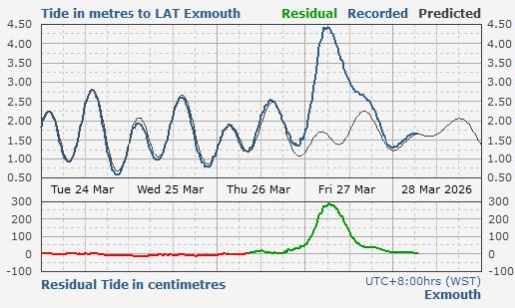
Figure 35 Storm surge recorded at Exmouth on 27 March 2026 as Narelle moved west of the North West Cape. Image courtesy of Storm surge comparison chart | Transport WA
In addition to the storm surge along the northern WA coastline, a coastally trapped wave was also recorded propagating down the west and southwest coasts in the days after the event. The observed residuals (observed height minus predicted height) are shown in Table 3.
Location | Height (m) | Time
Cape Cuvier | 0.6 m | 0400 UTC 28 March
Carnarvon | 0.5 m | 2300 UTC 27 March
Geraldton | 0.42 m | 0000 UTC 29 March
Jurien Bay | 0.32 m | 1600 UTC 29 March
Hillary's Boat Harbour | 0.4 m | 0300 UTC 30 March
Barack Street Jetty | 0.34 m | 1000 UTC 30 March
Bunbury | 0.35 m | 1000 UTC 30 March
Busselton | 0.38 m | 1100 UTC 30 March
Table 3 Residual heights from Western Australian tide gauges in relation to a shelf wave associated with Narelle.

- Forecast Performance
Refer to Figure 36 for the tropical cyclone probability risk matrix for Narelle. The first seven-day forecast for Narelle was issued on 10 March indicating a low risk of development in the Coral Sea from 17 March. By 14 March this probability had increased to moderate however no high probability was assigned prior to Narelle's formation. This was largely due to limited support from ensemble model guidance for development. In contrast, the redevelopment of Narelle into a tropical cyclone west of the Kimberley coast on 25 March was well forecast, with a high-risk outlook indicated in all forecasts issued beforehand.
The first forecast track map and Advice were issued concurrently at 0000 UTC 17 March. Due to the track of Narelle moving over three regions of Australia Track maps and Advices were issued continuously until 0000 UTC 28 March.
The accuracy statistics for Severe Tropical Cyclone Narelle are below in Table 4 and shown in Figure 37 and Figure 38.
Forecast track position accuracy was better than the five-year average at all time steps (see Figure 37). Narelle was steered west southwest by a mid-level ridge over much of its lifetime. This consistent motion was well captured by model guidance, contributing to the excellent position verification results.
Forecast intensity accuracy was comparable to or better than the 5-year average at all time steps (in Figure 38). This was a good result given the intensity changes Narelle experienced as it moved over land and water several times during its lifetime.

Time | 00 | 06 | 12 | 18 | 24 | 36 | 48 | 72 | 96 | 120
Position accuracy (km) | 21 | 35 | 41 | 46 | 50 | 55 | 63 | 95 | 157 | 230
Intensity accuracy (knots) | 2.7 | 4.9 | 6.1 | 6.1 | 6.9 | 7.6 | 8.4 | 6.8 | 8.7 | 11.4
Sample Size | 45 | 45 | 44 | 43 | 42 | 40 | 38 | 34 | 30 | 26
Table 4: Verification statistics for Severe Tropical Cyclone Narelle. Note: Verification is performed using the Official Forecast Tracks at the standard times of 00, 06, 12 and 18 UTC.
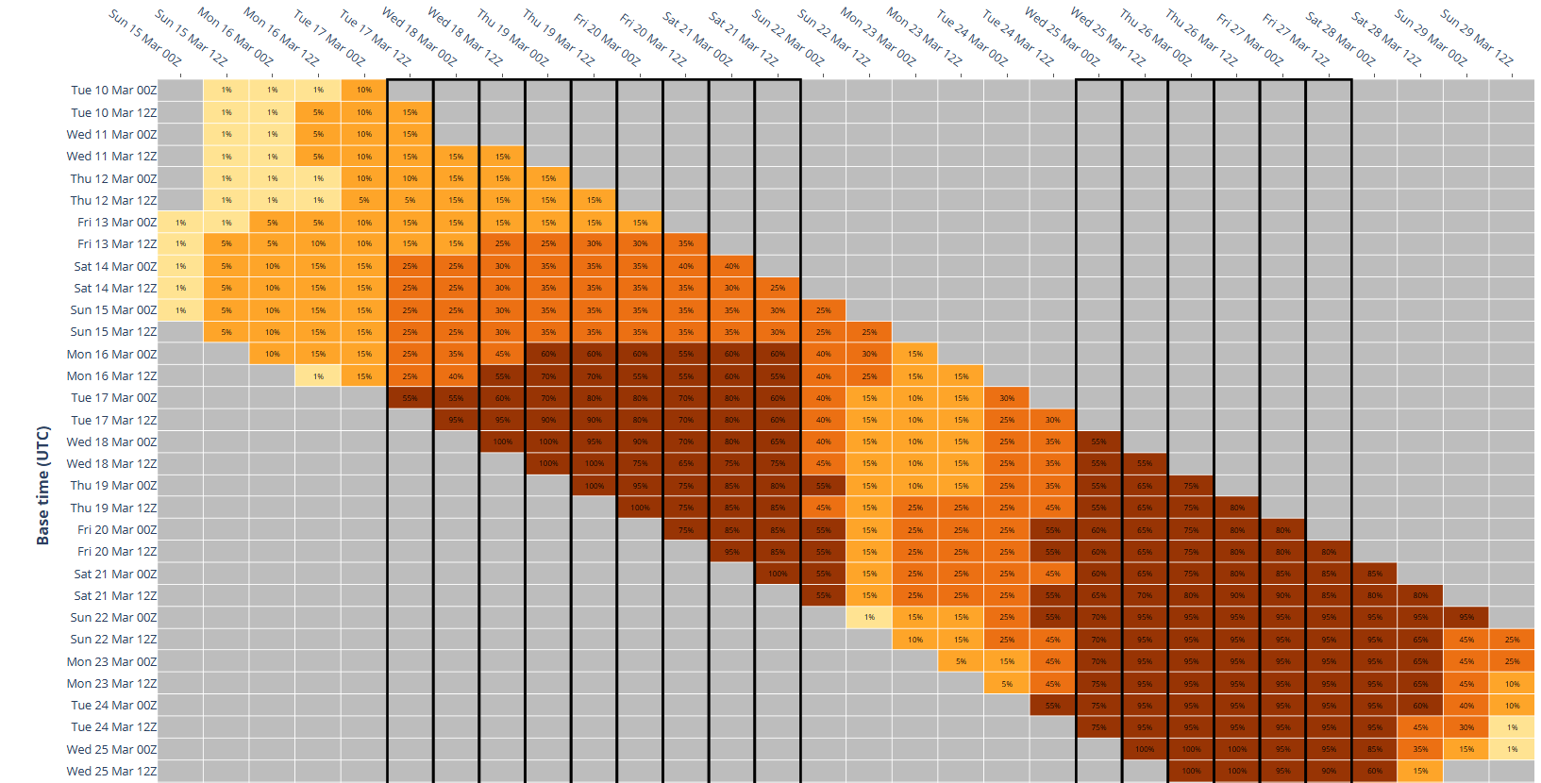
Figure 36: The forecast percentage risk of a low developing into a tropical cyclone taken from the 7-day forecast for Narelle from 10 to 29 March 2026. The forecast base time is shown on the vertical axis and the forecast validity time is shown on the horizontal axis. The box colours correspond to the tropical cyclone forecast rating, yellow for Very Low (<5%), light orange for Low (5-15%), orange for Moderate (20-45%) and brown for High (50-100%). The thick black lines indicate the period Narelle was a tropical cyclone.
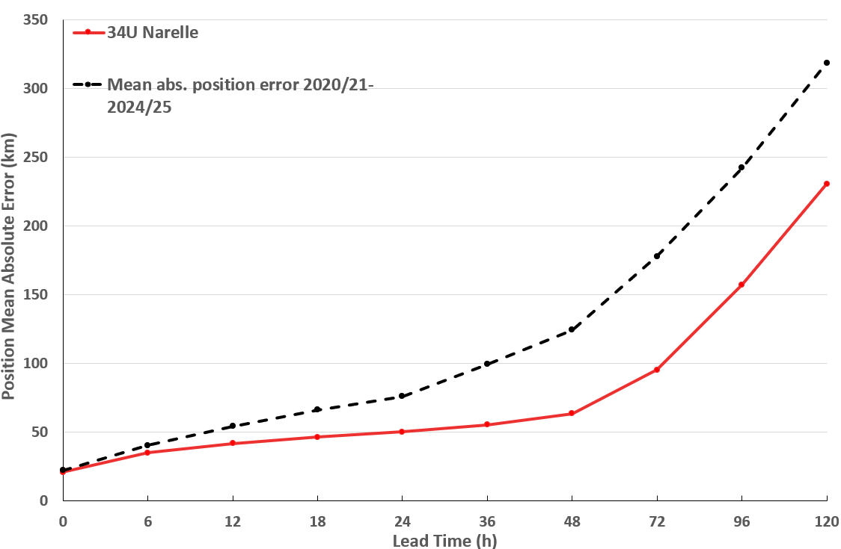
Figure 37: Position accuracy figures for Severe Tropical Cyclone Narelle compared against the 5-year average.
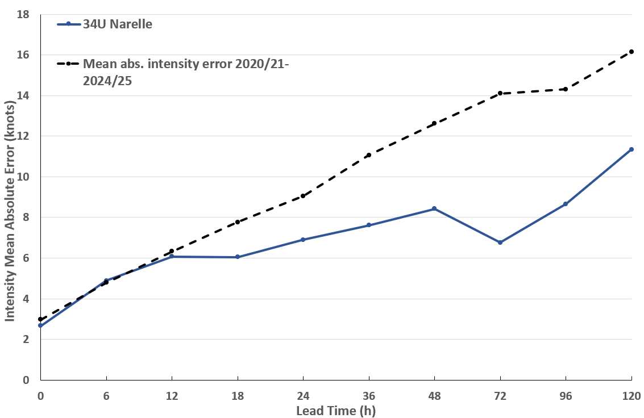
Figure 38: Intensity accuracy figures for Severe Tropical Cyclone Narelle compared against the 5-year average.

Appendix: List of abbreviations
Abbreviation | Term
ADT | Advanced Dvorak Technique
ACST | Australian Central Standard Time
AEST | Australian Eastern Standard Time
AiDT | AI-enhanced Dvorak Technique
AMSR2 | Advanced Microwave Scanning Radiometer
AMSU | Advanced Microwave Sounding Unit
ASCAT | Advanced Scatterometer
ATMS | Advanced Technology Microwave Sounder
AWS | automatic weather station
AWST | Australian Western Standard Time
°C | Celsius
CI | Current intensity
CIMSS | Cooperative Institute for Meteorological Satellite Studies (USA)
CIRA | Cooperative Institute for Research in the Atmosphere (USA)
D-MINT | Deep learning - Multispectral Intensity of TCs (formerly known as DMN)
D-PRINT | Deep learning - IR Intensity of TCs (formerly known as OPEN-AIIR)
DT | Data T-number
EIR | Enhanced InfraRed
ERC | eyewall replacement cycle
FNMOC | Fleet Numerical Meteorology and Oceanography Centre (USA)
FT | Final T-number
GCOM | Global Change Observation Mission
GHz | Gigahertz
GMI | Global Precipitation Measurement Microwave Imager
h | hour
hPa | hectopascal
HSCAT | Hai Yang 2 Scatterometer (HY-2B, HY-2C)
km | kilometres
km/h | kilometres per hour
kn | knot
LLCC | LLCC
m | metres
MET | Model Expected T-number
METOP | Meteorological Operational Satellite
MJO | Madden-Julian Oscillation
mm | millimetres
MPERC | Microwave-based Probability of Eyewall Replacement Cycle
MSLP | mean sea level pressure
NESDIS | National Environmental Satellite, Data, and Information Service
nm | nautical mile
NOAA | National Oceanic and Atmospheric Administration
NRL | Navy Research Lab (USA)
OPEN-AiiR | Ordered Pattern Encoding AI Infrared
OSCAT | Ocean Scatteromoter
PAT | Pattern T-number
RCM | RadarSat Constellation Mission – Synthetic Aperture Radar
RH | relative humidity
RMW | radius of maximum winds
RSMC | Regional Specialised Meteorological Centre
SAR | Synthetic Aperture Radar
SATCON | Satellite Consensus
SEN1 | Sentinel-1A – Synthetic Aperture Radar
SMAP | Soil Moisture Active Passive
SMOS | Soil Moisture and Ocean Salinity
SSMIS | Special Sensor Microwave Imager/Sounder
TC | Tropical Cyclone
TCWC | Tropical Cyclone Warning Centre
UTC | Universal Time Co-ordinated

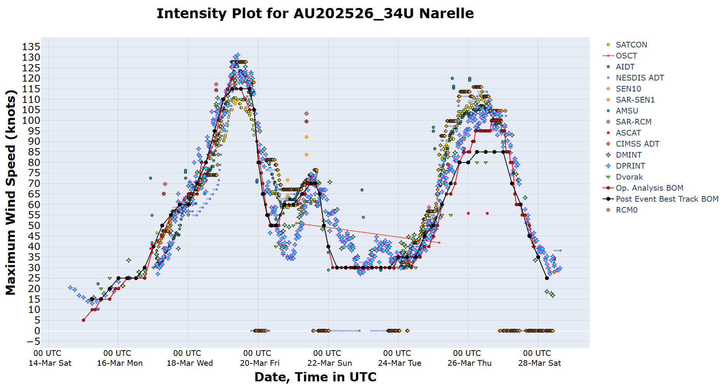
Figure 39: Intensity plot of objective and subjective guidance, operational analysis (red) and post event best track analysis (black) all plotted with 10-minute mean wind speeds.

