Tropical Cyclone Unnamed 09U

5 – 10 January 2001

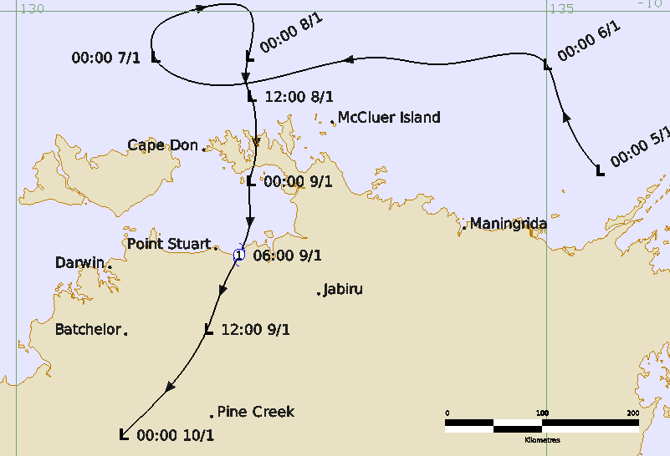

Revision history
Date | Version | Author | Description
16 October 2025 | 1.0 | EPS Tropical Cyclone Lead | Final Draft

Review status
Date | Version | Reviewer | Description
30 October 2025 | 1.0 | EPS Tropical Cyclone Lead | Complete

Release history
Date | Version | Status | Approval
1 November 2025 | 1.0 | Approved | EPS Tropical Cyclone Manager


Contact details:
Tropical Cyclone Team Lead
Severe Weather Environmental Prediction Services
Bureau of Meteorology, PO Box 1370, West Perth WA 6872
Email: tcwc@bom.gov.au
This work is copyright. Apart from any use as permitted under the Copyright Act 1968, no part may be reproduced without prior written permission from the Bureau of Meteorology. Refer to www.bom.gov.au/other/copyright.shtml for further information. Unless otherwise noted, all images in this document are licensed under the Creative Commons Attribution Australia Licence.
© Commonwealth of Australia 2025
Published by The Bureau of Meteorology
Cover image: Track of Unnamed Tropical Cyclone 09U 2000/01. Times in UTC.

Table of contents

1. Summary 4

2. Meteorological description 7

2.1. Intensity Analysis 7

2.2. Structure 9

2.3. Motion 9

3. Impact 10

4. Observations 10

Appendix 1: List of Abbreviations 11

List of Figures
Figure 1. Best track of 09U, 5 - 10 January 2001.. 6
Figure 2. Zoomed in best track of 09U 8-9 January 2001 as Unnamed 09U moved onto the coast. 6
Figure 3. Visible satellite image 0630 UTC 9 January. 9
Figure 4. Berrimah radar signature 0650 UTC 9 January 2001. 10
Figure 5. Weekly rainfall to 0900 ACST 13 January 2001. 12
List of Tables
Table 1. Best track summary of 09U. * gales in 2 or less quadrants. 6

- Summary
The unnamed tropical cyclone 09U was a small system that briefly reached tropical cyclone intensity as it passed over the Northern Territory coast east of Darwin on 9 January.
Tropical low 09U formed on 5 January off the east Arnhem Land coast of the Northern Territory. It moved west across the southern Arafura Sea on 6 January then slowed on 7 January. The weak circulation gained strength on 7-8 January as a monsoon surge combined with a short-wave upper trough to the south to improve organisation of deep convection. The low turned to the south on 8 January moving across the Cobourg Peninsula overnight and then into Van Diemen Gulf on 9 January.
The system intensified further to be a tropical cyclone intensity on 9 January prior to crossing the coast at around 1530 ACST (0600 UTC) near the Alligator Rivers Region, just east of Point Stuart. In the hours prior to landfall, Berrimah (Darwin) radar indicated the formation of a core region around 50 km diameter with an eye feature around 20 km across.
Gales are estimated to extend more than halfway around the centre for about six hours between 0930-1830 ACST (0000 - 0900 UTC) 9 January, satisfying the Australian definition of a tropical cyclone.
The system moved to the south southwest over land and winds gradually eased, and then during 10 January became difficult to identify on radar west of Katherine.
The only significant wind impact was to vegetation in the area near landfall point including some felled trees along the Point Stuart Road. The main impact was heavy rainfall and associated flooding along the north coast and in the Jabiru area on 9 January, extending to the Katherine region on 10 and 11 January. At Katherine, continuous rain fell from the evening of 10 January into the morning of 11 January (24-hour totals to 0900 ACST 11 January: 250-300 mm, highest total 325 mm at Dorisvale Crossing). The Katherine River rose sharply by 13 m, peaking at 14.9 m at 1130 ACST (0200 UTC) 11 January. The Stuart Highway was cut north of Katherine and many local roads were flooded. Flood waters continued downstream into the Daly River from 14 January, which peaked on 21 January at 12.8 m at Daly River Police Station, isolating the Nauiyu (Daly River) community.
During operations the system was not named a tropical cyclone, but a post-event review assessed that this system reached tropical cyclone intensity.
The post-event best track of 09U is shown in Figure 1 and Figure 2 (zoomed version) below and a summary is given in Table 1.
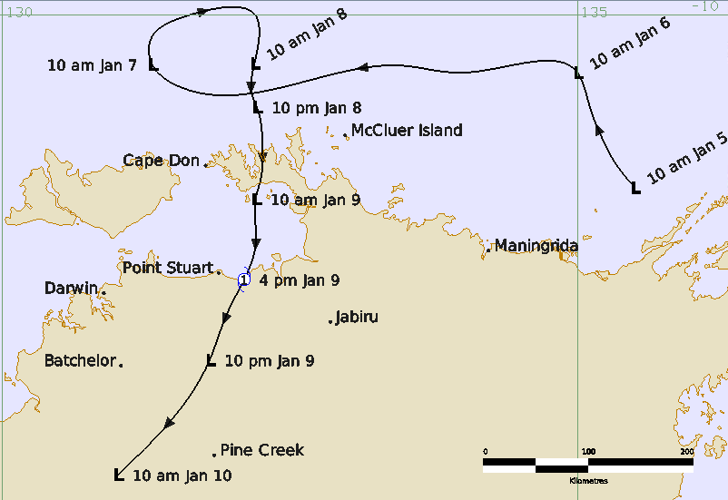
Figure 1. Best track of 09U, 5 - 10 January 2001. Times in ACST (UTC+9.5).

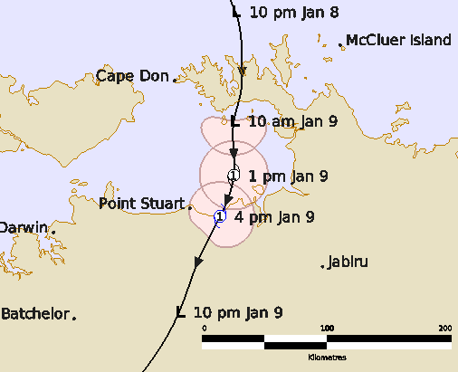

Figure 2. Zoomed in best track of 09U 8-9 January 2001 as Unnamed 09U moved onto the coast. The pink areas show the extent of gale-force winds, Times in ACST (UTC+9.5).

Year | Month | Day | Hour UTC | Pos. Lat. S | Pos. Long. E | Pos. Acc. nm | MaxWind (10m) kn | Max. gust kn | Cent. Press hPa | Rad of gales NE/SE/SW/NW nm | Rad of storm NE/SE/SW/NW nm | RMW nm
2001 | 1 | 5 | 0000 | 11.5 | 135.5 | 60 | 10 | 45 | 1008 | 0/0/0/0 | 0/0/0/0 | -
2001 | 1 | 5 | 0600 | 11.3 | 135.4 | 60 | 10 | 45 | 1005 | 0/0/0/0 | 0/0/0/0 | -
2001 | 1 | 5 | 1200 | 11.0 | 135.2 | 60 | 10 | 45 | 1007 | 0/0/0/0 | 0/0/0/0 | -
2001 | 1 | 5 | 1800 | 10.8 | 135.1 | 60 | 10 | 45 | 1006 | 0/0/0/0 | 0/0/0/0 | -
2001 | 1 | 6 | 0000 | 10.5 | 135.0 | 60 | 10 | 45 | 1006 | 0/0/0/0 | 0/0/0/0 | -
2001 | 1 | 6 | 0600 | 10.5 | 134.0 | 60 | 10 | 45 | 1006 | 0/0/0/0 | 0/0/0/0 | -
2001 | 1 | 6 | 1200 | 10.4 | 133.5 | 60 | 15 | 45 | 1006 | 0/0/0/0 | 0/0/0/0 | -
2001 | 1 | 6 | 1800 | 10.6 | 131.5 | 60 | 20 | 45 | 1004 | 0/0/0/0 | 0/0/0/0 | -
2001 | 1 | 7 | 0000 | 10.4 | 131.3 | 45 | 20 | 45 | 1004 | 0/0/0/0 | 0/0/0/0 | -
2001 | 1 | 7 | 0600 | 10.2 | 131.3 | 60 | 20 | 45 | 1002 | 0/0/0/0 | 0/0/0/0 | -
2001 | 1 | 7 | 1200 | 10.0 | 131.6 | 60 | 25 | 45 | 1001 | 0/0/0/0 | 0/0/0/0 | -
2001 | 1 | 7 | 1800 | 10.0 | 132.2 | 25 | 25 | 45 | 1001 | 0/0/0/0 | 0/0/0/0 | -
2001 | 1 | 8 | 0000 | 10.4 | 132.2 | 25 | 25 | 45 | 1001 | 0/0/0/0 | 0/0/0/0 | -
2001 | 1 | 8 | 0600 | 10.7 | 132.2 | 25 | 25 | 45 | 1000 | 0/0/0/0 | 0/0/0/0 | -
2001 | 1 | 8 | 1200 | 10.8 | 132.2 | 25 | 25 | 45 | 1000 | 0/0/0/0 | 0/0/0/0 | -
2001 | 1 | 8 | 1800 | 11.2 | 132.3 | 15 | 30 | 45 | 1000 | 0/0/0/0 | 0/0/0/0 | -
2001 | 1 | 9 | 0000 | 11.6 | 132.2 | 15 | 35* | 50 | 998 | 0/15/15/0 | 0/0/0/0 | -
2001 | 1 | 9 | 0300 | 12.0 | 132.2 | 15 | 35 | 50 | 996 | 15/15/15/15 | 0/0/0/0 | 6
2001 | 1 | 9 | 0600 | 12.3 | 132.1 | 15 | 40 | 55 | 996 | 15/10/10/15 | 0/0/0/0 | 6
2001 | 1 | 9 | 0900 | 12.6 | 132.0 | 10 | 30 | 45 | 997 | 0/0/0/0 | 0/0/0/0 | -
2001 | 1 | 9 | 1200 | 13.0 | 131.8 | 8 | 30 | 45 | 999 | 0/0/0/0 | 0/0/0/0 | -
2001 | 1 | 9 | 1800 | 13.6 | 131.4 | 15 | 25 | 45 | 1001 | 0/0/0/0 | 0/0/0/0 | -
2001 | 1 | 10 | 0000 | 14.0 | 131.0 | 30 | 20 | 45 | 1003 | 0/0/0/0 | 0/0/0/0 | -
Table 1. Best track summary of 09U. * gales in 2 or less quadrants.

- Meteorological description
  - Intensity Analysis
On 5 January 2001, convective activity around the Top End and Arafura Sea increased near a weak monsoon trough that formed near the north coast. The upper ridge was located over the area with low vertical wind shear present. A weak circulation formed in the trough on 5 January and drifted westward under the influence of a low to mid-level ridge over central Australia. The low was located north northeast of Maningrida early on 6 January.
On 7 January, a monsoon surge appeared to interact with the low, causing it to stall north of Cape Don and the central pressure deepened to around 1002 hPa by 0600 UTC. The low remained slow-moving during the following night before commencing a slow southward drift early on 8 January. Convective organization improved during this period as a short-wave upper trough to the south enhanced the environment and increased upper divergence. Central convection increased and a large, curved band formed in the northeast semicircle, allowing an assessment of Dvorak T2.0 at 0600 UTC 8 January when the low was located around 70 km north northeast of Cape Don.
The low maintained a steady southward drift and central convection weakened slightly after 0900 UTC as the circulation interacted with land. However, deep moist inflow combined with low vertical wind shear and upper divergence to allow further development while the centre was located over Cobourg Peninsula early on 9 January. Around 1800 UTC a burst of convection formed a central dense overcast (CDO) appearance which persisted and became part of a large, curved band in the eastern semicircle as the intensifying low crossed the peninsula and moved further south into Van Diemen Gulf. By 0000 UTC 9 January, the post analysis Dvorak DT reached 2.5-3.0 increasing to 3.0/3.5 by 0600 UTC when the system crossed the coast near the Alligator River Region (see Visible image in Figure 3).
In the hours prior to landfall, Berrimah radar (see Figure 4) indicated the formation of a core region of tightly wrapped rain bands of around 50 km in diameter with an eye feature around 20 km across. Doppler velocities increased after landfall to 50-60 kn around the eye for several hours as it moved south southwest across the floodplains east of Darwin, then slowly weakened as the circulation lost organization during the night.
The circulation became difficult to identify on radar early in the afternoon of 10 January over the southwest Top End, west of Katherine.
Note: During operations the system was not named a tropical cyclone, but the post-event review assessed that this system reached tropical cyclone intensity.

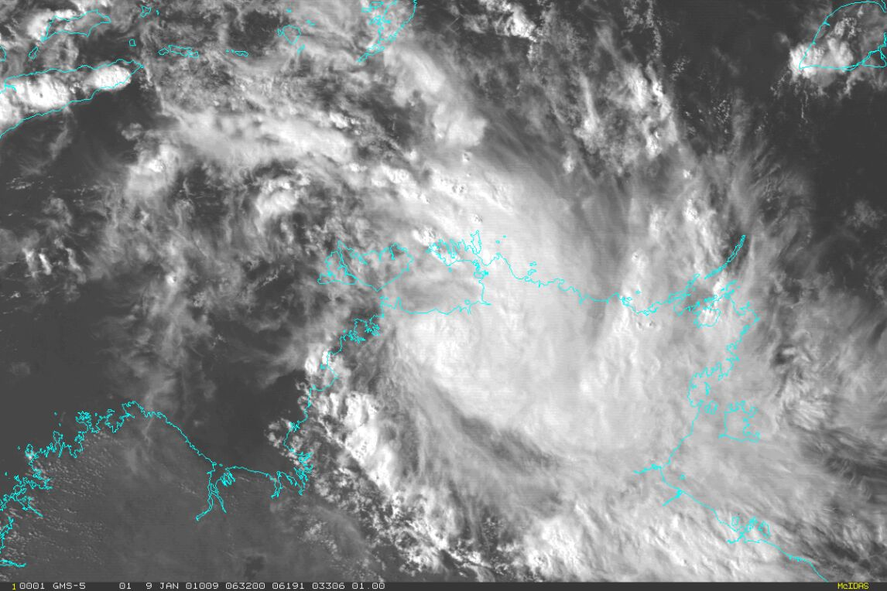Figure 3. Visible satellite image 0630 UTC (1600 ACST) 9 January 2001.
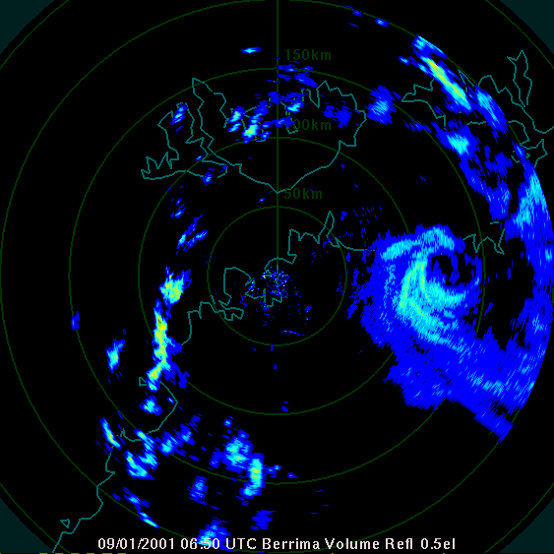
Figure 4. Berrimah (Darwin) radar signature 0650 UTC (1620 ACST) 9 January 2001.
  - Structure
Unnamed 09U was a very small tropical cyclone, the extent of gales being just 15 nm (28 km) as inferred by the radar signature. Point Stuart AWS, located about 35 km west of the crossing point, did not record gales. The gale radii are given in Table 1 while Figure 2 shows the gale extent on the track.
The radius of maximum winds (RMW) was estimated at just 6 nm (11 km).
  - Motion
As shown by the track in Figure 1, the low was initially steered to the west under the influence of a low to mid-level ridge over central Australia. The low slowed on 7 January as a monsoon surge interacted with the system causing it to turn to the east and then south on 7 January. The system tracked to the south through to landfall on 9 January and then to the south southwest over land until its demise on 10 January.

- Impact
Vegetation was damaged in the area near landfall point including some felled trees along the Point Stuart Road.
Heavy rainfall occurred along the north coast and in the Jabiru area on 9 January, extending to the Katherine region on 10 and 11 January. At Katherine, continuous rain fell from the evening of 10 January into the morning of 11 January (24-hour totals to 9 am 11 January: 250-300 mm, highest total: 324.6 mm at Dorisvale Crossing). The Katherine River rose sharply by 13 m, peaking at 14.9 m at 1130 ACST 11 January. The Stuart Highway was cut north of Katherine and many local roads were flooded. Flood waters continued downstream into the Daly River from 14 January, which peaked on 21 January at 12.8 m, isolating the Nauiyu (Daly River) community.
- Observations
A resident near the mouth of the South Alligator River reported a minimum pressure of 998 hPa (unknown calibration) and strong, gusty south southeasterly winds estimated at between 50 and 60 kn in heavy rain at 1350 ACST 9 January, while the low was crossing the coast. The observer also reported a period when rain and wind stopped for a while as the centre of the low passed overhead. This observation is consistent with the presence of an eye and the Doppler velocities measured at around the same time.
There were no other observations capturing the inner region of the circulation. Point Stuart AWS, located about 35 km to the east of the cyclone centre crossing point, recorded a lowest pressure of 999.6 hPa and mean winds of just 20 kn as the system crossed the coast. The maximum wind recorded was a 10-minute mean of 30 kn at Black Point on Cobourg Peninsula north of the developing low’s centre and 24 kn gusting 30 kn at McCluer Island in a rainband about 150 km northeast of the low.
Rainfall: The weekly rainfall distribution is shown in Figure 5.
Notable daily rainfall observations to 0900 ACST 10 January:
155.0 Ban Ban Springs, 152.6 mm Cooinda,146.8 mm Mary River Rangers,144.0 mm Emerald Springs, 144.0 mm Dry River Station, 143.2 mm The Pines.
Notable daily rainfall observations to 0900 ACST 11 January:
324.6 mm Dorisvale Crossing, 293.0 mm Jindare, 292.6 Fergusson River, 279.2 mm Claravale, 259.2 mm Asylum, 250.0 mm CDU Katherine, 244.0 mm Florina, 227.5 mm Katherine Aviation, 215 mm Katherine Bridge.
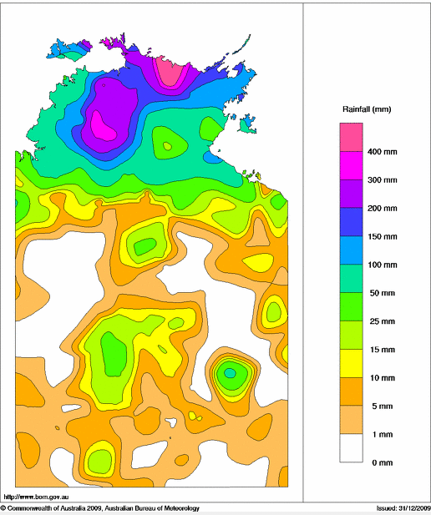
Figure 5. Weekly rainfall to 0900 ACST 13 January 2001.

Appendix 1: List of Abbreviations
Abbreviation | Term
ACST | Australian Central Standard Time
AWS | automatic weather station
CDO | central dense overcast
DT | Dvorak data T-number
h | hour
hPa | hectopascal
km | kilometres
km/h | kilometres per hour
kn | knot
m | metres
mm | millimetres
nm | nautical mile
RMW | radius of maximum winds
UTC | Universal Time Co-ordinated

