Tropical Cyclone Unnamed 25U

17 – 25 March 2025

Haydn Urquhart Boon, Lauren Pattie and Linda Paterson

Tropical Cyclone Environmental Prediction Services

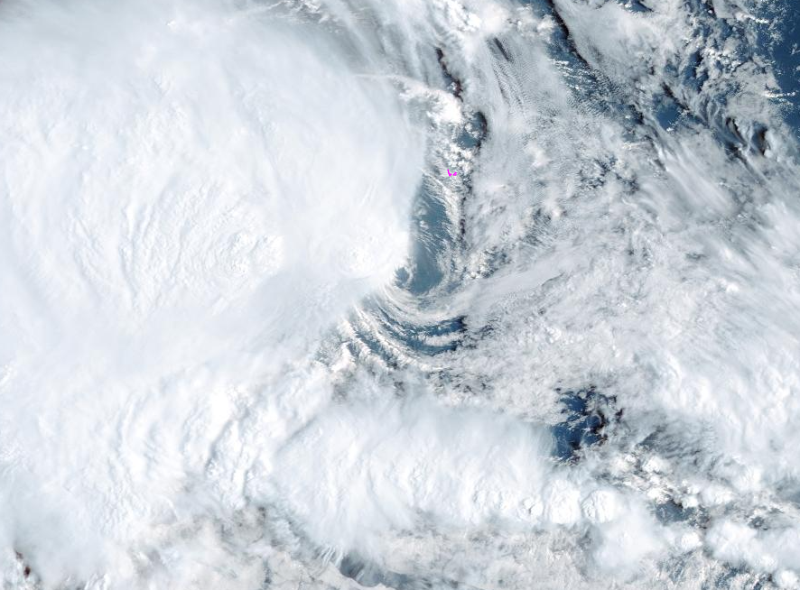

Revision history
Date | Version | Authors | Description
14 October 2025 | 1.0 | Haydn Urquhart Boon, Lauren Pattie and Linda Paterson | Final draft

Review status
Date | Version | Reviewer | Description
14 October 2025 | 1.0 | Vikash Prasad | Complete

Release history
Date | Version | Status | Approval
23 October 2025 | 1.0 | Craig Earl-Spurr | Approved

Contact details:
Tropical Cyclone Team Lead
Severe Weather Environmental Prediction Services
Bureau of Meteorology
PO Box 1370, West Perth WA 6872
Email: tcwc@bom.gov.au
This work is copyright. Apart from any use as permitted under the Copyright Act 1968, no part may be reproduced without prior written permission from the Bureau of Meteorology. Refer to www.bom.gov.au/other/copyright.shtml for further information. Unless otherwise noted, all images in this document are licensed under the Creative Commons Attribution Australia Licence.
© Commonwealth of Australia 2025
Published by The Bureau of Meteorology
Cover image: Himawari 9 visible satellite image of 25U at Category 1 intensity shortly after daybreak, 0100 UTC 19 March 2025. Image courtesy of the Japan Meteorological Agency.

Table of contents

1. Summary 5

2. Meteorological description 7

2.1. Intensity Analysis 7

2.2. Structure 12

2.3. Motion 16

3. Impact 17

4. Observations 18

4.1. Wind 18

4.2. Rainfall 18

4.3. Pressure 18

5. Forecast Performance 19

Appendix: List of Abbreviations 22

List of Figures
Figure 1. Best track of 25U 5
Figure 2. Hovmöller diagram of tropical wave activity 8
Figure 3. SMOS radiometry at 1116 UTC 18 March 9
Figure 4. ASCAT winds at 1540 UTC 18 March 10
Figure 5. ASCAT winds at 1427 UTC 19 March 11
Figure 6. Shear contours and streamlines at 0000 UTC 19 March 13
Figure 7. SMOS radiometry at 2337 UTC 18 March 14
Figure 8. ASCAT winds at 0314 UTC 20 March 15
Figure 9. Wind and pressure observations recorded at the Cocos (Keeling) Islands Airport 18
Figure 10. Mean absolute error in forecasted wind intensities 20
Figure 11. Mean absolute error in forecasted positions 21
Figure 12. Intensity plot of objective and subjective guidance 24

List of Tables
Table 1. Best track summary for unnamed tropical cyclone 25U 6
Table 2. Forecast accuracy of the Official Forecast Tracks as compared to the best track 21

- Summary
The unnamed tropical cyclone 25U was deemed to have briefly reached tropical cyclone intensity upon reanalysis. It moved close to the Cocos (Keeling) Islands in the Indian Ocean on 18 March and produced a period of strong winds and increased rainfall. However, no impacts were reported.
25U formed as a tropical low to the south of Christmas Island on 17 March 2025 during an active phase of the Madden-Julian Oscillation and initially moved in a generally westward direction. During 18 March, the environment became more favourable and the low developed gales in the western quadrants late that day. By 1800 UTC 18 March, gales extended more than halfway around the system centre and 25U was classified as a tropical cyclone. At this time, 25U was located to the southwest of the Cocos (Keeling) Islands. By 1200 UTC 19 March, gales had contracted to only the western quadrants and 25U was again classified as a tropical low. During 19 and 20 March 25U was generally slow moving with erratic motion. From 21 March the system drifted generally to the east with continued erratic motion before dissipating during 25 March.

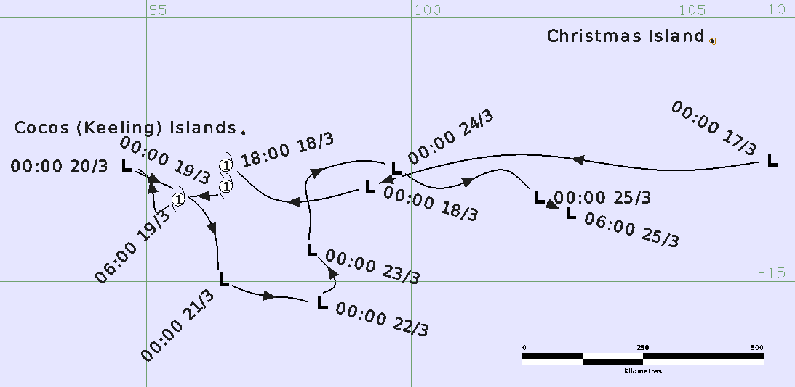
Figure 1. Best track of 25U, 17-25 March 2025. Times in UTC (AWST–8h).

Year | Month | Day | Hour UTC | Pos. Lat. S | Pos. Long. E | Pos. Acc. nm | Max Wind 10min kn | Max Gust kn | Cent. Press. hPa | Rad. of gales  (NE/SE/ SW/NW) | Rad. of storm  (NE/SE/ SW/NW) | RMW
2025 | 3 | 17 | 0000 | 12.7 | 106.8 | 35 | 25 | 45 | 1007 | 0/0/0/0 | 0/0/0/0 | -
2025 | 3 | 17 | 0600 | 12.9 | 104.9 | 30 | 25 | 45 | 1006 | 0/0/0/0 | 0/0/0/0 | -
2025 | 3 | 17 | 1200 | 12.6 | 102.0 | 60 | 25 | 45 | 1002 | 0/0/0/0 | 0/0/0/0 | -
2025 | 3 | 17 | 1800 | 12.8 | 100.7 | 60 | 25 | 45 | 1002 | 0/0/0/0 | 0/0/0/0 | -
2025 | 3 | 18 | 0000 | 13.2 | 99.2 | 45 | 25 | 45 | 1002 | 0/0/0/0 | 0/0/0/0 | -
2025 | 3 | 18 | 0600 | 13.4 | 97.3 | 30 | 30 | 45 | 1000 | 0/0/0/0 | 0/0/0/0 | -
2025 | 3 | 18 | 1200 | 13.0 | 96.8 | 30 | 35* | 50 | 1000 | 0/0/60/70 | 0/0/0/0 | -
2025 | 3 | 18 | 1800 | 12.8 | 96.5 | 35 | 35 | 50 | 998 | 35/0/40/40 | 0/0/0/0 | 25
2025 | 3 | 19 | 0000 | 13.2 | 96.5 | 15 | 40 | 55 | 998 | 40/0/160/70 | 0/0/0/0 | 25
2025 | 3 | 19 | 0600 | 13.5 | 95.6 | 30 | 40 | 55 | 998 | 40/0/130/90 | 0/0/0/0 | 25
2025 | 3 | 19 | 1200 | 13.7 | 95.2 | 20 | 45* | 65 | 991 | 0/0/130/100 | 0/0/0/0 | -
2025 | 3 | 19 | 1800 | 13.0 | 95.0 | 15 | 40* | 55 | 994 | 0/0/140/120 | 0/0/0/0 | -
2025 | 3 | 20 | 0000 | 12.8 | 94.6 | 20 | 40* | 55 | 995 | 60/0/0/90 | 0/0/0/0 | -
2025 | 3 | 20 | 0600 | 13.2 | 95.5 | 10 | 35* | 50 | 995 | 70/0/0/90 | 0/0/0/0 | -
2025 | 3 | 20 | 1200 | 13.7 | 96.1 | 10 | 30 | 45 | 1000 | 0/0/0/0 | 0/0/0/0 | -
2025 | 3 | 20 | 1800 | 14.4 | 96.3 | 10 | 30 | 45 | 1001 | 0/0/0/0 | 0/0/0/0 | -
2025 | 3 | 21 | 0000 | 15.0 | 96.4 | 10 | 30 | 45 | 1001 | 0/0/0/0 | 0/0/0/0 | -
2025 | 3 | 21 | 0600 | 15.1 | 96.6 | 10 | 30 | 45 | 1002 | 0/0/0/0 | 0/0/0/0 | -
2025 | 3 | 21 | 1200 | 15.3 | 97.5 | 15 | 30 | 45 | 1004 | 0/0/0/0 | 0/0/0/0 | -
2025 | 3 | 21 | 1800 | 15.4 | 97.9 | 20 | 30 | 45 | 1004 | 0/0/0/0 | 0/0/0/0 | -
2025 | 3 | 22 | 0000 | 15.4 | 98.3 | 30 | 30 | 45 | 1004 | 0/0/0/0 | 0/0/0/0 | -
2025 | 3 | 22 | 0600 | 15.3 | 98.3 | 15 | 25 | 45 | 1004 | 0/0/0/0 | 0/0/0/0 | -
2025 | 3 | 22 | 1200 | 15.2 | 98.5 | 15 | 25 | 45 | 1004 | 0/0/0/0 | 0/0/0/0 | -
2025 | 3 | 22 | 1800 | 14.6 | 98.3 | 25 | 25 | 45 | 1004 | 0/0/0/0 | 0/0/0/0 | -
2025 | 3 | 23 | 0000 | 14.4 | 98.1 | 30 | 25 | 45 | 1004 | 0/0/0/0 | 0/0/0/0 | -
2025 | 3 | 23 | 0600 | 13.8 | 98.1 | 30 | 25 | 45 | 1004 | 0/0/0/0 | 0/0/0/0 | -
2025 | 3 | 23 | 1200 | 13.1 | 98.1 | 30 | 20 | 45 | 1008 | 0/0/0/0 | 0/0/0/0 | -
2025 | 3 | 23 | 1800 | 12.9 | 98.4 | 15 | 20 | 45 | 1006 | 0/0/0/0 | 0/0/0/0 | -
2025 | 3 | 24 | 0000 | 12.9 | 99.7 | 15 | 20 | 45 | 1006 | 0/0/0/0 | 0/0/0/0 | -
2025 | 3 | 24 | 0600 | 13.2 | 100.3 | 20 | 25 | 45 | 1003 | 0/0/0/0 | 0/0/0/0 | -
2025 | 3 | 24 | 1200 | 13.2 | 100.8 | 30 | 25 | 45 | 1003 | 0/0/0/0 | 0/0/0/0 | -
2025 | 3 | 24 | 1800 | 12.9 | 101.8 | 45 | 25 | 45 | 1004 | 0/0/0/0 | 0/0/0/0 | -
2025 | 3 | 25 | 0000 | 13.4 | 102.4 | 45 | 20 | 45 | 1004 | 0/0/0/0 | 0/0/0/0 | -
2025 | 3 | 25 | 0600 | 13.7 | 103.0 | 40 | 20 | 45 | 1004 | 0/0/0/0 | 0/0/0/0 | -
Table 1. Best track summary of 25U, 17-25 March 2025. UTC = AWST–8h.
* Not considered a tropical cyclone by the Australian definition as gales not wrapping at least halfway around the centre.
- Meteorological description
  - Intensity Analysis
Tropical low 25U formed on the morning of 17 March during an active phase of the Madden-Julian Oscillation (Figure 2) over warm waters south of Christmas Island. The presence of the MJO contributed to increased northwest monsoon flow and coincided with an increased southeast flow due to a high pressure system in the southern Indian Ocean. Convection persisted and an initial Dvorak classification of T1.0 was given at 1200 UTC 17 March.
On 18 March northwest monsoon flow increased and southeast winds to the south of the system intensified as the high pressure system in the southern Indian Ocean strengthened and moved east. Gales were first analysed in western quadrants from 1200 UTC 18 March, based on SMOS radiometry wind speeds at 1116 UTC, Figure 3. Six hours later, at 1800 UTC 18 March, the monsoon and southeasterly flow had strengthened. Gales were analysed to have wrapped into the northeast quadrant, in addition to the western quadrants, and 25U was classified as a tropical cyclone by the Australian definition. This analysis was based on a 1540 UTC ASCAT pass, Figure 4, showing gales developing in three quadrants. It was also supported by Dvorak FT and CI both reaching 3.0, and was consistent with the objective aids shown in Figure 12.
With northwest monsoon flow and enhanced southeast flow persisting, Unnamed Tropical Cyclone 25U strengthened to a 40 knot system at 0000 UTC 19 March, it's peak intensity while classified as a tropical cyclone. However, by 1200 UTC 19 March increased easterly vertical wind shear had confined gales and deep convection to the western quadrants only and 25U was reclassified as a tropical low. At the same time, support from the monsoon surge was at its maximum, and 25U reached its peak system intensity of 45 knots, as shown in a 1427 UTC ASCAT pass, Figure 5. This was marginally higher than the peak intensity as a tropical cyclone, though still consistent with the range of objective aids as shown in Figure 12.
With high easterly vertical wind shear persisting during 20 March, 25U weakened steadily. Scatterometry and radiometry data depicted no gales in any quadrant from 1200 UTC 20 March (AMSR2 at 0735 UTC, SMOS at 1137 UTC, SAR at 1200 UTC, and ASCAT at 14:58 UTC, not shown here). During 25 March, dry air began to impact the system as an upper trough approached from the southwest and 25U dissipated over open waters. A comparison of subjective and objective intensity estimates is shown in Figure 12.

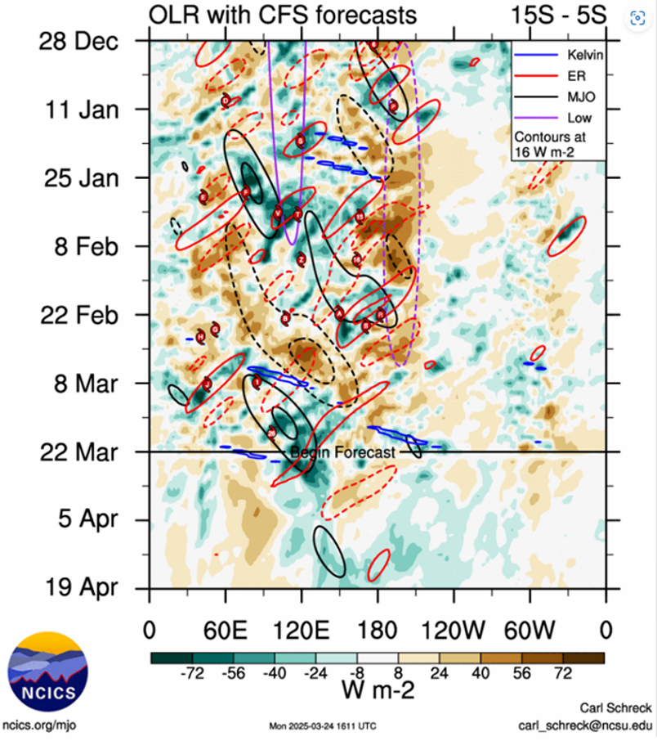
Figure 2. Hovmöller diagram of tropical wave activity showing an active Madden-Julian Oscillation supporting cyclogenesis of 25U (labelled "26" under U.S. nomenclature). Image courtesy of North Carolina Institute for Climate Studies: https://ncics.org/portfolio/monitor/mjo/

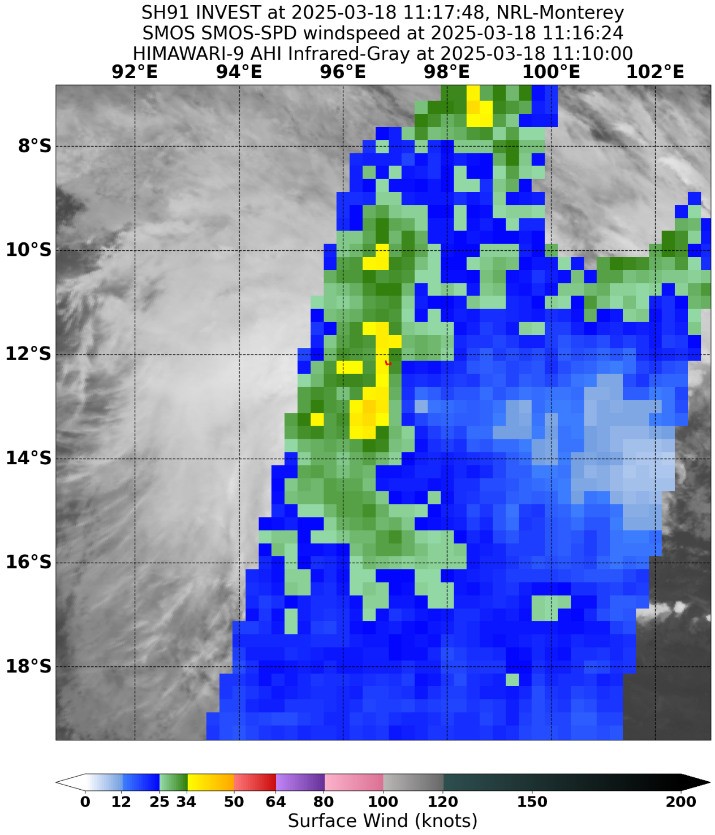
Figure 3. SMOS radiometry wind speeds overlaid on Himawari-9 infrared imagery depicting gales in the western quadrants of 25U at 1116 UTC 18 March. Image courtesy of the NRL: https://www.nrlmry.navy.mil/TC.html
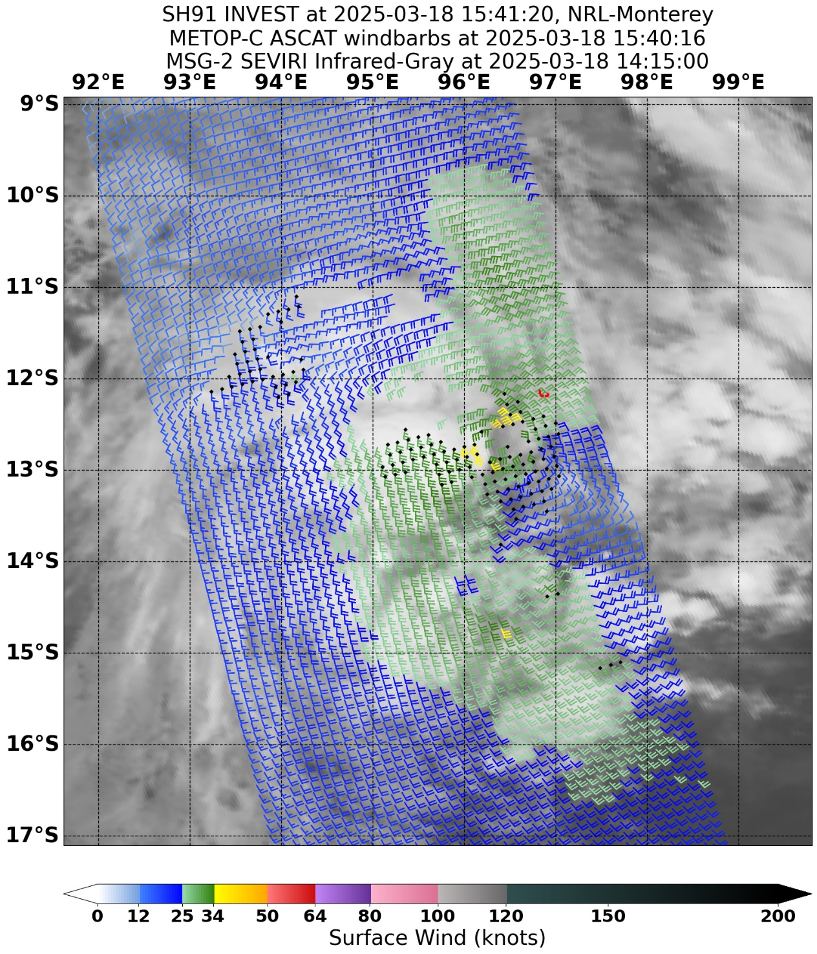
Figure 4. ASCAT winds from the METOP-C satellite overlaid on earlier MSG-2 SEVIRI infrared imagery depicting gales beginning to wrap more than halfway around the centre of 25U at 1540 UTC 18 March. Image courtesy of the NRL: https://www.nrlmry.navy.mil/TC.html
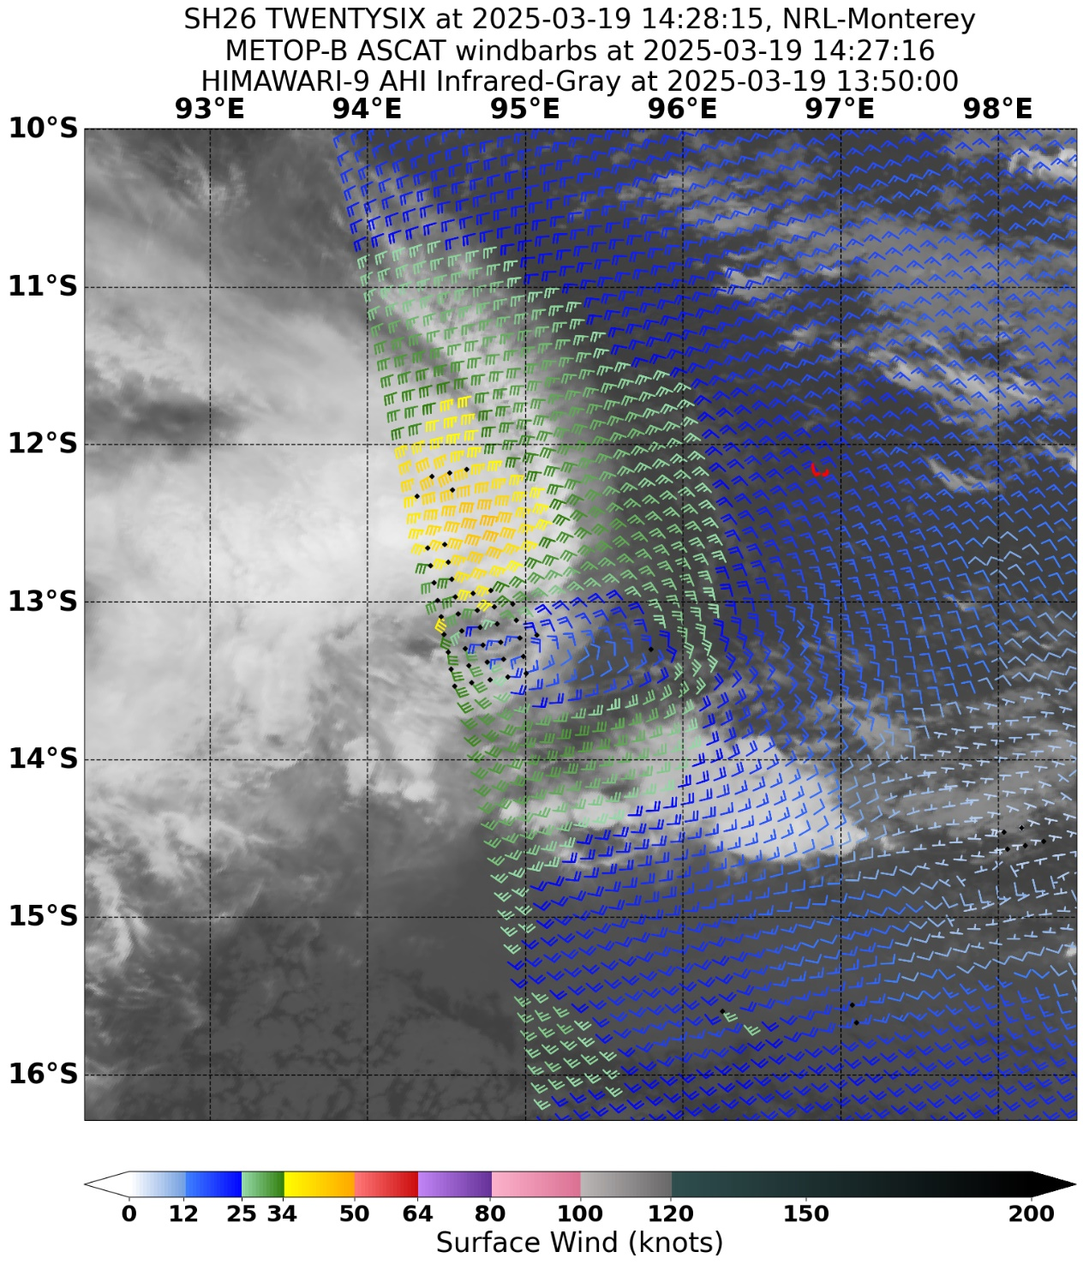
Figure 5. ASCAT winds from the METOP-B satellite overlaid on earlier Himawari-9 infrared imagery depicting gales in the northern quadrants of 25U with an intensity of 45 knots at 1427 UTC 19 March. Image courtesy of the NRL: https://www.nrlmry.navy.mil/TC.html

  - Structure
The structure of 25U was subject to a variety of competing factors and as a result gales were asymmetric about the centre. Gales first occurred at 1200 UTC 18 March and extended to 70 nm (130 km) in western quadrants, as shown by SMOS radiometry at 1116 UTC, Figure 3. At this time gales were confined to western quadrants due to the influence of easterly vertical wind shear. Soon after at 1800 UTC 18 March, gales contracted in western quadrants to 40 nm (75 km), as per an ASCAT pass at 1540 UTC shown in Figure 4. At the same time, an increase in monsoon flow to the northeast contributed to a lateral expansion of gales into the northeast quadrant out to 35 nm (65 km), Figure 4, classifying 25U as a tropical cyclone by the Australian definition. Under high easterly to southeasterly shear shown in Figure 6, the low-level centre of 25U was exposed by daybreak 19 March. Despite this, the SMOS radiometry of Figure 7 at 2337 UTC showed gales persisting in the western and northern quadrants. In addition, this same SMOS radiometry confirmed that gales had developed under the spiral convective band, and thus gale radii increased to 160 nm (295 km) in the southwest quadrant. At 1200 UTC 19 March, gales retracted from the northeast quadrant under high shear, and with gales only in the western quadrants 25U was no longer considered a tropical cyclone by the Australian definition. By 0000 UTC 20 March, 25U was reliant on monsoon flow to the north to assist in maintaining gales. Consequently, gales transitioned to the northern quadrants only, as confirmed by the ASCAT pass of Figure 8 at 0314 UTC 20 March. Later during 20 March, monsoon flow eased and 25U weakened steadily with no gales in any quadrant from 1200 UTC 20 March (AMSR2 at 0735 UTC, SMOS at 1137 UTC, SAR at 1200 UTC, and ASCAT at 14:58 UTC, not shown here).

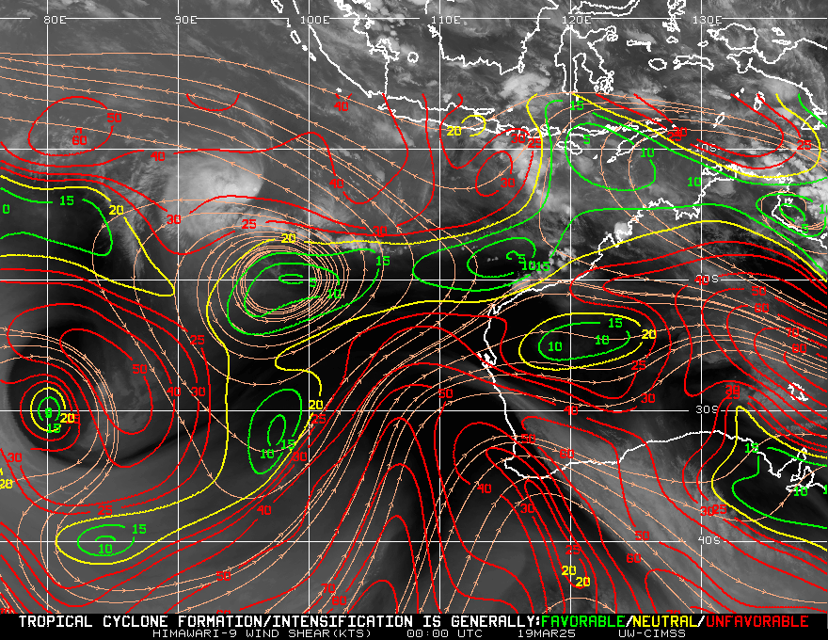
Figure 6. Shear contours and streamlines overlaid on Himawari-9 infrared imagery depicting approximately 30 knots of southeasterly shear over 25U at 0000 UTC 19 March. Image courtesy of CIMSS Tropical Cyclones: https://tropic.ssec.wisc.edu/

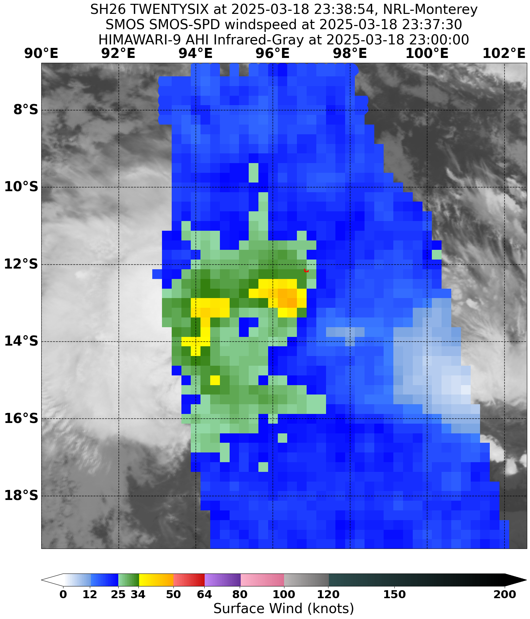
Figure 7. SMOS radiometry wind speeds overlaid on Himawari-9 infrared imagery depicting gales in the western and northeastern quadrants of 25U at 2337 UTC 18 March. Image courtesy of the NRL: https://www.nrlmry.navy.mil/TC.html
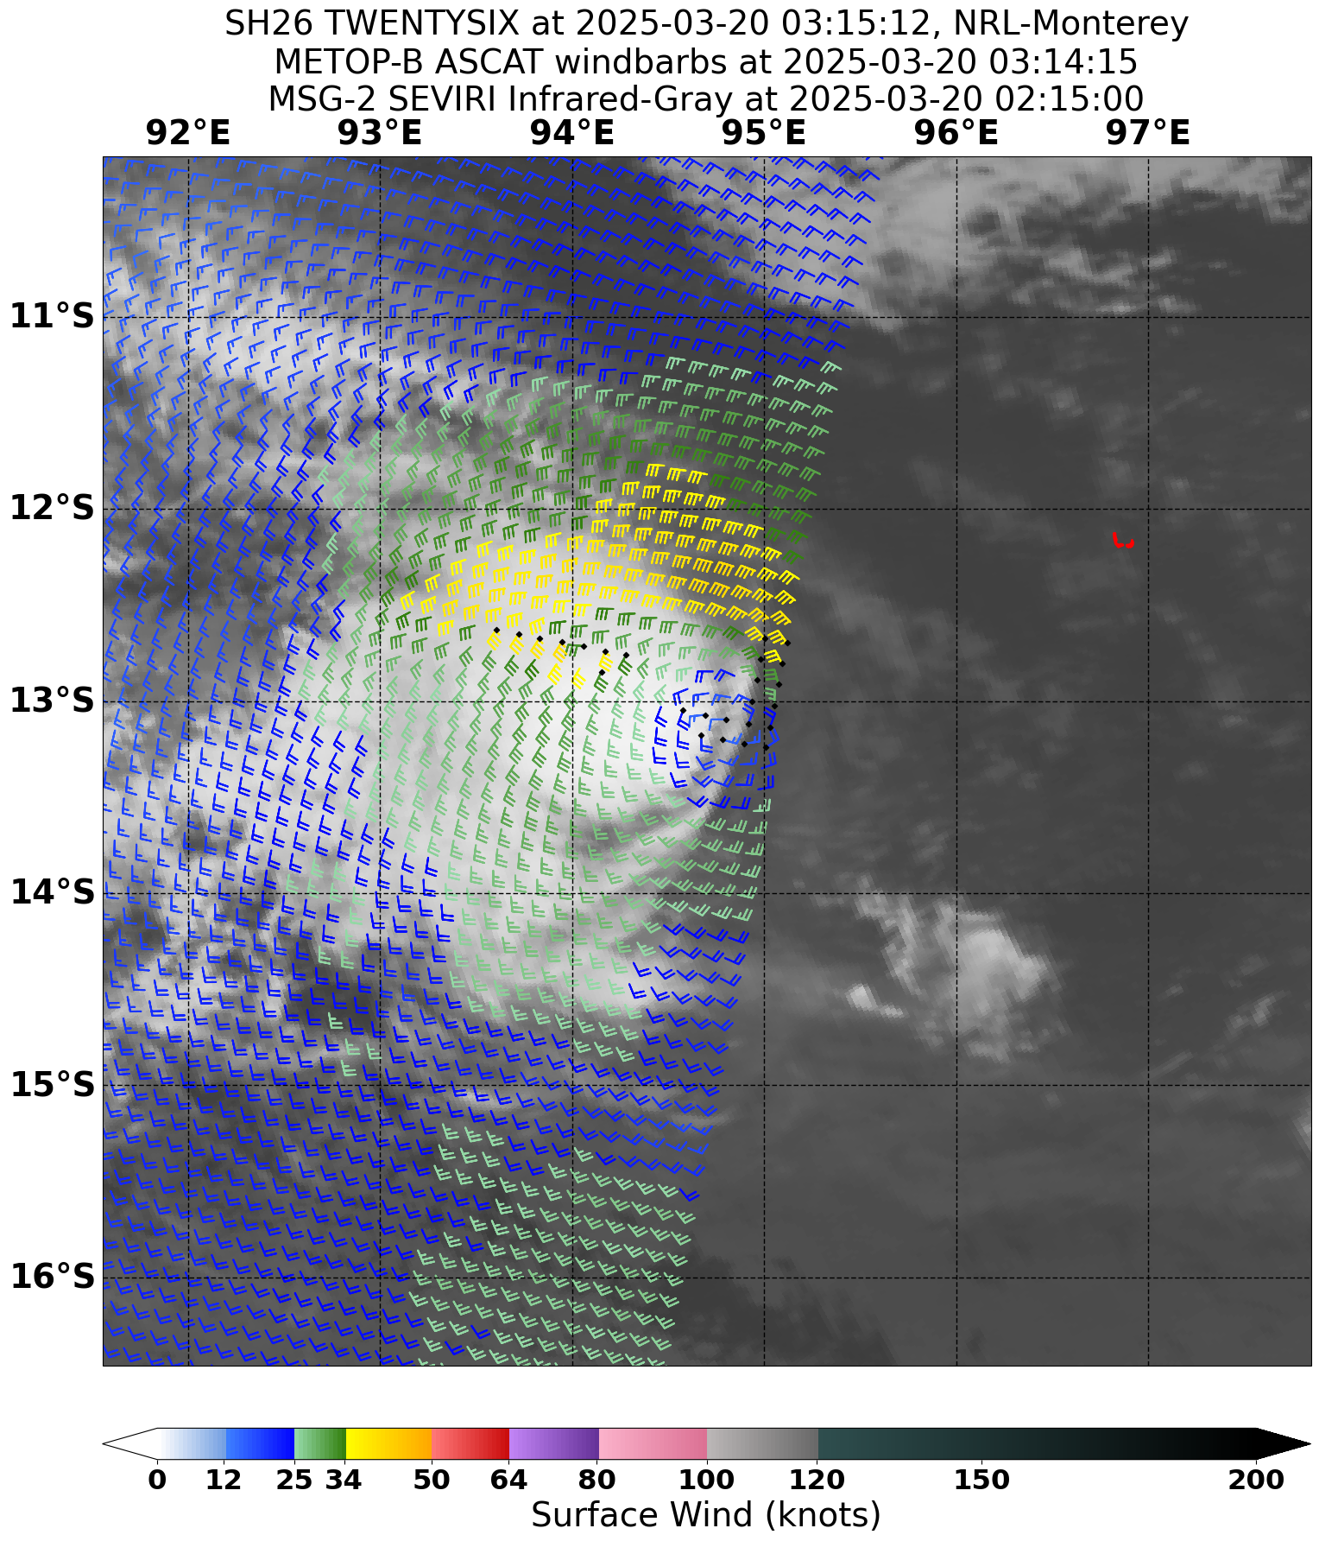
Figure 8. ASCAT winds from the METOP-B satellite overlaid on earlier MSG-2 infrared imagery depicting gales in the northern quadrants of 25U at 0314 UTC 20 March. Image courtesy of the NRL: https://www.nrlmry.navy.mil/TC.html

  - Motion
As shown by the track in Figure 1, Unnamed 25U was initially quickly steered to the west under the influence of a mid level ridge to the south. During 18 March, westward movement slowed as the influence of the mid level ridge was somewhat balanced by an increase in northwesterly monsoon flow to the system's north. This slow westward motion continued during 19 March, though with variations arising from the competing steering influences. During 20 March, the mid level ridge relaxed, and monsoonal flow continued to increase, becoming dominant and steering Unnamed 25U to the southeast. By 22 March, monsoon flow had temporarily weakened, with stronger and drier southeasterlies steering the system generally northwards. Stronger monsoon flow returned from late 23 March steering 25U generally to the east until the system dissipated during 25 March.

- Impact
Strong winds and the highest daily rainfall totals of the month were recorded on Cocos (Keeling) Islands overnight from 18 to 19 March associated with Unnamed 25U, but there were no reported impacts.

- Observations

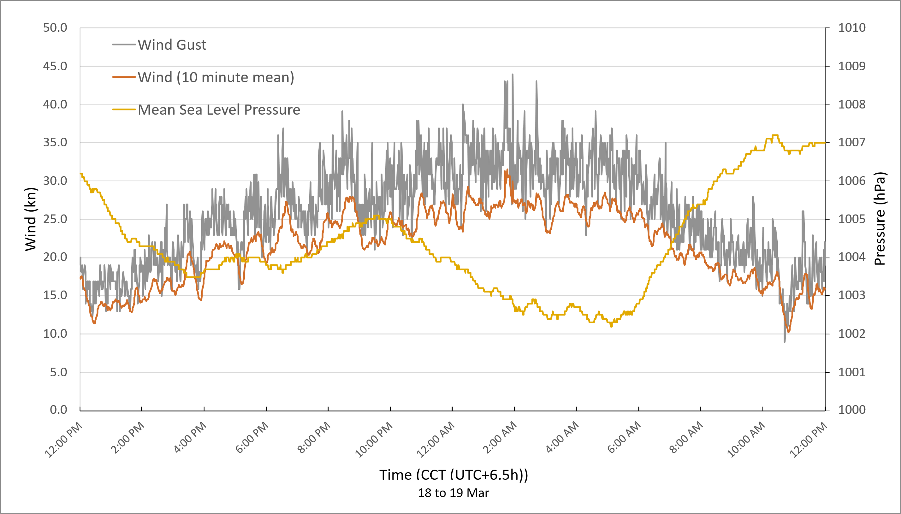
Figure 9. Wind and pressure observations associated with 25U recorded at the Cocos (Keeling) Islands Airport (ID: 200284) from 1200 CCT (0530 UTC) 18 March to 1200 CCT (0530 UTC) 19 March 2025. Times in CCT (UTC+6.5h).
  - Wind
Strong winds were recorded at the Cocos (Keeling) Islands Airport overnight from 18 to 19 March, as shown in Figure 9. These peaked in the very early morning with maximum sustained winds of 31.5 knots in the 10 minutes to 1918 UTC 18 March (0148 CCT 19 March), and a maximum wind gust of 43.9 knots at 1926 UTC 18 March (0156 CCT 19 March). At this time, 25U was classified as a tropical cyclone and located approximately 45 nm (85 km) to the south southwest.
  - Rainfall
The Cocos (Keeling) Islands Airport observed increased daily rainfall totals while Unnamed 25U was in the vicinity. 34.8 mm was observed in the 24 hours to 0230 UTC (0900 CCT) 18 March, and 62.6 mm in the 24 hours to 0230 UTC (0900 CCT) 19 March, the largest daily rainfall total of the month. However, these totals are not climatologically exceptional for the Cocos (Keeling) Islands.
  - Pressure
The lowest mean sea level pressures recorded at the Cocos (Keeling) Islands Airport were during the morning of 19 March, as shown in Figure 9. The recorded minimum was 1002.2 hPa at 2236 UTC 18 March (0506 CCT 19 March). At the time, 25U was classified as a tropical cyclone and was located approximately 60 nm (110 km) to the south southwest with an estimated central pressure of 998 hPa.
- Forecast Performance

Official Forecast Track Maps and Ocean Wind Warnings were first issued by the TCWC from 1200 UTC 18 March and ceased after 1800 UTC 20 March. The forecast tracks contained gale force winds in the western quadrants only from 1800 UTC 18 March, the northern quadrants only at 0600 UTC 20 March, and the northeast quadrant only at 1200 UTC 20 March. At no time in the operational analysis did gales extend more than halfway around the centre to meet the Australian definition of a tropical cyclone. There were no Advices issued as 25U did not threaten island communities. The system was included in the Tropical Cyclone 7 Day Forecast from 0800 UTC 13 March through to 2200 UTC 21 March.

The forecast performance of the Official Forecast Tracks as compared to the post-event best track is given in Table 2. This forecast performance is graphed against the Bureau's 5-year performance averages for intensity in Figure 10, and position in Figure 11. Intensity forecasts performed better than the 5-year average in the mid-term between about 12 and 72 hours lead time, but worse in the short and long term outside this window. Position forecasts were generally worse than the 5-year average but did perform better in the window between about 36 and 120 hours lead time. However, the sample size of Official Forecast Tracks for this comparison was only 10 members strong at most, so meaningful conclusions are difficult.

The post event best track reanalysed gales in the northeast quadrant between 1800 UTC 18 March and 0600 UTC 19 March. Consequently, 25U was retroactively classified as an unnamed category 1 tropical cyclone during this period.

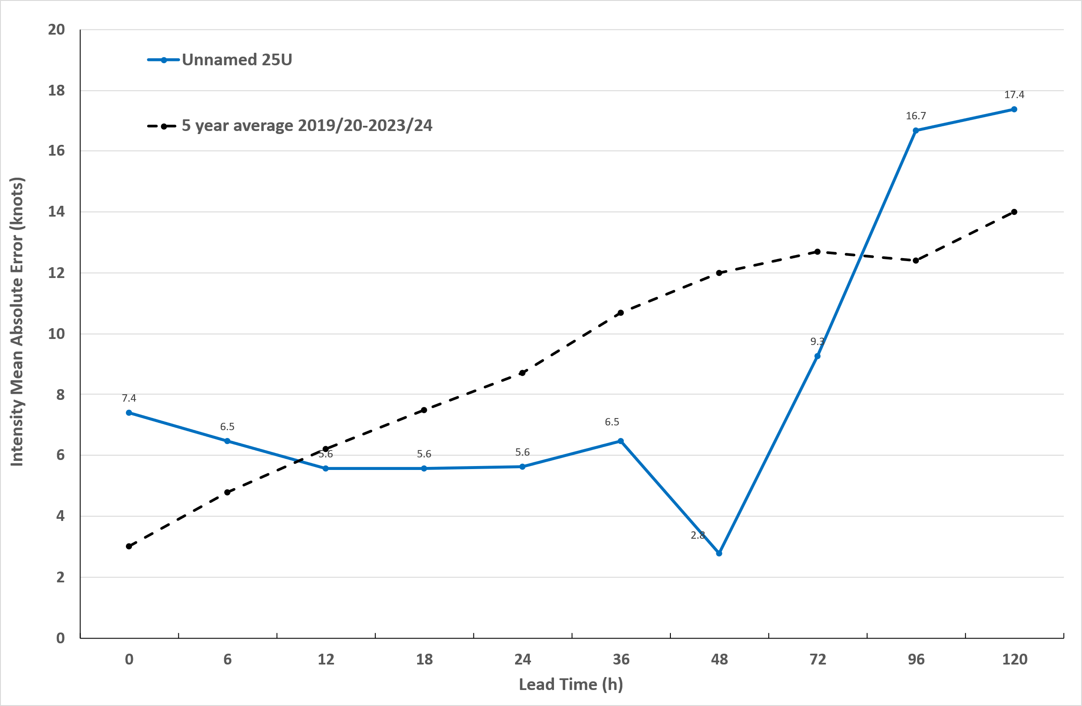
Figure 10. Mean absolute error in forecasted wind intensities for 25U (blue) compared with the Bureau's 5-year average for all relevant systems between 2019/20 to 2023/24 (dotted black).

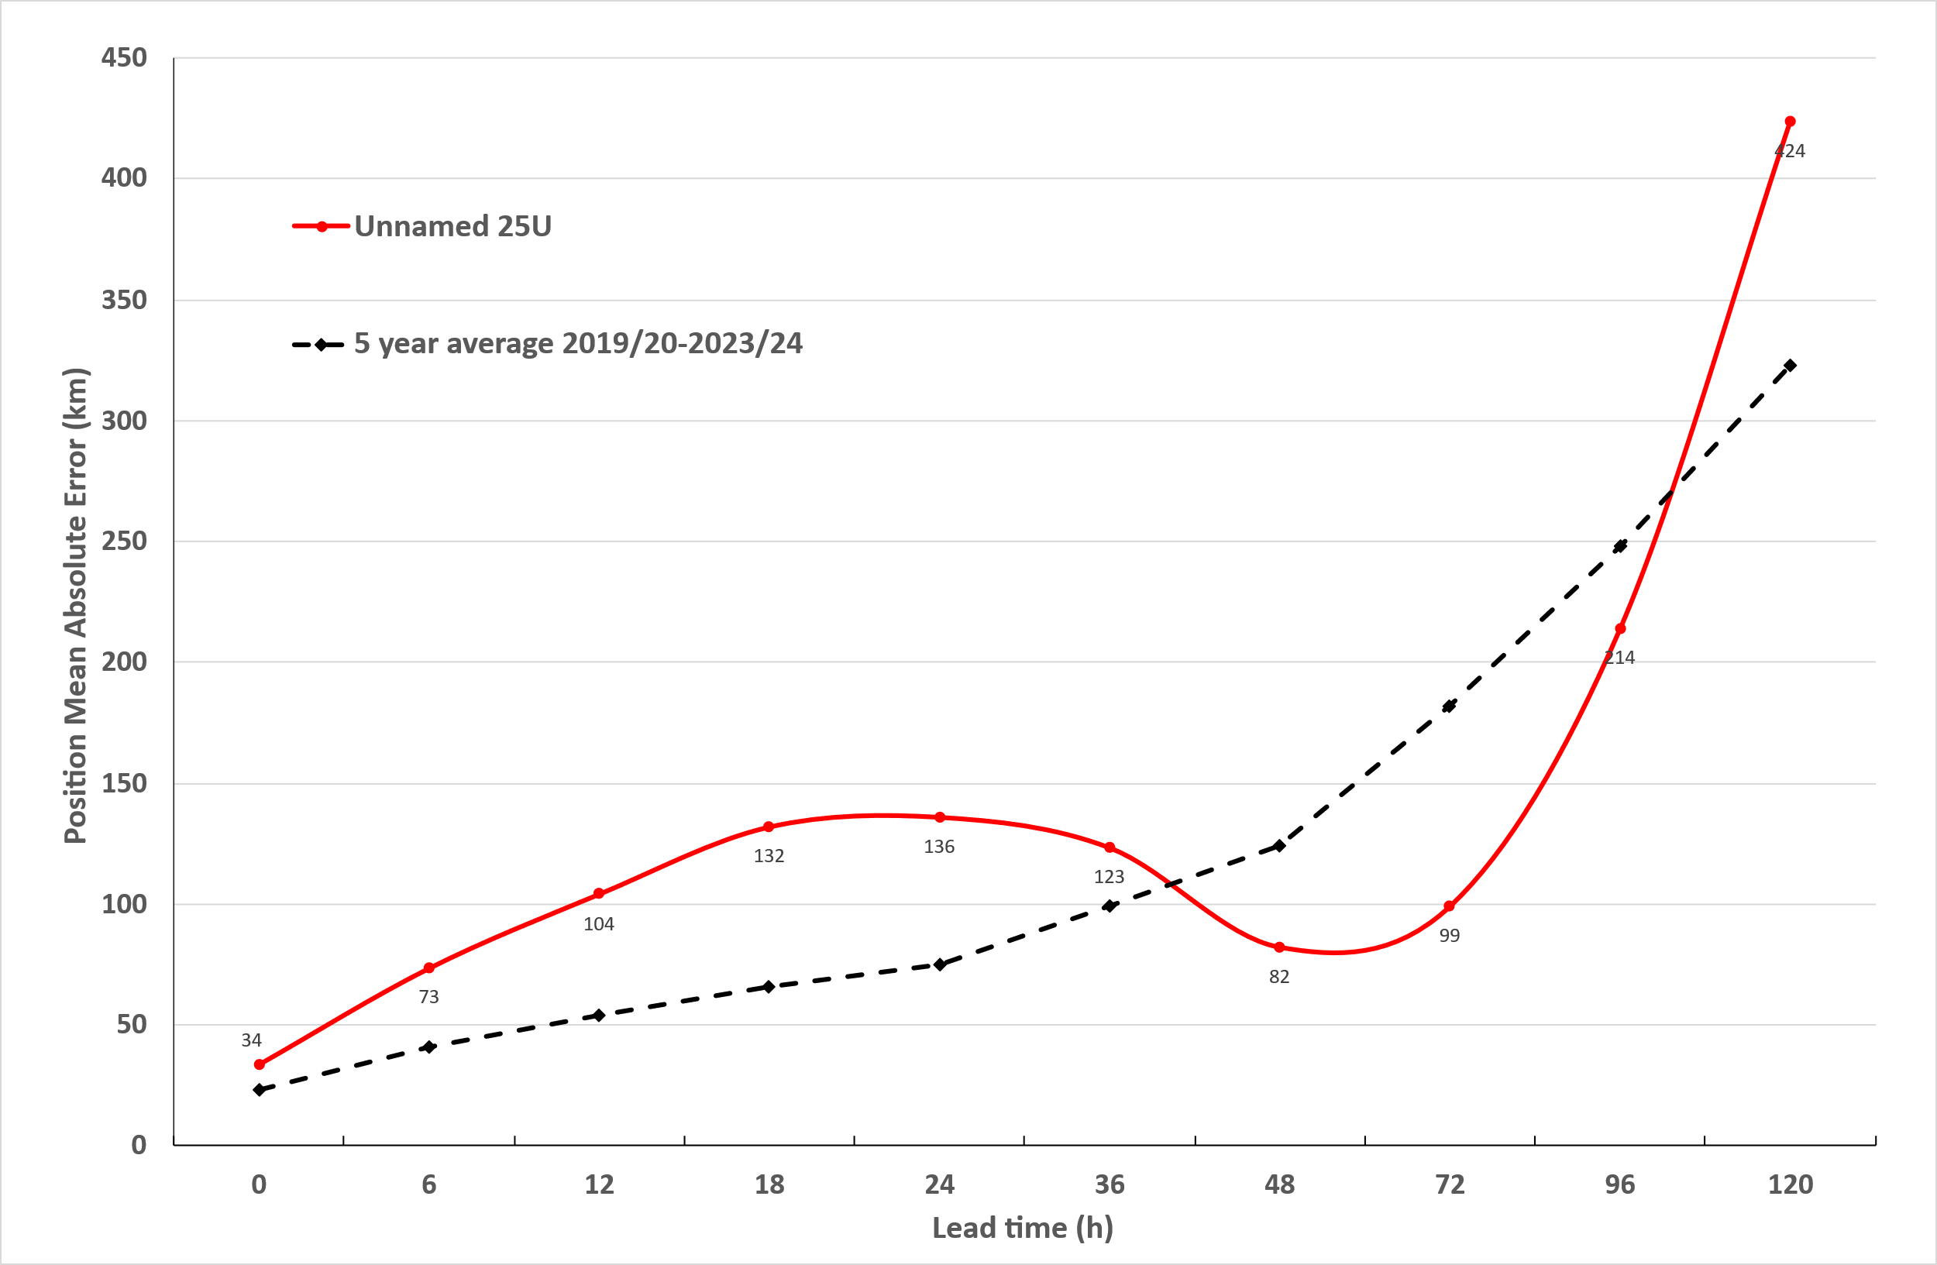
Figure 11. Mean absolute error in the forecasted positions of 25U (red) compared with the Bureau's 5-year average for all relevant systems between 2019/20 to 2023/24 (dotted black).

Time | 00 | 06 | 12 | 18 | 24 | 36 | 48 | 72 | 96 | 120
Position absolute error (km) | 34 | 73 | 104 | 132 | 136 | 123 | 82 | 99 | 214 | 424
Intensity absolute error (kn) | 7.4 | 6.5 | 5.6 | 5.6 | 5.6 | 6.5 | 2.8 | 9.3 | 16.7 | 17.4
Sample size | 10 | 10 | 10 | 10 | 10 | 10 | 10 | 10 | 10 | 8
Table 2. Forecast accuracy of the Official Forecast Tracks as compared to the 25U post-event best track positions and wind intensities.

- Appendix: List of Abbreviations
Abbreviation | Term
ADT | Advanced Dvorak Technique
ACST | Australian Central Standard Time
AEST | Australian Eastern Standard Time
AiDT | AI-enhanced Dvorak Technique
AMSR2 | Advanced Microwave Scanning Radiometer
AMSU | Advanced Microwave Sounding Unit
ASCAT | Advanced Scatterometer
ATMS | Advanced Technology Microwave Sounder
AWS | automatic weather station
AWST | Australian Western Standard Time
°C | Celsius
CCT | Cocos Islands Time
CI | Current intensity
CIMSS | Cooperative Institute for Meteorological Satellite Studies (USA)
CIRA | Cooperative Institute for Research in the Atmosphere (USA)
D-MINT | Deep learning - Multispectral Intensity of TCs (formerly known as DMN)
D-PRINT | Deep learning - IR Intensity of TCs (formerly known as OPEN-AIIR)
EIR | Enhanced InfraRed
ERC | Eyewall replacement cycle
FNMOC | Fleet Numerical Meteorology and Oceanography Centre (USA)
FT | Final T-number
GCOM | Global Change Observation Mission
GHz | Gigahertz
GMI | Global Precipitation Measurement Microwave Imager
h | hour
hPa | hectopascal
HSCAT | Hai Yang 2 Scatterometer (HY-2B, HY-2C)
km | kilometres
km/h | kilometres per hour
kn | knot
LLCC | Low-Level Cloud Centre
MET | Model Expected T-number
METOP | Meteorological Operational Satellite
MJO | Madden-Julian Oscillation
mm | millimetres
MSLP | mean sea level pressure
NESDIS | National Environmental Satellite, Data, and Information Service
nm | nautical mile
NOAA | National Oceanic and Atmospheric Administration
NRL | U.S. Naval Research Laboratory
OPEN-AiiR | Ordered Pattern Encoding AI Infrared
PAT | Pattern T-number
RCM | RadarSat Constellation Mission – Synthetic Aperture Radar
RH | Relative humidity
RMW | Radius of maximum winds
RSMC | Regional Specialised Meteorological Centre
SAR | Synthetic Aperture Radar
SATC | CIMSS Advanced Dvorak Technique
SATCON | Satellite Consensus
SEN1 | Sentinel-1A – Synthetic Aperture Radar
SMAP | Soil Moisture Active Passive
SMOS | Soil Moisture and Ocean Salinity
SSMIS | Special Sensor Microwave Imager/Sounder
TC | Tropical Cyclone
TCWC | Tropical Cyclone Warning Centre
UTC | Universal Time Co-ordinated

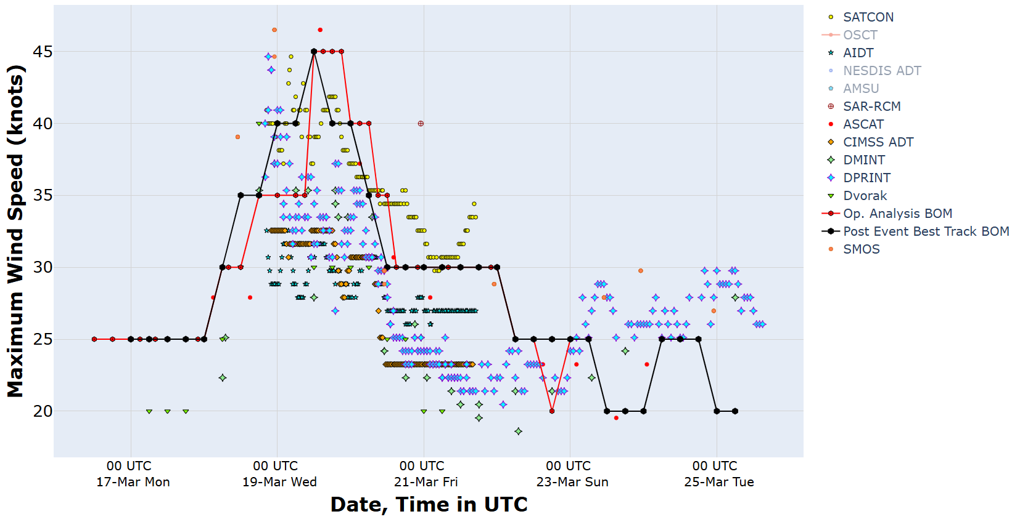
Figure 12. Intensity plot (10-min mean) of objective and subjective guidance. SATCON, AiDT, SAR-RCM, ASCAT, CIMSS ADT, DMINT, DPRINT, Dvorak (subjective estimate), operational analysis (red), and post event best track analysis (black).

