Unnamed 1954 'Great Gold Coast' Tropical Cyclone

16 – 21 February 1954

Environmental Prediction Services, Bureau of Meteorology

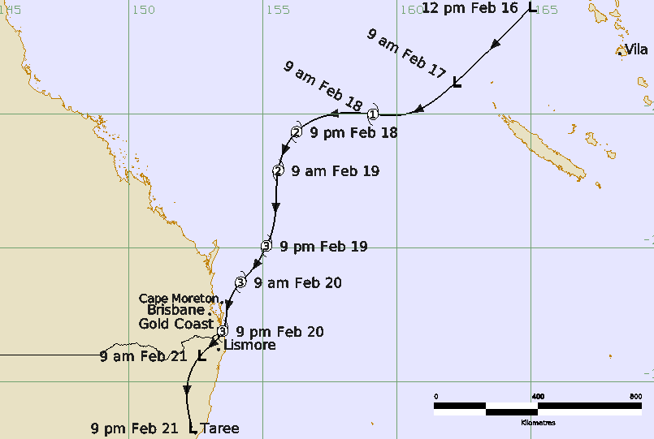

Revision history
Date | Version | Author | Description
13 May 2026 | 1.0 | Lead Meteorologist, TC-EPS | Final Draft

Review status
Date | Version | Reviewer | Description
18 May 2026 | 1.0 | Lead Meteorologist, TC-EPS | Complete

Release history
Date | Version | Status | Approval
18 May 2026 | 1.0 | Approved | Manager, EPS


Contact details:
Tropical Cyclone Team Lead
Severe Weather Environmental Prediction Services
Bureau of Meteorology, PO Box 1370, West Perth WA 6872
Email: tcwc@bom.gov.au
This work is copyright. Apart from any use as permitted under the Copyright Act 1968, no part may be reproduced without prior written permission from the Bureau of Meteorology. Refer to www.bom.gov.au/other/copyright.shtml for further information. Unless otherwise noted, all images in this document are licensed under the Creative Commons Attribution Australia Licence.
© Commonwealth of Australia 2026
Published by The Bureau of Meteorology
Cover image: Track of Tropical Cyclone 16-21 February 1954. Times in AEST (UTC+10h).

Table of contents

1. Summary 5

2. Meteorological description 7

3. Impacts 10

3.1. Wind 10

3.2. Storm Tide and waves 10

3.3. Flooding 10

4. Observations 11

4.1. Wind 11

4.2. Pressure 11

4.3. Rainfall 11

5. References 15

Appendix 1: List of Abbreviations 15

List of Figures
Figure 1. Best track of the unnamed Great Gold Coast Tropical Cyclone, 16-21 February 1954. 7
Figure 2. MSLP analysis with surface winds overlaid at 19 and 20 February 9
Figure 3. Location of Tweed, Lismore, and Kyogle catchments. 13
Figure 4. Weekly rainfall, week ending 22 February 1954. 13
Figure 5. Springbrook pluviograph 19-20 February 1954. 14
Figure 6. Erosion on Main Beach on the Gold Coast. 16
Figure 7. Flooding at Lismore. 16

List of Tables
Table 1. Track data for the Unnamed (Great Gold Coast) 1954 tropical cyclone.. 6
Table 2. Rainfall totals during February 1954 (mm). 12

- Summary
An unnamed tropical cyclone in February 1954, known as 'the Great Gold Coast Cyclone' was one of the most severe tropical cyclones to ever affect southeast Queensland and northern New South Wales. Tragically at least 34 people died, mostly as a result of floodwaters in northern New South Wales.
The tropical cyclone developed in the Pacific Ocean and intensified from 16-19 February as it moved southwest towards the southeast Queensland coast. South to southeasterly gales commenced about the southern Queensland coast on 19 February and late in the day the centre was analysed to be east of K'Gari (Fraser Island). The cyclone made landfall near Coolangatta on the Gold Coast at about 2200 AEST 20 February then moved into northern New South Wales and was moving south during 21 February.
Based on the observed pressures, it is probable that the cyclone reached at least category 3 intensity in the lead up and until landfall. Without satellite data it is impossible to determine the absolute peak of the tropical cyclone. The strongest winds are likely to have been over water and at exposed coastal sites such as on the east coast of Moreton and Stradbroke Islands just ahead of the cyclone. Brisbane City and Airport both recorded near gale-force winds in the southerly flow while higher winds were likely at the Gold Coast and adjacent northern New South Wales coast. A ship berthed at New Farm on the Brisbane River observed winds to 65 kn (120 km/h). Wind damage was reported from a wide area, being the most severe between the Gold Coast and Byron Bay. Gales are likely to have extended well south of the centre along the New South Wales coast.
Storm surge and wave action caused severe beach erosion across southeast Queensland and northern New South Wales particularly on the Gold Coast. Many jetties were destroyed and boats wrecked including at Byron Bay where 600 ft (183 m) of the outer section of the jetty was washed away taking with it most of the fishing fleet while the storm surge flooded parts of the town.
Heavy rainfall fell over a broad area in near coastal areas extending from the Queensland Sunshine Coast southward including most of the New South Wales coast. The heaviest falls were recorded in the Gold Coast hinterland (Springbrook Forestry 1047.5 mm) and northern New South Wales (Dorrigo 998.7 mm). Flooding was extensive and exacerbated following earlier heavy rains on 10-11 February.
The floods combined with storm surge on the Nerang River, described as being more than a mile-wide, to cause evacuations of families and a dramatic rescue of people from Macintosh Is.
Flooding in the Northern Rivers of NSW was devastating including on the Richmond River. Kyogle locals described it as a "wall of water" that claimed the lives of 10 people. During an attempted rescue at Casino, two men drowned when their motorboat hit a tree. The wall of water hit Lismore in the early evening, causing the river to swell up to 11 km wide in one place and a seven-year-old boy was swept away. One man drowned during a rescue at Murwillumbah.
At Armidale five people including a 21-month-old baby drowned after a car was washed into a flooded creek. Major flooding also affected Dorrigo, Grafton, Coffs Harbour, Hastings River, Macksville and Kempsey.
The historical context of this storm is examined in Callaghan (2023), Callaghan and Helman (2008), Granger and Hayne (2001) and Roche et al. (2013), the latter showing that had this event occurred in 2011, it would rank the third most expensive weather-related insurance loss in Australian history.
The post-event best track is shown in Figure 1 and a data summary is given in Table 1.
Note: This event occurred prior to the convention of naming tropical cyclones which formally commenced in 1964.
Year | Month | Day | Hour | Pos. | Pos. | Max Wind | Cent.
 |  |  | UTC | Lat. | Long. | 10min | Press.
 |  |  |  | S | E | kn | hPa
1954 | 2 | 16 | 0200 | 16.0 | 165.0 | 25 | 1000
1954 | 2 | 16 | 2300 | 18.8 | 162.2 | 25 | 998
1954 | 2 | 17 | 0800 | 20.0 | 160.3 | 30 | 994
1954 | 2 | 17 | 2300 | 20.0 | 159.1 | 40 | 990
1954 | 2 | 18 | 0500 | 20.0 | 157.6 | 50 | 985
1954 | 2 | 18 | 1100 | 20.7 | 156.3 | 55 | 980
1954 | 2 | 18 | 2300 | 22.1 | 155.6 | 60 | 975
1954 | 2 | 19 | 0800 | 24.4 | 155.3 | 70 | 968
1954 | 2 | 19 | 1100 | 24.9 | 155.1 | 70 | 968
1954 | 2 | 19 | 2000 | 25.8 | 154.6 | 70 | 968
1954 | 2 | 19 | 2300 | 26.3 | 154.2 | 70 | 968
1954 | 2 | 20 | 0500 | 27.3 | 153.7 | 70 | 970
1954 | 2 | 20 | 0800 | 27.8 | 153.6 | 65 | 972
1954 | 2 | 20 | 1100 | 28.1 | 153.5 | 65 | 972
1954 | 2 | 20 | 1400 | 28.4 | 153.3 | 50 | 976
1954 | 2 | 20 | 1700 | 28.6 | 153.1 | 35 | 980
1954 | 2 | 20 | 2300 | 29.0 | 152.7 | 30 | 988
1954 | 2 | 21 | 0500 | 30.0 | 152.2 | 30 | 994
1954 | 2 | 21 | 1100 | 31.7 | 152.3 | 30 | 994

Table 1. Track data for the Unnamed (Gold Coast) 1954 tropical cyclone (UTC=AEST-10h). Note: estimates of central pressure and maximum winds are of a lower confidence than for events when satellite data was available.

Figure 1. Best track of the unnamed Great Gold Coast Tropical Cyclone, 16-21 February 1954. Times in AEST (UTC+10).
- Meteorological description
The cyclone had its origins in the Pacific Ocean west of Vanuatu on 16 February (See Figure 1). Over the following days it developed as it tracked to the southwest across the Coral Sea. By late on 19 February, it was analysed east of K'Gari (Fraser Island) and moving southwest towards the southeast Queensland coast. The cyclone crossed the Gold Coast near Coolangatta at around 2200 AEST 20 February where the pressure was recorded at 971.9 hPa. Brisbane had earlier recorded a lowest pressure of 981.8 hPa at 1800 AEST and Cape Moreton recorded 979 hPa at 1500 AEST.
The cyclone continued on its southwest track over land into northern New South Wales. An eyewitness at Condong Sugar Mill, near Murwillumbah, described the calm of the eye taking two hours to pass over at 2300 AEST. Two barometers recorded pressures of 973 and 975 hPa during the eye.
The cyclone was tracked to be just inland from Taree on 21 February.
The Reanalysis
A reanalysis of the event was done first by Jeff Callaghan of the Bureau in the early 2000s using all the available observations. Figure 2 is a series of mean seal level pressure analyses from 19-20 February. In the absence of satellite imagery, estimated parameters of the cyclone whilst it was offshore are considerably less accurate compared to the modern satellite era.
Based on the observed pressures it is probable that the cyclone reached Category 3 intensity in the lead up and until landfall. The strongest winds are likely to have been over water and at exposed coastal sites such as on the east coast of Moreton and Stradbroke Islands just ahead of the cyclone. Brisbane City and Airport both recorded near gale-force winds in the southerly flow while higher winds were likely at the Gold Coast and adjacent northern New South Wales coast. The ship Kaipara (from New York), berthed at New Farm on the Brisbane River, observed the highest winds at 1000 AEST at 65 kn (120 km/h ) and the last recording was at 1600 AEST when the pressure was 967.1 hPa.

a. 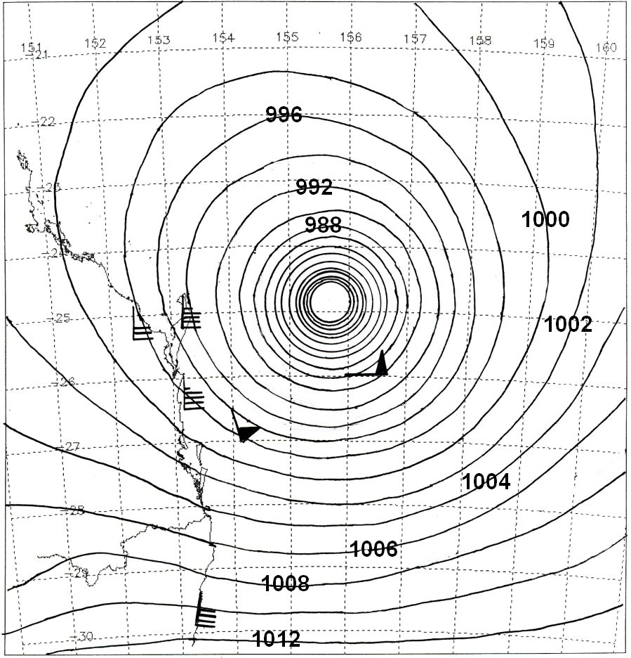

b. 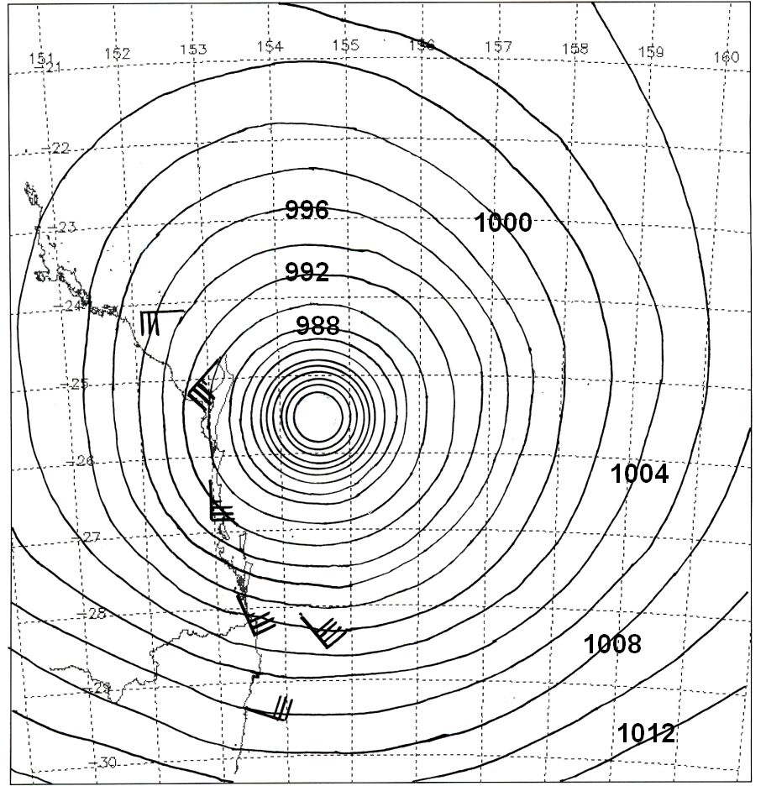
c. 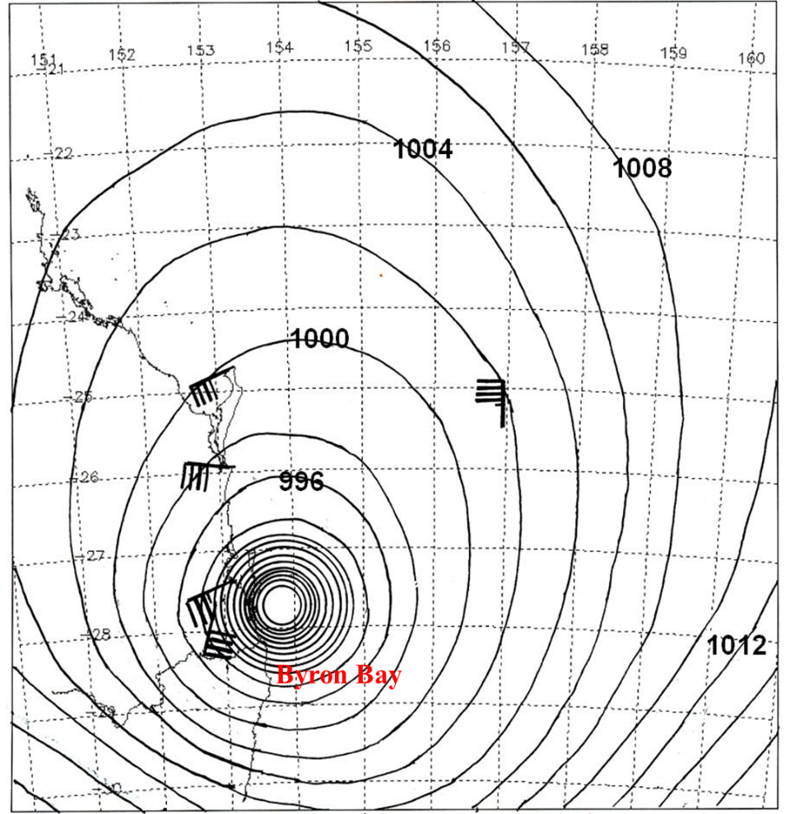
Figure 2. MSLP analysis with surface winds overlaid at a. 0800 UTC 19 February; b. 2000 UTC 19 February, and c. 0800 UTC 20 February (UTC=AEST-10h).
- Impacts
There were at least 34 deaths during this tropical cyclone. In Queensland, a man was killed at Newmarket, Brisbane when his car collided with a train in driving rain. A man was electrocuted at Nanango by a fallen livewire, and a man was killed by a fallen tree when on the Esk to Toogoolawah highway. In NSW ten people drowned at Kyogle; six people drowned at Lismore; six people drowned near Armidale after a car was washed into a flooded creek; four people drowned at Casino in two incidents; a man and baby drowned at Grafton; two drovers drowned at Maitland; and a boy was drowned in a canal at White Bay in Sydney.
A 2012 study by Roche et al. (2013) found that if this 1954 event was replicated in 2011, it would have ranked as the third most expensive weather-related insurance loss in Australian history. At the time the event resulted in an estimated $19 million in economic damages.
  - Wind
Wind damage was extensive from Queensland's Sunshine Coast, Brisbane, Gold Coast extending to northern New South Wales. Many buildings on the Gold Coast lost all or part of their roofs including hotels, churches, schools, and even the Currumbin Life Saving Club. The southern areas from Burleigh Heads to Tweed Heads were worst hit. Severe damage was also recorded in the area around Cudgen in NSW near Kingscliff, where some houses were described as being "blown apart" and trees more than 1 metre in diameter were twisted out of the ground. Severe wind damage extended further south to Kempsey where houses were unroofed and many trees uprooted.
  - Storm Tide and waves
Wave action caused severe beach erosion across southeast Queensland and northern New South Wales particularly on the Gold Coast (see Figure 6).
A 0.64m storm surge was recorded on the Moreton Bay gauge. At Beachmere, north of Brisbane, some boats were washed into the treetops.
At Kirra the waves caused a surge of water 2m high over the parking area and the Pacific Highway picking up cars. Beach erosion was extensive. Many jetties were destroyed and boats wrecked.
At Byron Bay, 600 ft (183 m) of the outer section of the jetty was washed away taking with it 23 vessels comprising most of the fishing fleet while the storm surge broke through the sand hills and reached areas five blocks back from the beach.
  - Flooding
Flooding was exacerbated following earlier heavy rains on 10-11 February (inc. 422.4 mm at Springbrook Forestry). Hence, the extreme rain late 19 February to late 20 February extending south from the Gold Coast hinterland into NSW (Springbrook 1047.5 mm 2-day total) caused massive flooding over wide areas.
On the Gold Coast, the combination of flooding and storm tide resulted in the Nerang River being more than a mile (1.6 km) wide at Surfers Paradise, flooding houses and businesses. Twenty-five residents of the flooded Macintosh Island were brought to the mainland after a combined effort from police, military and the Surfers Paradise Surf Club
Flooding in the northern Rivers of NSW was particularly devastating. The steep escarpments of the Tweed Caldera helped cause rapid rises in the upper tributaries of the Tweed, Richmond and Wilsons Rivers (Figure 3). On the western escarpment several creeks follow a steep descent of around 800 metres into the Richmond River.
When rescue aircraft surveyed the area on the morning of 21 February the sun was shining, and hundreds of motor vehicles could be seen on the hills where people had fled the floods and others were marooned on rooftops miles from safety. It looked like a vast sea between Kyogle and the coast. Throughout the Richmond-Tweed area cars and trucks could be seen half flooded or overturned on roads which bore testimony to how fast the waters rose.
On the main arm of the Richmond River the flood through Kyogle remains the highest on record. Kyogle locals described it as a "wall of water" that claimed the lives of 10 people including six members of one family. On 20 February, the river reached 16.37 m by 4:45 pm, 18.28 m by 6:30 pm and 18.90 m by 7 pm, a rise of 2.5 m in just 2:15 h.
At Casino the river broke its high banks which is rare and inundated low-lying sections of the town. The peak gauge height of 16.18 m occurred at 4 pm on 21 February. Seven houses were destroyed, and two lives were lost. Four men sheltering on a roof were swept into the floodwaters, one drowning, and another left stranded in a tree. During his attempted rescue the following day, another man drowned when the rescue boat became entangled in debris and went down..
Further east the Wilsons River at Lismore rose rapidly in the early evening of 20 February to 13.41 m, causing the river to swell up to 11 km wide in one place (see Figure 7). 300 people were rescued from their homes, but a seven-year-old boy was swept away.
At Murwillumbah a man drowned during a rescue. At Armidale five people including a 21-month-old baby drowned after a car was washed into a flooded creek. Heavy rainfall also extended further south through the Mid North Coast of NSW and led to extreme rainfall totals in the Dorrigo area and major flooding in the greater Coffs Harbour region and south to Kempsey. Some flooding then extended further south along the entire NSW coastline.

- Observations
  - Wind
The captain of the ship Kaipara, berthed at New Farm on the Brisbane River, estimated sustained winds at 65 kn (120 km/h) at 1200 AEST. Gale-force winds were recorded at many coastal and offshore sites during the event extending well south of the centre along the New South Wales coast.
  - Pressure
Cape Moreton: 979 hPa at 1500 AEST 20 February.
Brisbane Airport: 981.9 hPa at 1800 AEST 20 February (three-hourly observations). This is the lowest recorded pressure in Brisbane (to 2026).
Coolangatta: 971.9 hPa. There was a 10-minute calm at approximately 2200 AEST 20 February.
Condong Sugar Mill (NSW): A Mr Richard Everingham reported two barometers, one an aneroid barometer recorded 975 hPa (28.8 inches) while the other read 973 hPa.
The ship Kaipara, at New Farm on the Brisbane River, measured a low pressure of 967.1 hPa at 1600 AEST but was suspiciously lower than the more reliable nearby Brisbane Airport observation.
  - Rainfall
Heavy rainfall fell over a broad area in near coastal areas extending from the Queensland Sunshine coast southward, including most of the New South Wales coast (see Figure 4). The heaviest falls were recorded in the Gold Coast hinterland: Springbrook Forestry recorded a 2-day total of 1047.5 mm (360.7 mm 20 Feb., 686.8 mm 21 Feb., including 250 mm between 5-9:30 pm AEST. See Figure 5), and northern New South Wales including Dorrigo (2-day total of 998.7 mm; 189.5mm 20 Feb., 809.2 mm 21 Feb.) as shown in Table 2. Heavy rainfall also fell further south, the Sydney region registering 100-200 mm on 22 February (Concord Golf Club 198.4 mm).

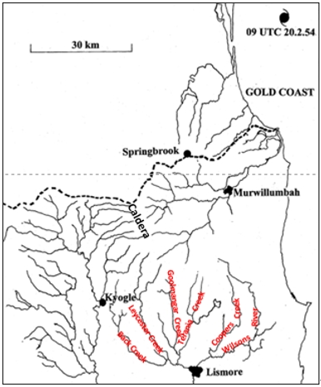
Figure 3. Location of Tweed (through Murwillumbah), Lismore, and Kyogle catchments together with location of the western edge of the Tweed Caldera, Springbrook, and position of the cyclone around the time Kyogle was devastated. (Reproduced from Callaghan 2023).
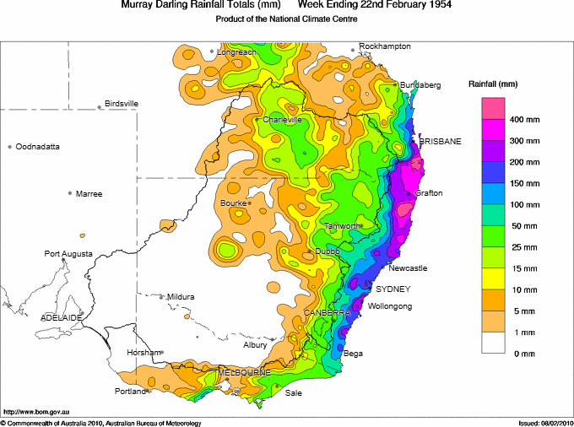
Figure 4. Weekly rainfall, week ending 22 February 1954.
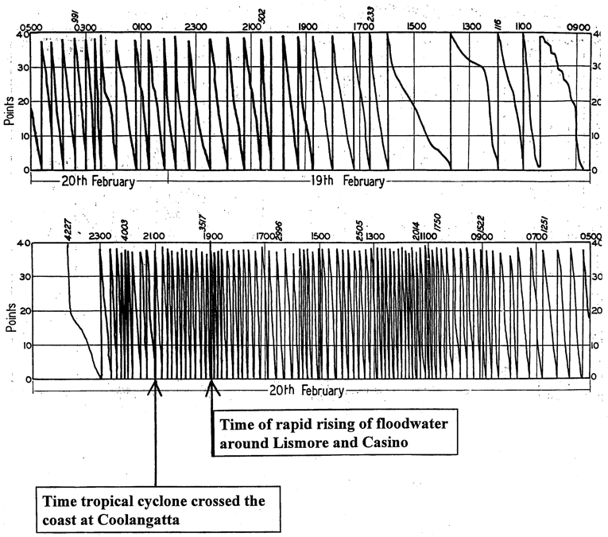
Figure 5. Springbrook pluviograph 19-20 February 1954 (annotated). Points (100 points to inch) equates to 0.25 mm so 40 points on scale is 10 mm.

Name | 20 Feb. | 21 Feb. | 20-21 total | Feb. Total
Springbrook Forestry | 360.7 | 686.8 | 1047.5 | 1787.7
Dorrigo (Myrtle St) | 189.5 | 809.2 | 998.7 | 1259.3
Dorrigo P.O. | 169.4 | 774.7 | 944.1 | 1244.7
Doon Doon (McCabes Rd) | 337.8 | 470.2 | 808.0 | 1168.3
Tallowwood Point | 144.3 | 504.7 | 649.0 | 962.3
Widgee | 179.6 | 436.4 | 616.0 | 903.6
Whian Whian (Rummery Park) | 172.7 | 430.5 | 603.2 | 919.7
Green Mountains | 397.0 | 197.4 | 594.4 | 1077.0
Darlington | 197.1 | 377.7 | 574.8 | 886.2
Tallebudgera Guineas | 154.7 | 417.3 | 572.0 | 1114.8
Rottington | 233.9 | 308.1 | 542.0 | 1181.9
Numinbah | 155.7 | 373.1 | 528.8 | 1120.2
Coramba (Glenfiddich) | 105.9 | 421.1 | 527.0 | 782.2
Glenreagh Forestry Station | 53.8 | 440.9 | 494.7 | 756.9
Chillingham (Limpinwood) | 165.1 | 325.1 | 490.2 | 1002.1
Lismore (Centre St) | 146.1 | 334.3 | 480.4 | 755.1
Wunburra | 227.3 | 246.9 | 474.2 | 1060.8
Lillian Rock | 147.3 | 315.7 | 463.0 | 786.6
Tabbimobile | 96.0 | 367.0 | 463.0 | 694.7
Condong Sugar Mill | 170.4 | 292.1 | 462.5 | 912.3
Nimbin P.O. | 160.5 | 291.6 | 452.1 | 674.2
Murwillumbah P.O. | 137.9 | 299.2 | 437.1 | 851.6
Table 2. Rainfall totals (mm) during February 1954.

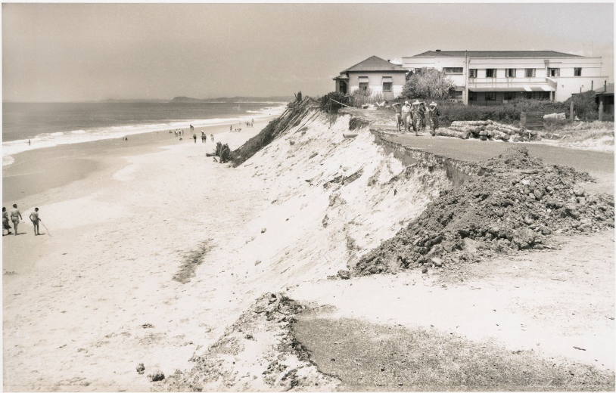
Figure 6. Erosion on Main Beach on the Gold Coast. Photo by Douglas Thompson, available via State Library of Queensland, http://hdl.handle.net/10462/deriv/231852

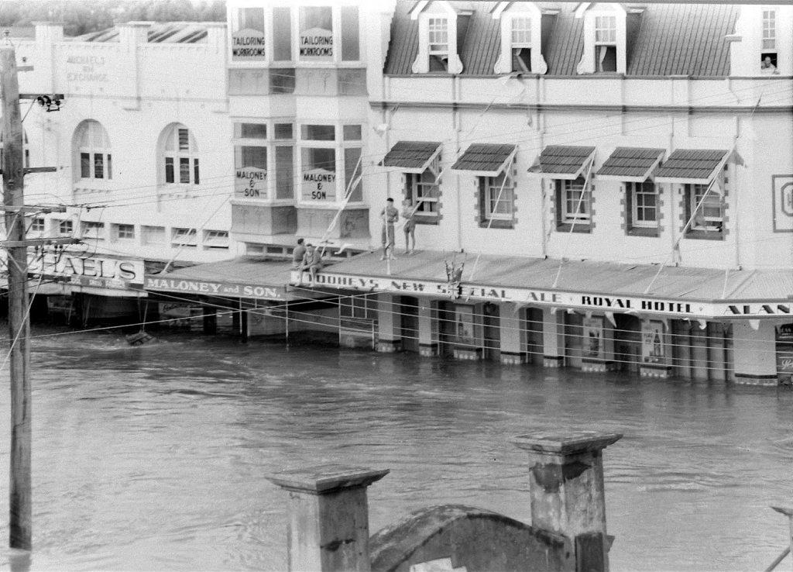
Figure 7. Flooding at Lismore. Photo Northern Star Archives.
- References
Callaghan J. 2023. The Eastern Australian Floods of February 2022 and Its Relationship with Climate Change. Journal of Energy and Power Technology 2023; 5(2): 014; https://doi:10.21926/jept.2302014.
Callaghan, J., and P. Helman, 2008. Severe Storms on the East Coast of Australia 1770–2008. Griffith University, 248 pp.
Granger, K., and M. Hayne, 2001; Natural hazards and the risks they pose to South-East Queensland. Geoscience Australia Cities Project, 410 pp.
Roche, K. M., K. J. McAneney, K. Chen, and R. P. Crompton, 2013: The Australian Great Flood of 1954: Estimating the Cost of a Similar Event in 2011. Wea. Climate Soc., 5, 199–209, https://doi.org/10.1175/WCAS-D-12-00018.1.

Appendix 1: List of Abbreviations
Abbreviation | Term
AEST | Australian Eastern Standard Time
h | hour
hPa | hectopascal
km | kilometres
km/h | kilometres per hour
kn | knot
m | metres
mm | millimetres
nm | nautical mile
UTC | Universal Time Co-ordinated

