Thunderstorm and Severe Weather Service Level Specification

Community Services Group

Season 2024–2025
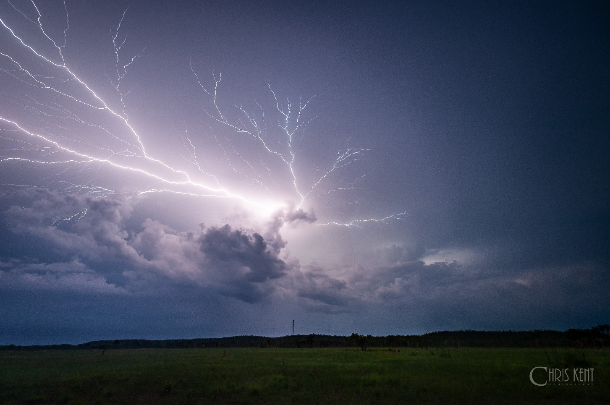

Revision history
Date | Version | Author | Description
10/08/2023 | 0.1 | Andrew Bufalino | Initial draft template
14/10/2023 | 0.2 | Dean Sgarbossa  Andrew Bufalino | Final internal draft
 | 0.3 | Evan Morgan | Draft sent for internal consultation
9/11/2023 | 0.4 | Evan Morgan | External consultation draft
02/07/2024 | 1.1 | Andrew Bufalino  Alex Majchrowski | Initial 24/25 draft created
01/11/2024 | 1.2 | Alex Majchrowski | Final 24/25 internal draft
18/11/2024 | 1.3 | Alex Majchrowski | 24/25 draft amendment following feedback from EPS-MA

Review status
Date | Version | Reviewer | Description
2023 | 1.0 | Evan Morgan
27/11/2024 | 1.3 | Evan Morgan | Review for 24/25 warm season

Release history
Date | Version | Status | Approval
2023 | 1.0 | Approved | Matt Collopy
12/2024 | 2.0 | Approved | Matt Collopy

Unless otherwise noted, all images in this document are licensed under the Creative Commons Attribution Australia Licence.
© Commonwealth of Australia 2024
Published by The Bureau of Meteorology
Cover image: Adelaide River, Northern Territory, Christopher Kent, 12 December 2019.

Contents

1. Introduction 7

1.1. Purpose 7

1.2. Scope 8

1.3. Authority 8

1.4. Distribution 8

2. National Thunderstorm and Severe Weather Services 10

2.1. Partnerships 10

2.2. Definitions 10

2.2.1. Thunderstorm 10

2.2.2. Severe Thunderstorm 10

2.2.3. Severe Weather 12

2.3. Severe Weather Seasonality 13

2.4. Area of Responsibility 13

2.5. Dissemination of Products 13

2.6. Briefing Services 13

2.7. Embedded Meteorologists 14

2.8. Communication and Adoption Activities 14

2.9. Service Continuity 14

3. Quality Assurance and Performance 14

3.1. Hazards Services Forum 14

3.2. Commonwealth, State and Territory Liaison and Consultation 15

3.3. Performance Statistics and Reporting 15

3.3.1. Verification 15

3.3.2. Damage Assessments 15

3.4. Lessons Management 15

3.5. Meteorologist Training and Competency 15

4. National Thunderstorm and Severe Weather Routine Product Suite 16

4.1. Real-time Data Services & Australian Digital Forecast Database 16

4.2. Thunderstorm Forecasts 16

4.2.1. Issue Criteria, Times, and Validity 16

4.2.2. Content 17

4.2.3. Amendment Criteria 17

5. National Thunderstorm and Severe Weather Non-Routine Product Suite 18

5.1. Severe Thunderstorm Warnings 18

5.1.1. Warning Content 18

5.1.2. Regional Severe Thunderstorm Warnings 19

5.1.3. Detailed Severe Thunderstorm Warnings 19

5.2. Severe Weather Warnings 20

5.2.1. Issue Criteria and Validity 20

5.2.1.1. Concurrent Severe Thunderstorm Warnings 21

5.2.1.2. Concurrent Coastal Hazard Warnings 21

5.2.2. Warning Content 22

5.3. Warning Escalations 23

5.3.1. Very Dangerous Storm (VDS) 23

5.3.2. Standard Emergency Warning Signal 23

5.3.3. Emergency Weather Alerts 23

6. Appendices 24

6.1. Coastal Hazard Warnings 24

6.1.1. Definitions 24

6.1.1.1. Coastal Hazards 24

6.2. Weather Forecast District Maps 26

6.3. Detailed Severe Thunderstorm Warning Domains 32

6.4. Product Samples 40

6.4.1. Thunderstorm Forecast Map 40

6.4.2. Regional Severe Thunderstorm Warning 41

6.4.3. Detailed Severe Thunderstorm Warning 43

6.4.4. Severe Weather Warning 45

6.4.5. Severe Weather Warning for offshore Islands 47

6.5. Product Identifiers 47

7. Navigation aids 50

7.1. List of figures 50

7.2. List of tables 50

List of acronyms used in this Service Level Specification
ACT | Australian Capital Territory
ADFD | Australian Digital Forecast Database
AEP | Annual Exceedance Probability
BMTC | Bureau of Meteorology Training Centre
NEMA | National Emergency Management Agency
EWA | Emergency Weather Alert
HAT | Highest Astronomical Tide
HMA | Hazard Management Agency
HSF | Hazard Services Forum
ID | Identification (numbers or codes)
IGA | The Intergovernmental Agreement on the Provision of Bureau of Meteorology Hazard Services to the States and Territories
LAT | Lowest Astronomical Tide
NSW | New South Wales
NT | Northern Territory
NWP | Numerical Weather Prediction
PERM | Post Event Review Management
PSG | Predictive Services Group
QLD | Queensland
QPF | Quantitative Precipitation Forecast
SA | South Australia
SES | State Emergency Service
SEWS | Standard Emergency Warning Signal
SLS | Service Level Specification
SOP | Standard Operating Procedures
SWH | Significant Wave Height
TAS | Tasmania
VIC | Victoria
VDS | Very Dangerous Storm
WA | Western Australia

- Introduction
  - Purpose
The purpose of the Service Level Specification (SLS) is to document the thunderstorm and severe weather services provided by the Bureau of Meteorology (the Bureau).

The Total Warning System recognises that a fully effective warning service is multi-faceted in nature and its development and operation involves input from several agencies each with specialised roles to play. It is vital that the agencies involved work in close cooperation through all stages of developing and operating the system. The services described here are the Bureau’s contribution to the Total Warning System for thunderstorms and severe weather.

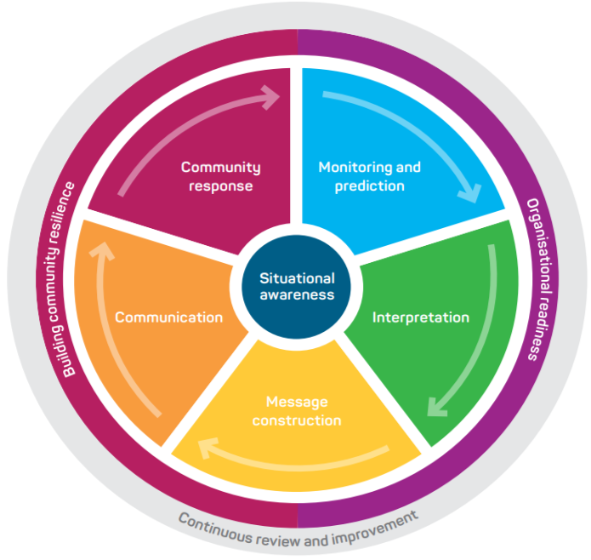
Figure 1: Total Warning System

The Bureau’s role in the thunderstorm and severe weather warning system is focussed on monitoring and prediction, message construction and communicating threats and impacts associated with these hazards to Government, industry, and the community.

The Bureau also contributes to activities designed to strengthen organisational readiness and build community resilience and participates in the planning and coordination of activities with disaster mitigation agencies.
  - Scope
The scope of the SLS is the Bureau's publicly available thunderstorm and severe weather services and additional services provided to support emergency management.

The SLS details what the Bureau does and when it does it, to provide thunderstorm and severe weather services. How the Bureau produces these services is addressed in internal Bureau documentation.
  - Authority
The Meteorology Act, 1955 provides the Bureau a number of functions including but not limited to the taking and recording of observations, forecasting the weather, and issuing of warnings for weather conditions likely to endanger life or property. The Intergovernmental Agreement on the Provision of Bureau of Meteorology Hazard Services to the States and Territories (IGA) confirms the roles and responsibilities of the Bureau and State and Territory governments and local governments.

The Bureau has historical and statutory responsibility for the issue of warnings of gales, storms, and other weather conditions likely to endanger life or property (Meteorology Act 1955 – Sect 6). This includes the provision of forecast and warning services for severe thunderstorms and severe weather. The responsibility for preparation for and response to thunderstorm and severe weather impacts lies with state and territory governments and local governments.

The Bureau of Meteorology Thunderstorm and Severe Weather SLS is issued by the General Manager Environmental Prediction Services under the authority of the Director of Meteorology.
  - Distribution
This document will be distributed to the agencies listed in Table 1.

Jurisdiction | Agency Name
National | National Emergency Management Agency (NEMA)
National | Australasian Fire and Emergency Services Authorities Council (AFAC)
QLD | Queensland Fire and Emergency Services (QFES)
QLD | Queensland Police Services (QPS)
QLD | Queensland Inspector General Emergency Management
NSW | New South Wales State Emergency Service (NSW SES)
ACT | Australian Capital Territory Emergency Services Authority (ACT ESA)
ACT | Australian Capital Territory Parks and Conservation (ACT PCS)
VIC | Emergency Management Victoria (EMV)
VIC | Victoria State Emergency Service (Vic SES)
VIC | Victoria Department of Environment, Land, Water and Planning (DELWP)
VIC | Victoria Police (VicPOL)
TAS | Tasmania State Emergency Service (Tas SES)
TAS | Tasmanian Parks and Wildlife Service
SA | South Australian State Emergency Service (SA SES)
SA | South Australian Country Fire Service (SA CFS)
SA | South Australia Department for Environment and Water (DEW)
SA | South Australia Police (SAPOL)
WA | Western Australia Department of Fire and Emergency Services (DFES)
NT | Northern Territory Police, Fire and Emergency Services (PFES)
Norfolk Is | Emergency Management Norfolk Island
Table 1: Bureau of Meteorology Thunderstorm and Severe Weather SLS distribution list by jurisdiction

- National Thunderstorm and Severe Weather Services
The Bureau's thunderstorm and severe weather services provide the Australian community and emergency management with essential thunderstorm and severe weather forecasts and warnings that are timely and accurate.

Thunderstorm and severe weather services are designed to inform the community and emergency management organisations of the occurrence of, or potential for, severe thunderstorms or other severe weather conditions.

An important role is to assist media and state or territory emergency services with community engagement programs, and to advise on meteorological aspects of severe thunderstorm and severe weather-related disaster preparedness and planning.
  - Partnerships
The Bureau has formed partnerships with emergency management organisations, other government authorities and media across the country to ensure that forecasts and warnings are fit-for-purpose and are broadly distributed in a timely manner.

Partnerships underpin the delivery of effective thunderstorm and severe weather services to the Australian community. The partnerships with Commonwealth, State and Territory Governments and local government are formalised through the IGA, which clarifies and confirms responsibilities across the Total Warning System. Specifically, the Bureau, and States and Territories agree to work together to mutually develop and maintain national standards for warnings of severe thunderstorms and severe weather.
  - Definitions
    - Thunderstorm
A thunderstorm is a localised atmospheric disturbance that produces lightning and thunder. There are various types of thunderstorms, and each type has a distinct structure and set of characteristics, affecting thunderstorm motion, intensity, and longevity as well as the type of weather phenomena that they produce. Thunderstorms may evolve through various thunderstorm types during their life cycle.
    - Severe Thunderstorm
The Bureau of Meteorology defines a severe thunderstorm as a thunderstorm which produces one or more of the following phenomena:
- Damaging wind gusts
- Large hailstones
- Heavy rainfall which may lead to flash flooding
- Tornadoes

A severe thunderstorm is categorised as a very dangerous storm (VDS) if it produces one or more of the following high-end severe phenomena:
- Destructive wind gusts
- Giant hailstones
- Intense rainfall which may lead to dangerous and life-threatening flash flooding
- Tornadoes
These weather phenomena are defined as in Table 2:
Phenomenon | Definition
Damaging Wind Gusts | Wind gusts ≥ 90 km/h (49 knots)
Destructive Wind Gusts | Wind gusts ≥ 125 km/h (68 knots)
Large Hailstones | Hailstones ≥ 2 cm in diameter  * Large accumulations of small hail may be included in the text of an existing warning for Large Hail in NSW when conditions are favourable.
Giant Hailstones | Hailstones ≥ 5 cm in diameter
Heavy Rainfall | Rainfall over a period between 30 minutes and 6 hours which exceeds the 10% AEP depth
Intense Rainfall | Rainfall over a period between 30 minutes and 6 hours which exceeds the 2% AEP depth  Exception – NSW  As above or if lower than 2% AEP depth,  ≥ 70 mm in 1 hour or less  ≥ 150 mm in 3 hours or less
Tornado | Any tornado occurrence
Table 2: Phenomena definitions associated with severe thunderstorms

    - Severe Weather
The Bureau of Meteorology defines severe weather as hazardous or dangerous weather that is not the direct consequence of thunderstorms, tropical cyclones or bushfires that consists of one or more of the following phenomena:
- Damaging and/or destructive winds
- Heavy rainfall which may lead to flash flooding and/or intense rainfall which may lead to dangerous and life-threatening flash flooding
- Damaging surf
- Abnormally high tides
- Blizzards

Land-based phenomena are defined in Table 3 below. Coastal phenomena are defined in Table 6 of Appendix 6.1.

Land Phenomenon | Definition
Damaging Winds | Wind gusts ≥ 90 km/h (49 knots) or mean wind speeds (averaged over 10 minutes) ≥ 63 km/h (34 knots)  Exception – Tasmania  Wind gusts ≥ 100 km/h (54 knots) for westerly winds or mean wind speeds (averaged over 10 minutes) ≥ 63 km/h (34 knots)  Wind gusts ≥ 80 km/h (43 knots) for easterly winds or mean wind speeds (averaged over 10 minutes) ≥ 63 km/h (34 knots)  Exception – NSW  For elevations ≥ 1900 metres:  Wind gusts ≥ 125 km/h (68 knots) or mean wind speeds (averaged over 10 minutes) ≥ 80 km/h (43 knots).
Destructive Winds | Wind gusts ≥ 125 km/h (68 knots) or mean wind speeds (averaged over 10 minutes) ≥ 89 km/h (48 knots)  Exception – Tasmania  Wind gusts ≥ 110 km/h (59 knots) for easterly winds
Heavy Rainfall | Rainfall over a period between 30 minutes and 6 hours which exceeds the 10% AEP depth
Intense Rainfall | Rainfall over a period between 30 minutes and 6 hours which exceeds the 2% AEP depth  Exception – NSW  As above or if lower than 2% AEP depth,  ≥ 70 mm in 1 hour or less  ≥ 150 mm in 3 hours or less
Blizzards | NSW and Victoria for elevations ≥ 1200 metres  * Included in text of existing warning when conditions are identified as favourable.
Table 3: Phenomena definitions associated with severe weather
  - Severe Weather Seasonality
There is no distinct severe weather season in Australia. Severe weather can occur across Australia throughout the year, with some types of severe weather more seasonal than others.

Severe thunderstorms can occur at any time of the year. However, for most parts of the country, they are more common during the warmer months between October and March.
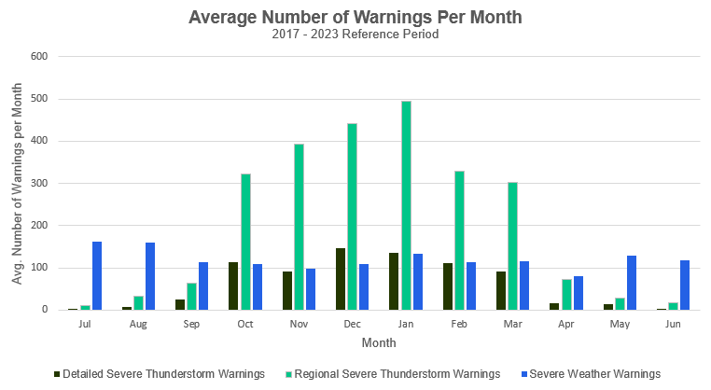
Figure 2: Average number of warnings per month across all mainland states and territories of Australia for the 2017-2023 reference period, centred about the warm season
  - Area of Responsibility
The Bureau's thunderstorm and severe weather services cover all Australian states and mainland territories. Severe weather services are also provided for Lord Howe Island and Norfolk Island.
  - Dissemination of Products
The Bureau thunderstorm and severe weather products are disseminated primarily through the Bureau's website and app. Products are also disseminated via email and are available as a recorded voice via the Bureau's telephone weather service.

Severe Thunderstorm and Severe Weather Warnings are issued directly to a list of stakeholders with emergency management responsibilities. This list is maintained by the Bureau but is not detailed in this document. The direct dissemination methods supported include email, fax, and internet protocols such as File Transfer Protocol (FTP).
  - Briefing Services
The Bureau provides briefings to emergency management partners to assist planning, response, and coordination. The format, timing and frequency of briefings is agreed through national, state and territory-based arrangements.
  - Embedded Meteorologists
The Bureau has arrangements with several emergency service organisations to provide services through an embedded meteorologist to support operational awareness and communication. In each instance, the services provided are agreed between the Bureau and the organisation and provided on a cost recovery basis.
  - Communication and Adoption Activities
In addition to issuing products through standard communication channels such as the website, app and via email, the Bureau undertakes a range of complementary communication and adoption activities in partnership with emergency management agencies. The purpose of these activities is to increase the uptake and effectiveness of the forecasts and warnings, and to ensure consistent weather safety messages are provided to the community.

Activities include community and industry preparedness briefings, social media campaigns and the Bureau's "Severe Weather Knowledge Centre" web pages. Ahead of, during and following significant severe thunderstorm and severe weather occurrences, this extends to joint press conferences and media interviews, as well as continuing social media public safety campaigns and additional community and industry briefings.
  - Service Continuity
The Bureau maintains service continuity through its Business Continuity Plans. Most pertinent to thunderstorm and severe weather services is the built-in redundancy of being able to transfer operations between offices, as required.

To maintain service continuity, the Bureau uses a large and diverse range of observational and forecast data in the delivery of all its thunderstorm and severe weather services. This provides redundancy if any data source is unavailable during operations and ensures all products and services are based on the best available information at the time.

As per 2.6(2) of the IGA, the Bureau will aim to provide a continuity of services across the nation subject to the Bureau's available resources, operational limitations and any applicable policy considerations.

- Quality Assurance and Performance
  - Hazards Services Forum
The IGA established the Hazards Services Forum (HSF) in 2018. The HSF facilitates consultation with state and territory operational emergency service agencies to guide current and future strategic development of the Bureau of Meteorology’s hazard services.

The forum provides a pathway for states and territories to request and prioritise changes to the standard services and to refer services that could be considered supplementary services to the Bureau for consideration. The HSF also assists with the process of consulting on modifications to services schedules.
  - Commonwealth, State and Territory Liaison and Consultation
The Bureau maintains ongoing liaison and engagement at a Commonwealth, state and territory level with emergency management organisations to ensure all parties maintain awareness of thunderstorm and severe weather operations and procedures. This occurs through regular meetings between team leaders and operations managers in the Bureau and the emergency service. The format, timing and frequency of these meetings is agreed through state and territory-based arrangements.
The Bureau engages with relevant emergency services agencies when revising formats, content and delivery of severe thunderstorms and severe weather warning services.
  - Performance Statistics and Reporting
    - Verification
All official forecast and warning products are verified against available observations and compiled into routine reports. Key performance measures are reported in the Bureau's Annual Report.
    - Damage Assessments
The Bureau may choose to undertake damage assessments after severe thunderstorm and/or severe weather events, to advance knowledge and understanding of these high impact occurrences, and for verification and reporting purposes. At times, the Bureau may ask emergency service organisations and local governments (councils) to provide additional information, reports, and intelligence about a specific event, which may ultimately improve the final damage assessment. The Bureau of Meteorology will liaise with the relevant emergency service organisation if access is desired to any restricted areas impacted by severe weather and will always respect the directions of emergency services.
  - Lessons Management
The Bureau conducts an internal debrief and lessons management process after the occurrence of severe thunderstorms and severe weather which have had a significant community or operational impact. The insights and recommendations gained from these post event reviews are used to improve processes, systems and services delivered by the Bureau.

Depending on the impact from the severe thunderstorm or severe weather event, the process may include a debrief with external partners. Upon request, the Bureau also contributes to post incident reviews conducted by emergency services and government.
  - Meteorologist Training and Competency
The Bureau undertakes competency-based training and assessment programs for qualified meteorologists involved in forecast, warning, and decision support operations.

This includes a public weather warning training and assessment program, and a specific severe thunderstorm training and competency-based assessment program. These programs ensure that staff involved in analysing, forecasting, and warning for severe thunderstorms and severe weather have the qualifications, training and demonstrated ability to provide a high standard service to the Australian community.

- National Thunderstorm and Severe Weather Routine Product Suite
Unless otherwise noted, all issue times are quoted as local time for the relevant jurisdiction and time of year.
  - Real-time Data Services & Australian Digital Forecast Database
The Bureau's real-time data services provide tailored delivery of real-time Bureau of Meteorology products including datasets such as numerical output grids, satellite and radar data and web map service layers.

Part of these services is the Australian Digital Forecast Database (ADFD), which provides detailed forecast information across all states and mainland territories, including grids that are relevant to thunderstorms. These grids are available all year round.

The ADFD files are updated routinely twice per day at approximately 6:00 am and 6:00 pm local time and updated at other times, as required. If the forecasts are updated, the ADFD grids are not necessarily updated at the same time as the changes to the forecasts. Priority is given to updating the forecasts and warnings issued directly to the Australian community through the media or internet.

Further details on real-time data services and the ADFD, including information on data bundles, can be found at http://reg.bom.gov.au/reguser/ or http://reg.bom.gov.au/catalogue/adfdUserGuide.pdf.
  - Thunderstorm Forecasts
The Bureau routinely provides geospatial thunderstorm forecasts to emergency services as a planning and operational decision support resource. These thunderstorm forecasts provide a graphical depiction of the geospatial areas which may be affected by thunderstorms and severe thunderstorms for the remainder of the current day (Day 1) and the following day (Day 2).

Thunderstorm forecasts are published to various Bureau registered user websites, from where they can be accessed by emergency services and are also provided to specific registered users by email.

Thunderstorm forecasts are published via social media from respective state or territory Bureau accounts, typically when severe thunderstorms are considered possible or likely and/or there is potential for significant community impact.
    - Issue Criteria, Times, and Validity
Thunderstorm forecasts are issued routinely, once a day, during selected periods of the year, as listed in Table 4. In some jurisdictions, forecasts may be issued outside this period when severe thunderstorms are considered possible and/or likely and/or there is potential for significant community impact.

Separate forecasts are issued for each state and mainland territory (ACT are included in NSW thunderstorm forecasts).

The issue times for thunderstorm forecasts are set to meet the needs of emergency services, and account for Bureau workflow processes and priorities.

State/Territory | Seasonal Coverage | Day 1 Issue Time | Day 2 Issue Time
Queensland | All year round | 09:45 am (23:45 UTC) | 11:30 am (01:30 UTC)
NSW/ACT | All year round | By 11:00 am (00:00 UTC) | By 11:00 am (00:00 UTC)
Victoria | All year round | By 7:00 am, updated by 11:30 am (00:30 UTC), if required | 1:45 pm (02:45 UTC)
Tasmania | Not provided
South Australia | 1/10 to 30/04, ad hoc at other times | 12:00 pm (01:30 UTC) | 12:00 pm (01:30 UTC)
Western Australia | 1/10 to 30/04 | 10:30 am (02:30 UTC) | 10:30 am (02:30 UTC)
Northern Territory | 1/10 to 30/04, ad hoc at other times | 12:00 pm (02:30 UTC) | 2:00 pm (04:30 UTC)
Table 4: The seasonal coverage and local issue times for the thunderstorm forecasts for each state and mainland territory.
    - Content
The thunderstorm forecast comprises of a national map and accompanying text description.
The map uses shaded polygons that depicts geospatial areas where thunderstorms are possible as well as areas where severe thunderstorms are considered possible or likely, as defined in Table 6.

Forecast polygon category | Definition
Thunderstorms Possible | ≥ 10% probability of lightning within 10 km of a point
Severe Thunderstorms Possible | If a thunderstorm occurs, the probability of it being severe is 10% to 30% within 10 km of a point
Severe Thunderstorms Likely | If a thunderstorm occurs, the probability of it being severe is ≥ 30% within 10 km of a point
Table 5: Definition and shading of polygon categories on the thunderstorm forecast
    - Amendment Criteria
There is no requirement to update thunderstorm forecasts after issue. However, at times, it may be beneficial to do so, to ensure significant changes to the thunderstorm forecast policy can be effectively communicated to emergency services, and possibly to the community via social media.
- National Thunderstorm and Severe Weather Non-Routine Product Suite
  - Severe Thunderstorm Warnings
A Severe Thunderstorm Warning is issued whenever there is sufficient meteorological evidence to suggest that severe thunderstorm development is likely, or when a severe thunderstorm has been directly reported or observed, or inferred through various observational datasets, and a Severe Thunderstorm Warning is not already current.

The Bureau issues two types of Severe Thunderstorm Warnings that alert the community, emergency services and other organisations about the threat of severe thunderstorms.

- Regional Severe Thunderstorm Warnings
- Detailed Severe Thunderstorm Warnings

If severe thunderstorms develop within an area that is already described by a Severe Weather Warning (refer Section 5.2), a separate Severe Thunderstorm Warning will only be issued if a hazard (as defined by section 2.2.2) other than those already included in the Severe Weather Warning is occurring or expected to occur. This may include escalations of hazards mentioned in the Severe Weather Warning, e.g., Severe Thunderstorm Warning for intense rainfall associated with thunderstorms within a broader Severe Weather Warning for heavy rainfall.
    - Warning Content
A Severe Thunderstorm Warning consists of information that highlight threat areas and potential phenomena in a graphical and textual format.

Title
The title states the warning type and lists potential phenomena and the affected weather forecast districts.

Issuance Time
The issuance time and date of the severe thunderstorm warning.

Headline Statement
A succinct one-line statement that describes the 'where, what, and when' of key severe thunderstorm threats.

Graphical Warning Content
Displays a geospatial map of weather forecast district boundaries overlain with one or more yellow shaded polygons depicting the spatial extent of the warning.

Weather Situation (Regional Severe Thunderstorm Warning only)
A brief description on the current and/or developing severe thunderstorm situation. It lists the synoptic drivers producing the severe thunderstorms and may provide an overview on the spatial and temporal extent of the severe thunderstorm activity.

Warning Details
The main body of the warning lists potential phenomena, qualitative confidence in phenomena, and affected locations.

Observations
Any significant observations recorded relevant to the hazards listed in the warning.

Action Statements
Automatically generated action statements that have been agreed upon by state and territory-based emergency services.

Warning Updates
The update time of the next severe thunderstorm warning.

Warning Accessibility
Automatically generated text that provides a brief statement on the additional channels where the severe thunderstorm warning is broadcast.

    - Regional Severe Thunderstorm Warnings
The Bureau provides Regional Severe Thunderstorm Warnings for all states and mainland territories. Warning areas are based on one or more weather forecast districts and/or parts of weather forecast districts.

Issue Criteria and Validity
Regional Severe Thunderstorm Warnings are issued whenever there is sufficient meteorological evidence to suggest that severe thunderstorm development is likely within the next 3 hours. They are also issued when a severe thunderstorm has been observed, or when a severe thunderstorm outside the warning domain is expected to move into the area. Note that in addition to the definitions of severe thunderstorms provided in Section 2.2, some discretion may be applied based on antecedent conditions.

Regional Severe Thunderstorm Warnings are valid for a three-hour period from the issuance time and will be updated routinely every one to two hours but may be updated more frequently during rapidly evolving situations. Depending on forecast confidence and the level of threat, Regional Severe Thunderstorm Warnings may be issued with shorter lead times.

If a current Regional Severe Thunderstorm Warning does not adequately describe the situation, it will be updated immediately. Examples for when this is necessary are an escalation or de-escalation of the hazard threat or a change in the communities expected to be impacted.

Graphical warning content may include additional sub-contours within warning areas to highlight very dangerous storm activity within the overall warning area.

Once the threat of severe thunderstorms has passed, the Regional Severe Thunderstorm Warning will be cancelled.
    - Detailed Severe Thunderstorm Warnings
The Bureau provides Detailed Severe Thunderstorm Warnings for all capital cities and surrounding areas, as shown in Appendix 6.3. They provide time and location-specific information about the severe thunderstorm threat.

Issue Criteria and Validity
Detailed Severe Thunderstorm Warnings are issued when one or more severe thunderstorms are detected within the warning domain, or an existing thunderstorm is forecast to become severe within the next 60 minutes. They are also issued when a severe thunderstorm outside of the detailed severe thunderstorm warning domain is expected to move into the area. Note that in addition to the definitions of severe thunderstorms provided in Section 2.2, some discretion may be applied based on antecedent conditions.

Detailed Severe Thunderstorm Warnings are valid for 30 or 60 minutes from the issuance time and will be updated routinely every 30 to 60 minutes. If a current Detailed Severe Thunderstorm Warning does not adequately describe the situation, it will be updated immediately. Examples for when this is necessary are an escalation or de-escalation of the hazard threat or a change in the communities expected to be impacted.

When the threat of severe thunderstorms has eased within a metropolitan area but further development is possible, and the Regional Severe Thunderstorm Warning which includes the metropolitan area remains current, the Detailed Severe Thunderstorm Warning will be suspended. The text of the suspended warning will advise that severe thunderstorms have eased but the situation will be closely monitored. Only once no further severe thunderstorms are expected will the Detailed Severe Thunderstorm Warning be cancelled.

In some instances, such as rapid intensification of thunderstorms, an initial Detailed Severe Thunderstorm Warning may be issued prior to a Regional Severe Thunderstorm Warning. In such cases, a Regional Severe Thunderstorm Warning will be issued shortly after.

Additional Graphical Warning Content
If a Regional Severe Thunderstorm Warning is in effect over parts of the relevant Detailed Severe Thunderstorm Warning domain, the Detailed Severe Thunderstorm Warning graphic will include the area of the Regional Severe Thunderstorm Warning as well as a depiction of the areas under immediate threat from individual severe thunderstorm cells.

Additional Warning Text Details
In addition to the information described in Section 5.1.1, the warning will also specify current and future impacted locations that correspond to an existing severe thunderstorm (red shaded ellipses) and an immediate threat area (orange-hashed shaded polygons).

  - Severe Weather Warnings
The Bureau issues Severe Weather Warnings that alert the community, emergency services and other organisations about the threat of severe weather. They are issued whenever there is sufficient meteorological evidence to suggest that severe weather, that is not the direct consequence of thunderstorms, is occurring or expected to develop.

Severe Weather Warnings are issued for all states and mainland territories where all warning areas are based on one or more weather forecast districts and/or parts of weather forecast districts.

Severe Weather Warnings for Lord Howe Island and Norfolk Island are issued for the whole island and are text-based warnings.
    - Issue Criteria and Validity
Severe Weather Warnings are issued when severe weather is occurring or is expected to develop. Note that in addition to the definitions of severe weather provided in Section 2.2, some discretion may be applied based on antecedent conditions or input from emergency management agencies to drive an appropriate response in the community to the weather event.

The lead-time provided for a Severe Weather Warning will depend on the nature of the event, the ability to forecast it with reasonable certainty and the time of day. In general, severe weather events will fall into two categories:

- Broad-scale phenomena such as east coast lows, recently decayed tropical cyclones, widespread land gales or vigorous cold fronts
- Local-scale phenomena such as localised heavy rain or damaging wind gusts caused by interactions between the weather conditions and topography

For broad-scale phenomena, Severe Weather Warnings will aim to be issued 24 to 36 hours ahead of the expected onset of severe weather conditions. Depending on forecast confidence and the level of threat, Severe Weather Warnings may be issued with shorter lead times.

Local-scale phenomena are more difficult to forecast with significant lead-time and in some instances, Severe Weather Warnings will be issued with shorter lead times.

Severe Weather Warnings do not have a prescribed validity period, this is described in general terms within the warning details section.

Graphical warning content may include additional sub-contours within warning areas to highlight very dangerous severe weather within the overall warning area

Once a Severe Weather Warning is issued, routine updates will be issued at least every six hours until the threat has passed. They are typically updated at the standard times of 4:30 – 5:00 am, 10:30 – 11:00 am, 4:30 – 5:00 pm and 10:30 – 11:00 pm in local time, but may be updated more frequently, during rapidly evolving situations or periods of high-impact severe weather.

      - Concurrent Severe Thunderstorm Warnings
A separate concurrent Severe Thunderstorm Warning is a Detailed or Regional Thunderstorm Warning that is issued over an accompanying Severe Weather Warning. This overlapping product is used to warn for a hazard that is not included in an accompanying Severe Weather Warning or to provide increased geographical detail for areas under effect of a high-end severe hazard.
If a severe or high-end severe hazard is expected to remain exclusively within the Detailed Severe Thunderstorm Warning domain, a Detailed Severe Thunderstorm Warning will be issued without an accompanying Regional Severe Thunderstorm Warning. If outside the Detailed Severe Thunderstorm Warning domain, a Regional Severe Thunderstorm Warning will be issued. If the severe or high-end severe hazard extends outside the Detailed Severe Thunderstorm Warning domain (e.g., Very Dangerous Thunderstorm) moving into or out of the Detailed Severe Thunderstorm Warning domain, then both Detailed and Regional Severe Thunderstorm Warnings will be issued until one of the products can be cancelled.
When concurrent Severe Weather Warnings and Severe Thunderstorm occur, the warning products will reference each other.
      - Concurrent Coastal Hazard Warnings
Coastal Hazard Warnings are provided for abnormally high tides and damaging surf for most states and territories. As a result, there may a Severe Weather Warning and a Coastal Hazard Warning in place for overlapping areas. In this instance, one warning would be covering land-based phenomena while the second warning would be covering coastal-based phenomena. When concurrent Coastal Hazard and Severe Weather Warnings for coastal-based phenomena and land-based phenomena occur, the warning products will reference each other.

Once the threat of severe weather or coastal hazards has passed the Severe Weather Warning or Coastal Hazard Warning will be cancelled.
    - Warning Content
A Severe Weather Warning consists of various sections that highlight threat areas and potential phenomena in a graphical and textual format.

Title
The title states the warning type and lists potential phenomena and the affected weather forecast districts.

Issuance Time
The issuance time (local time) and date of the severe weather warning.

Headline Statement
A succinct one-line statement that describes the 'where, what, and when' of key severe weather threats.

Graphical Warning Content
Displays a geospatial map of weather forecast district boundaries overlain with one or more yellow shaded polygons depicting the spatial extent of the warning.

Weather Situation
A description of the current and/or developing severe weather situation. It generally covers the current and future synoptic pattern along with the major weather systems that will produce the severe weather.

Warning Details
The main body of the warning lists potential phenomena, qualitative confidence in phenomena, and describes their upper limits or ranges, probability, and temporal characteristics. It may describe the current situation and the spatial distribution of the weather indicated by radar and satellite.

Locations
A summary of locations which may be affected by the severe weather event.

Observations
Any significant observations recorded relevant to the hazards listed in the warning.

Action Statements
Automatically generated action statements that have been agreed upon by state and territory-based emergency services.

Warning Updates
The update time of the next severe weather warning in local time.

Warning Accessibility
Automatically generated text that provides brief statement on the additional channels where the severe weather warning is broadcasted.
  - Warning Escalations
    - Very Dangerous Storm (VDS)
If there is an expectation or a report of one or more high-end severe phenomena listed in the VDS criteria from Section 2.2.2, a label that states 'This thunderstorm is very dangerous' will be added to the Detailed Severe Thunderstorm Warning graphic. An example has been provided in Section 6.3.3.

The warning details will also declare that a very dangerous storm has been detected on the weather radar with an updated list of destructive phenomena.

Once the threat of high-end severe phenomena listed in the VDS criteria from Section 2.2.2 has passed, the label will be excluded from the warning graphic.
    - Standard Emergency Warning Signal
The Standard Emergency Warning Signal (SEWS) is a siren sound used as an alerting signal in Queensland, Victoria, and Tasmania. The SEWS is designed to alert the community to the broadcast of an urgent safety message relating to a VDS with one or more confirmed high-end severe phenomena from Section 2.2.2 on the Australian Broadcasting Corporation (ABC) radio stations.

The signal is sounded immediately prior to an emergency warning message being played on ABC broadcasts, in the potential or likely impacted areas. As part of a coordinated national emergency plan, the SEWS is used to attract attention to emergency warnings.

The Bureau can request the use of the SEWS by including a standardised SEWS statement in a Severe Thunderstorm Warning. In the event where a request is warranted, SEWS text will be added above the title section on either or both Regional and Detailed Severe Thunderstorm Warnings. It will explicitly state the major towns, suburbs, cities or local government areas where the SEWS should be directed, transmitted, and broadcast on the ABC. An example has been provided in Appendix 6.4.3.

The official activation of the SEWS is at the discretion of the ABC.

Once the threat of high-end severe phenomena listed from Section 2.2.2 has passed, the SEWS request will be cancelled by excluding the associated text from the warning.

The following criteria is to be satisfied before requesting the use of the SEWS:
- A confirmed report of one or more high-end severe phenomena listed in the VDS criteria from Section 2.2.2 by a reliable source such as a Bureau observer, automatic weather station, storm spotter and/or trustworthy social media channel.
- It is of sufficient scale where a significant number of people will be warned. This includes all towns and cities that have a designated Bureau forecast (see Figure 4, 6 and 7 in Appendix 6.2), and all areas within the respective Detailed Severe Thunderstorm Warning domain.
- Is expected to continue for 30 minutes or more.
    - Emergency Weather Alerts
An Emergency Weather Alert (EWA) is a verbal notification provided to Queensland Fire and Emergency Services (QFES) and Queensland Police Service (QPS). It is done at the meteorologist's discretion when they believe there are special circumstances requiring notification but there is insufficient evidence such as a confirmed high-end severe report to trigger a request of the SEWS, as described in Section 5.3.2.

An EWA can be invoked for any area across Queensland, irrespective of known population.

Once the threat of high-end severe phenomena listed from Section 2.2.2 has passed, the meteorologist will provide a verbal notification of cancellation to QFES and the QPS.
- Appendices
  - Coastal Hazard Warnings
    - Definitions
      - Coastal Hazards
The Bureau of Meteorology defines coastal hazards as meteorological and oceanographic phenomena that lead to hazardous conditions resulting from saltwater impacting on land, especially elevated sea levels and powerful coastal waves. Coastal Hazard Warnings are issued for one or both of the following phenomena:
- Damaging surf
- Abnormally high tides

Forecasters consider a range of factors, often involving compound elements, in determining whether or not a warning is warranted, using specific thresholds as a basis. As such, the broad definitions of the phenomena are defined in Table 7. Note that given the complexities of Australia's coastlines, ongoing efforts aim to gather more evidence to refine definitions and enhanced the coastal hazards service to be more nationally consistent.

Coastal Phenomenon | Definition
Damaging Surf | Qld | SWH ≥ 4 metres (and from directions 0 to 150 degrees for coasts between Seventeen Seventy and the NSW border)
 | NSW | SWH ≥ 5 metres, from onshore directions.
 | Vic | SWH ≥ 7.5 metres near Portland
 | Tas | Cape Grim clockwise to South East Cape ONLY.  Cape Grim to Tasman Is: SWH ≥ 6 metres and from onshore directions; Southeast coasts: SWH ≥ 6 when primary swell is from S to SE, or swell height ≥ 7 metres at Cape Bruny when swell direction is from SW.
 | WA | SWH ≥ 5 metres or SWH ≥ 7 metres for locations between Cape Naturaliste and the SA border when primary direction from W to S.
 | NT | SWH ≥ 2 metres for Darwin Harbour, Beagle Gulf and Van Dieman Gulf; SWH ≥ 4 metres elsewhere
 | SA | No service
Abnormally High Tides | Qld | Sea levels > 0.5 metres above HAT or sea levels > HAT Torres Strait Islands
 | NSW | Sea levels > 0.5 metres above HAT
 | Vic | Sea levels ≥ 1.1 metres above AHD at Portland or ≥ 1.0 metre above AHD at St Kilda or ≥ 0.9 metres above AHD at Lakes Entrance.
 | Tas | Sea levels ≥ 1.9 metres above LAT at Battery Point (Hobart) or ≥ 4.0 metres above LAT at Burnie
 | WA | Sea levels > 0.5 metres above HAT or > 0.3 metres above HAT when combined with Damaging Surf conditions
 | NT | Sea levels > 0.5m above HAT in the Gulf of Carpentaria and Sea levels > HAT elsewhere
 | SA | For Gulf St Vincent and Spencer Gulf coastlines, sea levels ≥ 3.75 metres above LAT at Outer Harbor (Adelaide)
Table 6: Coastal hazard phenomena definitions
* SWH, HAT, LAT, and AHD correspond to Significant Wave Height, Highest Astronomical Tide, Lowest Astronomical Tide, and Australian Height Datum respectively
  - Weather Forecast District Maps
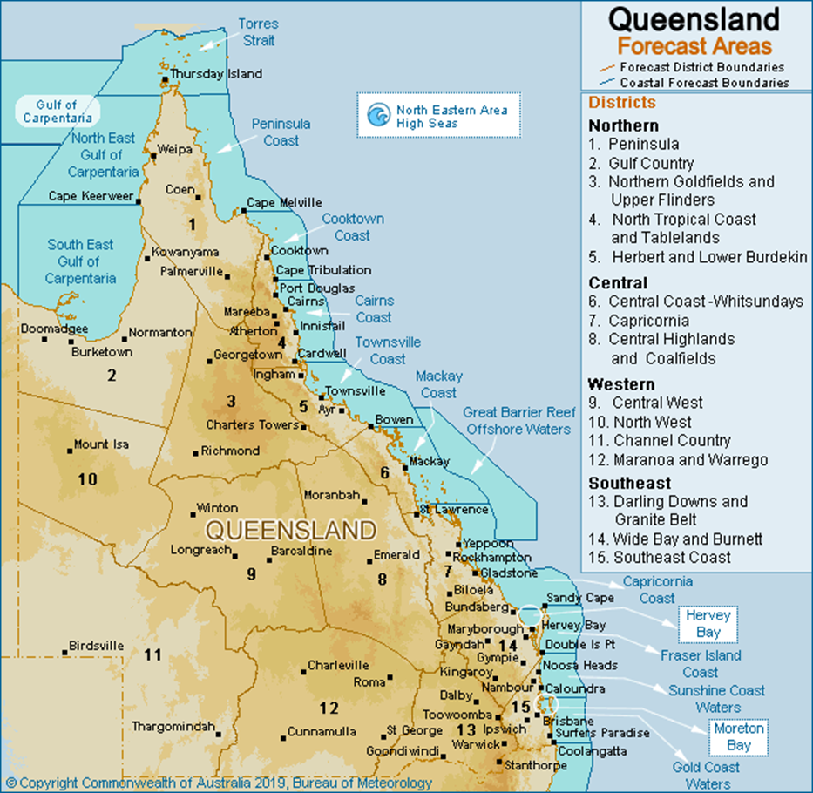
Figure 3: Weather Forecast Districts for Queensland
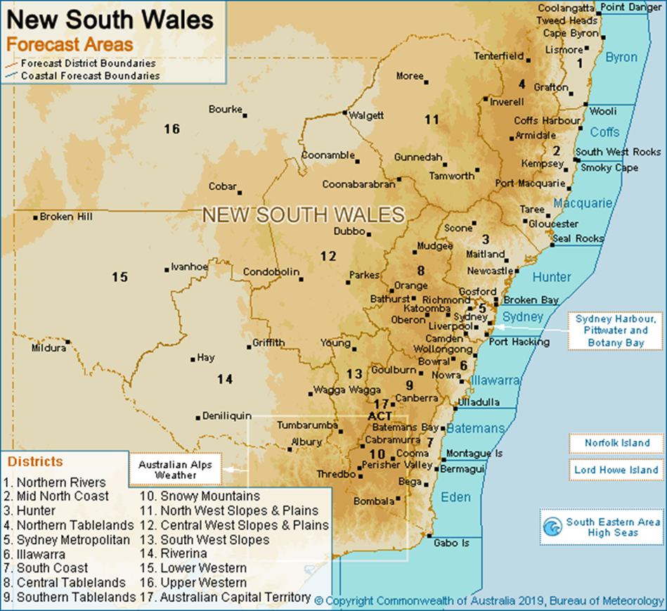
Figure 4: Weather Forecast Districts for New South Wales
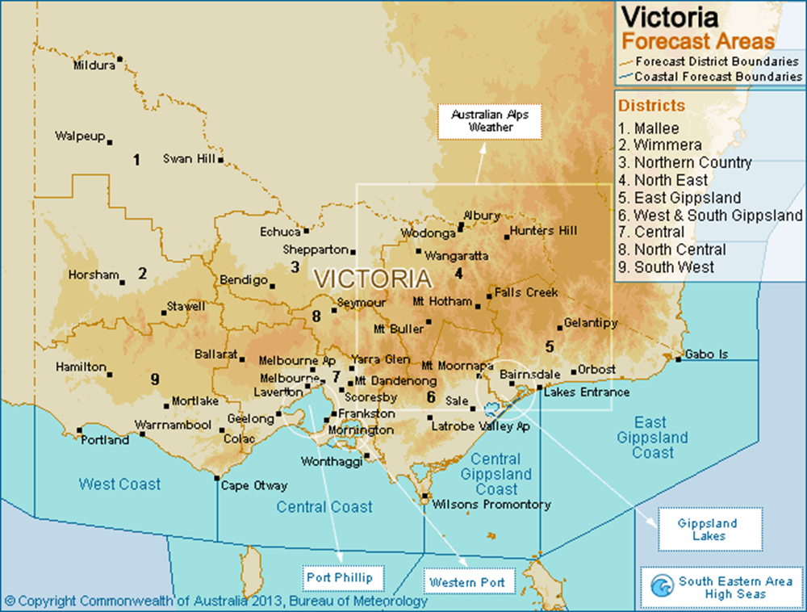
Figure 5: Weather Forecast Districts for Victoria
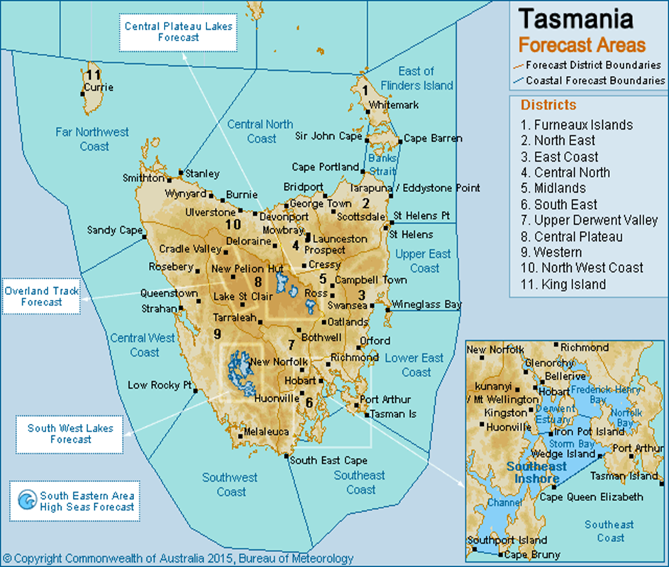
Figure 6: Weather Forecast Districts for Tasmania
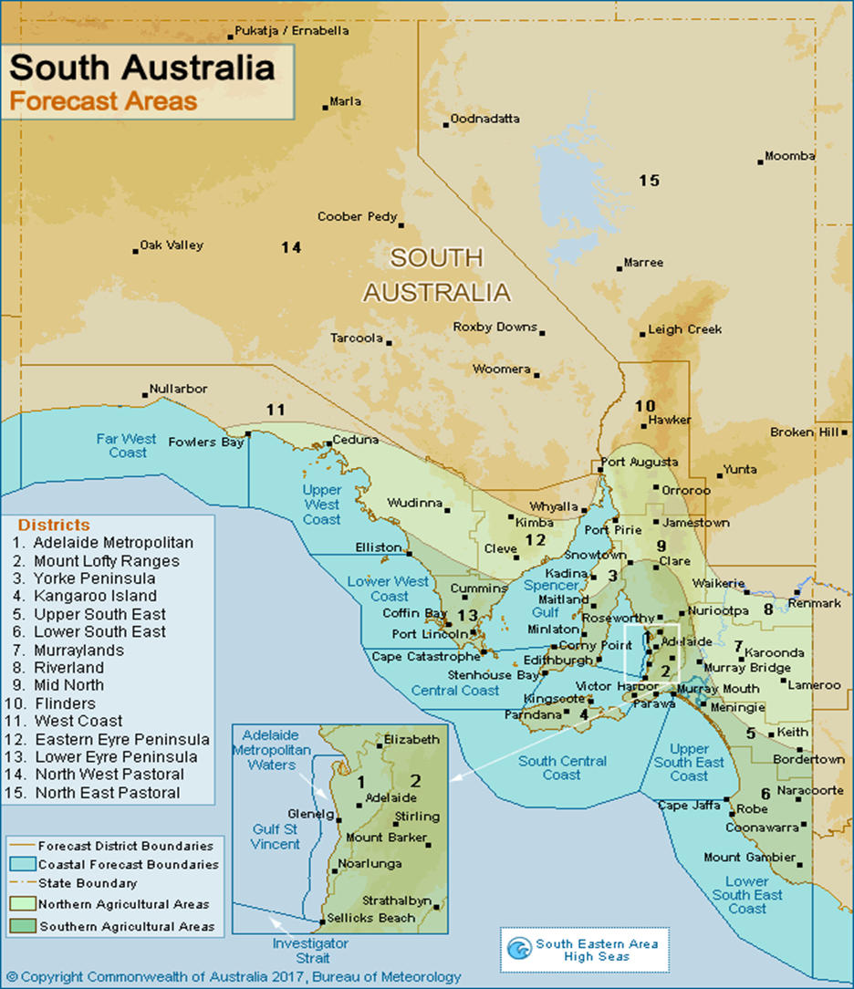
Figure 7: Weather Forecast Districts for South Australia
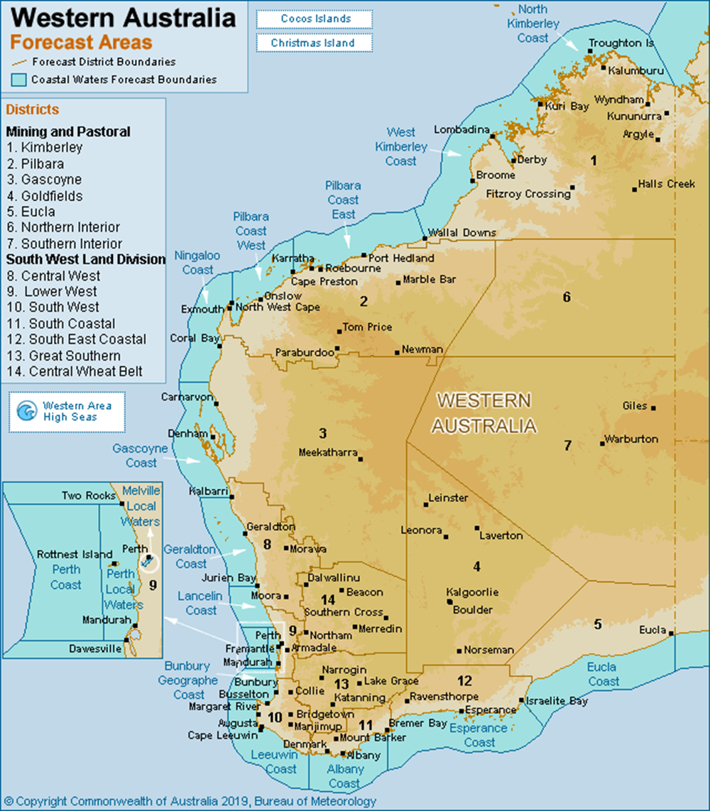
Figure 8: Weather Forecast Districts for Western Australia
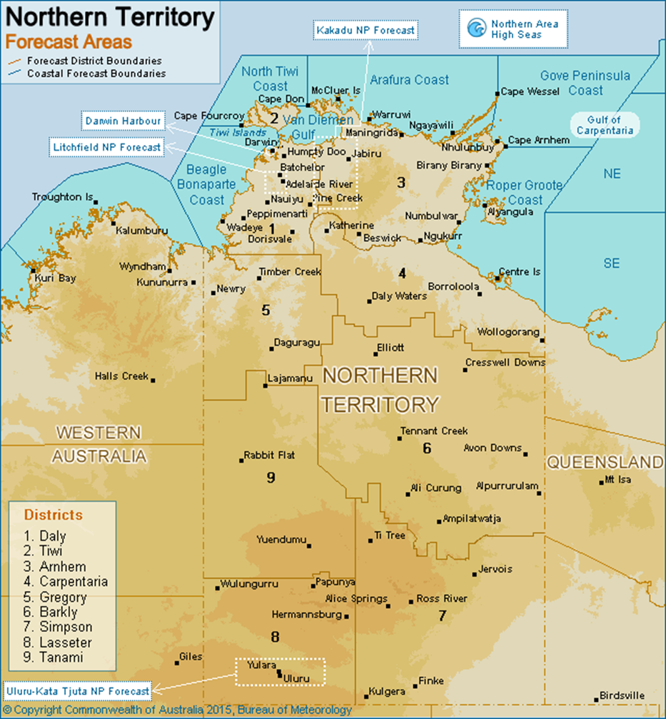
Figure 9: Weather Forecast Districts for Northern Territory
  - Detailed Severe Thunderstorm Warning Domains
Detailed Severe Thunderstorm Warnings are provided for all Australian capital cities and surrounding areas. The domains covered by this service are shown here.
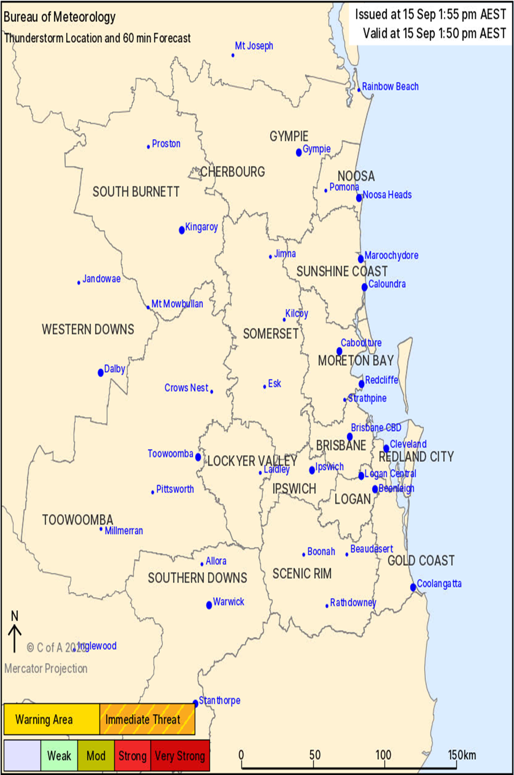
Figure 10: Detailed Severe Thunderstorm Warning domain – Brisbane and Southeast Queensland
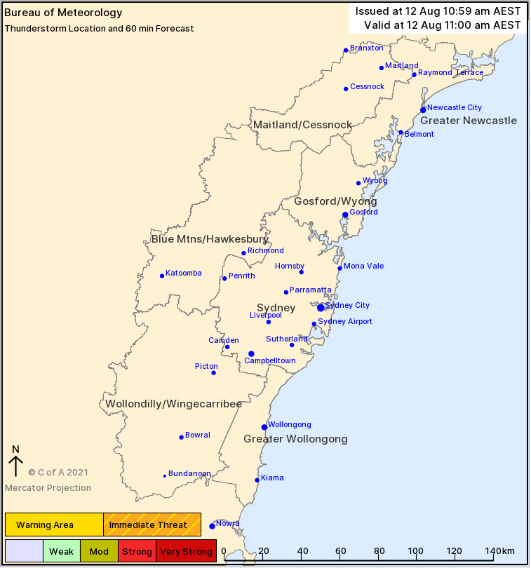
Figure 11: Detailed Severe Thunderstorm Warning domain – Sydney, Newcastle, Wollongong
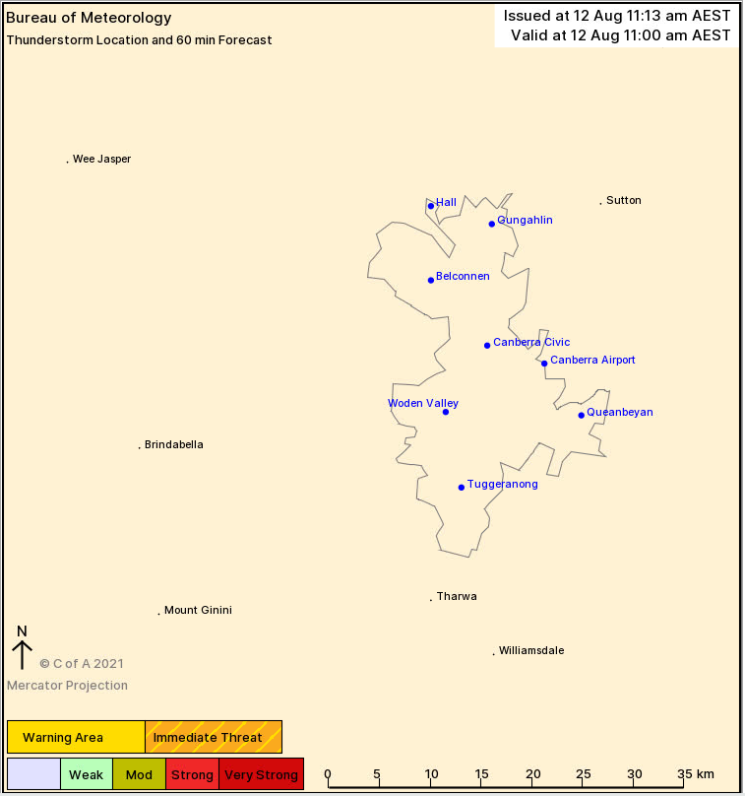
Figure 12: Detailed Severe Thunderstorm Warning domain – Canberra
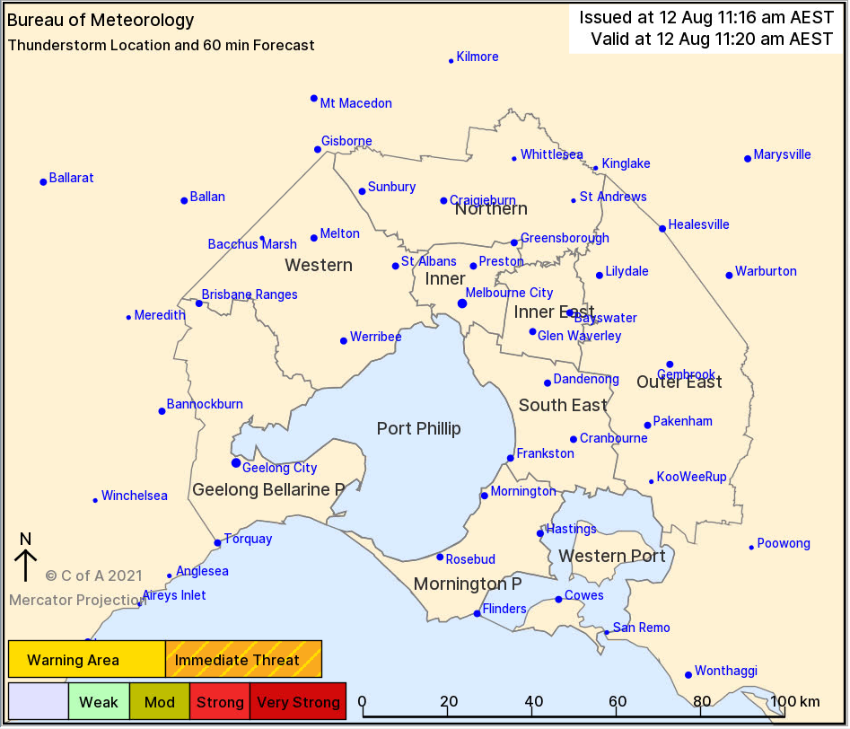
Figure 13: Detailed Severe Thunderstorm Warning domain – Melbourne
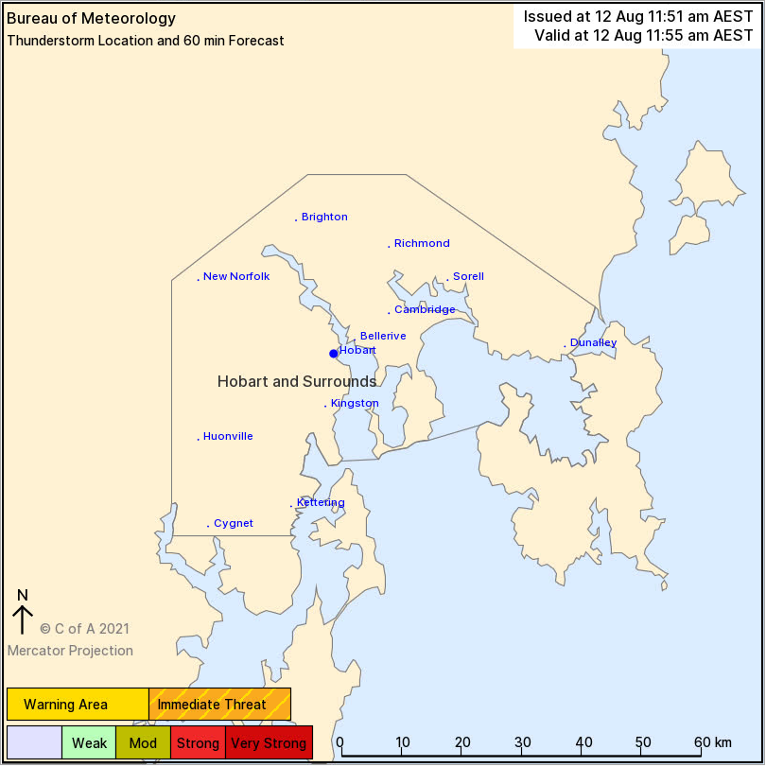
Figure 14: Detailed Severe Thunderstorm Warning domain – Hobart
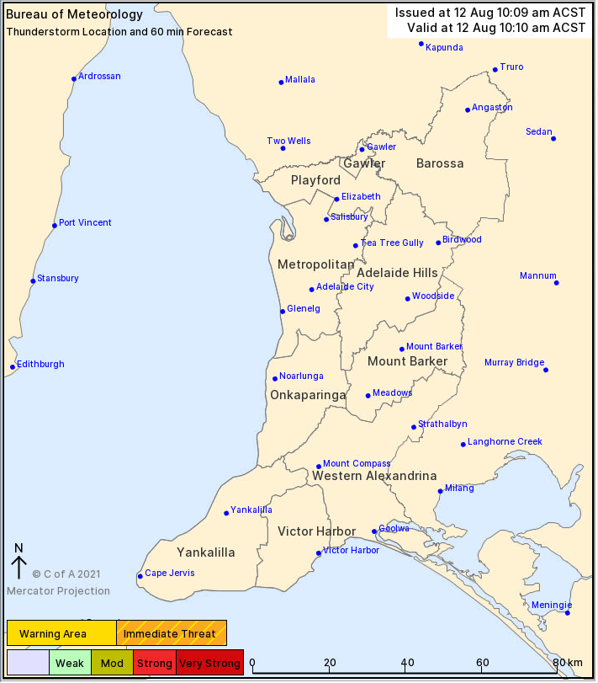
Figure 15: Detailed Severe Thunderstorm Warning domain – Adelaide
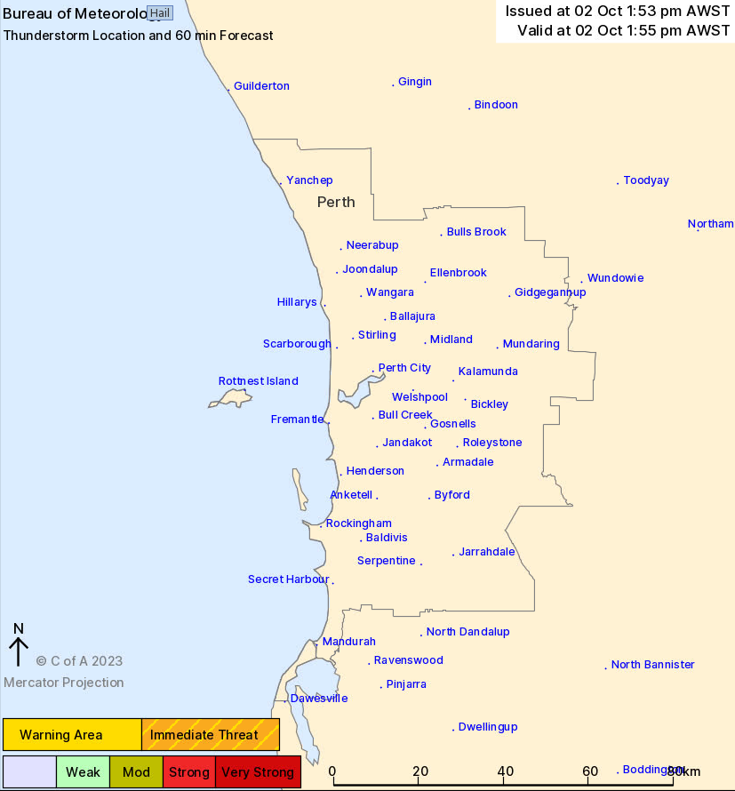
Figure 16: Detailed Severe Thunderstorm Warning domain – Perth
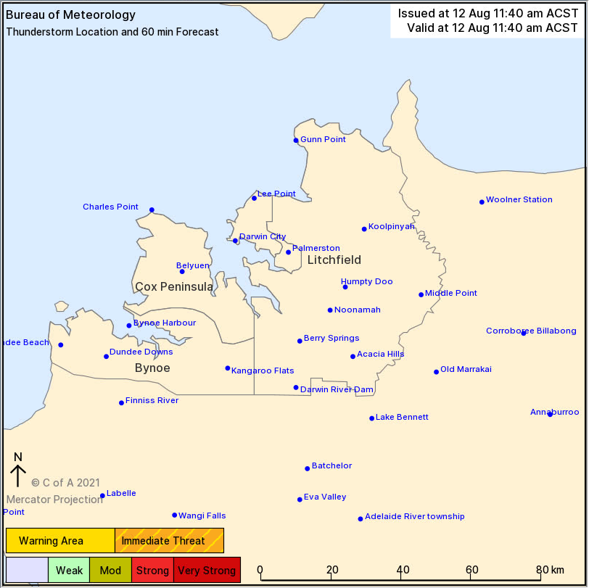
Figure 17: Detailed Severe Thunderstorm Warning domain – Darwin
  - Product Samples
    - Thunderstorm Forecast Map
IDS21032
Australian Government Bureau of Meteorology
South Australia

Day 2 Thunderstorm Forecast
Issued at 11:00am Friday, 30 November 2018,
Valid from midnight tonight until midnight on Saturday, 1 December 2018.

Thunderstorms are possible across SA on Saturday with severe thunderstorms possible across a broad swathe. There is a slight risk of damaging winds from the morning in the west and south. In the afternoon, severe thunderstorms are forecast to develop near the front over the Eyre Peninsula and the North West Peninsula district, moving eastward across central parts late afternoon and evening. Damaging to destructive wind gusts are possible. Large hailstones are also possible, particularly in the severe likely area.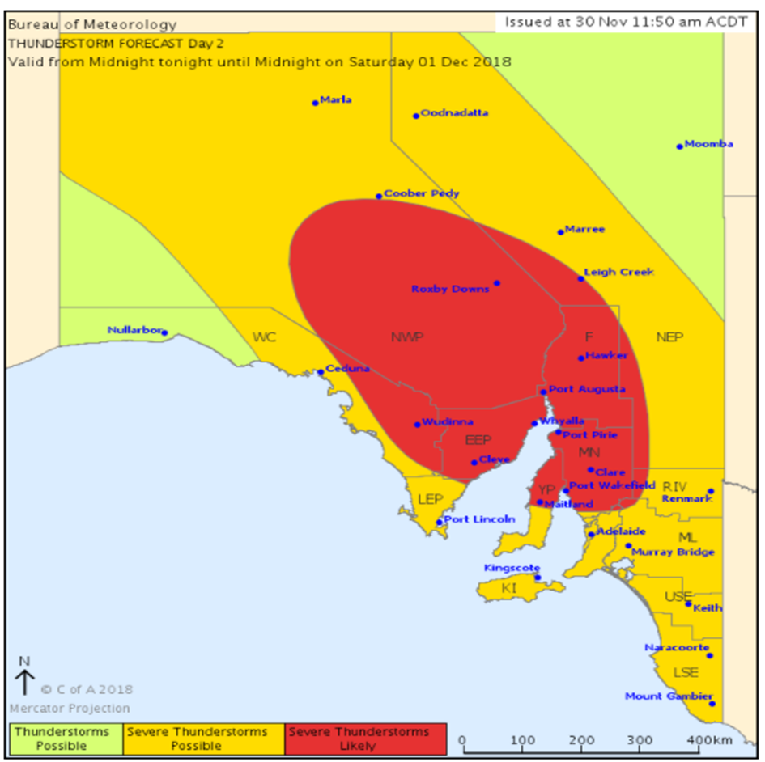
    - Regional Severe Thunderstorm Warning
IDQ21033
Australian Government Bureau of Meteorology
TOP PRIORITY FOR IMMEDIATE BROADCAST
Severe Thunderstorm Warning
for DAMAGING WINDS, LARGE HAILSTONES and HEAVY RAINFALL
For people in Southeast Coast and parts of Wide Bay and Burnett and Darling Downs and Granite Belt Forecast Districts.
Issued at 11:47 am Saturday, 31 October 2020.
Severe thunderstorms forecast to rapidly develop across Southeast Queensland.
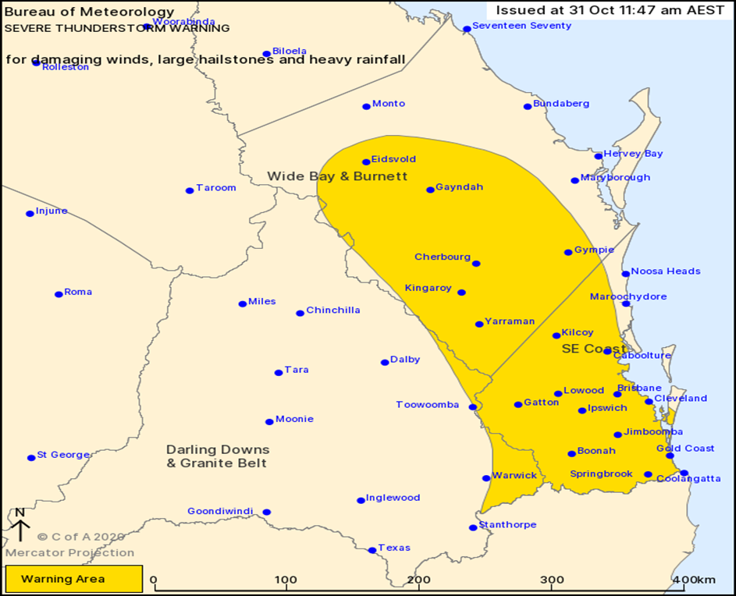

Weather Situation: Severe thunderstorms will rapidly develop over the coming hours with very dangerous thunderstorms with giant hail and destructive winds likely to initiate along the dryline and extend eastward during the afternoon period.
Severe thunderstorms are likely to produce damaging winds, large hailstones and heavy rainfall that may lead to flash flooding in the warning area over the next several hours. Locations which may be affected include Gold Coast, Brisbane, Gympie, Kingaroy, Caboolture, Coolangatta and Ipswich.
Queensland Fire and Emergency Services advises that people should:
* Move your car under cover or away from trees.
* Secure loose outdoor items.
* Never drive, walk or ride through flood waters. If it's flooded, forget it.
* Seek shelter, preferably indoors and never under trees.
* Avoid using the telephone during a thunderstorm.
* Beware of fallen trees and powerlines.
* For emergency assistance contact the SES on 132 500.

The next warning is due to be issued by 2:50 pm.

If severe thunderstorms develop in the Southeast Queensland area (east of Dalby from Rainbow Beach to Stanthorpe), a more detailed Severe Thunderstorm Warning will be issued to people in this area.
Warnings are also available through TV and Radio broadcasts, the Bureau's website at www.bom.gov.au or call 1300 659 210. The Bureau and Queensland Fire and Emergency Services would appreciate warnings being broadcast regularly.
    - Detailed Severe Thunderstorm Warning
DQ21035
Australian Government Bureau of Meteorology
Transmitters serving the area Ipswich, Greenbank, Logan area are REQUESTED TO USE THE STANDARD EMERGENCY WARNING SIGNAL BEFORE BROADCASTING THIS MESSAGE.

TOP PRIORITY FOR IMMEDIATE BROADCAST

Severe Thunderstorm Warning - Southeast Queensland
for DESTRUCTIVE WINDS, GIANT HAILSTONES and HEAVY RAINFALL
For people in Ipswich, Logan and parts of Scenic Rim, Lockyer Valley, Gold Coast, Redland City and Brisbane City Council Areas.
Issued at 1:18 pm Saturday, 31 October 2020.

VERY DANGEROUS STORMS WITH GIANT HAIL LOCATED OVER AND NEAR GATTON AND IPSWICH.

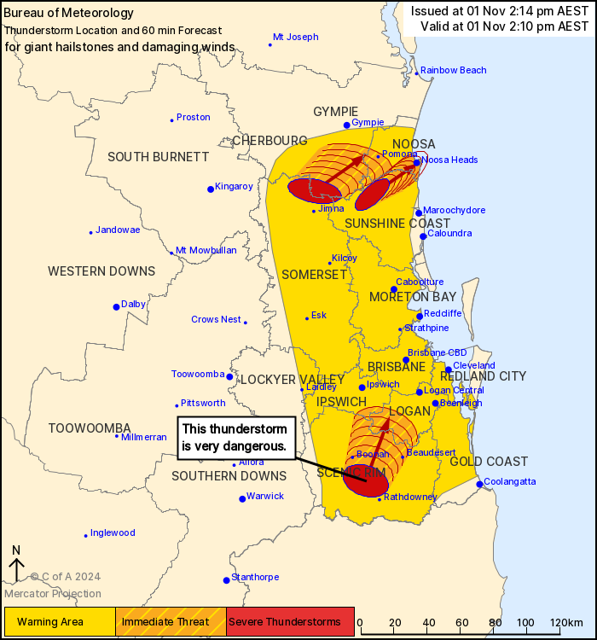

The Bureau of Meteorology warns that, at 1:10 pm, very dangerous thunderstorms were detected on the weather radar near Gatton, Rosewood and Grandchester. These thunderstorms are moving towards the east to southeast. Very dangerous thunderstorms are forecast to affect Laidley, Redbank Plains and Hatton Vale by 1:40 pm and Hope Island, Jimboomba and South Stradbroke Island by 2:10 pm.
Other severe thunderstorms were detected on the weather radar near Crows Nest and Hampton. They are forecast to affect the area southwest of Esk by 1:40 pm and the area south of Esk and the area west of Esk by 2:10 pm.
Damaging, locally destructive winds, large, possibly giant hailstones, and heavy rainfall that may lead to flash flooding are likely.
4-7cm has been observed around Gatton and Adare around 12:30pm
Queensland Fire and Emergency Services advises that people should:
* Move your car under cover or away from trees.
* Secure loose outdoor items.
* Never drive, walk or ride through flood waters. If it's flooded, forget it.
* Seek shelter, preferably indoors and never under trees.
* Beware of fallen trees and powerlines.
* For emergency assistance contact the SES on 132 500.
The next warning is due to be issued by 2:20 pm.
Warnings are also available through TV and Radio broadcasts, the Bureau's website at www.bom.gov.au or call 1300 659 210. The Bureau and Queensland Fire and Emergency Services would appreciate warnings being broadcast regularly.
    - Severe Weather Warning
IDQ21037
Australian Government Bureau of Meteorology
Queensland
TOP PRIORITY FOR IMMEDIATE BROADCAST

Severe Weather Warning
for HEAVY RAINFALL
For people in parts of North Tropical Coast and Tablelands, and Herbert and Lower Burdekin Forecast Districts.
Issued at 1:00 pm Wednesday, 30 January 2019.

HEAVY, LOCALLY INTENSE, RAINFALL CONTINUING ACROSS THE HERBET AND LOWER BURDEKIN.
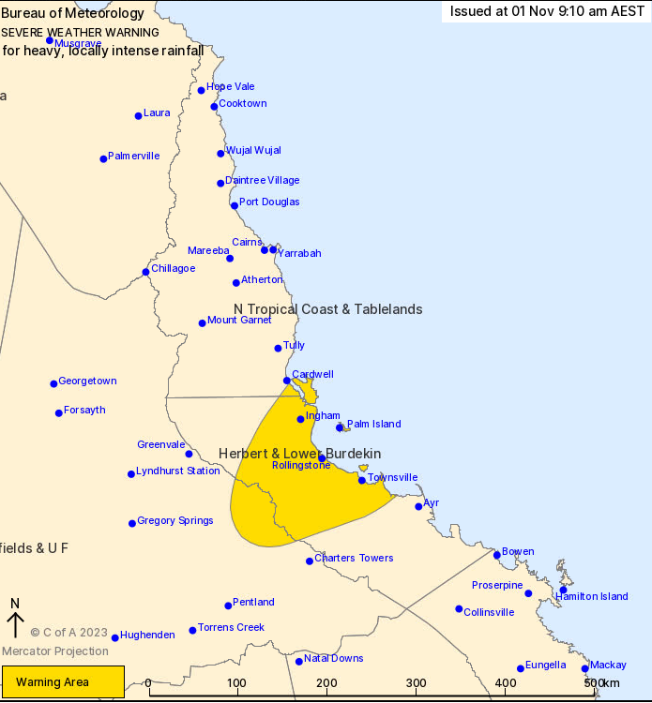

Weather Situation: A convergent zone embedded along the monsoon trough has developed to the west of Townsville, producing a swath of very heavy, locally intense, rainfall across the Herbert and Lower Burdekin district. The convergence zone is expected to remain near-stationary for the remainder of the day.
Heavy rainfall, which is likely to lead to flash flooding, will continue for the remainder of today and into Friday across the warning area. Six-hourly rainfall totals between 150mm to 200mm are likely, with locally intense rainfall totals up to 300mm possible.

Locations which may be affected include Townsville, Palm Island, Ingham, Cardwell, Woodstock and Lucinda.
Rainfall totals between 9am to 1pm on Wednesday:
274mm at Upper Black River
202mm at Blue Water

Queensland Fire and Emergency Services advises that people should:
* Never drive, walk or ride through flood waters. If it's flooded, forget it.
* Keep clear of creeks and storm drains
* For emergency assistance contact the SES on 132 500.

The next Severe Weather Warning will be issued by 5:00 pm AEST Wednesday.

Warnings are also available through TV and Radio broadcasts, the Bureau's website at www.bom.gov.au or call 1300 659 219. The Bureau and Queensland Fire and Emergency Services would appreciate warnings being broadcast regularly.

    - Severe Weather Warning for offshore Islands
IDN28504
Australian Government Bureau of Meteorology
New South Wales
Severe Weather Warning
for DAMAGING SURF
for Lord Howe Island

Issued at 10:54 pm LHST on Thursday 5 August 2021

LARGE AND POWERFUL SURF ON THURSDAY

Weather Situation
Large and powerful southwesterly swell has been generated by a deep complex low pressure system over the southern Tasman Sea and will slowly decrease as the low moves further east.

Damaging surf conditions, with waves exceeding 5 metres in the surf zone, may produce significant beach erosion for southwest facing beaches during Thursday evening and early Friday morning. Surf conditions are expected to ease during Friday morning.

The State Emergency Services advises that people should:
* Check your property regularly for erosion or inundation by sea water, and if necessary, raise goods and electrical items.
* Stay out of the water and stay well away from surf-exposed areas.

For emergency help in floods and storms, ring the Lord Howe Island Police on [02] 6563 2199

The next warning will be issued by 5:00am LHST on Friday 6th August 2021.
  - Product Identifiers
Product ID | Description
New South Wales
IDN21031 | Thunderstorm Forecast Day 1
IDN21032 | Thunderstorm Forecast Day 2
IDN21033 | Regional Severe Thunderstorm Warning
IDN21035 | Detailed Severe Thunderstorm Warning – Sydney, Wollongong, Newcastle
IDN21036 | Detailed Severe Thunderstorm Warning – Canberra
IDN21037 | Severe Weather Warning – 1
IDN21038 | Severe Weather Warning – 2
IDN21137 | Severe Weather Warning – 3
IDN28503 | Severe Weather Warning – Norfolk Island
IDN28504 | Severe Weather Warning – Lord Howe Island
Northern Territory
IDD21031 | Thunderstorm Forecast Day 1
IDD21032 | Thunderstorm Forecast Day 2
IDD21033 | Regional Severe Thunderstorm Warning – 1
IDD21034 | Regional Severe Thunderstorm Warning – 2
IDD21035 | Detailed Severe Thunderstorm Warning – Darwin City and Outer Darwin
IDD21037 | Severe Weather Warning – 1
IDD21038 | Severe Weather Warning – 2
IDD21137 | Severe Weather Warning – 3
Queensland
IDQ21031 | Thunderstorm Forecast Day 1
IDQ21032 | Thunderstorm Forecast Day 2
IDQ21033 | Regional Severe Thunderstorm Warning – 1
IDQ21035 | Detailed Severe Thunderstorm Warning – Southeast Queensland
IDQ21037 | Severe Weather Warning – 1
IDQ21038 | Severe Weather Warning – 2
IDQ21137 | Severe Weather Warning – 3
 | Thunderstorm Tracker – Southeast Queensland
South Australia
IDS21031 | Thunderstorm Forecast Day 1
IDS21032 | Thunderstorm Forecast Day 2
IDS21033 | Regional Severe Thunderstorm Warning – 1
IDS21035 | Detailed Severe Thunderstorm Warning – Adelaide Region
IDS21037 | Severe Weather Warning – 1
IDS21038 | Severe Weather Warning – 2
IDS21137 | Severe Weather Warning – 3
Tasmania
IDV21031 | Thunderstorm Forecast Day 1
IDV21032 | Thunderstorm Forecast Day 2
IDV21033 | Regional Severe Thunderstorm Warning – 1
IDV21035 | Detailed Severe Thunderstorm Warning – Melbourne Area
IDV21037 | Severe Weather Warning – 1
IDV21038 | Severe Weather Warning – 2
IDV21137 | Severe Weather Warning – 3
Victoria
IDV21031 | Thunderstorm Forecast Day 1
IDV21032 | Thunderstorm Forecast Day 2
IDV21033 | Regional Severe Thunderstorm Warning – 1
IDV21035 | Detailed Severe Thunderstorm Warning – Melbourne Area
IDV21037 | Severe Weather Warning – 1
IDV21038 | Severe Weather Warning – 2
IDV21137 | Severe Weather Warning – 3
Western Australia
IDW21031 | Thunderstorm Forecast Day 1
IDW21032 | Thunderstorm Forecast Day 2
IDW21033 | Regional Severe Thunderstorm Warning – 1
IDW21034 | Regional Severe Thunderstorm Warning – 2
IDW21035 | Detailed Severe Thunderstorm Warning – Greater Perth
IDW21037 | Severe Weather Warning – 1
IDW21038 | Severe Weather Warning – 2
IDW21137 | Severe Weather Warning – 3
Table 7: Product Identifiers

- Navigation aids
  - List of figures
Figure 1: Total Warning System 7
Figure 2: Average number of warnings per month across all mainland states and territories of Australia for the 2017-2023 reference period, centered about the warm season 13
Figure 3: Weather Forecast Districts for Queensland 26
Figure 4: Weather Forecast Districts for New South Wales 27
Figure 5: Weather Forecast Districts for Victoria 28
Figure 6: Weather Forecast Districts for Tasmania 29
Figure 7: Weather Forecast Districts for South Australia 30
Figure 8: Weather Forecast Districts for Western Australia 31
Figure 9: Weather Forecast Districts for Northern Territory 32
Figure 10: Detailed Severe Thunderstorm Warning domain – Brisbane and Southeast Queensland 33
Figure 11: Detailed Severe Thunderstorm Warning domain – Sydney, Newcastle, Wollongong 34
Figure 12: Detailed Severe Thunderstorm Warning domain – Canberra 35
Figure 13: Detailed Severe Thunderstorm Warning domain – Melbourne 36
Figure 14: Detailed Severe Thunderstorm Warning domain – Hobart 37
Figure 15: Detailed Severe Thunderstorm Warning domain – Adelaide 38
Figure 16: Detailed Severe Thunderstorm Warning domain – Perth 39
Figure 17: Detailed Severe Thunderstorm Warning domain – Darwin 40
  - List of tables
Table 1: Bureau of Meteorology Thunderstorm and Severe Weather SLS distribution list by jurisdiction 9
Table 2: Phenomena definitions associated with severe thunderstorms 11
Table 3: Phenomena definitions associated with severe weather 12
Table 4: The seasonal coverage and local issue times for the thunderstorm forecasts for each state and mainland territory. 17
Table 5: Definition and shading of polygon categories on the thunderstorm forecast 17
Table 6: Coastal hazard phenomena definitions 25
Table 7: Product Identifiers 49

https://knowledge.aidr.org.au/media/5972/warnings-handbook.pdf, pg. 10
The Annual Exceedance Probability (AEP) is the probability that a rainfall amount over a given period will be exceeded in any one year. The Design Rainfall Data System (2016) provides the national datasets for 10% and 2% AEP thresholds used in Bureau services.

