Tropical Cyclone Service Level Specification


Revision history
Date | Version | Author | Description
29/09/2025 | V7.0 | Adam Conroy | - Removed Australian Tropical Cyclone Seasonal Outlook  - Addition of Tropical Cyclone Statistical Ensemble Tracks  - Addition of Cancellation polygons to the Real-Time Event Data product  - Update frequency of Tropical Climate Note updated to fortnightly  - Updated Storm Tide hazard statement in TC Advice example.  - Replaced Queensland Fire and Emergency Service (QFES) with Queensland Police Service (QPS)  - Added and removed some product identifiers  - Broken links fixed
1/11/2024 | V6.0 | Adam Conroy | - Fixed issue times on Storm Tide Advice example  - Added time zones for Lord Howe Island and Norfolk Island  - Updated 'Tropical Cyclone Forecast' description to align with service changes  - Change to criteria for inclusion of SEWS on a TC Advice  - Change to TC Outlook description to remove probabilities
18/12/2023 | V5.0 | Craig Earl-Spurr  Adam Conroy | - Updated Area of Responsibility  - Replaced Tropical Cyclone Outlook with Tropical Cyclone Forecast  - Added Real-Time Event Data  - Changes to Storm Tide Advice products  - Changes to requirements for Solomon Islands Advisory  - Updated broken hyperlinks
4/10/2022 | v4.0 | Vikash Prasad  Craig Earl-Spurr | - Removed Special Advisory for Timor Leste  - 5.2.3 – TC Track Map – changed the "Cone of uncertainty" to "Forecast Confidence Cone"  - Appendix 3 – remove products that are internal, fax and SIMS despatch bundles
24/12/2021 | v3.0 | Andrew Burton | - 2021/22 release  - Added TC Wind Hazard Forecast service  - Minor changes to issue criteria for Satellite Analysis Bulletins
23/12/2020 | v2.0 | Andrew Burton | - 2020/21 release  - Storm tide appendix updated by Andy Taylor
25/8/2020 | v1.1 | Craig Earl-Spurr  David Grant | - PST change statement included in 2.1.1  - Figure 2 replaced  - Reworded 3.4 around post-tropical cyclones  - SEWS description included in 3.7  - Briefing services added in 3.9  - Included update on landfall process in 5.2.2  - Addition of three Qld storm tide forecast locations  - TCA section in 6.3 revised to align with ASH  - TCWC naming convention change included in product examples.  - Changed the remarks section in the Ocean Wind Warning  - Reference to ATCAG included in section 4
30/7/2019 | v1.0 | Vikash Prasad  Robyn Duell | 30 July 2019  - removed 41-knot rule (6 Aug 2019)  - Standard Operating Procedures (SOP) content removed  13 Aug 2019  - Table of Contents decided  - Product Schedule created  - Merged contents from the Qld Storm Tide Handbook  27 Aug 2019  - Replaced W, N and E Regions with Australian TCWC  - Copied Product Samples from 2018-19 directives.  23 September 2019  - Moved samples to appendix, reviewed category and naming sections. Included time zone and conversions.  30 October 2019  - Dissemination and Communication and Adoption sections added

Review status
Date | Version | Reviewer | Description
26 Sept 2025 | 7.0 | Evan Morgan | Annual review
20 Nov 2024 | 6.0 | Evan Morgan | Annual review
11 Jan 2024 | 5.0 | Evan Morgan | Annual review
22 Nov 2022 | 4.0 | Evan Morgan | Annual review
16 Dec 2021 | 3.0 | Evan Morgan | Annual review
9 Dec 2020 | 2.0 | Evan Morgan | Annual review

Release history
Date | Version | Status | Approval
Sept 2025 | 7.0 | Official | GM_EPS
Nov 2024 | 6.0 | Official | GM_EPS
Feb 2024 | 5.0 | Official | GM_EPS
24 Nov 2022 | 4.0 | Official | GM_EPS
24 Dec 2021 | 3.0 | Official | GM_EPS
23 Dec 2020 | 2.0 | Official | GM_EPS

Unless otherwise noted, all images in this document are licensed under the Creative Commons Attribution Australia Licence.
© Commonwealth of Australia 2025
Published by the Australian Bureau of Meteorology

Table of contents
1. Introduction 8
1.1. Purpose 8
1.2. Scope 9
1.3. Authority 9
2. International Tropical Cyclone services 9
2.1. World Meteorological Organization Tropical Cyclone Programme 9
2.1.1. Region V Tropical Cyclone Committee 10
2.1.2. Region I Tropical Cyclone Committee 10
3. National Tropical Cyclone Services 13
3.1. Tropical Cyclone Season 13
3.2. Area of Responsibility 13
3.3. Tropical Cyclone Definition 14
3.4. Extra-tropical and sub-tropical cyclones 14
3.5. Tropical Cyclone Naming Policy 15
3.6. Tropical Cyclone Categories 15
3.7. Standard Emergency Warning Signal (SEWS) 16
3.8. Dissemination of products 17
3.9. Briefing Services 17
3.10. Communication and adoption activities 17
3.11. Service Continuity 17
4. Quality Assurance and Performance 18
4.1. Australian Tropical Cyclone Advisory Group 18
4.2. Best Tracking 18
4.3. Performance Statistics and Reporting 18
4.4. Post Event Review 18
4.5. Forecaster Training and Competency 18
5. National Tropical Cyclone Product Schedule 20
5.1. Routine Services 20
5.1.1. Tropical Climate Note 20
5.1.2. Tropical Cyclone Forecast 20
5.2. Tropical Cyclone Wind Hazard Forecast 21
5.3. Non-Routine Services 22
5.3.1. Tropical Cyclone Information Bulletin 22
5.3.2. Tropical Cyclone Advice 23
5.3.3. Tropical Cyclone Forecast Track Map 25
5.3.4. Tropical Cyclone Technical Bulletin 27
5.3.5. Storm Tide Advice 28
5.3.6. Tropical Cyclone Real-Time Event Data 29
5.3.7. Tropical Cyclone Statistical Ensemble Tracks 30
5.3.8. CAP Tropical Cyclone Advice 31
5.3.9. GML Track 32
6. International Tropical Cyclone Product Schedule 33
6.1. Ocean Wind Warning 33
6.2. CREX Bulletin 34
6.3. Tropical Cyclone Advisory (Aviation) 35
6.4. Satellite Analysis Bulletin 37
6.5. Special Advisory for the Solomon Islands 38
7. Appendix 1: Storm Tide Advice Locations 41
7.1. Storm Tide Advice location list 41
7.2. Storm Tide Advice location maps 44
7.3. Interpretation of advice content 56
7.3.1. Communication risks association with vertical datums 56
7.3.2. Forecaster mediation of numerical model data 57
7.3.3. Importance of tidal range 57
7.3.4. Tidal plane comparison graph 57
7.3.5. Highlighted locations with mismatched tidal plane data 58
7.3.6. Highlighted locations with no standard tide table 63
8. Appendix 2: Product Samples 65
8.1. Tropical Cyclone Forecast 65
8.2. Tropical Cyclone Wind Hazard Forecast 67
8.3. Tropical Cyclone Information Bulletin 68
8.4. Tropical Cyclone Advice 69
8.5. Tropical Cyclone Forecast Track Map 71
8.6. Tropical Cyclone Technical Bulletin 73
8.7. Storm Tide Advice 74
8.8. Graphical Storm Tide Advice 77
8.9. Ocean Wind Warning 78
8.10. CREX Bulletin 80
8.11. Satellite Analysis Bulletin 81
8.12. Special Advisory for the Solomon Islands 82
9. Appendix 3: Product Identifiers 83
10. Navigation aids 93
10.1. List of figures 93
10.2. List of tables 93

- Introduction
  - Purpose
The purpose of the Service Level Specification (SLS) is to document the tropical cyclone forecast and warning services provided by the Bureau of Meteorology (the Bureau).

The Total Warning System recognises that a fully effective warning service is multi-faceted in nature and its development and operation involves input from several agencies each with specialised roles to play. It is vital that the agencies involved work in close cooperation through all stages of developing and operating the system. The services described here are the Bureau’s contribution to the Total Warning System for tropical cyclones.
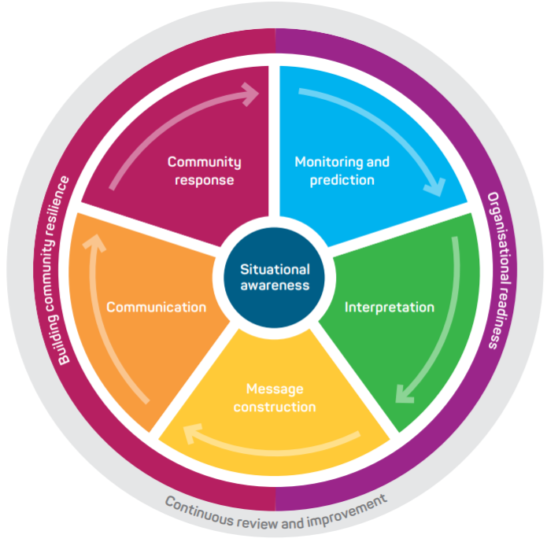
Figure 1 Total Warning System

The Bureau’s role in the tropical cyclone warning system is focussed on monitoring and prediction, message construction and communicating threats and impacts associated with tropical cyclones to Government, industry and the community.
The Bureau also contributes to activities designed to strengthen organisational readiness and build community resilience and participates in the planning and coordination of activities with disaster mitigation agencies.
  - Scope
The scope of the SLS is the Bureau's publicly available tropical cyclone services within the Australian Region (Figure 2) and a limited number of additional services provided to support emergency management, aviation, and meteorological services in neighbouring countries.
The SLS details what the Bureau does and when it does it, in order to provide tropical cyclone services. How the Bureau produces tropical cyclone services is addressed in an internal Bureau document National Tropical Cyclone Standard Operating Procedures (SOP).
  - Authority
The Bureau of Meteorology Tropical Cyclone Service Level Specification is issued by the General Manager Environmental Prediction Services under the authority of the Director of Meteorology.

- International Tropical Cyclone services
  - World Meteorological Organization Tropical Cyclone Programme
The Tropical Cyclone Programme (TCP) is run out of the World Meteorological Organization's (WMO's) Weather and Disaster Risk Reduction Services Department. This department is tasked with establishing national and regional coordinated systems to ensure that the loss of life and damage caused by tropical cyclones globally are reduced to a minimum.
The programme is implemented on both national and regional levels through cooperative action. It covers activities of Members, WMO regional associations, other international and regional bodies and the WMO Secretariat.
Australia is member of the WMO Regional Association V (RA V), which covers the South Pacific and South East Indian Ocean. Within RA V, international tropical cyclone warning services are coordinated through the RA V Tropical Cyclone Committee (RA V TCC).
    - Region V Tropical Cyclone Committee
The Region Association V Tropical Cyclone Committee (RA V TCC) has an operational plan which describes the agreed upon existing internationally coordinated systems and arrangements.
The committee currently meets every year with representatives invited from both WMO and non WMO member nations in the region.
Within the RA V area, there are five Tropical Cyclone Warning Centres (TCWC's) which are responsible for continuous monitoring of tropical cyclones and the issuing of forecasts, warnings, advisories and bulletins to the general population and for international marine and aviation sector. These are Regional Specialised Meteorological Centre (RSMC) Nadi, and TCWCs Melbourne, Jakarta, Port Moresby, and Wellington. The area of responsibility for each of these centres is shown in Figure 2.
The Bureau has a responsibility to provide the following tropical cyclone related services for the international community in its area of responsibility (see Figure 3 and Table 2):
- Ocean Wind Warning (Shipping)
- Tropical Cyclone Advisory (Aviation)
- SIGMET (Aviation)
- CREX Bulletin
The Bureau also provides guidance and tropical cyclone products to neighbouring TCWC's and RSMC's to ensure the maintenance of a satisfactory tropical cyclone monitoring and warning service from the Central Indian Ocean to Central Pacific Ocean, south of the Equator. These products include:
- Satellite Analysis Bulletin
- Special Advisory for the Solomon Islands
Within the RAV-TCC Operational Plan, procedures for maintaining tropical cyclone surveillance and issue of warnings are described for the instance where one of the TCWCs is, for any reason, unable to meet its responsibility.
    - Region I Tropical Cyclone Committee
The Region I Tropical Cyclone Committee (RAI-TCC) for Southwest Indian Ocean also has an operational plan that deals with warning service arrangements in their Region. An Australian representative occasionally attends the RAI-TCC meetings to ensure liaison processes for tropical weather systems near 90°E are up-to-date and understood by all National Meteorological and Hydrological Services (NMHSs) in the region.

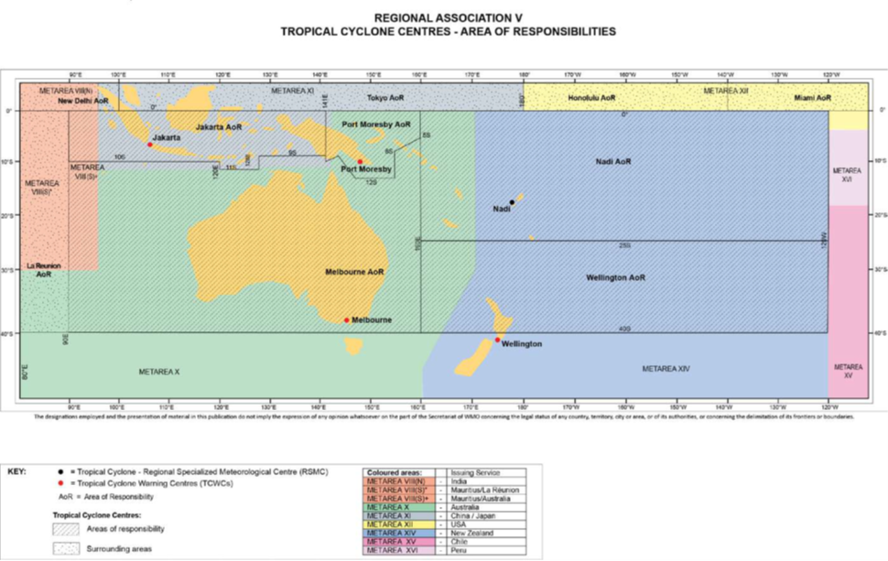
Figure 2 Tropical Cyclone Warning Centre areas of responsibility (AoR) in the South Pacific and South East Indian Ocean

- National Tropical Cyclone Services
The Bureau's tropical cyclone warning service provides the Australian community and other users (e.g., aviation and marine) with essential tropical cyclone warnings that are timely and accurate.
To do this, the Bureau has partnerships with emergency management organisations, other government authorities, media, and industry in tropical cyclone prone areas to ensure that warnings are fit-for-purpose and are broadly distributed in a timely manner.
The tropical cyclone warning service is designed to alert the community and counter-disaster organisations to impending tropical cyclone threats, and to provide advice and warnings until the threat has passed. An important secondary role is to assist local media and state or territory emergency services with public education programs, and to advise on meteorological aspects of tropical cyclone disaster preparedness and planning.
  - Tropical Cyclone Season
The Australian tropical cyclone season is defined as the period from 1 November to 30 April, inclusive. Tropical cyclones can occur outside this period and in such an event the Bureau will issue tropical cyclone products as would normally occur within the cyclone season.
  - Area of Responsibility
The Bureau is responsible for the issue of all warnings and related advices and information for tropical cyclones affecting the Australian area of responsibility (AoR) (See Table 1 and Figure 3). This includes the offshore territories of Cocos (Keeling) Islands, Christmas Island and Lord Howe Island. Tropical Cyclone Advices will also be issued by the Bureau for Norfolk Island. Storm Tide Advices are only issued for the Australian mainland.
For Tropical Cyclone Advisories issued to aviation the AoR extends north to the equator between 90°E and 160°E, covering the Jakarta AoR and Port Moresby AoR (see Figure 5).

Table 1 Australian area of responsibility
Area of responsibility | Area bounded by
Australian | 10°S 90°E, 10°S 120°E, 11°S 120°E, 11°S 128°E, 9°S 128°E, 9°S 141°E, 10°S 141°E, 9°S 144°E, 12°S 147°E, 12°S 155°E, 8°S 155°E, 5°S 160°E, 40°S 160°E, 40°S 90°E and 10°S 90°E

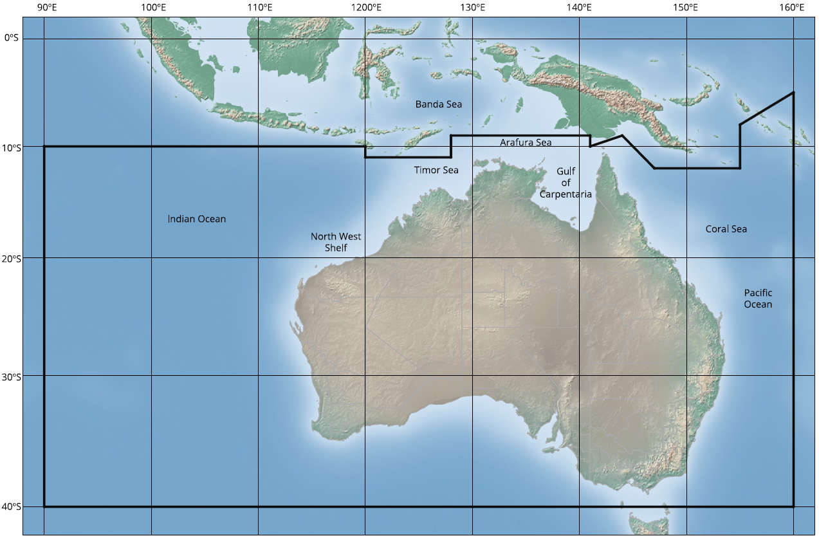
Figure 3 Australian area of responsibility for providing tropical cyclone services
  - Tropical Cyclone Definition
A tropical cyclone is defined as a warm-cored, non-frontal low-pressure system of synoptic scale developing over warm waters having organised convection and a maximum mean wind speed of 34 knots or 63 km/h (10-minute mean) or greater extending more than halfway around near the centre and persisting for at least six hours.
  - Extra-tropical and sub-tropical cyclones
Tropical cyclones can transition into an extra-tropical or sub-tropical cyclone as they move southwards out of the tropics. As a system undergoes this transition it can maintain an intensity equivalent to that of a tropical cyclone, or even further intensify.

  - Tropical Cyclone Naming Policy
The Bureau allocates tropical cyclone names, taken in order, from the list found here, until the list is exhausted, whereupon the sequence will be repeated.
The following policy is adhered to:
- Australian tropical cyclone names in each list alternate male and female. The exception occurs at the end of the list, with the last name being used for either gender.
- If a cyclone named by an adjacent WMO Region moves into the Australian area of responsibility, the existing name shall be retained.
- If a cyclone has a significant impact on coastal or island communities, the name assigned to it will be permanently retired and another name substituted in the list. Names are not officially added to the list until ratified by the RAV-TCC.
- RAI-TCC also ratify proposed additions to the list of names, as they retain the names of tropical cyclones that move from the Australian AoR into the southwest Indian Ocean (west of 90°E).
- If an upcoming name is not considered appropriate for use at the time, the Bureau may decide to use an alternate name from the list. This rarely occurs.
  - Tropical Cyclone Categories
Tropical cyclone intensity is an estimate of the maximum wind speed, at 10 m above the surface, averaged over a period of 10 minutes, occurring within the storm and not associated with phenomena on a scale significantly smaller than the cyclone's core circulation.
Tropical cyclones are categorised based on intensity, with Category 1 being the weakest and Category 5 the most intense. Category 3, 4 and 5 cyclones are given the appellation "Severe Tropical Cyclone". Severe Tropical Cyclones are equivalent in intensity to typhoons (North West Pacific) and hurricanes (Atlantic).
Although cyclone intensity is defined by the 10-minute wind, public messaging focuses on an indicative 3-second gust value as infrastructure damage is more closely related to the gust value. Expected wind gusts over land are assumed to be about 40% greater than the 10-minute mean wind. Table 2 shows how the maximum 10-minute surface wind relates to the cyclone category, status and the strongest gust that can be expected.
Table 2 Tropical Cyclone Category, Status and Wind Strength
Category | Status | 10-Minute Mean Wind (km/h)  (knots) | Indicative Maximum 3-Second Gust  (km/h)
1 | Tropical Cyclone | 63–88  (34-47) | 90–124
2 | Tropical Cyclone | 89–117  (48–63) | 125–164
3 | Severe Tropical Cyclone | 118–159  (64–85) | 165–224
4 | Severe Tropical Cyclone | 160–199  (86–107) | 225–279
5 | Severe Tropical Cyclone | ≥200  (≥108) | ≥280

  - Standard Emergency Warning Signal (SEWS)
The standard criteria for authorisation of the use of Standard Emergency Warning Signal (SEWS) is when any of the following conditions are expected within 12 hours:
- Wind gusts > 125 km/h, i.e., ‘destructive’ winds (Category 2 or higher)
- Storm tide > 0.5 m above HAT (discretion can be applied if there is a significant threat to areas below 0.5 m above HAT)
If intense rainfall (1–6-hour rainfall total exceeding the 2% Annual Exceedance Probability Threshold) is occurring near the centre of the tropical low or cyclone, and the SEWS criteria for wind gusts and/or storm tide are not being met, then authorisation for the use of SEWS may be added to the Tropical Cyclone Advice.
The SEWS may also be authorised outside the range of these criteria, at the request of the primary hazard management agency for tropical cyclone in the affected jurisdiction.
The following statement is included at the beginning of the Tropical Cyclone Advice when a SEWS is issued:
"Media: Transmitters serving the area ........ to ........ are requested to sound the Standard Emergency Warning Signal before broadcasting the following warning."
When the SEWS is not required the following statement will be included at the beginning of the Tropical Cyclone Advice:
"Media: The Standard Emergency Warning Signal should NOT be used with this warning."
  - Dissemination of products
Bureau tropical cyclone products – including all outlooks, advices, warnings, technical bulletins and machine-readable products – are transmitted via the Bureau's website and app and by email and FTP to registered users. Tropical cyclone warnings and advisories relevant to marine users are also provided through HF voice radio and satellite communications.
  - Briefing Services
The Bureau will provide briefings to Emergency Management partners in areas under threat from an approaching or developing tropical cyclone. The format, timing and frequency of briefings will be agreed through state and territory-based arrangements.
  - Communication and adoption activities
In addition to the issuing of products through standard communication channels (e.g., website, app, email), the Bureau undertakes a range of complementary communication and adoption activities in partnership with emergency management agencies. These activities are aimed to increase the uptake and effectiveness of the forecasts and warnings and ensure consistent weather safety messages are provided to the community.
This includes pre-season community and industry preparedness briefings, social media campaigns and the Bureau's Tropical cyclone knowledge centre web pages. During the season this extends to joint press conferences and media interviews, as well as continuing social media public safety campaigns and community and industry briefings.
  - Service Continuity
The Bureau maintains service continuity through its business continuity plans. Most pertinent to tropical cyclone services is the built-in redundancy of being able to deliver all the services mentioned in this document from several offices, primarily the Bureau's Perth and Brisbane offices. This includes the ability to transfer operations between offices as required.
To maintain service continuity, the Bureau uses a large and diverse range of observational and forecast data in the delivery of its tropical cyclone services. This provides redundancy if any data source is unavailable during operations and ensures all products and services are based on the best available information at the time.

- Quality Assurance and Performance
  - Australian Tropical Cyclone Advisory Group
The Australian Tropical Cyclone Advisory Group (ATCAG) supports tropical cyclone Hazard Management Agencies (HMAs) across northern Australia (primarily the Western Australia Department of Fire and Emergency Services (DFES), Northern Territory Emergency Services (NTES) and Queensland Police Service (QPS) and the Bureau of Meteorology (BoM), in mitigating the hazards caused by tropical cyclones.
ATCAG provides a forum to coordinate public education, services and warning processes across the primary HMAs, the Bureau and emergency broadcasters such as ABC Emergency.
  - Best Tracking
Quality assurance for tropical cyclone services is underpinned by a verification process that involves re-analysing the track, structure and intensity of each tropical cyclone after the event. The re-analysis process leverages all available data (some of which may not have been available during operations) to create a "Best Track" that is treated as an observational record against which forecast accuracy can be assessed.
In addition to generating a Best Track, a report is written for each tropical cyclone detailing the life cycle, warning performance and impacts.
Best Tracks are uploaded to the national Tropical Cyclone database, which is available as a .csv file for downloading.
The tropical cyclone database (Best Tracks) and individual cyclone reports are available on the Bureau website here: http://www.bom.gov.au/cyclone/tropical-cyclone-knowledge-centre/history/.
  - Performance Statistics and Reporting
All official forecast tropical cyclone locations and intensities are verified against the Best Track.
  - Post Event Review
The Bureau conducts an internal review after every tropical cyclone event that has had a significant community or operational impact and documents and tracks the insights and recommendations that arise.
Depending on the impact from a cyclone, the review process may include a debrief with external partners. Upon request, the Bureau also contributes to post incident reviews conducted by emergency services.
  - Forecaster Training and Competency
The Bureau runs a tropical cyclone training and competency-based assessment program for meteorologists. This program ensures that staff involved in analysing and forecasting tropical cyclones have the qualifications, training and demonstrated ability to provide a high standard of tropical cyclone warning service to the Australian community.
- National Tropical Cyclone Product Schedule
Standard issue times of products (e.g., Warnings, Advices, Bulletins) are provided in Coordinated Universal Time (UTC). Table 3 shows how to convert UTC to local time in different Australian time zones.
Table 3 Time Zone Conversions
Time zone | Conversion from UTC
Cocos Islands Time (CCT) | +6:30
Christmas Island Time (CXT) | +7:00
Australian Western Standard Time (AWST) | +8:00
Australian Central Standard Time (ACST) | +9:30
Australian Eastern Standard Time (AEST) | +10:00
Lord Howe Standard Time (LHST) | +10:30
Australian Eastern Daylight Time (AEDT) | +11:00
Lord Howe Daylight Time (LHDT) | +11:00
Norfolk Standard Time (NFST) | +11:00
Norfolk Daylight Time (NFDT) | +12:00

  - Routine Services
    - Tropical Climate Note
The Tropical Climate Note, issued fortnightly on Tuesdays, describes current conditions in the tropical Indian and Pacific oceans and summarises model forecasts for the coming weeks. When models indicate the risk of tropical cyclone development is higher, or lower than normal in the Australian region it is highlighted in the note. The Tropical Climate Note is available on the web at http://www.bom.gov.au/climate/tropical-note/.

    - Tropical Cyclone Forecast

Purpose
The Tropical Cyclone Forecast provides status and development potential of any tropical lows expected to develop or move into the Australian area of responsibility over the next 7 days. It is a graphical and interactive web-based display with quantitative probabilistic assessments of tropical cyclone development potential for individual tropical systems at 12-hourly intervals. A map shows the likely location of the centre of each individual tropical system at each of these 12-hourly intervals.

Issue Times
The Tropical Cyclone Forecast is available all year round via the Bureau external web page at http://www.bom.gov.au/cyclone/7dayforecast. It is updated whenever the Real-Time Event Data product is issued, which is at a minimum twice a day whenever there is a tropical system of interest.

Content
For each tropical system:
- Tropical system identifier, including tropical cyclone name if applicable.
- Forecast Confidence Areas (FCAs) of tropical system at 12-hourly timesteps out to 7 days. The 'likely' FCA is displayed at each timestep of the forecast, and there is a 50% chance of the centre of the system being located within this FCA. An additional 'possible' FCA is displayed within the first 3 days – the chance of the centre being located within the combination of the 'likely' and 'possible' FCAs is 70%.
- Categorical and percentage likelihood of the system being a tropical cyclone for each 12-hour timestep, with the following probability categories:
    - Very Low: 5% or less
    - Low: 5-20%
    - Moderate: 20-50%
    - High: 50% or more
- Tabular summary of each system and its likelihood of being a tropical cyclone.
- Brief worded details of each tropical system.

For further information on the Tropical Cyclone Forecast see http://www.bom.gov.au/cyclone/tc7_product_guide.pdf.
  - Tropical Cyclone Wind Hazard Forecast

Purpose
The Tropical Cyclone Wind Hazard Forecast is offered by the Bureau of Meteorology to the primary emergency management agencies in tropical parts of Australia. It presents an interactive display that provides guidance on the risk of exceeding three specified wind thresholds (matching category 1, category 2, and category 3 tropical cyclone intensity) for up to the next 10 days.
The Tropical Cyclone Wind Hazard Forecast is available to emergency management via a registered user web page. Due to the technical knowledge needed to interpret the forecast it is currently not available to the media or public. The forecast is automatically generated from the world's leading ensemble numerical weather prediction (NWP) models and is updated twice daily.
The web interface presents:
- An interactive map, which gives a visual summary of the wind risk.
- An interactive graph, to assist with assessing how the wind risk changes.
- A forecast table, demonstrating the degree of consistency in the guidance.

Issue Times
Forecasts will be issued twice daily throughout the tropical cyclone season (1 November to 7 May inclusive).
The TC Wind Hazard Forecast is updated twice a day, usually by 2100 UTC and 0900 UTC. On rare occasions the update may be as late as 0000 UTC and 1200 UTC. If the data cannot be updated by this later time a message will be placed on the web page advising of difficulties with the processing for that update.
Further information is available for emergency managers in tropical regions, through their local Bureau of Meteorology representative. Users of the product can find more information at https://reg.bom.gov.au/reguser/by_prod/tcwindhazard/static/Tropical_Cyclone_Wind_Hazard_Forecast_Product_Guide.pdf.
  - Non-Routine Services
    - Tropical Cyclone Information Bulletin

Purpose
The Tropical Cyclone Information Bulletin provides information on a tropical cyclone within or expected to move into the Australian TCWC area of responsibility but is not expected to produce gales at coastal locations within the next 48 hours.

Issue criteria and schedule
The Tropical Cyclone Information Bulletin is issued whenever a tropical cyclone or developing tropical low is likely to cause gales within the AoR within the next 24 hours but is not likely to impact Australian communities within 48 hours. Tropical Cyclone Information Bulletins are issued every six-hours at the standard times of 0100, 0700, 1300 and 1900 UTC. The Product IDs and standard issue times are as shown in Table 4.

Table 4 Tropical Cyclone Information Bulletin – Product IDs and Issue times
Product ID number(s) | Issue times UTC
IDW24000 – TC Information Bulletin 1 | 0100  0700  1300  1900
IDW24010 – TC Information Bulletin 2
IDW24020 – TC Information Bulletin 3
IDD20300 – TC Information Bulletin 1
IDD20301 – TC Information Bulletin 2
IDQ20065 – TC Information Bulletin 1
IDQ20066 – TC Information Bulletin 2
IDQ20067 – TC Information Bulletin 3

Content
- Tropical Cyclone name & category
- Location (latitude/longitude as well as distance and bearing relative to nearest key town/landmark)
- Current intensity and recent trend
- Current and future movement
- Statement that system is no threat to coastal areas and Island Communities within 48 hours.
- Next issue time
    - Tropical Cyclone Advice

Purpose
The Tropical Cyclone Advice provides information to communities that are under threat within 48 hours. It includes a description of the threat and advice from the lead emergency management agency regarding appropriate response actions. The area affected is divided to indicate those areas under threat of gales:
  - Within 24 hours (Tropical Cyclone Warning)
  - Beyond 24 hours but within 48 hours (Tropical Cyclone Watch)

Issue criteria and schedule

The first Tropical Cyclone Advice is issued as soon as the need arises. Subsequent TC Advices are issued at 6-hourly intervals if there are no communities under Warning, and at 3-hourly (or hourly – See Hourly warnings) intervals if there are any communities under Warning.
The Product IDs and standard issue times are as shown in Table 5.

Table 5 Tropical Cyclone Advice – product IDs and issue times
Product ID number(s) | Watch only issue times  UTC | Warning (with or without Watch) issue times  UTC
IDW24100 – TC Advice 1 | 0100  0700  1300  1900 | 0100  0400  0700  1000  1300  1600  1900  2200
IDW24200 – TC Advice 2
IDW24300 – TC Advice 3
IDW24400 – TC Advice (Cocos/Christmas Islands)
IDD20150 – TC Advice 1
IDD20250 – TC Advice 2
IDQ20023 – TC Advice 1
IDQ20026 – TC Advice 2
IDQ20029 – TC Advice 3
IDQ20064 – Norfolk Island Tropical Cyclone Advice

For landfalling systems that do not warrant the issuance of hourly warnings (category 1 system and/or unpopulated areas) an additional update will be issued as the system crosses the coast.

Flash Tropical Cyclone Advice
A Tropical Cyclone Advice is issued with the prefix 'FLASH' when:
      - It is the first TC Advice for a cyclone, and it places communities under Warning. In other words, communities are being given only 24 hours advance warning of the threat of cyclone impact.
      - A major change is needed to Action Statements made in a current TC Advice, i.e., at the request of Emergency Services
      - The analysed tropical cyclone position differs from its expected (previously forecast) position by more than the indicated uncertainty.
      - The tropical cyclone unexpectedly changes direction towards the coast and/or intensifies rapidly.

FLASH advices will contain text explaining why it was issued out of the normal sequence (i.e., as a FLASH Advice). The word FLASH will be deleted from subsequent advices.

Hourly warnings
In situations when a Category 2 or stronger tropical cyclone is threatening a major population centre and the tropical cyclone core region is under radar surveillance, then the frequency of tropical cyclone warning messages and forecast track maps may be increased to hourly.
The commencement and duration of hourly warnings will be dependent on the circumstances of each cyclone, based, amongst other things, on time of day, clarity of radar signature and community requirements (vulnerabilities – as provided by emergency management partners). Hourly warning frequency will be authorised by the Team Leader – Tropical Cyclone or the Bureau's Hazard Preparedness and Response Manager for the affected region.
When issuing hourly warnings, the location of the tropical cyclone will be given for the hour of issue rather than one hour previous (as is done in 3- and 6-hourly TC Advices).

Content
- SEWS advice to Media
- Priority Statement (PRIORITY during a Watch phase, TOP PRIORITY FOR IMMEDIATE BROADCAST during Warning phase)
- Header (with sequence number)
- Headline
- Watch & Warning zones
- Description of system:
  - Name
  - Category
  - Location (with relative bearing and distance to two key locations)
  - Movement (velocity & relation to coastline)
- Description of associated phenomena and expected impact.
- Community alerts and action statements (referenced to Emergency Service Organisation)
- Details:
  - Location (latitude/longitude)
  - Location Accuracy
  - Recent Movement
  - Max Gusts
  - Severity Category
  - Central Pressure
- Time of next Advice

Notes
- For each cyclone, the Advice will be numbered sequentially.
    - Tropical Cyclone Forecast Track Map

Purpose
The Tropical Cyclone Forecast Track Map is a graphical product that provides a track of the cyclone showing recent movement, forecast movement and the Forecast Confidence Cone (also known as the 'grey zone'). It also shows the current extent of damaging winds and a graphical representation of the areas under Cyclone Watch and Cyclone Warning.

Issue criteria and schedule
The Tropical Cyclone Forecast Track Map is issued when Australian communities are under threat within 48 hours. Additionally, a Tropical Cyclone Forecast Track Map will be issued if a Tropical Cyclone or developing Tropical Low is forecast to produce gales within the AoR within the next 24 hours. The Product IDs and standard issue times are shown in Table 6. A full list of product IDs, including machine-readable products associated with the Tropical Cyclone Advice and Tropical Cyclone Forecast Track Map, is included in Appendix 3.

Table 6 Tropical Cyclone Forecast Track Map – product IDs and issue times.
Product ID number(s) | Issue times UTC
IDW60281 – TC Forecast Track Map – System 1 | 0100  0700  1300  1900  or immediately after a Tropical Cyclone Advice is issued (which may be hourly or three-hourly if a Warning is current)
IDW60285 – TC Forecast Track Map – System 2
IDW60288 – TC Forecast Track Map – System 3
IDW60295 – TC Forecast Track Map – Send to NT
IDD65011 – Forecast Track Map – System 1
IDD65012 – Forecast Track Map – System 2
IDD65013 – Forecast Track Map for WA
IDD65014 – Forecast Track Map for Qld
IDQ65002 – Forecast Track Map 1
IDQ65004 – Forecast Track Map 2
IDQ65224 – Forecast Track Map 3
IDQ65019 – Forecast Track Map for NT
IDQ65231 – Forecast Track Map for NSW Border Areas
IDQ65253 – Forecast Track Map for Norfolk Island

Content
The Tropical Cyclone Forecast Track Map contains the following information (in sequence):
- Identifying Header: Australian Bureau of Meteorology Tropical Cyclone Warning Centre
- Tropical Cyclone Name
- Map indicating:
  - Past track. Generally, at least 24 hours of the past track is shown, with positions, intensity and time annotations (in black) shown every 12 hours. When 12-hourly positions are very close together, some of them might not be shown, to improve readability.
  - Official forecast track to +72 hours with forecast positions (in grey) shown every 12 hours (providing that does not create too much clutter).
  - Forecast positions, denoted by either a tropical low or cyclone symbol.
  - Forecast intensity category of the cyclone, indicated by a number (1–5) within the cyclone symbol.
  - Graphical depiction of the extent of damaging (gusts > 90 km/h, gale-force), destructive (gusts > 125 km/h, storm-force) and very destructive (gusts > 165 km/h, hurricane-force) winds every 12 hours (dependent on readability).
  - Forecast Confidence Cone of future track (+72 hours), shown as grey shaded area.
  - Warning and/or Watch zones.

Notes
- Further explanation of the Forecast Track Map, including a link to an explanatory video, are available here: https://beta.bom.gov.au/resources/learn-and-explore/tropical-cyclone-knowledge-centre/tropical-cyclone-warning-services
- The forecast track is the most likely path of the cyclone. This means it is more likely than any other single scenario. It does not mean that it is more than 50% likely that the cyclone will follow the forecast track scenario.
- The grey zone, also known as the 72-hour Forecast Confidence Cone, is constructed as follows. For each 6-hourly time step within the first 72 hours, a 70% Forecast Confidence Area is created. This area represents the region within which, at that time, the centre of the tropical low or cyclone will be found on 70% of occasions. The 72-hour Forecast Confidence Cone is the collective swathe of the 70% Forecast Confidence Areas over the first 72 hours of the forecast period.
- It is therefore expected that the cyclone centre will occasionally move outside of this area. Importantly, even if the cyclone does not move outside the Forecast Confidence Cone, the impact of the cyclone is still likely to extend beyond the grey zone.
    - Tropical Cyclone Technical Bulletin

Purpose
The Tropical Cyclone Technical Bulletin is issued to customers requiring technical data in a format that can be read by humans and parsed by a computer.

Issue criteria and schedule
Tropical Cyclone Technical Bulletins are issued at six-hourly intervals at 0130, 0730, 1330 and 1930 UTC for all tropical cyclones, and all tropical lows that have an intensity equivalent to a Dvorak Current Intensity (CI) number of 2.0 or greater. A tropical low with CI=2.0 can be generally described as a weather system that could become a tropical cyclone within 24 hours.
In situations where the Australian Tropical Cyclone Warning Centre is issuing products for Australian communities while a system is outside its Area of Responsibility (e.g., TC Advice for Norfolk Island for a system approaching from Fiji or New Zealand's AoR) the Technical Bulletin will be issued to facilitate communication of forecast rationale between meteorological agencies in the region. The Product IDs and standard issue times are shown in Table 7.

Table 7 Tropical Cyclone Technical Bulletin – product IDs and issue times
Product ID number(s) | Issue times UTC
IDW27600 – TC Technical Bulletin 1 | 0130  0730  1330  1930
IDW27700 – TC Technical Bulletin 2
IDW27800 – TC Technical Bulletin 3
IDD20020 – TC Technical Bulletin 1
IDD20021 – TC Technical Bulletin 2
IDQ20018 – TC Technical Bulletin 1
IDQ20068 – TC Technical Bulletin 2
IDQ20069 – TC Technical Bulletin 3

    - Storm Tide Advice

Purpose
Storm Tide Advices are issued to emergency management authorities for agreed locations (as detailed in Appendix 1: Storm Tide Advice Locations) to enable them to manage risks associated with elevated sea levels at the coast. Storm Tide Advices provide key forecast values for coastal sea level effects associated with the tropical cyclone. Storm Tide refers to the total water level at the coast but does not address inundation or landward extent of flooding.

Issue criteria and schedule
A Storm Tide Advice will always be issued with the first issue of a Tropical Cyclone Advice regardless of whether there is a risk of the Total Water Level exceeding the Highest Astronomical Tide. Subsequently, Storm Tide Advices will continue to be issued when the Total Water Level is expected to exceed the Highest Astronomical Tide (HAT) in the area under threat from a tropical cyclone. The Product IDs and standard issue times are shown in Table 8.

Table 8 Storm Tide Advice – product IDs and Issue times
Product ID number(s) | Issue times UTC
IDW26000 – Storm Tide Advice | 0230  0830  1430  2030
IDD20180 – Storm Tide Advice
IDQ20017 – Storm Tide Advice 1
IDQ20054 – Storm Tide Advice 2
IDQ20055 – Storm Tide Advice 3

Content
- Situation - coastal crossing location and approximate time of crossing.
- Storm tide forecast
  - Worst case scenario (for up to 10 locations)
  - Forecast track scenario (for up to 10 locations)
- Onset of damaging winds
- Next advice time

Notes
- Storm Tide Advices are not issued to the media or the general community due to the technical knowledge needed to interpret them.
- Storm Tide Advices may be provided for up to 10 locations that are situated within the Watch or Warning zones on the Tropical Cyclone Forecast Track Map.
- Storm tide heights in the warnings are referenced to Australian Height Datum (AHD), Lowest Astronomical Tide (LAT), and Highest Astronomical Tide (HAT).
- The "Worst Case Scenario" is defined as the Total Water Level value for which there remains 1 in 50 chance of storm tide going even higher.
- For Queensland, a graphical version of the Storm Tide Advice is also provided (see example Graphical Storm Tide Advice in Appendix 2). This product pictorially compares seawater level heights at a location with the elevation of known landmarks in the vicinity.
    - Tropical Cyclone Real-Time Event Data

Purpose
The Tropical Cyclone Real-Time Event Data product is a machine-readable file that contains all the information relating to an individual tropical system including (when applicable):
- Current and past analysis
- Forecast Track
- Forecast Confidence Areas
- Likelihood of being a tropical cyclone
It is designed for high-end users to be ingested into operational systems and is available to emergency management authorities and subscription holders.

Issue criteria and schedule
The Tropical Cyclone Real-Time Event Data product is first issued for a tropical system that is expected to form within or move into the area in the next seven days. It will then be updated a minimum of twice daily, and more often when other products are required, until such time as the tropical low dissipates or leaves the region. The Product IDs and standard issue times are shown in Table 9.
Table 9 Real-Time Event Data – product IDs and Issue times
Product ID number(s) | Issue Time (UTC)
IDW65350 – Tropical Cyclone Real-Time Event Data (WA System 1) | With the issue of a Forecast Track Map or a minimum of twice daily at;  0100  0900
IDW65351 – Tropical Cyclone Real-Time Event Data (WA System 2)
IDW65352 – Tropical Cyclone Real-Time Event Data (WA System 3)
IDQ65355 – Tropical Cyclone Real-Time Event Data (QLD System 1)
IDQ65356 – Tropical Cyclone Real-Time Event Data (QLD System 2)
IDQ65357 – Tropical Cyclone Real-Time Event Data (QLD System 3)
IDD65443 – Tropical Cyclone Real-Time Event Data (NT System 1)
IDD65444 – Tropical Cyclone Real-Time Event Data (NT System 2)

Content
The Tropical Cyclone Real-Time Event Data product congregates all information from Tropical Cyclone Advices and Forecast Track Maps. It also includes likelihood of a tropical cyclone and Forecast Confidence Area. This is all converted into a format that is machine readable and able to be displayed on geospatial systems. For more information see http://reg.bom.gov.au/catalogue/Tropical_Cyclone_Real-Time_Event_Data_Product_Guide.pdf.
    - Tropical Cyclone Statistical Ensemble Tracks

Purpose
The Tropical Cyclone Statistical Ensemble Tracks (TC SETs) product is a statistical ensemble of tropical cyclone tracks for a single tropical cyclone produced in real-time during an event. The ensemble is constructed by perturbing the Official Forecast Track where the perturbations are based on errors from the past 5 years, and are applied to intensity, position and size.
The perturbations are designed to create an envelope of tropical cyclone tracks based on the theory that very small changes in the initial conditions can result in increasingly large differences in the evolution of the tracks over a period. The result is a spread of 1000 possible tropical cyclone tracks for a real-time event at a particular time.
The product will be issued for any system satisfying the issue criteria from the product launch date of 1 December 2025.

Issue criteria and schedule
The product is produced 6-hourly when Tropical Cyclone Forecast Track Maps for an existing tropical weather system are being produced. One file per issue is produced for each tropical weather system. The Product IDs and standard issue times are shown in Table 10.
Each tropical weather system is assigned a unique Disturbance ID so that customers can unambiguously identify which weather system is being referred to. If a tropical weather system moves from one state to another, then the product ID may change, but the Disturbance ID will not.
Table 10 Tropical Cyclone Statistical Ensemble Tracks – product IDs and issue times
Product ID number(s) | Issue times UTC
IDW65353 – Tropical Cyclone Statistical Ensemble Tracks (WA 1) | 0100  0700  1300  1900
IDW65354 – Tropical Cyclone Statistical Ensemble Tracks (WA 2)
IDW65355 – Tropical Cyclone Statistical Ensemble Tracks (WA 3)
IDQ65353 – Tropical Cyclone Statistical Ensemble Tracks (QLD 1)
IDQ65354 – Tropical Cyclone Statistical Ensemble Tracks (QLD 2)
IDQ65836 – Tropical Cyclone Statistical Ensemble Tracks (QLD 3)
IDD65461 – Tropical Cyclone Statistical Ensemble Tracks (NT 1)
IDD65462 – Tropical Cyclone Statistical Ensemble Tracks (NT 1)

Content
The product provides machine readable data in CXML format. One zip archive file is produced per issue per tropical weather system. Each zip archive file contains three CXML files: the analysis track, the forecast track, and the ensembles.
    - CAP Tropical Cyclone Advice

Purpose
The Common Alerting Protocol (CAP) Tropical Cyclone Advice is a product that standardises the content of alerts and warnings and provides warning messages that are machine-readable by a range of technologies.
The Common Alerting Protocol (CAP) allows a warning message to be consistently disseminated simultaneously over many warning systems, across all hazards and to many applications.

Issue criteria and schedule
The CAP Tropical Cyclone Advice is issued each time a Tropical Cyclone Advice is issued. The Product IDs and standard issue times are shown in Table 11.

Table 11 CAP Tropical Cyclone Advice – product IDs and issue times
Product ID number(s) | Issue times UTC
IDW24500 - CAP Tropical Cyclone Advice – System 1 | Issued with every TC Advice (e.g., hourly, three-hourly or six-hourly)
IDW24510 - CAP Tropical Cyclone Advice – System 2
IDW24520 - CAP Tropical Cyclone Advice – System 3
IDD24500 - CAP Tropical Cyclone Advice – System 1
IDD24510 - CAP Tropical Cyclone Advice – System 2
IDQ24500 - CAP Tropical Cyclone Advice – System 1
IDQ24510 - CAP Tropical Cyclone Advice – System 2
IDQ24520 - CAP Tropical Cyclone Advice – System 3

Content
The CAP Tropical Cyclone Advice obtains information automatically from the coastal threat area (Watch or Warning zone) of the Tropical Cyclone Forecast Track Map.
For further information on machine-readable tropical cyclone products see http://reg.bom.gov.au/catalogue/Bureau_of_Meteorology_warning_products_user_guide.pdf.
    - GML Track

Purpose
The GML file contains data to display the forecast track as a layer on a display system (i.e., GIS compatible format).

Issue criteria and schedule
The GML Track is issued each time the Tropical Cyclone Forecast Track Map is issued. The Product IDs and standard issue times are shown in Table 12. A full list of all product IDs, including all machine-readable products and product components is included in Appendix 3.

Table 12 GML Tropical Cyclone Forecast Track Map – product IDs and issue times
Product ID number(s) | Issue times UTC
IDW60266 - GML Tropical Cyclone Forecast Track Map 1 | Issued with every TC Forecast Track Map (i.e., hourly, three-hourly or six-hourly)
IDW60267 - GML Tropical Cyclone Forecast Track Map 2
IDW60268 - GML Tropical Cyclone Forecast Track Map 3
IDW60283 - GML Tropical Cyclone Forecast Track Map for NT
IDD65401 - GML Tropical Cyclone Forecast Track Map 1
IDD65402 - GML Tropical Cyclone Forecast Track Map 2
IDD65408 - GML Tropical Cyclone Forecast Track Map for WA
IDD65409 - GML Tropical Cyclone Forecast Track Map for QLD
IDQ65248 - GML Tropical Cyclone Forecast Track Map 1
IDQ65249 - GML Tropical Cyclone Forecast Track Map 2
IDQ65250 - GML Tropical Cyclone Forecast Track Map 3
IDQ65251 - GML Tropical Cyclone Forecast Track Map for NT
IDQ65252 - GML Tropical Cyclone Forecast Track Map for NSW
IDQ65253 - GML Tropical Cyclone Forecast Track Map for Norfolk Island

Content
The track includes past positions to 72 hours prior, as well as forecast positions to 120 hours ahead. For further information on machine readable tropical cyclone products see http://reg.bom.gov.au/catalogue/Bureau_of_Meteorology_warning_products_user_guide.pdf .
- International Tropical Cyclone Product Schedule
  - Ocean Wind Warning

Purpose
Ocean Wind Warnings are issued to warn mariners on ocean-going vessels in the Australian AoR of impending threats of gale-force or stronger winds.

Issue criteria and schedule
Ocean Wind Warnings are issued whenever a tropical cyclone or developing tropical low is likely to cause gales in the Australian AoR within the next 24 hours. Note that the issue criteria relate only to the occurrence of gales and do not stipulate formation of a tropical cyclone, which requires gales to wrap more than halfway around the system. The product is issued at six hourly intervals. The Product IDs and standard issue times are shown in Table 13.

Table 13 Ocean Wind Warnings – product IDs and issue times
Product ID number(s) | Issue times UTC
IDW23100 – Ocean Wind Warning 1 | 0100  0700  1300  1900
IDW23200 – Ocean Wind Warning 2
IDW23300 – Ocean Wind Warning 3
IDD20130 – Ocean Wind Warning 1
IDD20230 – Ocean Wind Warning 2
IDQ20008 – Ocean Wind Warning 1
IDQ20009 – Ocean Wind Warning 2
IDQ20074 – Ocean Wind Warning 3

Content
- Product ID
- GMDSS code
- Message priority (SECURITE)
- Warning status (Corrected or Updated)
- METAREA number (8/10/11) and issuing TCWC office location.
- Type of warning (Gale, Storm or Hurricane)
- Standard statement "Please be aware, wind gusts can be a further 40 percent stronger than the averages given here, and maximum waves may be up to twice the height."
- Situation - Tropical Cyclone Name, location (Lat/Lon), location uncertainty, movement, maximum winds and central pressure
- Forecast - affected area and forecast winds, seas and swell over the next 24 hours.
- Forecast positions - +12 and +24 hours.
- Remarks
- Next issue time [UTC]

Notes
- The Global Marine Distress and Safety System (GMDSS) code (e.g., 40:2:1:24:08S133E999:11:00) above the message priority code ensures that the satellite broadcast of the Ocean Wind Warning via Inmarsat (Satcom C) reaches ships within 999 nautical miles of the specified location (e.g., 08S 133E).
  - CREX Bulletin

Purpose
The Character form for Representation and EXchange of data (CREX) bulletins are designed to provide tropical cyclone data to international numerical weather prediction (NWP) centres for including in numerical weather prediction models. The data is provided in a compact binary (BUFR) or pseudo-binary ASCII (CREX) code.

Issue criteria and schedule
CREX Bulletins are issued for tropical cyclones, and for tropical lows that have reached a defined intensity threshold, within the Area of Responsibility. The CREX products are issued at six-hourly intervals.

The Product IDs and standard issue times are shown in Table 14.

Table 14 Tropical Cyclone CREX Bulletin – product IDs and issue times
Product ID number(s) | Issue times UTC
IDW20015 – CREX TC Bulletin 1 | 0100  0700  1300  1900
IDW20016 – CREX TC Bulletin 2
IDW20017 – CREX TC Bulletin 3
IDD20015 – CREX TC Bulletin 1
IDD20016 – CREX TC Bulletin 2
IDQ20056 – CREX TC Bulletin 1
IDQ20057 – CREX TC Bulletin 2
IDQ20058 – CREX TC Bulletin 3

Content
The Bulletin is coded from the analysis of the tropical cyclone data one hour before the issue time (i.e., 00, 06, 12 and 18 UTC):
  - Time
  - Latitude/Longitude
  - Central Pressure
  - Pressure Outermost Closed Circular Isobar
  - Radius Outermost Closed Circular Isobar
  - Radius Max Wind
  - Mean Wind
  - Gale Radius/Storm Radius
  - Tropical Cyclone Advisory (Aviation)

Purpose
Tropical Cyclone Advisories (TCA) provide international civil aviation with information concerning the position of the cyclone centre, its direction and speed of movement, central pressure and maximum surface wind near the centre.

Area of responsibility
The Australian TCWC issues Tropical Cyclone Advisories to aviation under the banner of the Darwin Tropical Cyclone Advisory Centre (TCAC). The Darwin Tropical Cyclone Advisory Centre (TCAC) is one of seven ICAO designated TCACs. The Darwin TCAC area of responsibility is illustrated in Figure 5.

Issue criteria and schedule
The first TCA shall be issued as soon as a tropical cyclone is expected to develop within twelve hours.

Subsequent TCAs are issued every 6 hours (0100|0700|1300|1900 UTC). Cyclone details are given for the standard synoptic times (0000|0600|1200|1800 UTC) and the message content includes analysis data and 6-hourly forecast data out to 24 hours. This issue cycle parallels the issue of Ocean Wind Warnings.

Advisories may be updated at any time there is a significant change in information.

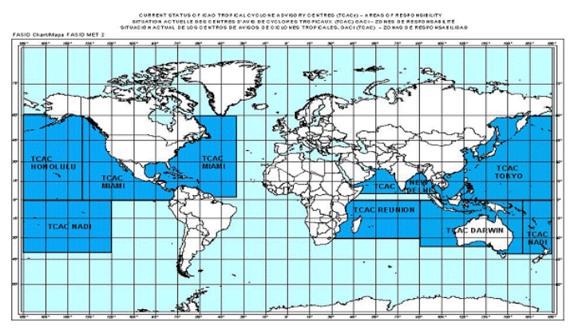
Figure 5 ICAO TCAC areas of responsibility

The Product IDs are shown in Table 15.

Table 15 Tropical cyclone Advisory – product IDs
Product ID number(s)
IDW41170 – Tropical Cyclone Advisory 1
IDW41180 – Tropical Cyclone Advisory 2
IDW41190 – Tropical Cyclone Advisory 3
IDD41170 – Tropical Cyclone Advisory 1
IDD41180 – Tropical Cyclone Advisory 2
IDQ41170 – Tropical Cyclone Advisory 1
IDQ41180 – Tropical Cyclone Advisory 2
IDQ41190 – Tropical Cyclone Advisory 3

Content
- Header
- Identification of the type of message
- Status indicator
- Time of fix
- Name of TCAC
- Name of cyclone
- Advisory number
- Observed position of centre
- Observed thunderstorm cloud (optional)
- Direction and speed of movement
- Changes in Intensity
- Central pressure
- Maximum surface wind
- Forecast of centre position and surface wind (+6, +12, +18 and +24 hrs)
- Remarks
- Expected time of issuance of next advisory or "NO MSG EXP"
  - Satellite Analysis Bulletin

Purpose
This product is issued as guidance to the Nadi Regional Specialised Meteorological Centre (Nadi RSMC) operated by Fiji Meteorological Service. It contains location and intensity information on tropical cyclones and developing tropical disturbances in the Southwest Pacific Ocean region.

The Nadi RSMC area of responsibility for which Satellite Analysis Bulletins are issued is shown in Figure 6 and Table 16.
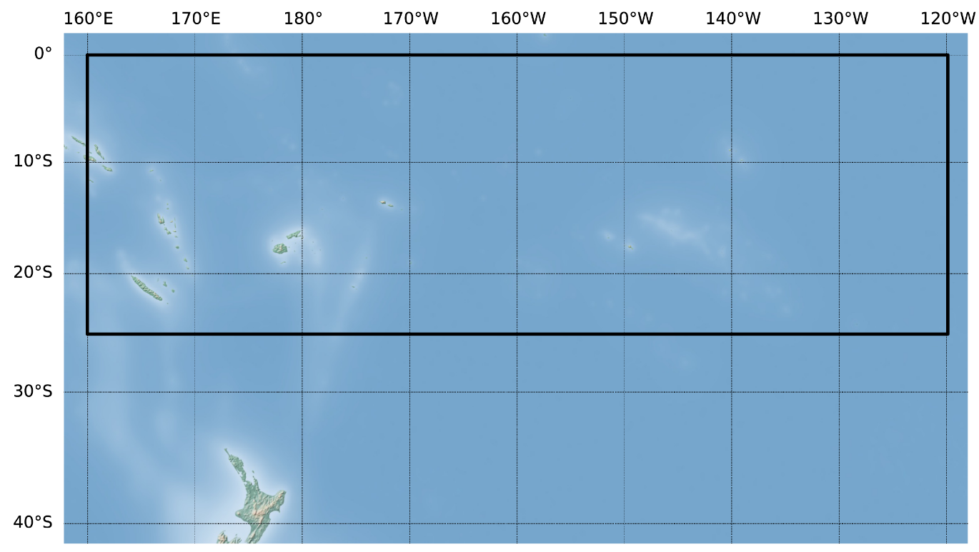
Figure 6 Nadi RSMC area of responsibility

Table 16 Nadi RSMC area of responsibility
Area of responsibility | Area bounded by
Nadi RSMC | 25°S 160°E, 25°S 120°W, EQ 120°W, EQ 160°E and 25°S 160°E

Issue criteria and schedule
The Satellite Analysis Bulletin is issued daily at 0630UTC when a tropical disturbance has reached a Dvorak CI-number of 2.0 or greater and when further development is expected. The bulletin may be issued more frequently (usually at 0030, 1230 or 1830 UTC) See Note 2. The Product IDs and standard issue times are shown in Table 17.

Table 17 Tropical Cyclone Satellite Analysis Bulletin – product ID and issue time
Product ID number(s) | Issue times UTC
IDQ20015 – Satellite Analysis Bulletin | 0630

Content
- Location (latitude/longitude in decimal degrees)
- Data used for determining intensity.
- Latitude and longitude detection sums - e.g., for an analysis position of 17.5S 162.0 E, the latitude detection sum would be 13 (1+7+5) and longitude detection sum would be 9 (1+6+2+0)
- Dvorak analysis code E.g., T2.5/3.0/D0.5/24HRS, where 2.5 is the FT, 3.0 is the CI and D- indicates slight development over the last 24 hours.
- Remarks relating to the Dvorak analysis.
- Next issue time

Notes
- Satellite Analysis Bulletins (SABs) provide satellite analysis details for existing tropical cyclones and developing tropical disturbances. SABs do not include forecast information.
- The frequency of the bulletins may be increased upon activation of the Australian TCWC for a system with the potential to (a) move into the Australian AoR and/or (b) initiate Special Advisories for the Solomon Islands (See section 6.5)
  - Special Advisory for the Solomon Islands

Purpose
The Australian Bureau of Meteorology provides a Special Advisory for the Solomon Islands for tropical cyclones and developing tropical lows that have the potential to affect communities of the Solomon Islands.

The area that relates to Special Advisories for the Solomon Islands is shown in Figure 7 and Table 18. The Bureau will issue the Special Advisory for the Solomon Islands when the tropical low or cyclone expected to impact the area is located west of 160E, with Nadi RSMC (Fiji) having responsibility when the tropical low or cyclone is east of 160E.

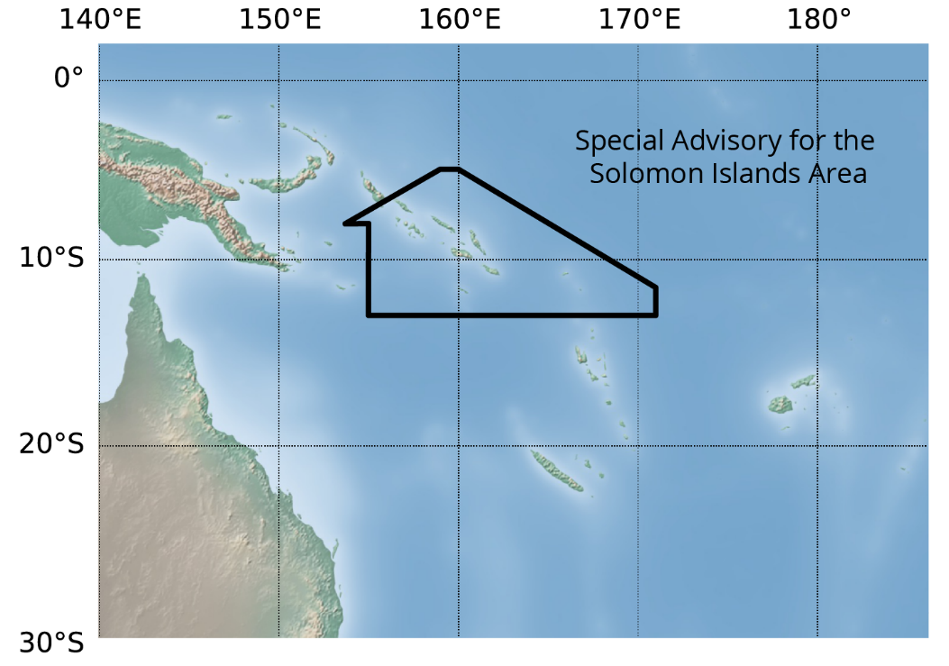
Figure 7 Area of Interest for the Special Advisory for the Solomon Islands

Table 18 Special Advisory for the Solomon Islands Area
Area of interest | Area bounded by
Special Advisory for the Solomon Islands | 5°S 160°E, 11.5°S 171°E, 13°S 171°E, 13°S 160°E, 13°S 155°E, 8°S 155°E, 8°S 153.7°E, 5°S 159°E and 5°S 160°E

Issue criteria and schedule
The Special Advisory for the Solomon Islands will be issued as soon as a tropical cyclone or developing tropical disturbance is considered likely to cause gales over any islands within the defined area within 48 hours.
The Advisories are issued as soon as the need becomes apparent, then at 6-hourly intervals. The Product IDs and standard issue times are shown in Table 19.

Table 19 Special Advisory for the Solomon Islands – product ID and issue times
Product ID number(s) | Issue times UTC
IDQ20016 – Special Advisory for the Solomon Islands | 0200  0800  1400  2000

Content
- Tropical Cyclone Name and Category
- Date/Time
- Latitude
- Longitude
- Movement Direction and Speed
- Maximum 10-Minute Wind and forecast Wind
- Radius of gales
- Radius of storm force winds
- Radius of hurricane force winds
- Forecast Position
- The next advisory issued time

Notes
- The frequency of the advisories may be increased to 3-hourly upon request from the Solomon Islands Meteorological Service. The frequency may only be increased as soon as a tropical cyclone or developing tropical disturbance is considered likely to cause gales about any of the provinces of the Solomon Islands within 24 hours.

- Appendix 1: Storm Tide Advice Locations
  - Storm Tide Advice location list
All the Storm Tide Advice products are point-based. The points included are selected by forecasters from a pre-defined list of coastal locations. Table 20 lists each storm tide advice location along with nominal coordinates. The two tidal plane elevations that define tidal range are also listed. Tidal plane values are important but may differ from local sources as discussed in Section 7.3.

Table 20 Storm tide advice locations
Location | Longitude | Latitude | LAT mAHD | HAT mAHD | Note
Abbot Point | 148.09 | -19.87 | -1.67 | 1.93
Agnes Water | 151.91 | -24.19 | -1.48 | 1.78
Airlie Beach | 148.71 | -20.26 | -1.84 | 2.32
Albert River | 139.76 | -17.55 | -1.92 | 2.47
Alligator Point | 140.79 | -17.45 | -2.09 | 2.78
Alva | 147.49 | -19.45 | -1.48 | 1.78
Alyangula | 136.42 | -13.85 | -1.16 | 1.22
Angurugu | 136.42 | -13.90 | -1.16 | 1.21
Aurukun (Archer River) | 141.61 | -13.35 | -1.27 | 0.95 | See 7.3.5
Balgal | 146.41 | -19.01 | -1.72 | 2.07 | See 7.3.6
Baniyala | 136.23 | -13.20 | -1.04 | 0.87
Bidyadanga | 121.78 | -18.68 | -4.22 | 4.19
Bing Bong Port | 136.39 | -15.63 | -1.43 | 1.14
Bloomfield | 145.37 | -15.91 | -1.43 | 1.55
Boigu Island | 142.22 | -9.23 | -2.01 | 2.24 | See 7.3.5
Bowen | 148.24 | -20.02 | -1.67 | 2.06
Brisbane River | 153.16 | -27.38 | -1.27 | 1.46
Brisk Bay | 148.29 | -20.09 | -1.67 | 2.06
Broad Sound | 149.95 | -22.51 | -3.32 | 3.68 | See 7.3.5
Broome | 122.24 | -17.96 | -5.32 | 5.20
Bunbury | 115.64 | -33.33 | -0.60 | 0.67
Burnett Heads | 152.46 | -24.79 | -1.73 | 1.97
Busselton | 115.35 | -33.65 | -0.61 | 0.59
Bynoe Harbour | 130.54 | -12.63 | -4.01 | 3.55
Cairns Harbour | 145.79 | -16.90 | -1.69 | 1.84
Cape Cuvier | 113.39 | -24.22 | -0.95 | 0.95
Cape Preston | 116.21 | -20.83 | -2.19 | 2.21
Cardwell | 146.04 | -18.25 | -1.94 | 2.18
Carnarvon | 113.66 | -24.88 | -1.03 | 1.02
Clump Point | 146.13 | -17.85 | -1.79 | 1.89
Coconut Grove | 130.85 | -12.39 | -4.12 | 3.86
Conway_Beach | 148.77 | -20.49 | -2.36 | 2.82 | See 7.3.5
Cooktown | 145.25 | -15.44 | -1.49 | 1.70
Coolangatta_Beach | 153.53 | -28.16 | -0.93 | 1.08
Cooloola_Beach | 153.15 | -26.07 | -1.03 | 1.20
Coral Bay | 113.77 | -23.14 | -0.89 | 0.91
Cox Peninsula | 130.74 | -12.43 | -4.06 | 3.67
Cungulla | 147.11 | -19.40 | -1.83 | 2.06
Dampier | 116.71 | -20.66 | -2.65 | 2.47
Darwin | 130.85 | -12.47 | -4.15 | 4.00
Darwin Harbour | 130.79 | -12.43 | -4.12 | 3.86
Dauan_Island | 142.55 | -9.42 | -1.67 | 2.08
Denham | 113.53 | -25.93 | -0.77 | 0.92
Derby | 123.64 | -17.31 | -6.20 | 5.99
Dingo_Beach | 148.51 | -20.09 | -1.75 | 2.18
Dubbar_Point | 139.14 | -16.67 | -1.92 | 1.95
Dundee Beach | 130.35 | -12.72 | -3.66 | 3.09
Evans Landing | 141.85 | -12.66 | -1.83 | 1.54
Exmouth | 114.13 | -21.93 | -1.44 | 1.48
Flying Fish Point | 146.08 | -17.49 | -1.69 | 1.74
Fremantle | 115.74 | -32.06 | -0.74 | 0.66
Galiwinku | 135.57 | -12.02 | -2.70 | 2.51
Geraldton | 114.61 | -28.78 | -0.57 | 0.69
Gladstone | 151.27 | -23.84 | -2.30 | 2.45
Golden Beach | 153.12 | -26.82 | -0.95 | 1.11
Great Keppel Island | 150.92 | -23.19 | -2.40 | 2.61
Green Island | 145.98 | -16.75 | -1.54 | 1.56
Hamilton Marina | 148.95 | -20.34 | -2.07 | 2.53
Hay Point | 149.31 | -21.28 | -3.37 | 3.77
Hayman Island | 148.88 | -20.06 | -1.92 | 2.36
Iama (Yam) Island | 142.77 | -9.90 | -2.00 | 2.16
Kalbarri | 114.16 | -27.71 | -0.47 | 0.63
Kalumburu | 126.64 | -14.30 | -1.49 | 2.09
Karratha | 116.84 | -20.74 | -2.65 | 2.46 | See 7.3.5
King Ash Bay | 136.68 | -15.81 | -1.68 | 1.29
Kubin | 142.22 | -10.25 | -1.95 | 1.82
Kuri Bay | 124.52 | -15.48 | -5.28 | 5.36
Laguna Quays | 148.68 | -20.59 | -2.37 | 2.83 | See 7.3.5
Lizard Island | 145.44 | -14.65 | -1.41 | 1.58
Lockhart River | 143.37 | -12.81 | -1.57 | 1.61
Lucinda | 146.35 | -18.52 | -1.87 | 2.09
Mackay | 149.22 | -21.15 | -3.04 | 3.57
Main Beach | 153.44 | -27.97 | -0.87 | 1.09
Maningrida | 134.20 | -12.05 | -2.57 | 2.04
Mapoon | 141.91 | -11.97 | -1.75 | 1.05 | See 7.3.5
Milikapiti | 130.68 | -11.43 | -1.73 | 1.37
Milingimbi | 134.90 | -12.10 | -2.85 | 2.53
Milyakburra | 136.20 | -13.78 | -1.14 | 1.22
Minjilang | 132.58 | -11.15 | -1.37 | 1.05
Molongle Creek | 147.69 | -19.82 | -1.50 | 1.81
Mooloolaba | 153.13 | -26.68 | -0.97 | 1.20
Nelly Bay | 146.86 | -19.17 | -1.93 | 1.89
Nhulunbuy | 136.80 | -12.20 | -1.60 | 1.69
Noosa Heads | 153.09 | -26.36 | -1.06 | 1.22
Numbulwar | 135.70 | -14.30 | -1.44 | 1.36
Onslow | 115.11 | -21.64 | -1.55 | 1.52
Palm Cove | 145.69 | -16.73 | -1.71 | 1.73
Palm Island | 146.55 | -18.74 | -1.68 | 2.01
Palmerston | 130.94 | -12.50 | -4.13 | 3.93
Perth | 115.86 | -31.95 | -0.57 | 0.58
Pirlangimpi | 130.42 | -11.40 | -2.49 | 1.51
Pormpuraaw | 141.59 | -14.92 | -1.33 | 1.16 | See 7.3.5
Port Alma | 150.86 | -23.58 | -2.85 | 3.07
Port Douglas | 145.48 | -16.48 | -1.58 | 1.78
Port Hedland | 118.60 | -20.31 | -3.83 | 3.73
Port Roper | 135.40 | -14.70 | -1.37 | 1.35
Rainbow Beach | 153.11 | -25.90 | -1.02 | 1.19
Redland Bay | 153.31 | -27.61 | -1.24 | 1.50
Saint Pauls | 142.33 | -10.20 | -1.76 | 2.16
Scarborough Boat Harbour | 153.11 | -27.19 | -1.11 | 1.31
Shoalwater Bay | 150.56 | -22.55 | -3.51 | 3.85 | See 7.3.5
Southport | 153.42 | -27.95 | -0.86 | 1.09
St Lawrence | 149.60 | -22.29 | -4.08 | 4.71
Toolakea | 146.58 | -19.15 | -1.73 | 2.07 | See 7.3.6
Townsville | 146.82 | -19.24 | -1.93 | 2.18
Ugar (Stephen) Island | 143.53 | -9.52 | -1.99 | 2.08
Umbakumba | 136.81 | -13.86 | -0.85 | 0.95
Urangan | 152.90 | -25.28 | -2.07 | 2.22
Wadeye | 129.50 | -14.20 | -4.44 | 3.75
Waiben (Thursday Is) | 142.22 | -10.59 | -1.87 | 1.67
Wallal Downs | 120.64 | -19.78 | -3.81 | 3.78
Warruwi | 133.39 | -11.65 | -1.73 | 1.33
Weddell | 130.85 | -12.47 | -4.15 | 4.00
Wickham | 117.14 | -20.67 | -3.19 | 2.94
Wurrumiyanga | 130.63 | -11.77 | -3.81 | 3.30
Wyndham | 128.12 | -15.48 | -4.60 | 4.11
Yarrabah | 145.89 | -16.87 | -1.69 | 1.60
Yeppoon | 150.79 | -23.13 | -2.36 | 2.77
Yirrkala | 136.89 | -12.25 | -1.18 | 1.14

  - Storm Tide Advice location maps
All of the Storm Tide Advice locations listed in Table 20 are shown below as a series of map views. In each map, named storm tide advice locations are coloured to reflect relative tidal range. Red symbols indicate locations where the tidal range is especially large. The relevance of tidal range is discussed below in Section 7.3.3.
The nominal location of the numerical model grid cell corresponding to each advice location is indicated by a black 'X' symbol, noting that where this coincides with the advice location, it is less visible.

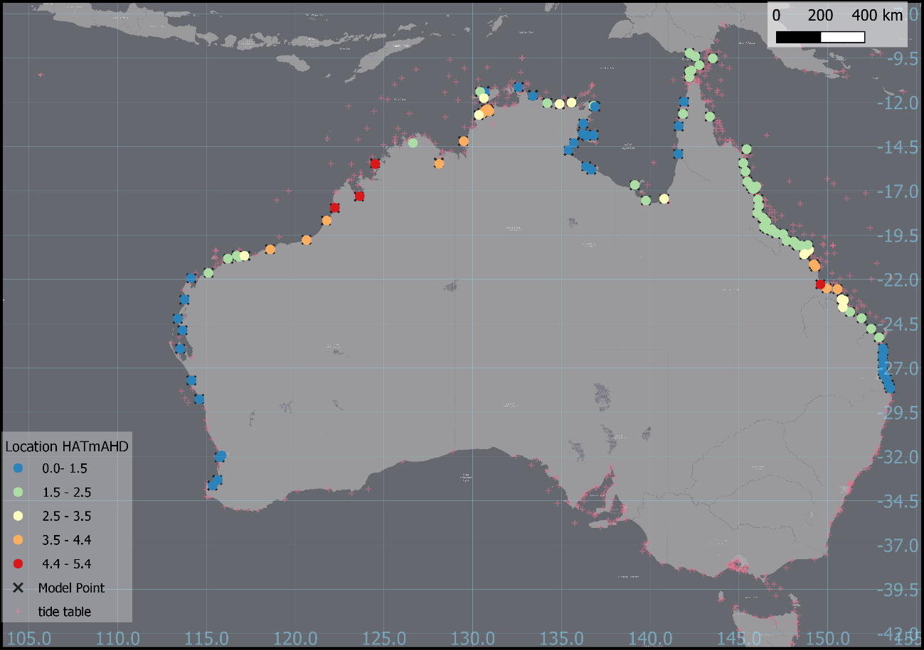
Figure 8 Storm tide advice locations overview

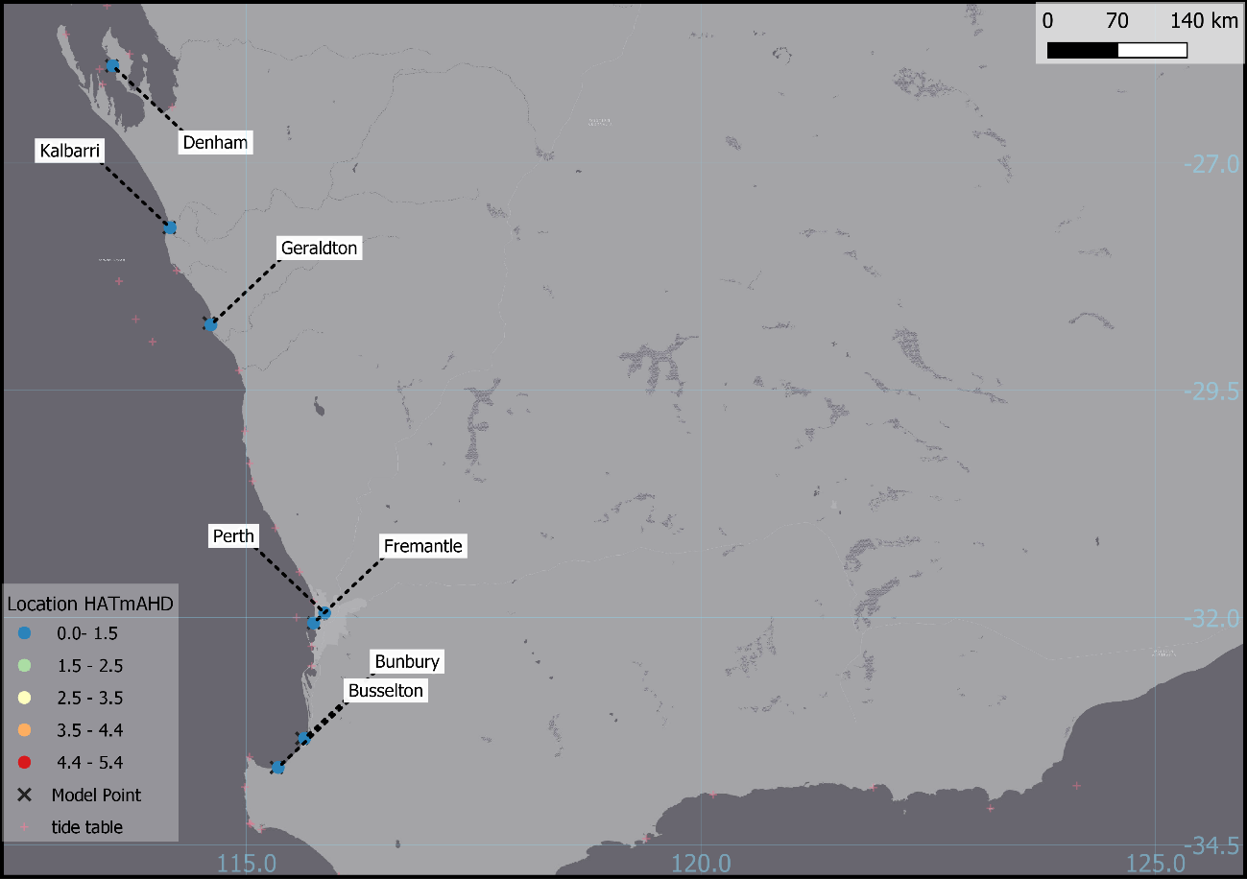
Figure 9 Storm tide advice locations – WA view 1
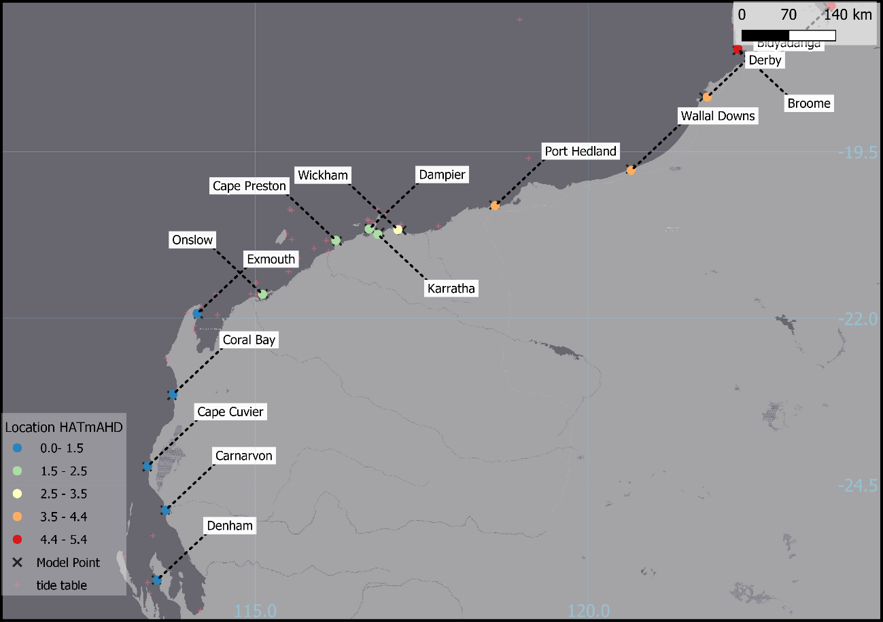
Figure 10 Storm tide advice locations – WA view 2

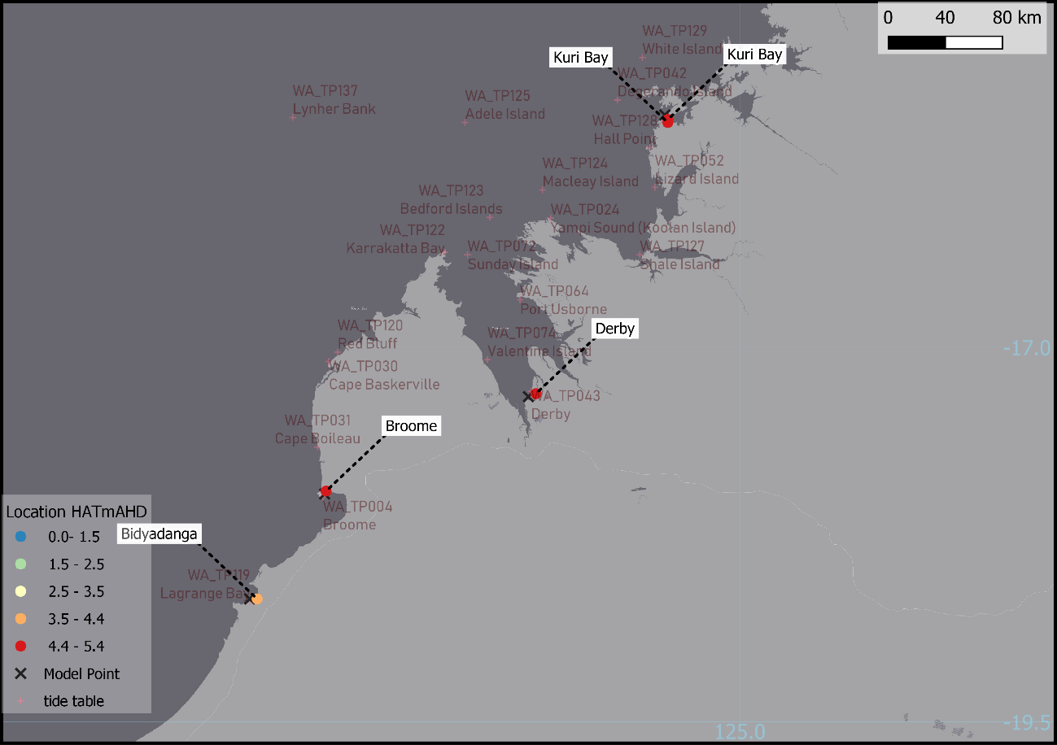
Figure 11 Storm tide advice locations – WA view 3
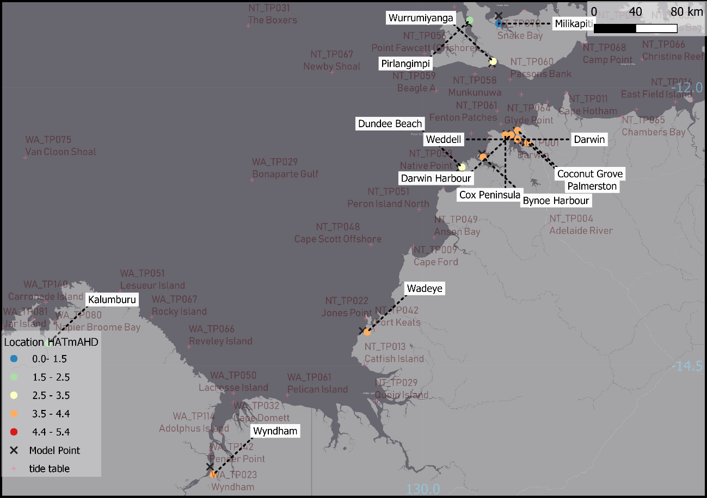
Figure 12 Storm tide advice locations – NT view 1

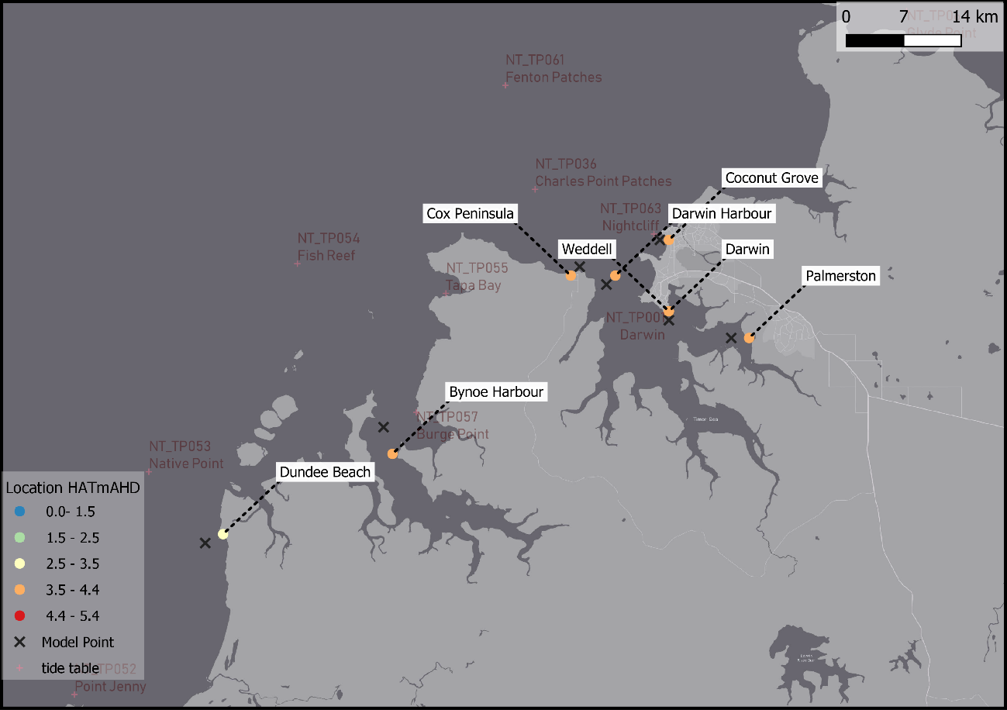
Figure 13 Storm tide advice locations – NT view 2

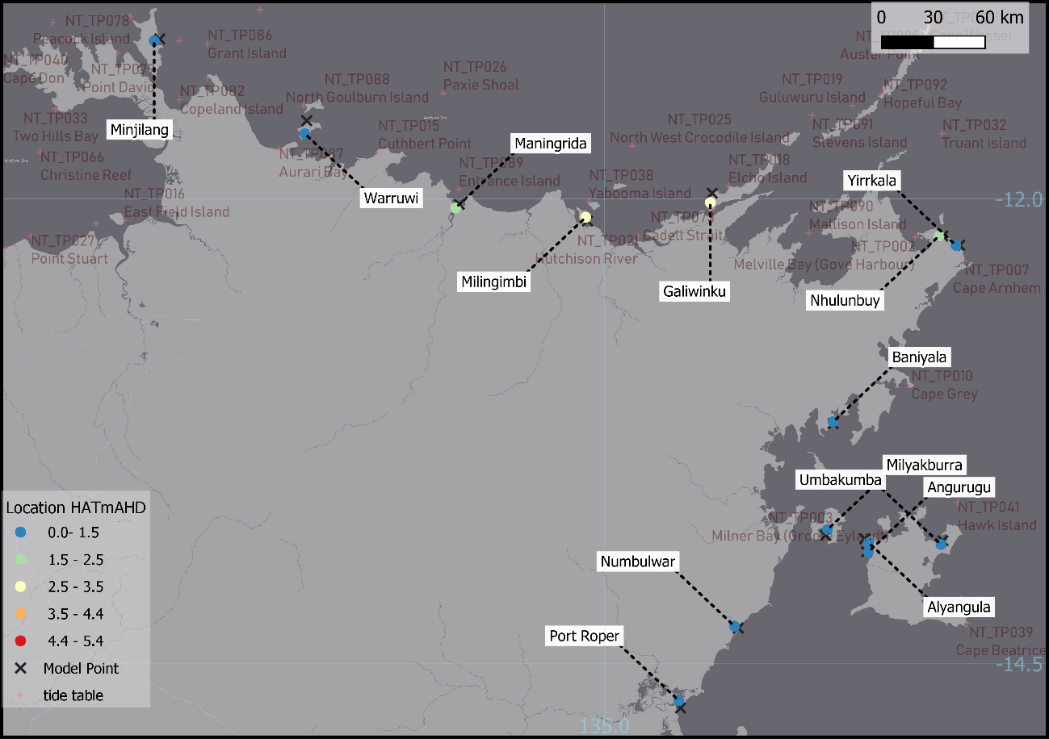
Figure 14 Storm tide advice locations – NT view 3
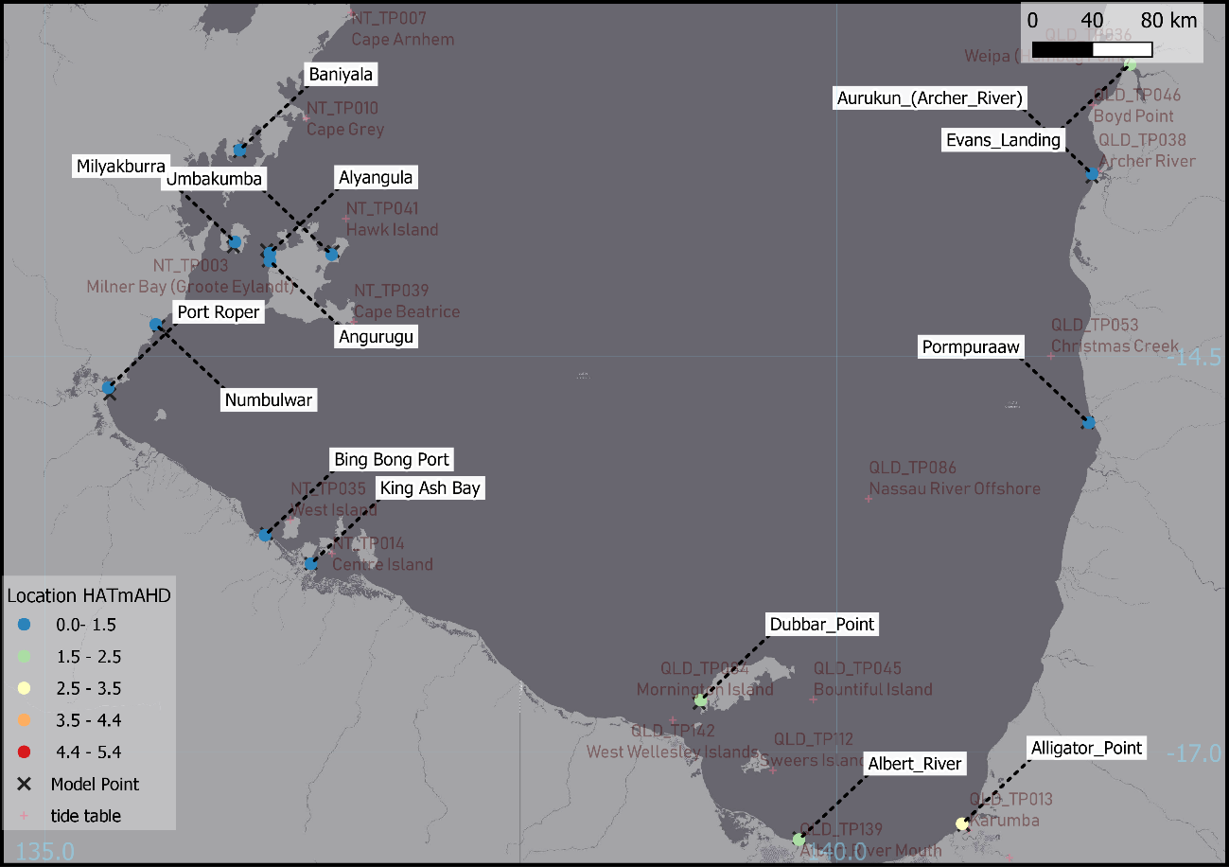
Figure 15 Storm tide advice locations – NT/QLD view
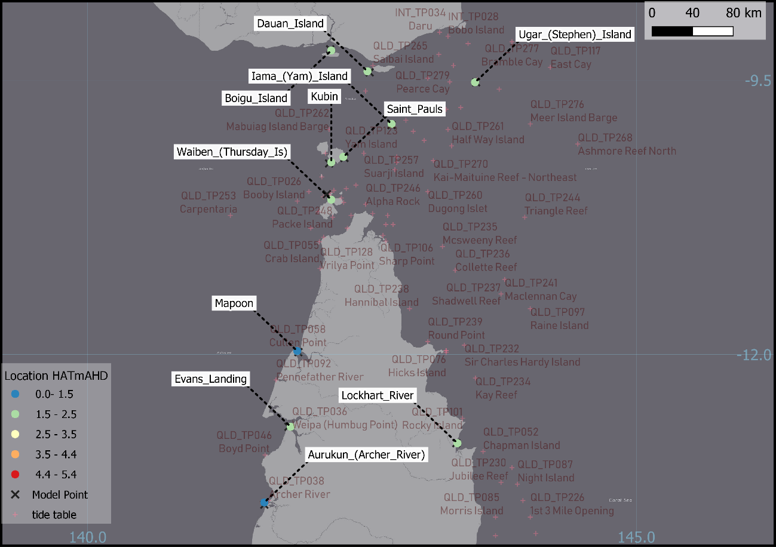
Figure 16 Storm tide advice locations – QLD view 1

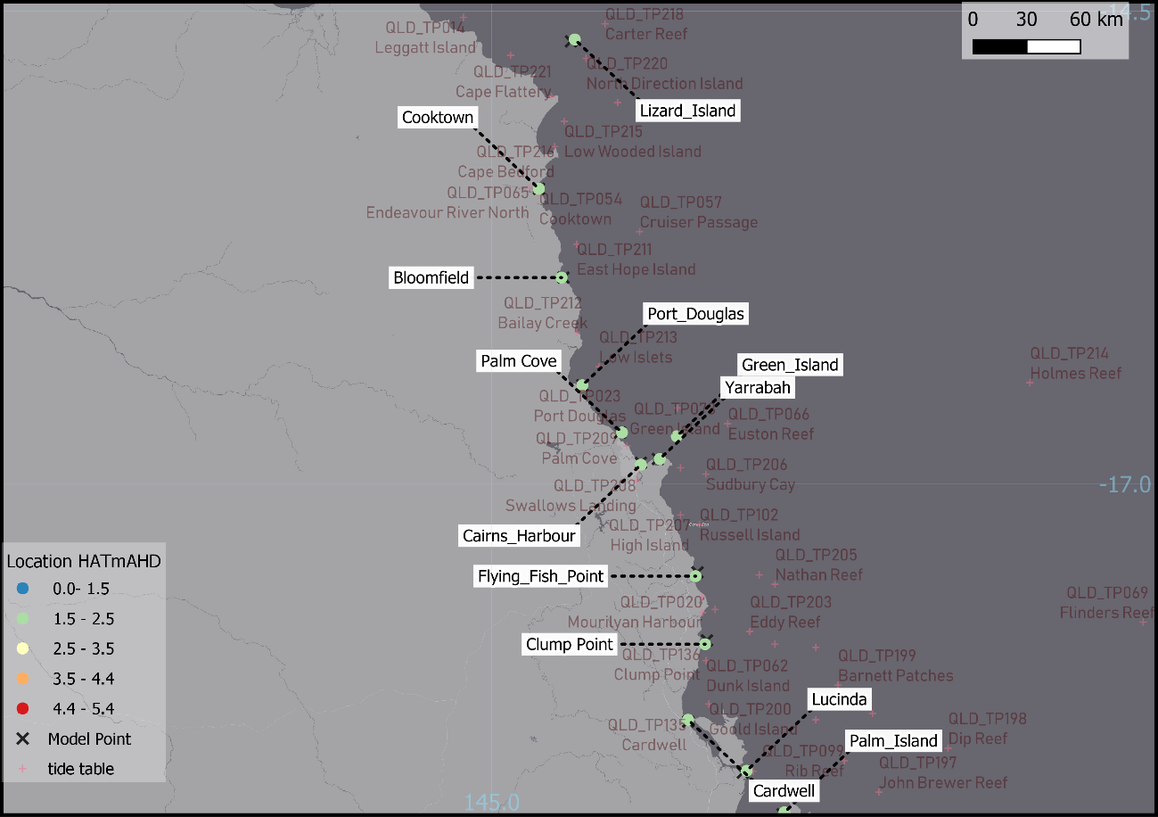
Figure 17 Storm tide advice locations – QLD view 2
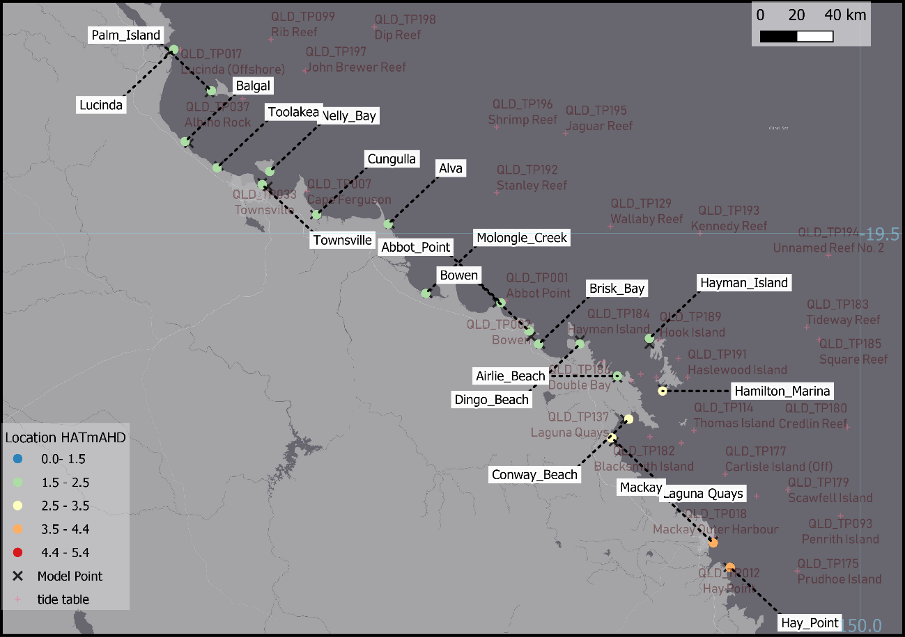
Figure 18 Storm tide advice locations – QLD view 3

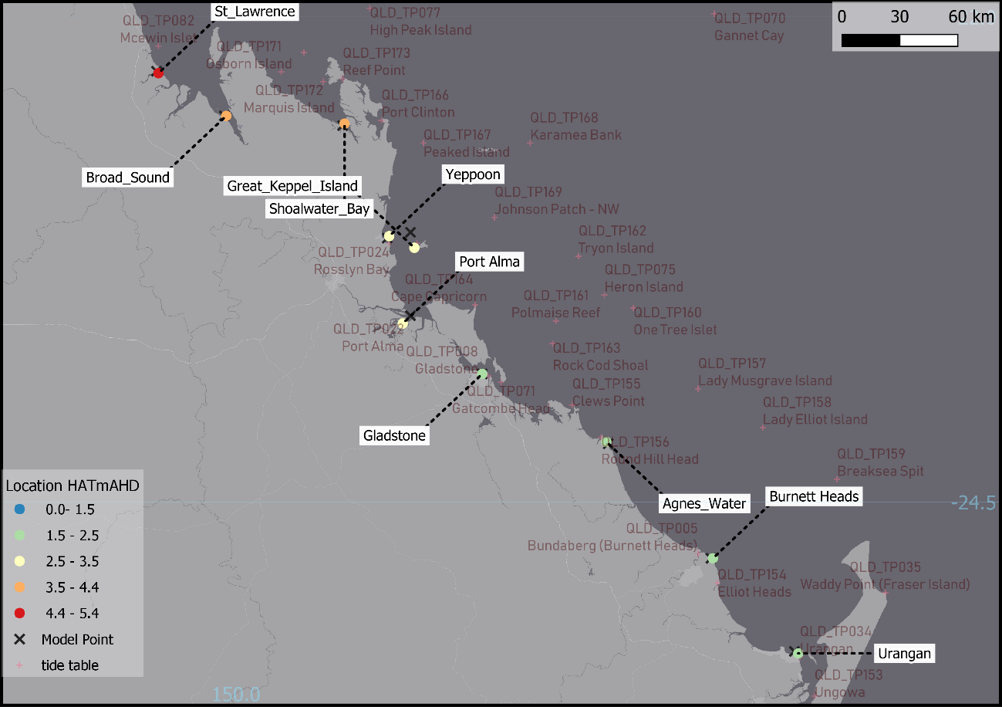
Figure 19 Storm tide advice locations – QLD view 4
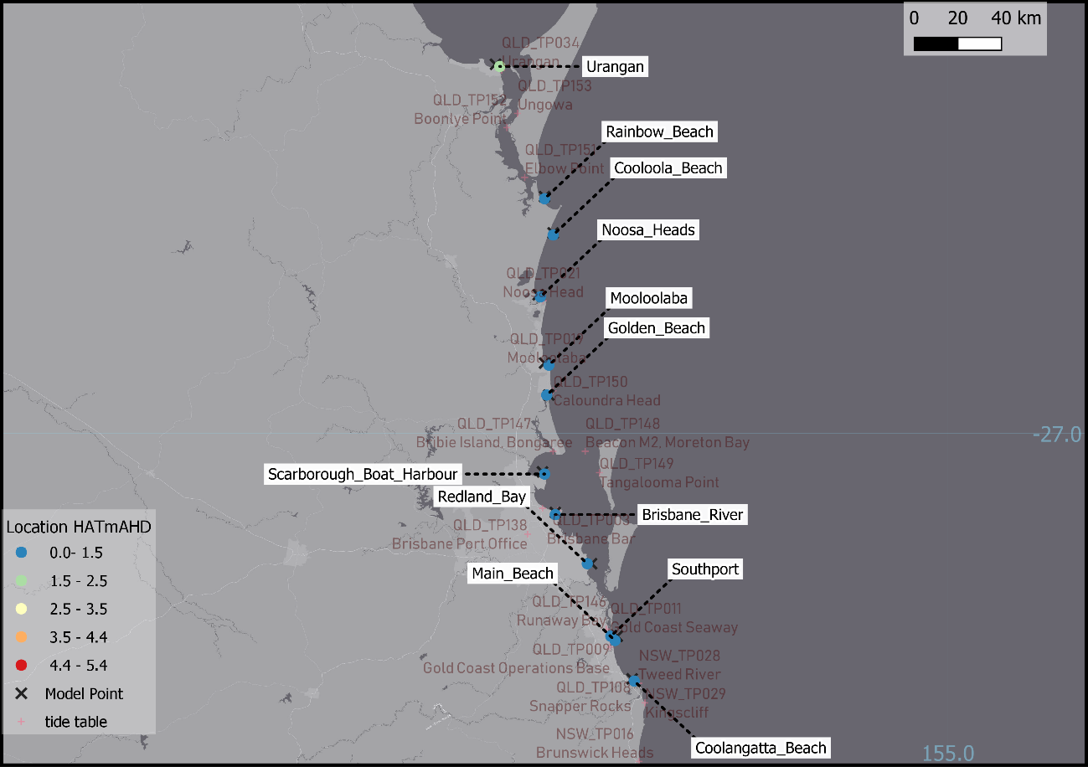
Figure 20 Storm tide advice locations – QLD view 5

  - Interpretation of advice content
    - Communication risks association with vertical datums
Coastal elevations are core to the value of Storm Tide Advices. The potential impact of a storm tide is a function of the relative elevations of coastal water and coastal land. Unfortunately, coastal elevations are often problematic and lead to technical and communication issues. Multiple vertical references are in use by coastal decision makers and offsets between datums are not well defined for the whole coast; so special caution is required to avoid miscommunication.
This situation reflects a history of different authorities working around the Australian coast as well as the rapidly expanding role of Global Navigation Satellite System (GNSS) technology. Marine and land-based elevations have been managed separately by a mixture of state and federal agencies and storm tide responses have necessarily worked with a hybrid of such sources. Coordination is improving under the aegis of the Inter-governmental Committee on Survey and Mapping (ICSM). ICSM activities directly relevant to storm tide applications include:
- https://www.icsm.gov.au/what-we-do/aushydroid
- https://www.icsm.gov.au/what-we-do/elevation-and-depth-data

Regardless of the changing technology, tidal analysis continues to play a role in connecting marine and land elevations. Tidal analysis is the basis for defining "tidal planes" which at the coast are conventionally used as fixed reference elevations. Select tidal planes are included in the Storm Tide Advice products. Tidal planes of special relevance to storm tide include the following:
- LAT = Lowest Astronomical Tide.
- MSL = Mean Sea Level
- HAT = Highest Astronomical Tide
It is notable the land elevation reference Australian Height Datum (AHD) is founded on the analysis of point tide gauge observations. It is not identical to MSL but can approximate it within a few decimetres.
Tide tables are typically, but not always, reported relative to a prediction datum chosen to match LAT.
The Bureau of Meteorology storm tide systems are based on elevation offsets and grids supplied by the Australian Hydrographic Service (AHS). This information is an active area of development as discussed above and is not guaranteed to match information used by all agencies.
    - Forecaster mediation of numerical model data
Storm tide advice products are based on numerical model data.
To a large degree the values included in the products are automatically generated, however forecasters have discretion to modify when additional information is available.
Modifications can include:
- choice of locations included in the Advice;
- modification of the numerical forecast water levels;
- modification of reference metadata such as tidal plane elevations.
    - Importance of tidal range
Tide patterns at the coast are a fundamental contextual factor in forecasting storm tide impacts. The Australian coast encompasses an especially wide range of tidal patterns that can be summarised by tidal range, the height difference between the highest and lowest normal tides. Where the tidal range is very large, the timing of a storm surge event relative to tidal patterns can become the most impact factor that renders an event impactful.
    - Tidal plane comparison graph
The tidal range at each site sets the background on which inconsistencies of elevation information can be interpreted. The tidal range background is relevant to the communication risks discussed in section 7.3.1.
Figure 21 summarises the tidal range at each of the storm tide advice locations in order of smallest to largest tidal range. Tidal range is shown as the height of the grey bar between each LAT and HAT value.
Reference values sourced from the Queensland Department of Environment and Science document Storm Tide Reference Landmarks 2018 are shown for comparison.
Locations with known mismatch between the Queensland state reference landmark tidal planes and the Bureau system are highlighted and labelled in red. In all cases of mismatch, the HAT tidal plane used by the Bureau is lower than the state reference. Similar landmark data is not yet available for NT or WA.
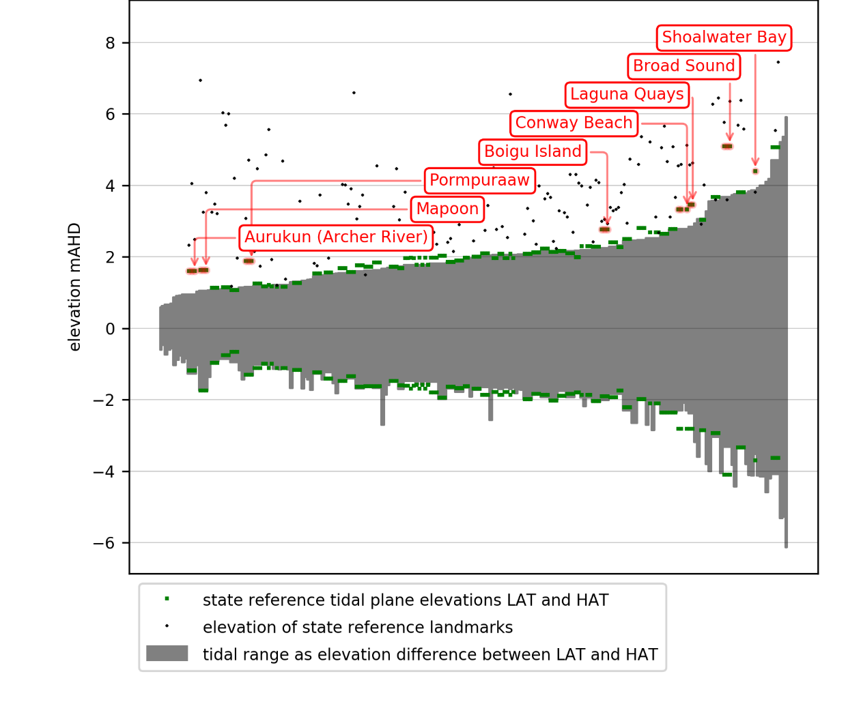
Figure 21 Visualisation of tidal planes as a function of tidal range

Queensland landmark data overlayed and large mismatches highlighted.

    - Highlighted locations with mismatched tidal plane data

QLD: Eastern Gulf of Carpentaria
Notable mismatch between tidal plane data for Aurukun, Mapoon and Pormpuraaw in the Eastern Gulf of Carpentaria. These sites have very low astronomical tidal range.
The storm tide model HAT value is lower than the Queensland landmark report.
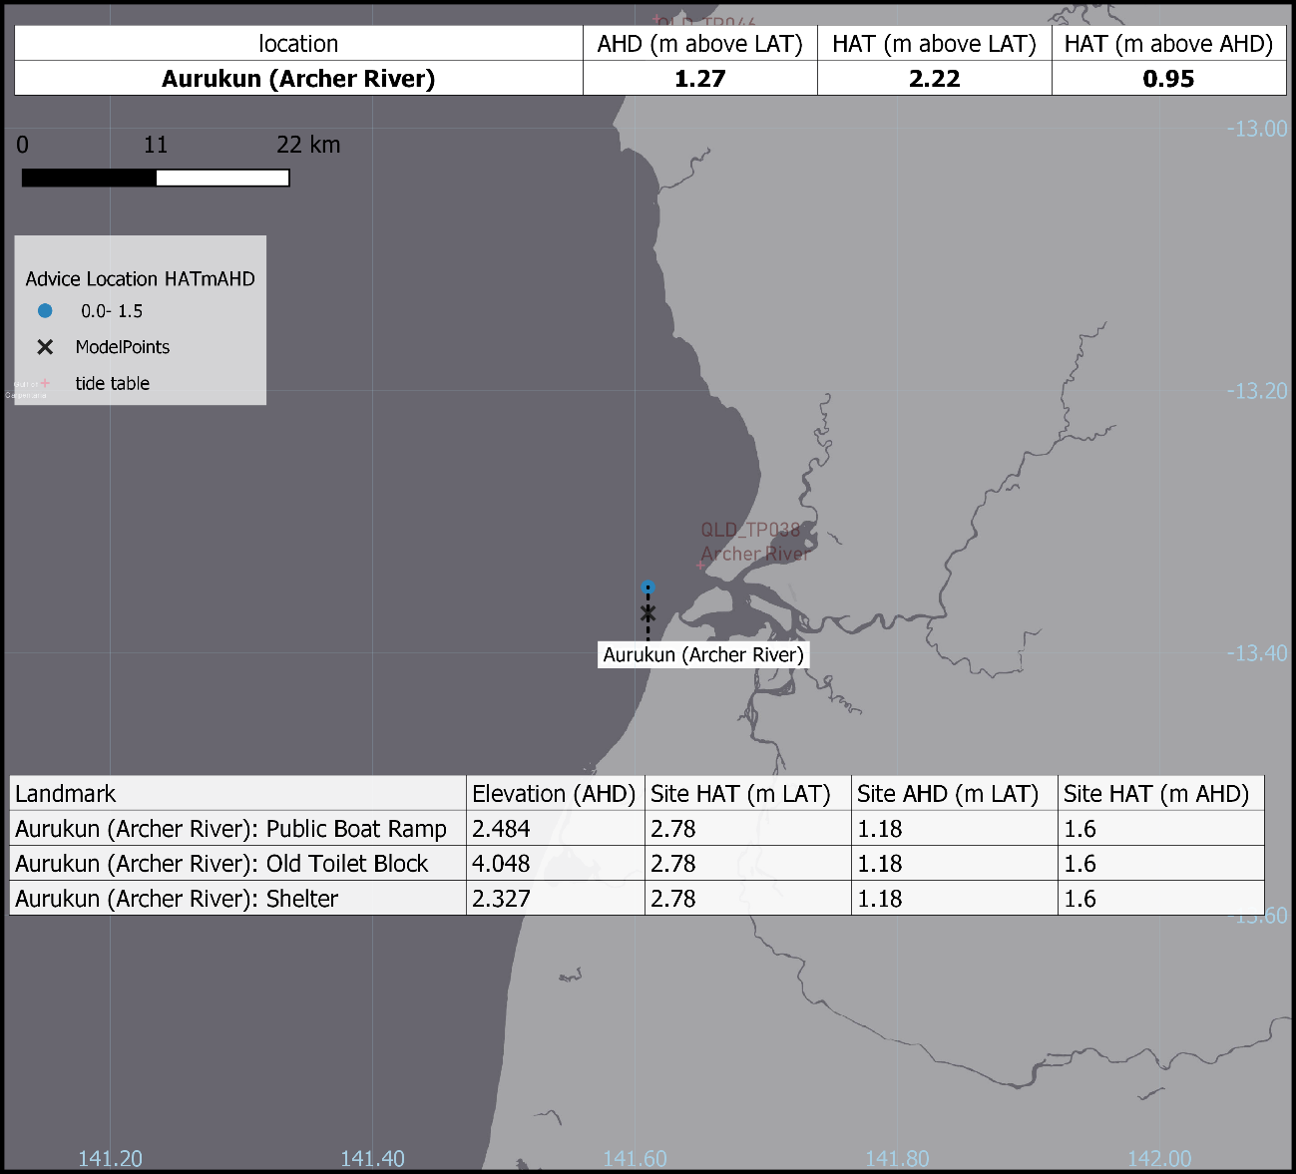
Figure 22 Highlight map – Aurukun

QLD: Northern Torres Strait
Notable mismatch between tidal plane data for Boigu Island in the Northern Torres Strait. The storm tide model HAT value is lower than the Queensland landmark report.
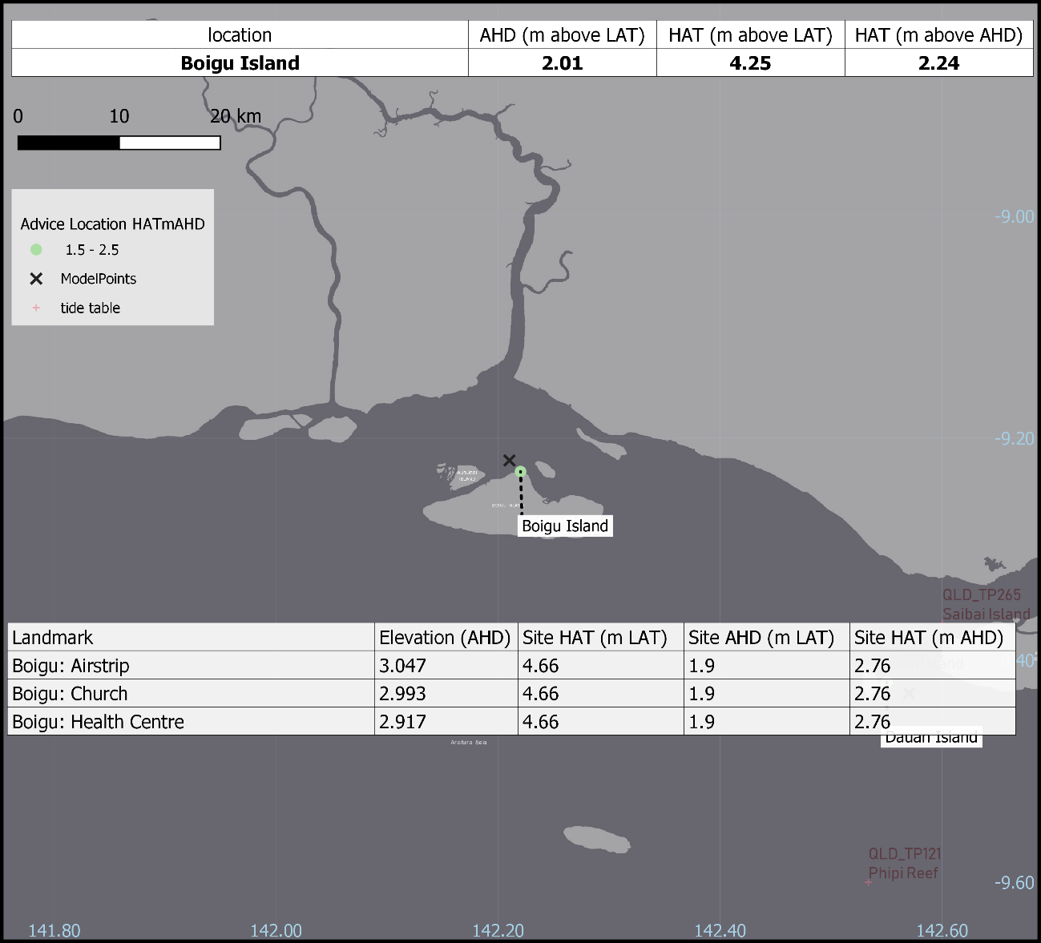
Figure 23 Highlight map – Boigu Island

QLD: Broad Sound
Notable mismatch between tidal plane data for Broad Sound and Shoalwater Bay. These sites have very large astronomical tidal range. The storm tide model HAT values are lower than the Queensland landmark report.
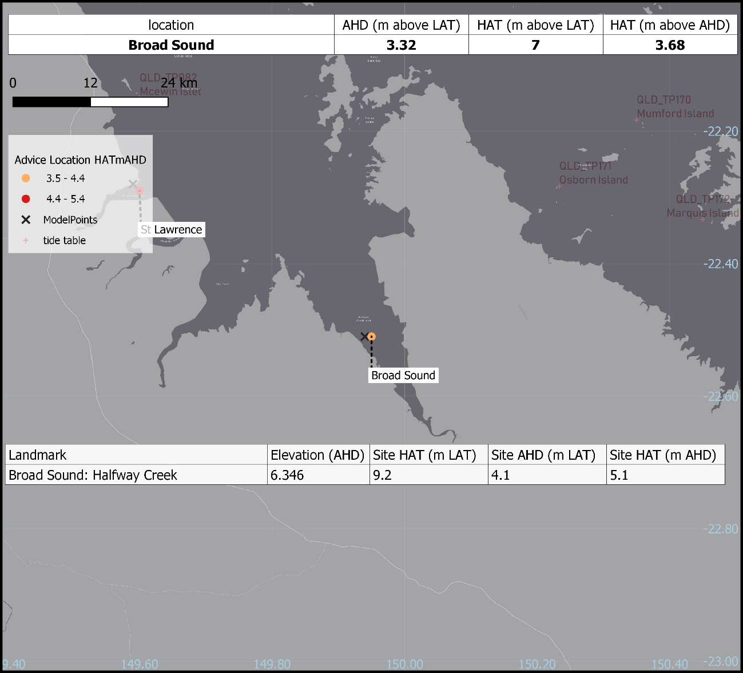
Figure 24 Highlight map – Broad Sound

QLD: Laguna Quay and Conway Beach
Notable mismatch between tidal plane data for Laguna Quays and Conway Beach These sites have a large astronomical tidal range. The storm tide model HAT values are lower than the Queensland landmark report.
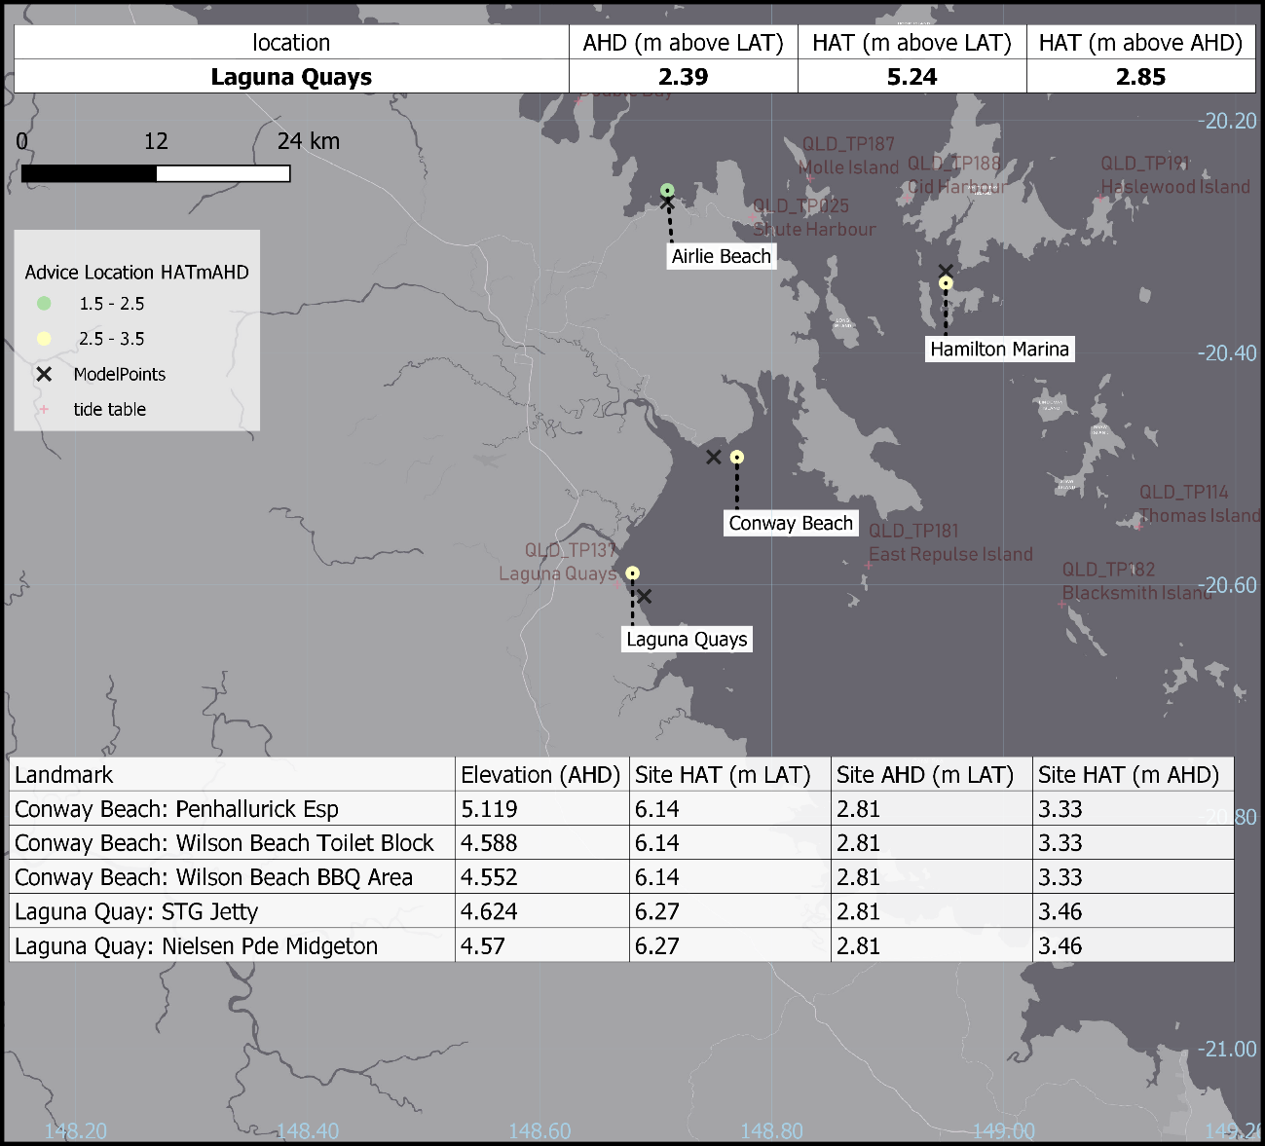
Figure 25 Highlight map – Laguna Quays

    - Highlighted locations with no standard tide table

QLD: Balgal and Toolakea
Additional sites to the north of Townsville that are not included in the Queensland landmark report and not associated with a standard tide table.
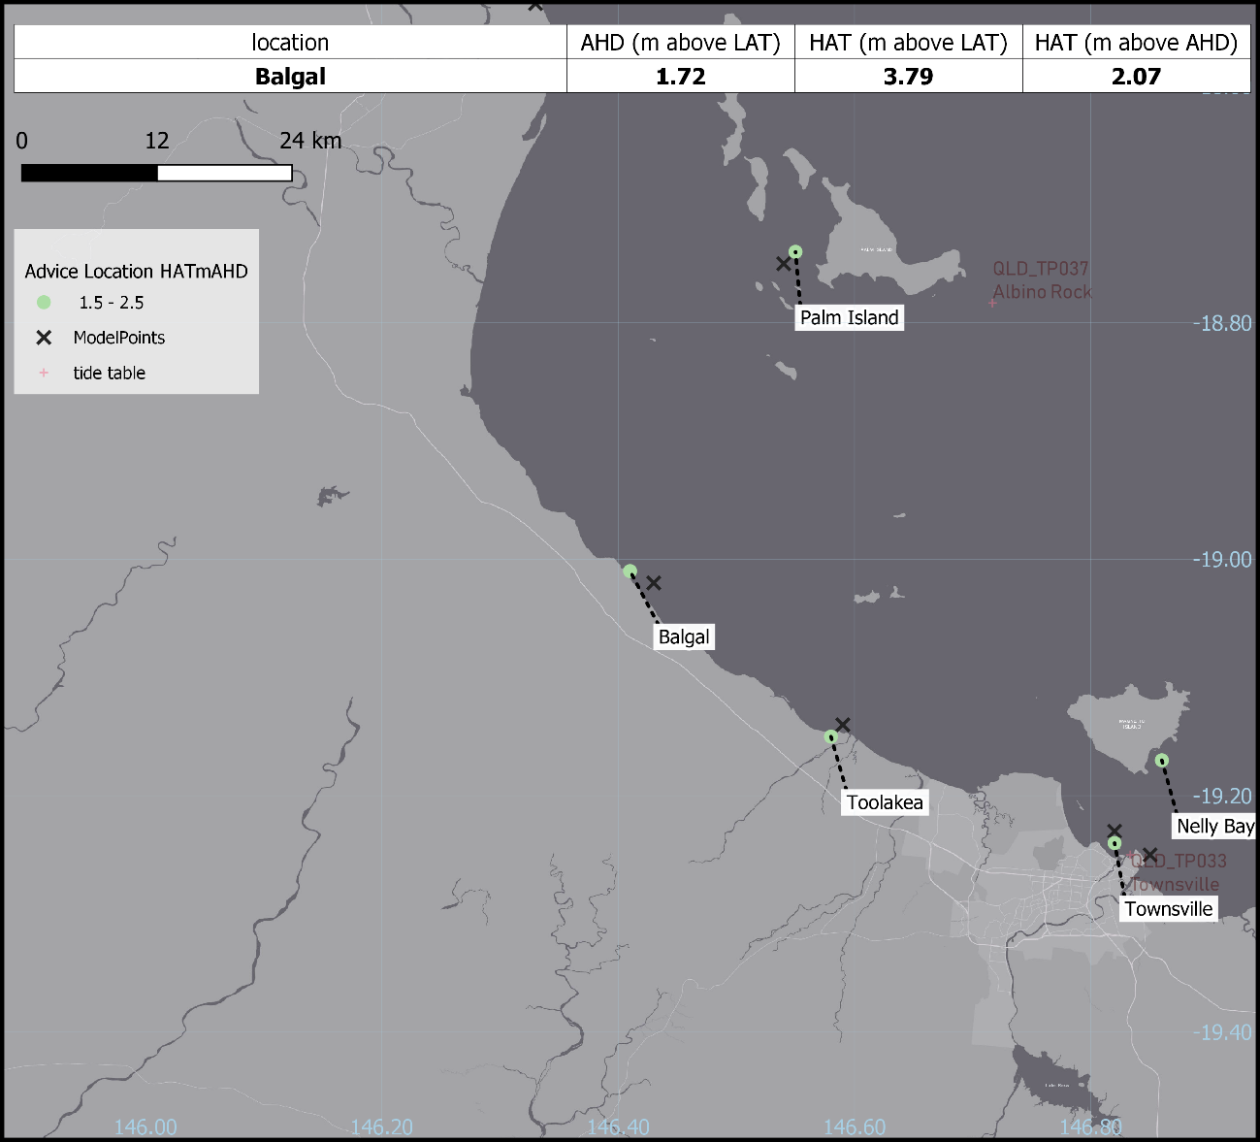
Figure 26 Highlight map – Balgal

WA: Karratha
Karratha township is not associated with a standard tide table.
Storm Tide Advices for Karratha have historically referenced tidal heights from Port Walcott (WA_TP021). All new Advices for Karratha will be based on tidal heights from the numerical model point closest to the township. Subsequently, the new HAT value of 5.1m above LAT has been reduced from the 6.1m used in previous years with the agreement of the WA Department of Fire and Emergency Services.
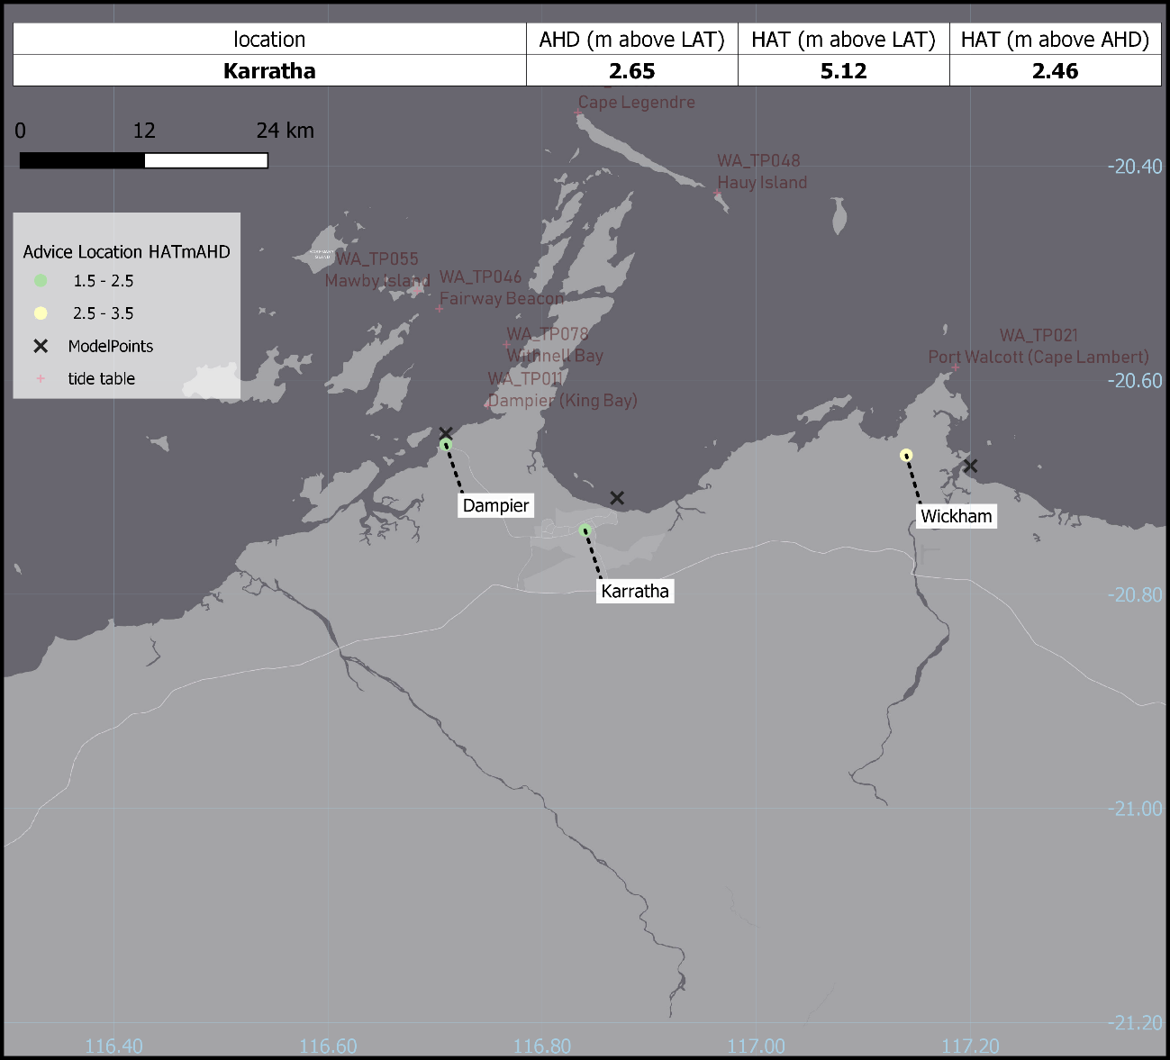
Figure 27 Highlight map – Karratha

- Appendix 2: Product Samples
  - Tropical Cyclone Forecast
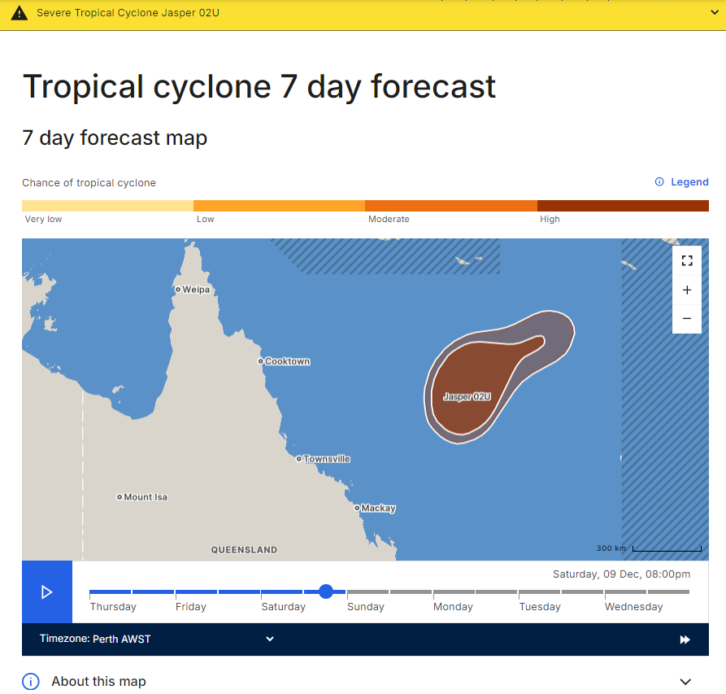
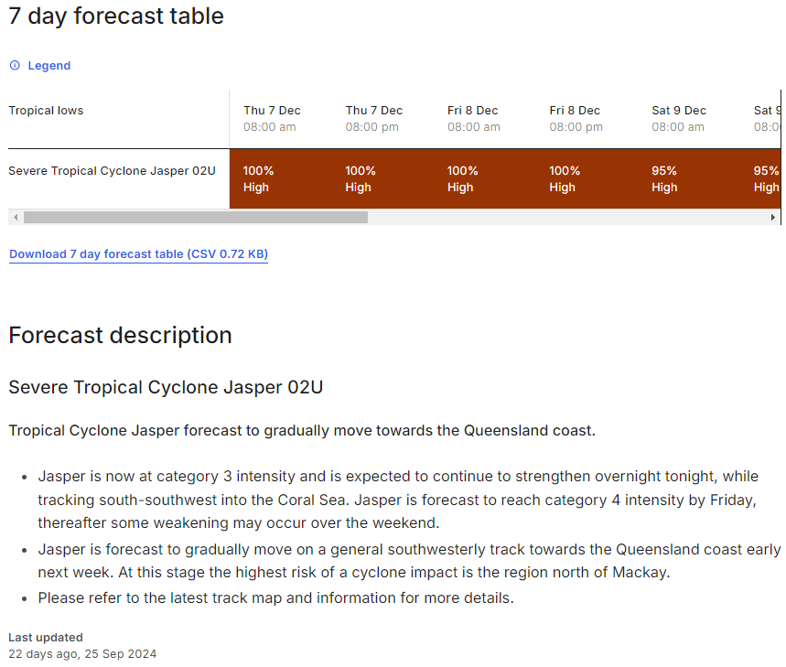
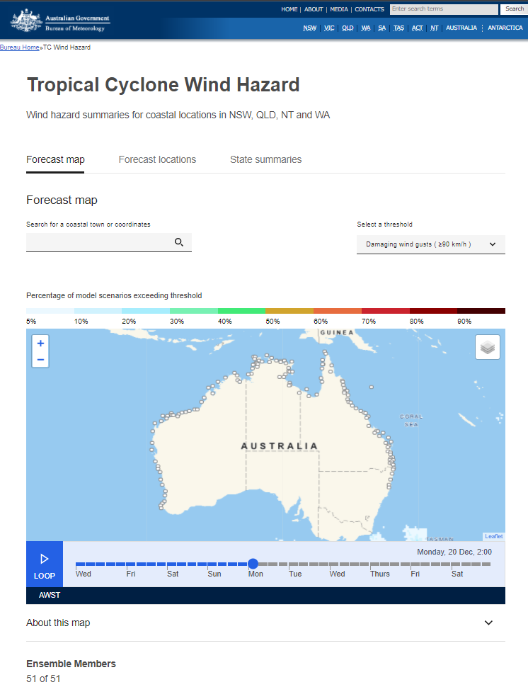
  - Tropical Cyclone Wind Hazard Forecast

  - Tropical Cyclone Information Bulletin
TROPICAL CYCLONE INFORMATION BULLETIN
Issued at 5:00pm EST on Saturday the 23rd of January 2011

At 4 pm EST Friday, Tropical Cyclone Zelia (Category 1) with central pressure 992 hPa was located over the Coral Sea near latitude 12.8 south longitude 151.5 east, which is about 770 km northeast of Cairns and 425 km north northeast of Willis Is.

The cyclone is moving east southeast at about 15 kilometres per hour and should intensify over the next 24 hours.

Tropical Cyclone Zelia, Category 1, is expected to continue moving in a south-easterly direction away from the Queensland coast.

The next Information Bulletin will be issued by 11 pm AEST today.

  - Tropical Cyclone Advice
IDD20150
Australian Bureau of Meteorology
Tropical Cyclone Warning Centre

Media: The Standard Emergency Warning Signal should NOT be used with this
warning.

TOP PRIORITY FOR IMMEDIATE BROADCAST
TROPICAL CYCLONE WARNING

TROPICAL CYCLONE ADVICE NUMBER 7
Issued at 11:04 am ACST on Friday 16 March 2018

Headline:
Tropical Cyclone Marcus has formed off the NT north coast.

Areas Affected:
Warning zone: Maningrida to Daly River Mouth, including Darwin and the Tiwi
Islands.

Watch zone: Daly River Mouth to Mitchell Plateau.
Cancelled zone: Maningrida to Milingimbi.

Details of Tropical Cyclone Marcus at 9:30 am ACST:
Intensity: Category 1, sustained winds near the centre of 65 kilometres per
hour with wind gusts to 95 kilometres per hour.
Location: within 55 kilometres of 10.3 degrees South 132.6 degrees East, estimated to be 95 kilometres north of Croker Island and 310 kilometres northeast of Darwin.
Movement: southeast at 13 kilometres per hour.

Tropical Cyclone Marcus has formed north of Cobourg Peninsula. Tropical Cyclone Marcus is expected to approach the northwest Top End coast today, most likely crossing the Cobourg Peninsula tonight. The tropical cyclone is expected to turn south towards the southwest, passing close to Darwin during Saturday, before moving into the Timor Sea late on Saturday or early Sunday. During Sunday, Tropical Cyclone Marcus is expected to approach the north Kimberley
coast.

Hazards:
GALES with DAMAGING WIND GUSTS to 110 km/h are expected to develop over the Cobourg Peninsula during this afternoon, then extend to Goulburn Island later this evening. Damaging wind gusts may extend to Maningrida tonight if the tropical cyclone takes a more easterly track.

Damaging wind gusts are expected to extend to Darwin and the Tiwi Islands from early Saturday morning as the tropical cyclone passes through the Van Diemen Gulf. However, if the tropical cyclone crosses the coast east of the Cobourg Peninsula tonight, the tropical cyclone will likely weaken before approaching Darwin, reducing the chance of gales being experienced.

Damaging wind gusts may extend to Daly River Mouth by Saturday afternoon and further south to the WA/NT border later on Saturday or Sunday as the cyclone moves into the Timor Sea later. Gales are expected to extend to the north Kimberley during Sunday.

Coastal residents between Milikapiti and Maningrida, including the Van Diemen Gulf, are specifically warned of a DANGEROUS STORM TIDE as the cyclone centre crosses the coast. Tides are likely to rise significantly above the normal high tide, with DAMAGING WAVES and DANGEROUS FLOODING tonight and into Saturday morning.

HEAVY RAIN is expected along the north coast today, extending into the northwest Top End on Saturday.

Recommended Action:
NTES advises residents from Milikapiti to Goulburn Island, including Croker Island:

-Prepare for gales and heavy rain during today into this evening;
-Move indoors and shelter as the conditions deteriorate;
-Stay indoors and avoid travel during the storm;
-Stay away from beaches and immediate coastal areas as dangerous coastal flooding may occur.

Milikapiti to Cape Fourcroy, Point Stuart to Daly River Mouth including Darwin and Goulburn Island to Maningrida.
- Be ready for wet and windy conditions to arrive in your area;
- Finalise your home preparations;
- Check your family, friends and neighbours understand and are prepared;
- Move indoors and take shelter as the weather deteriorates.

NTES advises communities under Watch:
- Prepare your home, yard and family for a cyclone, finalise your emergency kit;
- Decide NOW where you will shelter - at home, with friends or family, or a public shelter, where available;
- If you plan to leave the area, leave while it is safe to do so.

DFES advises of the following community alerts:

BLUE ALERT: People from the NT border to Mitchell Plateau, including Kununurra and Wyndham need to prepare for cyclonic weather and organise an emergency kit including first aid kit, torch, portable radio, spare batteries, food and water.

Further advice on cyclone emergencies is available at www.securent.nt.gov.au

Please ensure that friends, family and neighbours have heard and understood this message, particularly new arrivals to the area.

Next Advice:
The next advice will be issued by 2:00 pm ACST Friday 16 March.
  - Tropical Cyclone Forecast Track Map
Tropical Cyclone Alessia
Issued at 1:00 pm AEST Wednesday 27 November 2013. Refer to Tropical Cyclone Advice Number 1.
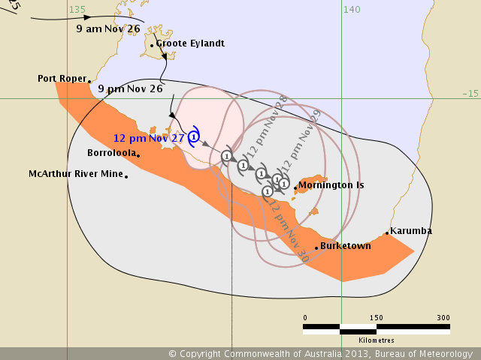

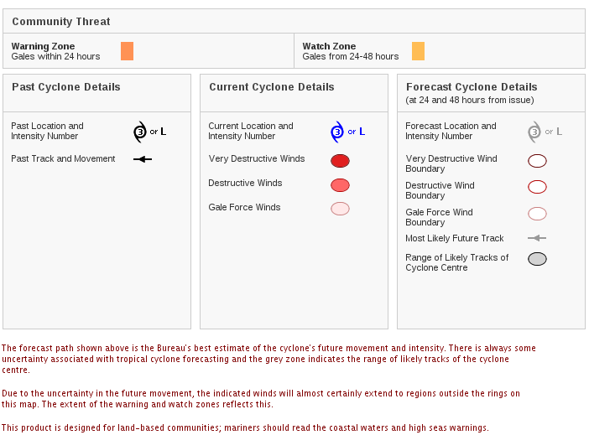
Headline
Tropical Cyclone Alessia develops in the Gulf of Carpentaria

Areas affected
Warning zone: Port Roper to Karumba
Watch zone: Nil
Details of Tropical Cyclone Alessia at 1:00pm AEST:
Intensity: category 1, sustained winds near centre 65 kilometres per hour with gusts 90 kilometres per hour.
Location: within 30 kilometres of 15.7 degrees South, 137.3 degrees East.
Movement: southeast at 10 kilometres per hour.

Hazards
Damaging winds with gusts to 120km/hr are expected to develop about coastal areas between Borroloola and the Northern Territory/Queensland border today and possibly extending to coastal areas between the Northern Territory/Queensland border and Karumba during Thursday.

Community Alerts
People between Port Roper and Karumba should take precautions and listen to the next advice at 5pm.
  - Information is available from your local government
  - For cyclone preparedness and safety advice, visit Queensland's Disaster Management Services website (www.disaster.qld.gov.au)
  - For emergency assistance call the Queensland State Emergency Service (SES) on 132 500 (for assistance with storm damage, rising flood water, fallen trees on buildings or roof damage).
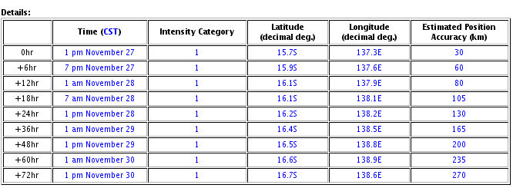
Tropical Cyclone information is also available in MetEye.
Next Issue
The next Forecast Track Map will be issued by 5:00 pm AEST Wednesday

  - Tropical Cyclone Technical Bulletin
TROPICAL CYCLONE TECHNICAL BULLETIN:
Issued by Australian Bureau of Meteorology
Tropical Cyclone Warning Centre
at: 0648 UTC 16/01/2011
Name: Severe Tropical Cyclone Zelia
Identifier: 10U
Data At: 0600 UTC
Latitude: 19.0S
Longitude: 158.7E
Location Accuracy: within 20 nm (35 km)
Movement Towards: southeast (130 deg)
Speed of Movement: 24 knots (44 km/h)
Maximum 10-Minute Wind: 85 knots (155 km/h)
Maximum 3-Second Wind Gust: 120 knots (220 km/h)
Central Pressure: 957 hPa
Radius of 34-knot winds NE quadrant: 120 nm (220 km)
Radius of 34-knot winds SE quadrant: 100 nm (185 km)
Radius of 34-knot winds SW quadrant: 60 nm (110 km)
Radius of 34-knot winds NW quadrant: 120 nm (220 km)
Radius of 48-knot winds NE quadrant: 40 nm (75 km)
Radius of 48-knot winds SE quadrant: 40 nm (75 km)
Radius of 48-knot winds SW quadrant: 40 nm (75 km)
Radius of 48-knot winds NW quadrant: 40 nm (75 km)
Radius of 64-knot winds: 25 nm (45 km)
Radius of Maximum Winds:
Dvorak Intensity Code: T5.0/5.0/D1.5/24HRS
Pressure of outermost isobar: 1000 hPa
Radius of outermost closed isobar: 150 nm (280 km)
FORECAST DATA
Date/Time Location Loc. Accuracy Max Wind Central Pressure
(UTC) degrees nm (km) knots(km/h) hPa
+12: 16/1800 22.8S 162.1E 070 (130) 080 (150) 960
+24: 17/0600 27.3S 165.5E 100 (185) 065 (120) 971
+36: 17/1800 32.3S 168.6E 125 (230) 035 (065) 990
+48: 18/0600 38.3S 171.4E 155 (285) 035 (065) 988
+60: 18/1800 44.9S 176.9E 190 (350) 030 (055) 989
+72: 19/0600 51.1S 175.2W 245 (455) 030 (055) 986
REMARKS:
Dvorak based on eye pattern with B surround and LG centre, giving DT of 5.0. MT and PT both suggest 5.0. FT based on DT. Severe Tropical Cyclone Zelia has rapidly intensified over the past 24 hours while moving into a more favourable environment for development with weak vertical wind shear and very warm sea surface temperatures. Zelia has also increased in speed during today with the development of an upper trough across the western Coral Sea, allowing north-westerly mid-level steering to develop.
Zelia will begin to move over cooler sea surface temperatures south of New Caledonia on Monday and as a result should begin to weaken during the day.

The next bulletin for this system will be issued by Nadi RSMC.

  - Storm Tide Advice

IDQ20017
Australian Bureau of Meteorology
Tropical Cyclone Warning Centre

Storm Tide Warning
Issued at 12:12 pm AEST on Monday 27 March 2017.

Technical Information - not suitable for public dissemination

SITUATION
Below is the forecast based on the 10am forecast track map.

Tropical cyclone Debbie, category 3, is intensifying as it moves in a south-westerly direction towards the coast. The system is expected to intensify further to category 4 prior to making landfall on Tuesday morning.

The forecast track is based on a category 4 system crossing near the high tide on Tuesday morning. The forecast storm tide values are highly dependent on the crossing timing in relation to the local tide times, as well as the specific crossing location. The worst-case scenarios are generally based on a slightly stronger system crossing the coast close to each location. Impacts are likely to be most significant around the high tide Tuesday, depending on the time and location of crossing.

STORM TIDE: WORST CASE SCENARIO
Location Tide Storm Wave Storm Storm Storm
(m above Surge setup Tide Tide Tide
LAT) (m) (m) (m above (m above (m above
LAT) AHD) HAT)
Laguna Quays 5.4m
11:18 AM
28 Mar 4.5 0.0 9.9 7.1 3.6
Molongle Creek 2.6m
7:18 AM
28 Mar 4.2 0.0 6.7 5.1 3.0
Abbot Point 3.1m
9:08 AM
28 Mar 2.7 0.8 6.6 4.9 3.0
Bowen 3.2m
9:58 AM
28 Mar 3.1 0.0 6.3 4.6 2.6
Mackay 6.0m
10:38 AM
28 Mar 2.8 0.4 9.2 6.1 2.5
Airlie Beach 3.3m
9:58 AM
28 Mar 2.3 0.5 6.1 4.3 2.1
Alva 3.1m
9:48 AM
28 Mar 2.2 0.4 5.7 4.1 2.0
Townsville 3.4m
8:58 PM
28 Mar 1.2 0.3 5.0 3.1 0.9
Hamilton Marina 4.1m
10:48 AM
28 Mar 1.4 0.0 5.5 3.4 0.6

STORM TIDE: FORECAST TRACK SCENARIO
Location Tide Storm Wave Storm Storm Storm
(m above Surge setup Tide Tide Tide
LAT) (m) (m) (m above (m above (m above
LAT) AHD) HAT)
Laguna Quays 5.2m
10:48 AM
28 Mar 2.4 0.1 7.7 4.8 1.4
Molongle Creek 3.2m
9:28 AM
28 Mar 0.2 0.1 3.4 1.7 -0.3
Abbot Point 3.1m
9:58 AM
28 Mar 0.8 0.6 4.4 2.8 0.8
Bowen 3.2m
9:38 AM
28 Mar 1.4 0.1 4.7 3.0 1.0
Mackay 6.0m
10:38 AM
28 Mar 1.3 0.3 7.5 4.5 0.8
Airlie Beach 3.4m
10:18 AM
28 Mar 1.7 0.5 5.6 3.8 1.6
Alva 3.2m
9:08 AM
28 Mar 0.0 0.2 3.4 1.8 -0.3
Townsville 3.7m
8:48 AM
28 Mar 0.0 0.1 3.8 2.0 -0.3
Hamilton Marina 4.1m
10:28 AM
28 Mar 1.0 0.0 5.1 2.9 0.2

Notes:

1. Advice values do not represent all factors that can contribute to inundation or damage.
2. Rivers, erosion and highly localised effects are not represented.
3. Wave set-up is included in storm tide, but wave run-up is excluded.
4. Water level values are objective estimates based on many variations of the most recent TC forecast track map.
5. Track variations are processed into summary scenarios for each location separately.
6. Water levels higher than the "Worst Case Scenario" are possible.
7. "Worst Case" can be thought of the height for which there remains 1 in 50 chance of storm tide going even higher.
8. "Forecast Track" heights are linked to the latest track map but do not have an associated likelihood.
9. "Forecast Track" heights can vary more abruptly than likelihood values across the full TC event.
10. Tide values are at the specified time for each location and are not the highest tide for the day.
11. AHD is the Australian Height Datum
12. HAT is the Highest Astronomical Tide reference (caution: HAT values are known to differ between sources).
13. LAT is the Lowest Astronomical Tide reference (caution: LAT values are known to differ between sources).

ONSET OF DAMAGING WINDS

Wind gusts expected to exceed 100 kilometres per hour are expected at:

Location Earliest Onset Time Forecast Track Onset
(EST) Time (EST)
Laguna Quays 27 Mar 27 Mar
2:00 PM 5:00 PM
Molongle Creek 28 Mar 28 Mar
2:00 AM 7:00 AM
Abbot Point 27 Mar 28 Mar
5:00 PM 4:00 AM
Bowen 27 Mar 28 Mar
3:00 PM 3:00 AM
Mackay 27 Mar
3:00 PM
Airlie Beach 27 Mar 27 Mar
1:00 PM 3:00 PM
Alva 28 Mar 28 Mar
3:00 AM 10:00 AM
Townsville 28 Mar
8:00 AM
Hamilton Marina 27 Mar 27 Mar
1:00 PM 1:00 PM

The next Storm Tide Warning will be issued by 6:30pm AEST Monday 27 March 2017.

Contact for Tropical Cyclone forecasts and warning details:
Bureau of Meteorology Operations Lead - Telephone (08) 9263 xxxx

  - Graphical Storm Tide Advice
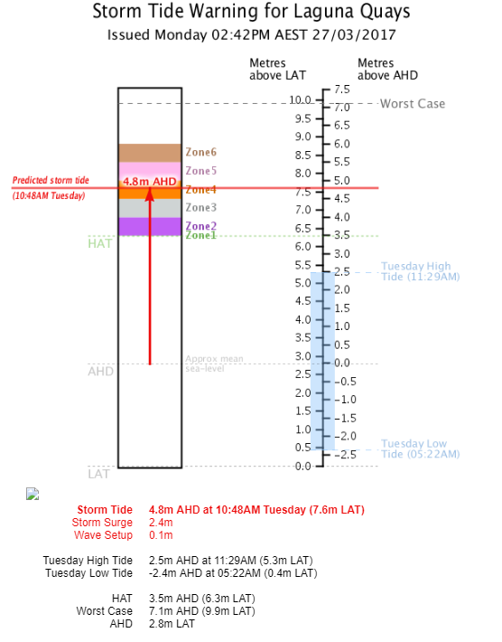

  - Ocean Wind Warning
WTAU03 ADRM 211953
IDD20130
Australian Bureau of Meteorology
Tropical Cyclone Warning Centre

40:2:2:24:14S140E400:11:00
SECURITE

OCEAN WIND WARNING

OCEAN WIND WARNING FOR METAREA 10/11
Issued by the AUSTRALIAN BUREAU OF METEOROLOGY
Issued at 1953UTC 21 MARCH 2019

PLEASE BE AWARE
Wind gusts can be a further 40 percent stronger than the averages
given here, and maximum waves may be up to twice the height.

HURRICANE FORCE WIND WARNING FOR NORTHERN AREA

SITUATION
At 1800 UTC Tropical Cyclone Trevor was centred within 15 nautical miles of
latitude fourteen decimal one south (14.1S)
longitude one hundred and forty decimal three east (140.3E)
Recent movement : southwest at 7 knots
Maximum winds : 60 knots
Central pressure: 981 hPa

AREA AFFECTED
Within 80 nautical miles in NE quadrant
and within 90 nautical miles in SE quadrant
and within 100 nautical miles in SW quadrant
and within 80 nautical miles in NW quadrant.

FORECAST

Maximum winds to 60 knots near the centre increasing to 90 knots by 0600 UTC 22
March.

Winds above 64 knots developing within 20 nautical miles of centre with very
high to phenomenal seas.

Winds above 48 knots within 20 nautical miles of centre with very rough to high
seas and heavy swell.

Winds above 34 knots within 50 nautical miles in NE quadrant
and within 50 nautical miles in SE quadrant
and within 90 nautical miles in SW quadrant
and within 50 nautical miles in NW quadrant with rough to very rough seas and
moderate to heavy swell.

Forecast positions
At 0600 UTC 22 March: Within 35 nautical miles of 14.7 south 139.3 east
Central pressure 950 hPa.
Winds to 90 knots near centre.
At 1800 UTC 22 March: Within 60 nautical miles of 15.5 south 138.1 east
Central pressure 940 hPa.
Winds to 105 knots near centre.

REMARKS
All ships in the area please send weather reports every three hours. Regular weather observing ships use normal channels. Other ships please use email to tcwc@bom.gov.au.

Next warning will be issued by 0130 UTC 22 March 2019.

  - CREX Bulletin
CREX++
T000101 A007 B01033 B01025 B01027 D01011 D01012
D01023 B02041 B19001 B19007 B19005 B19006 B19008
B08005 B10004 B08005 B10004 B19007 B08005 B08021 B04075 B11040 B19007
R05004 B05021 B05021 R02002 B19003 B19009++
065 10U ZELIA 2011 01 16 06 00
-1900 15870 00 04 0278 130 01209
3 01 09570 02 10000 0278 03 02 10 0437 0041
36000 09000 025 0074 015 0222
09000 18000 025 0074 015 0185
18000 27000 025 0074 015 0111
27000 36000 025 0074 015 0222++
7777

  - Satellite Analysis Bulletin
Australian Bureau of Meteorology
Tropical Cyclone Warning Centre

SATELLITE ANALYSIS BULLETIN
0732 UTC 25 January 2011

Tropical Cyclone Wilma
251100 UTC

21.4S 177.4W

Analysis based on: GOES enhanced IR image at 0652UTC.

Latitude Detection Sum: 7

Longitude Detection Sum: 19

T5.0/5.0/D1.5/24HRS

Eye pattern with LG surround and OW centre, giving DT of 5.0.MT 4.0 and PT 4.5.
FT based on DT as it is clear.

Next Satellite Analysis Bulletin will be issued at 262300 UTC

  - Special Advisory for the Solomon Islands
Australian Bureau of Meteorology
Tropical Cyclone Warning Centre

SOLOMON ISLANDS ADVISORY
Issued at 1316 UTC on 30/01/11
Special Advisory Number 3

Tropical Cyclone Yasi at 301200 UTC
Located at
Latitude: 13.9S
Longitude: 167.7E

Moving: W/SW at 10 knots

Central Pressure: 987 hPa

Mean maximum winds to 45 knots with maximum gusts to 65 knots, increasing to 55 knots with gusts to 75 knots by 310000UTC.

The system is intensifying.

Expect gales out to 150 nautical miles in the eastern semicircle and out to 60 nautical miles in the southwest quadrant.

Expect storm force winds to develop out to 40 nautical miles within the next 12 to 18 hours.

Expect hurricane force winds to develop out to 20 nautical miles within 24 to 36 hours.

Gales are likely to continue about southern Santa Cruz Islands near Tikopia and extend west towards Vanikolo within the next 12 hours. Gales could also develop about Rennell Island and Bellona Island within 24 to 36 hours.

Forecast position at 0000 UTC 31 January 2011
Latitude: 14.5S
Longitude: 165.0E

The next Special Advisory will be issued at 1630 UTC 30 January 2011

Please acknowledge receipt of this bulletin to the Australian Tropical Cyclone Warning Centre via email at tcwc@bom.gov.au

- Appendix 3: Product Identifiers
Product ID | Description
IDA25000 | Tropical Cyclone Probability of Wind Package
IDBDM007 | National GIS Tropical Cyclone Track Maps Bundle (without wind_areas)
IDC10021 | Tropical Cyclone Lines GIS Dataset
IDC10022 | Tropical Cyclone Points GIS Dataset
IDC10023 | Tropical Cyclone segments GIS dataset
IDD20015 | Tropical Cyclone Bulletin 1 - Northern Region - CREX (NT)
IDD20016 | Tropical Cyclone Bulletin 2 - Northern Region - CREX (NT)
IDD20020 | Tropical Cyclone Technical Bulletin 1 (NT)
IDD20021 | Tropical Cyclone Technical Bulletin 2 (NT)
IDD20130 | Ocean Wind Warning 1 - Metarea 10 Northern - Tropical Cyclone (NT)
IDD20150 | Tropical Cyclone Advice 1 (NT)
IDD20230 | Ocean Wind Warning 2 - Metarea 10 Northern - Tropical Cyclone (NT)
IDD20250 | Tropical Cyclone Advice 2 (NT)
IDD20300 | Tropical Cyclone Information Bulletin 1 (NT)
IDD20301 | Tropical Cyclone Information Bulletin 2 (NT)
IDD24500 | Tropical Cyclone Advice 1 - CAP (NT)
IDD24510 | Tropical Cyclone Advice 2 - CAP (NT)
IDD24600 | Tropical Cyclone Tweet 1 (NT)
IDD24610 | Tropical Cyclone Tweet 2 (NT)
IDD41170 | Tropical Cyclone Aviation Advisory 1 (NT)
IDD41171 | Tropical Cyclone Aviation Advisory 1 - Graphic (NT)
IDD41172 | Tropical Cyclone Aviation Advisory 1 - IWXXM (NT)
IDD41180 | Tropical Cyclone Aviation Advisory 2 (NT)
IDD41181 | Tropical Cyclone Aviation Advisory 2 - Graphic (NT)
IDD41182 | Tropical Cyclone Aviation Advisory 2 - IWXXM (NT)
IDD41225 | SIGMET - Non Tropical Cyclone 2 - YBBB (NT)
IDD41235 | SIGMET - Non Tropical Cyclone 2 - YMMM (NT)
IDD41240 | SIGMET - Tropical Cyclone 1 (NT)
IDD41250 | SIGMET - Tropical Cyclone 2 (NT)
IDD60001 | Cyclone Warnings - Perth (NT)
IDD60017 | Cyclone Warnings - Darwin (NT)
IDD60019 | Cyclone Warnings - Brisbane (NT)
IDD60123 | Tropical Cyclone Warnings Bulletin - High Seas Forecasts (NT)
IDD60124 | Tropical Cyclone Warnings Bulletin - Tropical Weather Advisories (NT)
IDD63023 | TTS 1196 Tropical Cyclone Warning List - Darwin (NT)
IDD65001 | Tropical Cyclone Forecast Track Map 1 - Graphic (NT)
IDD65002 | Tropical Cyclone Forecast Track Map 2 - Graphic (NT)
IDD65003 | Tropical Cyclone Forecast Track Map for WA - Graphic (NT)
IDD65004 | Tropical Cyclone Forecast Track Map for QLD - Graphic (NT)
IDD65011 | Tropical Cyclone Forecast Track Map 1 (NT)
IDD65012 | Tropical Cyclone Forecast Track Map 2 (NT)
IDD65013 | Tropical Cyclone Forecast Track Map for WA (NT)
IDD65014 | Tropical Cyclone Forecast Track Map for QLD (NT)
IDD65401 | Tropical Cyclone Forecast Track Map 1 - GML (NT)
IDD65402 | Tropical Cyclone Forecast Track Map 2 - GML (NT)
IDD65408 | Tropical Cyclone Forecast Track Map for WA - GML (NT)
IDD65409 | Tropical Cyclone Forecast Track Map for QLD - GML (NT)
IDD65441 | Tropical Cyclone Technical Bulletin 1 - CXML (NT)
IDD65442 | Tropical Cyclone Technical Bulletin 2 - CXML (NT)
IDD65443 | Tropical Cyclone Real-Time Event Data (NT System 1)
IDD65444 | Tropical Cyclone Real-Time Event Data (NT System 2)
IDD65461 | Tropical Cyclone Statistical Ensemble Tracks (NT 1)
IDD65462 | Tropical Cyclone Statistical Ensemble Tracks (NT 1)
IDD66031 | TTS Tropical Cyclone Advice 1 (NT)
IDD66032 | TTS Tropical Cyclone Advice 2 (NT)
IDD66035 | TTS Tropical Cyclone Advice 1 - WA Border Area (NT)
IDD66036 | TTS Tropical Cyclone Advice 1 - QLD Border Area (NT)
IDD66037 | TTS Tropical Cyclone Advice 2 - WA Border Area (NT)
IDD66038 | TTS Tropical Cyclone Advice 2 - QLD Border Area (NT)
IDD66044 | TTS Tropical Cyclone Information Bulletin 1 (NT)
IDD66045 | TTS Tropical Cyclone Information Bulletin 2 (NT)
IDD66061 | TTS Ocean Wind Warning 1 - Metarea 10 Northern - Tropical Cyclone - Radio (NT)
IDD66063 | TTS Ocean Wind Warning 2 - Metarea 10 Northern - Tropical Cyclone - Radio (NT)
IDDP0007 | QLD Tropical Cyclone Advice for System Affecting NT
IDDP0008 | QLD Tropical Cyclone Forecast Track Map for System Affecting NT - Graphic
IDDP0009 | QLD Tropical Cyclone Forecast Track Map for System Affecting NT
IDDP0010 | WA Tropical Cyclone Forecast Track Map for System Affecting NT - Graphic
IDDP0011 | WA Tropical Cyclone Forecast Track Map for System Affecting NT
IDM00005 | Tropical Cyclone Service Area boundaries
IDN29980 | Tropical Cyclone Warnings from Queensland (NSW)
IDN40487 | SIGMET - Tropical Cyclone (NSW)
IDNP0004 | QLD Tropical Cyclone Advice for System Affecting NSW
IDQ20008 | Ocean Wind Warning 1 - Metarea 10 Northeast - Tropical Cyclone (QLD)
IDQ20009 | Ocean Wind Warning 2 - Metarea 10 Northeast - Tropical Cyclone (QLD)
IDQ20015 | Tropical Cyclone Satellite Analysis Bulletin (QLD)
IDQ20016 | Tropical Cyclone Special Advisory - Solomon Islands (QLD)
IDQ20018 | Tropical Cyclone Technical Bulletin 1 (QLD)
IDQ20023 | Tropical Cyclone Advice 1 (QLD)
IDQ20026 | Tropical Cyclone Advice 2 (QLD)
IDQ20029 | Tropical Cyclone Advice 3 (QLD)
IDQ20056 | Tropical Cyclone Bulletin 1 - CREX (QLD)
IDQ20057 | Tropical Cyclone Bulletin 2 - CREX (QLD)
IDQ20058 | Tropical Cyclone Bulletin 3 - CREX (QLD)
IDQ20064 | Tropical Cyclone Advice - Norfolk Island (QLD)
IDQ20065 | Tropical Cyclone Information Bulletin 1 (QLD)
IDQ20066 | Tropical Cyclone Information Bulletin 2 (QLD)
IDQ20067 | Tropical Cyclone Information Bulletin 3 (QLD)
IDQ20068 | Tropical Cyclone Technical Bulletin 2 (QLD)
IDQ20069 | Tropical Cyclone Technical Bulletin 3 (QLD)
IDQ20074 | Ocean Wind Warning 3 - Metarea 10 Northeast - Tropical Cyclone (QLD)
IDQ24500 | Tropical Cyclone Advice 1 - CAP (QLD)
IDQ24510 | Tropical Cyclone Advice 2 - CAP (QLD)
IDQ24520 | Tropical Cyclone Advice 3 - CAP (QLD)
IDQ24600 | Tropical Cyclone Tweet 1 (QLD)
IDQ24610 | Tropical Cyclone Tweet 2 (QLD)
IDQ24620 | Tropical Cyclone Tweet 3 (QLD)
IDQ41170 | Tropical Cyclone Aviation Advisory 1 (QLD)
IDQ41171 | Tropical Cyclone Aviation Advisory 1 - Graphic (QLD)
IDQ41172 | Tropical Cyclone Aviation Advisory 1 - IWXXM (QLD)
IDQ41180 | Tropical Cyclone Aviation Advisory 2 (QLD)
IDQ41181 | Tropical Cyclone Aviation Advisory 2 - Graphic (QLD)
IDQ41182 | Tropical Cyclone Aviation Advisory 2 - IWXXM (QLD)
IDQ41190 | Tropical Cyclone Aviation Advisory 3 (QLD)
IDQ41191 | Tropical Cyclone Aviation Advisory 3 - Graphic (QLD)
IDQ41192 | Tropical Cyclone Aviation Advisory 3 - IWXXM (QLD)
IDQ48500 | SIGMET - Brisbane FIR - Tropical Cyclone 1 (QLD)
IDQ48600 | SIGMET - Brisbane FIR - Tropical Cyclone 2 (QLD)
IDQ48700 | SIGMET - Brisbane FIR - Tropical Cyclone 3 (QLD)
IDQ48800 | SIGMET - Brisbane FIR - Tropical Cyclone 4 (QLD)
IDQ60327 | Tropical Cyclone Warnings - Perth (QLD)
IDQ60328 | Tropical Cyclone Warnings - Darwin (QLD)
IDQ60329 | Tropical Cyclone Warnings - Brisbane (QLD)
IDQ65001 | Tropical Cyclone Forecast Track Map 1 - Graphic (QLD)
IDQ65002 | Tropical Cyclone Forecast Track Map 1 (QLD)
IDQ65003 | Tropical Cyclone Forecast Track Map 2 - Graphic (QLD)
IDQ65004 | Tropical Cyclone Forecast Track Map 2 (QLD)
IDQ65018 | Tropical Cyclone Forecast Track Map for NT - Graphic (QLD)
IDQ65019 | Tropical Cyclone Forecast Track Map for NT (QLD)
IDQ65026 | TTS 1196 Tropical Cyclone Warning List - Brisbane/Ipswich (QLD)
IDQ65027 | TTS 1196 Tropical Cyclone Warning List - Gold Coast (QLD)
IDQ65028 | TTS 1196 Tropical Cyclone Warning List - Sunshine Coast (QLD)
IDQ65029 | TTS 1196 Tropical Cyclone Warning List - Rockhampton (QLD)
IDQ65030 | TTS 1196 Tropical Cyclone Warning List - Townsville (QLD)
IDQ65031 | TTS 1196 Tropical Cyclone Warning List - Cairns (QLD)
IDQ65223 | Tropical Cyclone Forecast Track Map 3 - Graphic (QLD)
IDQ65224 | Tropical Cyclone Forecast Track Map 3 (QLD)
IDQ65230 | Tropical Cyclone Forecast Track Map for NSW - Graphic (QLD)
IDQ65231 | Tropical Cyclone Forecast Track Map for NSW (QLD)
IDQ65248 | Tropical Cyclone Forecast Track Map 1 - GML (QLD)
IDQ65249 | Tropical Cyclone Forecast Track Map 2 - GML (QLD)
IDQ65250 | Tropical Cyclone Forecast Track Map 3 - GML (QLD)
IDQ65251 | Tropical Cyclone Forecast Track Map for NT - GML (QLD)
IDQ65252 | Tropical Cyclone Forecast Track Map for NSW - GML (QLD)
IDQ65253 | Tropical Cyclone Forecast Track Map - Norfolk Island (QLD)
IDQ65254 | Tropical Cyclone Forecast Track Map - Norfolk Island - Graphic (QLD)
IDQ65255 | Tropical Cyclone Technical Bulletin 1 - CXML (QLD)
IDQ65256 | Tropical Cyclone Technical Bulletin 2 - CXML (QLD)
IDQ65257 | Tropical Cyclone Technical Bulletin 3 - CXML (QLD)
IDQ65355 | Tropical Cyclone Real-Time Event Data (QLD System 1)
IDQ65356 | Tropical Cyclone Real-Time Event Data (QLD System 2)
IDQ65357 | Tropical Cyclone Real-Time Event Data (QLD System 3)
IDQ65353 | Tropical Cyclone Statistical Ensemble Tracks (QLD 1)
IDQ65354 | Tropical Cyclone Statistical Ensemble Tracks (QLD 2)
IDQ65356 | Tropical Cyclone Statistical Ensemble Tracks (QLD 3)
IDQ66043 | TTS Tropical Cyclone Advice 1 (QLD)
IDQ66044 | TTS Tropical Cyclone Advice 2 (QLD)
IDQ66045 | TTS Tropical Cyclone Advice 3 (QLD)
IDQ66055 | TTS Tropical Cyclone Information Bulletin 1 (QLD)
IDQ66056 | TTS Tropical Cyclone Information Bulletin 2 (QLD)
IDQ66057 | TTS Tropical Cyclone Information Bulletin 3 (QLD)
IDQ66061 | TTS Ocean Wind Warning 1 - Metarea 10 Northeast - Tropical Cyclone (QLD)
IDQ66063 | TTS Ocean Wind Warning 2 - Metarea 10 Northeast - Tropical Cyclone (QLD)
IDQ66140 | TTS Ocean Wind Warning 3 - Metarea 10 Northeast - Tropical Cyclone (QLD)
IDQP0004 | NT Tropical Cyclone Advice for System Affecting QLD
IDQP0011 | NT Tropical Cyclone Forecast Track Map for System Affecting QLD - Graphic
IDQP0012 | NT Tropical Cyclone Forecast Track Map for System Affecting QLD
IDW20015 | Tropical Cyclone Bulletin 1 - Western Region - CREX (WA)
IDW20016 | Tropical Cyclone Bulletin 2 - Western Region - CREX (WA)
IDW20017 | Tropical Cyclone Bulletin 3 - Western Region - CREX (WA)
IDW23100 | Ocean Wind Warning 1 - Metarea 10 Western - Tropical Cyclone (WA)
IDW23200 | Ocean Wind Warning 2 - Metarea 10 Western - Tropical Cyclone (WA)
IDW23300 | Ocean Wind Warning 3 - Metarea 10 Western - Tropical Cyclone (WA)
IDW24000 | Tropical Cyclone Information Bulletin 1 (WA)
IDW24010 | Tropical Cyclone Information Bulletin 2 (WA)
IDW24020 | Tropical Cyclone Information Bulletin 3 (WA)
IDW24100 | Tropical Cyclone Advice 1 (WA)
IDW24200 | Tropical Cyclone Advice 2 (WA)
IDW24300 | Tropical Cyclone Advice 3 (WA)
IDW24400 | Tropical Cyclone Advice - Cocos Island and Christmas Island (WA)
IDW24500 | Tropical Cyclone Advice 1 - CAP (WA)
IDW24510 | Tropical Cyclone Advice 2 - CAP (WA)
IDW24520 | Tropical Cyclone Advice 3 - CAP (WA)
IDW24600 | Tropical Cyclone Tweet 1 (WA)
IDW24610 | Tropical Cyclone Tweet 2 (WA)
IDW24620 | Tropical Cyclone Tweet 3 (WA)
IDW27600 | Tropical Cyclone Technical Bulletin 1 (WA)
IDW27700 | Tropical Cyclone Technical Bulletin 2 (WA)
IDW27800 | Tropical Cyclone Technical Bulletin 3 (WA)
IDW41170 | Tropical Cyclone Aviation Advisory 1 (WA)
IDW41171 | Tropical Cyclone Aviation Advisory 1 - Graphic (WA)
IDW41172 | Tropical Cyclone Aviation Advisory 1 - IWXXM (WA)
IDW41180 | Tropical Cyclone Aviation Advisory 2 (WA)
IDW41181 | Tropical Cyclone Aviation Advisory 2 - Graphic (WA)
IDW41182 | Tropical Cyclone Aviation Advisory 2 - IWXXM (WA)
IDW41190 | Tropical Cyclone Aviation Advisory 3 (WA)
IDW41191 | Tropical Cyclone Aviation Advisory 3 - Graphic (WA)
IDW41192 | Tropical Cyclone Aviation Advisory 3 - IWXXM (WA)
IDW44710 | SIGMET - Perth-YBBB Tropical Cyclone (WA)
IDW44810 | SIGMET - Perth-YMMM Tropical Cyclone 1 (WA)
IDW44820 | SIGMET - Perth-YMMM Tropical Cyclone 2 (WA)
IDW44830 | SIGMET - Perth-YMMM Tropical Cyclone 3 (WA)
IDW60266 | Tropical Cyclone Forecast Track Map 1 - GML (WA)
IDW6026601 | Tropical Cyclone Forecast Map 1 - Fix
IDW6026602 | Tropical Cyclone Forecast Map 1 - Track
IDW6026603 | Tropical Cyclone Forecast Map 1 - Wind Areas
IDW6026604 | Tropical Cyclone Forecast Map 1 - Areas
IDW60267 | Tropical Cyclone Forecast Track Map 2 - GML (WA)
IDW6026701 | Tropical Cyclone Forecast Map 2 - Fix
IDW6026702 | Tropical Cyclone Forecast Map 2 - Track
IDW6026703 | Tropical Cyclone Forecast Map 2 - Wind Areas
IDW6026704 | Tropical Cyclone Forecast Map 2 - Areas
IDW60268 | Tropical Cyclone Forecast Track Map 3 - GML (WA)
IDW6026801 | Tropical Cyclone Forecast Map 3 - Fix
IDW6026802 | Tropical Cyclone Forecast Map 3 - Track
IDW6026803 | Tropical Cyclone Forecast Map 3 - Wind Areas
IDW6026804 | Tropical Cyclone Forecast Map 3 - Areas
IDW60280 | Tropical Cyclone Forecast Track Map 1 - Graphic (WA)
IDW60281 | Tropical Cyclone Forecast Track Map 1 (WA)
IDW60283 | Tropical Cyclone Forecast Track Map for NT - GML (WA)
IDW60284 | Tropical Cyclone Forecast Track Map 2 - Graphic (WA)
IDW60285 | Tropical Cyclone Forecast Track Map 2 (WA)
IDW60287 | Tropical Cyclone Forecast Track Map 3 - Graphic (WA)
IDW60288 | Tropical Cyclone Forecast Track Map 3 (WA)
IDW60294 | Tropical Cyclone Forecast Track Map for NT - Graphic (WA)
IDW60295 | Tropical Cyclone Forecast Track Map for NT (WA)
IDW60350 | Tropical Cyclone Technical Bulletin 1 - CXML (WA)
IDW60351 | Tropical Cyclone Technical Bulletin 2 - CXML (WA)
IDW60352 | Tropical Cyclone Technical Bulletin 3 - CXML (WA)
IDW65015 | TTS 1196 Tropical Cyclone Warning List - Perth (WA)
IDW65350 | Tropical Cyclone Real-Time Event Data (WA System 1)
IDW65351 | Tropical Cyclone Real-Time Event Data (WA System 2)
IDW65352 | Tropical Cyclone Real-Time Event Data (WA System 3)
IDW65353 | Tropical Cyclone Statistical Ensemble Tracks (WA 1)
IDW65354 | Tropical Cyclone Statistical Ensemble Tracks (WA 2)
IDW65355 | Tropical Cyclone Statistical Ensemble Tracks (WA 3)
IDW66207 | TTS Tropical Cyclone Advice 1 (WA)
IDW66208 | TTS Tropical Cyclone Advice 2 (WA)
IDW66209 | TTS Tropical Cyclone Advice 3 (WA)
IDW66210 | TTS Tropical Cyclone Information Bulletin 2 (WA)
IDW66211 | TTS Tropical Cyclone Information Bulletin 1 (WA)
IDW66220 | TTS Tropical Cyclone Advice - Cocos Island and Christmas Island (WA)
IDW66224 | TTS Tropical Cyclone Information Bulletin 3 (WA)
IDW66413 | TTS Ocean Wind Warning 1 - Metarea 10 Western - Tropical Cyclone (WA)
IDW66415 | TTS Ocean Wind Warning 2 - Metarea 10 Western - Tropical Cyclone (WA)
IDW66417 | TTS Ocean Wind Warning 3 - Metarea 10 Western - Tropical Cyclone (WA)
IDWP0004 | NT Tropical Cyclone Advice for System Affecting WA
IDWP0005 | NT Tropical Cyclone Forecast Track Map for System Affecting WA - Graphic
IDWP0006 | NT Tropical Cyclone Forecast Track Map for System Affecting WA
IDZ00025 | Tropical Cyclone ID code description list
IDZ20009 | National Tropical Cyclone for WMS

- Navigation aids
  - List of figures
Figure 1 Total Warning System 8
Figure 2 Tropical Cyclone Warning Centre areas of responsibility (AoR) in the South Pacific and South East Indian Ocean 12
Figure 3 Australian area of responsibility for providing tropical cyclone services 14
Figure 5 ICAO TCAC areas of responsibility 36
Figure 6 Nadi RSMC area of responsibility 37
Figure 7 Area of Interest for the Special Advisory for the Solomon Islands 39
Figure 8 Storm tide advice locations overview 44
Figure 9 Storm tide advice locations – WA view 1 45
Figure 10 Storm tide advice locations – WA view 2 46
Figure 11 Storm tide advice locations – WA view 3 47
Figure 12 Storm tide advice locations – NT view 1 48
Figure 13 Storm tide advice locations – NT view 2 49
Figure 14 Storm tide advice locations – NT view 3 50
Figure 15 Storm tide advice locations – NT/QLD view 51
Figure 16 Storm tide advice locations – QLD view 1 52
Figure 17 Storm tide advice locations – QLD view 2 53
Figure 18 Storm tide advice locations – QLD view 3 54
Figure 19 Storm tide advice locations – QLD view 4 55
Figure 20 Storm tide advice locations – QLD view 5 56
Figure 21 Visualisation of tidal planes as a function of tidal range 58
Figure 22 Highlight map – Aurukun 59
Figure 23 Highlight map – Boigu Island 60
Figure 24 Highlight map – Broad Sound 61
Figure 25 Highlight map – Laguna Quays 62
Figure 26 Highlight map – Balgal 63
Figure 27 Highlight map – Karratha 64
  - List of tables
Table 1 Australian area of responsibility 13
Table 2 Tropical Cyclone Category, Status and Wind Strength 16
Table 3 Time Zone Conversions 20
Table 4 Tropical Cyclone Information Bulletin – Product IDs and Issue times 22
Table 5 Tropical Cyclone Advice – product IDs and issue times 23
Table 6 Tropical Cyclone Forecast Track Map – product IDs and issue times. 26
Table 7 Tropical Cyclone Technical Bulletin – product IDs and issue times 27
Table 8 Storm Tide Advice – product IDs and Issue times 28
Table 9 Real-Time Event Data – product IDs and Issue times 29
Table 10 Tropical Cyclone Statistical Ensemble Tracks – product IDs and issue times 30
Table 11 CAP Tropical Cyclone Advice – product IDs and issue times 31
Table 12 GML Tropical Cyclone Forecast Track Map – product IDs and issue times 32
Table 13 Ocean Wind Warnings – product IDs and issue times 33
Table 14 Tropical Cyclone CREX Bulletin – product IDs and issue times 34
Table 15 Tropical cyclone Advisory – product IDs 36
Table 16 Nadi RSMC area of responsibility 38
Table 17 Tropical Cyclone Satellite Analysis Bulletin – product ID and issue time 38
Table 18 Special Advisory for the Solomon Islands Area 39
Table 19 Special Advisory for the Solomon Islands – product ID and issue times 39
Table 20 Storm tide advice locations 41

https://knowledge.aidr.org.au/media/9104/aidr_handbookcollection_publicinfoandwarnings_2021.pdf, pg. 5
https://public.wmo.int/en/programmes/tropical-cyclone-programme
https://community.wmo.int/en/ra-v-tropical-cyclone-committee-south-pacific-and-south-east-indian-ocean
https://community.wmo.int/en/tropical-cyclone-operational-plans links to RA-V Tropical Cyclone Operational Plan for the South Pacific and the South-East Indian Ocean
https://community.wmo.int/tropical-cyclone-operational-plans links to RA-I Tropical Cyclone Operational Plan for the South-West Indian Ocean
All references to gust values in tropical cyclone products are for indicative values only.
The third character of the product ID denotes the region (Western Australia, Darwin, Queensland.
Dvorak Current Intensity number of 2.0 or higher.

