Heatwave Service Level Specification

Season 2025–2026



Revision history
Date | Version | Description
24/06/2022 | 0.1 | Initial Draft
29/08/2022 | 0.2 | Updated to respond to feedback from Bureau teams
27/03/2023 | 0.3 | Updated to include example products from the 2022-2023 season
21/06/2023 | 0.4 | Converted to new Bureau template
8/09/2023 | 0.5 | Added 2 new tables to visualise the heatwave validity periods
23/10/2023 | 0.6 | Incorporating internal feedback
29/07/2024 | 1.1 | Draft update for 2024/2025
01/10/2024 | 2.0 | Finalised update for 2024/25
26/05/2025 | 2.1 | Draft update for 2025/2026
02/10/2025 | 2.2 | Draft update for 2025/2026

Review status
Date | Version | Description
2/2/2024 | 1.0 | Endorsed for approval
22/10/2024 | 2.0 | Endorsed for approval by GM-EPS
10/10/2024 | 3.0 | Endorsed for approval by GM-EPS

Release history
Date | Version | Status
09/02/2024 | 1.0 | Approved
06/11/2024 | 2.0 | Approved
21/11/2025 | 3.0 | Approved

Unless otherwise noted, all images in this document are licensed under the Creative Commons Attribution Australia Licence.
© Commonwealth of Australia 2025
Published by The Bureau of Meteorology
Cover image: People at a fair on a hot day in Eungella, Queensland, in October 2021 purchased under licence from iStockphoto.com.

Table of contents

1. Introduction 6

1.1. Purpose 6

1.2. Scope 7

1.3. Authority 7

1.4. Distribution 7

2. National Heatwave Services 8

2.1. Partnerships 8

2.2. Heatwave Season 9

2.3. Area of Responsibility 9

2.4. Dissemination of products 9

2.5. Briefing Services 9

2.6. Outposted Meteorologists 9

2.7. Communication and adoption activities 9

2.8. Service Continuity 10

3. Quality Assurance and Performance 10

3.1. Hazard Services Forum 10

3.2. National Heatwave Advisory Group 10

3.3. Performance Statistics and Reporting 10

3.4. Post Event Review 11

3.5. Meteorologist Training 11

4. National Heatwave Product Schedule 11

4.1. Routine Services 11

4.1.1. Geospatial Data Products 11

4.1.1.1. Purpose 11

4.1.1.2. Issue times and validity 12

4.1.1.3. Accessing geospatial data products 12

4.1.2. Web-based Heatwave Products 12

4.1.2.1. Purpose 12

4.1.2.2. Issue times and validity 13

4.1.2.3. Accessing the web-based heatwave products 13

4.1.3. Heatwave Decision Support Product 13

4.1.3.1. Purpose 13

4.1.3.2. Issue times and validity 13

4.1.3.3. Accessing the Heatwave Decision Support Product 14

4.2. Non-Routine Services 14

4.2.1. Heatwave Warning 14

4.2.1.1. Purpose 14

4.2.1.2. Issue times and validity 14

4.2.1.3. Accessing Heatwave Warnings 15

5. Appendix 1: Excess Heat Factor Calculation 16

5.1. Excess Heat Factor 16

6. Appendix 2: Public Weather District Maps 18

6.1. Western Australia Public Weather Districts 18

6.2. Northern Territory Public Weather Districts 19

6.3. Queensland Public Weather Districts 20

6.4. New South Wales and Australian Capital Territory Public Weather Districts 21

6.5. Victoria Public Weather Districts 22

6.6. Tasmania Public Weather Districts 23

6.7. South Australia Public Weather Districts 24

7. Appendix 3: Product Samples 25

7.1. Web-based Heatwave Map Products 25

7.2. Heatwave Decision Support Product 26

7.3. Heatwave Warning 29

8. Appendix 4: List of Product Identifiers 31

9. Navigation aids 32

9.1. List of figures 32

9.2. List of tables 32

9.3. List of acronyms 32

- Introduction
  - Purpose
The purpose of the Service Level Specification (SLS) is to document the heatwave services provided by the Bureau of Meteorology (the Bureau).
The Total Warning System recognises that a fully effective warning service is multi-faceted in nature. Therefore, its development and operation requires input from several agencies, each with specialised roles to play. It is vital that the agencies involved work collaboratively through all stages of developing and operating the system. The services described here are the Bureau’s contribution to the Total Warning System for heatwave services.
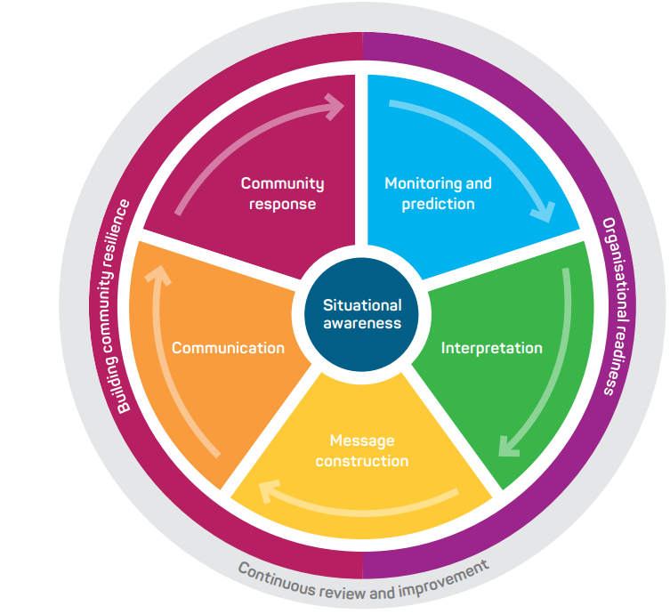
Figure 1. Total Warning System
As detailed in the National Heatwave Warning Framework the Bureau’s role in the heatwave warning system is focussed on: (i) monitoring and prediction; (ii) message construction; and (iii) communicating threats associated with weather conditions that influence heatwave impacts. The Bureau's role is to provide this service to Government, industry, and the community.
The Bureau also contributes to activities designed to strengthen organisational readiness and build community resilience. The Bureau achieves this through participating in the planning and coordination of activities with health and emergency services agencies and other key stakeholders.
  - Scope
The scope of the SLS is the Bureau's publicly available heatwave services and additional heatwave services provided to support health and emergency management agencies and key industry bodies.
The SLS details what the Bureau does and when it does it, to provide heatwave services. How the Bureau produces heatwave services is addressed in internal Bureau documents.
  - Authority
The Meteorology Act, 1955 (Cth) provides the Bureau with a number of functions including to take observations, forecast the weather and issue warnings for weather conditions likely to endanger life or property, including heatwaves. The Intergovernmental Agreement on the Provision of Bureau of Meteorology Hazard Services to the States and Territories (IGA) confirms the roles and responsibilities of the Bureau and State and Territory governments and local governments. The Bureau has responsibility for the provision of forecasting and warning services for heatwaves. The responsibility for heatwave preparation, response and providing more detailed warnings of heatwave impacts lies with State and Territory governments and local governments.
The Bureau of Meteorology Heatwave Service Level Specification is issued by the General Manager Environmental Prediction Services under the authority of the Director of Meteorology.
  - Distribution
This document will be distributed to members of the National Heatwave Advisory Group including members from the agencies listed in Table 1.

Jurisdiction | Agency Name
National | National Health and Emergency Management Standing Committee (NHEMS)
National | National Emergency Management Agency (NEMA)
National | Department of Health
National | Australian Energy Market Operator (AEMO)
National | National Broadband Network (NBN) – emergency management
WA | Department of Fire and Emergency Services (DFES)
WA | Department of Health
QLD | Queensland Police Service (QPS)
QLD | Department of Health
NT | Police, Fire and Emergency Services (PFES)
NT | Department of Health
NSW | NSW Reconstruction Authority
NSW | Department of Health
NSW | NSW Ambulance
ACT | Emergency Services Authority (ACT ESA)
ACT | Department of Health
ACT | Ambulance Service
SA | State Emergency Service (SES)
SA | Department of Health
TAS | Department of Health
VIC | Emergency Management Victoria (EMV)
VIC | Department of Health
Table 1. Heatwave SLS distribution list by jurisdiction
- National Heatwave Services
The Bureau's heatwave services provide the Australian community, health agencies and other relevant agencies with essential heatwave forecasts and warnings that are timely and accurate.
The heatwave service is designed to inform the community and response organisations of weather conditions that will lead to heatwave conditions. An important secondary role is to assist local media and state or territory health and emergency services with public education programs, and to advise on meteorological aspects of heatwave disaster preparedness and planning.
  - Partnerships
Partnerships underpin the delivery of effective heatwave services to the Australian community. The Bureau has formed partnerships with health and emergency management organisations, other government authorities and media organisations across the country to ensure that products are fit-for-purpose and are broadly distributed in a timely manner.
The partnerships with State and Territory Governments and local government are formalised through the National Heatwave Warning Framework and the IGA which clarifies and confirms responsibilities across the total warning system. As described in the framework, partner health and emergency services agencies at the state and territory level issue heatwave messaging aligned with the Australian Warning System.
Importantly, the Bureau, States and Territories agree to work together to mutually develop and maintain national standards for warnings of heatwaves. This is coordinated through the National Heatwave Advisory Group.
  - Heatwave Season
The heatwave season starts in early October and continues until the end of March. The season can be extended if periods of significant heat are expected to occur earlier in the year or continue past the end of March. Routine heatwave products are issued daily during the heatwave season, while heatwave warnings are issued as required throughout the year.
  - Area of Responsibility
The Bureau's heatwave services cover all Australian states, mainland territories and islands within Coastal Forecast boundaries. This is covered by the domain within 111.975°E - 155.080°E; 9.975°S - 44.525°S, as outlined in the registered users heatwave guide.
  - Dissemination of products
Publicly available Bureau heatwave products are transmitted via the Bureau's website and app. Products for health and other response agencies are transmitted by email, registered user web services and file transfer protocol (ftp).
  - Briefing Services
The Bureau provides briefings to Health and Emergency Management partners to assist planning, response, and coordination. The format, timing and frequency of briefings is determined through arrangements with each agency.
  - Outposted Meteorologists
The Bureau has arrangements with several federal, state and territory-based agencies to provide services through an embedded meteorologist service to support operational awareness and communication, as well as to deepen relationships and understanding between the two organisations. These outposted meteorologists will provide heatwave information as part of their briefings and services where relevant. In each instance, the services provided are agreed between the Bureau and the relevant agency and are provided on a cost recovery basis.
  - Communication and adoption activities
In addition to issuing products through standard communication channels (e.g., website, app, email), the Bureau undertakes a range of complementary communication and adoption activities in partnership with relevant agencies. These activities are aimed to increase the uptake and effectiveness of the forecasts and warnings and ensure consistent weather safety messages are provided to the community.
This includes community, industry and government preparedness briefings, social media campaigns, targeted community engagement activities and the Bureau's Heatwave knowledge centre web pages. During the season, this extends to joint press conferences and media interviews, as well as continuing social media public safety campaigns and community, industry and government briefings.
  - Service Continuity
The Bureau uses a number of strategies and contingency plans to maintain service continuity. Heatwave services are delivered by trained staff across multiple locations, allowing for service continuity in the case of failures in a specific office or team.
To maintain service continuity, the Bureau uses a large and diverse range of observational and forecast data in the delivery of its heatwave services. This provides redundancy if any data source is unavailable during operations and ensures all products and services are based on the best available information at all times.
- Quality Assurance and Performance
  - Hazard Services Forum
The IGA established the Hazards Services Forum (HSF) in 2018. The HSF facilitates consultation with State and Territory operational emergency service agencies to guide current and future strategic development of the Bureau of Meteorology’s hazard services.
The forum enables the States and Territories to request and prioritise changes to the Standard Services and to refer services that could be considered Supplementary Services to the Bureau for consideration. The HSF also assists with the process of consulting on modifications to Services Schedules.
  - National Heatwave Advisory Group
The National Heatwave Advisory Group (NHAG) will oversee the implementation, evaluation and review of the National Heatwave Warning Framework (the Framework), and the Bureau of Meteorology's (the Bureau's) heatwave service.
As an advisory group, the NHAG will consolidate and share heatwave related information and provide feedback and recommendations on the Bureau's heatwave service. Feedback and recommendations will be formally reported to the Hazards Services Forum (HSF) as the strategic body to discuss national resource prioritisation for the provision of the Bureau's hazards services to the states and territories.
  - Performance Statistics and Reporting
Bureau Heatwave products are verified against available observations and compiled into routine reports. These reports investigate the accuracy and timeliness of products issued and assist the continuous improvement cycle within the Bureau.
In circumstances where heatwaves are deemed to have had a significant impact on community safety and/or livelihoods, the Bureau may prepare an event report. The purpose of the report is to provide an overview of the meteorological aspects surrounding the event, as well as forecast and warning performance. This forms part of the Bureau's post event review process.
  - Post Event Review
The Bureau conducts internal post event reviews after heatwave events that have had a significant community or operational impact.
The insights and recommendations gained from these post event reviews are used to improve processes, systems and services delivered by the Bureau.
Depending on the impact from a heatwave event, this process may include a debrief with external partners. Upon request, the Bureau also contributes to post incident reviews conducted by health and emergency services agencies and government.
  - Meteorologist Training
The Bureau requires that meteorologists involved in delivering the heatwave service undergo peer-to-peer training prior to delivering the service operationally. This ensures that staff involved in analysing and forecasting heatwaves have the training and demonstrated ability to provide a high standard of heatwave services to the Australian community.
- National Heatwave Product Schedule
Heatwave services provided by the Bureau utilise gridded observed and forecast data covering the entire Australian domain, as defined in the Area of Responsibility above in section 2.3. The service utilises the Excess Heat Factor (EHF) to provide a measure of heatwave severity.
Detailed information on how the Excess Heat Factor is calculated is included in Appendix 1: Excess Heat Factor Calculation. For a complete listing of Public Weather Districts used for Heatwave Warnings, see Appendix 2: Public Weather District Maps.
Unless otherwise noted, all issue times in this document are quoted as local time for the relevant jurisdiction and time of year.
  - Routine Services
    - Geospatial Data Products
      - Purpose
Geospatial data products provide gridded heatwave data. The highest spatial resolution data is available in the NetCDF grids. These are at a 5km resolution across Australia and available for download via FTP. There are 4 different data products available:
- Excess Heat Factor (EHF)
- Excess Heat Factor – Severity (EHFsev)
- Heat Stress Acclimatisation (EHI accl)
- Significant Excess Heat (EHI sig)

A sample of these are available at ftp://ftp.bom.gov.au/anon/sample/catalogue/Heatwave/. Please note that due to most web browsers no longer supporting FTP, it is generally necessary to use an FTP client such as Filezilla to retrieve the sample files. Alternatively, they can be accessed via Windows File Explorer by pasting the above link into the address bar.
The user guide is available at http://reg.bom.gov.au/catalogue/heatwave.pdf (which also describes the generation of heatwave areas for the WMS product).
The heatwave WMS layer was previously a smoothed version of the data in the NetCDF grids. Due to the smoothing algorithm, some small areas of heatwave were smoothed out and did not appear on this product. The production process for the heatwave WMS layer has been changed this year to more accurately represent the gridded data and align with the information shown in heatwave warning maps. Page 27 of the user guide describes the Heatwave WMS layer http://reg.bom.gov.au/catalogue/GIS2Web.pdf.
Metadata information for the GIS layer is available at The Bureau of Meteorology Data Catalogue | Bureau Data Catalogue (bom.gov.au).
      - Issue times and validity
The heatwave geospatial data products are issued by around 14:15 AEDT daily during heatwave season. The information is valid for 7 three-day periods.
      - Accessing geospatial data products
Agencies will need to set up separate FTP and GIS2Web accounts to access all geospatial products. The Real Time Data Services team manages all account set up and administration: webreg@bom.gov.au.
    - Web-based Heatwave Products
      - Purpose
The web-based heatwave page contains the following:
- Search for a location function, including "Use my current location"
- Heatwave severity areas (low-intensity, severe, extreme) on a dynamic map (pan/zoom).
- Maps labelled with the last day of the 3-day heatwave period they represent.
- Listing of any heatwave warnings.
- Text description of the heatwave areas shown on the map, for accessibility purposes.
- Link to the Heatwave knowledge centre.

      - Issue times and validity
The Web-based Heatwave Products are issued at around 15:30 AEDT daily during heatwave season. The information is valid for 7 three-day periods. The first 2 maps are heatwave assessment periods and the following 5 maps are heatwave forecast periods. The maps are labelled with the last day of the 3-day heatwave period they represent.
Day −2 | Day −1  (yesterday) | Day +0  (today) | Day +1  (tomorrow) | Day +2 | Day +3 | Day +4 | Day +5 | Day +6
Heatwave Assessment Map 1
 | Heatwave Assessment Map 2
 |  | Heatwave Forecast Map 1
 |  |  | Heatwave Forecast Map 2
 |  |  |  | Heatwave Forecast Map 3
 |  |  |  |  | Heatwave Forecast Map 4
 |  |  |  |  |  | Heatwave Forecast Map 5
Table 2. Visualisation of the validity of the 7 heatwave maps that are issued each day.
      - Accessing the web-based heatwave products
The web-based heatwave products are available at: https://www.bom.gov.au/weather-and-climate/specialised-forecasts-and-observations/heatwave.
    - Heatwave Decision Support Product
      - Purpose
The Heatwave Decision Support Product (HDSP) is provided to Health and Emergency Service agencies and includes aggregated information to the weather district and town level based on the EHFsev gridded heatwave data. It covers 7 three-day periods with the dates listed in the tables being the first and last days of the three-day period.
The district severity summary forecast section shows the heatwave severity category for each district based on the highest severity affecting at least 10% of that district.
The district severity detailed forecast section shows the % area covered by each severity category. This allows users to understand how widespread the heatwave area is in the area of interest.
The Town Excess Heat Factor (EHF) detailed forecast section shows the numerical EHFsev values at each location. This provides information about the severity of the heatwave.
The HDSP should be used in conjunction with the geospatial data products and maps to understand where the heatwave risk is within the weather district.
      - Issue times and validity
The HDSP is issued by around 14:15 AEDT daily. The information is valid for 7 three-day periods.
      - Accessing the Heatwave Decision Support Product
The HDSP is available on the registered user webpage: https://reg.bom.gov.au/reguser/by_prod/HWDecisionSupport/#/.
Health and Emergency Services agencies responsible for heatwave response have been provided the username and password details to access this page.
The HDSP is also available in xlsx and csv formats via the FTP platform.
Agencies require an account to access FTP. The Real Time Data Services team manages all account set up and administration and can be contacted at webreg@bom.gov.au.
  - Non-Routine Services
    - Heatwave Warning
      - Purpose
The Heatwave Warning is issued when Severe or Extreme heatwaves are expected to affect at least 10% of a weather district. A Severe heatwave is defined as 10% or greater of a weather district meeting the EHFsev threshold: EHFsev >= 1 and EHFsev < 3. An Extreme heatwave is defined as 10% or greater of a weather district meeting the EHFsev threshold: EHFsev >=3.
A warning can be issued up to one day in advance of the heatwave starting (i.e. at 3pm on the day prior to the EHF reaching 1), to allow time for agencies and the public to take protective actions.
Agreed action statements will appear in the warning, depending on warning severity and timing. There is also a link to further information from the relevant state/territory authority.
The warning will include a description of the expected maximum and minimum temperatures, the timing of when the heatwave will peak and/or ease and affected towns and communities within the warning area.
      - Issue times and validity
Heatwave Warnings are issued by 3pm local time in all states and territories except Western Australia, where they are issued by 2pm local time. Warnings are updated daily during heatwave events and then cancelled at the end of the event.
The warning covers 4 overlapping three-day periods, extending out to 3 days in the future. A severe or extreme heatwave on one or more of those 4 periods will trigger a warning.
If a heatwave warning is triggered for the Heatwave Assessment 1 period shown in Table 3, but no warning for the state or territory has previously been issued for the event, the operational team will initiate a discussion with the decision support team and the lead heatwave agency to determine whether a warning should be issued. There is discretion to either issue or choose not to issue a warning based on these discussions.

Day −2 | Day −1  (yesterday) | Day +0  (today) | Day +1  (tomorrow) | Day +2 | Day +3 | Day +4 | Day +5 | Day +6
Heatwave Assessment 1
 | Heatwave Assessment Map 2
 |  | Heatwave Forecast Map 1
 |  |  | Heatwave Forecast Map 2
 |  |  |  | Heatwave Forecast Map 3
 |  |  |  |  | Heatwave Forecast Map 4
 |  |  |  |  |  | Heatwave Forecast Map 5
Heatwave Warning Map 1
 | Heatwave Warning Map 2
 |  | Heatwave Warning Map 3
 |  |  | Heatwave Warning Map 4
Table 3. Visualisation of the validity of the 4 maps included in the heatwave warning.
The PDF version of the Heatwave Warning contains 4 maps as described in Table 3. The maps are labelled with the first day of the 3-day heatwave period. The web-version contains the heatwave severity areas (low-intensity, severe, extreme) on a dynamic map (pan/zoom) for 7 three-day periods. The web version maps are labelled with the last day of the 3-day heatwave period.
      - Accessing Heatwave Warnings
Heatwave warnings appear on the web alongside other Bureau warnings at https://www.bom.gov.au/weather-and-climate/warnings-and-alerts, https://www.bom.gov.au/weather-and-climate/specialised-forecasts-and-observations/heatwave and on the Bureau's mobile app. Subscribers to the App can choose to receive push notifications when a heatwave warning is issued for their weather district.
A voice version of the heatwave warning is available on the Bureau's telephone weather service.
Partner agencies receive heatwave warnings via email.
Heatwave Warnings are included in the All Warnings Bundle for registered subscribers.

- Appendix 1: Excess Heat Factor Calculation
  - Excess Heat Factor
The Excess Heat Factor (EHF) is calculated based on average daily temperatures over three consecutive days. This is measured in relation to the local long-term climate (by comparing the three days to a climatological threshold for that particular location) and to the local recent past (by comparing the three days to observed temperatures over the previous thirty days at that particular location).
Details of the EHF Calculation as described by Nairn and Fawcett (2013) are shown below.
Significant excess heat (EHI_{sig}) is the three-day mean temperature anomaly relative to the 95th percentile climatology value at each location. The daily mean temperature (𝑇) is calculated as the average of the maximum and minimum temperatures recorded across the 24-hour period (9am to 9am local time) for each grid cell where the maximum temperature usually precedes the minimum temperature. Units are °C.
The significant excess heat index at a given grid cell for a particular date is calculated as:
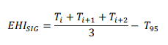
where 𝑖 is the day in the three-day heatwave period and 𝑖 = 1 is the first day in the sequence. 𝑇₉₅ is the 95th percentile of daily mean temperature 𝑇𝑖 for a grid cell for the climate reference period 1971-2000 across all days of the year.
Heat Stress (Acclimatisation) (EHI_{accl}) for a given grid cell on a particular date is the three-day mean temperature anomaly relative to the previous 30-day mean temperature value. This is calculated as:
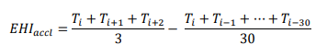
where 𝑖 = 1 is the first day in the three-day heatwave period.
Excess heat factor (EHF) is the combined effect of EHI_{sig} and EHI_{accl} and is calculated as:
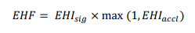
Heatwave conditions exist when EHF is positive.
Excess Heat Factor – Severity (EHF_{sev})
The EHF threshold for a severe heatwave varies by location and is taken to be the 85th percentile (𝐸𝐻𝐹₈₅) at each grid cell for all positive EHF values during the reference period 1958–2016.

To categorise heatwave severity, EHF is compared to the 85th percentile value at that grid cell. The EHF_{sev} is calculated as:
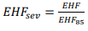
Heatwaves are classified into three severity levels (low-intensity, severe, extreme), based on EHF values exceeding EHFsev thresholds within an event. Thresholds, likely recurrence and likely impacts are listed below.
Low-Intensity Heatwave
- EHFsev > 0 and EHFsev < 1 – i.e., greater than zero but less than one
- Most common
- Most people can cope

Severe Heatwave
- EHFsev >= 1 and EHFsev < 3 – i.e., between one and three
- Less frequent
- Can impact vulnerable people

Extreme Heatwave
- EHFsev >= 3 – i.e., three or greater
- Rarest
- Capable of causing widespread health issues
- Can impact infrastructure such as power and transport

- Appendix 2: Public Weather District Maps
  - Western Australia Public Weather Districts
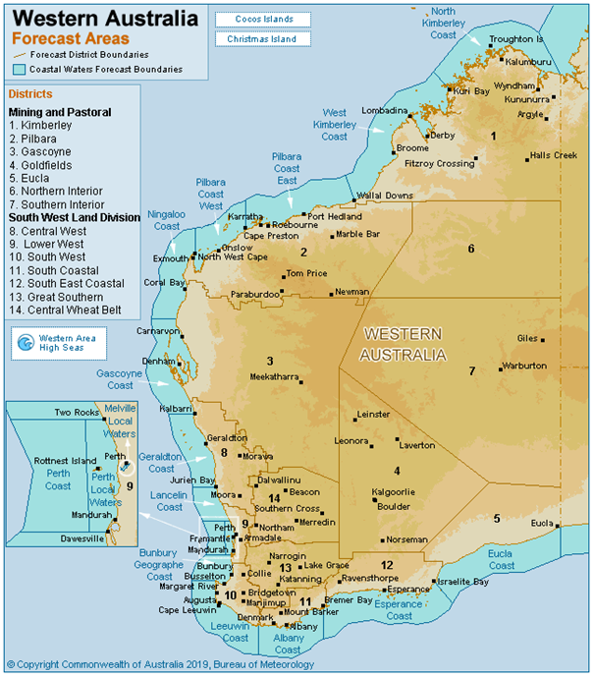
Figure 2. Map showing WA public weather districts.
  - Northern Territory Public Weather Districts
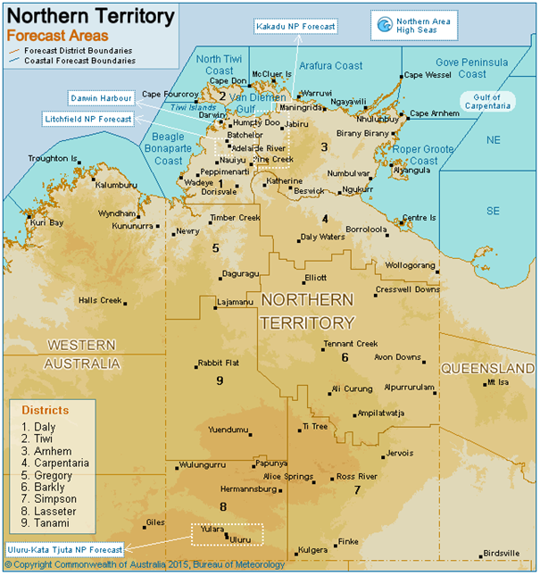
Figure 3. Map showing NT public weather districts.

  - Queensland Public Weather Districts
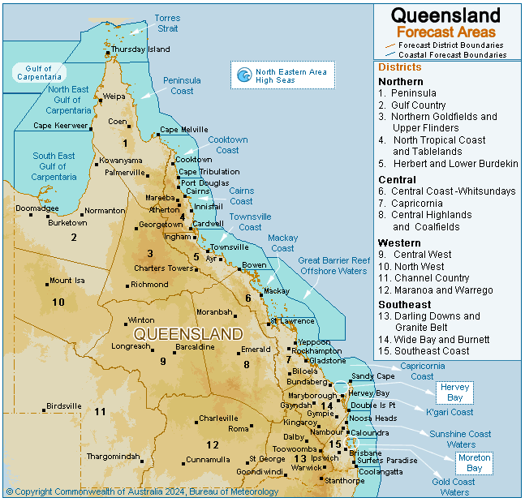
Figure 4. Map showing QLD public weather districts.
  - New South Wales and Australian Capital Territory Public Weather Districts
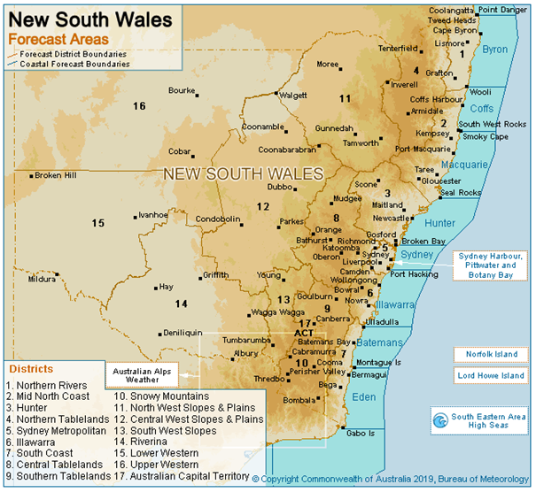
Figure 5. Map showing NSW and ACT public weather districts.
  - Victoria Public Weather Districts
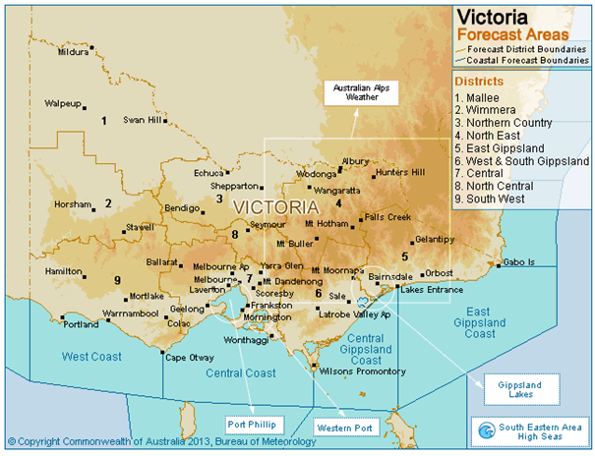
Figure 6. Map showing VIC public weather districts.
  - Tasmania Public Weather Districts
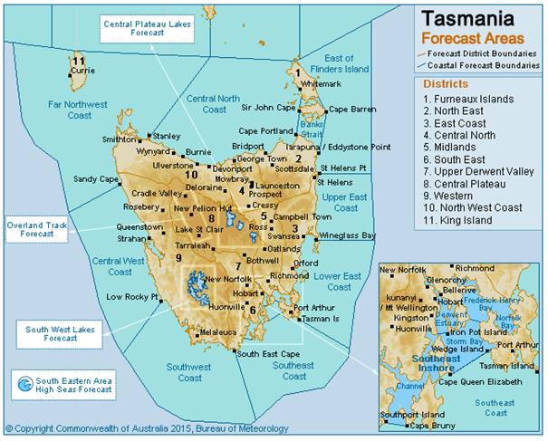
Figure 7. Map showing TAS public weather districts.

  - South Australia Public Weather Districts
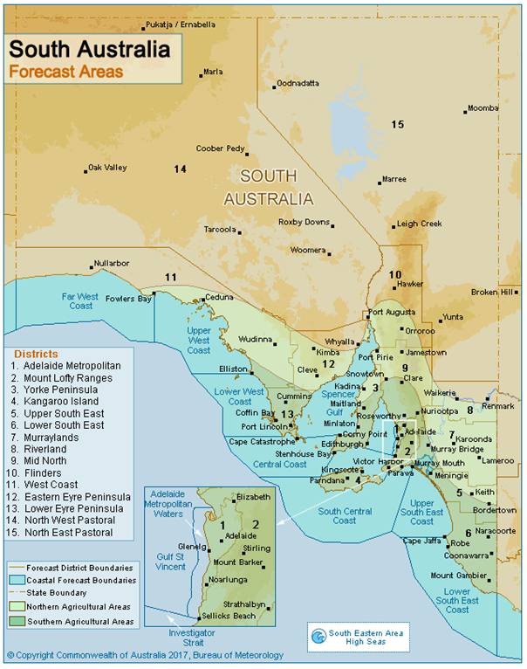
Figure 8. Map showing SA public weather districts.
- Appendix 3: Product Samples
  - Web-based Heatwave Map Products
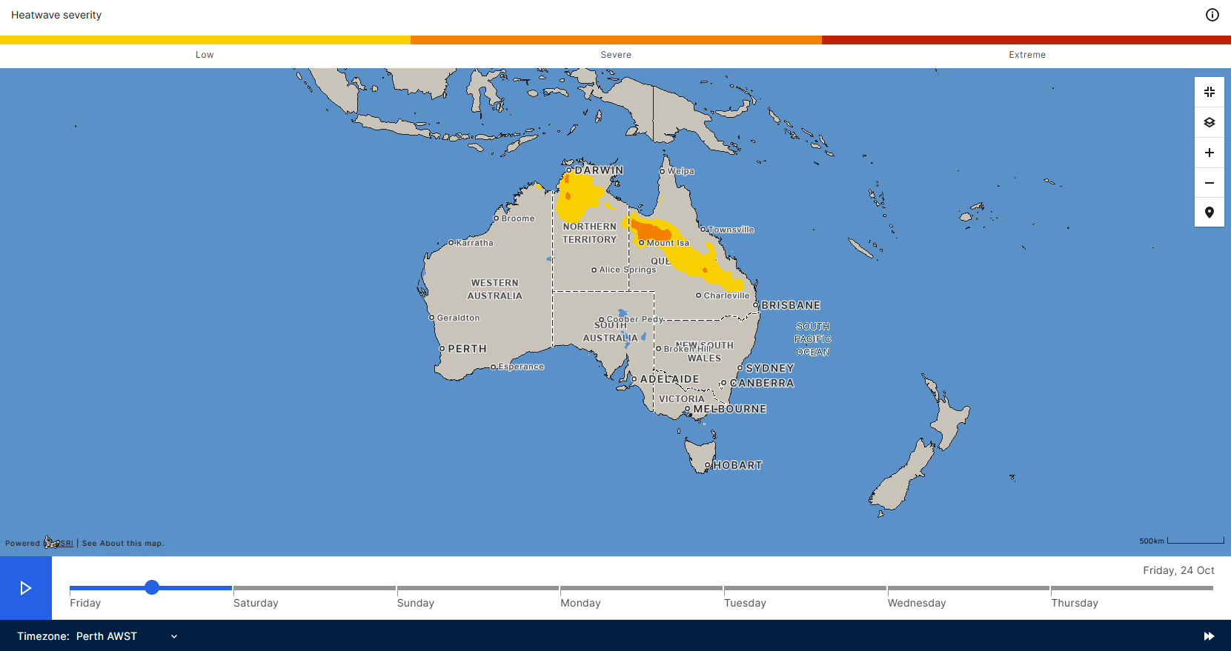
Figure 9. Heatwave Assessment Map
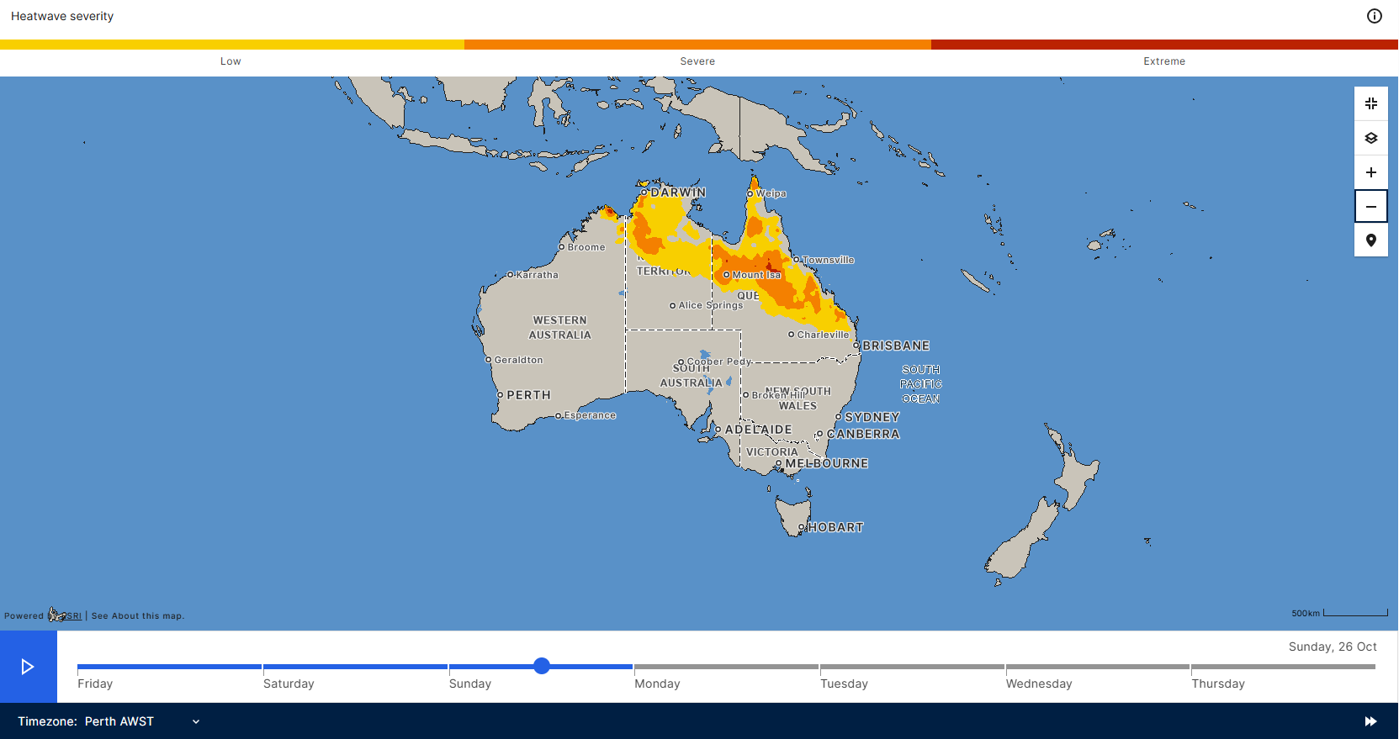
Figure 10. Heatwave Forecast Map
  - Heatwave Decision Support Product
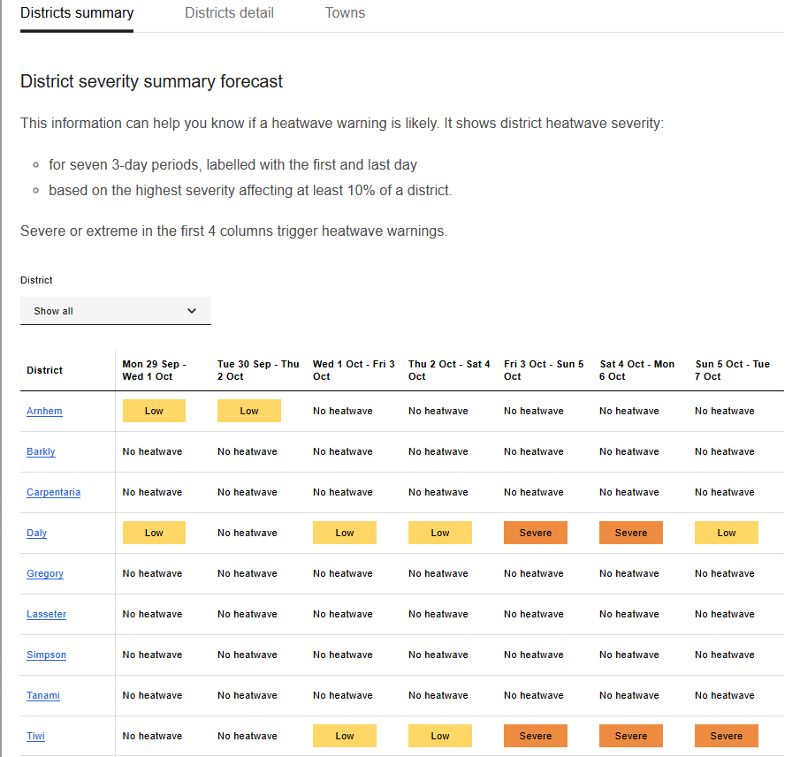
Figure 11. District summary component of the HDSP showing heatwave severity categories. Example from product issued for the Northern Territory on 1 October 2025.
The categories shown in the first four columns of the District Summary section are used to determine whether a heatwave warning is required for each weather district. The highest heatwave category in the 4 three-day periods is assigned for warning purposes.

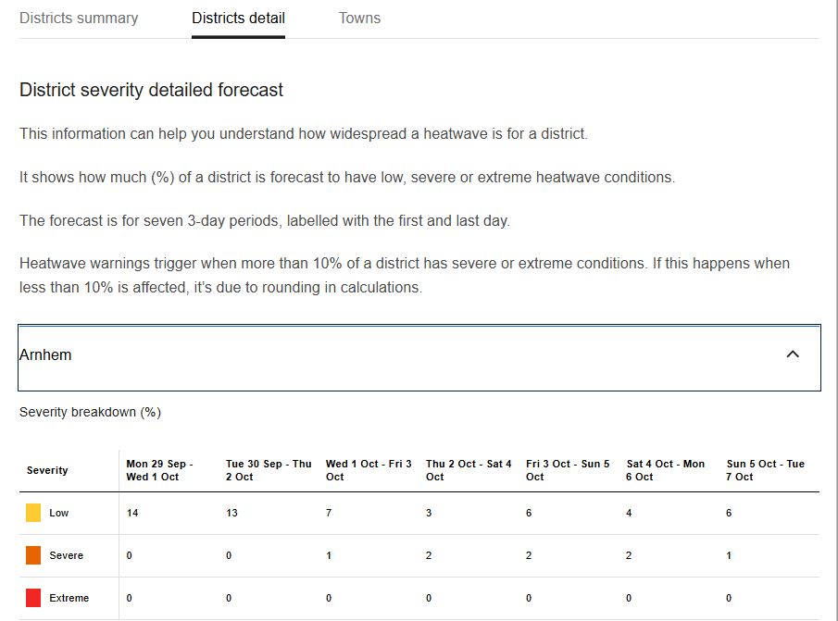
Figure 12. Detailed district section of the HDSP showing the percentage of the weather district in each heatwave severity category. Example from product issued for the Northern Territory on 1 October 2025.

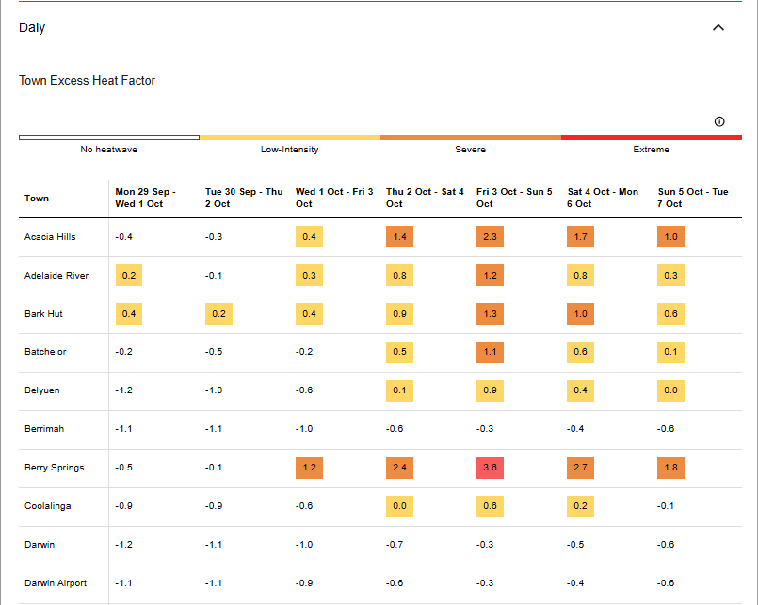
Figure 13. Town forecasts component of the HDSP showing numerical EHFsev values. Example from product issued for the Northern Territory on 1 October 2025.
  - Heatwave Warning
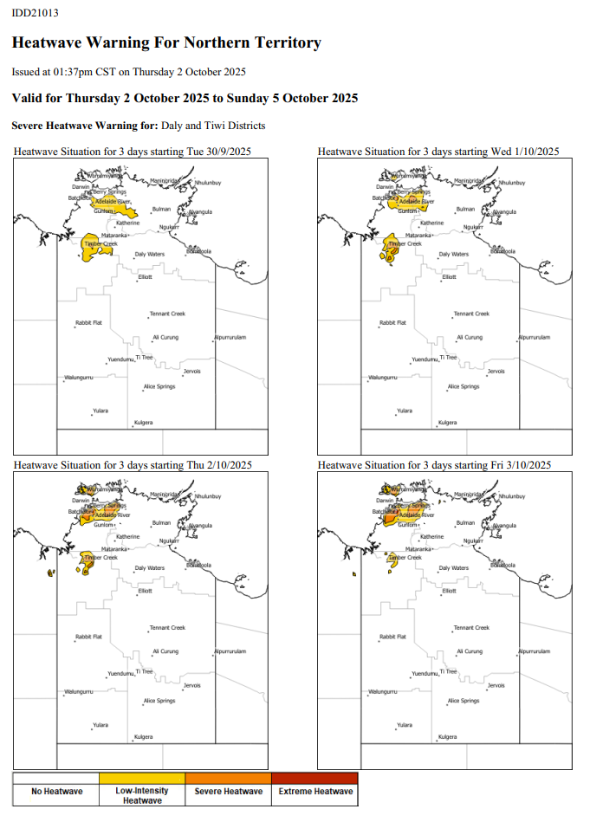

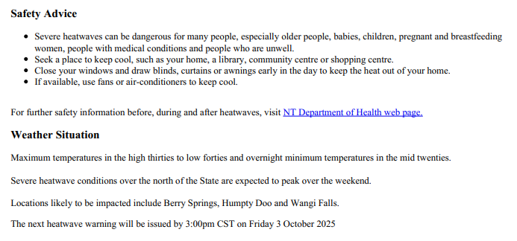
Figure 14. Heatwave Warning including the heading, image and text components. Example from product issued for the Northern Territory on 2 October 2025.

- Appendix 4: List of Product Identifiers
Product Identifier | Description | Coverage
IDY11001 | Heatwave Grid – Excess Heat Factor (EHF) | National
IDY11002 | Heatwave Grid – Excess Heat Factor – Severity (EHFsev) | National
IDY11003 | Heatwave Grid – Heat Stress (Acclimatisation) (EHI accl) | National
IDY11004 | Heatwave Grid – Significant Excess Heat (EHI sig) | National
IDBY1100 | Heatwave Grids – Bundle | National
IDY10008 | Australian Heatwave Forecast Summary | National
IDY10012 | Heatwave Shapefile for GIS2Web layer | National
IDW10015 | Heatwave Decision Support Product (WA) | WA
IDD10015 | Heatwave Decision Support Product (NT) | NT
IDQ10015 | Heatwave Decision Support Product (QLD) | QLD
IDN10115 | Heatwave Decision Support Product (NSW & ACT) | NSW & ACT
IDV10015 | Heatwave Decision Support Product (VIC) | VIC
IDT10015 | Heatwave Decision Support Product (TAS) | TAS
IDS10015 | Heatwave Decision Support Product (SA) | SA
IDW21013 | Heatwave Warning (WA) | WA
IDD21013 | Heatwave Warning (NT) | NT
IDQ21013 | Heatwave Warning (QLD) | QLD
IDN21013 | Heatwave Warning (NSW) | NSW
IDN21014 | Heatwave Warning (ACT) | ACT
IDV21013 | Heatwave Warning (VIC) | VIC
IDT21013 | Heatwave Warning (TAS) | TAS
IDS21013 | Heatwave Warning (SA) | SA
Table 4. Product identifiers for all heatwave products.

- Navigation aids
  - List of figures
Figure 1. Total Warning System 6
Figure 2. Map showing WA public weather districts. 18
Figure 3. Map showing NT public weather districts. 19
Figure 4. Map showing QLD public weather districts. 20
Figure 5. Map showing NSW and ACT public weather districts. 21
Figure 6. Map showing VIC public weather districts. 22
Figure 7. Map showing TAS public weather districts. 23
Figure 8. Map showing SA public weather districts. 24
Figure 9. Heatwave Assessment Map 25
Figure 10. Heatwave Forecast Map 25
Figure 11. District summary component of the HDSP showing heatwave severity categories. Example from product issued for the Northern Territory on 1 October 2025. 26
Figure 12. Detailed district section of the HDSP showing the percentage of the weather district in each heatwave severity category. Example from product issued for the Northern Territory on 1 October 2025. 27
Figure 13. Town forecasts component of the HDSP showing numerical EHFsev values. Example from product issued for the Northern Territory on 1 October 2025. 28
Figure 14. Heatwave Warning including the heading, image and text components. Example from product issued for the Northern Territory on 2 October 2025. 30
  - List of tables
Table 1. Heatwave SLS distribution list by jurisdiction 8
Table 2. Visualisation of the validity of the 7 heatwave maps that are issued each day. 13
Table 3. Visualisation of the validity of the 4 maps included in the heatwave warning. 15
Table 4. Product identifiers for all heatwave products. 31
  - List of acronyms
ACT | Australian Capital Territory
ADFD | Australian Digital Forecast Database
AFAC | Australasian Fire and Emergency Service Authorities Council
BMTC | Bureau of Meteorology Training Centre
EHF | Excess Heat Factor
FTP | File Transfer Protocol
GIS | Graphical Information System
HDSP | Heatwave Decision Support Product
HMA | Hazard Management Agency
HSF | Hazard Services Forum
ID | Identification (numbers or codes)
NEMA | National Emergency Management Agency
NetCDF | Network Common Data Form
NHAG | National Heatwave Advisory Group
NSW | New South Wales
NT | Northern Territory
NWP | Numerical Weather Prediction
PERM | Post Event Review Management
QLD | Queensland
SA | South Australia
SES | State Emergency Service
SLS | Service Level Specification
SOP | Standard Operating Procedures
TAS | Tasmania
VIC | Victoria
WA | Western Australia

https://knowledge.aidr.org.au/media/9104/aidr_handbookcollection_publicinfoandwarnings_2021.pdf, pg. 5.

