Fire Weather Service Level Specification
Season 2025–2026
Severe Weather Environmental Prediction Services

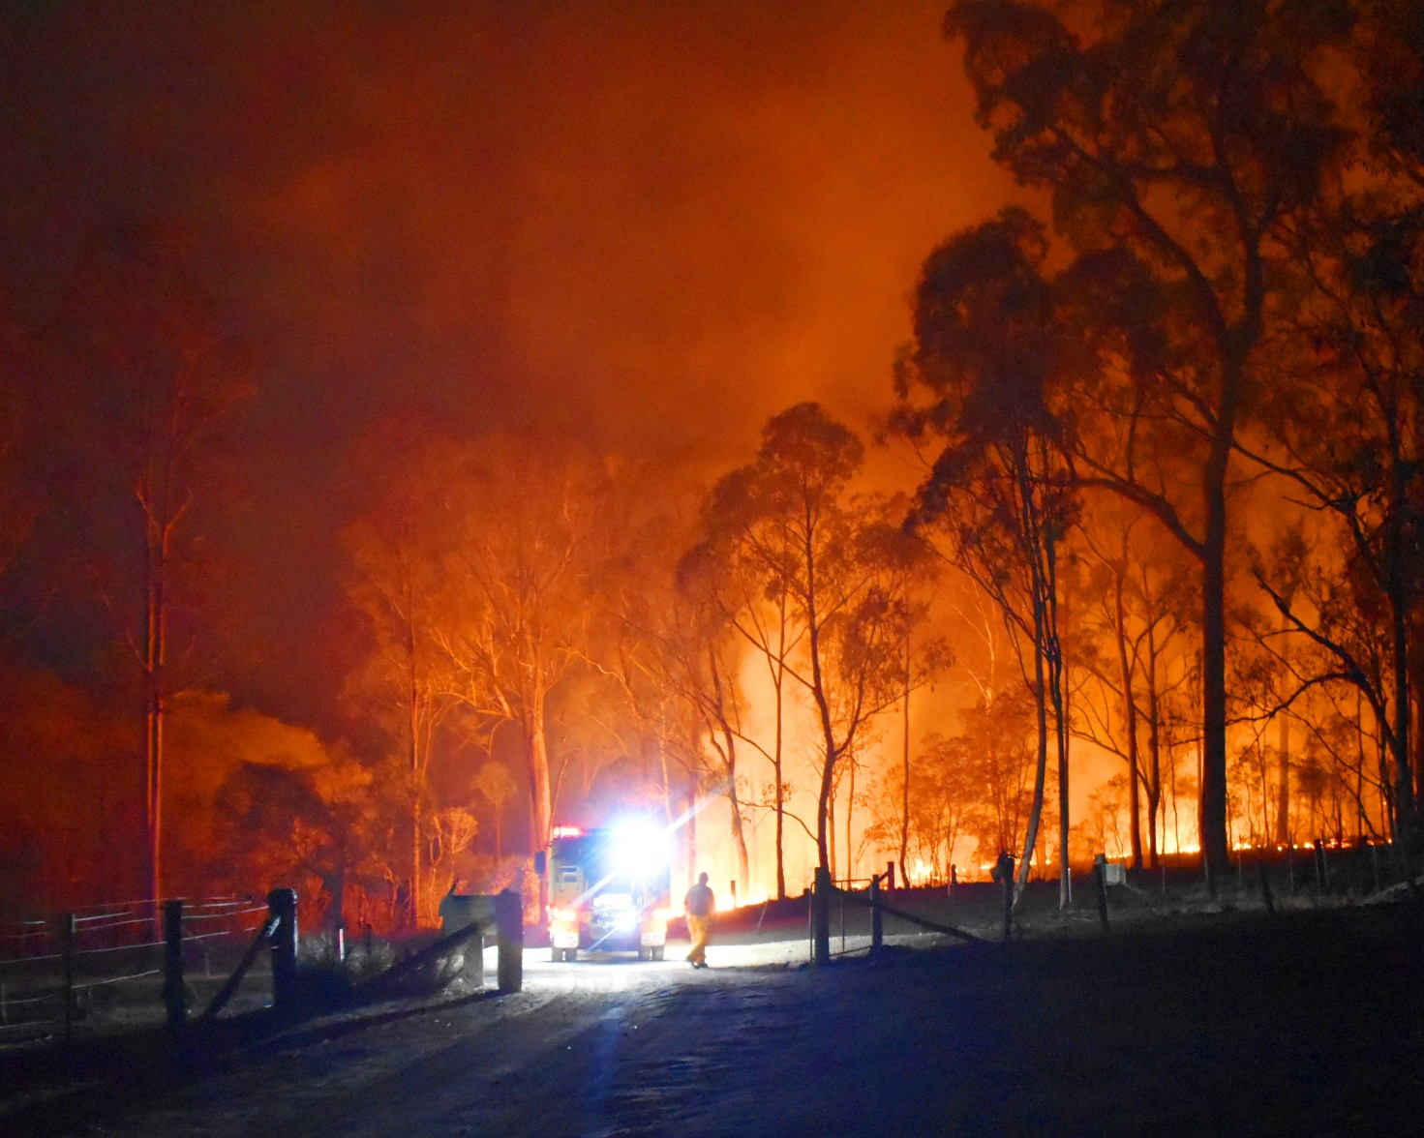

Revision history
Date | Version | Description
21/06/2023 | 2.1 | Draft for 2023 consultation
19/09/2023 | 2.2 | Draft for external feedback
18/12/2023 | 2.3 | Draft for 2023/2024
29/07/2024 | 3.1 | Draft for 2024/2025
29/11/2024 | 3.2 | Final draft 2024/2025
26/05/2025 | 4.1 | Draft for 2025/2026
01/10/2025 | 4.2 | Final draft 2025/2026

Review status
Date | Version
03/02/2022 | 1.0
10/03/2023 | 2.0
12/01/2024 | 3.0
13/12/2024 | 4.0
15/12/2025 | 5.0

Release history
Date | Version | Status
11/02/2022 | 1.0 | Approved
14/03/2023 | 2.0 | Approved
16/01/2024 | 3.0 | Approved
17/12/2024 | 4.0 | Approved
17/12/2025 | 5.0 | Approved

Unless otherwise noted, all images in this document are licensed under the Creative Commons Attribution Australia Licence.
© Commonwealth of Australia 2025
Published by The Bureau of Meteorology
Cover image: Gregory Fires, Queensland, purchased under licence from iStockphoto.com

Table of contents

1. Introduction 7

1.1. Purpose 7

1.2. Scope 8

1.3. Authority 8

1.4. Distribution 8

2. National Fire Weather Services 10

2.1. Australian Fire Danger Rating System (AFDRS) 10

2.2. Partnerships 10

2.3. Fire Weather Season 10

2.4. Area of Responsibility 11

2.5. Dissemination of products 12

2.6. Briefing Services 12

2.7. Embedded Meteorologists 12

2.8. Portable Automatic Weather Stations 12

2.9. Communication and adoption activities 12

2.10. Service Continuity 12

3. Quality Assurance and Performance 13

3.1. Hazard Services Forum 13

3.2. Performance Statistics and Reporting 13

3.3. Post Event Review 13

3.4. Meteorologist Training and Competency 13

4. National Fire Weather Product Schedule 14

4.1. Fuel Data 14

4.2. Routine Services 14

4.2.1. Australian Seasonal Bushfire Outlook 14

4.2.2. Fire Danger Outlook Products 15

4.2.3. Australian Digital Forecast Database 15

4.2.4. Fire Danger Ratings 16

4.2.4.1. Purpose 16

4.2.4.2. Determining Fire Weather District Ratings 16

4.2.4.3. Routine Issue and Validity Times 17

4.2.5. Fire Weather Forecast 18

4.2.5.1. Purpose 18

4.2.5.2. Routine Issue and Validity Times 18

4.2.5.3. Preliminary Fire Weather Forecast 18

4.2.5.4. Amendment Criteria for Fire Weather Forecasts and Warning 18

4.2.5.5. Content 19

4.2.6. Fire Weather Observations Bulletin 20

4.2.6.1. Purpose 20

4.2.6.2. Content 20

4.2.7. Ground Moisture Data 21

4.3. Non-Routine Services 21

4.3.1. Fire Weather Warning 21

4.3.1.1. Purpose 21

4.3.1.2. Issue Criteria, Times and Validity 21

4.3.1.3. Amendment Criteria 21

4.3.1.4. Content 22

4.3.1.5. Notes 22

4.3.2. Incident Weather Forecasts 22

4.3.2.1. Purpose 22

4.3.2.2. IWF Requests 22

4.3.2.3. Issue Time and Validity 23

4.3.2.4. Prioritisation of IWFs during busy periods 24

4.3.2.5. Guidance for Incident Weather Forecasts Amendment 24

4.3.2.6. Content 25

4.3.3. Wind Change Chart 26

4.3.3.1. Purpose 26

4.3.3.2. Issue Criteria, Times and Validity 26

4.3.3.3. Amendment Criteria 27

4.3.3.4. Content 27

4.3.3.5. Notes 27

4.3.4. Smoke Modelling 27

5. Appendix 1: AFDRS Fire Behaviour Index and Model Guides 29

6. Appendix 2: Fire Weather District Maps 30

7. Appendix 3: Product Samples 38

7.1. 4 Day Fire Danger Rating Forecast 38

7.2. 7 Day Fire Danger Rating Forecast 40

7.3. Fire Weather Forecast 41

7.4. Fire Weather Warning 44

7.5. Incident Weather Forecast 45

7.6. Incident Weather Forecast – 4 Day Outlook 47

7.7. Wind Change Charts 49

7.8. Fire Danger Outlooks 51

7.9. Ground Moisture Data 54

7.10. Fire Weather Observations Bulletin 55

8. Appendix 4: Product Identifiers 56

9. Navigation aids 69

9.1. List of figures 69

9.2. List of tables 69

9.3. List of acronyms 70

- Introduction
  - Purpose
The purpose of the Service Level Specification (SLS) is to document the fire weather services provided by the Bureau of Meteorology (the Bureau).
The Total Warning System recognises that a fully effective warning service is multi-faceted in nature and its development and operation involves input from several agencies each with specialised roles to play. It is vital that the agencies involved work in close cooperation through all stages of developing and operating the system. The services described here are the Bureau’s contribution to the Total Warning System for fire weather.

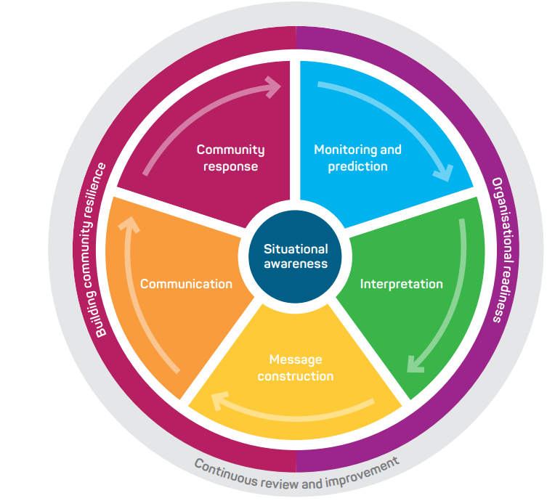
Figure 1. Total Warning System

The Bureau’s role in the fire weather warning system is focussed on (i) monitoring and prediction; (ii) message construction; and (iii) communicating threats and impacts associated with weather conditions that influence fire behaviour to Government, industry, and the community.
The Bureau also contributes to activities designed to strengthen organisational readiness and build community resilience and participates in the planning and coordination of activities with disaster mitigation agencies.
  - Scope
The scope of the SLS is the Bureau's publicly available fire weather services and additional services provided to support emergency management and other key stakeholders.
The SLS details what the Bureau does and when it does it, to provide fire weather services. How the Bureau produces fire weather services are addressed in internal Bureau documents.
  - Authority
The Meteorology Act, 1955 (Cth) provides the Bureau a number of functions including to take observations, forecast the weather and issue warnings for weather conditions including those likely to give rise to bush fires. The Intergovernmental Agreement on the Provision of Bureau of Meteorology Hazard Services to the States and Territories (IGA) confirms the roles and responsibilities of the Bureau and State and Territory governments and local governments. The Bureau has responsibility for the provision of forecasting and warning services for weather conditions likely to give rise to bush fires. The responsibility for bush fire preparation, response and warning of bush fires lies with State and Territory governments and local governments. The Schedule 2 of the IGA details the nationally agreed fire weather services.
The Bureau of Meteorology Fire Weather Service Level Specification is issued by the General Manager Environmental Prediction Services under the authority of the Director of Meteorology.
  - Distribution
This document will be distributed to the agencies listed in Table 1.
Jurisdiction | Agency Name
National | Australasian Fire and Emergency Services Authorities Council (AFAC) – Predictive Services Group (PSG)
National | National Emergency Management Agency (NEMA)
National | Australian Energy Market Operator (AEMO)
National | National Broadband Network (NBN) – emergency management
National | Australian Energy Market Operator: AEMO
WA | Department of Fire and Emergency Services (DFES)
WA | Department of Biodiversity, Conservation and Attractions, Parks and Wildlife Service (DBCA PWS)
QLD | Queensland Fire Department (QFD)
QLD | Parks and Wildlife Service (QPWS)
QLD | Queensland Police Service
NT | Police, Fire and Emergency Services (PFES)
NT | Bushfires NT
NSW | Rural Fire Service (NSW RFS)
NSW | National Parks and Wildlife Service (NPWS)
ACT | Emergency Services Authority (ACT ESA)
ACT | Rural Fire Service (ACT RFS)
ACT | Parks and Conservation (ACT PCS)
SA | Country Fire Service (CFS)
SA | Department of Environment and Water (DEW)
TAS | Tasmania Fire Service (TFS)
TAS | Tasmania Parks and Wildlife Service
TAS | Sustainable Timber Tasmania
VIC | Emergency Management Victoria (EMV)
VIC | Country Fire Authority (CFA)
VIC | Department of Energy, Environment and Climate Action (DEECA)
VIC | Fire Rescue Victoria
Table 1. Fire Weather SLS distribution list by jurisdiction

- National Fire Weather Services
The Bureau's fire weather services provide the Australian community and emergency management organisations with essential fire weather forecasts and warnings that are timely and accurate.
To do this, the Bureau has formed partnerships with emergency management organisations, other government authorities and media organisations across the country to ensure that forecasts are fit-for-purpose and are broadly distributed in a timely manner.
The fire weather service is designed to inform the community and counter-disaster organisations of weather conditions that will lead to dangerous fire conditions and subsequently to manage fire in the landscape. An important secondary role is to assist local media and state or territory emergency services with public education programs, and to advise on meteorological aspects of fire weather disaster preparedness and planning.
  - Australian Fire Danger Rating System (AFDRS)
Forecast and observed fire weather conditions are determined using the Australian Fire Danger Rating System (AFDRS). This replaced the previously used McArthur system as of September 2022.
The AFDRS calculates, forecasts and reports fire danger using fuel state data, spatial and satellite data, and weather data. It takes advantage of many decades of research about how fire behaves and interacts with weather conditions, incorporating a wide range of fire behaviour models to better represent the variety of Australian vegetation and fuel types. The AFDRS is regularly improved upon using the latest science and technology in fire weather.
  - Partnerships
Partnerships underpin the delivery of effective fire weather services to the Australian community. The Bureau has formed partnerships with emergency management organisations, other government authorities and media organisations across the country to ensure that forecasts are fit-for-purpose and are broadly distributed in a timely manner.
The partnerships with State and Territory Governments and local government are formalised through the IGA which clarifies and confirms responsibilities across the total warning system. Specifically, the Bureau, States and Territories agreed to work together to mutually develop and maintain national standards for warnings of bush fires and Fire Danger Ratings.
State and Territory governments have responsibility for determination of Fire Danger Ratings using fuel state information determined by the jurisdictions and forecast weather provided by the Bureau.
  - Fire Weather Season
The season of peak fire danger varies across the country due to different climatic zones. Figure 2 broadly illustrates when peak fire danger occurs.
The typical peak fire danger seasons shown in the map are based on the Forest Fire Danger Index. Forest fuel is one of 8 major fuel types in the Australian Fire Danger Rating System. Fire Seasons can extend beyond the months shown. Source: Seamless climate change projections and seasonal predictions for bushfires in Australia by Andrew Dowdy, Bureau of Meteorology.
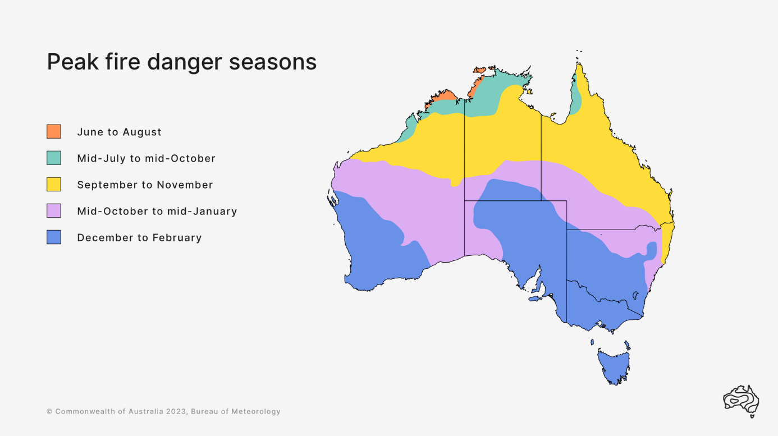

Figure 2. Peak Fire Danger Seasons across Australia
Routine fire weather products are issued during the local fire weather season as detailed in Table 2. For those jurisdictions that do not issue fire weather products year-round, the dates are indicative, the commencement and cessation of the service will be agreed between the Bureau and local fire agencies on a season-by-season basis. A subset of products may also be issued outside of the state/territory fire weather season indicated below.
State | NSW/ACT | NT | Qld | SA | Tas | Vic | WA
Season | Year round | Year round | Year round | Oct–Apr | Oct–May | Nov–Apr | Year round
Table 2. Local fire seasons in each jurisdiction
Fire weather products can be issued outside of the designated fire seasons during periods of elevated fire dangers or 'spike' fire weather days. Outside of the designated fire seasons, gridded fire weather products will continue to be produced. Fire agencies need to maintain fuel state data to ensure that the output is reflective of fire weather conditions.
  - Area of Responsibility
The Bureau's fire weather services cover all land within Australian states, mainland territories and islands within Coastal Forecast boundaries. This is effectively a domain within 111.96°E – 155.07°E; 8.28°S – 45.03°S, as outlined in the registered users AFDRS guide.
  - Dissemination of products
Publicly available Bureau fire weather products are transmitted via the Bureau's website and app. Products for fire agencies are transmitted by email, registered user web services and file transfer protocol (ftp).
  - Briefing Services
The Bureau provides briefings to Emergency Management partners to assist planning, response, and coordination. The format, timing and frequency of briefings is determined through Memorandum of Understanding (MOU) and Service Orders with each Emergency Management agency.
  - Embedded Meteorologists
The Bureau has arrangements with several state- and territory-based fire agencies to provide services through an embedded meteorologist to support operational awareness and communication, as well as to deepen relationships and understanding between the two organisations. Embedded meteorologists within relevant national agencies and bodies, such as those within the Australian Energy Market Operator (AEMO) and those within the National Situation Room (NSR), include fire weather within their briefings to assist in planning and preparedness for key industry sectors and broader whole-of-government response. In each instance, the services provided are agreed between the Bureau and the agency and are provided on a cost recovery basis.
  - Portable Automatic Weather Stations
The Bureau supports fire agencies by ingesting and displaying data from fire agency owned and operated Portable Automatic Weather Stations (PAWS) into observational product suites.
  - Communication and adoption activities
In addition to issuing products through standard communication channels (e.g., website, app, email), the Bureau undertakes a range of complementary communication and adoption activities in partnership with emergency management agencies. These activities are aimed to increase the uptake and effectiveness of the forecasts and warnings and ensure consistent weather safety messages are provided to the community.
This includes community, industry and government preparedness briefings, social media campaigns and the Bureau's Fire weather knowledge centre web pages. During the season this extends to joint press conferences and media interviews, as well as continuing social media public safety campaigns and community, industry and government briefings.
  - Service Continuity
The Bureau uses a number of strategies and contingency plans to maintain service continuity. Fire weather services are delivered by trained staff across multiple locations, allowing for service continuity in the case of failures in a specific office or team.
To maintain service continuity, the Bureau uses a large and diverse range of observational and forecast data in the delivery of its fire weather services. This provides redundancy if any individual data source is unavailable during operations and ensures all products and services are based on the best available information at all times.

- Quality Assurance and Performance
  - Hazard Services Forum
The IGA established the Hazards Services Forum (HSF) in 2018. The HSF facilitates consultation with State and Territory operational emergency service agencies to guide current and future strategic development of the Bureau of Meteorology’s hazard services.
The forum enables the States and Territories to request and prioritise changes to the Standard Services and to refer services that could be considered Supplementary Services to the Bureau for consideration. The HSF also assists with the process of consulting on modifications to Services Schedules.
  - Performance Statistics and Reporting
Official forecast and warning products are verified against available observations and compiled into routine reports. These reports investigate the accuracy and timeliness of products issued and assist the continuous improvement cycle within the Bureau.
Following fires that have had a significant impact on community safety and/or livelihoods, the Bureau may prepare a report on the meteorological aspects surrounding the event and forecast performance as part of its post event review process.
  - Post Event Review
The Bureau conducts internal post event reviews after fire events that have had a significant community or operational impact.
The insights and recommendations gained from these post event reviews are used to improve processes, systems and services delivered by the Bureau.
Depending on the impact from a fire event, this process may include a debrief with external partners. Upon request, the Bureau also contributes to post incident reviews conducted by emergency services and government.
  - Meteorologist Training and Competency
The Bureau delivers a fire weather training and competency-based assessment program for meteorologists. This program ensures that staff involved in analysing and forecasting fire weather have the qualifications, training and demonstrated ability to provide a high standard of fire weather services to the Australian community.
In addition to the formal competency-based assessment, pre-season training is provided to staff which complements existing skills and aims to enhance skills and knowledge in areas of fire weather that are complex or have rapidly evolving scientific understanding.

- National Fire Weather Product Schedule
Fire weather services provided by the Bureau utilise gridded forecast data covering the entire Australian domain, defined in the Area of Responsibility in section 2.4 above. The service utilises Fire Behaviour Indices derived from the AFDRS and corresponding Fire Danger Ratings at grid points across Australia to provide a measure of the level of danger of a potential bushfire at that point. These are also summarised to the Fire Weather District level and sub-area level.
Detailed information on how the Fire Behaviour Indices and Ratings are determined are included in Appendix 1: Fire Danger Ratings and Fire Behaviour Indices. For a complete listing of Fire Weather Districts, see Appendix 2: Fire Weather District Maps.
Unless otherwise noted, all issue times in this document are quoted as local time for the relevant jurisdiction and time of year.
  - Fuel Data
State and Territory fire agencies are responsible for providing the Bureau with fuel state data through the Fuel State Editor (FSE) to calculate forecast and observed fire behaviour indices. Agencies are additionally responsible for checking the accuracy and validity of the fuel state data they send to the Bureau as erroneous data can affect the calculation of fire behaviour indices across the whole country.
The Bureau will update the fuel state data using the information provided by the agencies to ensure the most up to date information is included in fire behaviour index calculations. If erroneous data is identified in a timely manner, the Bureau will roll back to the previously correct data to ensure products can be generated. As detailed in the document "AFDRS BAU Support Arrangements", fire agencies are requested to provide any updates to fuel state data (curing, fuel load, fuel conditions, time since fire) by 8pm AEST/AEDT Fridays/Wednesdays for inclusion in fire weather forecasts (including preliminary fire weather forecasts) on Mondays/Thursdays. Changes can be made at other times, but these may cause a (significant) change in forecast FBIs/FDRs between the preliminary and official forecast and/or between the afternoon official forecast and morning update of the official forecast.
  - Routine Services
    - Australian Seasonal Bushfire Outlook
The Seasonal Bushfire Outlook is a quarterly product that identifies potential areas of increased risk of bushfire based on weather, fuel and fire agency resource and management implications along with community and industry impacts, as well as other significant events.
The Bushfire Seasonal Outlook is part of the Total Warning System and informs communities of increased bushfire risk, so they are aware of the risk and primed to take appropriate actions. It is not intended as a prediction of where and when bushfires will occur, nor is it intended to suggest that bushfires will not occur.
The Seasonal Bushfire Outlook is developed collaboratively by AFAC, the Bureau of Meteorology, Queensland Fire Department, the NSW Rural Fire Service, ACT Emergency Services Agency, ACT Parks and Conservation Service, VIC Country Fire Authority, Department of Energy, Environment and Climate Action Victoria, Tasmania Fire Service, SA Country Fire Service, Department of Fire and Emergency Services and Department of Biodiversity, Conservation and Attractions WA, and Bushfires NT.
The Bureau contributes Recent Conditions and Climate Outlook information within a bushfire context to assist in the production of the Seasonal Bushfire Outlook.
    - Fire Danger Outlook Products
The fire danger outlook service consists of:
(a) National AFDRS index-based chance of above median and tercile map visualisations, covering the Australian land forecast domain that are updated at the same frequency as the Bureau’s temperature and rainfall outlooks (for the various outlook periods),
(b) Tercile timeseries of AFDRS intensity and index for selected land-based point locations for 5 weeks from the initialization date, and
(c) Gridded chance above median and tercile AFDRS intensity and index gridded data.
These products are provided as images and grids through registered user websites. They are released on the same schedule as the Bureau’s temperature and rainfall outlooks: Weekly outlooks issued twice weekly on Monday and Thursday, monthly and seasonal outlooks issued weekly on Thursdays.
Examples of fire danger outlooks can be found in 7.8 Fire Danger Outlooks.
    - Australian Digital Forecast Database
The Bureau's Real-time Data Services provide tailored delivery of real-time Bureau of Meteorology products including datasets such as numerical output grids, satellite and radar data and web map service layers.
Part of these services is the Australian Digital Forecast Database (ADFD) which includes grids that are relevant to Fire Weather, providing detailed forecast information across all States and mainland Territories. These grids are available all year round.
The ADFD files are typically updated routinely four times per day, at 9am, 3pm, 9pm and 3am AEDT. They may also be updated at other times as required.
Fire-related elements in the ADFD that will be updated as part of the 4 times per day ADFD issuance schedule include:
- Continuous Haines Index (C-Haines)
- Wind Speed (km/h) & direction at 1000/1500/3000m AMSL
- Mount Soil Dryness Index (Observed)
- Keetch-Byram Drought Index (Observed)
- Drought Factor
- Mixing Height
- LAL
AFDRS files will be updated twice daily, at around 6am and 5pm AEDT.
Preliminary grids will be published at the same time as preliminary fire weather forecasts in addition to the normal afternoon AFDRS grid update. Gridded forecast data may be updated at other times during the day, and users should note the issue time of the outputs.
Further details, including information on data bundles, can be found at http://reg.bom.gov.au/reguser/ or http://reg.bom.gov.au/catalogue/adfdUserGuide.pdf.
    - Fire Danger Ratings
      - Purpose
A 4-day summary of Fire Danger Ratings for each Fire Weather District is provided to the public to increase awareness of the extent to which weather conditions will enhance fire related risks for this period, to allow for forward planning of activities sensitive to fire risk and to assist with agency tactical planning.
The Fire Danger Ratings are issued in consultation with the fire agency, as State and Territory governments have responsibility for determination of final Fire Danger Ratings using fuel state information determined by the jurisdictions and forecast weather provided by the Bureau.
A 7-day Detailed Fire Danger Ratings product is made available to Emergency Service agencies. This contains ratings along with the fire behaviour index on a sub-area level for the next seven days. Agency personnel use this product to assess the fire weather risk at a state, district and sub-area level which will assist them in making operational planning and preparedness decisions in relation to the fire risk.
Fire Danger Ratings are assigned according to the corresponding Fire Behaviour Index values in Table 3: Fire Danger Ratings and Fire Behaviour Index values..

FDR level | FBI range
No Rating | 0–11
Moderate | 12–23
High | 24–49
Extreme | 50–99
Catastrophic | 100+
Table 3. Fire Danger Ratings and Fire Behaviour Index values

      - Determining Fire Weather District Ratings
- Fire Behaviour Indices are calculated according to the relevant FBI formulas for each forecast grid cell at hourly time intervals.
- The Maximum FBI (MaxFBI) across each day is determined for each grid cell, according to the relevant fuel type (as advised by local fire agencies).
- The Maximum FDR is determined for each grid cell based on the MaxFBI, corresponding FDR and relevant fuel type.
- The highest Maximum FDR met or exceeded by at least 10% of grid cells in a district determines the Fire Danger Rating for that District.
- The local Hazard Management Agency (HMA) responsible for fire weather has absolute discretion to vary the District Fire Danger Rating from the value determined by this method. Liaison arrangements between the Bureau and agencies for the final determination of District Fire Danger Ratings are agreed to at the state/territory level.
      - Routine Issue and Validity Times
Routine issue times are summarised in Table 3. Fire Danger Ratings Issue Times (Local)
The following validity applies for each product:
- Fire Danger Ratings – 4 Day: Valid for the next 4 days when issued in the afternoon and valid for the current day and following 3 days when issued in the morning.
- Detailed Fire Danger Ratings: Valid for the next 7 days when issued in the afternoon and valid for the current day and following 6 days when issued in the morning.
State | Afternoon Issue | Morning Issue
NSW/ACT | 4:15 pm | 5:05 am
NT | 4:00 pm | 5:00 am
QLD | 4:00 pm | n/a
SA | 4:05 pm | n/a
TAS | 4:00 pm | n/a
VIC | 4:00 pm | 5:30 am
WA | 4:10 pm | 4:35 am
Table 4. Fire Danger Ratings Issue Times (Local)
The public 4 Day Fire Danger Ratings (FDRs) and Fire Behaviour Indices (FBIs) are available on the Bureau's website at:
NSW/ACT: https://www.bom.gov.au/location/australia/new-south-wales
NT: https://www.bom.gov.au/location/australia/northern-territory
QLD: https://www.bom.gov.au/location/australia/queensland
SA: https://www.bom.gov.au/location/australia/south-australia
TAS: https://www.bom.gov.au/location/australia/tasmania
VIC: https://www.bom.gov.au/location/australia/victoria
WA: https://www.bom.gov.au/location/australia/western-australia
    - Fire Weather Forecast
      - Purpose
The Fire Weather Forecast provides fire agencies information about forecast weather parameters that are of greatest consequence to fire ignition, suppression and behaviour at a fire weather district and sub-area level.
      - Routine Issue and Validity Times
Fire Weather Forecasts are issued each afternoon during the Fire Weather season at the times in Table 4. A separate product is issued for each of the following 4 days, with a morning update for the current day issued in some states/territories.
      - Preliminary Fire Weather Forecast
When more than 1% of the grid cells in a fire weather district exceed 50 FBI, or at the request of the fire agency, a preliminary issue for the following day will be provided to agencies in the relevant state or territory. This product is intended to provide agencies with greater time to determine the final district rating that will be issued at the routine issue time, as well as giving greater time to prepare for potential elevated fire activity more generally.
A preliminary fire weather forecast uses observations and model guidance available up to the time of issue. Subsequent to this, on receipt of the latest observational data and latest model guidance the afternoon issue of fire weather forecast may contain changes.
State/Territory | Preliminary Issue | Afternoon Issue | Morning Issue
NSW | By 12:00 pm (if catastrophic FDR forecast for Day 1), otherwise by 2:00 pm | 4:15 pm | 6:00 am
ACT | By 2:00 pm | 4:00 pm | 6:00 am
NT | By 12:30pm | 4:00 pm | 5:30 am
QLD | By 2:00 pm | 4:00 pm | n/a
SA | By 1:00pm | 4:00 pm (Day 1)  4:30 pm (Days 2–4) | n/a
TAS | By 12:00 pm | 4:00 pm | n/a
VIC | By 12:30 pm | 4:00 pm | 6:30 am
WA | By 12:00 pm | 4:00 pm | 4:30 am
Table 5. Fire Weather Forecast Issue Times (Local)
      - Amendment Criteria for Fire Weather Forecasts and Warning
Fire Weather Forecasts will be monitored and, in consultation with fire agencies, updated in accordance with the below criteria.

If earlier than 11:30 am local time:
- New observance of FBI exceeding 50 Extreme for a period of 1 hour or more and is expected to persist for at least an hour, or high confidence of extreme fire danger rating affecting more than 10% of the district for at least an hour in place of a lower fire danger rating.
- New observance of FBI exceeding 100 Catastrophic for a period of 1 hour or more and is expected to persist for at least an hour, or high confidence of catastrophic fire danger rating affecting more than 10% of the district for at least an hour in place of a lower fire danger rating.
- High confidence that previously forecast Catastrophic fire danger rating will not be met. This means that all grid points within the district must be below the catastrophic fire danger rating threshold.
- High confidence that previously forecast Extreme fire danger rating will not be met. This means that all grid points within the district must be below the extreme fire danger rating threshold.
Fire Weather Forecasts for the current day will not be updated after 11:30 am local time.
An update to the Fire Weather Forecast will likely be accompanied with an update to the district ratings, in discussion with the relevant agency.
      - Content
Date/Time
Fire Weather District Summary section.
  - Fire Danger Rating
  - Maximum Sub Area Rating
  - District Fire Behaviour Index
  - cHaines
  - Wind Change Danger Index
  - Thunderstorm Activity Level (TAL)
  - Minor Fuel Type Rating Extreme or above
  - Text Forecast
Detailed Fire Weather District Forecast section.
  - Fuel Type and Coverage
  - FBI
  - Percentage Coverage, Start Time, and duration for significant FBI thresholds.
Fire Weather District Weather Information section.
  - Maximum Temperature
  - Minimum Relative Humidity
  - Wind Direction, Speed and Gust Strength
  - 1500m Wind Direction and Speed
  - Mixing Height (m)
  - Thunderstorm Activity Level (TAL)
  - Rainfall
    - Fire Weather Observations Bulletin
      - Purpose
The Fire Weather Observations Bulletin displays real time weather observations and associated FDR/FBI calculations along with the details of the maximum FBI observed since local midnight. It is provided to Fire Agencies to assist with situational awareness and monitoring actual weather conditions. The bulletin is available through a Registered User Web Page with the option of selecting a state or territory. The bulletin is also available in JSON format (with additional fields). Please refer to the Fire Weather Observation Bulletin User Guide for further information.
      - Content
State/Territory page:
- Station
- Current Observations
  - Time (local)
  - Primary fuel type (FT 1)
  - Primary FBI/FDR
  - Secondary fuel type (FT 2)
  - Secondary FBI/FDR
  - Wind Direction and Wind Speed
  - Wind Gust
  - Relative Humidity
  - Temperature
  - Dew Point Temperature
- Max observations
  - Time (local)
  - Primary fuel type (FT 1)
  - Primary FBI/FDR
  - Time (local)
  - Secondary fuel type (FT2)
  - Secondary FBI/FDR

Historical observations for a location:
- Station name
- Primary fuel type: Fire behaviour model, Vegetation fuel type, Sub-Fuel Type code
- Secondary fuel type: Fire behaviour model, Vegetation fuel type, Sub-Fuel Type code
- Time (local)
- Primary fuel type (FT 1)
  - Primary fuel state data
  - Primary FBI/FDR
- Secondary fuel type (FT 2)
  - Secondary fuel state data
  - Secondary FBI/FDR
- Wind Direction and Wind Speed
- Wind Gust
- Temperature
- Relative Humidity
- Dew Point Temperature

Please refer to: Fire Weather Observations Bulletin for sample observational products.

Fire agencies have selected the most appropriate sub-fuel type based on a statistical analysis of the predominant fuels within 20km of each AWS location. This better aligns the observation bulletin FBI outputs with both the fire weather forecasts and IWF outputs.

Wind observations at 10, 20, 40 and 50 mins past the hour use a 1 minute averaged wind speed, rather than the standard 10 minute averaged wind speed. 1 minute averaged wind speeds can often be higher than the 10 minute averaged wind speed and so can lead to spikes in the FBIs.
    - Ground Moisture Data
The Bureau provides Ground Moisture Data to fire agencies to assist with strategic planning. The data is calculated by applying dryness or drought indices to observational data and can be viewed on registered user pages and is presented in tabular and/or graphical formats, depending on the jurisdiction. See Ground Moisture Data 7.9 for a product example.

  - Non-Routine Services
    - Fire Weather Warning
      - Purpose
The Bureau issues fire weather warnings to alert the community that weather conditions are likely to make the suppression or control of fires difficult.
      - Issue Criteria, Times and Validity
Fire Weather Warnings for a Fire Weather District are issued when the Fire Danger Rating is Extreme or greater (see Fire Danger Ratings). They are issued no later than 4:15pm local time in the afternoon for either the remainder of the current day and/or the following day, with a 5:00am local time morning update covering the remainder of the current day.
      - Amendment Criteria
Fire Weather Warnings will be monitored and updated as needed at any time of day, in consultation with local fire agencies.
See 4.2.5.4 for more detail on amendment criteria.
      - Content
- Fire Weather Warning for the affected fire weather districts
- Issue time and date
- Fire/Emergency Service Organisation action statement
- Validity period
- Fire Danger Rating and affected districts
- Weather Situation
- Fire/Emergency Service Organisation link
- Next issue time
      - Notes
In consultation with fire agencies, some discretion can be applied for the issuance of a Fire Weather Warning when the FBI 50 / FDR Extreme District Fire Danger Rating criterion is not satisfied.
    - Incident Weather Forecasts
      - Purpose
Incident Weather Forecasts (IWF) are site-specific forecasts issued to assist with tactical decision making in operations. IWF are only provided to designated fire agencies and are only provided for fire (uncontrolled fires/bushfires or prescribed/hazard reduction burns), structural fires, HAZMAT operations or training purposes.
IWFs provide greater detail than is available from the Fire Danger Viewer or ADFD datasets, with additional text-based information on uncertainty as well as forecasts tailored for local topography and other effects by fire weather meteorologists.
IWFs for planned/prescribed/hazard reduction burns are a cost-recovered service.
      - IWF Requests
IWFs are requested by a designated fire agency through the Bureau's online IWF request system. Any subsequent issues of an IWF require additional requests to be submitted. A follow up phone call is required after each submission to confirm receipt and provide an opportunity to discuss specific details of the incident, including any sensitivities or watch points.
Requests should be made only when the existing gridded weather forecast service via MetEye, AFDRS Fire Danger Viewer and through the ADFD is insufficient to make tactical decisions regarding the incident. Requesting officers should investigate these data sources and surrounding existing IWFs prior to submitting their request.
Where multiple IWFs are in close proximity and weather conditions are not expected to be significantly different, meteorologists may combine these into a single IWF, with comments to note any minor variations in forecast conditions.
It is highly desirable for requests to be channelled through a coordination point for each state/territory to avoid duplication and confusion. Requesting officers should be aware of the coordination arrangements for their agency and within the state/territory.
Requests should provide the best estimate possible of observed weather conditions, including location, time, temperature, dew point, relative humidity, wind (direction and speed) and weather, if available. A description of the height and type of wind observation and exposure is desirable.
An IWF request has the option to include an outlook for up to 4 days ahead. A 4-day outlook will only be included when specifically requested. In Queensland, South Australia, and Western Australia, the 4-day outlook can be requested as a separate product to the standard IWF for all types of IWF requests.

      - Issue Time and Validity
For urgent requests, usually those associated with out-of-control bushfires without a pre-existing forecast, the IWF is issued as soon as possible and generally within one hour of receiving the request. In other cases, an IWF may be issued any time between the receipt of the request and the noted start-time of the forecast. The issue time will be determined by the requirements of the incident as discussed with the requesting officer and operational requirements in the Bureau.
IWF validity period should be included in the request and can be 6hr, 12hr, 18hr, 24hr or 30hr from the forecast start time. If no validity period is included in the request, a 12hr forecast will be issued. The requesting officer can choose the period for which they want the hourly forecast data: first 12 hours, middle 12 hours or last 12 hours. If no period is chosen, the first 12 hours will be hourly forecast data.
In the case of ongoing or campaign fires requiring regular IWF updates, the Bureau will work with agencies and requesting officers to establish a routine update schedule that allows for a balanced workload. In these cases, new requests must still be submitted by the requesting officer for each forecast instance, to allow for changes to the incident location, observed conditions, requesting officer and any other variations from the previous request.
In most circumstances the schedule should generally allow for one update every 24 hours, with hourly data covering the period of highest interest. For higher priority fires, for example where there is active overnight firefighting, the Bureau may accommodate 12 hourly updates to allow for continuing hourly forecast data. In such circumstances forecasts will be issued twice per day (i.e. not prepared/issued concurrently with differing start times).
All requests need to be submitted via the online request system for each update. A phone call by the requesting officer is required to confirm receipt of the IWF Request and to discuss any sensitivities or watch points for the request. Requests should not be made more than 24 hours ahead of the agreed schedule. When considering sending an update request for an ongoing fire it is important to note that all IWFs will be monitored throughout their validity and updated if required (see amendment details below).
      - Prioritisation of IWFs during busy periods
During periods when there are a significant number of fires and/or large number of IWF requests, the Bureau's Fire Weather Meteorologists will prioritise IWF preparation based on information including: the alert level of the incident, existing and valid (or nearby) IWF for the incident, and the likelihood of adverse weather conditions impacting the site. Where these methods do not identify a clear priority, the Bureau will liaise with the relevant fire agencies to clarify and prioritise forecast requirements. Where possible, agencies should complete a prioritisation and triage of forecast requests prior to contacting the Bureau with the day's requests.
For lower priority fires (including fires at or below Advice level) or fires with no active fire fighting operations, it may be more appropriate for fire agencies to access weather information from MetEye, the ADFD or Fire Danger Viewer and/or receive a briefing from Decision Support meteorologists.
When the number of IWFs is approaching a level where all subsequent requests will be subject to prioritisation and the above conditions, the Bureau will provide notification through respective state and territory Decision Support teams. The prioritisation will also extend to the monitoring of IWFs, particularly in the overnight period.
The Bureau will work with fire agencies to further develop agreed IWF prioritisation processes during times of increased demand. Any process will require real-time input from fire agencies on factors including impacts, community risk and forecast uncertainty.
If the IWF is no longer being used for fire operations or if the incident has been closed, the Bureau should be made aware through a phone call made by the responsible fire agency officer. The IWF will then not be monitored for the remaining forecast period.

      - Guidance for Incident Weather Forecasts Amendment
IWFs will be monitored and updated if one or more of the following criteria are observed and forecast to persist for at least 1 hour where conditions lead to higher FBIs than forecast, and where conditions are expected to last more than 3 hours where FBIs are expected to be lower than forecast.
An amendment may also be made where there is an equivalent change in forecast conditions.
- Change in the likelihood of thunderstorms affecting the incident site.
- Change in the timing of a thunderstorm affecting the incident site.
- Change in the timing of a wind change by 1 hour or more.
- Change in temperature of 5 degrees, or agency specified temperature requirement.
- Change in dew point temperature of 5 degrees, or agency specified dew point temperature requirement.
- Change in relative humidity of 20%, when RH is below 60%, or agency specified relative humidity requirement.
- Change in wind speed of 20 km/h, or agency specified wind speed requirement.
- Change in wind direction of 45 degrees for wind speeds greater than 20 km/h, or agency specified wind speed requirement.
These guidelines apply only to the validity period of an IWF, no amendments will be issued for changes to outlook days.
When an IWF is amended, the reason is included in the Significant wind changes and uncertainties section. The Requesting Officer will be contacted to provide a verbal briefing of changed conditions, usually in advance of the amended IWF.
Prescribed burn / hazard reduction IWFs will not be monitored overnight unless there has been a specific request made by the relevant agency.
      - Content
- Incident Details, including:
  - Issue Time (local) and date
  - Incident Type
  - Forecast Location
  - Latitude/Longitude
  - Elevation (metres ASL)
  - Fuel Type: Fire Behaviour Model and Sub-Fuel Type
  - Form Number
  - Request Number
  - Contact Phone
  - Contact Name
  - Email
  - Significant wind changes and uncertainties
  - Thunderstorm potential, precipitation, cloud, and uncertainties
  - Spatial variation of conditions and other important information
Validity Time
FBI type and Sub-Fuel Type
Fuel State Data
Tabular details including:
- Local Time
- Temperature
- Dewpoint temperature
- Relative Humidity
- 10m Wind Direction, Speed and Gust Strength
- 1000m AGL Wind Direction and Speed
- FBI (based on sub-fuel type)
- Mixing Height
- cHaines
- Thunderstorm Activity Level (TAL)
Notes on information in table:
- Notes on taking observations and liaising with forecasters.

The 4-day outlook component (if requested) includes:
- Text summary for each relevant day
- FBI type and Sub-Fuel Type
- Fuel State Data
- Tabular forecast data at time of maximum fire behaviour index and time of minimum fire behaviour index, including:
  - Time
  - Temperature
  - Dewpoint temperature
  - Relative Humidity
  - 10m Wind Direction, Speed and Gust Strength
  - 1000m AGL Wind Direction and Speed
  - FBI (based on sub-fuel type)
  - Mixing Height MSL
- Daily summary of maximum cHaines, maximum TAL, Probability of rain >5mm

    - Wind Change Chart
      - Purpose
A Wind Change Chart (WCC) is provided to fire agencies in New South Wales, South Australia, and Victoria to advise of the forecast time of a significant wind change to assist operations. The WCC also contains details of conditions ahead of and behind the change.
      - Issue Criteria, Times and Validity
A WCC service is issued on days when a significant, trackable synoptic wind change is expected to impact at least one district in the relevant state which has a forecast District Fire Behaviour Index reaching the threshold in Table 6. The validity will generally be 12 to 15 hours, but may be extended beyond this for long-lived changes. Forecasts will be reissued according to the frequency in Table 5 and cease when conditions no longer pose a significant threat to any ongoing fire.
State | District FBI Threshold | First Issue | Following Issues
SA, Vic, NSW | 24 | Dependent on wind change timing, but typically by 9am [8:30am in SA] local time (with an 8am [7:30am in SA] local time analysis position) | 3 hourly
Table 6. Wind Change Chart issue times (Local)
Reaching the District FBI Threshold of 24 initiates a discussion between the Bureau and the fire agencies in the relevant state regarding the need for a WCC. If there are no significant operational concerns, and therefore no need for a WCC, it would be agreed to not issue a WCC for that event. Otherwise, the WCC would be issued as described.
      - Amendment Criteria
- If the position of the wind change is significantly different to the forecast position (defined as more than 1 hour faster or slower than forecast within the next 3 hours), or the difference is likely to impact fire agencies.
- If the given wind speeds are greater than 20km/h stronger than forecast around the time of the change.
- If weather (e.g. thunderstorms) is significantly different than forecast, this should trigger a conversation with agencies via DSS teams to check if an amendment should be issued.
Amendment Methodology
  - An analysed Observed line will be added to an amended chart with the time of analysis (rounded to 30 minutes) labelled.
  - Subsequent forecast lines will be maintained at previously defined (standardised) forecast times, even if that means less than 3 hours between the observed time and the first forecast time. Adjusted accordingly based on latest available evidence.
  - In the case of an amendment 30 minutes prior to the next routine update, the first forecast line may be omitted however there will be no more than 3hrs, 30 minutes between the observed line and the first forecast line.
  - Subsequent standard issue times will be maintained, UNLESS the amendment was less than 60 minutes prior to the next standard issue time.
      - Content
The WCC consists of a graphic showing a recent observed location of the wind change where this is possible and forecast locations of the wind change at 3 hour increments (once the change is within 3 hours of affecting the state) as it moves over the area of concern, accompanied by supporting text.
The first WCC may be issued with only forecast positions of the wind change if the change has not yet reached the state border. This will support morning briefing activities.
The last WCC for the day will contain the message "No further routine Wind Change Forecasts will be issued today."
      - Notes
Following consultation with fire agencies, the WCC service may be activated when FBI triggers are not met. Typically, this would be when there are significant fires.
In South Australia, the criteria for issuing only applies to the southern half of the state.
    - Smoke Modelling
The Australian Smoke Dispersion System (ASDS) is available to fire agencies and is provided on a cost recovery basis. It combines bushfire, fuel reduction burn and atmospheric data with weather, fire spread and chemical transport models to estimate the likely concentration and distribution of smoke at ground level from a range of sources.
Features of the service include:
- Point-specific deterministic and ensemble fire weather information for the next 6 days for specified locations at 3-hourly intervals.
- Point-specific upper atmosphere data shown as aerological diagrams for the next 3 days for specified locations at 3-hourly intervals.
- Gridded ventilation parameters for the next 3 days at 3-hourly intervals.
  - Ventilation index
  - Atmospheric boundary layer height
  - Transport wind
- Gridded pollutant forecasts for the past 3 days and next 3 days at hourly intervals.
  - Smoke (levoglucosan)
  - PM2.5
  - PM10
  - Ozone
  - Sulphur Dioxide
  - Carbon Monoxide
  - PM2.5 24 hour rolling average
- Gridded smoke forecasts for the next 24 hours at hourly intervals for prescribed burn sites, based on the size and fuel of the burn.

- Appendix 1: AFDRS Fire Behaviour Index and Model Guides
Fire Behaviour Index and Model Guides provide a technical description of each of the Fire Behaviour Models used in the AFDRS.
The AFDRS aims to provide information that is simple and consistent by using four public rating categories and a numerical fire behaviour index that applies to all fuels across the entire country.
These simple products are built on considerable complexity in the underlying fire behaviour models, aiming to use accurate predictions based on a detailed understanding of fire spread and fuel structure.
Technical guides are available for eight fuel types. For further information, please see:
https://www.afac.com.au/public-resources/afdrs--fire-behaviour-index-and-model-guides

- Appendix 2: Fire Weather District Maps

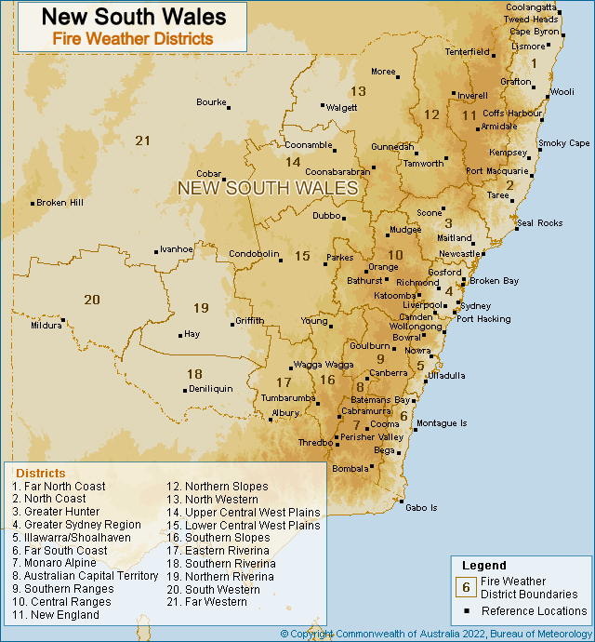
Figure 3. New South Wales Fire Weather Districts

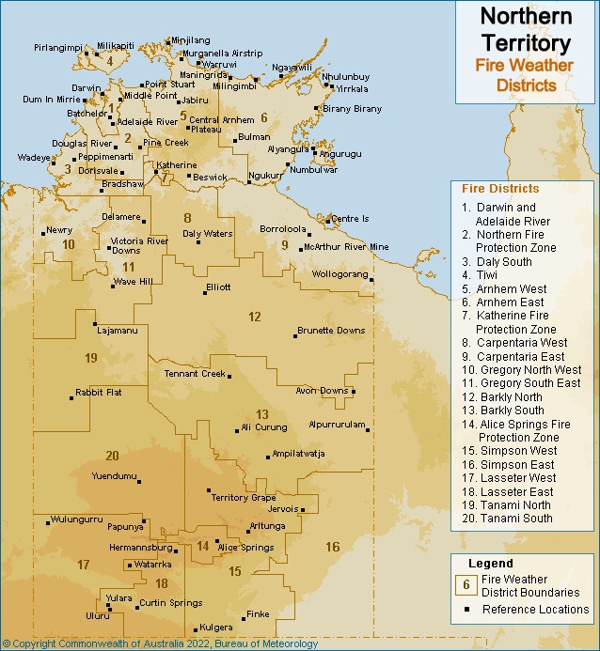
Figure 4. Northern Territory Fire Weather Districts

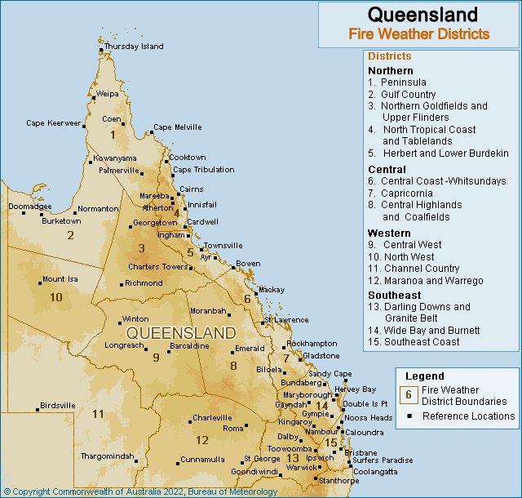
Figure 5. Queensland Fire Weather Districts

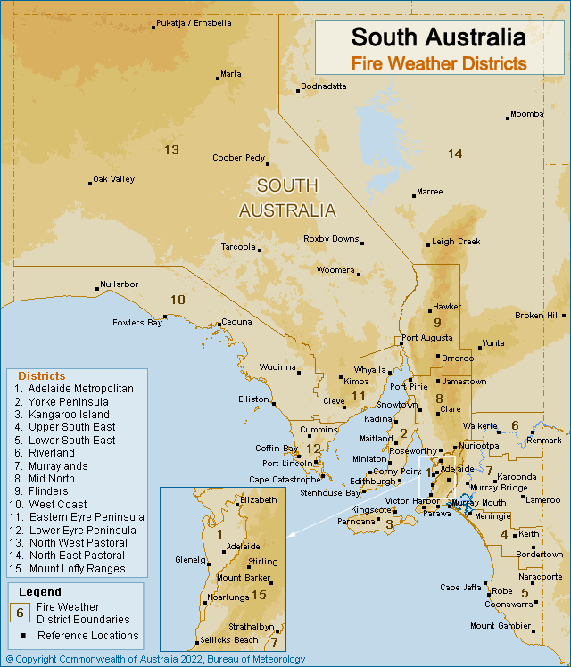
Figure 6. South Australia Fire Weather Districts

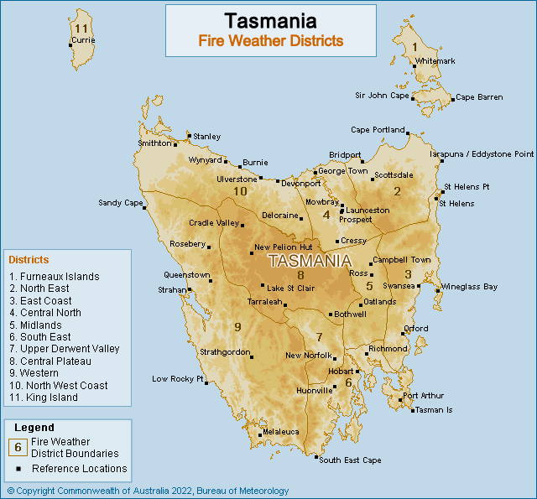
Figure 7. Tasmania Fire Weather Districts

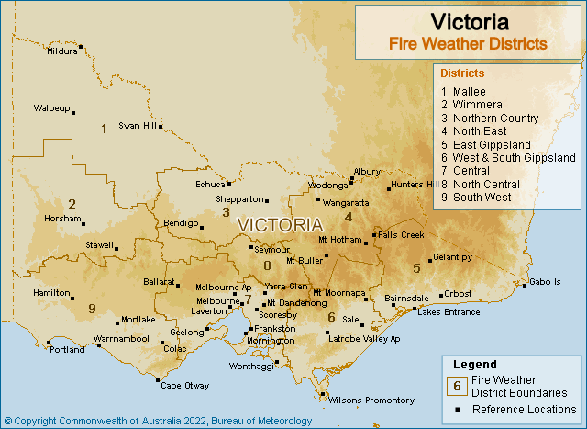
Figure 8. Victoria Fire Weather Districts

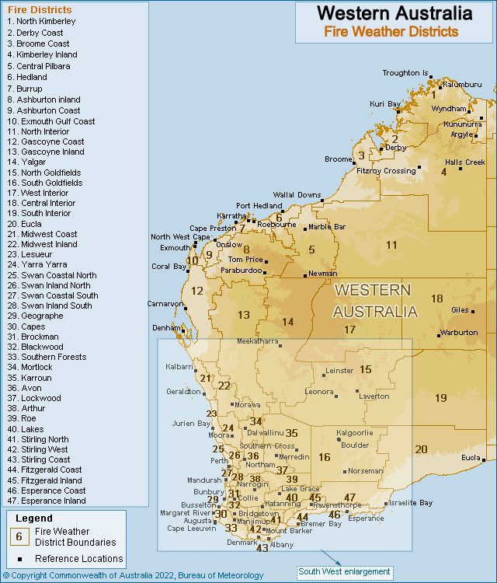
Figure 9. Western Australia Fire Weather Districts

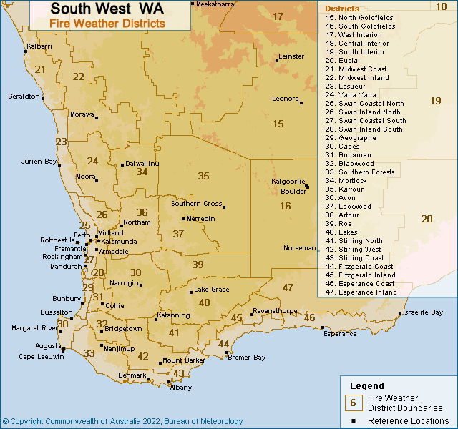
Figure 10. South West WA Fire Weather Districts

- Appendix 3: Product Samples
  - 4 Day Fire Danger Rating Forecast
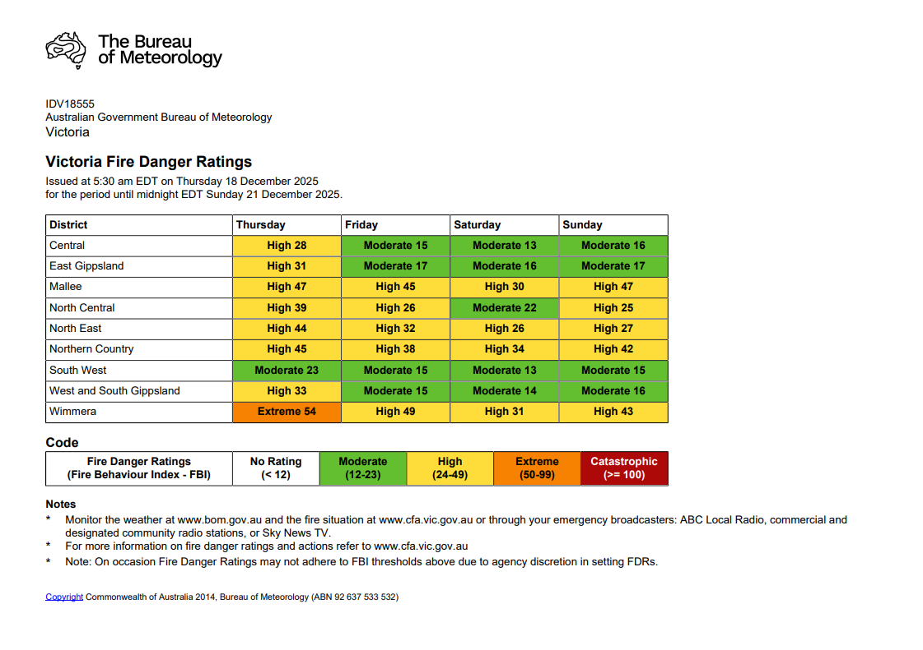

4 Day Fire Danger Rating Forecast: Web Display
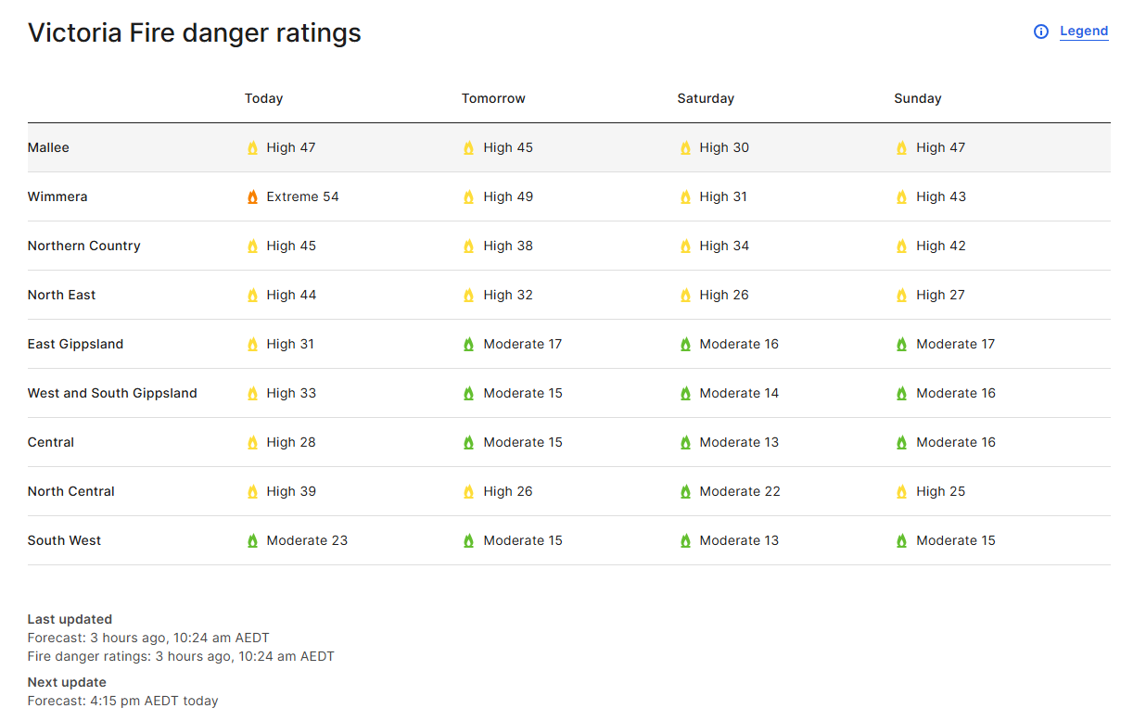

  - 7 Day Fire Danger Rating Forecast

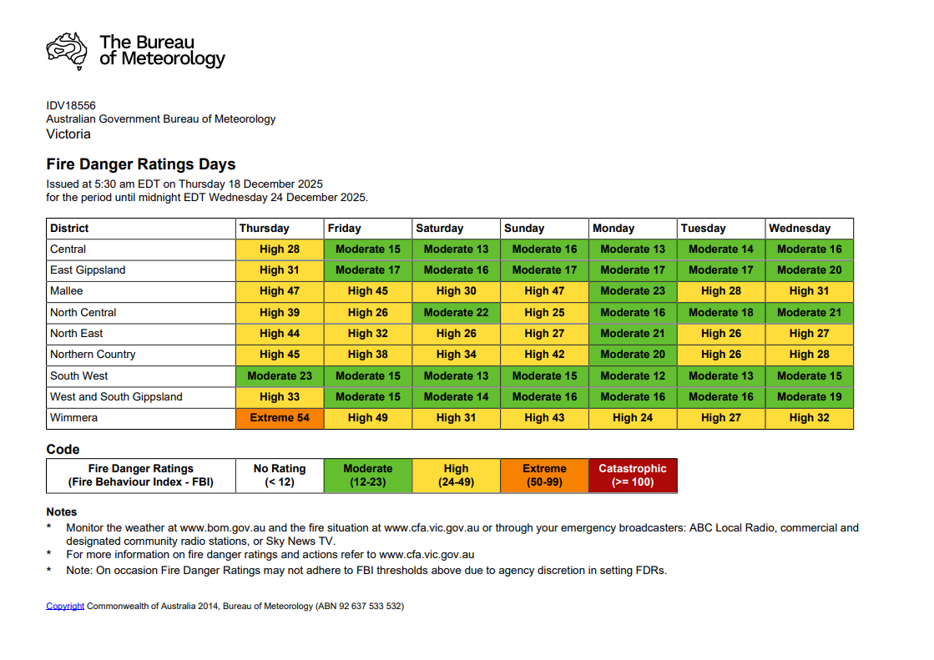

  - Fire Weather Forecast

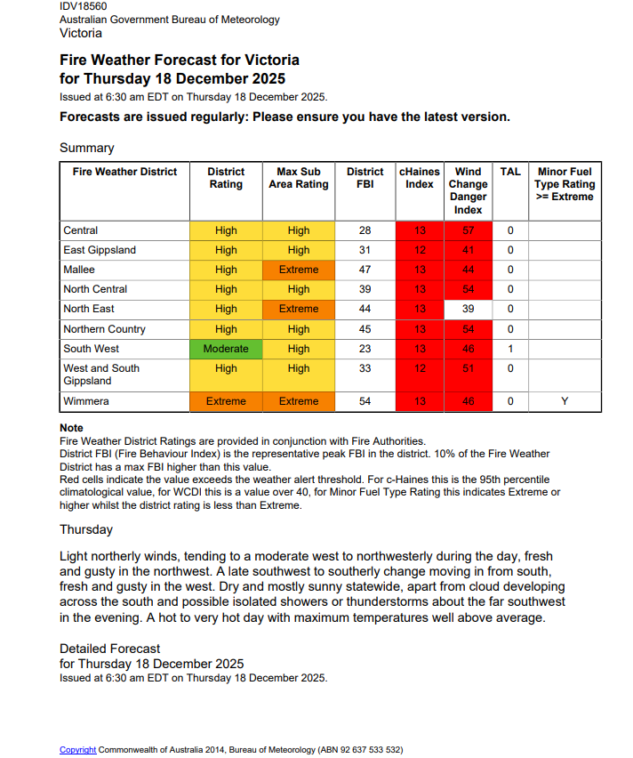

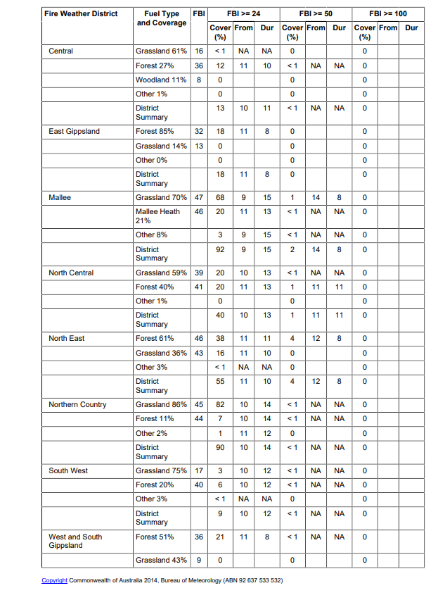

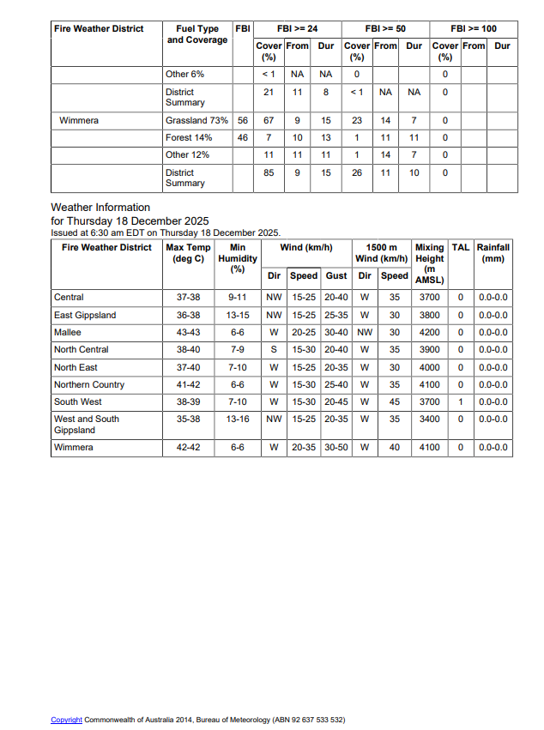

  - Fire Weather Warning

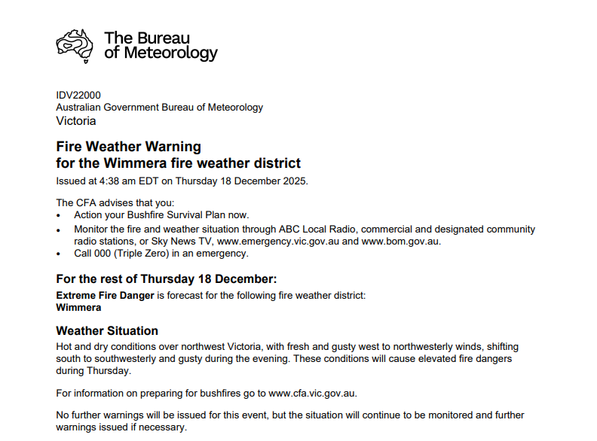

  - Incident Weather Forecast
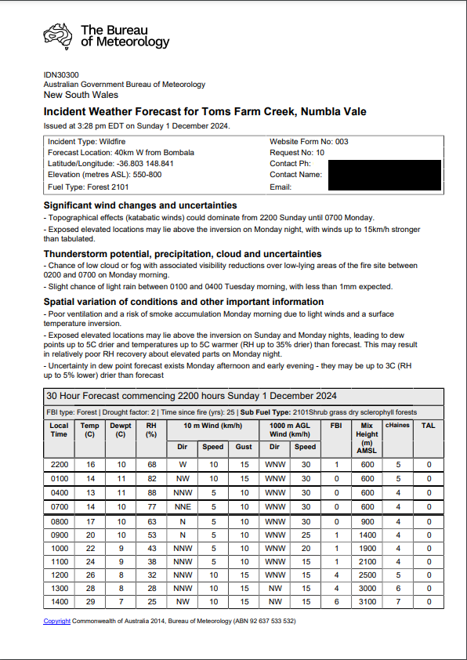
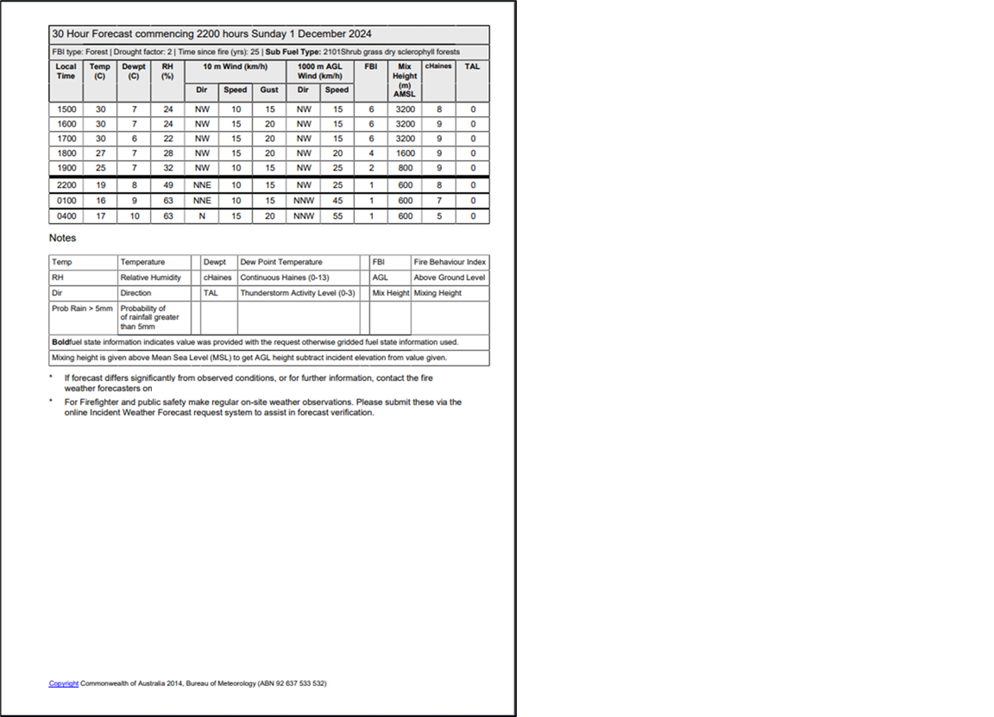

  - Incident Weather Forecast – 4 Day Outlook
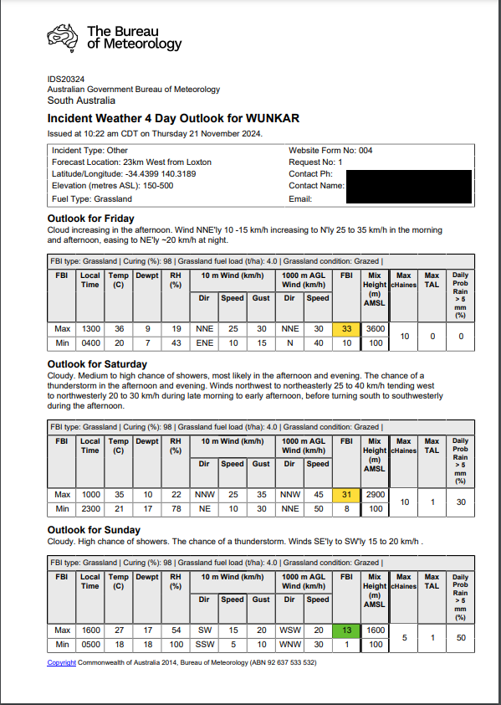
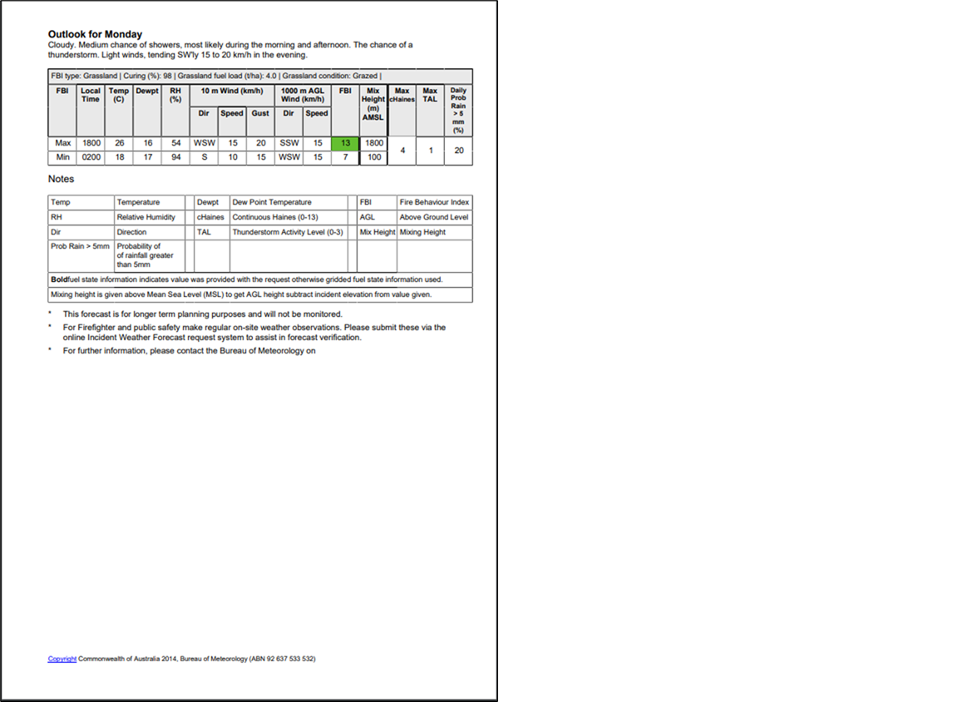

  - Wind Change Charts
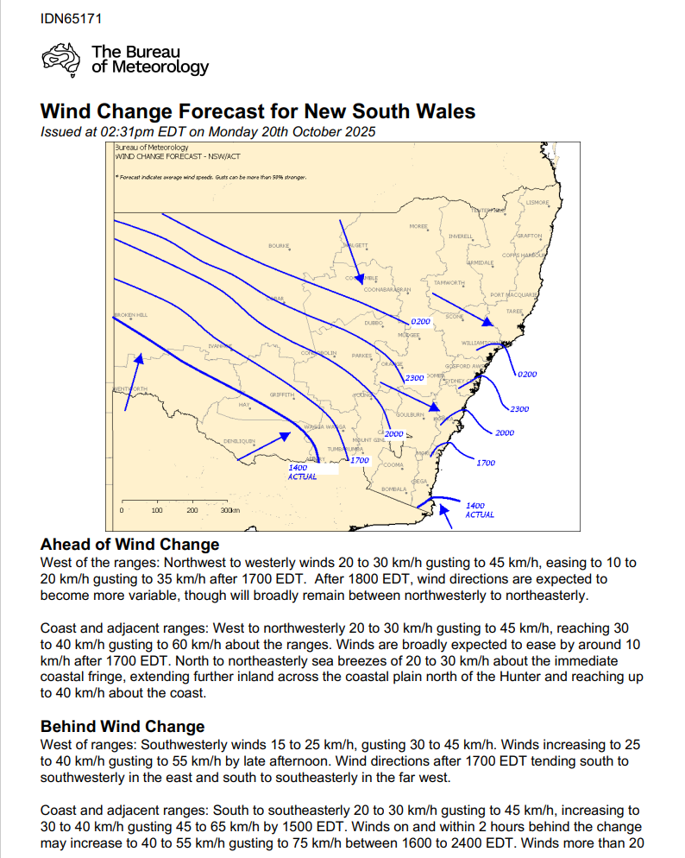

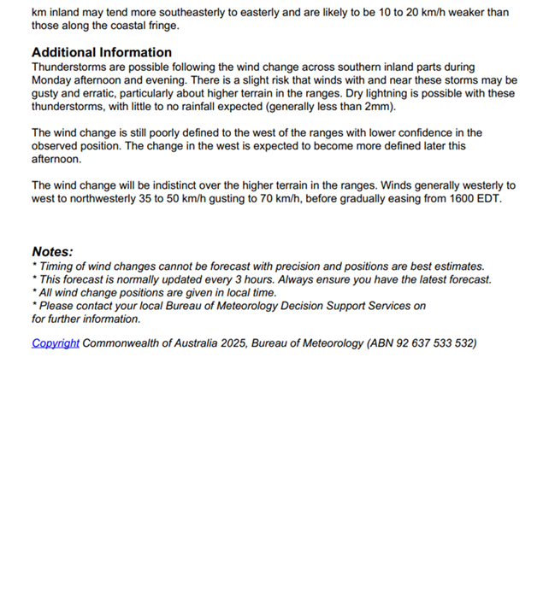

  - Fire Danger Outlooks
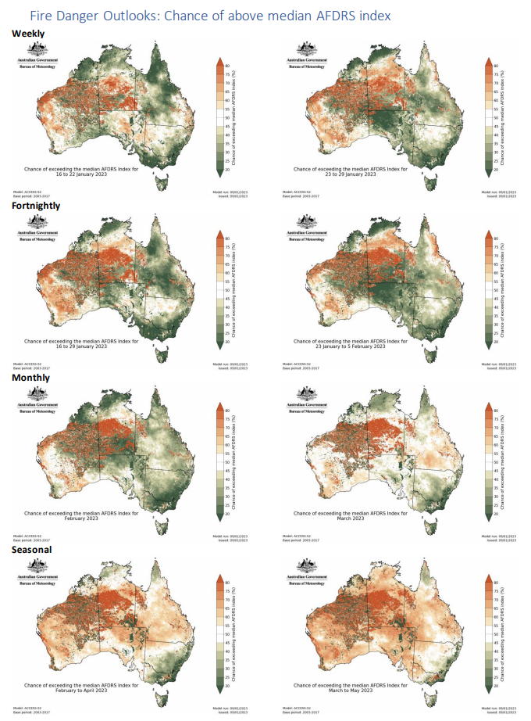

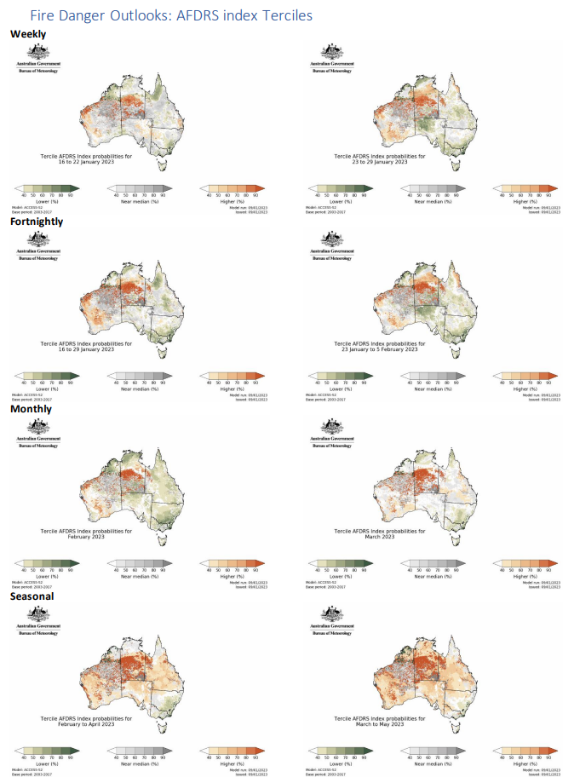

Tercile weekly time series
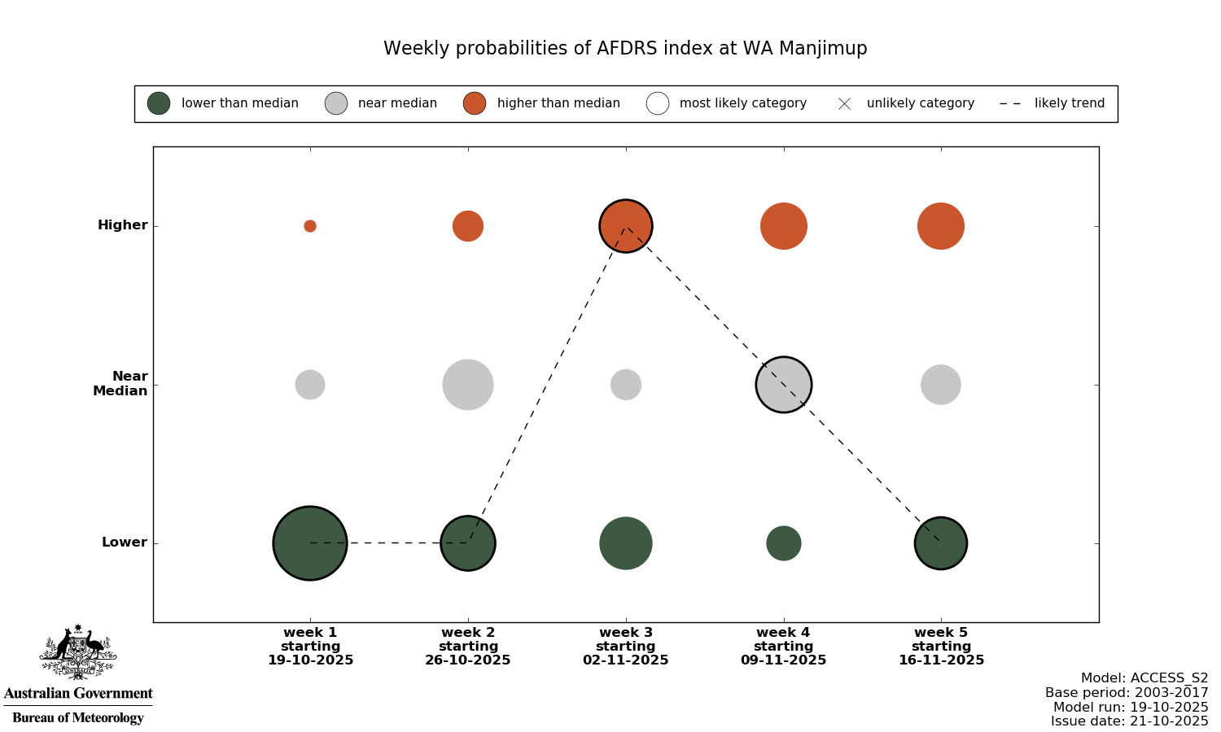

  - Ground Moisture Data
Example from Western Australia. Subset of the full dataset.
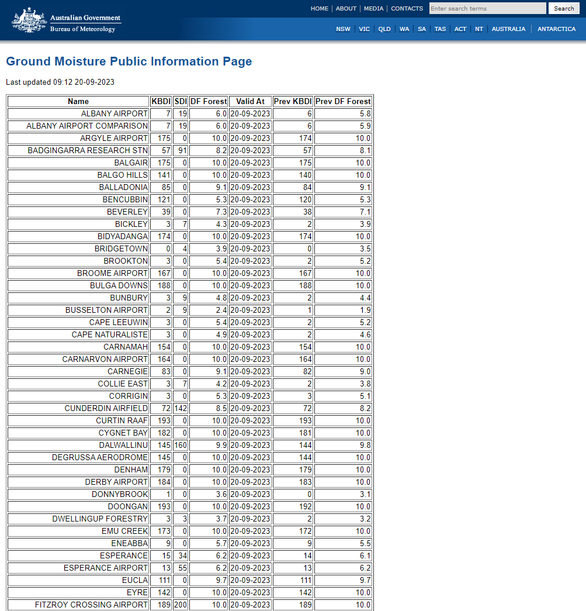

  - Fire Weather Observations Bulletin

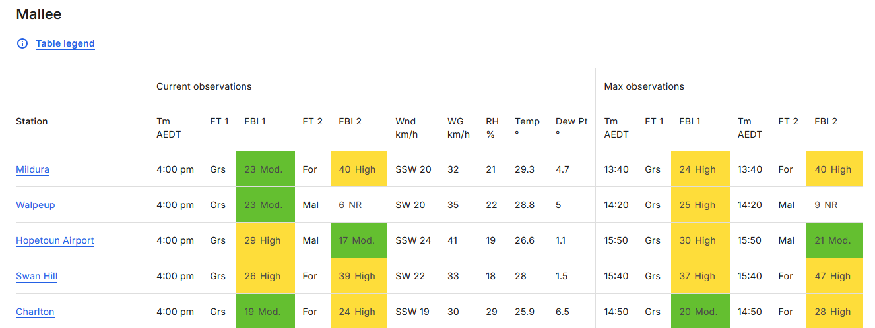

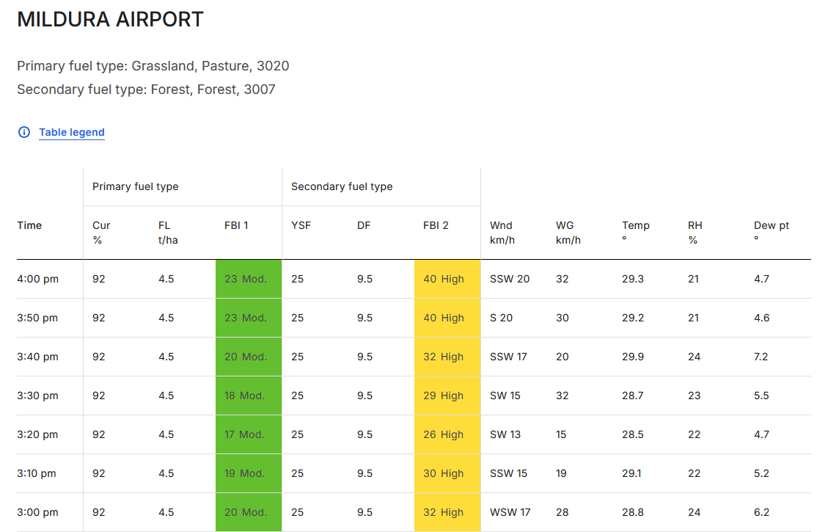

- Appendix 4: Product Identifiers
Product ID | Description
Fire Weather Forecasts for Australia
IDZ20081 | Fire Weather Observation Bulletin
Fire Weather Forecasts for NSW
IDN10017 | Day 0/1 Preliminary Forecast
IDN10018 | Day 0/1 Forecast
IDN10020 | Day 1/2 Outlook
IDN10021 | Day 2/3 Outlook
IDN10022 | Day 3/4 Outlook
Fire Weather Forecasts for ACT
IDN29199 | Day 0/1 Preliminary Forecast
IDN29200 | Day 0/1 Forecast
IDN29201 | Day 1/2 Outlook
IDN29202 | Day 2/3 Outlook
IDN29203 | Day 3/4 Outlook
Fire Danger Ratings NSW/ACT
IDN10016 | Fire Danger Ratings 4 Days
IDN10026 | Detailed Fire Danger Ratings 7 Days
Warnings NSW/ACT
IDN22000 | NSW Fire Weather Warning 1
IDN22001 | NSW Fire Weather Warning 2
IDN22200 | ACT Fire Weather Warning
Wind Change Chart NSW/ACT
IDN65171 | Wind Change Forecast for New South Wales
Incident Weather Forecasts NSW/ACT
IDN30100 | Incident Weather Forecast 1
IDN30200 | Incident Weather Forecast 2
IDN30300 | Incident Weather Forecast 3
IDN30400 | Incident Weather Forecast 4
IDN30500 | Incident Weather Forecast 5
IDN30600 | Incident Weather Forecast 6
IDN30700 | Incident Weather Forecast 7
IDN30800 | Incident Weather Forecast 8
IDN30900 | Incident Weather Forecast 9
IDN31000 | Incident Weather Forecast 10
IDN31100 | Incident Weather Forecast 11
IDN31200 | Incident Weather Forecast 12
IDN31300 | Incident Weather Forecast 13
IDN31400 | Incident Weather Forecast 14
IDN31500 | Incident Weather Forecast 15
IDN31600 | Incident Weather Forecast 16
IDN31700 | Incident Weather Forecast 17
IDN31800 | Incident Weather Forecast 18
IDN31900 | Incident Weather Forecast 19
IDN32000 | Incident Weather Forecast 20
IDN32100 | Incident Weather Forecast 21
IDN32200 | Incident Weather Forecast 22
IDN32300 | Incident Weather Forecast 23
IDN32400 | Incident Weather Forecast 24
IDN32500 | Incident Weather Forecast 25
IDN32600 | Incident Weather Forecast 26
IDN32700 | Incident Weather Forecast 27
IDN32800 | Incident Weather Forecast 28
IDN32900 | Incident Weather Forecast 29
IDN33000 | Incident Weather Forecast 30
IDN33100 | Incident Weather Forecast 31
IDN33200 | Incident Weather Forecast 32
IDN33300 | Incident Weather Forecast 33
IDN33400 | Incident Weather Forecast 34
IDN33500 | Incident Weather Forecast 35
IDN33600 | Incident Weather Forecast 36
IDN33700 | Incident Weather Forecast 37
IDN33800 | Incident Weather Forecast 38
IDN33900 | Incident Weather Forecast 39
IDN34000 | Incident Weather Forecast 40
IDN34100 | Incident Weather Forecast 41
IDN34200 | Incident Weather Forecast 42
IDN34300 | Incident Weather Forecast 43
IDN34400 | Incident Weather Forecast 44
IDN34500 | Incident Weather Forecast 45
IDN34600 | Incident Weather Forecast 46
IDN34700 | Incident Weather Forecast 47
IDN34800 | Incident Weather Forecast 48
IDN34900 | Incident Weather Forecast 49
IDN35000 | Incident Weather Forecast 50
Fire Weather Forecasts NT
IDD10720 | Day 0/1 Preliminary Forecast
IDD10721 | Day 0/1 Forecast
IDD10722 | Day 1/2 Outlook
IDD10723 | Day 2/3 Outlook
IDD10724 | Day 3/4 Outlook
Fire Danger Ratings NT
IDD10731 | Fire Danger Ratings 4 Days
IDD10732 | Detailed Fire Danger Ratings 7 Days
Warnings NT
IDD20320 | Fire Weather Warning 1
IDD20330 | Fire Weather Warning 2
Incident Weather Forecasts NT
IDD20340 | Incident Weather Forecast 1
IDD20341 | Incident Weather Forecast 2
IDD20342 | Incident Weather Forecast 3
IDD20343 | Incident Weather Forecast 4
IDD20344 | Incident Weather Forecast 5
IDD20345 | Incident Weather Forecast 6
IDD20346 | Incident Weather Forecast 7
IDD20347 | Incident Weather Forecast 8
IDD20348 | Incident Weather Forecast 9
IDD20349 | Incident Weather Forecast 10
IDD20351 | Incident Weather Forecast 11
IDD20352 | Incident Weather Forecast 12
IDD20353 | Incident Weather Forecast 13
IDD20354 | Incident Weather Forecast 14
IDD20355 | Incident Weather Forecast 15
IDD20356 | Incident Weather Forecast 16
IDD20357 | Incident Weather Forecast 17
IDD20358 | Incident Weather Forecast 18
IDD20359 | Incident Weather Forecast 19
IDD20360 | Incident Weather Forecast 20
Fire Weather Forecasts QLD
IDQ13014 | Day 0/1 Preliminary Forecast
IDQ13010 | Day 0/1 Forecast
IDQ13011 | Day 1/2 Outlook
IDQ13012 | Day 2/3 Outlook
IDQ13013 | Day 3/4 Outlook
Fire Danger Ratings QLD
IDQ13016 | Fire Danger Ratings 4 Days
IDQ13017 | Detailed Fire Danger Ratings 7 Days
Warnings QLD
IDQ20035 | Fire Weather Warning 1
IQD20036 | Fire Weather Warning 2
Incident Weather Forecasts QLD
IDQ20100 | Incident Weather Forecast 1
IDQ20101 | Incident Weather Forecast 2
IDQ20102 | Incident Weather Forecast 3
IDQ20103 | Incident Weather Forecast 4
IDQ20104 | Incident Weather Forecast 5
IDQ20105 | Incident Weather Forecast 6
IDQ20106 | Incident Weather Forecast 7
IDQ20107 | Incident Weather Forecast 8
IDQ20108 | Incident Weather Forecast 9
IDQ20109 | Incident Weather Forecast 10
IDQ20110 | Incident Weather Forecast 11
IDQ20111 | Incident Weather Forecast 12
IDQ20112 | Incident Weather Forecast 13
IDQ20113 | Incident Weather Forecast 14
IDQ20114 | Incident Weather Forecast 15
IDQ20115 | Incident Weather Forecast 16
IDQ20116 | Incident Weather Forecast 17
IDQ20117 | Incident Weather Forecast 18
IDQ20118 | Incident Weather Forecast 19
IDQ20119 | Incident Weather Forecast 20
IDQ20160 | Incident Weather Forecast 21
IDQ20161 | Incident Weather Forecast 22
IDQ20162 | Incident Weather Forecast 23
IDQ20163 | Incident Weather Forecast 24
IDQ20164 | Incident Weather Forecast 25
IDQ20165 | Incident Weather Forecast 26
IDQ20166 | Incident Weather Forecast 27
IDQ20167 | Incident Weather Forecast 28
IDQ20168 | Incident Weather Forecast 29
IDQ20169 | Incident Weather Forecast 30
IDQ20170 | Incident Weather Forecast 31
IDQ20171 | Incident Weather Forecast 32
IDQ20172 | Incident Weather Forecast 33
IDQ20173 | Incident Weather Forecast 34
IDQ20174 | Incident Weather Forecast 35
IDQ20175 | Incident Weather Forecast 36
IDQ20176 | Incident Weather Forecast 37
IDQ20177 | Incident Weather Forecast 38
IDQ20178 | Incident Weather Forecast 39
IDQ20179 | Incident Weather Forecast 40
Incident Weather 4 Day Forecasts QLD
IDQ20140 | Incident Weather 4 Day Forecast 1
IDQ20141 | Incident Weather 4 Day Forecast 2
IDQ20142 | Incident Weather 4 Day Forecast 3
IDQ20143 | Incident Weather 4 Day Forecast 4
IDQ20144 | Incident Weather 4 Day Forecast 5
IDQ20145 | Incident Weather 4 Day Forecast 6
IDQ20146 | Incident Weather 4 Day Forecast 7
IDQ20147 | Incident Weather 4 Day Forecast 8
IDQ20148 | Incident Weather 4 Day Forecast 9
IDQ20149 | Incident Weather 4 Day Forecast 10
IDQ20150 | Incident Weather 4 Day Forecast 11
IDQ20151 | Incident Weather 4 Day Forecast 12
IDQ20152 | Incident Weather 4 Day Forecast 13
IDQ20153 | Incident Weather 4 Day Forecast 14
IDQ20154 | Incident Weather 4 Day Forecast 15
IDQ20155 | Incident Weather 4 Day Forecast 16
IDQ20156 | Incident Weather 4 Day Forecast 17
IDQ20157 | Incident Weather 4 Day Forecast 18
IDQ20158 | Incident Weather 4 Day Forecast 19
IDQ20159 | Incident Weather 4 Day Forecast 20
Fire Weather Forecasts SA
IDS65310 | Day 0/1 Preliminary Forecast
IDS65006 | Day 0/1 Forecast
IDS65307 | Day 1/2 Outlook
IDS65308 | Day 2/3 Outlook
IDS65309 | Day 3/4 Outlook
Fire Danger Ratings SA
IDS10070 | Fire Danger Ratings 4 Day
IDS10080 | Detailed Fire Danger Ratings 7 Day
Warnings SA
IDS20290 | Fire Weather Warning 1
IDS20299 | Fire Weather Warning 2
Wind Change Chart SA
IDS20310 | Wind Change Forecast for South Australia
Incident Weather Forecasts SA
IDS20311 | Incident Weather Forecast 1
IDS20312 | Incident Weather Forecast 2
IDS20313 | Incident Weather Forecast 3
IDS20314 | Incident Weather Forecast 4
IDS20315 | Incident Weather Forecast 5
IDS20316 | Incident Weather Forecast 6
IDS20317 | Incident Weather Forecast 7
IDS20318 | Incident Weather Forecast 8
IDS20319 | Incident Weather Forecast 9
IDS20320 | Incident Weather Forecast 10
IDS20330 | Incident Weather Forecast 11
IDS20331 | Incident Weather Forecast 12
IDS20332 | Incident Weather Forecast 13
IDS20333 | Incident Weather Forecast 14
IDS20334 | Incident Weather Forecast 15
IDS20335 | Incident Weather Forecast 16
IDS20336 | Incident Weather Forecast 17
IDS20337 | Incident Weather Forecast 18
IDS20338 | Incident Weather Forecast 19
hazardIDS20339 | Incident Weather Forecast 20
Incident Weather 4 Day Forecasts SA
IDS20321 | Incident Weather 4 Day Forecast 1
IDS20322 | Incident Weather 4 Day Forecast 2
IDS20323 | Incident Weather 4 Day Forecast 3
IDS20324 | Incident Weather 4 Day Forecast 4
IDS20325 | Incident Weather 4 Day Forecast 5
IDS20326 | Incident Weather 4 Day Forecast 6
IDS20327 | Incident Weather 4 Day Forecast 7
IDS20328 | Incident Weather 4 Day Forecast 8
IDS20329 | Incident Weather 4 Day Forecast 9
IDS20343 | Incident Weather 4 Day Forecast 10
Fire Weather Forecasts TAS
IDT13134 | Day 0/1 Preliminary Forecast
IDT13130 | Day 0/1 Forecast
IDT13131 | Day 1/2 Outlook
IDT13132 | Day 2/3 Outlook
IDT13133 | Day 3/4 Outlook
Fire Danger Ratings TAS
IDT13151 | Fire Danger Ratings 4 Days
IDT13152 | Detailed Fire Danger Ratings 7 Days
Warnings TAS
IDT31100 | Fire Weather Warning 1
IDT31200 | Fire Weather Warning 2
Incident Weather Forecasts TAS
IDT31000 | Incident Weather Forecast 1
IDT31005 | Incident Weather Forecast 2
IDT31010 | Incident Weather Forecast 3
IDT31015 | Incident Weather Forecast 4
IDT31020 | Incident Weather Forecast 5
IDT31025 | Incident Weather Forecast 6
IDT31030 | Incident Weather Forecast 7
IDT31035 | Incident Weather Forecast 8
IDT31040 | Incident Weather Forecast 9
IDT31045 | Incident Weather Forecast 10
IDT31050 | Incident Weather Forecast 11
IDT31055 | Incident Weather Forecast 12
IDT31060 | Incident Weather Forecast 13
IDT31065 | Incident Weather Forecast 14
IDT31070 | Incident Weather Forecast 15
IDT31075 | Incident Weather Forecast 16
IDT31080 | Incident Weather Forecast 17
IDT31085 | Incident Weather Forecast 18
IDT31090 | Incident Weather Forecast 19
IDT31095 | Incident Weather Forecast 20
Fire Weather Forecasts VIC
IDV22010 | Day 0/1 Preliminary Forecast
IDV18560 | Day 0/1 Forecast
IDV18570 | Day 1/2 Outlook
IDV18580 | Day 2/3 Outlook
IDV18590 | Day 3/4 Outlook
Fire Danger Ratings VIC
IDV18555 | Fire Danger Ratings 4 Days
IDV18556 | Detailed Fire Danger Ratings 7 Days
Warnings VIC
IDV22000 | Fire Weather Warning 1
IDV22001 | Fire Weather Warning 2
Wind Change Chart VIC
IDV65059 | Wind Change Forecast for Victoria
Incident Weather Forecasts VIC
IDV31050 | Incident Weather Forecast 1
IDV31150 | Incident Weather Forecast 2
IDV31250 | Incident Weather Forecast 3
IDV31350 | Incident Weather Forecast 4
IDV31450 | Incident Weather Forecast 5
IDV31550 | Incident Weather Forecast 6
IDV31650 | Incident Weather Forecast 7
IDV31750 | Incident Weather Forecast 8
IDV31760 | Incident Weather Forecast 9
IDV31770 | Incident Weather Forecast 10
IDV31780 | Incident Weather Forecast 11
IDV31790 | Incident Weather Forecast 12
IDV31800 | Incident Weather Forecast 13
IDV31810 | Incident Weather Forecast 14
IDV31820 | Incident Weather Forecast 15
IDV31830 | Incident Weather Forecast 16
IDV31840 | Incident Weather Forecast 17
IDV31850 | Incident Weather Forecast 18
IDV31860 | Incident Weather Forecast 19
IDV31870 | Incident Weather Forecast 20
Fire Weather Forecasts for WA
IDW15230 | Day 0/1 Preliminary Forecast
IDW15000 | Day 0/1 Forecast
IDW15200 | Day 1/2 Outlook
IDW15210 | Day 2/3 Outlook
IDW15220 | Day 3/4 Outlook
Fire Danger Ratings WA
IDW15100 | Fire Danger Ratings 4 Days
IDW15101 | Fire Danger Ratings 7 Days
Warnings WA
IDW30000 | Fire Weather Warning 1
IDW30100 | Fire Weather Warning 2
IDW38900 | Fire Weather Warning 3
Incident Weather Forecasts WA
IDW30500 | Incident Weather Forecast 1
IDW30600 | Incident Weather Forecast 2
IDW30700 | Incident Weather Forecast 3
IDW30800 | Incident Weather Forecast 4
IDW30900 | Incident Weather Forecast 5
IDW31000 | Incident Weather Forecast 6
IDW31100 | Incident Weather Forecast 7
IDW31200 | Incident Weather Forecast 8
IDW31250 | Incident Weather Forecast 9
IDW31260 | Incident Weather Forecast 10
IDW31400 | Incident Weather Forecast 11
IDW31500 | Incident Weather Forecast 12
IDW31600 | Incident Weather Forecast 13
IDW31700 | Incident Weather Forecast 14
IDW31800 | Incident Weather Forecast 15
IDW31900 | Incident Weather Forecast 16
IDW32000 | Incident Weather Forecast 17
IDW32050 | Incident Weather Forecast 18
IDW32060 | Incident Weather Forecast 19
IDW32070 | Incident Weather Forecast 20
IDW32080 | Incident Weather Forecast 21
IDW32090 | Incident Weather Forecast 22
IDW32100 | Incident Weather Forecast 23
IDW32110 | Incident Weather Forecast 24
IDW32120 | Incident Weather Forecast 25
IDW32130 | Incident Weather Forecast 26
IDW32140 | Incident Weather Forecast 27
IDW32150 | Incident Weather Forecast 28
IDW32160 | Incident Weather Forecast 29
IDW32170 | Incident Weather Forecast 30
IDW32172 | Incident Weather Forecast 32
IDW32173 | Incident Weather Forecast 33
IDW32174 | Incident Weather Forecast 34
IDW32175 | Incident Weather Forecast 35
IDW32176 | Incident Weather Forecast 36
IDW32177 | Incident Weather Forecast 37
IDW32178 | Incident Weather Forecast 38
IDW32179 | Incident Weather Forecast 39
IDW32180 | Incident Weather Forecast 40
Incident Weather 4 Day Forecasts WA
IDW32200 | Incident Weather 4 Day Forecast 1
IDW32210 | Incident Weather 4 Day Forecast 2
IDW32220 | Incident Weather 4 Day Forecast 3
IDW32230 | Incident Weather 4 Day Forecast 4
IDW32240 | Incident Weather 4 Day Forecast 5
IDW32250 | Incident Weather 4 Day Forecast 6
IDW32260 | Incident Weather 4 Day Forecast 7
IDW32270 | Incident Weather 4 Day Forecast 8
IDW32280 | Incident Weather 4 Day Forecast 9
IDW32290 | Incident Weather 4 Day Forecast 10
IDW32300 | Incident Weather 4 Day Forecast 11
IDW32310 | Incident Weather 4 Day Forecast 12
IDW32320 | Incident Weather 4 Day Forecast 13
IDW32330 | Incident Weather 4 Day Forecast 14
IDW32340 | Incident Weather 4 Day Forecast 15
IDW32350 | Incident Weather 4 Day Forecast 16
IDW32360 | Incident Weather 4 Day Forecast 17
IDW32370 | Incident Weather 4 Day Forecast 18
IDW32380 | Incident Weather 4 Day Forecast 19
IDW32390 | Incident Weather 4 Day Forecast 20
IDQ65022 | Ground Moisture Table with KBDI (Qld)
IDN65053 | Ground Moisture Table with KBDI (NSW)
IDV65053 | Ground Moisture Table with KBDI (Vic)
IDS65001 | Ground Moisture SDI Data (SA)
IDW61004 | Fire Weather – Ground Moisture – Summary (WA)
IDT65120 | Soil Dryness Index (Tas)

Product ID | Description
Fire Weather Gridded Forecasts for Australia
IDBZ0010 | AFDRS Australia Grids Bundle
IDZ10130 | Preliminary Fire Danger Rating
IDZ10131 | Preliminary Daily Maximum fire danger Rating
IDZ10132 | Preliminary Fire Behaviour Index
IDZ10133 | Preliminary Daily Maximum fire behaviour index
IDZ10134 | Fire Danger Rating
IDZ10135 | Fire Behaviour Index
IDZ10136 | Daily Maximum fire danger rating
IDZ10137 | Daily Maximum fire behaviour index
IDZ10138 | Rate of spread
IDZ10139 | Fire line intensity
IDZ10141 | Flame height
IDZ10142 | Spotting distance
IDZ10143 | Continuous Haines above 95th climatology Flag
IDZ10144 | C Haines Climatological Value (95)
IDZ10145 | Root Zone Soil Moisture
IDZ10146 | Wind Change Danger Index
IDZ10147 | Wind Change Danger Index Alert Threshold
IDZ10148 | Fuel State Editor: Curing
IDZ10149 | Fuel State Editor: Grass Fuel Condition
IDZ10150 | Total Precipitation 48 hours
IDZ10151 | Hours Since Last Precipitation
IDZ10159 | Fuel State Editor: Grass Fuel Load
IDZ10161 | Fuel State Editor: Fuel Type
IDZ10162 | Fuel State Editor: Time Since Fire
IDZ10163 | Fuel State Editor: Fuel Type Table

- Navigation aids
  - List of figures
Figure 1. Total Warning System 7
Figure 2. Peak Fire Danger Seasons across Australia 11
Figure 3. New South Wales Fire Weather Districts 30
Figure 4. Northern Territory Fire Weather Districts 31
Figure 5. Queensland Fire Weather Districts 32
Figure 6. South Australia Fire Weather Districts 33
Figure 7. Tasmania Fire Weather Districts 34
Figure 8. Victoria Fire Weather Districts 35
Figure 9. Western Australia Fire Weather Districts 36
Figure 10. South West WA Fire Weather Districts 37
  - List of tables
Table 1. Fire Weather SLS distribution list by jurisdiction 9
Table 2. Local fire seasons in each jurisdiction 11
Table 3. Fire Danger Ratings and Fire Behaviour Index values 16
Table 4. Fire Danger Ratings Issue Times (Local) 17
Table 5. Fire Weather Forecast Issue Times (Local) 18
Table 6. Wind Change Chart issue times (Local) 26

  - List of acronyms
ACT | Australian Capital Territory
ADFD | Australian Digital Forecast Database
AFAC | Australasian Fire and Emergency Service Authorities Council
AFDRS | Australian Fire Danger Rating System
AGL | Above Ground Level
ASL | Above Sea Level
BMTC | Bureau of Meteorology Training Centre
BNHCRC | Bushfire and Natural Hazards Cooperative Research Centre
cHaines | Continuous Haines Index
DF | Drought Factor
EMA | Emergency Management Australia
FDI | Fire Danger Index
FDR | Fire Danger Rating
FFDI | Forest Fire Danger Index
FSE | Fuel State Editor
GFDI | Grassland Fire Danger Index
HAZMAT | Hazardous Materials
HMA | Hazard Management Agency
HSF | Hazard Services Forum
ID | Identification (numbers or codes)
IGA | Intergovernmental Agreement on the Provision of Bureau of Meteorology Hazard Services to the States and Territories
IWF | Incident Weather Forecast
KBDI | Keetch-Byram Drought Index
MaxFBI | Maximum Fire Behaviour Index
MSDI | Mount Soil Dryness Index
MSL | Mean Sea Level
NSW | New South Wales
NT | Northern Territory
NWP | Numerical Weather Prediction
PERM | Post Event Review Management
PSG | Predictive Services Group
QLD | Queensland
SA | South Australia
SES | State Emergency Service
SLS | Service Level Specification
SOP | Standard Operating Procedures
TAL | Thunderstorm Activity Level
TAS | Tasmania
VIC | Victoria
WA | Western Australia

https://knowledge.aidr.org.au/media/9104/aidr_handbookcollection_publicinfoandwarnings_2021.pdf, p. 5.
cHaines: The continuous Haines Index (C-Haines) is a measure of the humidity and (in)stability of the atmosphere. The index ranges up to about 13 (very dry and unstable) but by definition has no specified lower bounds. C-Haines can link vertical atmospheric stability and humidity with erratic fire behaviour, potentially highlighting states where intensely burning fires have an increased probability of producing a significant convective column that could lead to long distance spotting and sudden changes in fire spread due to erratic local winds.
TAL (Thunderstorm Activity Level): A spatial forecast for thunderstorms. 0 for no thunderstorms, 1 for isolated thunderstorms, 2 for scattered thunderstorms, 3 for widespread thunderstorms.
The height in metres above mean sea level to which the atmosphere is uniform with respect to heat energy.
The Fire Danger Viewer (FDV) is a visualisation tool that allows users to view and interrogate fire danger Information. The FDV is not a Bureau of Meteorology tool. It was developed and is maintained by a third-party provider.

